Supplementary Information
- Ice-stripping Delamination experimental procedures

Water Freezing Tray Stripping
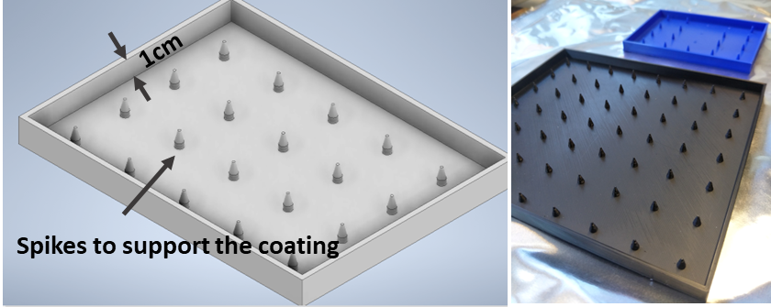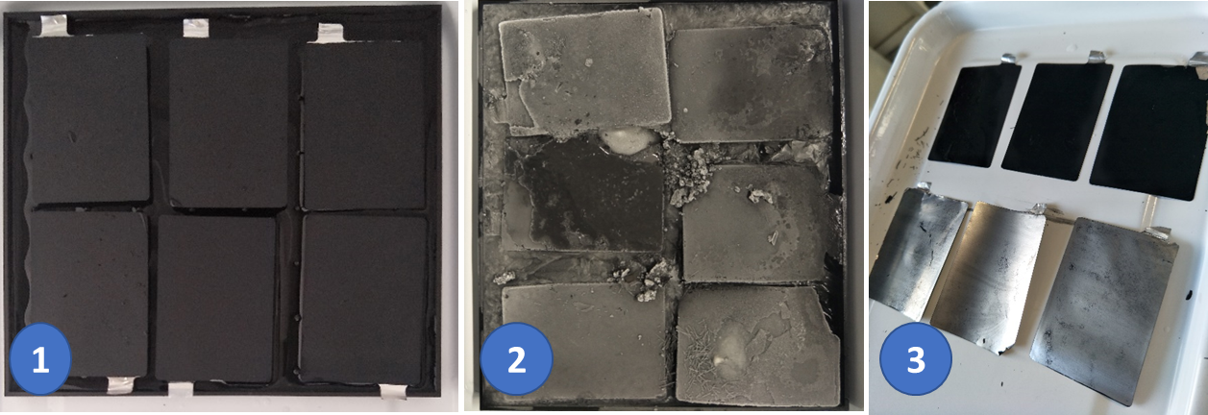
Figure S 12. 3D printed tray for ice-stripping and the ice-stripping delamination process demonstration for end-of-life A7 sodium-ion pouch cells with PW positive and HC negative electrode, made with CMC-SBR binders.

1.2 Cold Surface Stripping
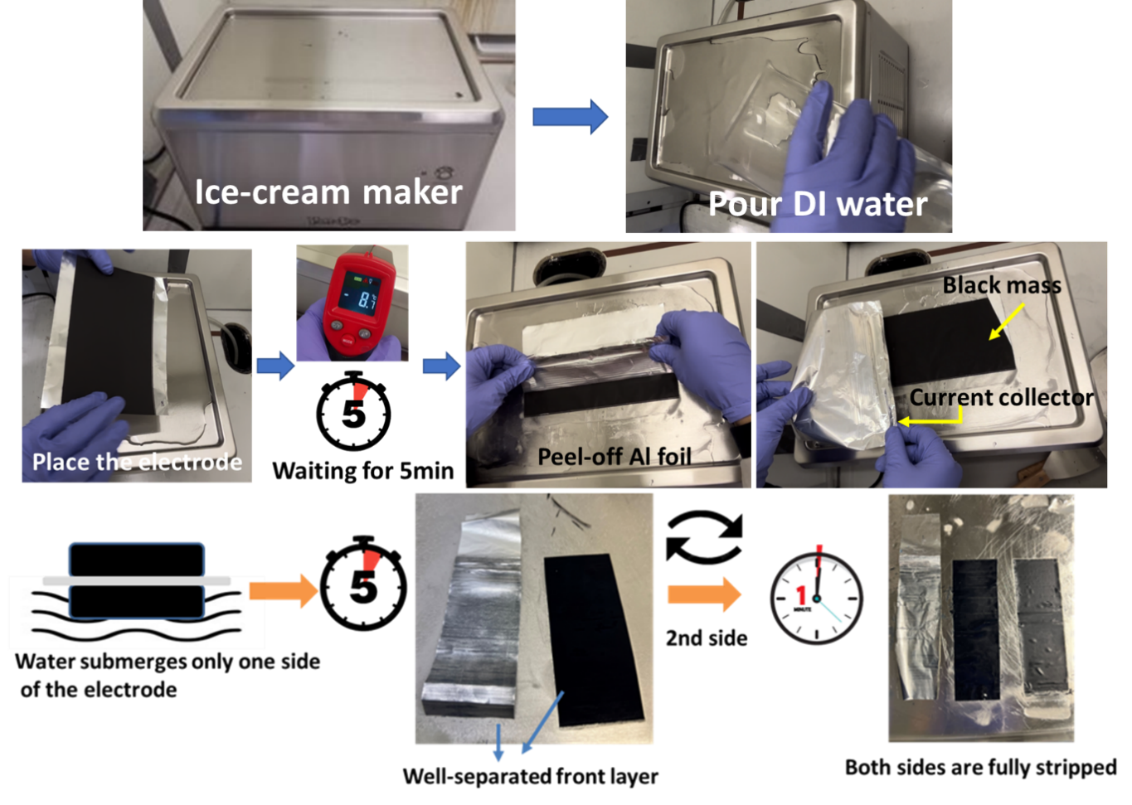
Figure S 2. Ice-cream maker for ice-striping delamination process for double-sided electrode coatings. Water was initially poured onto the cold plate, and the electrode was then wetted with the water. The porous electrode frozen to the surface of the cold plate, and the current collector peeled off.
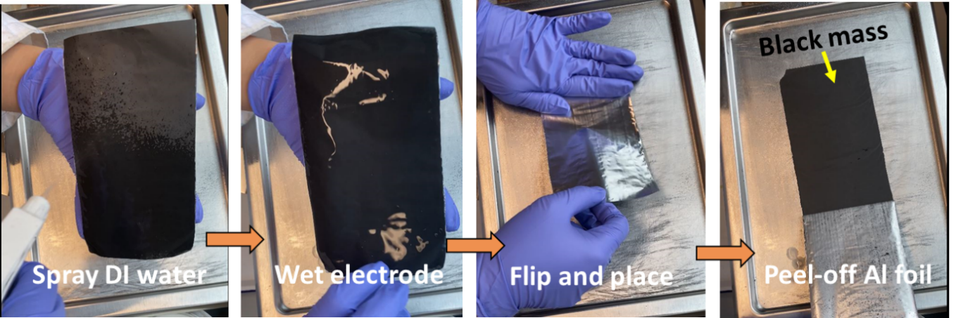
Figure S 3. Further improved ice-striping delamination process with ice-cream maker through spraying the electrode with water, then delaminating by placing on the cold surface and stripping.
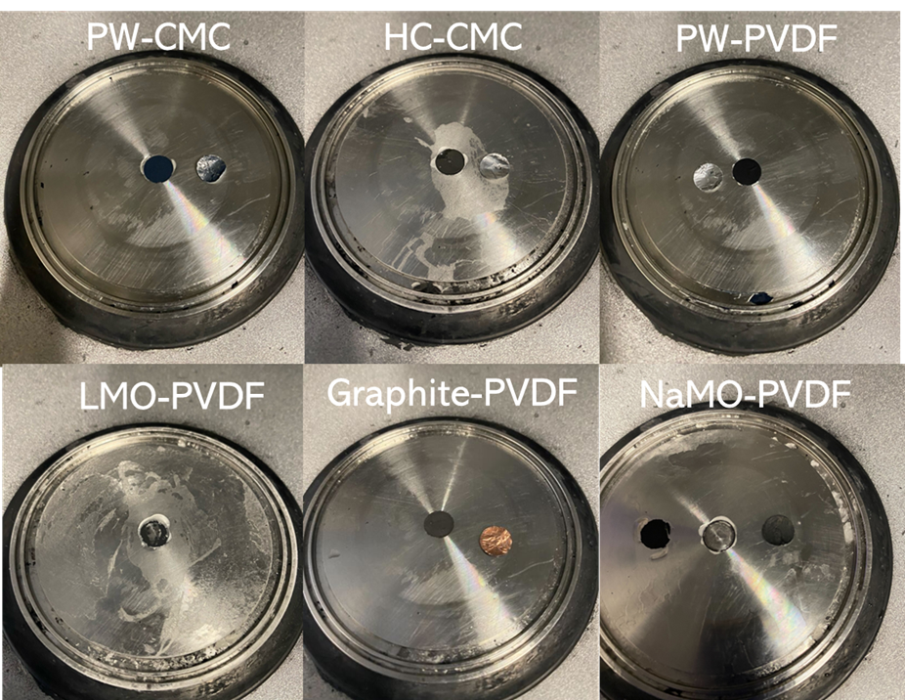
Figure S 4. Adhesion force test on different electrodes at -5deg by pull-off the electrode from cold substrate.

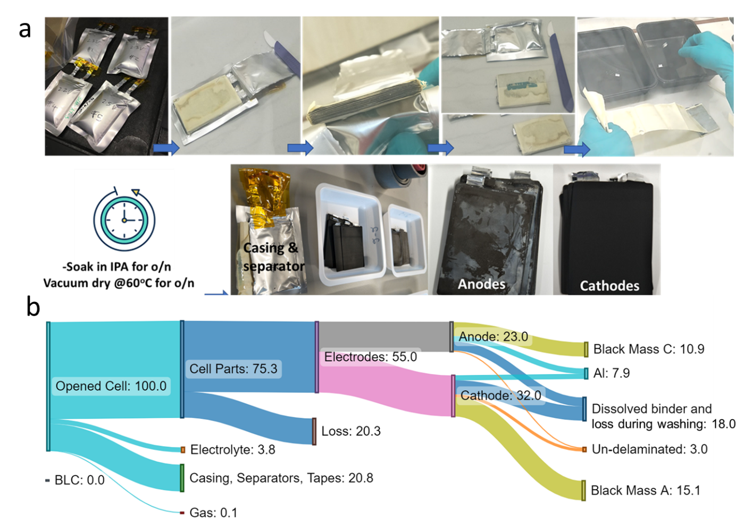
Figure S 5. A. End-of-life A7 pouch cell disassembly process and cell parting sorting. b. Diagram for separation processes used in the pouch cells.

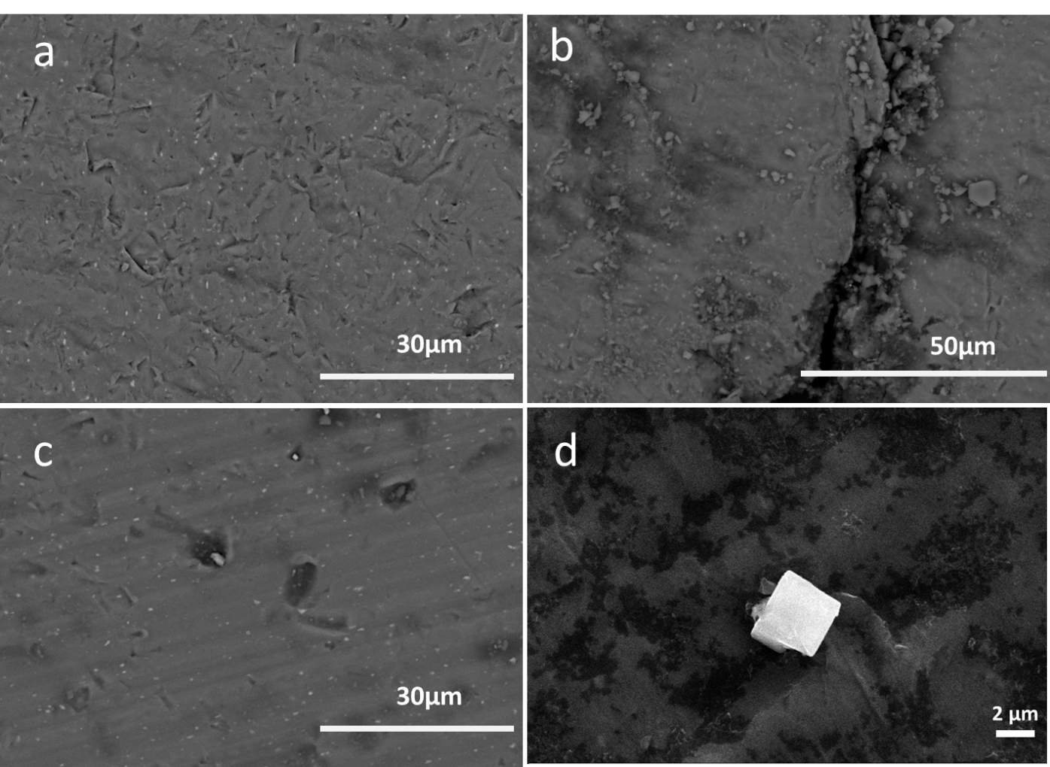
Figure S6 SEM Images of Al after a: ball-milling from PW coatings, b: un-removed PW from after ball-milling. Al after ice-stripping technique using c: 3D designed tray and d: ice-cream maker . The results show much less damage using the ice-stripping process.

