Minimising the societal costs of manure management: Modelling the optimal strategy and location for nutrient recycling
Ruben Vingerhoets^{a,b}*, Marc Spiller^{b,c},, Rahul Raviª, David de Pue^{e}, Siegfried E. Vlaeminck^{b,c}, Jeroen Buysse^{g}, Erik Meersª

ªGhent University, Department of Green Chemistry and Technology, Laboratory for Re-Source Recovery, 9000 Gent, Belgium.
^{b}University of Antwerp, Department of Bioscience Engineering, Research Group of Sustainable Energy, Air and Water Technology, 2020 Antwerpen, Belgium.
^{c}Centre for Advanced Process Technology for Urban Resource Recovery (CAPTURE), Frieda Saeysstraat 1, 9052 Gent, Belgium
^{d}VITO WaterClimateHub, Wetenschapspark 1, 8400 Oostende, Belgium
^{e}ILVO, Instituut voor Landbouw-, Visserij- en Voedingsonderzoek, Melle, Belgium
^{g}Ghent University, Department of Agricultural Economics, Ghent University, 9000 Ghent, Belgium

A Manure characteristic
Table A.1 The characterisation of the different manure streams (kg/tonne)
Kg/tonne | N | P | K | S
Cattle manure | 3.5 | 1.4 | 3.2 | 0.1
Pig manure | 6.5 | 3.5 | 4.5 | 0.12
Other manure | 5.3 | 3 | 3.2 | 0.1

B Processing technologies
Figure B.1 shows the different processing options added in the model.
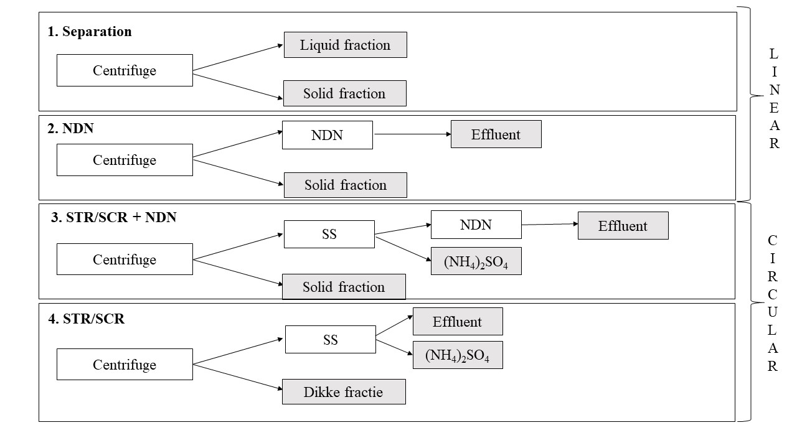
Figure B.1 Graphical representation of the considered treatment technologies without/ with RENURE legislation
The mass separation coefficients for each technology are shown in Table B.1 with the product composition shown in Table B.2.
Table B.1 Mass separation coefficient for the considered technologies
 |  | Cattle | Pig | Other
Separation | SF | 0.198 | 0.198 | 0.198
Separation | LF | 0.802 | 0.802 | 0.802
NDN | SF | 0.198 | 0.198 | 0.198
NDN | Effluent_{bio} | 0.757 | 0.756 | 0.756
SS | SF | 0.198 | 0.198 | 0.198
SS | Effluent_{SS}
SS | Effluent_{bio} | 0.802 | 0.802 | 0.802
SS | AS | 0.01225 | 0.022825 | 0.01855
SS+NDN | SF | 0.198 | 0.1983 | 0.1987
SS+NDN | Effluent_{SS} | 0.802 | 0.802 | 0.802
SS+NDN | Effluent_{bio} | 0.756 | 0.756 | 0.0756
SS+NDN | AS | 0.01225 | 0.026 | 0.01855

Table B.2 Manure derived product composition (kg/tonne)
Kg/tonne |  | N | P | K | S
Cattle | SF | 3.53 | 4.6 | 1.6 | 0.1
Cattle | LF | 3.49 | 0.6 | 3.6 | 0.1
Cattle | Effluent_{SS} | 2.27 | 0.6 | 3.6 | 0.1
Cattle | Effluent_{SS} | 0.2 | 0.3 | 3.6 | 0.1
Cattle | AS | 80 | 0 | 0 | 84
Pig | SF | 6.55 | 11.5 | 3.6 | 0.1
Pig | LF | 6.43 | 1.6 | 5.1 | 0.1
Pig | Effluent_{SS} | 4.18 | 1.6 | 5.1 | 0.1
Pig | Effluent_{SS} | 0.43 | 0.7 | 5.1 | 0.1
Pig | AS | 80 | 0 | 0 | 84
Other | SF | 5.33 | 9.8 | 1.6 | 0.1
Other | LF | 5.29 | 1.35 | 3.6 | 0.1
Other | Effluent_{SS} | 3.44 | 1.35 | 3.6 | 0.1
Other | Effluent_{SS} | 0.35 | 0.6 | 3.6 | 0.1
Other | AS | 80 | 0 | 0 | 84

C Emission factors

Storage
Pig waste is retained in a slurry form within a pit underneath the stable. This storage method contributes to the release of methane and nitrous oxide into the environment. Although direct nitrous oxide emissions are relatively minor when compared to the substantial methane emissions from the storage of pig slurry. These computations are established on a storage duration of 6 months before spreading, as the storage capacity must accommodate at least the quantity of waste generated by the animals in the stable throughout a 6 month period and 1.5 months for processing.

Methane
Under conditions devoid of oxygen, methane is generated through the process of manure decomposition. the quantity of emitted methane is significantly influenced by both temperature and storage duration^{1,2}.The calculation of methane emissions employs the IPCC Tier 2 methodology, which considers both the quantity of volatile solids excreted by the animals (VS) and the maximum methane-producing capacity of the manure:

$${{CH}_{4}}_{Manure}=\sum_{T}{\frac{{EF}_{T}{*M}_{T}}{{10}^{6}}}$$

Where $M_{T}$ represents the amount of manure per livestock species and ${EF}_{T}$denotes the annual CH₄ emission factor for the livestock category T in kilograms of CH₄ per animal per year. This factor is calculated using following equation:
$${EF}_{T}= {VS}_{T}*B_{0T}*0.67*\sum_{s,k}{\frac{{MCF}_{s,k}}{100}}$$
With MCF_{S,k} representing the methane conversion factor for the specific manure management system S in the climate region k. B_{OT} is the maximum methane producing capacity of manure for livestock category T in cubic meters of CH₄ per kilogram of volatile solids (VS) excreted, 0.67 is the conversion factor from cubic meters of CH₄ to kilograms of CH₄, VS_{T} signifies the VS content in one tonne of manure per animal for category.

For manure storage in pits beneath animal housing, the methane conversion factor MCF is 19% when the average storage temperature is 11°C or higher, and the storage duration exceeds one month. The default value for the maximum methane production in Western Europe is 0.45 m³ CH₄ (kgVS)⁻¹ ². When manure is separated the methane emissions from storage are 12 times lower than for raw manure for the same time frame.

Manure processing

Separation
It was postulated that the mechanical separation of the slurry utilized a centrifuge, as this method was prevalent in the Flanders region. As indicated by Vingerhoets et al. (2023)³, a centrifuge consumes 2 kWh per cubic meter of raw manure. The separation process predominantly takes place within enclosed equipment or in stable environments, resulting in minimal emissions. Consequently, the input and output of nutrients into the system were anticipated to balance. It was assumed that 20% of the mass, 20% of N, 85% of P and 10 % of K ends up in the solid fraction. The liquid fraction is typically stored for an average duration of 4 months before being applied to crop fields, whereas the solid fraction is promptly transported to the composting facility. Methane emission during storage of the liquid fraction is significantly reduced in comparison to the methane emissions observed with raw slurry, namely 12 tomes lower. The anaerobic conditions prevailing in the liquid fraction are expected to result in negligible nitrous oxide emissions, as nitrification is effectively suppressed. It is assumed that the solid fraction is transported around an average distance of 50 km to a composting facility. The energy consumption for large-scale composting, inclusive of pre- and post-treatment, conversion, and aeration, is estimated at 50 kWh per ton, based on research by Lemmens et al. (2007)¹. During the composting process, about 28% of the nitrogen present in the solid manure is emitted as NH₃-N, 1% as N₂O-N, and 1% as N₂ ⁴. Methane emissions from the solid fraction are presumed to be neglectable. However, the emissions are captured in the closed system (hall or tunnel composting) and treated. Also, 61% of the total mass is lost during composting. The remainder is exported to the North of France where it is applied on land (distance = 200 km).

Separation + NDN of liquid fraction
Similar as separation treatment trajectory. Only the liquid fraction is further treated by nitrification and denitrification processes to remove nitrogen (90% of N). During the nitrification process, aeration is required which consumes 16 kWh m⁻³ - 17 kWh m⁻³ ⁵. NDN results in N₂O and NH₃ emissions, 1% and 0.01% of N-input respectively⁵. The effluent with the remainder of the nutrients, mainly K, is applied on land as it is not in accordance with Flemish discharge limits.

Separation + Stripping-scrubbing + NDN of liquid fraction
For this processing scenario, a part of the nitrogen (67% of NH₄⁺-N) is recovered before entering the NDN. Introducing a stripping-unit comes with an increase in energy requirement³, while the energy requirement for aeration decreases with due to the reduced nitrogen content. Also, N₂O and NH₃ emissions originating from NDN are expected to decrease according to the nitrogen content.

Land application
Depending on the product form and cropping system, the Flemish EMAV model⁶ provides NH₃ emission factors of the mineral fraction of manure for land applications (Table C.1).
Table C.1 NH3 emission factors for land application of the different manure (derived) products (SF= Solid fraction; LF= Liquid fraction)
 | Arable land (%) | Grassland (%)
Cattle manure | 18.52 | 20.99
Pig manure | 18.52 | 20.99
Other manure | 18.52 | 20.99
SF Cattle manure | 38.1 | /
SF Pig Manure | 38.1 | /
SF other manure | 38.1 | /
LF cattle manure | 18.52 | 20.99
LF pig manure | 18.52 | 20.99
LF other manure | 18.52 | 20.99
Effluent cattle manure | 18.52 | 20.99
Effluent pig manure | 18.52 | 20.99
Effluent other manure | 18.52 | 20.99
Ammonium sulphate | 4 | 4
Mineral N fertiliser | 2 | 2

The calculation of direct N₂O emissions from managed soils can be performed utilizing following equation⁵:
$$N_{2}O_{Direct}=\left(F_{SN} + F_{ON}\right)*{EF}_{1}*(44/28)$$

In this equation, N₂O_{Direct} represents the annual direct N₂O emissions stemming from N inputs, where F_{SN} corresponds to the yearly application of synthetic fertilizer N to soils in kilograms per year (kg N yr⁻¹), F_{ON} represents the annual application of animal manure, compost, and other organic N additions to soils in kilograms per year (kg N yr⁻¹), and EF₁ (=1%) signifies the emission factor for N₂O emissions from N inputs in units of kg N₂O-N (kg N input)⁻¹.

Moreover, the assessment of indirect N₂O emissions originating from the atmospheric deposition of N that has been volatilized from managed soils can be estimated by assuming that 1% of the NH₃-N emissions are converted into N₂O-N.

N and P leaching are calculated based on a location-specific coefficient derived from the Flemish NEMO model⁷.

Mineral fertiliser
The application of manure (derived products) on agricultural land can partly serve as a substitution for synthetic fertilizers. The Mineral Fertilizer Equivalent, based on effective nitrogen, gives an indication on the quantity of nitrogen embedded in the product is available to plants during the growing season (Table C.2)⁸.
Table C.2 Effective nitrogen of the manure (derived) products (SF= Solid fraction; LF= Liquid fraction)
 | (%)
Cattle manure | 55
Pig manure | 60
Other manure | 55
SF Cattle manure | 30
SF Pig Manure | 30
SF other manure | 30
LF cattle manure | 70
LF pig manure | 70
LF other manure | 70
Effluent cattle manure | 100
Effluent pig manure | 100
Effluent other manure | 100
Ammonium sulphate | 100
Mineral N fertiliser | 100

However, the input of animal derived nutrients alone is not sufficient to sustain crop nutrient requirements. Therefore, additional mineral nutrients are applied to the fields. The production of fertilizers requires substantial energy input, consequently contributing significantly to the carbon footprint. The production of 1 kg of nitrogen using results in the emission of 2.2 kg of CO₂ equivalents⁵, accounting for the energy consumption in ammonia production through the Haber-Bosch process. This energy use stands at 31.8 GJ per ton of ammonia, which is lower than the European average of 35.2 GJ per tonne⁵.Additionally, the energy consumption for solidification and the release of nitrous oxide during nitric acid production contribute to emissions of 1.3 kg and 0.1 kg of CO₂ equivalents, respectively. Transportation via various modes like ships, trucks, or railways contributes 0.1 kg of CO₂ equivalents, bringing the total carbon footprint to 3.7 kg CO₂ equivalents per kg of nitrogen. For phosphorus and potassium fertilizers, the average carbon footprint from production (cradle-to-gate) in Western Europe is 0.46 kg CO₂ equivalents (per kg P₂O5) and 0.29 kg CO₂ equivalents (per kg K₂O), respectively⁵. An emission factor of 0.1 kg CO₂ equivalents is assumed for transportation. The energy consumption associated with the application of mineral fertilizers is approximated using average diesel consumption for injecting 1 ton of product (0.8 L)⁵.

Energy use

The inclusion of non-renewable energy in this context encompasses the energy utilized for transporting the manure slurry to the designated spreading area and for the subsequent injection process. The transportation is envisaged to be carried out by trucks with a load exceeding 20 tons, resulting in an emission of 110 g CO₂ equivalents per tonne and kilometer⁵. For the injection of slurry, an assumed fuel consumption of 0.8 liters of diesel per cubic meter is considered⁵. As stated by Defra (2012)⁹, the comprehensive greenhouse gas emissions from the combustion of 1 liter of diesel stand at 3.18 kg CO₂ equivalents when considering the entire production-to-use cycle. The consumption of 1 kwh equals 215 g CO₂ equivalents in Flanders¹⁰.

[1] Lemmens, B., Ceulemans, J., Elsander, H., Vanassche, S., Brauns, E., Vrancken, K., Beste Beschikbare Technieken ( BBT ) voor mestverwerking 335 p. (2007).
[2] IPCC. Chapter 10 Emissions from livestock and manure management. Forestry. (2006).
[3] Vingerhoets, R., Brienza, C., Sigurnjak, I., Buysse, J., Vlaeminck, S. E., Spiller, M., & Meers, E. Ammonia stripping and scrubbing followed by nitrification and denitrification saves costs for manure treatment based on a calibrated model approach. Chem. Eng. J. 477, 146984-.(2023). https://doi.org/10.1016/j.cej.2023.146984
[4] Basset-Mens, C., van der Werf, H.M.G., Robin, P., Morvan, T., Hassouna, M., Paillat, J.M., Vertès, F. Methods and data for the environmental inventory of contrasting pig production systems. J. Clean. Prod. 15, 1395–1405. (2007). doi:10.1016/j.jclepro.2006.03.009
[5] Willeghems, G., De Clercq, L., Michels, E., Meers, E., & Buysse, J. Can spatial reallocation of livestock reduce the impact of GHG emissions? Agricultural Systems, 149, 11–19. (2016). https://doi.org/10.1016/j.agsy.2016.08.006
[6] Foqué, D., & Demeyer, P. Optimalisering en actualisering van de emissie-inventaris ammoniak landbouw: Rapport en handleiding. Instituut voor Landbouw-, Visserij- en Voedingsonderzoek.
(2009).
[7] VMM. NEMO: een nutriëntenemissiemodel voor de landbouw. (2017). https://www.vmm.be/water/kwaliteit-waterlopen/waterkwaliteitsmodellen/nemo_tw.pdf
[8] VLM. Normen en richtwaarden 2021. (2021). https://www.vlm.be/nl/SiteCollectionDocuments/Publicaties/mestbank/Bemestingsnormen_2021.pdf
[9] Defra. 2012 Guidelines to Defra / DECC’s GHG Conversion Factors for Company Reporting. Methodol. Pap. Emiss. Factors 1–85. (2012).
[10] VLAAMS ENERGIE- & KLIMAATAGENTSCHAP. CO₂-emissiefactoren, calorische onderwaarden en soortelijke gewichten van fossiele brandstoffen en elektriciteit. (2023). https://www.vlaanderen.be/veka/energie-en-klimaatbeleid-in-cijfers/co2-emissiefactoren-calorische-onderwaarden-en-soortelijke-gewichten-van-fossiele-brandstoffen-en-elektriciteit

Corresponding author: Ruben.vingerhoets@ugent.be

