Synthesis of Ag/Cu decorated 3D self-assembled nanowire TiO₂ Photocatalyst for Hydrogen Production: A Promising Pathway towards Sustainable Energy Generation

Sachin Wadhai and Pragati Thakur*
Department of Chemistry, Savitribai Phule Pune University, Ganeshkhind, Pune 411007, India
*Corresponding author email ID : pragati.thakur@unipune.ac.in

Keywords:
Photocatalytic hydrogen production, titania, photocatalysis, morphological study, SPR effect, nanowire

Experimental section, Figure S1 – S9
Experimental section
Synthesis of Pt decorated NWT (Pt-NWT)
The decoration of Pt on NWT was carried out by photo-deposition method. Typically, 200 mg of NWT in 10% 100 mL methanol solution was taken and 0.132 mL of 0.08 M Hexachloroplatinic acid (H₂PtCl₆) was added as a Pt precursor for the preparation of 1% Pt-NWT. Then this solution was irradiated under UV light for 3h, washed with distilled water and dried at 60º C. Similarly, 0.2, 0.4, 0.5, 0.6 and 0.8 % Pt-NWT (Labelled as 0.2Pt-NWT, 0.4Pt-NWT, 0.5Pt-NWT, 0.6Pt-NWT and 0.8Pt-NWT) were synthesized by varying the amount of Pt precursor in the above synthesis method (Shinde et al. 2018).
Synthesis of Cu decorated NWT (Cu-NWT)
Cu decorated NWT was synthesized by photo-deposition method. For that, typically 0.02 M Copper sulphate solution has been prepared and calculated 1.58 mL of copper sulphate solution mixed with 200 mg of NWT in 10% methanol solution has been carried out for the preparation of 1.0% Cu photocatalyst. The solution has been irradiated in UV light for 3h, washed with distilled water and dried at 60º C. Different Cu % i.e., 0.5, 0.75, 1.0, 1.5 and 2.0 % decorated on NWT, labelled as 0.5Cu-NWT, 0.75Cu-NWT, 1.0Cu-NWT, 1.5Cu-NWT and 2.0Cu-NWT photocatalysts were synthesized by varying the copper sulphate solution.
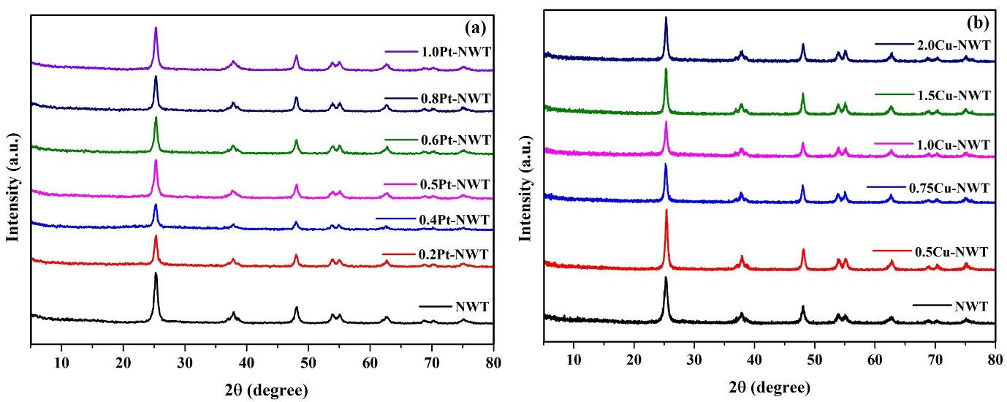
Fig. S1. (a) Powder XRD pattern recorded on NWT, 0.2Pt-NWT, 0.4Pt-NWT, 0.5Pt-NWT, 0.6Pt-NWT, 0.8Pt-NWT and 1.0Pt-NWT photocatalysts, (b) Powder XRD pattern recorded on NWT 0.5Cu-NWT, 0.75Cu-NWT, 1.0Cu-NWT, 1.5Cu-NWT and 2.0Cu-NWT photocatalysts.
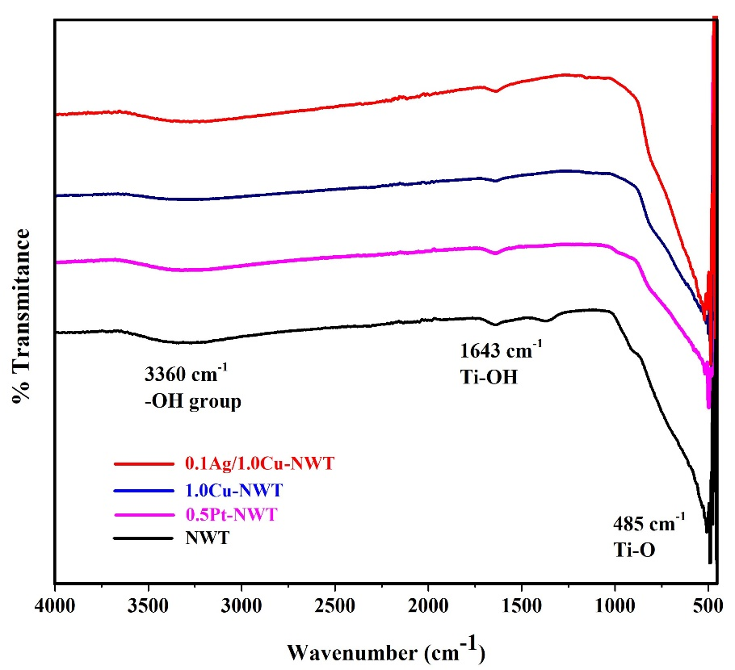
Fig. S2. FTIR spectra of NWT, 0.5Pt-NWT, 1.0Cu-NWT and 0.1Ag/1.0Cu-NWT photocatalysts.
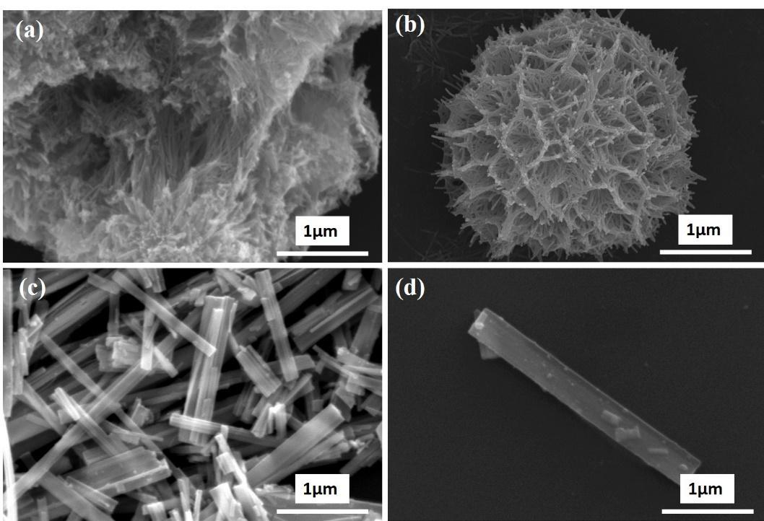
Fig. S3. FESEM micrographs of TiO₂ synthesized at different NaOH concentrations (a) at 5M, (b) at 10M, (c) at 15M and (d) at 20M.
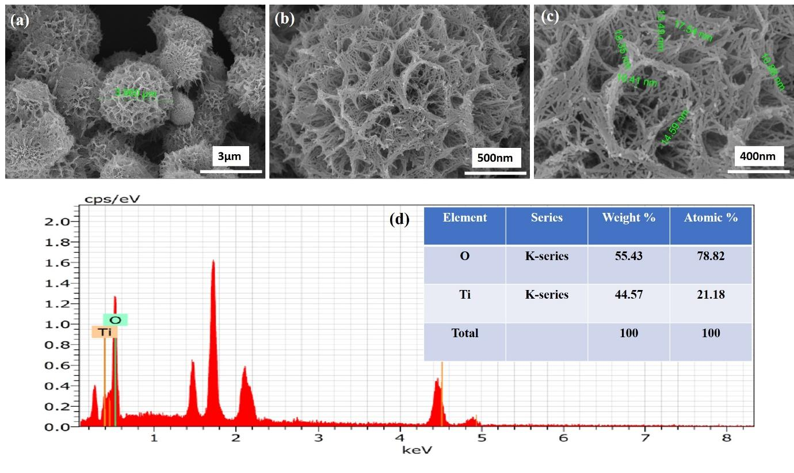
Fig. S4. (a-c) FESEM micrograph and (d) EDS report of NWT photocatalyst.
Figure S4d shows EDS spectra of NWT photocatalyst which confirms the presence of 78.82% O and 21.18% Ti atomic percentages. Figure S5d shows the HRTEM image of 0.5Pt-NWT shows the lattice fringes with a d-space value of 0.23 nm corresponding to the (111) plane of Pt and 0.326 nm corresponds to (101) plane of anatase TiO₂. Figure S5h shows the HRTEM image of 1.0Cu-NWT shows the lattice fringes with a d-space value of 0.211 nm corresponding to the (111) plane of Cu and 0.326 nm corresponds to (101) plane of anatase TiO₂. Results depicted the presence of metal nanoparticles homogeneously dispersed on the NWT surface.
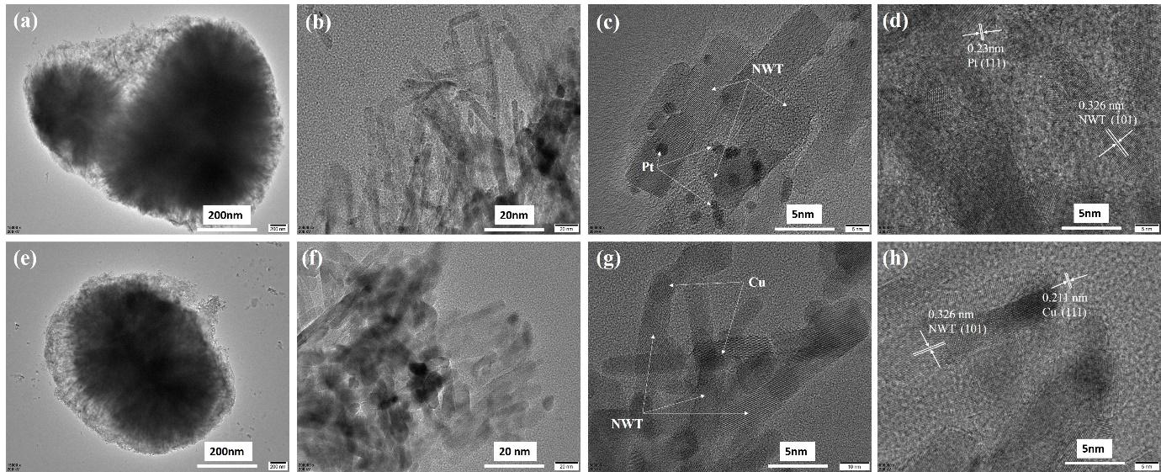
Fig. S5. LR-HRTEM images of (a-d) 0.5Pt-NWT and (e-h) 1.0Cu-NWT photocatalysts.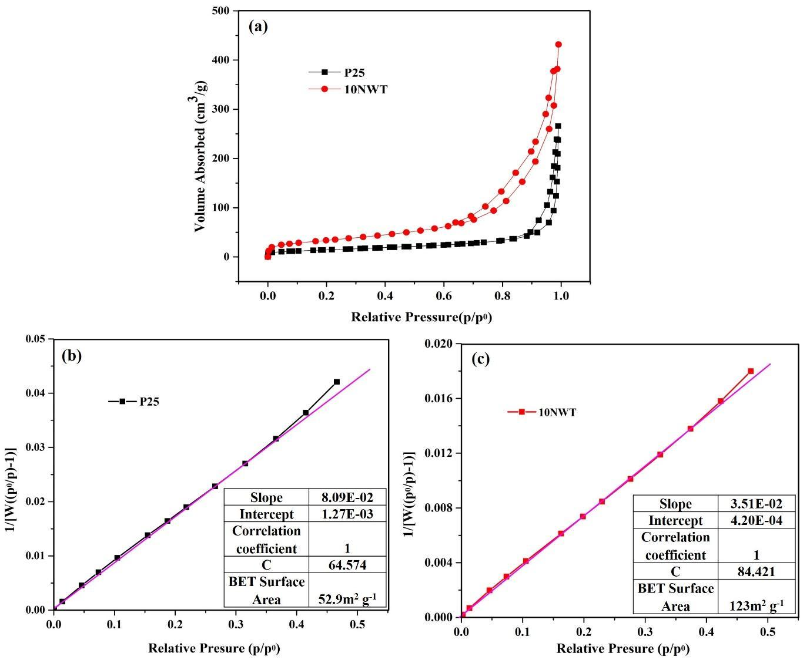
Fig. S6. BET analysis of P25 TiO₂ and NWT (a) nitrogen adsorption-desorption isotherm and (b-c) corresponding BET surface area plot.
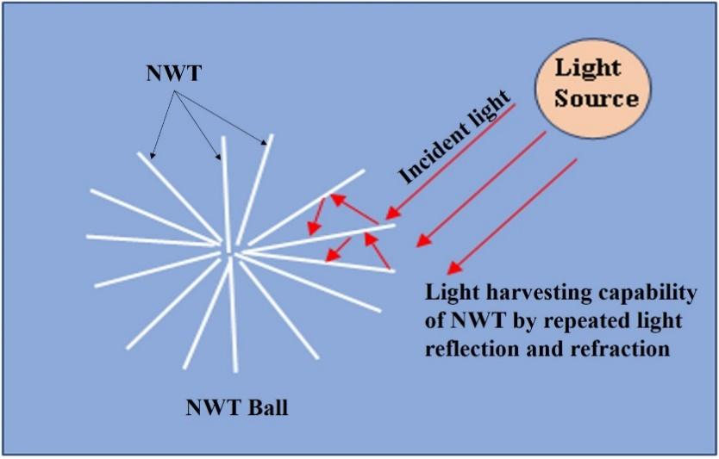
Fig. S7. Schematic diagram of NWT showing light harvesting ability by repeated light interaction with NWTs.
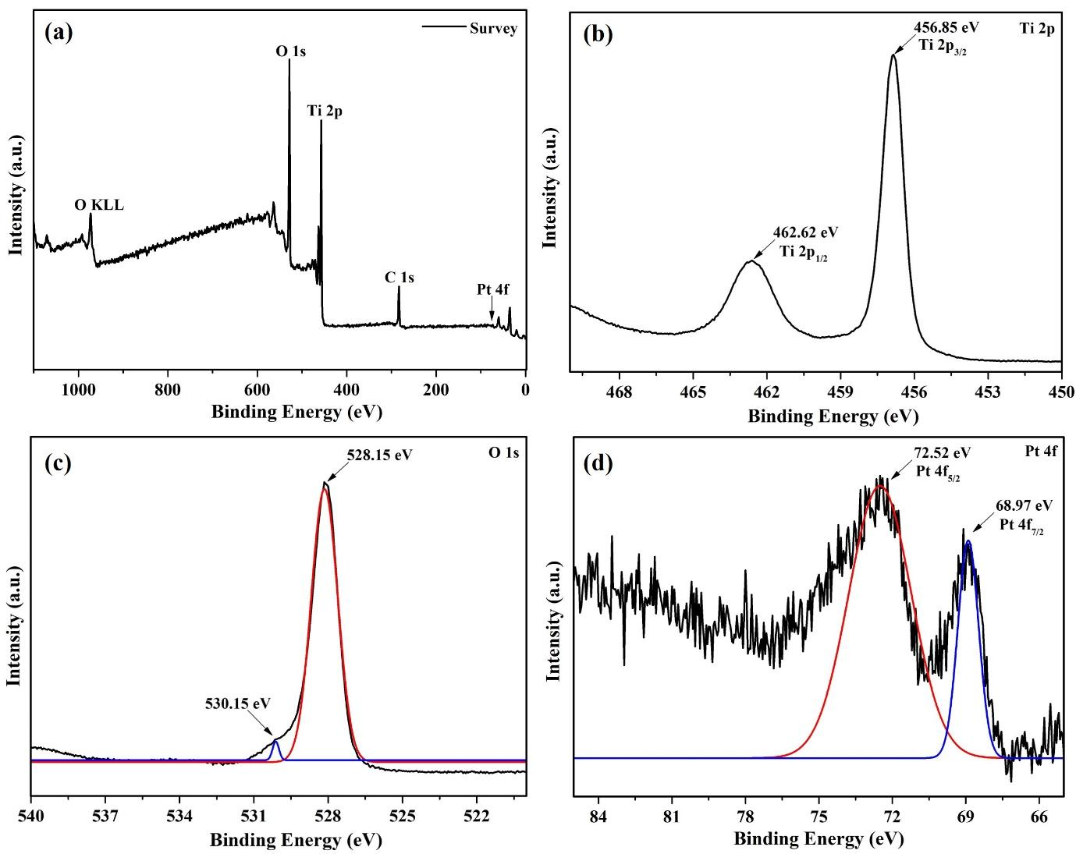
Fig. S8. XPS spectra of 0.5Pt-NWT photocatalyst (a) survey scan and high-resolution spectra of (b) Ti 2p, (c) O 1s and (d) Pt 4f.
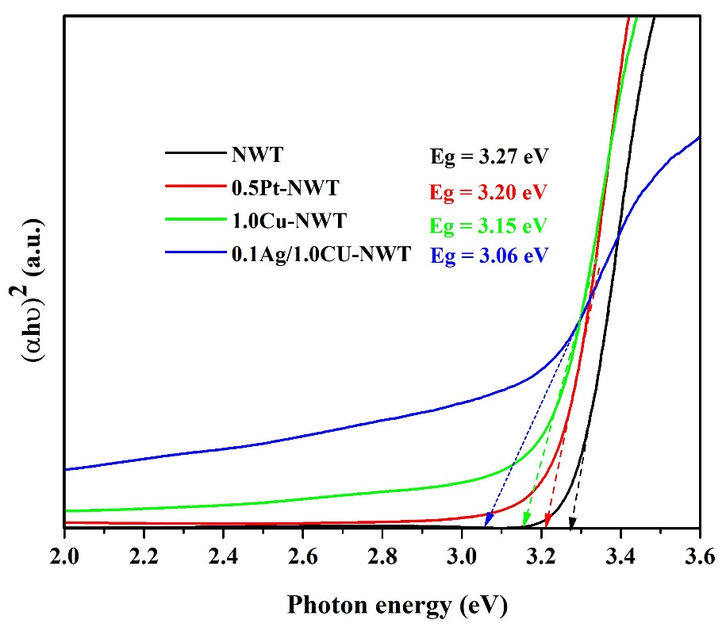
Fig. S9. Tauc plot graph of the optical band gap energy calculated by extrapolation of the linear part of (αhν)² versus (hc/λ)

References:
Shinde Y, Wadhai S, Ponkshe A, et al (2018) Decoration of Pt on the metal free RGO-TiO₂ composite photocatalyst for the enhanced photocatalytic hydrogen evolution and photocatalytic degradation of pharmaceutical pollutant β blocker. Int J Hydrogen Energy 43:4015–4027. https://doi.org/10.1016/j.ijhydene.2017.10.089

