Organic amendments with low C/N ratios enhanced the deposition of crop root exudates into stable soil organic carbon in a sodic soil
This WORD file includes:
Supplementary methods of identifying organic amendments
Supplementary tables S1–S2
Supplementary figures S1–S8

Isolation of lignin-derived and humus-derived organic amendments
For lignin-derived organic amendments (LDA) isolation, we followed the method of Wang et al. (2022) with minor modifications. In brief, the black liquor (100 mL) was acidified with 2 M HCl solution until reaching a pH of 2.5, centrifuged, washed with deionized water (pH 2.5, 2 × 50 mL), and freeze-dried to obtain kraft lignin with a yield of 78% (based on the Klason lignin content of the raw material). The crude lignin (2.5 g) was extracted using dichloromethane (4 × 50 mL) at 20–30 °C and stirred for 1 h. After filtration through a G4 glass filter, the combined organic phase was evaporated at 40 °C under reduced pressure to obtain the dichloromethane-soluble fraction, and the insoluble part was vacuum-dried to obtain the LDA fraction. Humus-derived organic amendments (HAD) isolation was performed in potassium humus acid.

Measurement of the chemical structure of organic amendments
The chemical structure of organic amendments was measured using pyrolysis-gas chromatography/mass spectrometry (MDGCMSMS TQ8050, SHIMADZU, Japan). Briefly, 0.5 mg of small molecules was acetylated by 1 mL of equivoluminal pyridine and 1 mL of acetic anhydride for 5 h. The acetylated product was transferred into a GC and analyzed using a Shimadzu GCMS-TQ8040 instrument equipped with a SH-Rxi-5Sil MS column. High-purity helium was used as carrier gas. The parameters and conditions for analysis were as follows: injector temperature 300 °C, carrier gas at a rate of 1 mL min^{–1}, ion source temperature 250 °C, m/z in the range of 45–700, with the temporal temperature variation: 80 to 250 °C at 8 °C min^{–1}, then increased at 5 °C min^{–1} to 300 °C, and held for 30 m
Table S1 Properties of the soils used in the present study.
 | Non-sodic soil | Sodic soil
pH | 7.36±0.04 | 9.06±0.02
Total nitrogen (g kg⁻¹) | 1.08±0.04 | 0.76±0.04
Total Phosphorus (g kg⁻¹) | 0.61±0.02 | 0.32±0.01
Total Potassium (g kg⁻¹) | 22.81±0.02 | 22.12±0.04
Available Nitrogen (mg kg⁻¹) | 116.76±12.12 | 79.87±17.59
Available Phosphorus (mg kg⁻¹) | 23.06±0.50 | 13.95±1.07
Available Potassium (mg kg⁻¹) | 152.75±7.54 | 188±7.78
Exchangeable sodium (cmol kg⁻¹) | 2.24±0.32 | 72.77±3.12
Aation exchange capacity (cmol kg⁻¹) | 22.67±1.75 | 53.76±2.30
Exchangeable sodium percentage (%) | 2.01±0.01 | 41.21±2.00

Table S2 The organic compounds of organic amendments were classified into four types based on the chemical structure type of organic carbon skeletons
The type of organic compounds | Biogenic groups | Chemical structure type of organic carbon skeletons | Typical example
Alicyclic compounds | Cyclic hydrocarbon | Cyclic hydrocarbon chain | 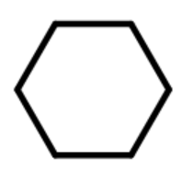
Aliphatic compounds | Alkane, alkene, fatty acids | Lipid chain | 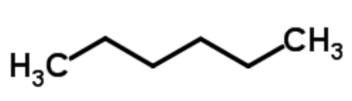
Aromatic compounds | Lignin | Aromatic chain | 
Heterocyclic compounds | N-containing compounds; polysaccharid | Heterocyclic chain, N or O embedded in carbon chain | 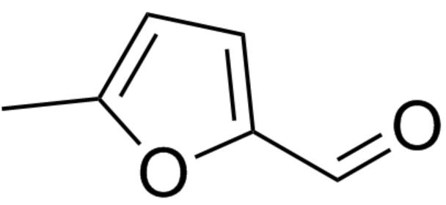
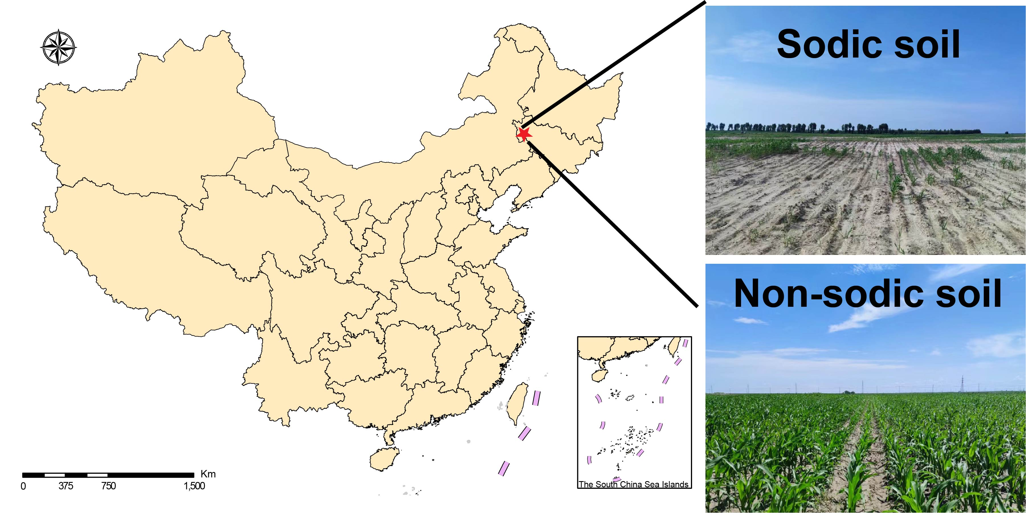
Fig. S1 Map of the sampling site

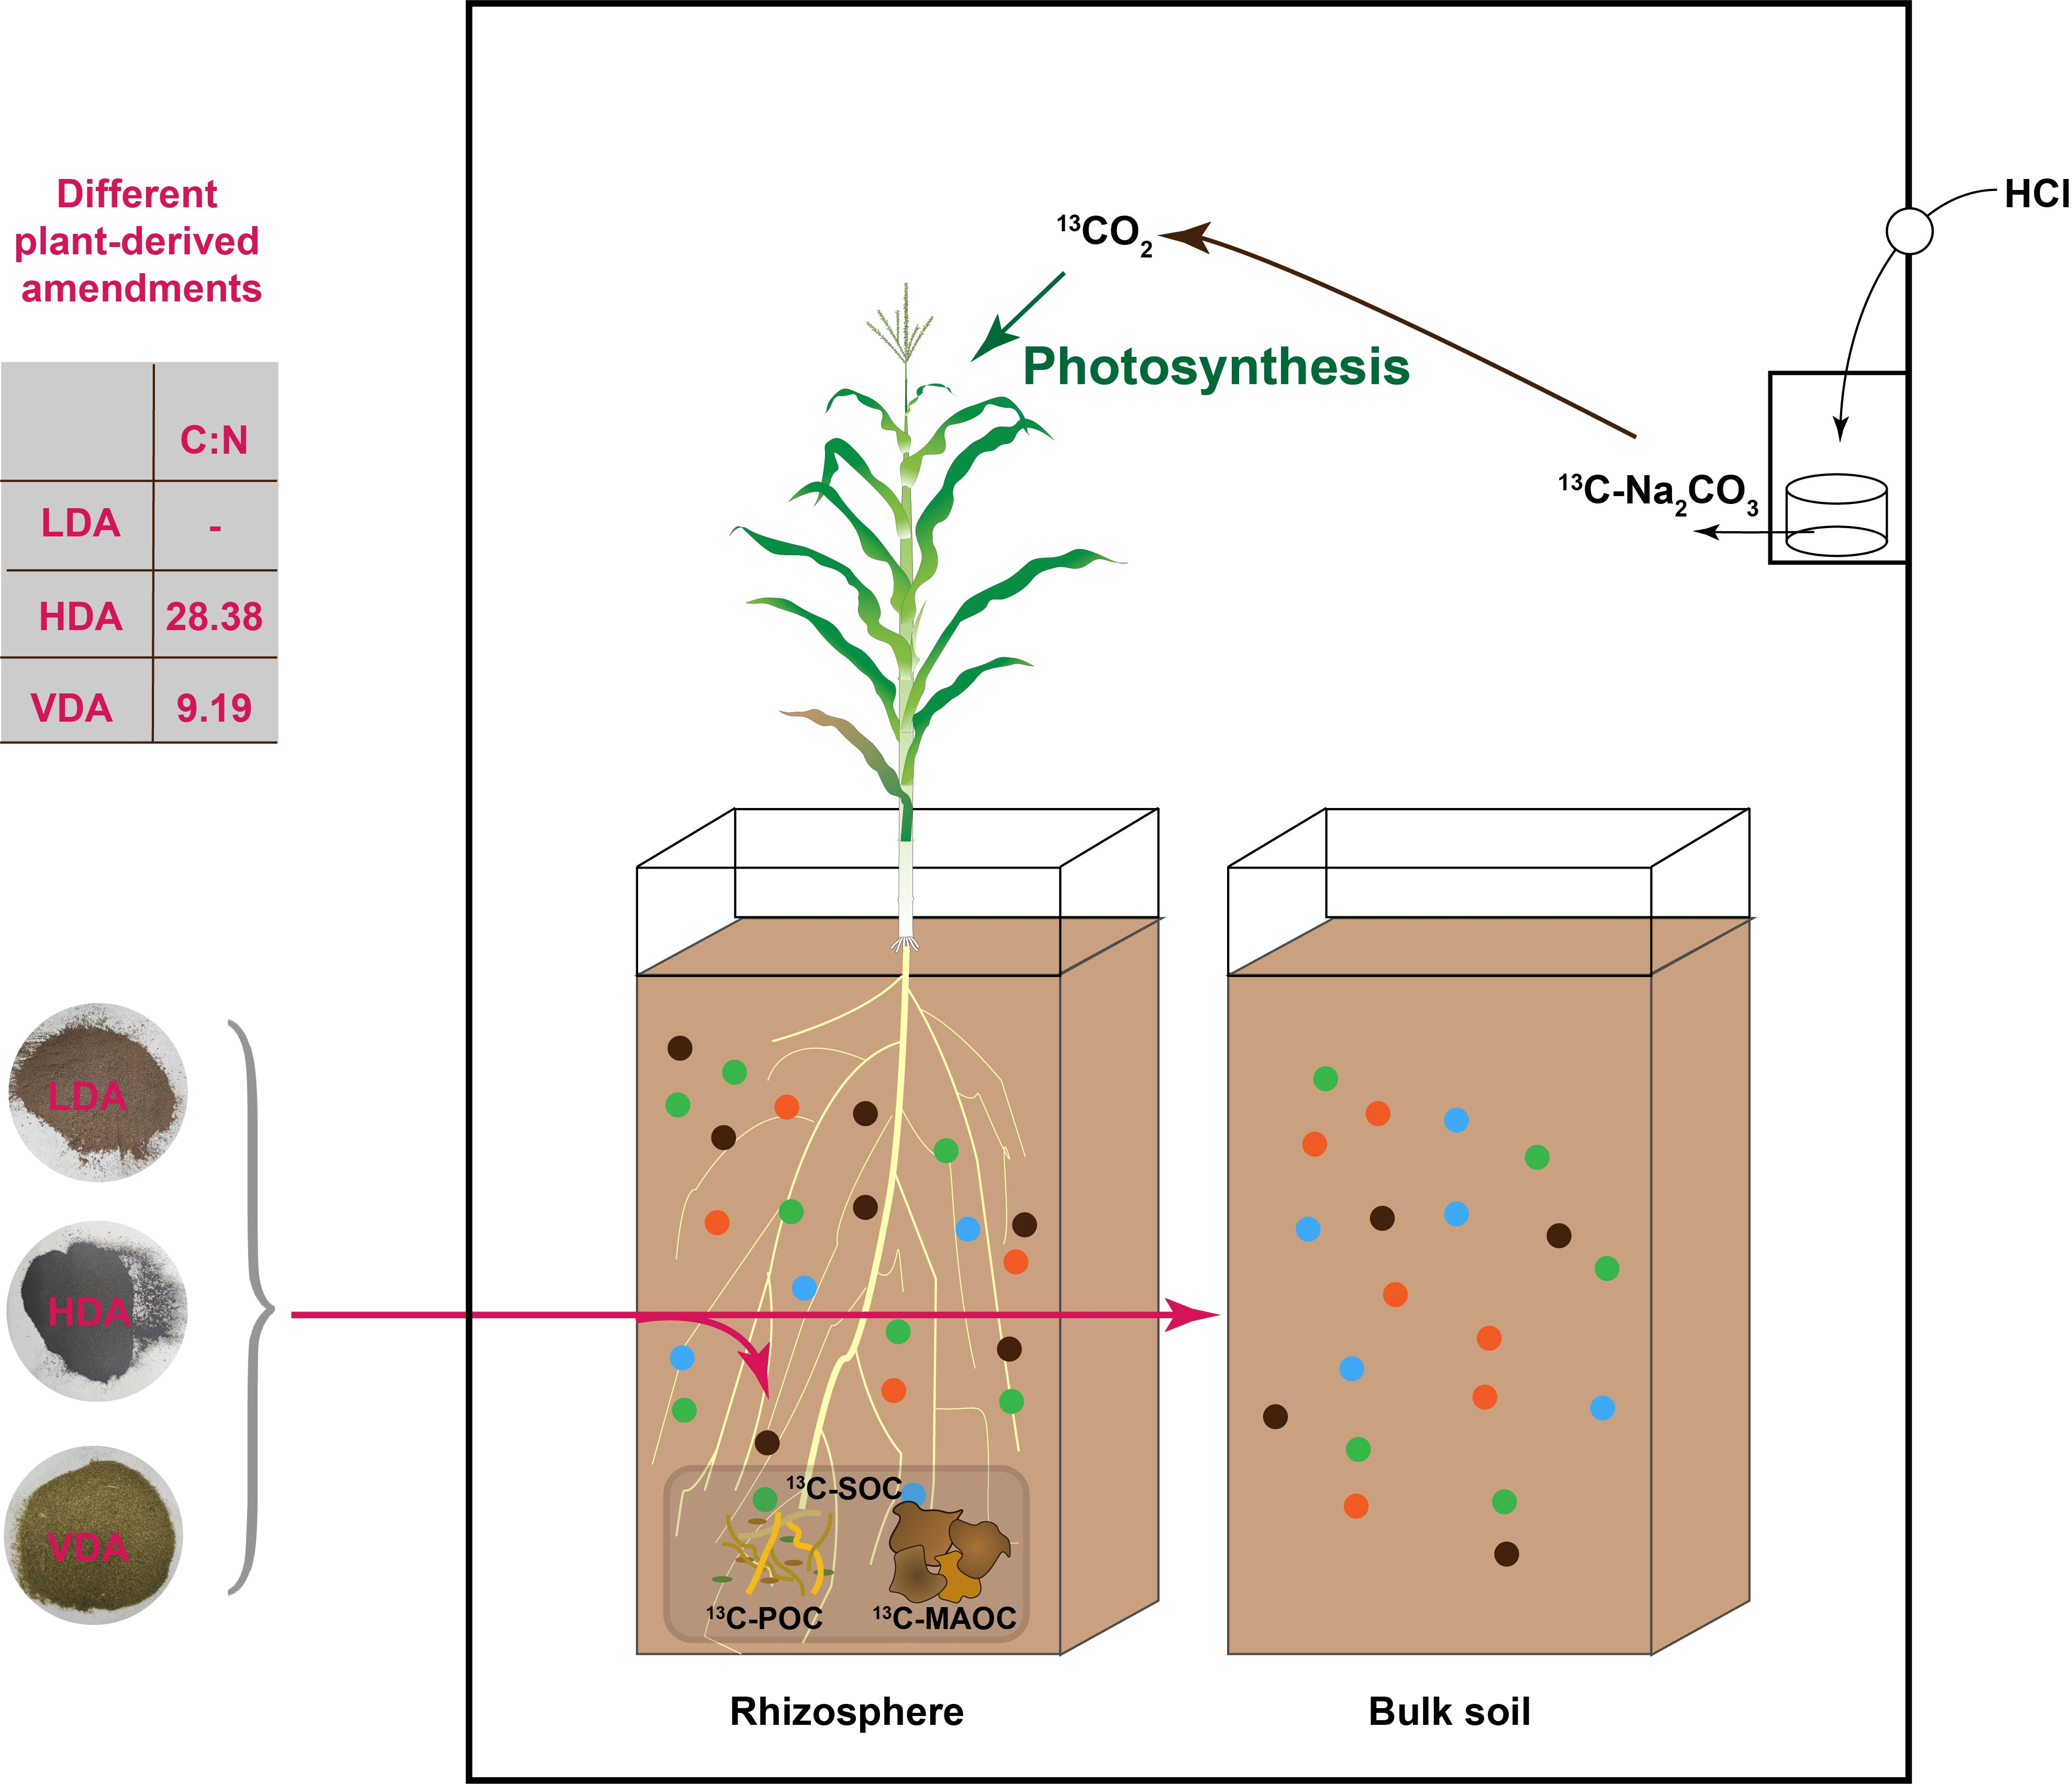
Fig. S2 Experimental design for rhizosphere organic amendments incubation study. Three organic amendments, (1) lignin-derived organic amendments (LDA), (2) humus-derived derived organic amendments (HDA), and (3) vetch-derived organic amendments (VDA) were placed to soil microcosms with a full 3 month a sorghum growing season (n = 4). From 75 days, they were incubated for a full 7 days in a 99 atom% ¹³CO₂ labeling chamber. After the labeling, they were then incubated for a full 8 days in natural state. After that, microcosms were destructively harvested.
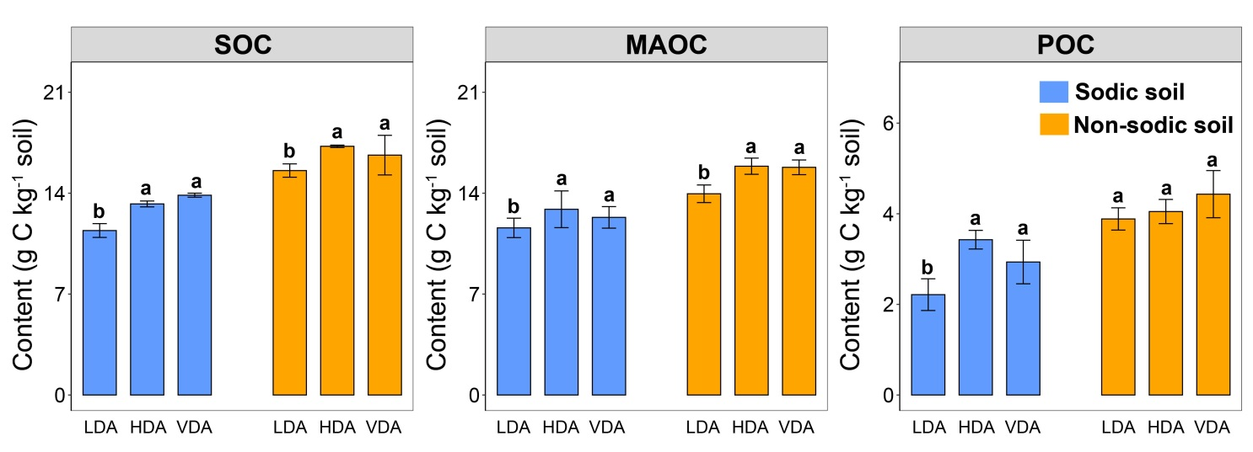
Fig. S3 The content of soil organic carbon (SOC), mineral-associated organic carbon (MAOC) and particulate organic carbon (POC) in corp rhizosphere. The soils were treated with lignin-derived organic amendments (LDA) or humus-derived organic amendments (HDA), or vetch-derived organic amendments (VDA). Error bars indicate standard deviations (n = 4).
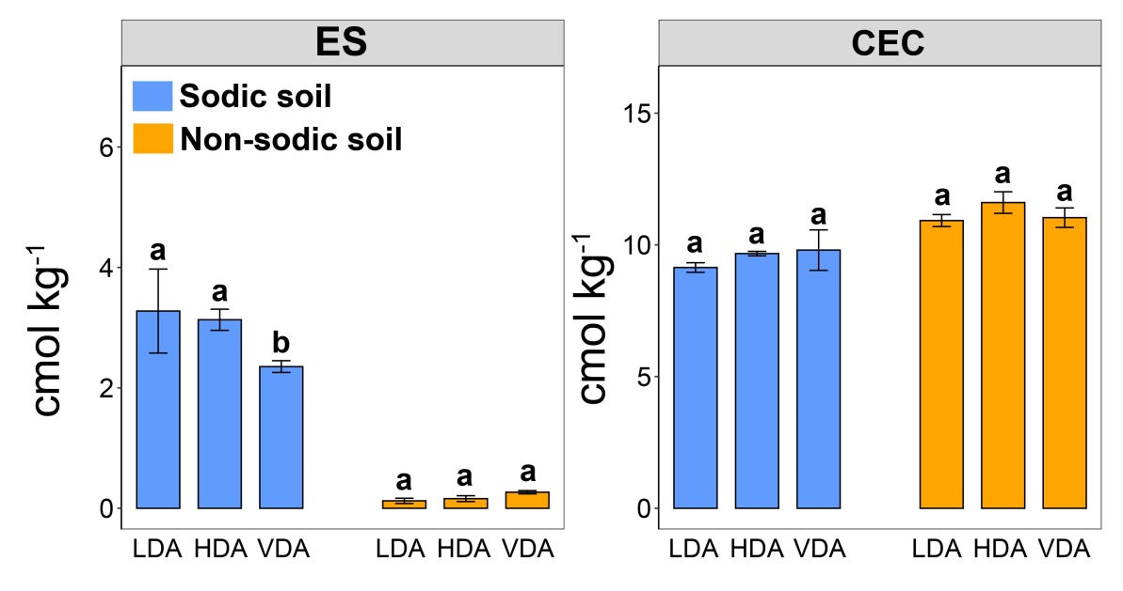
Fig. S4 The content of exchangeable sodium (ES) and cation exchange capacity (CEC) in corp rhizosphere. The soils were treated with lignin-derived organic amendments (LDA) or humus-derived organic amendments (HDA), or vetch-derived organic amendments (VDA). Error bars indicate standard deviations (n = 4).

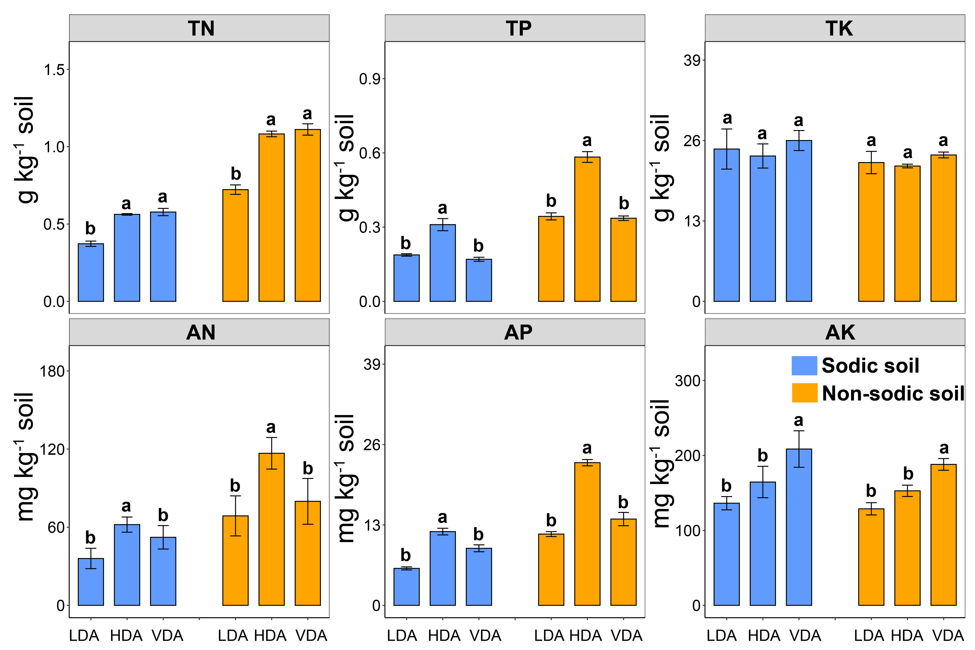

Fig. S5 The content of total nitrogen (TN), total phosphorus (TP), total potassium (TK), available nitrogen (AN), available phosphorus (TP) and available potassium (AK) in corp rhizosphere. The soils were treated with lignin-derived organic amendments (LDA) or humus-derived organic amendments (HDA), or vetch-derived organic amendments (VDA). Error bars indicate standard deviations (n = 4).

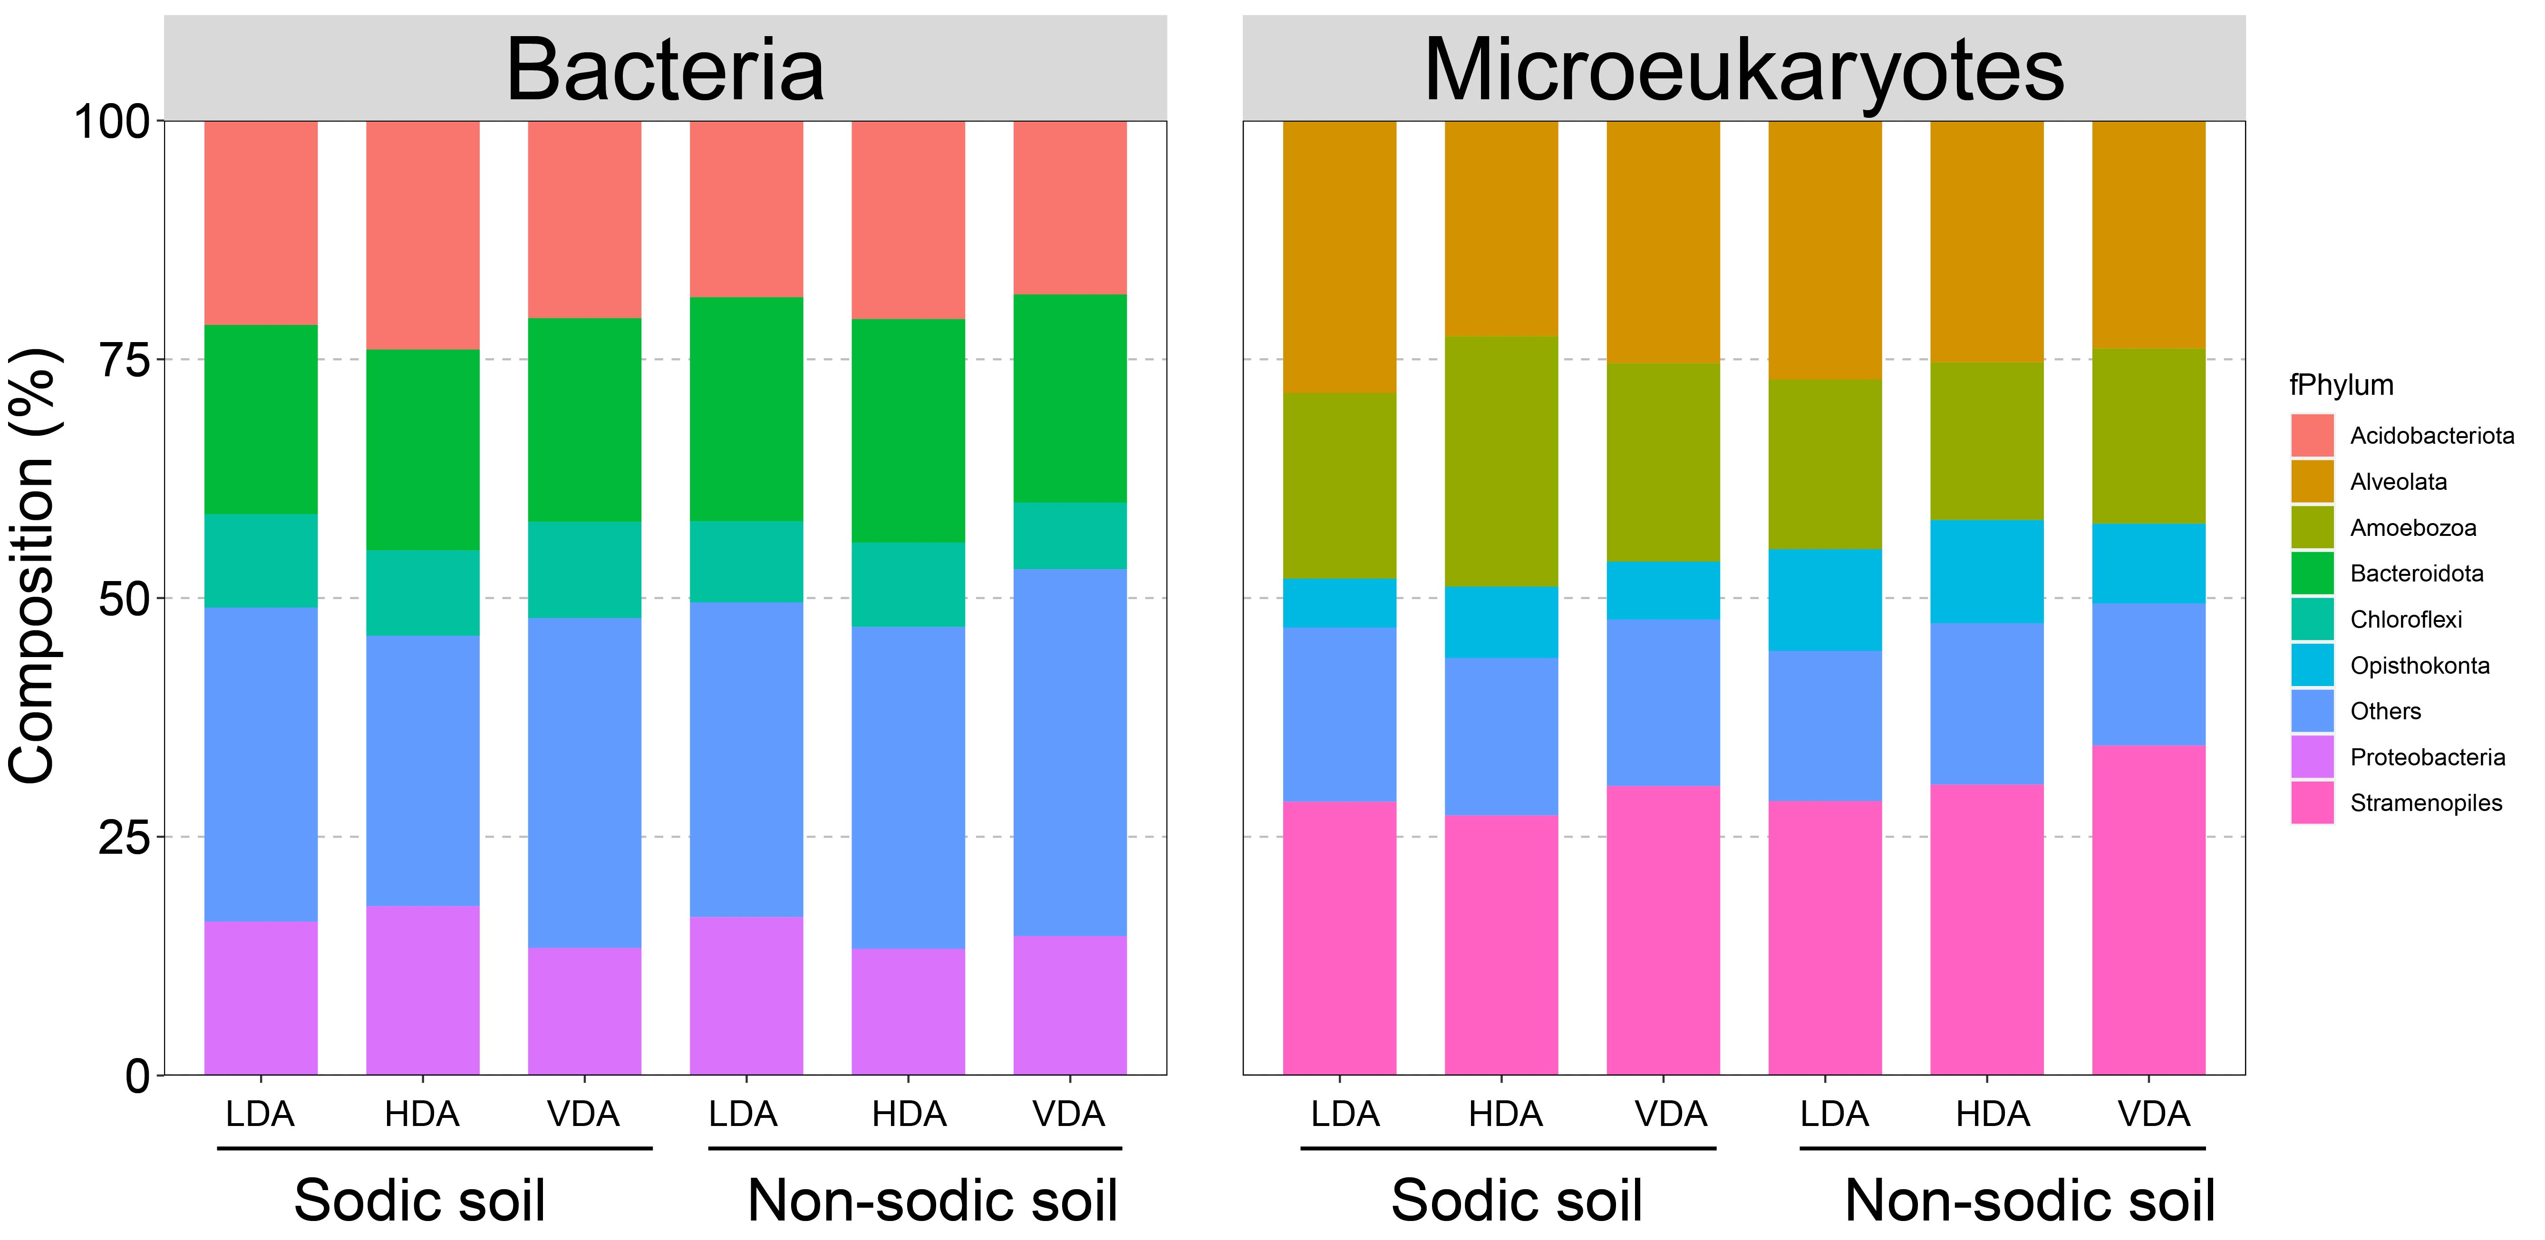
Fig. S6 The relative abundance of bacteria and microeukaryotes in phylum levels in corp rhizosphere. The soils were treated with lignin-derived organic amendments (LDA) or humus-derived organic amendments (HDA), or vetch-derived organic amendments (VDA). Error bars indicate standard deviations (n = 4).

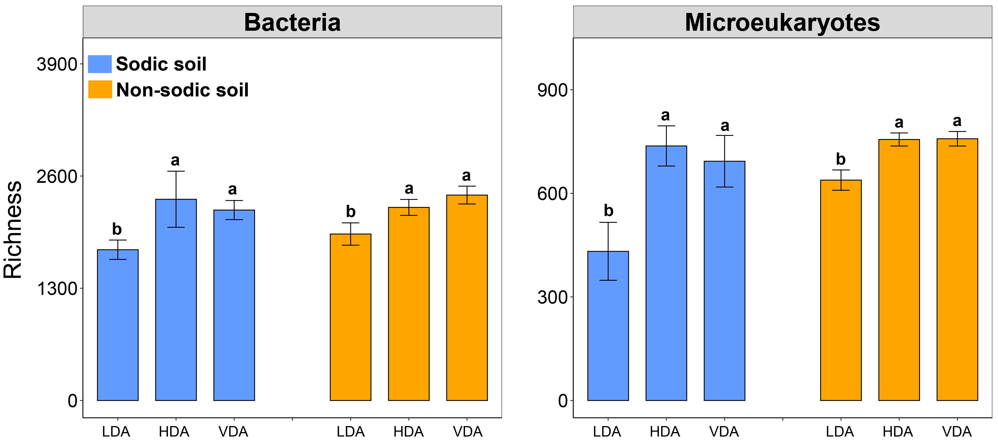
Fig. S7 The richness of bacteria and microeukaryotes in phylum levels in corp rhizosphere. The soils were treated with lignin-derived organic amendments (LDA) or humus-derived organic amendments (HDA), or vetch-derived organic amendments (VDA). Error bars indicate standard deviations (n = 4).

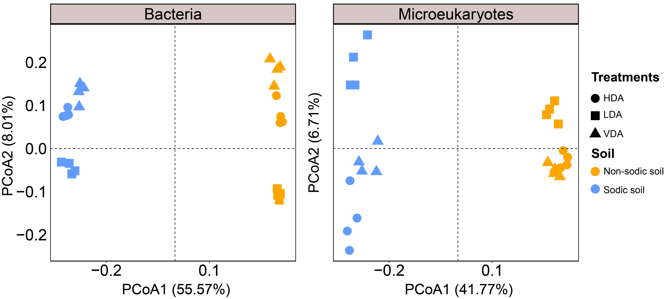
Fig. S8 Principal coordinate analysis (PCoA) was performed based on Bray–Curtis distances to visualize the differences in the bacterial and microeukaryotic communities in soil with the addition of lignin-derived organic amendments (LDA) or humus-derived organic amendments (HDA), or vetch-derived organic amendments (VDA) across sodic and non-sodic soil samples. The permutational multivariate analysis of variance results showed the community dissimilarities of bacteria and micoreukaryotes between sodic and non-sodic soils in LDA, HDA and VDA based on the Bray–Curtis distance.

