Figure S1. Scatter plot of BMI versus iron metabolism with linear regression.
a b
c d
e
a: The relationship between BMI and serum iron;
b: The relationship between BMI and serum ferritin;
c: The relationship between BMI and total iron binding force;
d: The relationship between BMI and soluble transferrin receptor;
e: The relationship between BMI and transferrin saturation.

Figure S2. Levels of iron metabolism between obese and non-obese groups
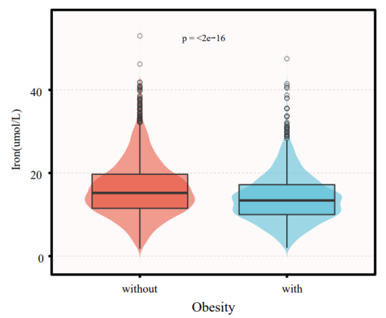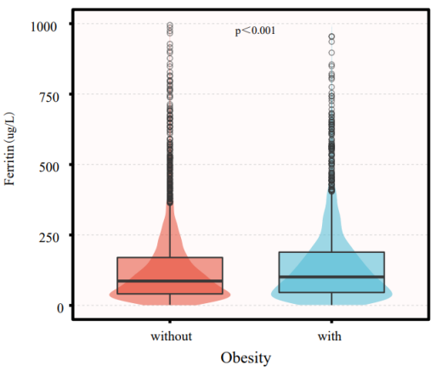
a b
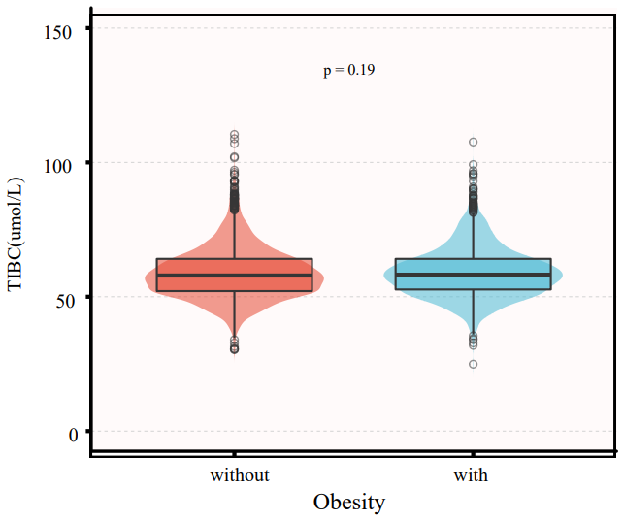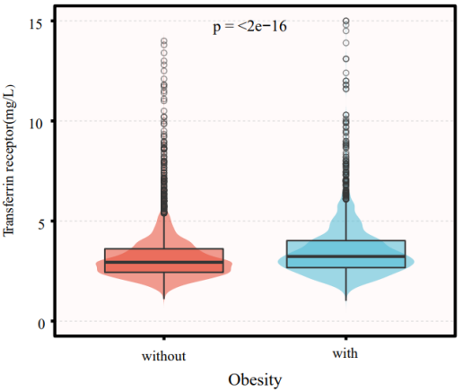
c d
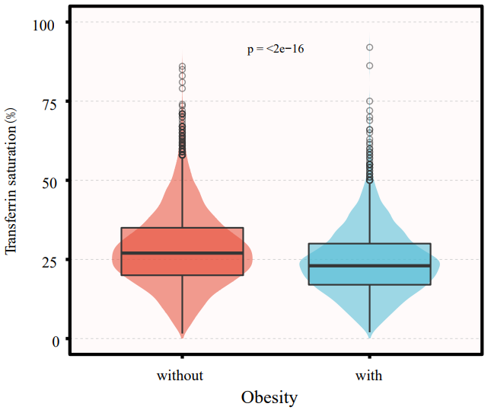
e
a: Serum iron frozen between obese and non-obese groups;
b: Serum ferritin between obese and non-obese groups;
c: The total iron binding capacity between obese and non-obese groups;
d: Transferrin receptor between obese and non-obese groups;
e: Transferrin saturation between obese and non-obese groups;

Table S1 Association of covariates and obesity
Variable | β(95CI%) | P
Age (years) | 0.01 (0.00,0.03) | 0.029
Gender(%)
Male | 1(reference)
Fmale | 0.32 (-0.10,0.74) | 0.133
Race(%)
Non-Hispanic white | 1(reference)
Non-Hispanic black | 1.84 (1.30,2.38) | < 0.001
Mexican American | 0.96 (0.33,1.59) | 0.003
Others | -1.45 (-1.98,-0.93) | < 0.001
Education level (years)
<9 | 1(reference)
9-12 | 0.19 (-0.67,1.05) | 0.665
>12 | -0.14 (-0.98,0.69) | 0.741
Marital status
Married or living with a partner | 1(reference)
Living alone | 0.24 (-0.18,0.66) | 0.268
Family income(%)
Low | 1(reference)
Medium | 0.01 (-0.49,0.51) | 0.983
High | -1.08 (-1.62,-0.55) | < 0.001
Diabetes（%）
No | 1(reference)
Yes | 3.61 (3.02,4.20) | < 0.001
Hypertension(%)
No | 1(reference)
Yes | 3.35 (2.90,3.80) | < 0.001
Smoking
Never | 1(reference)
Former | 1.34 (0.83,1.85) | < 0.001
Now | -0.44 (-0.98,0.10) | 0.107
SI(umol/L) | -0.23 (-0.26,-0.19) | < 0.001
SF(ug/L) | 0.00(0.00,0.00) | 0.015
sTfR (mg/L) | 0.44 (0.33,0.54) | < 0.001
TSAT(%) | -0.12 (-0.14,-0.10) | < 0.001
TIBC(umol/L) | 0.02 (0.00,0.04) | 0.063
CRP(mg/L) | 0.26 (0.24,0.29) | < 0.001
Total cholesterol(mmol/L) | 0.07 (-0.13,0.27) | 0.484
HDL(mmol/L) | -5.26 (-5.75,-4.77) | < 0.001
WBC(103/uL) | 0.09 (0.06,0.12) | < 0.001
Neutrophils(103/uL) | 0.73 (0.61,0.84) | < 0.001
Eosinophils(103/uL) | 3.10 (1.85,4.34) | < 0.001
RBC(106/uL) | 1.78 (1.36,2.20) | < 0.001
MCV(fL) | -0.22 (-0.25,-0.19) | < 0.001
RDW(%) | 1.05 (0.91,1.19) | < 0.001
PLT(103/uL) | 0.02 (0.01,0.02) | < 0.001
Abbreviations: HDL, high-density lipoprotein cholesterol; RBC, red blood cell count; MCV, mean cell volume;
RDW, red cell distribution width; WBC, white blood cell count; CRP, hypersensitive C-reactive protein; SI, serum iron; SF, serum ferritin; TSAT, transferrin saturation; sTfR, soluble transferrin receptor; TIBC: total iron binding force; PLT, platelet; β, beta; 95% CI, 95% confidence interv.

Table S2. Overview of GWAS data used in MR Analyses

Phenotype | Consortium/cohort | Ancestry | No of participants (case/control) | Author | Year of publication | PubMed ID
Body mass index | GIANT+ UK Biobank | European | 681,275 | Yengo, et al. | 2018 | 30124842
Body mass index | GIANT | European | 339,224 | Locke, et al | 2014 | 25673413
Serum iron | GIS | European | 23,986 | Benyamin, et al. | 2014 | 25352340
Liver iron content | UK Biobank | European | 32,858 | Liu, et al. | 2021 | 34128465
Spleen iron content | UK Biobank | European | 35,324 | Sorokin, et al. | 2022 | 35568031
Pancreas iron content | UK Biobank | European | 32,858 | Liu, et al. | 2021 | 34128465
Ferritin | GIS | European | 23,986 | Benyamin, et al. | 2014 | 25352340
Transferrin Saturation | GIS | European | 23,986 | Benyamin, et al. | 2014 | 25352340
Transferrin receptor | INTERVAL (UK) | European | 3,301 | Sun, et al | 2018 | 29875488

Table S3. Mendelian randomization analysis of the causal estimates of body mass index on various iron status.
Exposure | Outcome | No. of SNP | Methods | MR results |  | Heterogeneity test |  | Pleiotropy test
 |  |  |  | β / β (95%CI) | p-value | Q statistic | Q p-value | Egger intercept | p-value
Body mass index (GIANT+ UK Biobank) | Serum iron (GIS) | 437 | IVW | -0.073 (-0.14 ~ -0.0049) | 0.036 | 486.74 | 0.044
Body mass index (GIANT+ UK Biobank) | Serum iron (GIS) | 437 | MR Egger | -0.20 (-0.38 ~ -0.025) | 0.026 | 489.44 | 0.039 | 0.0023 | 0.12
Body mass index (GIANT+ UK Biobank) | Serum iron (GIS) | 437 | Weighted median | -0.077 (-0.20 ~ 0.042) | 0.20
Body mass index (GIANT) | Serum iron (GIS) | 73 | IVW | -0.085 (-0.19 ~ 0.015) | 0.097 | 83.53 | 0.16
Body mass index (GIANT) | Serum iron (GIS) | 73 | MR Egger | -0.11 (-0.36 ~ 0.13) | 0.36 | 83.61 | 0.15 | 0.00087 | 0.80
Body mass index (GIANT) | Serum iron (GIS) | 73 | Weighted median | -0.05 (-0.20 ~ 0.098) | 0.077
Body mass index (GIANT) | Liver iron content (UK Biobank) | 79 | IVW | -0.076 (-0.16 ~ -0.0043) | 0.041 | 97.09 | 0.061
Body mass index (GIANT) | Liver iron content (UK Biobank) | 79 | MR Egger | -0.25 (-0.44 ~ -0.061) | 0.012 | 102.05 | 0.035 | 0.0054 | 0.051
Body mass index (GIANT) | Liver iron content (UK Biobank) | 79 | Weighted median | -0.16 (-0.28 ~ -0.041) | 0.063
Body mass index (GIANT) | Pancreas iron content (UK Biobank) | 79 | IVW | -0.13 (-0.21 ~ -0.05) | 0.0014 | 76.97 | 0.51
Body mass index (GIANT) | Pancreas iron content (UK Biobank) | 79 | MR Egger | -0.23 (-0.42 ~ -0.042) | 0.019 | 75.56 | 0.52 | 0.0032 | 0.24
Body mass index (GIANT) | Pancreas iron content (UK Biobank) | 79 | Weighted median | -0.20 (-0.32~-0.74) | 0.0018
Body mass index (GIANT) | Spleen iron content (UK Biobank) | 79 | IVW | -0.013 (-0.099 ~ 0.074) | 0.78 | 114.91 | 0.0042
Body mass index (GIANT) | Spleen iron content (UK Biobank) | 79 | MR Egger | -0.18 (-0.40 ~ 0.020) | 0.08 | 110.20 | 0.0078 | 0.0054 | 0.073
Body mass index (GIANT) | Spleen iron content (UK Biobank) | 79 | Weighted median | -0.023 (-0.15 ~ 0.10) | 0.71
Body mass index (GIANT+ UK Biobank) | Ferritin | 427 | IVW | 0.14 (0.069 ~ 0.21) | 0.035 | 527.87 | 0.00054
Body mass index (GIANT+ UK Biobank) | Ferritin | 427 | MR Egger | 0.0046 (-0.18 ~ 0.19) | 0.96 | 524.98 | 0.00065 | 0.0023 | 0.13
Body mass index (GIANT+ UK Biobank) | Ferritin | 427 | Weighted median | 0.090 (-0.022 ~ 0.20) | 0.12
Body mass index (GIANT+ UK Biobank) | Transferrin Saturation | 436 | IVW | -0.11 (-0.18 ~ -0.04) | 0.0014 | 472.34 | 0.10
Body mass index (GIANT+ UK Biobank) | Transferrin Saturation | 436 | MR Egger | -0.29 (-0.46 ~ 0.11) | 0.0015 | 467.43 | 0.13 | 0.0031 | 0.033
Body mass index (GIANT+ UK Biobank) | Transferrin Saturation | 436 | Weighted median | -0.16 (-0.28 ~ 0.047) | 0.005
Body mass index (GIANT) | Transferrin receptor | 79 | IVW | 0.090 (-0.13 ~ -0.31) | 0.43 | 66.76 | 0.81
Body mass index (GIANT) | Transferrin receptor | 79 | MR Egger | -0.0075 (-0.55 ~ 0.54) | 0.97 | 66.61 | 0.79 | 0.0030 | 0.70
Body mass index (GIANT) | Transferrin receptor | 79 | Weighted median | 0.026 (-0.35 ~ 0.40) | 0.19

IVW: inverse variance-weighted method; SNP, Single-nucleotide polymorphism; β, beta; 95% CI, 95% confidence interv; MR, mendelian randomizat

Table S4. Mendelian randomization analysis of the causal estimates of various iron status on body mass index.
Exposure | Outcome | No. of SNP | Methods | MR results |  | Heterogeneity test |  | Pleiotropy test
 |  |  |  | β / β (95%CI) | p-value | Q statistic | Q p-value | Egger intercept | p-value
Serum iron (GIS) | Body mass index (GIANT+ UK Biobank) | 3 | IVW | -0.017 (-0.041 ~ -0.0079) | 0.18 | 8.45 | 0.015
Serum iron (GIS) | Body mass index (GIANT+ UK Biobank) | 3 | MR Egger | -0.026 (-0.091 ~ 0.039) | 0.58 | 7.65 | 0.0057 | 0.0021 | 0.80
Serum iron (GIS) | Body mass index (GIANT+ UK Biobank) | 3 | Weighted median | -0.030 (-0.046 ~ -0.014) | 0.0033
Serum iron (GIS) | Body mass index (GIANT) | 3 | IVW | -0.0007 (-0.024 ~ 0.023) | 0.95 | 2.10 | 0.35
Serum iron (GIS) | Body mass index (GIANT) | 3 | MR Egger | -0.014 (-0.077 ~ 0.050) | 0.74 | 1.74 | 0.19 | 0.0027 | 0.73
Serum iron (GIS) | Body mass index (GIANT) | 3 | Weighted median | -0.0024 (-0.027 ~ 0.022) | 0.85
Liver iron content (UK Biobank) | Body mass index (GIANT) | 5 | IVW | -0.0054 (-0.050 ~ -0.039) | 0.81 | 16.70 | 0.0012
Liver iron content (UK Biobank) | Body mass index (GIANT) | 5 | MR Egger | -0.014 (-0.081 ~ 0.053) | 0.71 | 16.69 | 0.0022 | 0.0023 | 0.73
Liver iron content (UK Biobank) | Body mass index (GIANT) | 5 | Weighted median | -0.0071 (-0.030 ~ -0.016) | 0.55
Pancreas iron content (UK Biobank) | Body mass index (GIANT) | 1 | Wald ratio | 0.067 (-0.091 ~ 0.23) | 0.40
Spleen iron content (UK Biobank) | Body mass index (GIANT) | 2 | IVW | -0.029 (-0.11 ~ 0.049) | 0.46 | 0.27 | 0.60
Ferritin | Body mass index (GIANT+ UK Biobank) | 4 | IVW | -0.043 (-0.065 ~ -0.021) | 0.00015 | 2.5 | 0.47
Ferritin | Body mass index (GIANT+ UK Biobank) | 4 | MR Egger | -0.066 (-0.11 ~ -0.025) | 0.089 | 0.81 | 0.67 | 0.0026 | 0.32
Ferritin | Body mass index (GIANT+ UK Biobank) | 4 | Weighted median | -0.041 (-0.068 ~ -0.014) | 0.013
Transferrin Saturation | Body mass index (GIANT+ UK Biobank) | 3 | IVW | -0.013 (-0.030 ~ -0.0057) | 0.18 | 8.06 | 0.017
Transferrin Saturation | Body mass index (GIANT+ UK Biobank) | 3 | MR Egger | -0.029 (-0.44 ~ 0.14) | 0.16 | 0.50 | 0.48 | 0.0053 | 0.22
Transferrin Saturation | Body mass index (GIANT+ UK Biobank) | 3 | Weighted median | -0.013 (-0.022 ~ -0.0032) | 0.0083
Transferrin receptor | Body mass index (GIANT) | 2 | IVW | -0.011 (-0.034 ~ -0.011) | 0.36 | 0.081 | 0.78
IVW: inverse variance-weighted method; SNP, Single-nucleotide polymorphism; β, beta; 95% CI, 95% confidence interv; MR, mendelian randomizat

