Supplementary Information

Disentangling Degradation Pathways of Narrow Bandgap Lead-Tin Perovskite Material and Photovoltaic Devices

Florine Rombach,¹ Akash Dasgupta,¹ Manuel Kober-Czerny,¹ James M. Ball,¹ Joel A. Smith,¹ Heon Jin,¹ Michael D. Farrar,¹ Henry J. Snaith¹*

¹Department of Physics, University of Oxford, Clarendon Laboratory, Parks Road, Oxford, OX1 3PU, UK

Email: henry.snaith@physics.ox.ac.uk
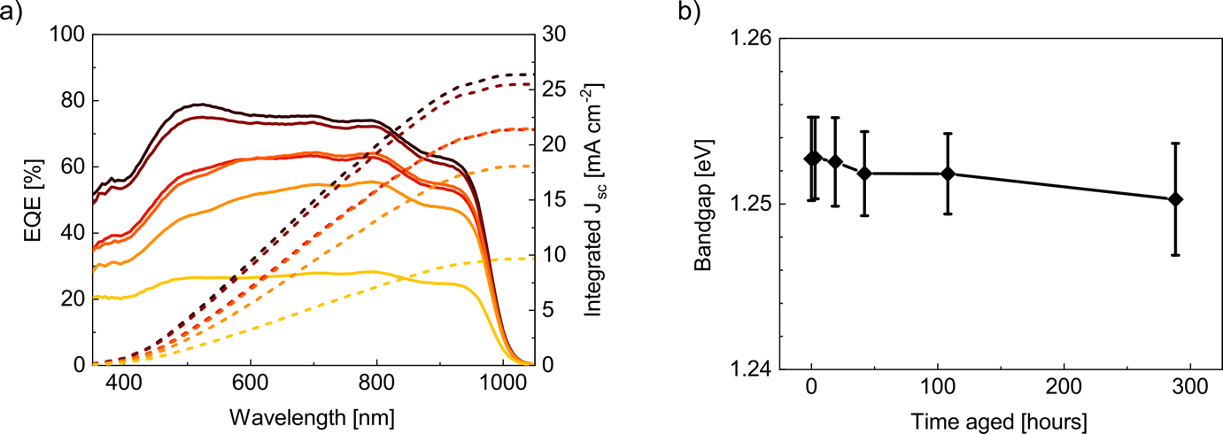

Figure S1. a) External quantum efficiency (EQE) measurements of a typical ITO/PEDOT:PSS/FA_{0.83}Cs_{0.17}Pb_{0.5}Sn_{0.5}I₃/PCBM/BCP/Cr/Au device after various periods of encapsulated aging under open circuit, 65 °C, and simulated full spectrum sun light (76 mW cm⁻²) irradiance conditions. b) Change in the bandgap of devices over time, extracted from measurements in a) by (E*EQE)² gradient.^{[1]}

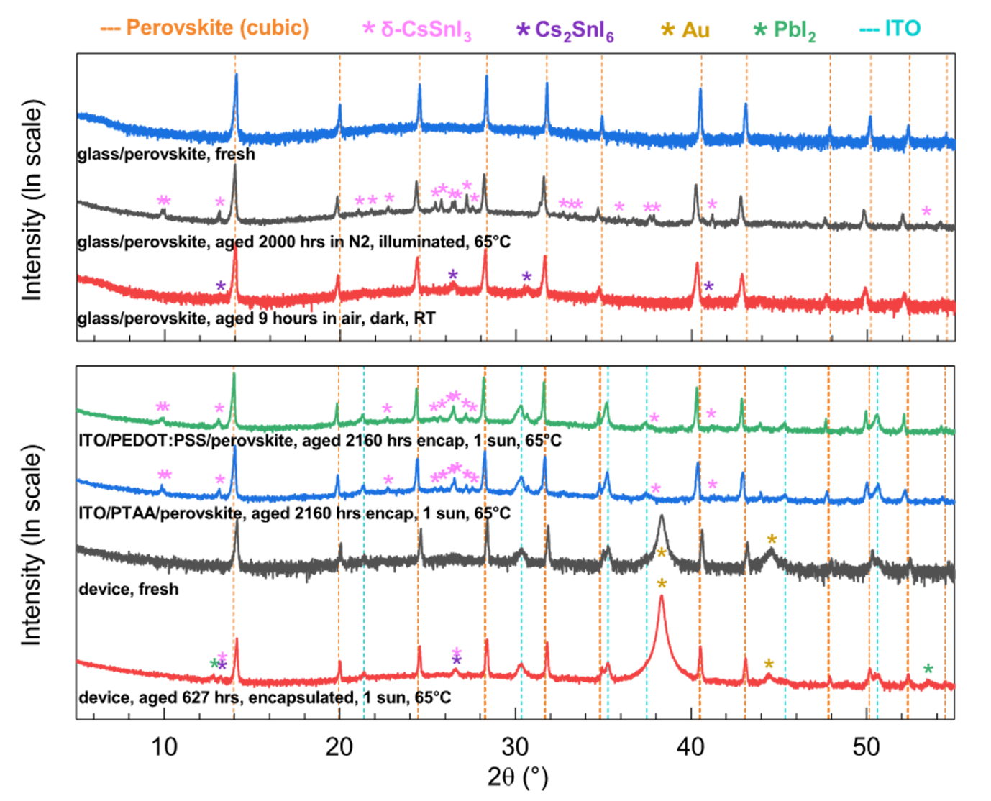

Figure S2. XRD measurements of FA_{0.83}Cs_{0.17}Pb_{0.5}Sn_{0.5}I₃ films deposited on glass or ITO/HTLs, and ITO/PEDOT:PSS/FA_{0.83}Cs_{0.17}Pb_{0.5}Sn_{0.5}I₃/PCBM/BCP/Cr/Au devices, aged at 65 °C and simulated full spectrum sun light (76 mW cm⁻²) irradiance for various periods of time under ambient, ambient encapsulated, or N₂ conditions at open circuit. Films that were encapsulated during aging were measured by cutting the glass edges of the sample to remove the encapsulation glass and epoxy.
Table S1. Unit cell volume of the cubic perovskite cell fitted to PbSn-perovskite films and device before and after aging at 65 °C and simulated full spectrum sun light (76 mW cm⁻²) irradiance.

Stack (aging condition) | Unit cell volume before aging [Å³] | Unit cell volume after aging (aging time) [Å³]
ITO/PEDOT:PSS/ FA_{0.83}Cs_{0.17}Pb_{0.5}Sn_{0.5}I₃/PCBM/BCP/Cr/Au (encapsulated, 65°C, 0.76 suns) | 248.76 | 250.28 (627 hours)
ITO/PEDOT:PSS/ FA_{0.83}Cs_{0.17}Pb_{0.5}Sn_{0.5}I₃ (encapsulated, 65°C, 0.76 suns) | 250.18 | 252.58 (2160 hours)
ITO/PTAA/Al₂O₃ NPs/ FA_{0.83}Cs_{0.17}Pb_{0.5}Sn_{0.5}I₃  (encapsulated, 65°C, 0.76 suns) | 250.39 | 252.23 (2160 hours)
Glass/Al₂O₃ NPs/ FA_{0.83}Cs_{0.17}Pb_{0.5}Sn_{0.5}I₃ (unencapsulated ambient, room temperature) | 250.16 | 253.05 (9 hours in air)
Glass/Al₂O₃ NPs/ FA_{0.83}Cs_{0.17}Pb_{0.5}Sn_{0.5}I₃ (unencapsulated in N₂, 65°C, 0.76 suns) | 250.39 | 254.39 (2000 hours)

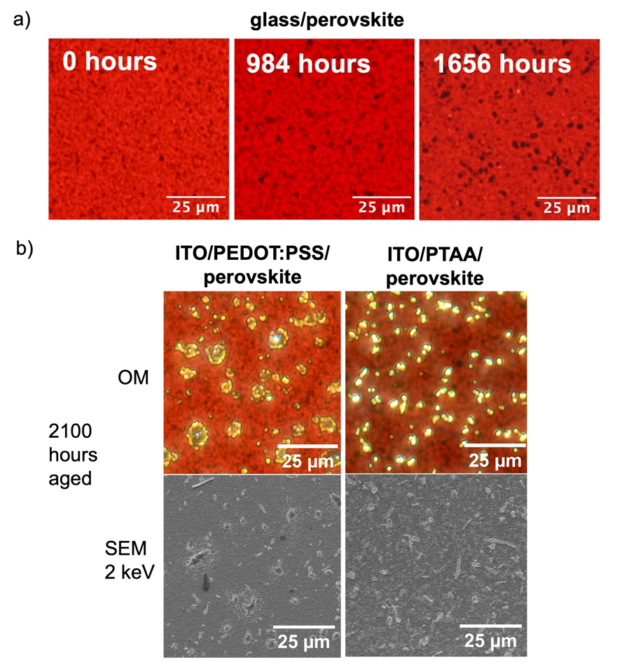

Figure S3. Optical microscope (OM) or scanning electron microscope (SEM) images of the surface of lead-tin perovskite films deposited on a) glass and b) ITO/PEDOT:PSS or ITO/PTAA/Al₂O₃ NPs. Images show evolution over time during encapsulated aging under 65 °C and simulated full spectrum sun light (76 mW cm⁻²) irradiance.

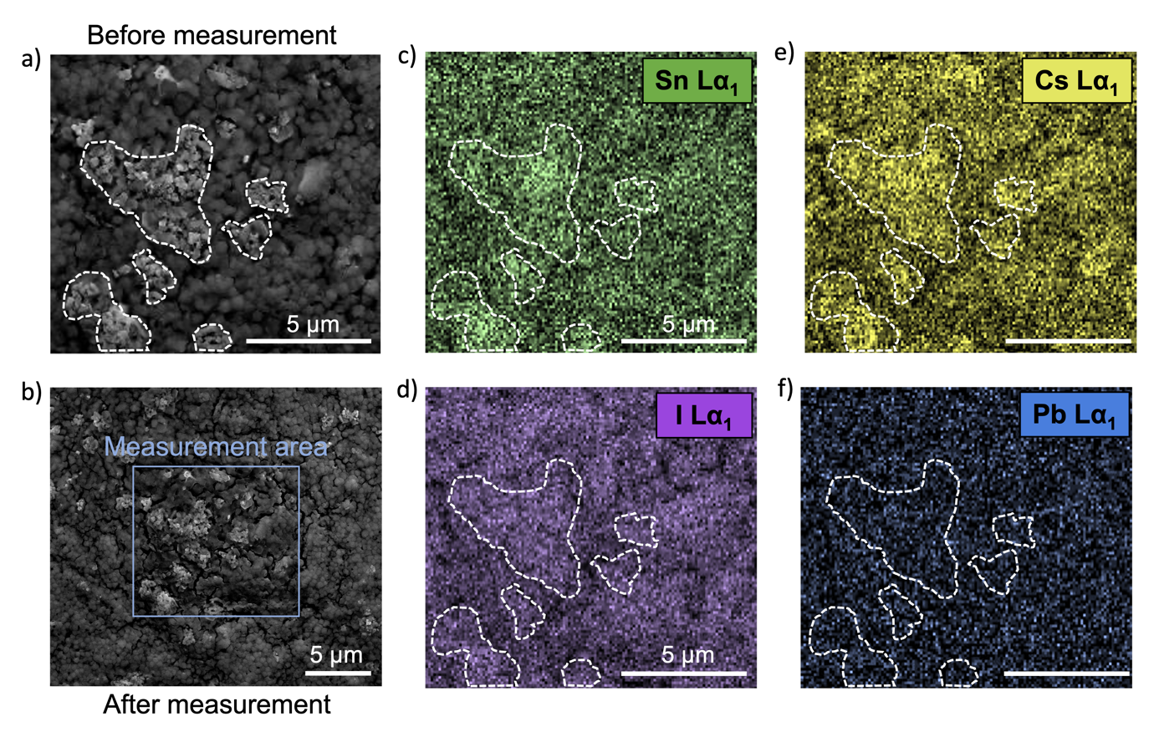

Figure S4. Energy-dispersive X-ray scanning electron microscopy (EDX-SEM) analysis of the surface of lead-tin perovskite films on glass, after 2592 hours of encapsulated aging under 65 °C and simulated full spectrum sun light (76 mW cm⁻²) irradiance. a) SEM image of the area prior to measurement (new crystallites are marked with white dashed lines) and b) after 7 minutes of measurement, showing some grain boundary decomposition but no heavy degradation. Elemental maps using the Lα₁ spectral line for c) Sn, d) I, e) Cs and f) Pb, with a 5 μm scalebar.
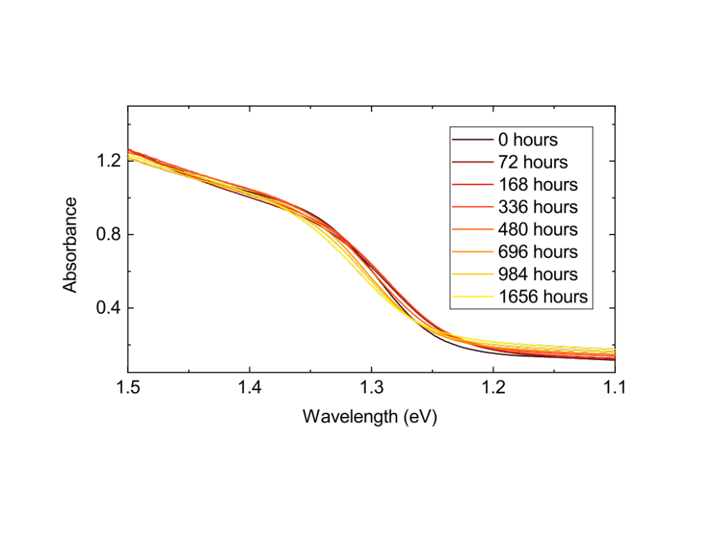

Figure S5. Absorbance of encapsulated lead-tin perovskite films on glass after various periods of encapsulated aging under 65 °C and simulated full spectrum sun light (76 mW cm⁻²) irradiance.

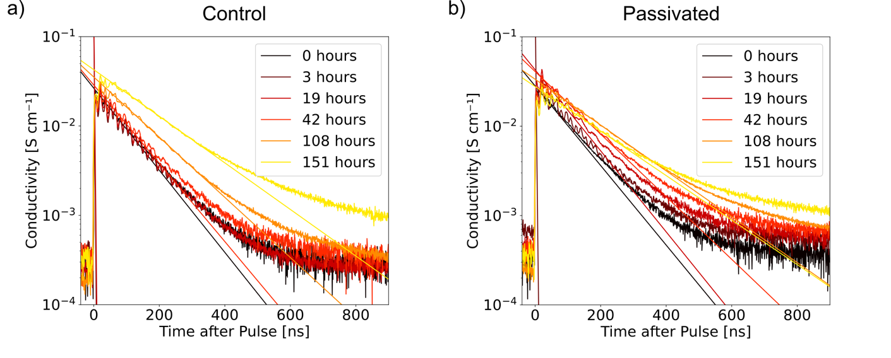

Figure S6. Photoconductivity transients of lead-tin perovskite films on glass a) without passivation and b) with an EDAI₂ passivation layer, after pulsed excitation at 10 Hz with 3.74 ns pulses, measured after various periods of aging under 65 °C and simulated full spectrum sun light (76 mW cm⁻²) irradiance. Various fluences were measured at each aging step, and the fluence resulting in the highest conductivity at t₀ was selected and displayed here, either 3.0 x 10⁴ nJ cm⁻² or 9.5 x 10⁴ nJ cm⁻². Solid lines represent fits to a monoexponential decay, which are extrapolated to t = 0 to extract the maximum photoconductivity (solid dot).
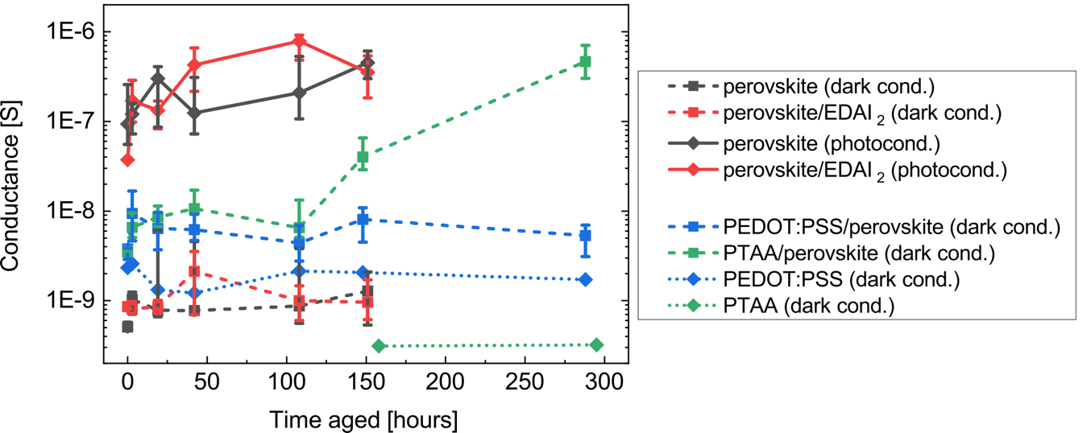

Figure S7. Conductance measured laterally across 300 μm channels on lead-tin perovskite films (660 nm thickness) deposited on glass or thin layers of PEDOT:PSS (diluted 1:6 with IPA) or undoped PTAA (1.5 mg/ml). For films on glass, the maximum conductance after excitation with a pulse of light as determined from figure S6 is also shown. Conductance of a thin film of PEDOT:PSS (diluted 1:6 with IPA) and PTAA (1.5 mg ml⁻¹) deposited on glass measured using the same technique is also shown. Measurements were performed after various periods of encapsulated aging under 65 °C and simulated full spectrum sun light (76 mW cm⁻²) irradiance.
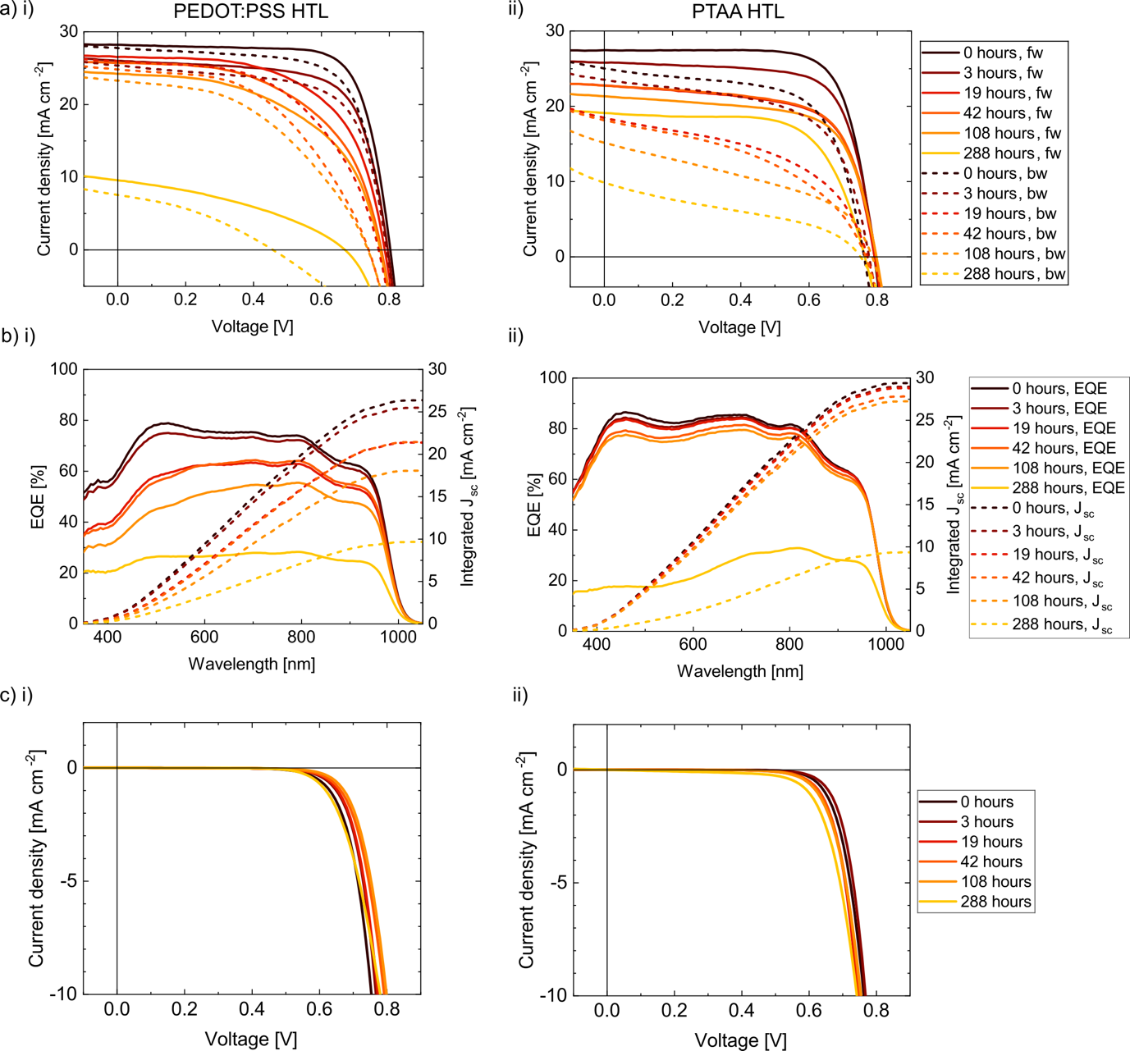

Figure S8. a) Current-voltage (J-V) curves measured under AM1.5 100 mW cm⁻² simulated sun light, b) EQE curves and c) J-V curves measured in the dark of champion ITO/HTL/FA_{0.83}Cs_{0.17}Pb_{0.5}Sn_{0.5}I₃/PCBM/BCP/Cr/Au devices using i) PEDOT:PSS or ii) PTAA HTLs. Measurements were performed after various periods of encapsulated aging under 65 °C and simulated full spectrum sun light (76 mW cm⁻²) irradiance under open circuit conditions.
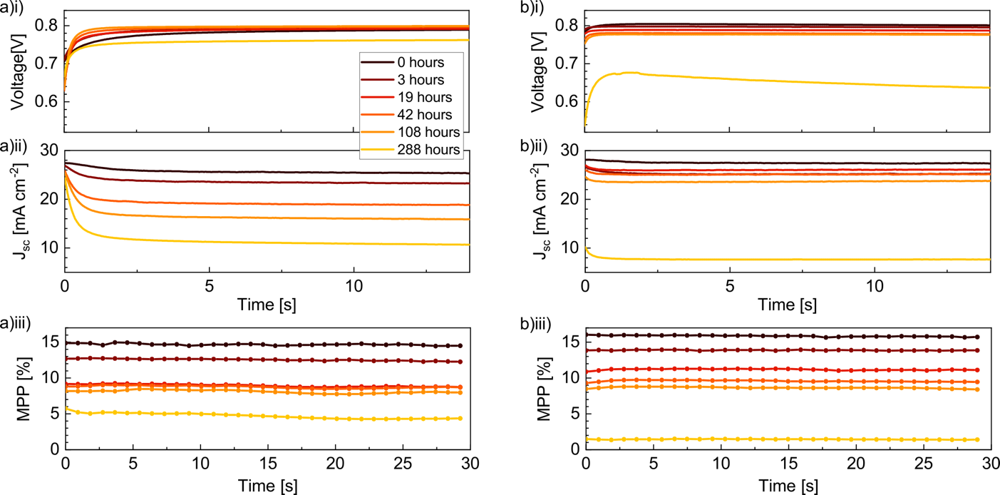

Figure S9. a) Voltage at open circuit, b) current density at short circuit, and c) maximum power point (MPP) measured under AM1.5 100 mW cm⁻² simulated sun light of a champion ITO/HTL/ FA_{0.83}Cs_{0.17}Pb_{0.5}Sn_{0.5}I₃/PCBM/BCP/ Cr/Au device using i) PEDOT:PSS or ii) PTAA HTLs. Measurements were performed after various periods of encapsulated aging under 65 °C and simulated full spectrum sun light (76 mW cm⁻²) irradiance under open circuit conditions.
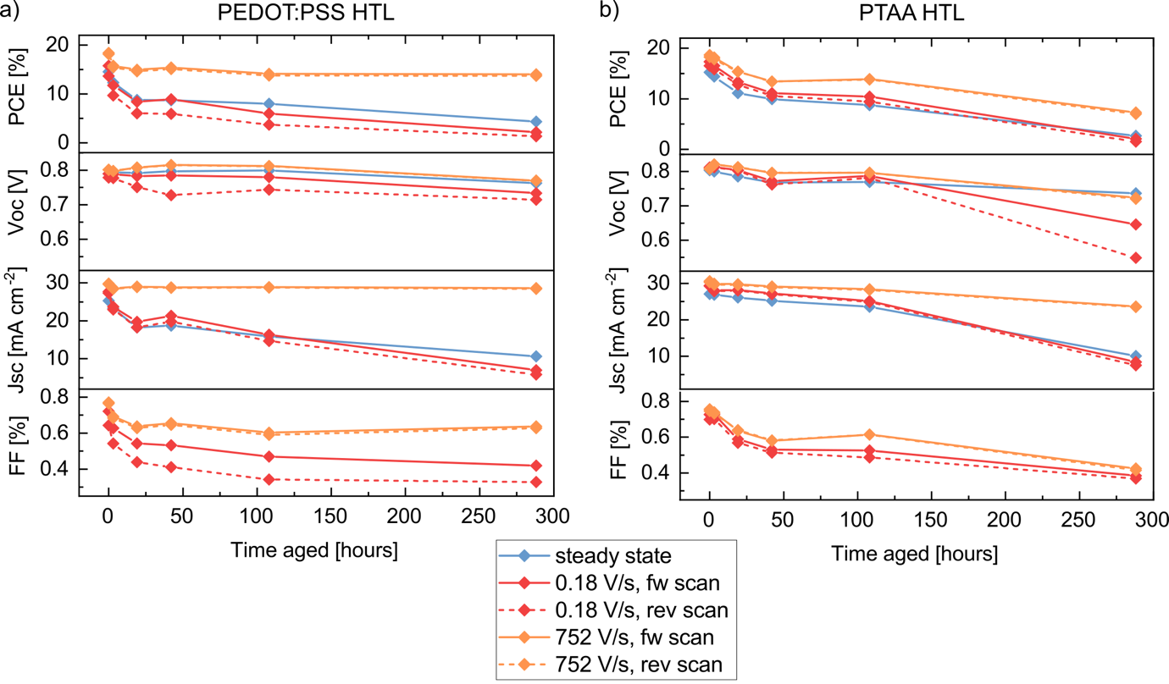

Figure S10. J-V parameters extracted from fast 752 V s⁻¹ (orange) and slow 0.18 V s⁻¹ (red) J-V scans of a champion ITO/HTL/FA_{0.83}Cs_{0.17}Pb_{0.5}Sn_{0.5}I₃/PCBM/BCP/Cr/Au device using a) PEDOT:PSS or b) PTAA HTLs. Parameters from steady-state measurements of the same devices from figure 3a in the main text are overlaid in blue. Measurements were performed after various periods of encapsulated aging under 65 °C and simulated full spectrum sun light (76 mW cm⁻²) irradiance under open circuit conditions.
Table S2. SCAPS fitting parameters.
Parameter | Symbol | Unit | Value | Comment
HTL (PEDOT:PSS)
Thickness | d | nm | 30 | From cross-sectional SEM
Bandgap | $$E_{g}^{HTL}$$ | eV | 2.6 | ^{[2]}
Electron Affinity | $$χ^{HLT}$$ | eV | 2.54 | Near QFLS = V_{oc} match
Dielectric Permittivity | $$ϵ_{r}^{HTL}$$ | - | 2.46 | ^{[3]}
CB effective density of states | $$g_{CB}^{HTL}$$ | cm⁻³ | 1 x 10²⁰ | ^{[4]}
VB density of states | $$g_{VB}^{HTL}$$ | cm⁻³ | 1 x 10²⁰ | Symmetric DOS
Electron mobility | $$μ_{e}^{HTL}$$ | cm² V⁻¹ s⁻¹ | 1.5 x 10⁻² | ^{[5]}
Hole mobility | $$μ_{p}^{HTL}$$ | cm² V⁻¹ s⁻¹ | 1.5 x 10⁻² | ^{[5]}
Shallow uniform donor density | $$n_{0}^{HTL}$$ | cm⁻³ | 1 x 10⁵ | Low value (p-doped)
Shallow uniform acceptor density | $$p_{0}^{HTL}$$ | cm⁻³ | 5 x 10¹⁹ | Heavily p-doped^{[5]}
HTL / Perovskite Interface (PEDOT:PSS)
Surface recombination velocity: electrons | $$S_{n}^{HTL}$$ | cm s⁻¹ | 1000 | Informed from TRPL, tweaked to fit measured V_{oc}
Surface recombination velocity: Holes | $$S_{p}^{HTL}$$ | cm s⁻¹ | 1000 | Informed from TRPL, tweaked to fit measured V_{oc}
HTL (PTAA)
Thickness | d | nm | 10 | ^{[6]}
Bandgap | $$E_{g}^{HTL}$$ | eV | 3 | ^{[7]}
Electron Affinity | $$χ^{HLT}$$ | eV | 2.14 | ^{[7]}
Dielectric Permittivity | $$ϵ_{r}^{HTL}$$ | - | 3.5 | ^{[7]}
CB effective density of states | $$g_{CB}^{HTL}$$ | cm⁻³ | 1 x 10²⁰ | ^{[7]}
VB density of states | $$g_{VB}^{HTL}$$ | cm⁻³ | 1 x 10²⁰ | ^{[7]} Symmetric DOS
Electron mobility | $$μ_{e}^{HTL}$$ | cm² V⁻¹ s⁻¹ | 1 x 10⁻⁵ | ^{[7]}
Hole mobility | $$μ_{p}^{HTL}$$ | cm² V⁻¹ s⁻¹ | 1 x 10⁻⁵ | ^{[7]}
Shallow uniform donor density | $$n_{0}^{HTL}$$ | cm⁻³ | 1 x 10⁵ | Low value (p-doped)
Shallow uniform acceptor density | $$p_{0}^{HTL}$$ | cm⁻³ | 5 x 10¹⁶ | ^{[7]} Slightly p-doped
HTL / Perovskite Interface (PTAA)
Surface recombination velocity: electrons | $$S_{n}^{HTL}$$ | cm s⁻¹ | 1000 | Informed from TRPL, tweaked to fit measured V_{oc}
Surface recombination velocity: Holes | $$S_{p}^{HTL}$$ | cm s⁻¹ | 1000 | Informed from TRPL, tweaked to fit measured V_{oc}
Perovskite
Thickness | d | nm | 660 | From cross-sectional SEM
Bandgap | $$E_{g}^{AL}$$ | eV | 1.25 | EQE data
Electron Affinity | $$χ^{AL}$$ | eV | 3.90 | ^{[5]}
Dielectric Permitivity | $$ϵ_{r}^{AL}$$ | - | 40 | ^{[5]}
CB effective density of states | $$g_{CB}^{AL}$$ | cm⁻³ | 2.2 x 10¹⁸ | ^{[5]}
VB density of states | $$g_{VB}^{AL}$$ | cm⁻³ | 2.2 x 10¹⁸ | ^{[5]}
Electron mobility | $$μ_{e}^{AL}$$ | cm² V⁻¹ s⁻¹ | 5 | ^{[5]} raised slightly to fit data
Hole mobility | $$μ_{p}^{AL}$$ | cm² V⁻¹ s⁻¹ | 5 | ^{[5]} raised slightly to fit data
Shallow uniform donor density | $$n_{0}^{AL}$$ | cm⁻³ | 1 x 10¹⁰ | ^{[5]}
Shallow uniform acceptor density | $$p_{0}^{AL}$$ | cm⁻³ | 1 x 10¹⁴ | Measured background carrier density
Neutral defect density lifetime | $$τ^{AL}$$ | ns | 2.5 x 10³ | Informed from TRPL
Single acceptor defect density | $$T_{d}^{-}$$ | cm⁻³ | 1 x 10¹⁴ | Same density as acceptor density
Electron/hole capture cross section for single acceptor defect | $$σ_{n}$$ | cm⁻² | 1 x 10⁻¹⁷ | Tweaked for longer lifetime than neutral defects
Perovskite / ETL Interface
Surface recombination velocity: electrons | $$S_{n}^{ETL}$$ | cm s⁻¹ | 1000 | Informed from TRPL, tweaked to fit measured V_{oc}
Surface recombination velocity: holes | $$S_{p}^{ETL}$$ | cm s⁻¹ | 1000 | Informed from TRPL, tweaked to fit measured V_{oc}
ETL (PCBM)
Thickness | d | nm | 20 | From cross-sectional SEM
Bandgap | $$E_{g}^{ETL}$$ | eV | 2 | ^{[8]}
Electron Affinity | $$χ^{ELT}$$ | eV | 3.9 | ^{[8]}
Dielectric Permittivity | $$ϵ_{r}^{ETL}$$ | - | 5 | ^{[8]}
CB effective density of states | $$g_{CB}^{ETL}$$ | cm⁻³ | 1 x 10²⁰ | ^{[8]}
VB density of states | $$g_{VB}^{ETL}$$ | cm⁻³ | 1 x 10²⁰ | ^{[8]}
Electron mobility | $$μ_{e}^{ETL}$$ | cm² V⁻¹ s⁻¹ | 2 x 10⁻³ | ^{[8]}
Hole mobility | $$μ_{p}^{ETL}$$ | cm² V⁻¹ s⁻¹ | 2 x 10⁻³ | ^{[8]}
Shallow uniform donor density | $$n_{0}^{ETL}$$ | cm⁻³ | 1 x 10⁵ | ^{[8]}
Shallow uniform acceptor density | $$p_{0}^{ETL}$$ | cm⁻³ | 1 x 10⁵ | ^{[8]}

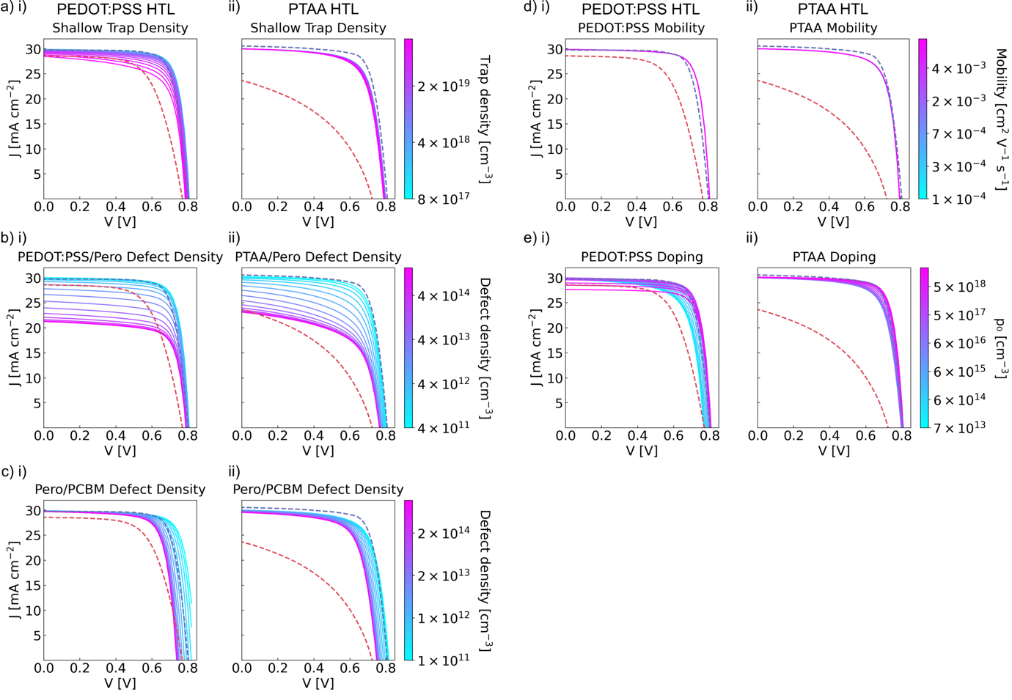

Figure S11. Simulated J-V curves of ITO/HTL/ FA_{0.83}Cs_{0.17}Pb_{0.5}Sn_{0.5}I₃/PCBM/BCP/Cr/Au devices produced with SCAPS-1D^{[9]} (full list of parameters given in SI table 2) using the HTL parameters of i) PEDOT:PSS or ii) PTAA. J-V curves presented are created by varying a) shallow (0.03 eV from conduction band) electron trap density in the perovskite bulk, b) defect density at the perovskite/PEDOT:PSS or PTAA interface, c) defect density at the perovskite/PCBM interface, d) mobility in the PEDOT:PSS or PTAA HTL, and e) acceptor density in the PEDOT:PSS or PTAA HTL. Real device data is overlaid as dotted lines, showing fast (752 V s⁻¹) J-V scans of the champion devices when fresh (blue dotted line) and after 288 hours of aging (red dotted line).
References

[1] R. Carron, C. Andres, E. Avancini, T. Feurer, S. Nishiwaki, S. Pisoni, F. Fu, M. Lingg, Y. E. Romanyuk, S. Buecheler, A. N. Tiwari, Thin Solid Films 2019, 669, 482.
[2] H.-T. Cai, H. Xu, C. Tang, J. Li, Z.-Y. Yang, S.-H. Ye, W. Huang, Polymer 2019, 180, 121732.
[3] Y. Zhao, Y. Lin, Z. Zeng, C. Su, C. Jiang, Opt. Mater. Express 2021, 11, 3049.
[4] N. Tessler, Y. Vaynzof, ACS Energy Lett. 2020, 5, 1260.
[5] J. Thiesbrummel, V. M. Le Corre, F. Peña‐Camargo, L. Perdigón‐Toro, F. Lang, F. Yang, M. Grischek, E. Gutierrez‐Partida, J. Warby, M. D. Farrar, S. Mahesh, P. Caprioglio, S. Albrecht, D. Neher, H. J. Snaith, M. Stolterfoht, Adv. Energy Mater. 2021, 2101447.
[6] M. Stolterfoht, C. M. Wolff, Y. Amir, A. Paulke, L. Perdigon, P. Caprioglio, D. Neher, Energy & Environmental Science 2017, 10, 1530.
[7] P. Caprioglio, J. A. Smith, R. D. J. Oliver, A. Dasgupta, S. Choudhary, M. D. Farrar, A. J. Ramadan, Y.-H. Lin, M. G. Christoforo, J. M. Ball, J. Diekmann, J. Thiesbrummel, K.-A. Zaininger, X. Shen, M. B. Johnston, D. Neher, M. Stolterfoht, H. J. Snaith, Nat Commun 2023, 14, 932.
[8] P. Caprioglio, M. Stolterfoht, C. M. Wolff, T. Unold, B. Rech, S. Albrecht, D. Neher, Adv. Energy Mater. 2019, 9, 1901631.
[9] M. Burgelman, P. Nollet, S. Degrave, Thin Solid Films 2000, 361–362, 527.

