Extended Data Figures

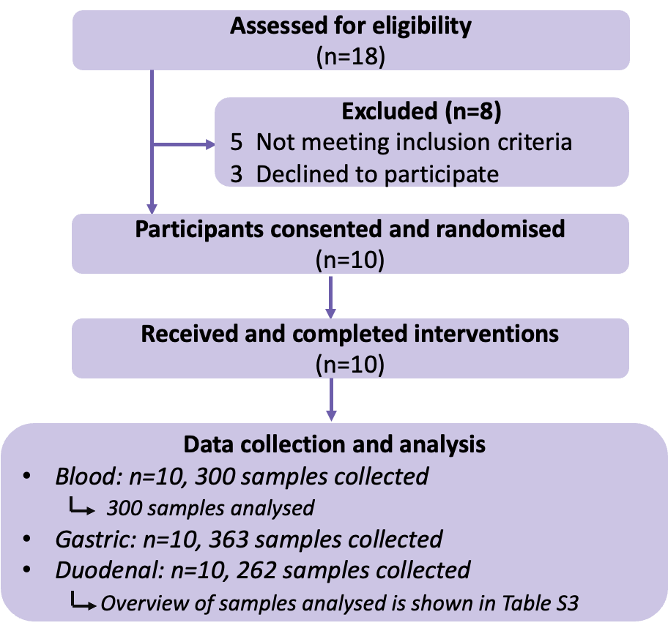
Extended Data Fig. 1 Study flowchart. CONSORT flow diagram illustrating the study procedures, data collection and analysis. Missing data was described in Supplementary Table 3.

Extended Data Fig.2 Subjective appetite scores responses to meal type. Delta changes in feeling of hunger (A), desire to eat (B), and appetite for a meal (C) and composite appetite score (CAS) (D) following consumption of chickpea test meals. Data presented as mean ± SEM (n=10). Repeated measures two-way ANOVA with post hoc Tukey’s test was performed to test the effect of diets, time points and their interactions. Significant differences between interventions annotated: a –Intact-S vs Intact-C; b Intact-S vs Broken and c- Intact-C vs Broken.

Extended Data Fig. 3 Intestinal carbohydrates responses to meal type. Intestinal concentrations of gastric sucrose (A), duodenal sucrose (B) and maltotriose (C) following consumption of chickpea test meals. Time-series data (mean with SEM) showed analyte concentrations measured at time-points to up 3 h after each meal structure using samples from 9 participants. Bar charts showed average concentrations of each analyte over the 3 h period and connected data points are from the same individual. Repeated measures one-way mixed effects ANOVA was performed on each bart chart; annotations refer to multiplicity adjusted P-values from pairwise comparisons using Tukey’s post-hoc test: *p<0.05, **p<0.01, ***p<0.001. One-way ANOVA showed non-significant effect on gastric sucrose (p=0.055), significant meal effect on average 0-3 h duodenal sucrose (p=0.041) and duodenal maltotriose (p=0.0381).

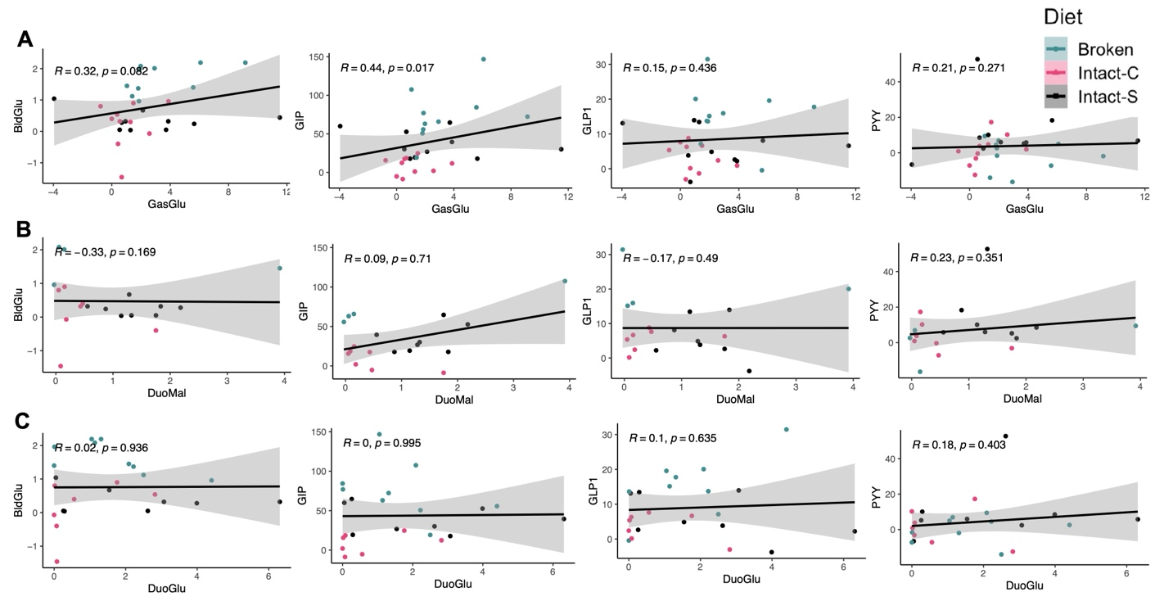
Extended Data Fig. 4 Spearman correlations of 0-30min delta changes in luminal carbohydrates with blood responses.
(A) Relationship between gastric glucose (mg/mL) and blood glucose (mmol/L), GIP(pg/mL), GLP-1 (pmol/L), and PYY (pmol/L).
(B) Relationship between duodenal maltose (mg/mL) and blood glucose (mmol/L), GIP(pg/mL), GLP-1 (pmol/L), and PYY (pmol/L).
(C) Relationship between duodenal glucose (mg/mL) and blood glucose (mmol/L), GIP(pg/mL), GLP-1 (pmol/L), and PYY (pmol/L).
All scatterplots displayed individual points with a regression line and 95% CI (n=9). BldGlu, blood glucose; GasGlu, gastric glucose; DuoGlu, duodenal glucose; DuoMal, duodenal maltose.

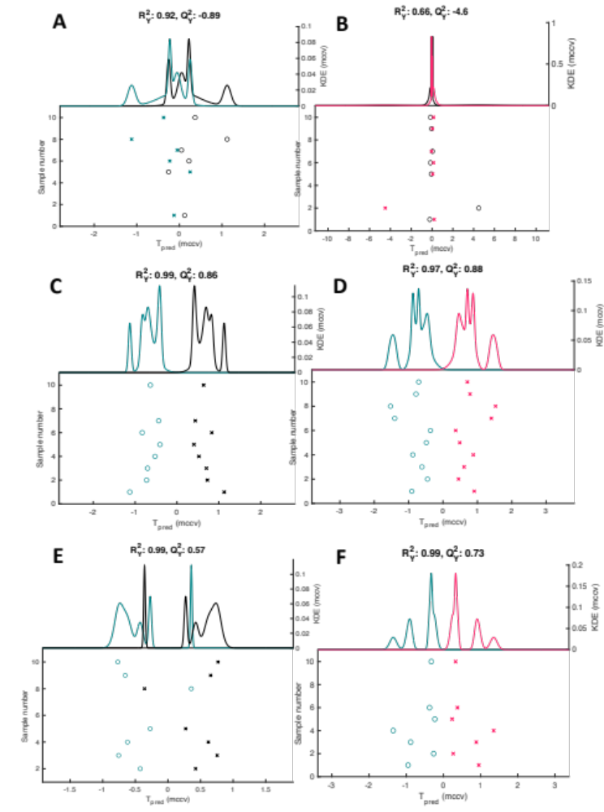
Extended Data Fig.5 Metabolomic profiling of gastric and duodenal aspirates. Repeated Measures, Monte-Carlo Cross-Validation, Partial Least Squares Discriminant Analysis (RM-MCCV-PLSDA) models on ¹H-NMR spectra derived from gastric and duodenal aspirates comparing participants receiving Broken, Intact-S, or Intact-C meal pre- and post-prandial 60 min. Dots represent individual participant metabolic profiles. Abbreviations: Q²Y, capability of prediction; R²Y, explained variance. Model scores:
(A) Intact-S vs. Broken , gastric T=0 (n = 6, R²Y 0.92, Q²Y -0.89)
(B) Intact-S vs. Intact-C, gastric T=0 (n = 7, R²Y 0.66, Q²Y -4.60)
(C) Intact-S vs. Broken, gastric postprandial T=60min (n = 8, R²Y 0.99, Q²Y 0.86)
(D) Intact-C vs. Broken, gastric postprandial T=60min (n = 10, R²Y Y 0.97, Q²Y 0.88)
(E) Intact-S vs. Broken, duodenal postprandial T=60min (n = 7, R²Y 0.99, Q²Y 0.57)
(F) Intact-C vs. Broken, duodenal postprandial T=60min (n = 7, R²Y 0.99, Q²Y 0.73)

