Supplementary Information

List of Supplementary Text
Supplementary Text 1. Meal Preparation
List of Supplementary Tables
Supplementary Table 1. Inclusion and exclusion criteria
Supplementary Table 2. Participant characteristics (n=10)
Supplementary Table 3. Overview of intestinal samples used for analyses
Supplementary Table 4. Peak parameters of the glycaemic, insulinemic and gut hormone responses to meal type
Supplementary Table 5. Mean analyte concentrations in aspirated gastric and duodenal samples after meals with different structures
Supplementary Table 6. pH values of gastric aspirates
Supplementary Table 7. Metabolite identifications for NMR spectra
Supplementary Table 8. List of metabolites that are associated with the difference between food structure interventions
List of Supplementary Figures
Supplementary Figure 1. Visualization of algorithmically fitted pseudo-Voigt profiles used for metabolite quantification
Supplementary Figure 2. Validation of metabolite quantifications through correlation between separate signals

Supplementary Text 1. Meal Preparation



Meal Preparation
Meals: Chickpeas were the main ingredient of the test meals. Whole chickpeas Cicer arietinum L., Kabuli type, Argentine variety (7mm diameter) were supplied by AGT Poortman Ltd. These were dehulled through an abrasive process by holding 200 g batches of dry chickpea (as supplied) in a Steelbrush dehuller (Westrup pre-cleaning debranner, coarse blue roll) for 30s, then sieved on a 3mm grid to exclude fragments of testa. The resulting dehulled chickpea material was weighed out into 75.0 g portions (by a researcher independent to the study), sealed and labelled. These dehulled chickpea portions were the main ingredient for the ‘broken cell’ (Broken) and ‘intact separated cell’ (Intact-S) chickpea meals, which were freshly prepared on the morning of each study visit using standardised processing protocols to deliver different structures. For the ‘cell cluster’ (Intact-C) meal, the dehulled chickpeas were further processed by milling to obtain intact tissue particles (1.6-2.0 mm) containing whole cells, before portioning out. These coarse particles were obtained by trickle feeding the dehulled chickpeas through a Buhler miag Vario mill set up with a Roll Gap of 1.8 mm and Roller speed 220:450 rpm on 24.5 mm diameter break rolls 5 flutes/cm break rolls in Sharp-Sharp disposition for the first break. Output material was analytically sieved to collect target size fraction (≥ 1.6 and < 2.0 mm), and the oversize material (≥ 2.0 mm) was then re-milled according to the same setting as used for the first break, but with a smaller Roll Gap (0.8 mm), to increase recovery of the target size fraction. This coarsely milled chickpea material (≥1.6 and <2.0 mm ‘semolina’) was the main ingredient for the ‘cell-cluster’ meal, and was weighed into 75 g portions in preparation for the study visits.
Each chickpea ingredient portion was then processed further, as described below, using a Thermomix® TM5 (Vorwerk) food processor to deliver freshly cooked meals with different structures to the study participants.
For the ‘Broken cell’ and ‘Separated cells’ meal types, the pre-weighed 75 g portion of de-hulled chickpeas was rinsed with drinking water from the tap in a colander until the water ran clear, and then immersed in 1L tap water under cover overnight for ~16 h. The following morning, the soaked chickpeas were then drained, rinsed briefly with fresh tap water, and drained thoroughly before transferring to the Thermomix. For the Broken meal, additional tap water was then added to the soaked chickpea to achieve a total weight of 637.5 g. This mixture was then blended (forward direction, speed setting 10) for 3 min at 37 °C, which breaks the chickpea cotyledon cells, before further heating and cooking at 95 °C for 28 min, with gentle stirring (blender in reverse setting, speed setting 4). A portion (~490 g) of the cooked mixture was then weighed into a bowl and seasoned with a 115 g pot of jelly (Hartleys’ no added sugar raspberry jelly) and 15 g of sugar-free jam (Stutes no added sugar blackcurrant jam), to aid palatability, and served with drinking water (~270 mL) and served immediately to participants while still warm (above 60 °C).
The Intact-S meal, additional tap water was added after the overnight soak to achieve a total weight of 375.0 g, and then covered, heated and cooked at 95 °C for 80 min, with gentle stirring (blender in reverse direction, speed setting 5). A portion (~280 g) of the cooked mixture was then weighed into a bowl, seasoned as described above, and served immediately while still warm, together with drinking water (~480 mL).
For the Intact-C meal, the soaked semolina were drained and transferred into the Thermomix together with additional tap water to achieve a total wet weight of 300 g. This was then cooked for 50 min at 95 °C with gentle stirring (reverse, speed setting 1). A serving of ~120 g drained cooked chickpea solids was then transferred into a bowl, seasoned as above, and served immediately while warm together with drinking water.
For all meals, the volume of water served in the drinking glass was adjusted based on the cooked meal weight, so that all meals provided 30 g total starch from chickpea, the same amount of seasoning and similar total mass (~760 g).

Supplementary Table 1. Inclusion and exclusion criteria
Inclusion Criteria | Exclusion Criteria
Male or female | Abnormal ECG
Age between 18-65 years (inclusive) | Screening blood results outside of normal reference values.  Fasting glucose 3.9-5.6 mmol/L  Haemoglobin M125-170/ F114-150 g/L  White blood cell count 4.2-11.2 x 10⁹/L  Red blood cell count 3.73-4.96 million/mcL
Body mass index (BMI) of 18-30 kg/m² | Weight change of ≥ 5kg in the preceding 2 months
Willingness and ability to give written informed consent and willingness and ability to understand, to participate and to comply with the study requirements | Current Smokers
 | History of substance abuse and/or excess alcohol intake
 | Cancer
 | Gastrointestinal disease e.g., inflammatory bowel disease or irritable bowel syndrome, kidney disease, liver disease and pancreatitis
 | Pregnancy
 | Diabetes or cardiovascular disease
 | Participant in a research study or blood donation 12 weeks prior
 | Started new medication within the last 3 months likely to interfere with glucose and energy metabolism, appetite regulation and hormonal balance, including: anti-inflammatory drugs or steroids, antibiotics, androgens, phenytoin, erythromycin, or thyroid hormones.

Supplementary Table 2. Participant characteristics (n=10)
Variable | Baseline measurements
Gender (M:F) | 6:4
Age (years) | 30.8 ± 2.41¹
Height (m) | 1.70 ± 0.02¹
Weight (kg) | 72.07 ± 3.20¹
BMI (kg/m²) | 24.91 ± 0.82¹
Body Fat (%) | 17.35 ± 1.91¹
¹Results presented as Mean ± SEM

Supplementary Table 3. Overview of intestinal samples used for analyses¹
 | Gastric Supernatants |  |  | Gastric Pellets |  |  | Duodenal Supernatants |  |  | Duodenal Pellets
Time (min) | Intact-S | Intact-C | Broken | Intact-S | Intact-C | Broken | Intact-S | Intact-C | Broken | Intact-S | Intact-C | Broken
-10 | 7 | 4 | 3 | 3 | 4 | 3 | 3 | 2 | 1 | 0 | 0 | 0
0 | 6 | 4 | 3 | 5 | 3 | 3 | 2 | 3 | 2 | 0 | 0 | 0
15 | 8 | 8 | 9 | 8 | 6 | 9 | 6 | 6 | 4 | 3 | 1 | 2
30 | 9 | 9 | 9 | 9 | 9 | 9 | 7 | 7 | 3 | 5 | 2 | 1
45 | 9 | 7 | 9 | 8 | 7 | 9 | 6 | 6 | 8 | 2 | 3 | 5
60 | 9 | 9 | 9 | 8 | 9 | 9 | 4 | 7 | 6 | 3 | 3 | 4
75 | 9 | 8 | 9 | 9 | 7 | 9 | 9 | 5 | 7 | 5 | 3 | 5
90 | 9 | 9 | 9 | 9 | 9 | 9 | 4 | 2 | 6 | 3 | 1 | 5
105 | 9 | 8 | 9 | 8 | 7 | 9 | 3 | 4 | 4 | 4 | 0 | 3
120 | 9 | 5 | 8 | 9 | 3 | 8 | 4 | 7 | 6 | 4 | 2 | 2
135 | 9 | 6 | 8 | 9 | 6 | 8 | 4 | 6 | 7 | 2 | 0 | 4
150 | 9 | 7 | 7 | 9 | 6 | 7 | 5 | 4 | 5 | 2 | 2 | 4
165 | 7 | 7 | 6 | 7 | 5 | 6 | 4 | 4 | 3 | 4 | 1 | 2
180 | 8 | 5 | 8 | 7 | 5 | 6 | 4 | 2 | 3 | 5 | 0 | 1
¹ The reason for lower numbers of samples used in analyses was that the volume of sample collected was not always sufficient for further analyses to be conducted.

Supplementary Table 4. Peak parameters of the glycemic, insulinemic and gut hormone responses to meal type ¹

 | Intact-S | Intact-C | Broken
Plasma Glucose | Time x Treatment P < 0.001
Fasting (mM) | 4.94 (4.57 5.36) | 4.98(4.63 5.37) | 5.09 (4.80 5.42)
iPeak (mM) | 0.76 (0.43 1.34)ª | 0.65(0.22 0.97)ª | 1.80(1.36 2.30)^{b}
Peak X (min) | 41(23 74) | 26(18 39) | 35(25 42)
Last X (min) | 87(56 136) | 62(33 117) | 105(81 136)
iAUC (mM.min⁻¹) | 31.4(11.5 85.9) ^{ab} | 12.7(2.9 54.9)ª | 81.0(55.1 119.2) ^{b}
Plasma Insulin | Time x Treatment P = 0.006
Fasting (µU/mL) | 6.95(5.43 9.28) | 8.91(7.88 10.26) | 8.15(6.57 10.74)
iPeak (µU/mL) | 22.0(15.4 31.3)^{ab} | 13.5(9.3 19.4)ª | 36.2(23.4 55.9)^{b}
Peak X(min) | 39(23 66) | 25(18 34) | 37(23 56)
Last X (min) | 163(135 196) ª | 74(46 120) ^{b} | 136(116 162) ª
iAUC (µU/mL.min⁻¹) | 1538(986 2398)ª | 410(235 715)^{b} | 1910(1384 2636)ª
Plasma GIP | Time x Treatment P =0.006
Fasting (pg/mL) | 47.29(38.88 59.62) | 51.58(42.48 64.90) | 51.90(44.06 62.78)
iPeak (pg/mL) | 66.8(54.2 82.2) ª | 26.7(15.0 47.4) ^{b} | 84.3(68.0 104.6) ª
Peak X (min) | 113(77 166) ª | 88(43 180) ª | 39(25 49) ^{b}
Last X (min) | 180(180,180) | 151(112 204) | 160(132 185)
iAUC (pg/mL.min⁻¹) | 7267(4988 10587) ª | 1962(794 4847) ^{b} | 6187(4383 8732) ª
Plasma GLP-1 | Time x Treatment P =0.034
Fasting (pM) | 12.49(9.21 19.62) | 12.51(9.54 17.44) | 12.37(9.37 18.22)
iPeak (pM) | 21.0(17.3 25.5) | 11.4(6.2 21.1) | 19.6(13.6 28.2)
Peak X (min) | 97(56 169) ª | 51(23 113) ^{ab} | 29(20 43) ^{b}
Last X (min) | 180 (180, 180) | 102(58 180) | 123(80 190)
iAUC (pM.min⁻¹) | 2015(1668 2435)ª | 591(225 1555)^{ab} | 978(488 1960)^{b}
Plasma PYY | Log-transformed data: Time x Treatment P = 0.186, Treatment P=0.0158
Fasting (pM) | 11.12(7.53 17.28) | 11.14(7.51 18.62) | 10.62(7.59 17.13)
iPeak (pM) | 19.7(10.3 37.8) ª | 16.0(10.6 24.0) ^{ab} | 7.4(5.0 10.9) ^{b}
Peak X (min) | 65(34 125) | 35(18 72) | 33(17 63)
Last X (min) | 120(69 206)ª | 66(33 129)^{ab} | 50(29 85)^{b}
iAUC (pM.min⁻¹) | 1049(350 3134) ª | 425(176 1028) ^{ab} | 162(70 372) ^{b}
¹The fasting, the maximal postprandial rise (iPeak), time to peak (Peak X), time to return to baseline levels (Last X), and iAUC of the 1st peak values for blood glucose, plasma insulin, plasma GIP, GLP-1 and plasma PYY following consumption to macronutrient matched chickpea meals (30 g starch/serving) in which cotyledon cells are present as separated cells ‘Intact-S’, cell clusters ‘Intact-C’ or no longer cellular ‘Broken’. Values were obtained from the postprandial time-series data, for which significance (P<0.05) of time x treatment interactions was determined by mixed-effects ANOVA. Data presented as geometric means with 95%CI. Superscript letters refer to pairwise comparisons' results (Tukey’s post-hoc analysis); different letters represent significant differences at p < 0.05 probability level.

Supplementary Table 5. Mean analyte concentrations in aspirated gastric and duodenal samples after meals with different structures
Site | Fraction | Analyte | Intact-S |  |  | Intact-C |  |  | Broken |  |  | P-value
Gastric | Fluid | Maltose (mg/mL) | 0.912 | ± | 0.465 | 0.6467 | ± | 0.171 | 3.04 | ± | 1.453 | 0.006
Gastric | Fluid | Sucrose (mg/mL) | 0.192 | ± | 0.088 | 0.112 | ± | 0.043 | 0.233 | ± | 0.100 | 0.055
Gastric | Solids | Dry Matter (mg/mL) | 39.04 | ± | 8.58 | 9.16 | ± | 1.95 | 15.44 | ± | 3.16 | <0.001
Duodenal | Fluid | Maltose (mg/mL) | 0.7539 | ± | 0.262 | 0.4907 | ± | 0.187 | 1.1800 | ± | 0.422 | 0.020
Duodenal | Fluid | Maltotriose (mg/mL) | 0.3632 | ± | 0.183 | 0.1229 | ± | 0.082 | 0.6265 | ± | 0.350 | 0.018
Duodenal | Fluid | Glucose | 0.3754 | ± | 0.175 | 0.1915 | ± | 0.096 | 0.4448 | ± | 0.153 | 0.003
Duodenal | Fluid | Sucrose (mg/mL) | 0.1115 | ± | 0.04715 | 0.0890 | ± | 0.049 | 0.1689 | ± | 0.058 | 0.041
Duodenal | Solids | Dry Matter (mg/mL) | 16.290 | ± | 1.260 | 9.840 | ± | 4.290 | 6.000 | ± | 2.778 | 0.009
Duodenal | Solids | Total CHO (mg/mg DM) | 0.536 | ± | 0.054 | 0.524 | ± | 0.042 | 0.427 | ± | 0.045 | 0.060
Duodenal | Solids | Starch (mg/mg total CHO) | 0.71 | ± | 0.028 | 0.682 | ± | 0.046 | 0.386 | ± | 0.065 | <0.001
Duodenal | Solids | Starch (mg/mL aspirate) | 6.353 | ± | 2.678 | 3.263 | ± | 1.667 | 1.306 | ± | 0.456 | <0.002
Values are means with 95% CIs obtained using samples collected from 10 participants up to 3h after test meal consumption. P-values are main effects by One Way RM ANOVA. Total CHO – Total carbohydrate is the total amount of sugars in acid hydrolysate of aspirated solids and is mainly from plant cell wall polysaccharides and starch

Supplementary Table 6. pH values of gastric aspirates
Subject | Diet | Time (min)
Subject | Diet | 0 | 15 | 30 | 60
Subject 1 | Intact-S | 1.5 | 4 | 4 | 2.5
Subject 1 | Intact-C | 1.5 | 4.5 | 4 | 2
Subject 1 | Broken | 2 | 4.5 | 4 | 2
Subject 2 | Intact-S | 1 | 4 | 4 | 2
Subject 2 | Intact-C | 1.5 | 4.5 | 4.5 | 2
Subject 2 | Broken | 1 | 4 | 4 | 2
Subject 3 | Intact-S | 1.5 | 3.5 | 2 | 1
Subject 3 | Intact-C | 1.5 | 3.5 | 2 | 1
Subject 3 | Broken | 1.5 | 3.5 | 2 | 1.5
Subject 4 | Intact-S | 1.5 | 3.5 | 3.5 | 2
Subject 4 | Intact-C | 1.5 | 4 | 4 | 2
Subject 4 | Broken | 1 | 4 | 4 | 2
Subject 5 | Intact-S | 1.5 | 4 | 4 | 3
Subject 5 | Intact-C | 1.5 | 4 | 4 | 2.5
Subject 5 | Broken | 1.5 | 4 | 3.5 | 3
pH of gastric aspirates was measured by pH test strips.

Supplementary Table 7. Metabolite identifications for NMR spectra.
Numberª | Metabolite | Chemical shift (multiplicity)
1 | Bile acids/lipids | 0.67(s), 0.73(s), 0.92(s), 0.98(d), 2.26(m)
2 | Valine | 1.04(d)
3 | Leucine/Isoleucine | 0.94-0.97
4 | Propionate | 1.07(t)
5 | Buyurate | 1.55(q), 0.89(t)
6 | Lactate | 1.32(d),4.1(dd)
7 | Alanine | 1.48(d)
8 | Acetate | 1.92(s)
9 | Methionine | 2.143(s)
10 | Glutamine | 2.46(m)
11 | Succinate | 2.41(s)
12 | Citrate | 2.55(d),2.67(d)
13 | Aspartate | 2.82(dd)
14 | Asparagine | 2.962(dd)
15 | Taurine-conjugated bile acids | 3.08(t), 7.98-8.0(m)
16 | Glycine-conjugated bile acids | offset at 7.91
17 | Glucose | 4.65(d), 5.24(d)
18 | Maltose/Maltotriose | 5.39-5.42
19 | Oligosaccharides,(1→4) | 5.34(d),5.36(d),5.374 (d), 5.382 (d))
20 | Oligosaccharides (1→6) | 4.96(d)-5.01 (m)
21 | Stachyose/Raffinose | 5.43 (d), 4.23 (d), 4.99 (d), 5.00 (d)
22 | Fumarate | 6.523(s)
23 | Tyrosine | 6.90(d), 7.20(d)
24 | Histidine | 7.10 (d), 3.16(dd), 3.23(dd)
25 | Phenylalanine | 7.34(m),7.38(m), 7.43(m)
26 | Tryptophan | 7.54(d), 7.74(d)
27 | Formate | 8.46(s)
28 | Trigonelline | 9.127(s),8,84(m),8.08(m),4.44(s)
ªNumber is related to the labels in Figure 6A. Multiplicity key is as follows: d: doublet, 2dd: doublet of doublet, 2xd: Two doublets s: singlet, t = triplet, m = (other) multiplet

Supplementary Table 8. List of metabolites that are associated with the difference between food structure interventions in Partial Least Squares-Discriminant Analysis (PLS-DA) models (Fig. 6B-E)

Models | Metabolites | Association | Adjusted- P values
G30 | Tyrosine | ↓ | 6.6E-07
 | Phenylalanine | ↓ | 5.8E-03
 | Tryptophan | ↓ | 3.1E-03
 | Glucose | ↑ | 7.4E-06
 | Maltose | ↑ | 1.2E-05
 | Oligosaccharides,(1→4) | ↑ | 1.3E-13
 | Oligosaccharides (1→6) | ↑ | 9.8E-09
G120 | Glucose | ↑ | 6.4E-10
 | Maltose | ↑ | 6.9E-03
 | Oligosaccharides,(1→4) | ↑ | 1.3E-03
 | Oligosaccharides (1→6) | ↑ | 9.8E-09
D30 | total BAs | ↓ | 1.2E-03
 | TCBAs | ↓ | 1.7E-02
 | GCBAs | ↓ | 1.1E-08
 | Glucose | ↑ | 1.1E-16
 | Maltose | ↑ | 1.4E-21
 | Oligosaccharides,(1→4) | ↑ | 3.2E-16
 | Oligosaccharides (1→6) | ↑ | 3.8E-09
D120 | total BAs | ↓ | 5.9E-04
 | TCBAs | ↓ | 4.4E-05
 | GCBAs | ↓ | 5.0E-05
 | Valine | ↓ | 5.4E-06
 | Leucine/Isoleucine | ↓ | 9.0E-05
 | Alanine | ↓ | 2.3E-08
 | Formate | ↑ | 1.9E-05
 | Citrate | ↑ | 8.1E-04
↑ indicates higher after ‘Broken’ meal, ↓ indicates higher after ’Intact’ meal. P-values were adjusted for multiple testing using the Benjamini-Hochberg False Discovery Rate (FDR). Abbreviations: G30, Gastric T=30min; G120, Gastric T=120min; D30, Duodenal T=30min; D120, Duodenal T=120min. BAs, bile acids; TCBAs, taurine-conjugated bile acids; GCBAs, glycine-conjugated bile acids.

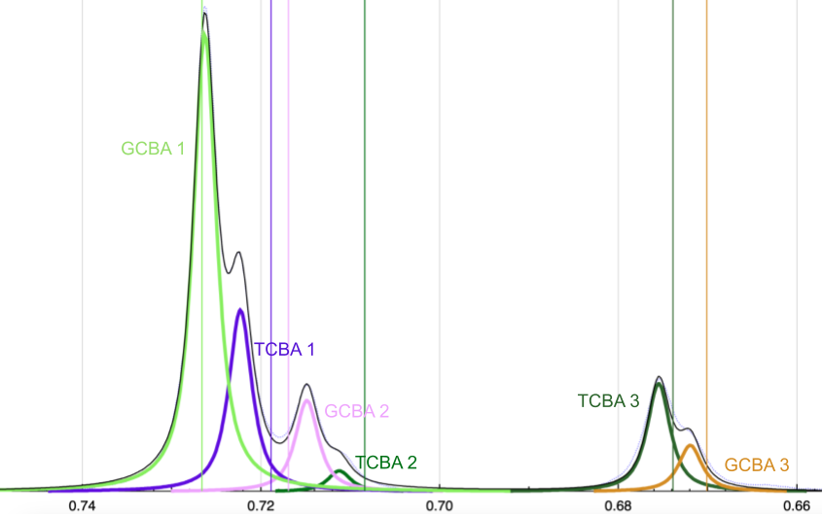
Supplemtary Figure 1. Visualization of algorithmically fitted pseudo-Voigt profiles used for metabolite quantification. The image is a snapshot from our visual assessment tool, displaying a SROI comprising signals from methyl resonances of Bile Acids. The dotted grey line is the experimental spectrum, the black line is the model prediction, and the colored curves are the individual pseudo-Voigt profiles of the signals that constitute the model. The integrals of the colored cuves divided by the number of protons provide the concentrations of the corresponding metabolites.

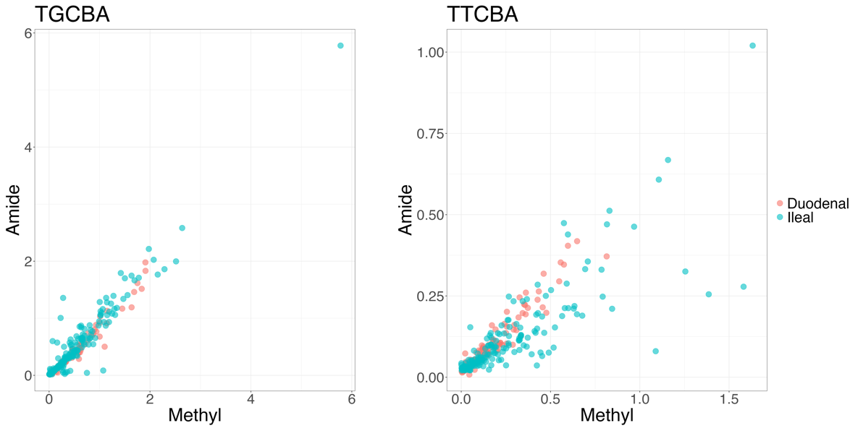
Supplemtary Figure 2. Validation of metabolite quantifications through correlation between separate signals. In this example the horizontal axis represents the aggregate concentrations of Glycine-Conjugated (TGCBA, left) and Taurine-Conjugated (TTCBA, right) Bile Acids computed from the methyl resonance at 0.7 ppm (Figure S6), while the vertical axis represents the corresponding values computed from the amide resonance at 7 – 8 ppm. As concentration is independent of the chosen NMR signal, the scatter plots should approach the identity.

