Supplementary table 1. Comparison of the clinicopathological factors between the patient with and without acute remnant pancreatitis (n=142)
Variable, median (interquartile range), or Ratio | Acute remnant pancreatitis (n=10) | Non-acute remnant pancreatitis (n=132) | p-value
Male | 7 (70%) | 85 (64%) | 0.720
Age (years) | 57 (44–71) | 68 (60–76) | 0.010
Body mass index (kg/m²) | 24.0 (20.0–28.1) | 22.0 (19.9–24.3) | 0.121
Chronic alcohol use | 2 (18%) | 8 (7%) | 0.206
Diagnosis |  |  | 0.155
Intraductal papillary mucinous carcinoma | 2 (20%) | 25 (19%)
Bile duct cancer | 5 (50%) | 69 (52%)
Neuroendocrine tumor | 0 (0%) | 15 (11%)
Intraductal papillary mucinous neoplasm | 1 (10%) | 12 (9%)
Metastatic tumor | 0 (0%) | 7 (5%)
Benign tumor | 2 (20%) | 4 (3%)
Soft pancreas | 7 (70%) | 93 (70%) | 0.976
Duration of operation (min) | 539 (481–584) | 510 (439–595) | 0.446
Intraoperative blood loss (ml) | 450 (325–1,435) | 670 (360–1,070) | 0.628
Pancreaticojejunostomy
Blumgart | 3 (30%) | 49 (37%) | 0.652
Pancreatic duct stent (Fr) | 6 (6–8) | 6 (5–6) | 0.245
Main pancreatic duct size (mm) | 2 (2–3) | 3 (2–4) | 0.028
Number of sutures | 8 (8–8.5) | 8 (8–8) | 0.040
Suture pitch (mm) | 0.79 (0.79–0.98) | 1.18 (0.79-1.57) | 0.012
Postoperative pancreatic fistula | 3 (30%) | 36 (27%) | 0.852
Local recurrence | 1 (10%) | 16 (12%) | 0.836

Supplementary table 2. Univariate and multivariate analyses of clinicopathologic variables in relation to postoperative pancreatic fistula following pancreaticoduodenectomy (n=142)
Variable |  | Univariate analyses |  |  |  | Multivariate analyses
Variable | n | Odds ratio | 95% CI | p-value |  | Odds ratio | 95% CI | p-value
Male | 92 | 2.67 | 1.12–6.37 | 0.027 |  | 2.63 | 1.09–6.30- | 0.030
Age ≤62 years | 53 | 4.36 | 1.08–17.67 | 0.039 |  | 1.62 | 0.76–3.48 | 0.215
Chronic alcohol use | 11 | 2.86 | 0.53-15.55 | 0.224 |  | – | – | –
Soft pancreas | 100 | 2.35 | 0.94–5.87 | 0.066 |  | – | – | –
Narrow suture pitch | 68 | 1.85 | 0.88–3.91 | 0.106 |  | – | – | –
Abbreviations: CI, confidence interval.

Supplementary Figure 1.
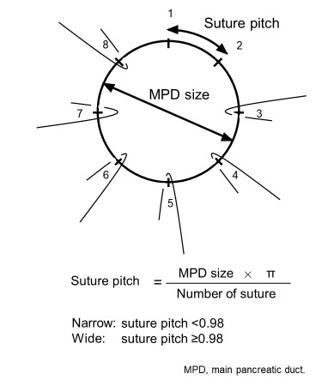
The suture pitch was defined as the distance between the ligations of the duct-to-mucosa anastomosis and was calculated using the following formula: main pancreatic duct size × π ÷ number of sutures. To assess the significance of the suture pitch, the patients were classified into two groups: those with a narrow suture pitch and those with a wide suture pitch. This cut-off value was determined according to the receiver operating characteristic curve in Figure 3.

