Supplementary Material

Lateral Size-Controlled Single-Layer MoS₂ Synthesis via Chemical Vapor Deposition
B.A. Küçük^{1,2}, M.A. Çağlar^{1,2,3}, G. Turgut^{1,2,3}*
¹2D Material Research Lab., High Technology Research and Application Centre, Erzurum Technical University, 25100 Erzurum, Turkey
²Department of Photonics, Science Institute, Erzurum Technical University, 25100 Erzurum, Turkey
³Department of Basic Sciences, Science Faculty, Erzurum Technical University, 25100 Erzurum, Turkey
The Corresponding author (*): Güven Turgut
Phone: +90 444 5 333 22 73
e-mail: guven.turgut@erzurum.edu.tr
Adress: Department of Basic Sciences, Science Faculty, Erzurum Technical University, Erzurum, 25100, Turkey

Supplementary Materials :
Figure S1. Diagram of CVD experimental setup during growth of MoS₂ flakes
Figure S2. MoS₂ growth in alumina boat zones
Figure S3. CVD-grown mechanisims of MoS₂ layers for close-ended alumina boat and open-ended quartz boat
Figure S4.MoS₂ flakes grown on SiO₂/Si substrate , Experimental setup, Photo of experimental
boat,O.M
Table 1. Optimizations of MoS₂ grown by CVD have been reported in the literature.
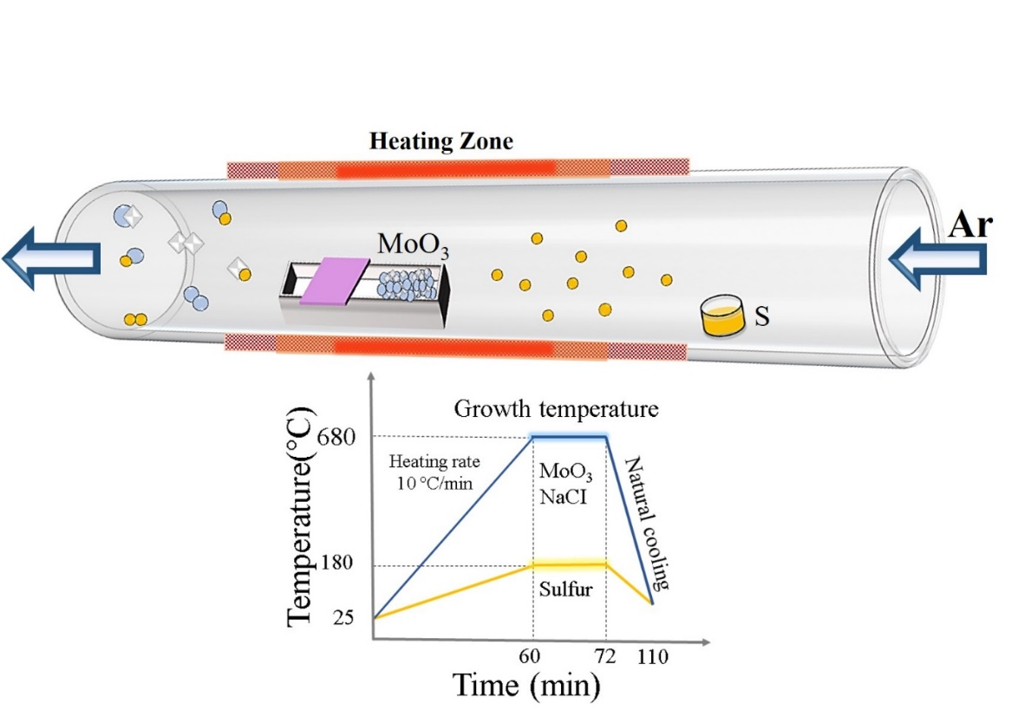
Figure S1. Diagram of CVD experimental setup during growth of MoS₂ flakes

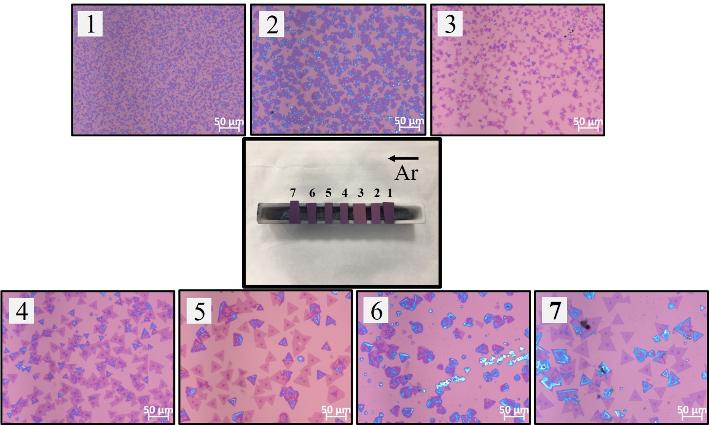

Figure S2. MoS₂ growth for different zones in alumina boat

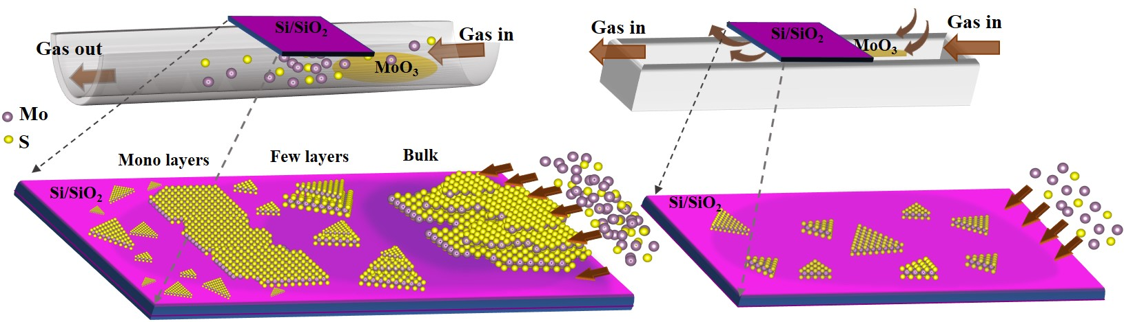

Figure S3. CVD-grown mechanisims of MoS₂ layers for close-ended alumina boat and open-ended quartz boat

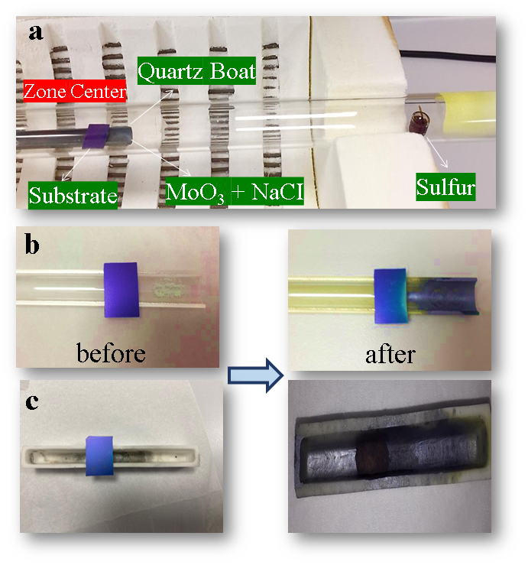
Figure S4. .MoS₂ flakes grown on SiO₂/Si substrate , Experimental setup, Photo of experimental boat,O.M
Table 1. Optimizations of MoS₂ grown by CVD have been reported in the literature(*DMS; Distance between Mo precursor and substrate, ACVD; Atomopheric Pressure CVD, LCVD; Low Pressure CVD )
Method | Optimized Parameters | Mo Precursor and Amount | Gas type and flow rate (sccm) | Catalysist Type and Amount | Growth Temperature (°C) | Ramp to growth temperature (°C/min.) | Growth Time  (min.) | Growht Substrate Type | Boat Type | Maximum Flake Size  (μm) | Ref.
ACVD | Gas flow rate | MoO₃  (30 mg) | Ar  15 | NaCl  1mg/ml solution | 670 | / | 15 | SiO₂/Si | Quartz | 60 | [1]
ACVD | Temperature | MoO₂  (10 mg) | Ar  200 | / | 750 | 3 | 15 | SiO₂/Si | Alumina | 10-50 | [2]
ACVD | DMS | MoO₃  (5 mg) | Ar  100 | / | 850 | 8 | 10 | SiO₂/Si | / | ~770 nm | [3]
ACVD | Gas flow rate | MoO₃  (100 mg) | Ar | / | 750 | / | 5 | SiO₂/Si | Alumia | / | [4]
LCVD | Pressure  Temperature  Time  DMS | MoO₃  (1 mg) | Ar  30-1000 | PTAS | 750 | / | 10 | SiO₂/Si | Quartz | 150 - mm | [5]
ACVD | Temperature | MoO₃  (3 mg) | Ar  100 | / | 850 | 18.4 | 5 | SiO₂/Si | / | 109 | [6]
ACVD | Temperature | MoO₃  (10 mg) | Ar  50 | / | 720-780 | 10 | 10 | SiO₂/Si | Quartz | 20 | [7]
ACVD | Temperature | MoO₃  (15 mg)) | Ar  10 | / | 760 | 15 | 30 | SiO₂/Si | Quartz | 50 | [8]
ACVD | Temperature  Time  M | MoO₃  (2 mg) | Ar  140 | / | 700 | 20 | 15 | SiO₂/Si | Quartz | ~10 | [9]
LCVD | Temperature  DMS | MoO₃  (10 mg) | N2  100 | / | 850 | 34 | 20 | Sapphire | / | 90 | [10]
ACVD | Temperature | MoO₃  (5 mg) | Ar  60 | / | 800 | 10 | 15 | SiO₂/Si | Quartz | ~25.3 | [11]
LCVD | M/S  Temperature | MoO₃  (0.9 mg) | N2  10 | PTAS | 620-720 | / | 3 | SiO₂/Si | Alumina | 120 | [12]
LCVD | DMS | MoO₃  (1:13 mg) | Ar  10 | / | 700 | / | 30 | SiO₂/Si | Alumina | 80 | [13]
ACVD | C.T | MoO₃  (36 mg) | Ar+H2  65 (%10) | NACI, BR ve I | 780 | 39 | 20 | SiO₂/Si | Quartz | 60 | [14]
ACVD | Precursor type  Catalysis type  Time | MoO₃  (6 mg) | Ar  100 | NaNO3  2 mg | 550 | 33 | 12 | SiO₂/Si | Alumina | ~10 | [15]
ACVD | Precursor type  Gas flow rate Time  M/S | MoO₂  (3 mg) | 10 | / | 760 | 15 | 1 | SiO₂/Si | Alumina | 70 | [16]
ACVD | Temperature  Time  Precursor type  Gas flow rate | NaOH: SMD:DI  4 :0.5:0.5 | N₂  200 | / | 700-800 | / | 18-22 | SiO₂/Si | Quartz | 100 | [17]
ACVD | M/C.T  Gas flow rate G.S  Time  Temperature  Boat type | MoO₃  (3 mg) | Ar  15 | NaCI  0.3 | 680 | 10 | 20 | SiO₂/Si | Quartz  (open-ended) | mm scale  /continous film | This Work

Table 1. Optimizations of MoS₂ grown by CVD have been reported in the literature(*DMS; Distance between Mo precursor and substrate, ACVD; Atomopheric Pressure CVD, LCVD; Low Pressure CVD )

References
[1] L. Zang, L. Chen, D. Tan, X. Cao, N. Sun, C. Jiang, Research on Multi-morphology Evolution of MoS2 in Chemical Vapor Deposition, ChemistrySelect. 6 (2021) 8107–8113. https://doi.org/10.1002/slct.202101843.
[2] Bilgin, F. Liu, A. Vargas, A. Winchester, M.K.L. Man, M. Upmanyu, K.M. Dani, G. Gupta, S. Talapatra, A.D. Mohite, S. Kar, Chemical Vapor Deposition Synthesized Atomically Thin Molybdenum Disulfide with Optoelectronic-Grade Crystalline Quality, ACS Nano. 9 (2015) 8822–8832. https://doi.org/10.1021/acsnano.5b02019.
[3] M.H. Johari, M.S. Sirat, M.A. Mohamed, S.N.F. Mohd Nasir, M.A. Mat Teridi, A.R. Mohmad, Effects of Mo vapor concentration on the morphology of vertically standing MoS2 nanoflakes, Nanotechnology. 31 (2020) 0–8. https://doi.org/10.1088/1361-6528/ab8666.
[4] Y. Cao, X. Luo, S. Han, C. Yuan, Y. Yang, Q. Li, T. Yu, S. Ye, Influences of carrier gas flow rate on the morphologies of MoS2 flakes, Chem. Phys. Lett. 631–632 (2015) 30–33. https://doi.org/10.1016/j.cplett.2015.05.001.
[5] P. Tummala, A. Lamperti, M. Alia, E. Kozma, L.G. Nobili, A. Molle, Application-oriented growth of a molybdenum disulfide (Mos2) single layer by means of parametrically optimized chemical vapor deposition, Materials (Basel). 13 (2020) 1–13. https://doi.org/10.3390/ma13122786.
[6] W. Wang, X. Zeng, S. Wu, Y. Zeng, Y. Hu, J. Ding, S. Xu, Effect of Mo concentration on shape and size of monolayer MoS2 crystals by chemical vapor deposition, J. Phys. D. Appl. Phys. 50 (2017) 395501. https://doi.org/10.1088/1361-6463/aa81ae.
[7] L. Wang, F. Chen, X. Ji, Shape consistency of MoS2 flakes grown using chemical vapor deposition, Appl. Phys. Express. 10 (2017) 2–6. https://doi.org/10.7567/APEX.10.065201.
[8] S. Wang, Y. Rong, Y. Fan, M. Pacios, H. Bhaskaran, K. He, J.H. Warner, Shape evolution of monolayer MoS2 crystals grown by chemical vapor deposition, Chem. Mater. 26 (2014) 6371–6379. https://doi.org/10.1021/cm5025662.
[9] F. Chen, W. Su, The effect of the experimental parameters on the growth of MoS2 flakes, CrystEngComm. 20 (2018) 4823–4830. https://doi.org/10.1039/c8ce00733k.
[10] Y. Yang, H. Pu, J. Di, S. Zhang, J. Hu, Y. Zang, C. Gao, C. Chen, Influences of temperature gradient and distance on the morphologies of MoS2 domains, AIP Adv. 8 (2018). https://doi.org/10.1063/1.5050652.
[11] F. Chen, W. Su, S. Zhao, Y. Lv, S. Ding, L. Fu, Morphological evolution of atomically thin MoS2flakes synthesized by a chemical vapor deposition strategy, CrystEngComm. 22 (2020) 4174–4179. https://doi.org/10.1039/d0ce00558d.
[12] S.Y. Yang, G.W. Shim, S.B. Seo, S.Y. Choi, Effective shape-controlled growth of monolayer MoS2 flakes by powder-based chemical vapor deposition, Nano Res. 10 (2017) 255–262. https://doi.org/10.1007/s12274-016-1284-6.
[13] S. Smagulova, A. Semenova, E. Zakharkina, P. Vinokurov, Investigation of the properties of two-dimensional molybdenum disulfide films synthesized by the CVD method, IOP Conf. Ser. Mater. Sci. Eng. 693 (2019). https://doi.org/10.1088/1757-899X/693/1/012030.
[14] W. Wang, H. Shu, J. Wang, Y. Cheng, P. Liang, X. Chen, Defect Passivation and Photoluminescence Enhancement of Monolayer MoS2 Crystals through Sodium Halide-Assisted Chemical Vapor Deposition Growth, ACS Appl. Mater. Interfaces. 12 (2020) 9563–9571. https://doi.org/10.1021/acsami.9b19224.
[15] S.H. Safeer, M.V.O. Moutinho, A.R.J. Barreto, B.S. Archanjo, O.G. Pandoli, M. Cremona, M.E. Huguenin Maia Da Costa, F.L. Freire, V. Carozo, Sodium-Mediated Low-Temperature Synthesis of Monolayers of Molybdenum Disulfide for Nanoscale Optoelectronic Devices, ACS Appl. Nano Mater. 4 (2021) 4172–4180. https://doi.org/10.1021/acsanm.1c00491.
[16] T. Chiawchan, H. Ramamoorthy, K. Buapan, R. Somphonsane, Cvd synthesis of intermediate state-free, large-area and continuous mos2 via single-step vapor-phase sulfurization of moo2 precursor, Nanomaterials. 11 (2021). https://doi.org/10.3390/nano11102642.
[17] S.K. Kang, H.S. Lee, Study on Growth Parameters for Monolayer MoS2 Synthesized by CVD Using Solution-based Metal Precursors, Appl. Sci. Converg. Technol. 28 (2019) 159–163. https://doi.org/10.5757/ASCT.2019.28.5.159.

