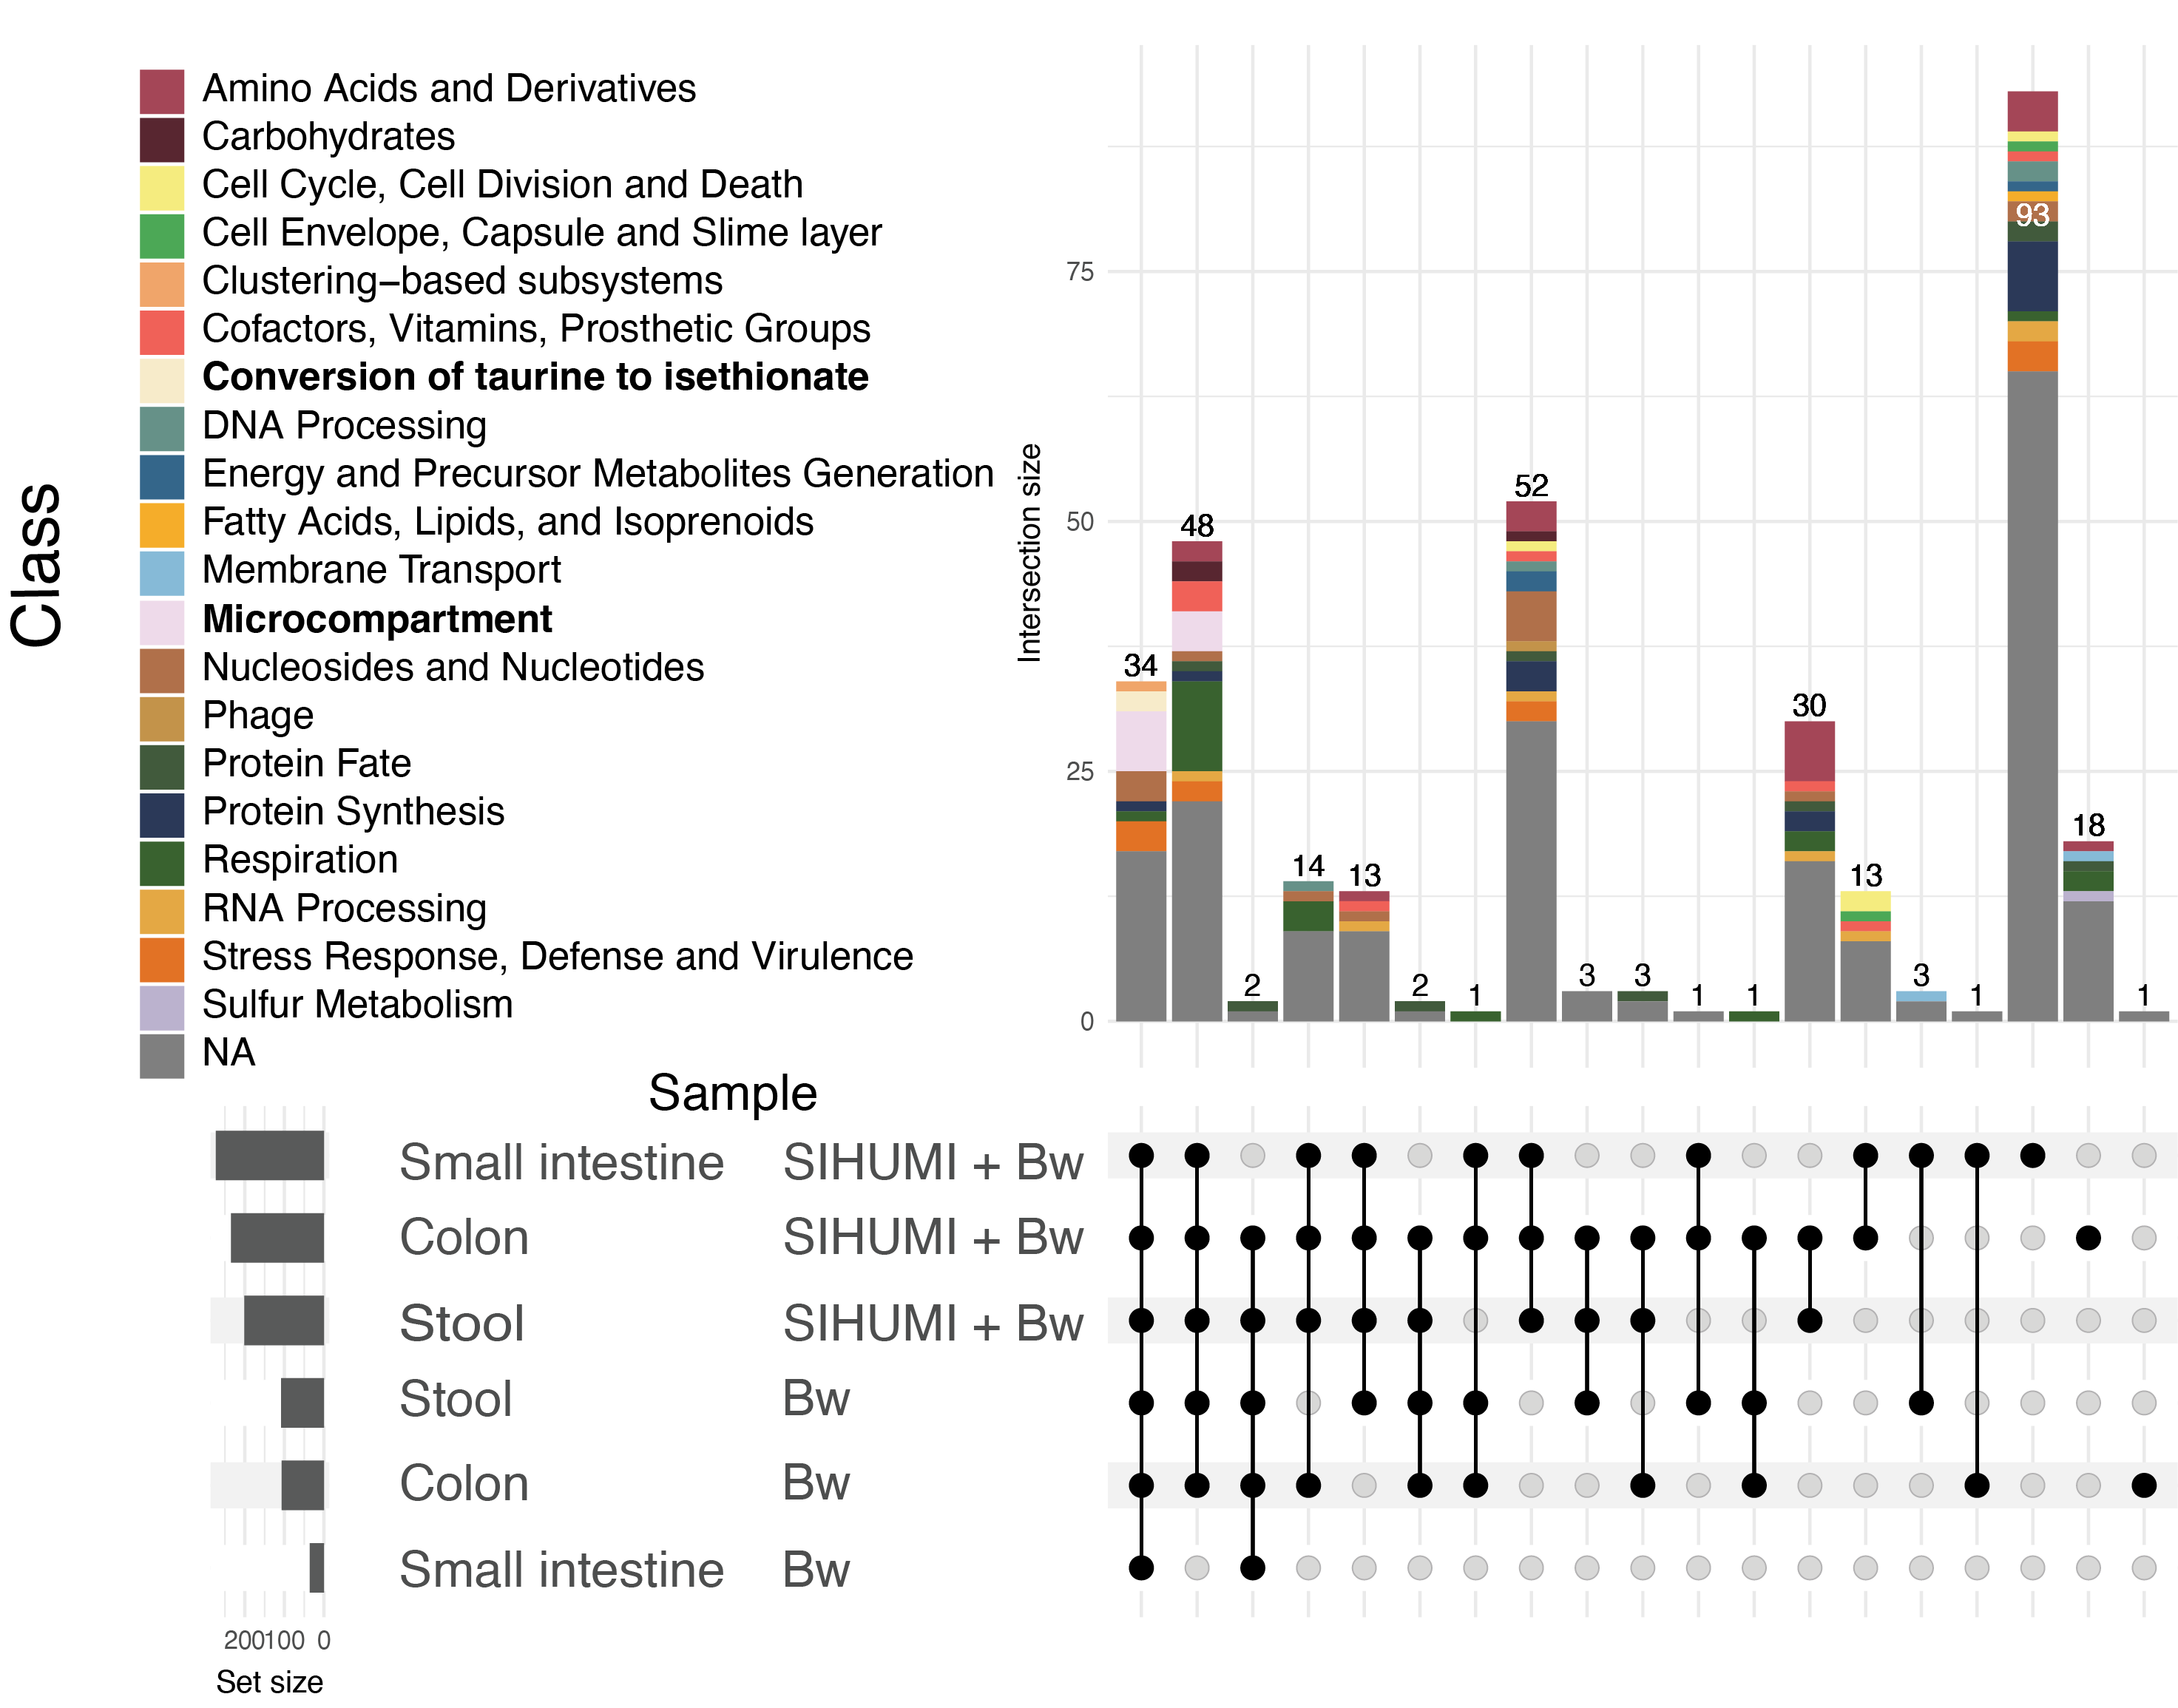
Supplementary Figure 1. Upset plot showing the classification of genes essential among tissues with the gavage of B. wadsworthia or SIHUMI+Bw
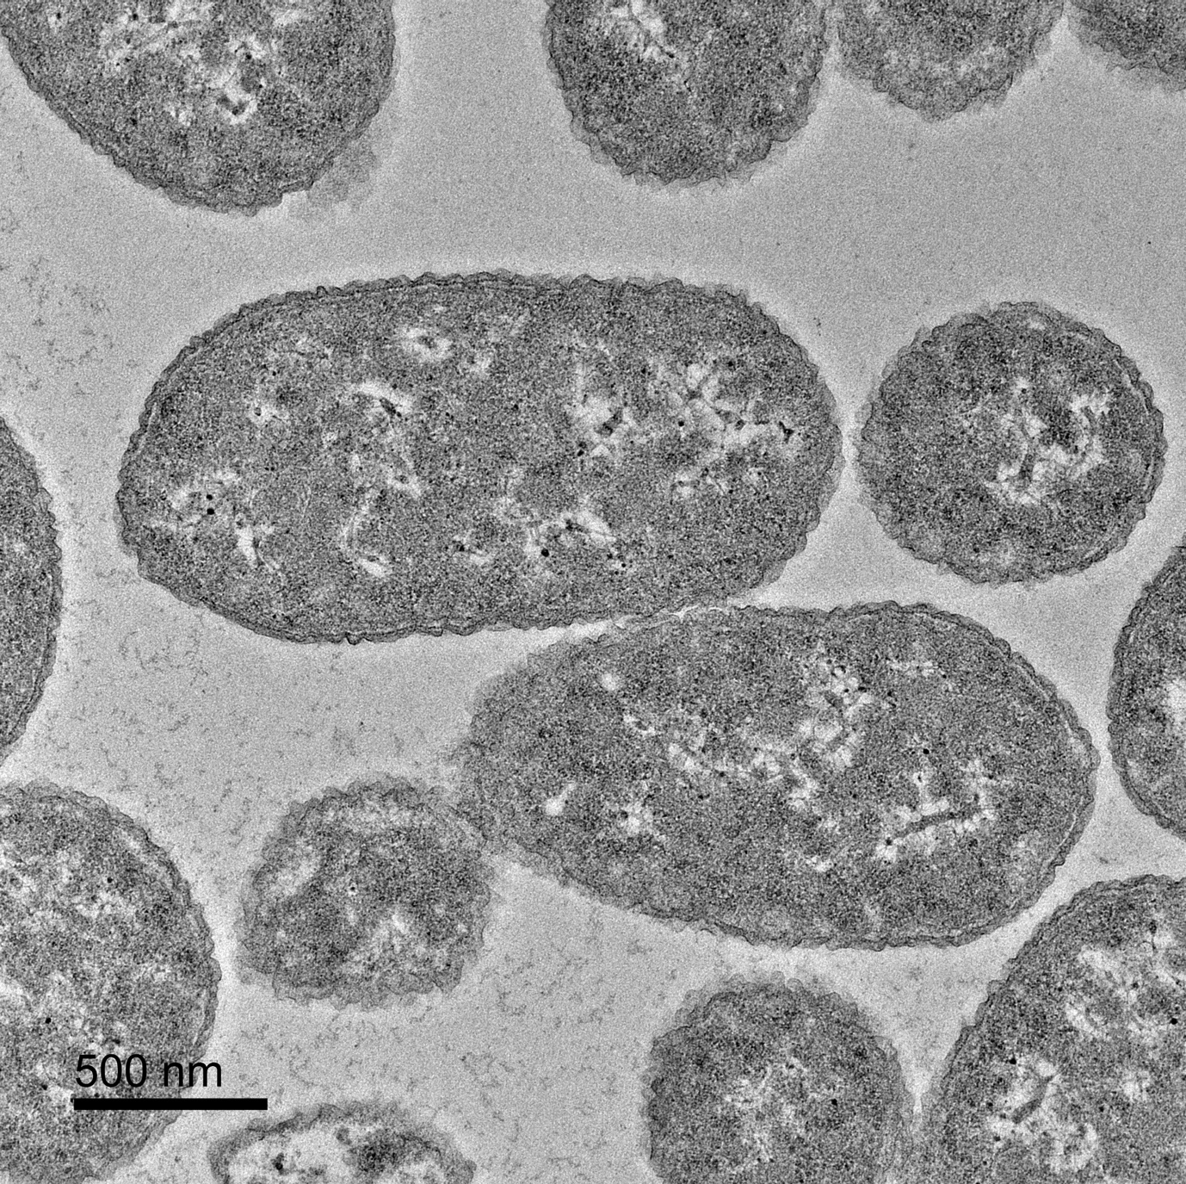
Supplementary Figure 2. B. wadsworthia grown in ABB media supplemented with taurine

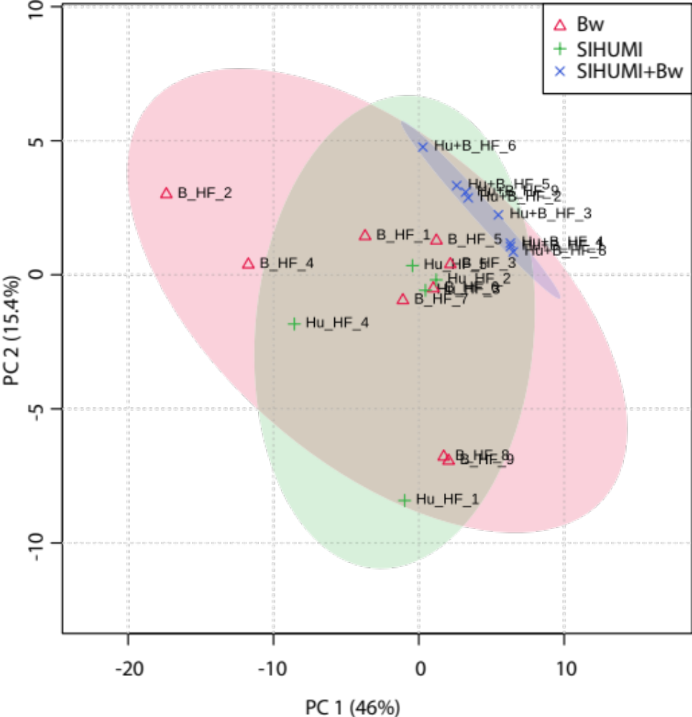
Supplementary Figure 3. Score plot of metabolites present in faecal water samples. The plot was generated using Metaboanalyst v.5.0.
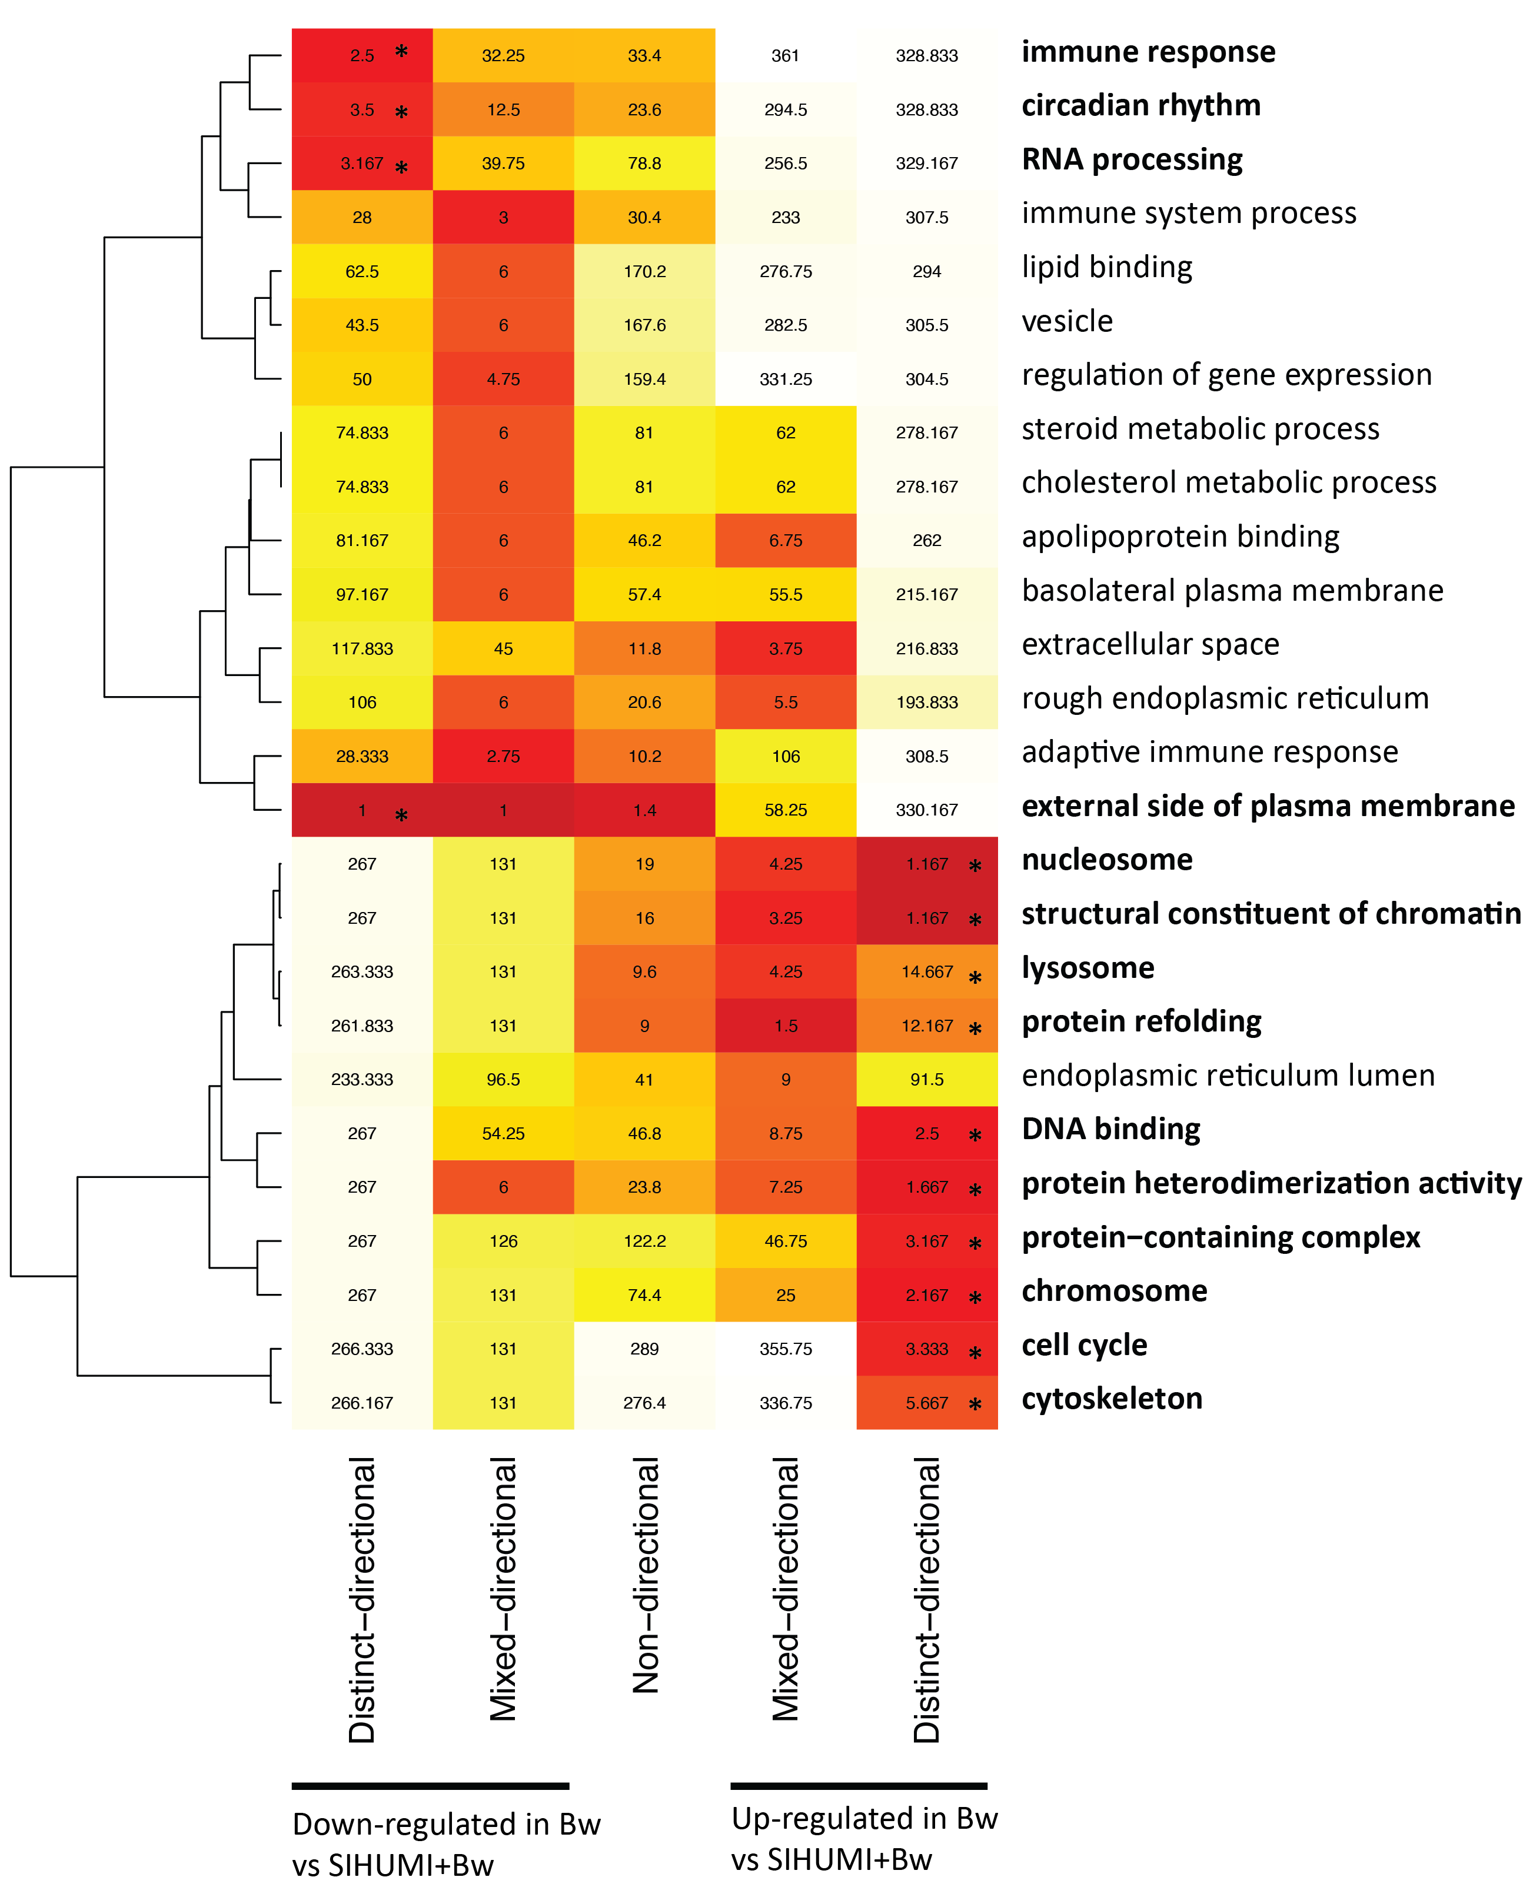
Supplementary Figure 4. Heatmap of consensus score ranks for gene class sets of the mouse host. * (p-value <0.01)

