Supplemental Table 1. Chinese Medicine Constitutional Questionnaire
Please try to recall as much as possible regarding whether you experienced the following signs or symptoms in the last one month? For each question, please select (V) the box that best indicates the intensity or frequency of each sign or symptom. The last 1 month in this section refers to the last 30 days from today.

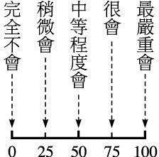
In severe cases
Frequently
Rarely
Never
In moderate cases
1. Although I do not have a cold, my throat was filled with phlegm. - □ □ □ □ □
2. I felt that my palms, feet, or body were hot. --------------------------- □ □ □ □ □
3. I felt afraid of the cold, felt cold hands and feet, or wore more clothing. □ □ □ □ □
4. I experienced heavy-headedness, dizziness, and other discomfort. □ □ □ □ □

5. I felt fatigued or weak. ------------------------------------------------
6. I felt that my mouth was sticky or my saliva was viscous. -------
□ □ □ □ □
□ □ □ □ □

7. I felt that my body or lower half of my body was heavy. -----------□ □ □ □ □
8. I experienced amaurosis fugax when I suddenly stood up. --------- □ □ □ □ □
9. I felt fatigued and unwilling to speak or lacked the strength to talk. □ □ □ □ □
10. I experienced tears on my tongue or mouth. --------------------------□ □ □ □ □
11. I felt that my eyes were dry or could not see clearly. ---------------□ □ □ □ □
12. My chest, abdomen, or limbs experienced oppressive pain and discomfort. □ □ □ □ □
13. My chest, abdomen, or limbs experienced stinging pain and discomfort. □ □ □ □ □
14. I felt that the duration of my sleep was sufficient, but still wanted more sleep more or felt that I did not have sufficient sleep. -------------------------------------------------- □ □ □ □ □
15. I felt short of breath and required deep breathing. ----------------- □ □ □ □ □
16. My body or hands and feet felt numb. ------------------------------- □ □ □ □ □
17. I felt chest tightness, like something was pressing on it. ---------- □ □ □ □ □
18. I experienced tinnitus. -------------------------------------------------- □ □ □ □ □
19. My skin developed blood stasis or bruises for no reason. --------- □ □ □ □ □
20. My skin became dry, cracked, thickened, or hardened. ----------- □ □ □ □ □

In severe cases
Never
Frequently
Rarely
In moderate cases
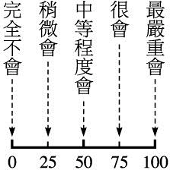

- I could see distorted blood vessels in my body or limbs (varicose veins). □ □ □ □ □
- I experienced aches, pains, weakness, or chills in my waist, kneecaps, or feet. □ □ □ □ □
23. I experienced cramps without vigorous exercise. ---------------------------------□ □ □ □ □
24. I felt that my breathing was shallow or gasping. ----------------------------------□ □ □ □ □

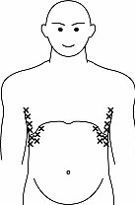
25. The ribs on the side of the body or bilateral epigastric region --
(X in the image) experienced tightness, distention, or pain.
□ □ □ □ □

26. I felt thirsty, had a dry mouth, or dry and cracked lips, and felt thirsty very soon after drinking water.---------------------------------------------------------------------------------------------- □ □ □ □ □
27. There was edema in my limbs, body, face, or around the eyes. -------------- □ □ □ □ □
28. I experienced shortness of breath when lying supine. ------------------------- □ □ □ □ □
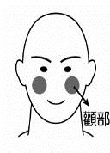
29. My face turned red. (See image for site) ---------------------------- □ □ □ □ □

Regio zygomatica
30. I felt that my throat was dry, but not my mouth or lips. ---------------------- □ □ □ □ □
31. I experienced vertigo when my posture changed. ----------------------------- □ □ □ □ □
32. I experienced hearing loss. ------------------------------------------------------- □ □ □ □ □
33. I became sick if exposed to the wind. ------------------------------------------- □ □ □ □ □
34. My tongue coating was thick or sticky. ----------------------------------------- □ □ □ □ □
35. I experienced sudden hot flashes in my body or head. ------------------------ □ □ □ □ □
36. I liked drinking warm beverages. ------------------------------------------------ □ □ □ □ □
37. My waist was easily sprained without vigorous exercise. -------------------- □ □ □ □ □

Always
Never
Seldom
About half the time
Usually
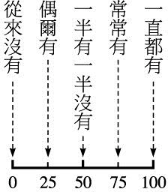

38. The color of my urine was dark yellow or tea-colored, except for the first urination in the morning. ------------------------------------------------------------------------------------ □ □ □ □ □
39. My urine volume was low. -------------------------------------------- □ □ □ □ □
40. My stools were dry and hard. ------------------------------------------□ □ □ □ □
41. My stools did not have a definite shape (diarrhea). -----------------□ □ □ □ □
42. I felt that I had no taste in my mouth. -------------------------------- □ □ □ □ □
42. My urine volume was large even if I did not drink a lot of water. -□ □ □ □ □
44. I woke up before dawn because of diarrhea. -------------------------□ □ □ □ □

