Table S1 26 up-regulated genes genes (DEGs) in the GC tissues compared to normal gastric tissues were detected from three profile datasets
DEGs | Up-regulated genes
GSE19826 GSE54129 GSE79973 | ADAMTS2 ASPN BGN CEMIP COL1A1 COL1A2 COL6A3 COL8A1 COL10A1 COL11A1 CST1 CTHRC1 FAP FNDC1 INHBA MFAP2 PDLIM7 RARRES1 SFRP4 SPP1 SULF1 THBS2 THY1 TIMP1 WISP

Table S2 Pathway enrichment analysis of CCN family genes (Metascape)
GO | Category | Description | Count | % | Log10  (P) | Log10  (q)
M3008 | Canonical pathways | NABA ECM GLYCOPROTEINS | 6 | 100 | -12.58 | -8.26

Table S3 Protein expression patterns of CCN family members in GC via the HPA database
Gene | Antibody | High | Medium | Low | Not-detected | Total
Cyr61 (CCN1) | HPA029853 | 3 | 3 | 5 | 0 | 11
CTGF (CCN2) | CAB005123 | 0 | 0 | 2 | 10 | 12
Nov (CCN3) | HPA019684 | 0 | 1 | 0 | 0 | 10
WISP1 (CCN4) | CAB012205 | 7 | 5 | 0 | 0 | 12
WISP2 (CCN5)  WISP3 (CCN6) | CAB019273  — | 0 | 0 | 0 | 12 | 12

Table S4 The specific Affymetrix ID of CCNs in the Kaplan–Meier plotter database
Gene | Affymetrix ID
Cyr61 (CCN1) | 201289_at
CTGF (CCN2) | 209101_at
Nov (CCN3) | 214321_at
WISP1 (CCN4) | 229802_at
WISP2 (CCN5)  WISP3 (CCN6) | 205792_at  210861_s_at

Fig. S1 and 2
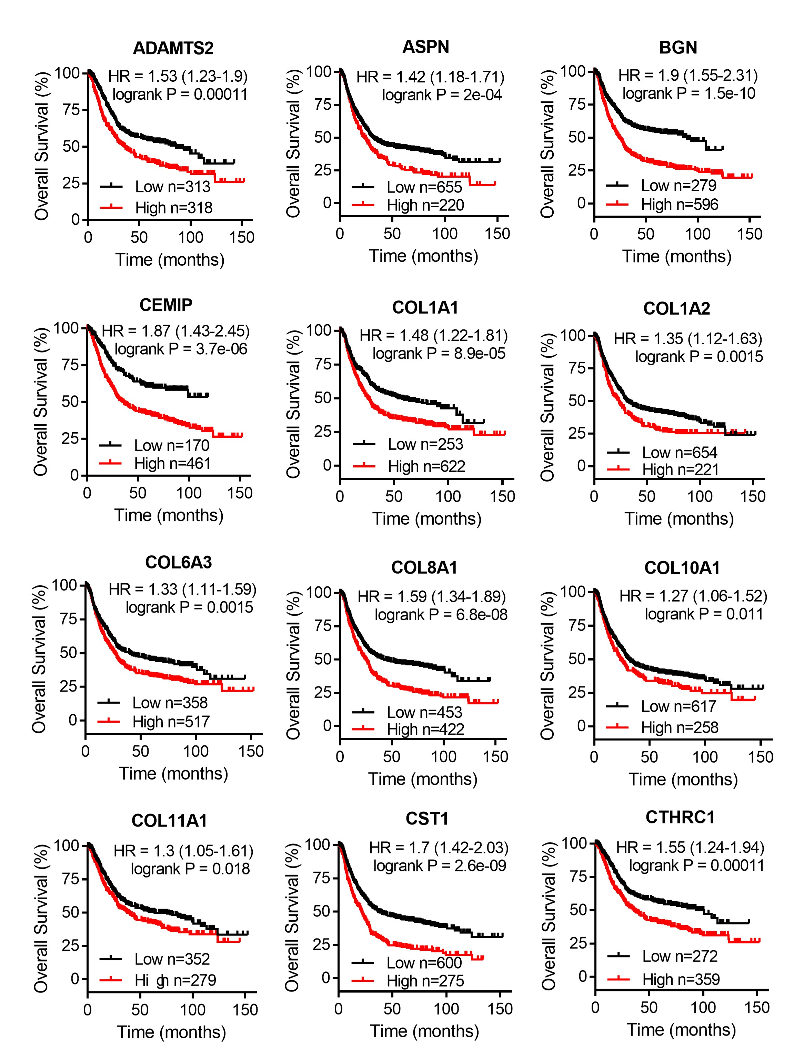

Fig. S3

Fig. S4

Fig. S1 and 2 Survival analysis of 26 commonly up-regulated genes in patients with GC.
Fig. S3 First progression survival analysis of CCN family genes in patients with GC. First progression survival curves of CYR61 (A), CTGF (B), NOV (C), WISP1 (D), WISP2 (E), and WISP3 (F) analyzed via the Kaplan–Meier plotter database.
Fig. S4 Survival analysis of CCN family genes in patients with intestinal GC. Overall survival curves of CYR61 (A), CTGF (B), NOV (C), WISP1 (D), WISP2 (E), and WISP3 (F) analyzed via the Kaplan–Meier plotter database.

