SUPPLEMENTARY MATERIAL

Supplementary Fig. 1: Maximum pit depths for P. profundus driven corrosion
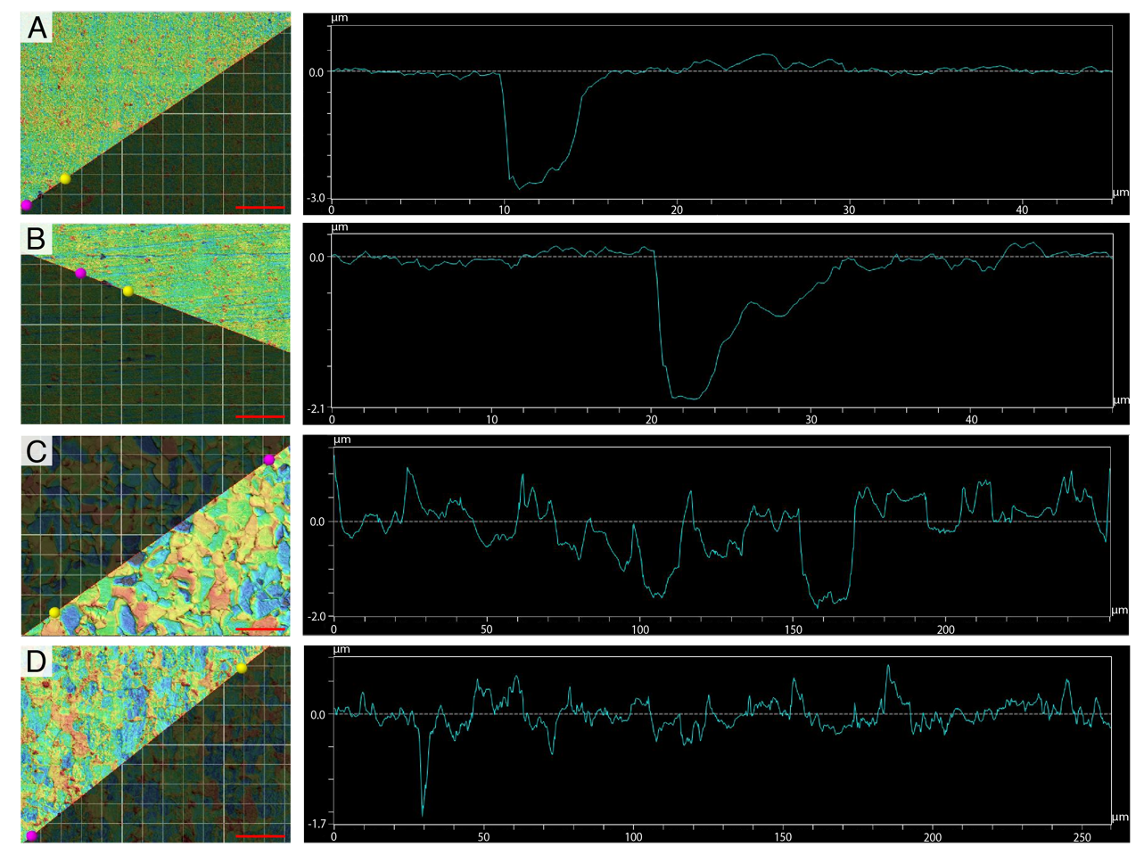
Maximum pit depths on the surface of coupons incubated with P. profundus was obtained through CLSM analysis. A, B In static conditions, at 0.1 and 30 MPa respectively, the surface of the coupons is characterised by the presence of pitting corrosion, with wider pits under HHP. C, D Under flow conditions the topography is consistent with generalised corrosion, with deeper features at atmospheric pressure.

Supplementary Fig. 2: Visualisation of the biofilm matrix
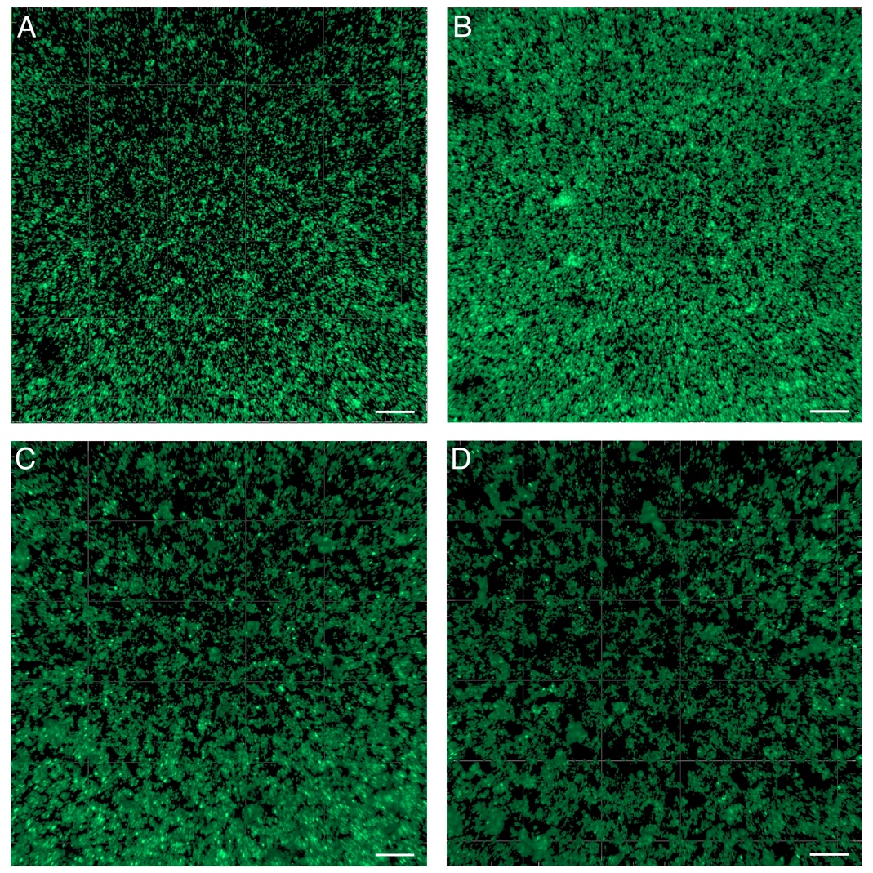
P. profundus biofilm matrix was characterised after staining with Syto9 under CLSM. In static conditions (A, B) the amount of EPS/corrosion product mix appears to be lower than in flow conditions (C, D) regardless of the pressure. Scale bar = 50 μm.

Supplementary Fig. 3: Photo of the high-pressure bioelectrochemostat.
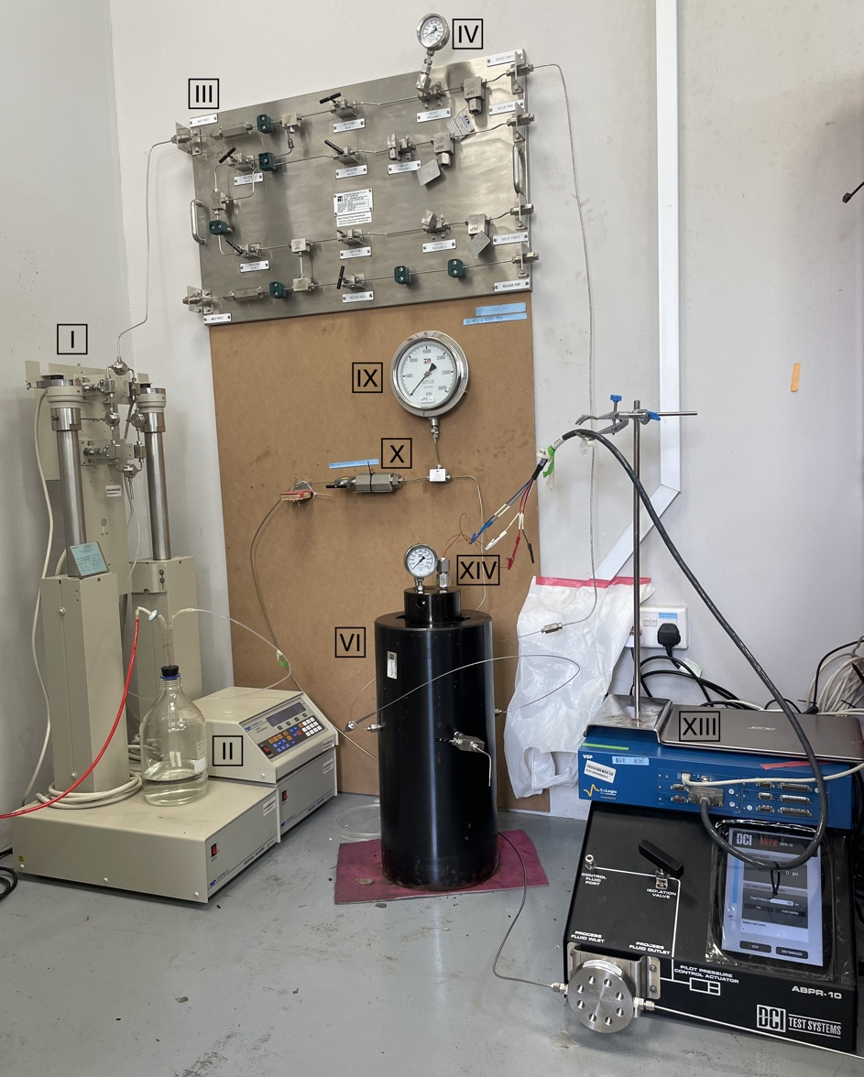
Visible are the dual pump continuous-flow system (I), anaerobic medium reservoir (II), control panel (III), pre-reactor pressure gauge (IV), pressure vessel (VI), post-reactor pressure gauge (IX), flow check valve (X), ABPR (XI), high-pressure connector (XIV) and potentiostat (XIII).

Supplementary Fig. 4: Schematics of the corrosion model of the coupon.
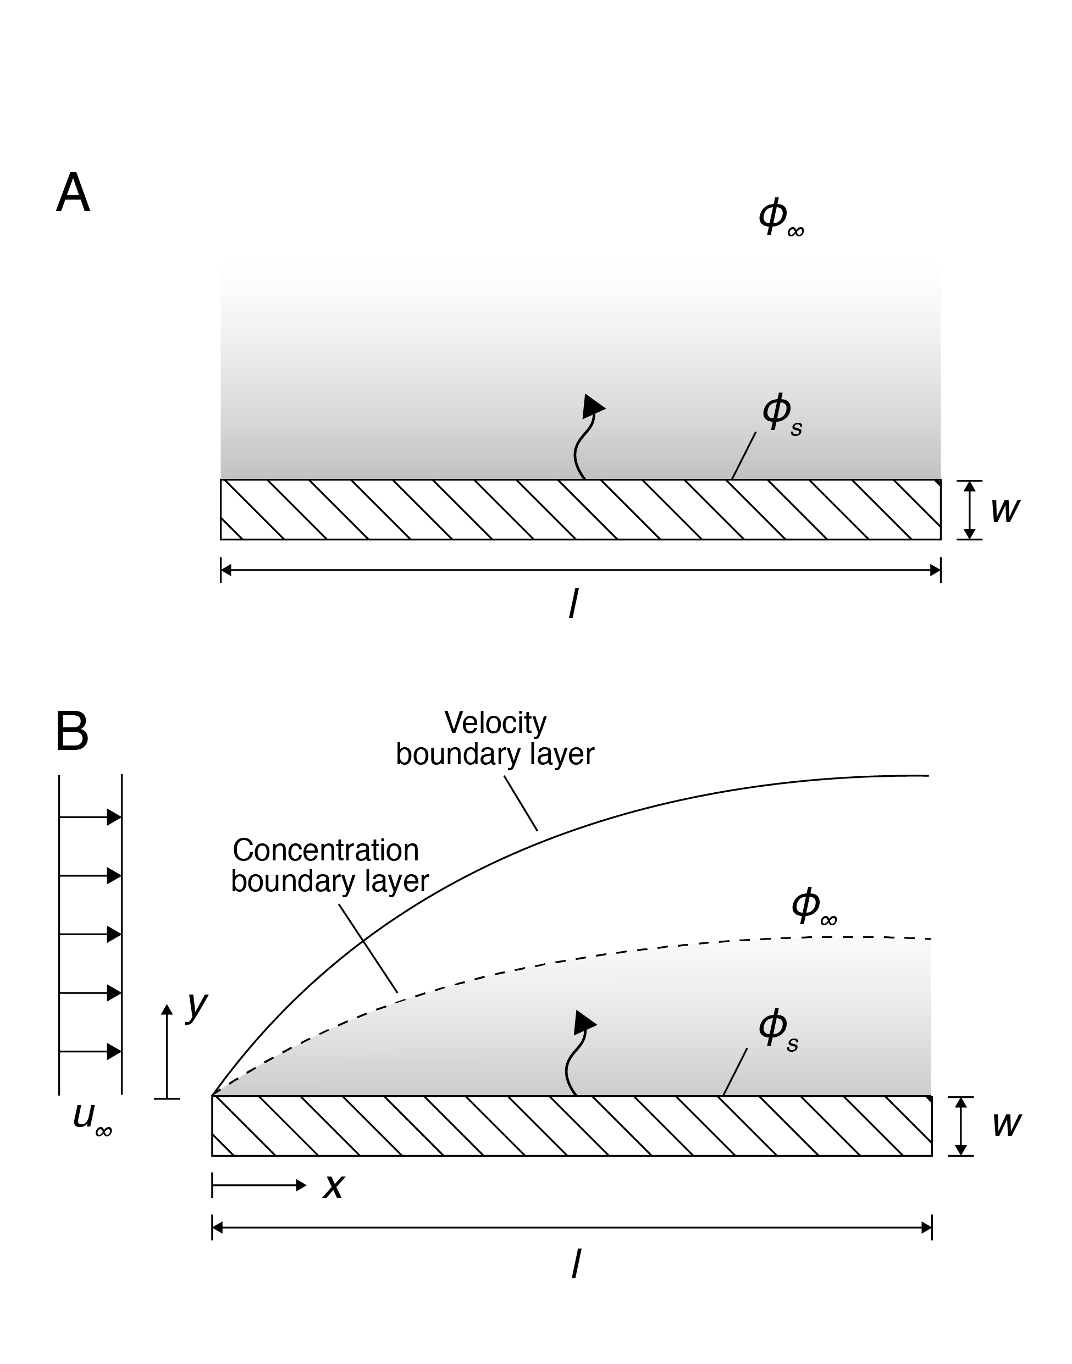
A Without the background flow, the substance diffuses from the plate surface of species concentration, 𝜑_{s}, to the bulk fluid of species concentration, 𝜑∞. B In the continuous flow condition with the averaged flow velocity of u∞, the mass transfer rate of the corrosion products released from the coupon’s surface to the bulk fluid is speed up by convection. In the experimental setup, the concentration boundary layer of the corrosion products is well contained in the velocity boundary layer of the flow.

Supplementary Table 1: Chemical composition (in wt%) of AH36 steel.
Chemical composition (in wt%) of the metal used for the experiments, as stated in inspection certificate provided by supplier (Nippon Steel Corp., Japan).

Supplementary Table 2: Summary of all conditions tested in the study.
The effect of the flow in P. profundus cultures and sterile medium was analysed at atmospheric pressure (0.1 MPa) and HHP (30 MPa).

