Synthesis of corn straw based carbon doped Nb₂O₅ as photocatalysts for Rhodamine B degradation under visible light illumination

Experimental section
Chemicals and materials
Corn straw was purchased from Huifeng Straw Processing Factory Shop; Anhydrous ethanol(analytical grade) was produced by Beijing Chemical Company; NbCl5(99.9%) was purchased from Alfa Elsa (Tianjin) Chemical Co., Ltd; Rhodamine B and P25 were purchased from China National Pharmaceutical Group Chemical Reagent Co., Ltd; Ultra pure water used in the experience was purified by a Milliper system.

Preparation of samples
Wash the corn straw powder repeatedly with deionized water, filter it, dry the precipitate, and cool it to room temperature to obtain corn straw powder. Weigh a certain amount of corn straw powder, add it to anhydrous ethanol, stir for 30 minutes, transfer it to a hydrothermal reactor at 200 ℃ for 24 hours. After the reaction is complete, filter and purify the supernatant in the hydrothermal reactor through a needle filter. Collect the clarified filtrate after filtration and purification to obtain liquid corn stover based carbon material, which is sealed and stored in a centrifuge tube. Refrigerate it at low temperature of 4 ℃. Add 0, 0.1, 0.2, 0.3mL of liquid corn stover based carbon material to 30 mL of anhydrous ethanol and stir evenly. Add 0.002 mol of NbCl₅ and stir evenly. Then add 1mL of deionized water and continue stirring evenly. Then transfer it to a hydrothermal reactor and react at 200 ℃ for 24 hours. After the reaction is completed, the obtained reaction solution is centrifuged and separated, and the precipitate is washed separately with deionized water and anhydrous ethanol. The obtained precipitate is dried and then ground into powder, with a drying temperature of 60℃ and a time of 12 hours. The obtained powdered product is calcined under nitrogen protection at 300℃ for 2 hours with a heating rate of 5℃/min. After calcination, it is naturally cooled to room temperature to obtain a corn straw based carbon doped nano semiconductor composite material. The synthesized samples are named as C/Nb₂O₅-0, C/Nb₂O₅-1, C/Nb₂O₅-2 and C/Nb₂O₅-3.

Photodegradation experiment
The light source for photodegradation testing is the PLS-SXE300C xenon lamp light source provided by Beijing Bofeilai Technology Co., Ltd. Under normal circumstances, the steps of visible light photodegradation testing are as follows: 0.05 g of catalyst is added to 100 ml of 10 mg/L Rhodamine B solution, sonicated for 10 minutes to disperse the catalyst in the Rhodamine B solution, then stirred under dark conditions for 40 minutes, and then the lamp source is turned on to begin the photodegradation process under illumination. Take the mixed liquid every 10 minutes and place it in a centrifuge tube. After the photodegradation process is completed, the catalyst is separated and its concentration changes are measured using a Hitachi U-3900 liquid ultraviolet spectrophotometer

Characterizations
The X-ray powder diffraction(XRD) was conducted on the Rigaku D/Max 2550 X-ray diffractometer with Cu α Radiation（ λ= 1.540598) at operating voltage of 40kV with a scan rate of 10°/min. Scanning electron microscopy(SEM)was performed on the ZEISS Gemini 300 scanning electron microscope. The energy spectrometer model is OXFORD XPLORE30, and the gold spray target material is gold palladium alloy. The nitrogen adsorption was conducted on the Micro Meritics Tristar II 3020 specific surface and pore size analyzer. The adsorption analysis was conducted under liquid nitrogen conditions (77 K), with a purity of 99.999% using nitrogen gas. The specific surface area was analyzed by the multi-point BET method, and the pore distribution was analyzed by the DFT method. The X-ray photoelectron spectroscopy(XPS)was studied using the apparatus of Thermo Fisher Scientific ESCALAB Xi+ . Ultraviolet-visible (UV-Vis) adsorption spectra were measured using a Hitachi UV spectrophotometer U-3900.
In the paper, the Hitachi UV spectrophotometer was used to test the concentration of target degradation products during the photodegradation process. The degradation rate of the catalyst can be calculated by calculation.
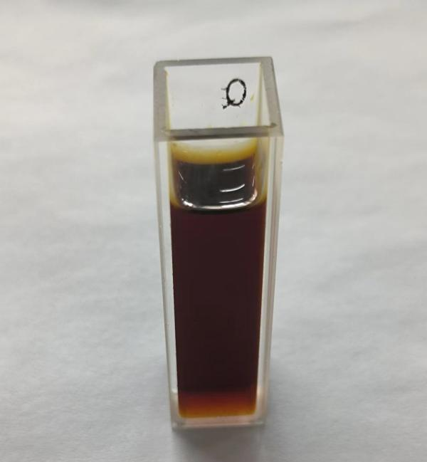
Fig S1. Corn straw based liquid carbon material
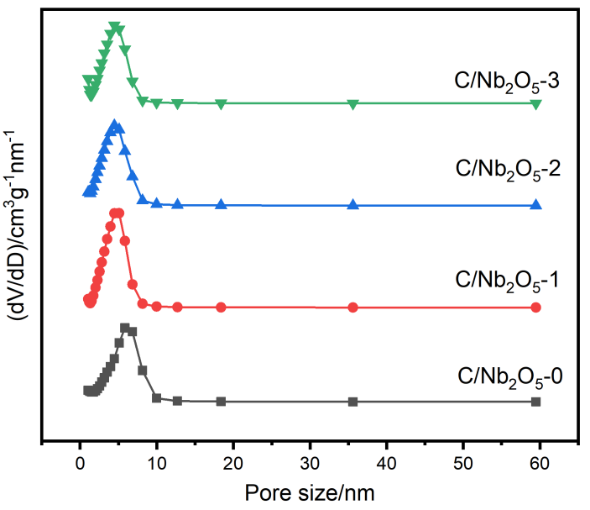
Fig S2.Pore size distribution curve of C/Nb₂O₅-0, C/Nb₂O₅-1,C/Nb₂O₅-2, C/Nb₂O₅-3.
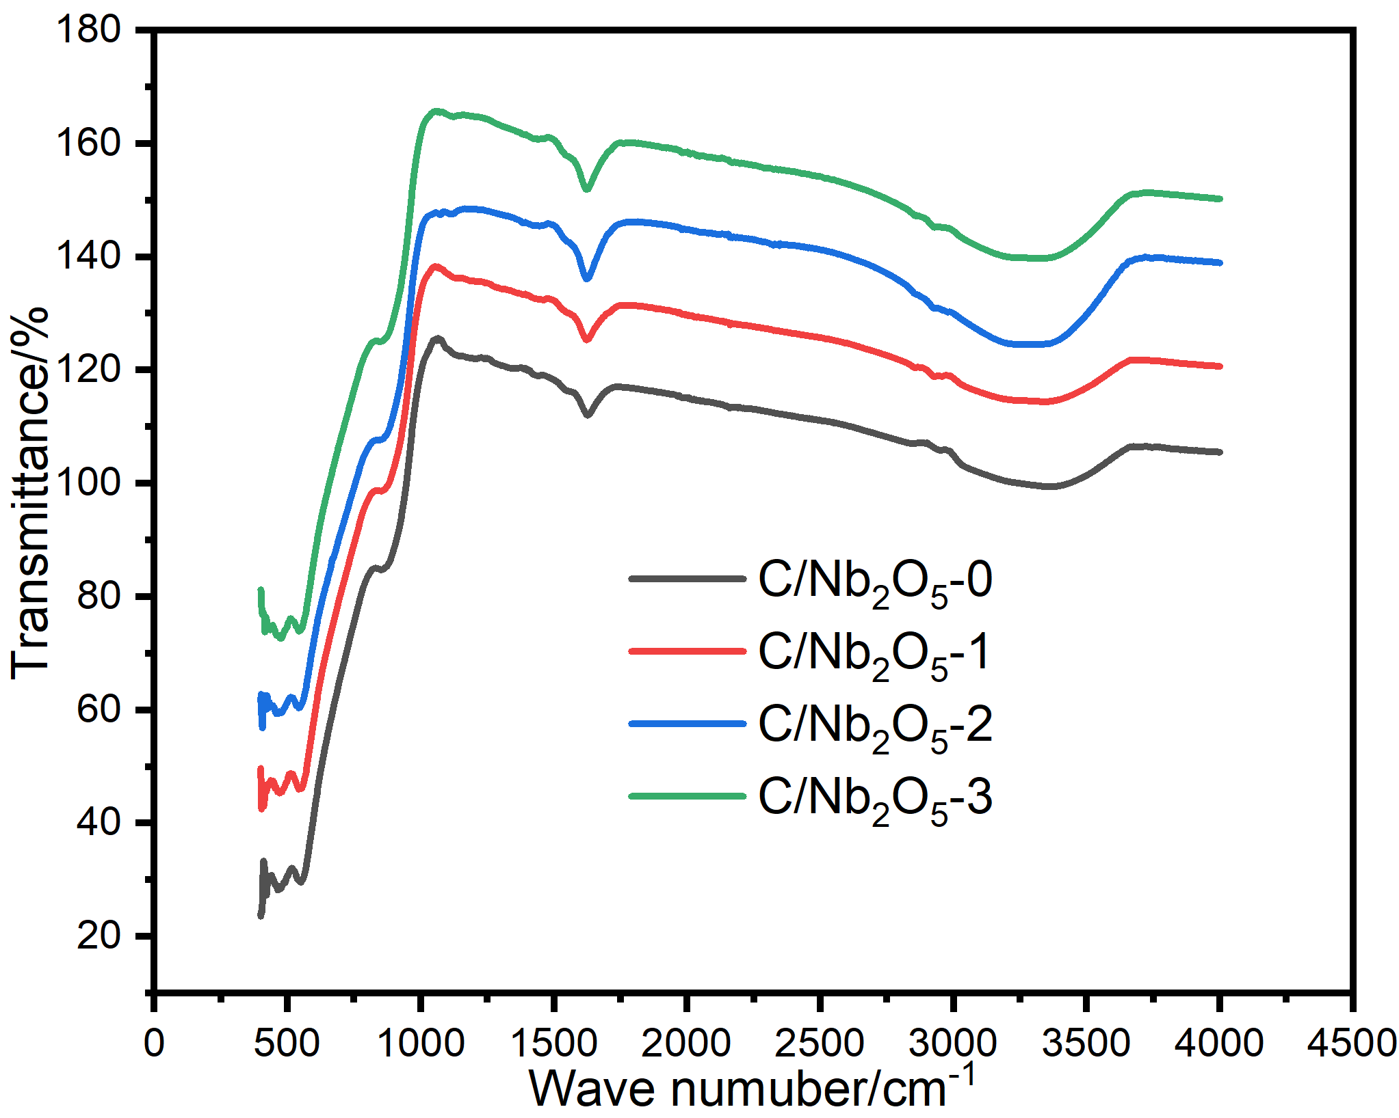
Fig S3. FTIR spectra of C/Nb₂O₅-0, C/Nb₂O₅-1,C/Nb₂O₅-2, C/Nb₂O₅-3

Table S1
Item  Sample Name | S_{BET}  m²/g | Pore size  nm
C/Nb₂O₅-0 | 281 | 5.84
C/Nb₂O₅-1 | 333 | 5.08
C/Nb₂O₅-2 | 336 | 4.46
C/Nb₂O₅-3 | 292 | 4.46

