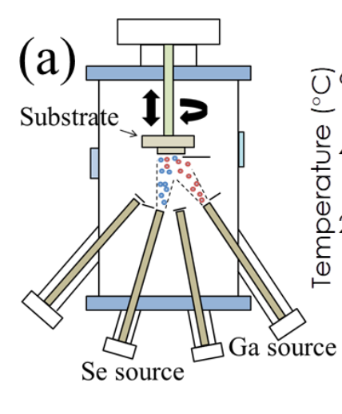
Se source
Te source
Substrate
Ga source
In source
Figure S1. Schematic representation of the MBE system
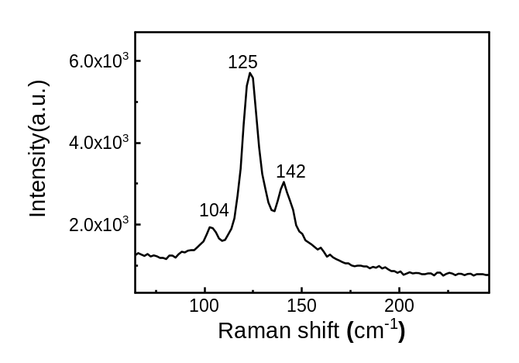
A molecular beam epitaxy (MBE) system for the growth of group III-VI chalcogenides was used to grow In₂Te₃.

Figure S2. Raman spectrum of In₂Te₃ grown on h-BN
Raman spectroscopy confirmed the formation of In₂Te₃, as evidenced by the significant three peaks. Peaks associated with In₂Te₃ were observed.

