Supplementary Data

Table S1: Surface area of 14 out of 20 reefs and calculated area and percent loss (red) and gain (green) over 1000m² changes for 1950, 1991, and 2022.
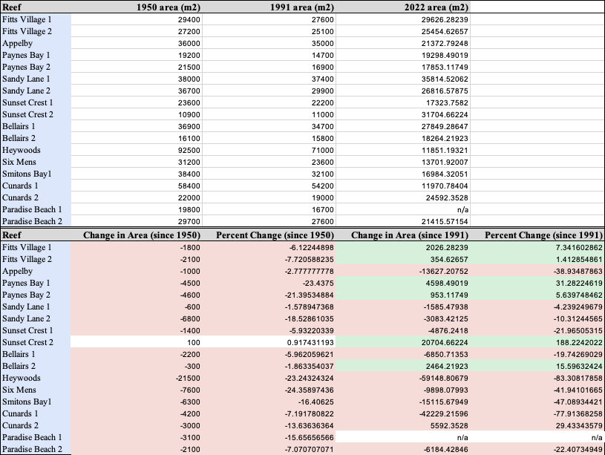
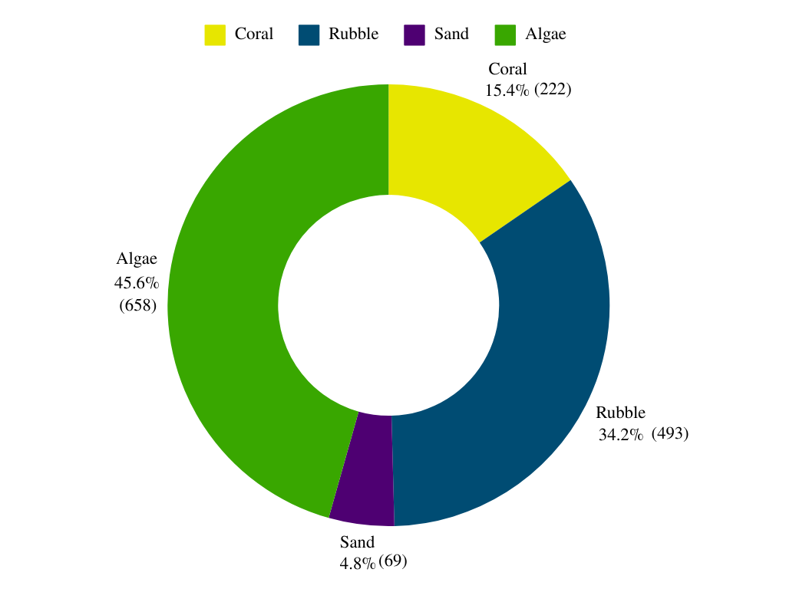
Figure S1: Percent Distribution of Present Substrate in the 5 highly degraded sites

