Table 4: Risk of Bias in RCTs
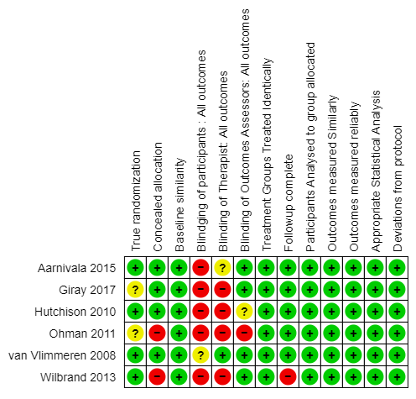

Table 5: Risk of Bias in Cohort Studies
Lead Author  Year | Were the two groups similar and recruited from the same population? | Were the exposures measured similarly to assign people to both exposed and unexposed groups? | Was the exposure measured in a valid and reliable way? | Were confounding factors identified? | Were strategies to deal with confounding factors stated? | Were the groups/ participants free of the outcome at the start of the study | Were the outcomes measured in a valid and reliable way? | Was the follow up time reported and sufficient to be long enough for outcomes to occur? | Was follow up complete? | Were strategies to address incomplete follow up utilized? | Was appropriate statistical analysis used?
Van Vlimmeren 2007 | NA | NA | + | + | + | - | + | + | + | + | +
Leung 2018 | NA | NA | + | + | + | + | + | + | + | + | +
Cheng 2000 | NA | + | + | + | + | + | + | + | + | + | +
Celayir 2000 | NA | NA | ? | + | - | + | ? | + | + | - | ?
Aarnivala 2016 | NA | + | + | + | ? | - | + | + | - | ? | +
N/A - Not Applicable.

Table 6: Risk of Bias of non-randomised controlled trials
Lead Author Year | Is it clear in the study what is the ‘cause’ and what is the ‘effect’? | Were the participants included in any comparisons similar? | Were the participants included in any comparisons receiving similar treatment/care, other than the exposure or intervention of interest? | Was there a control group? | Were there multiple measurements of the outcome both pre and post the intervention/ exposure? | Was follow up complete and if not, were differences between groups in terms of their follow up adequately described and analyzed? | Were the outcomes of participants included in any comparisons measured in the same way? | Were outcomes measured in a reliable way? | Was appropriate statistical analysis used?
Lennartsson 2019 | + | - | + | + | + | + | + | + | +
LeeJ-Y \2013 | + | + | - | - | + | + | + | + | +
Lennartsson 2011 | + | - | + | + | + | + | + | - | +
Cavalier 2011 | + | + | + | + | + | + | + | + | +

