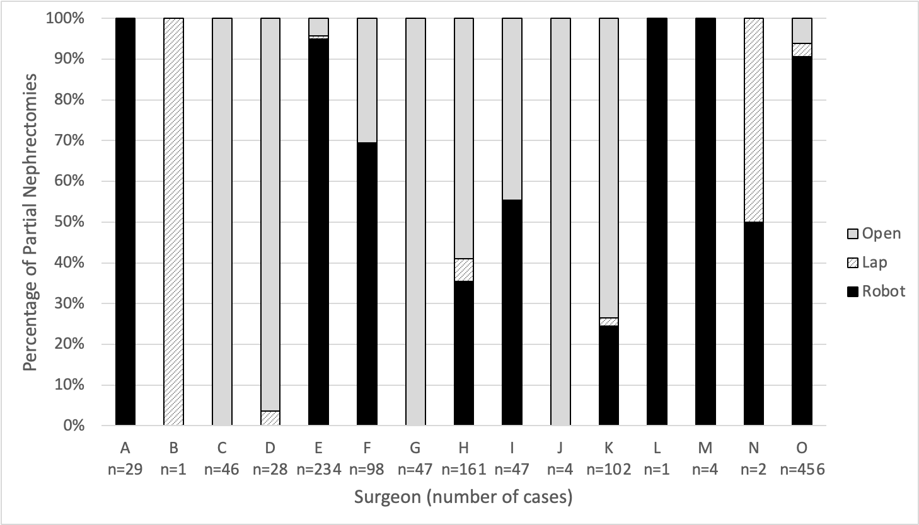
Supplemental Figure 1. Proportion of open, laparoscopic, and robotic partial nephrectomies by surgeon. There were 15 surgeons who performed partial nephrectomies during the study period. Most surgeons focused on either robotic or open partial nephrectomies; few regularly performed both techniques.

