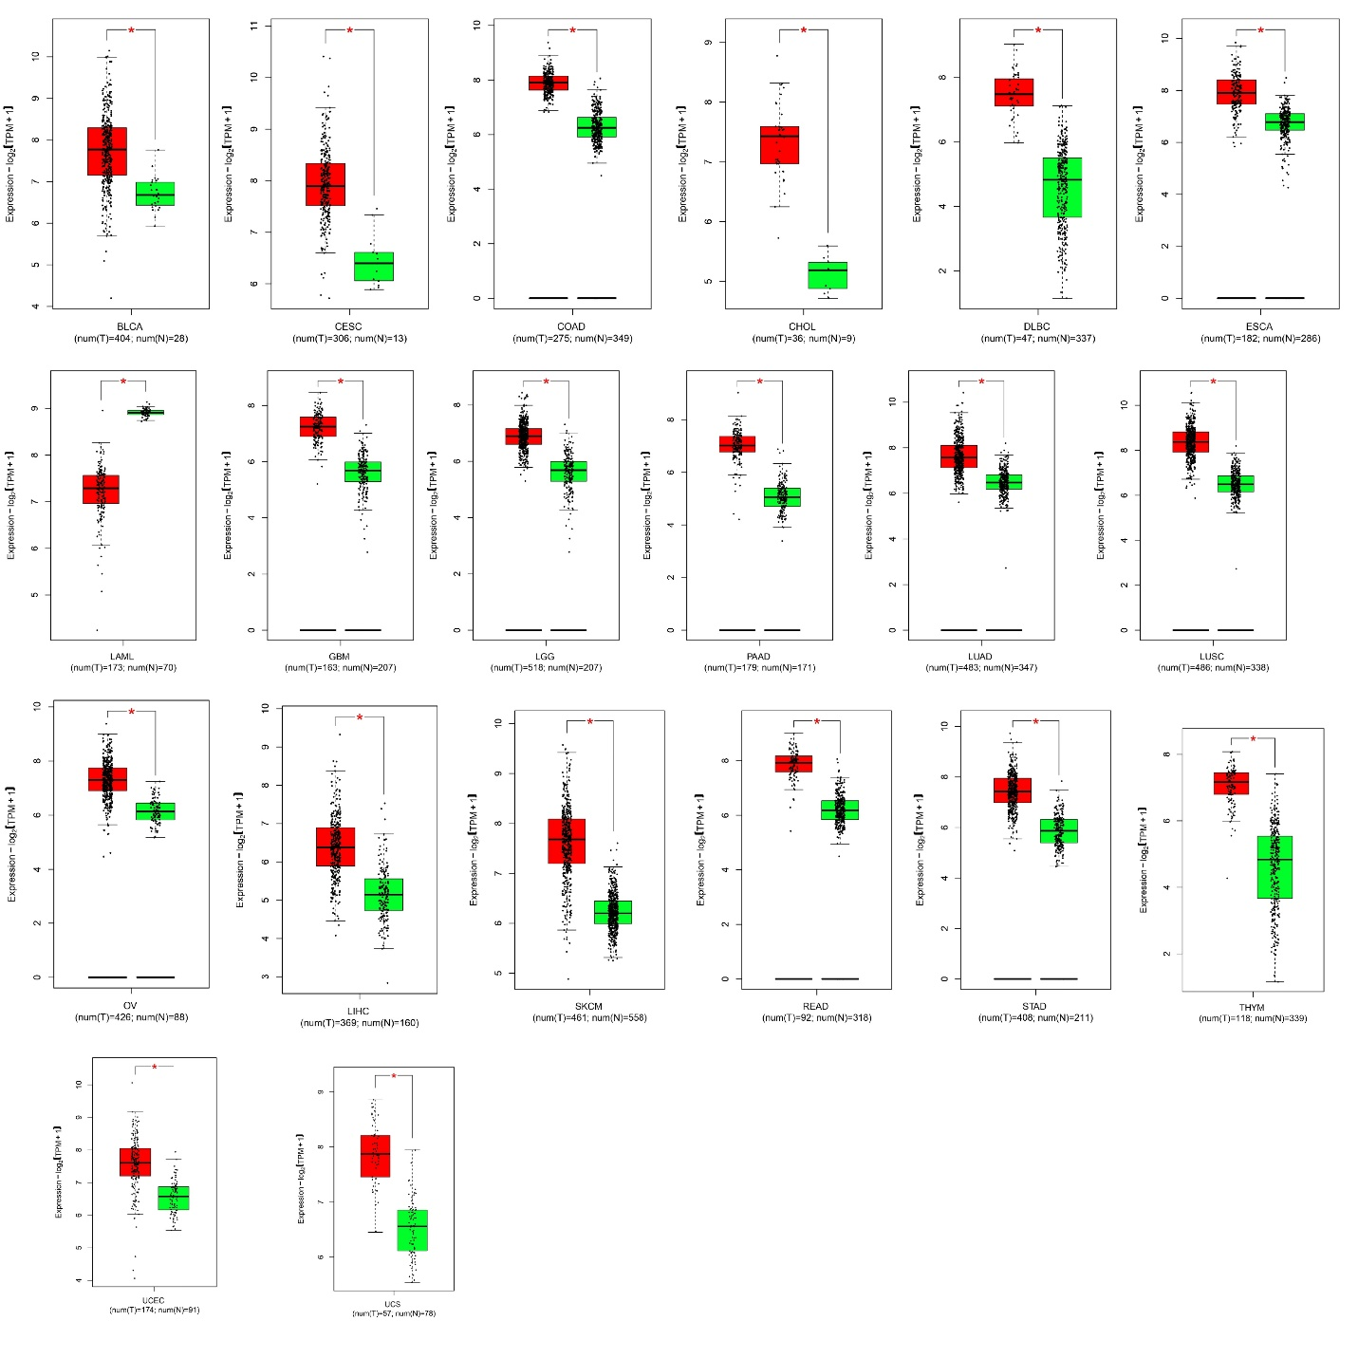
Supplementary Figure 1: Differential expression analysis conducted using GEPIA2 (http://gepia2.cancer-pku.cn/). Red box plots indicate tumors, and green indicates corresponding normal tissues. Significant overexpression of CCT5 in BLCA, CESC, COAD, CHOL, DLBC, ESCA, GBM, LGG, PAAD, LUAD, LUSC, OV, LIHC, SKCM, READ, STAD, THYM, UCEC, and UCS. Significant underexpression was observed only in LAML.

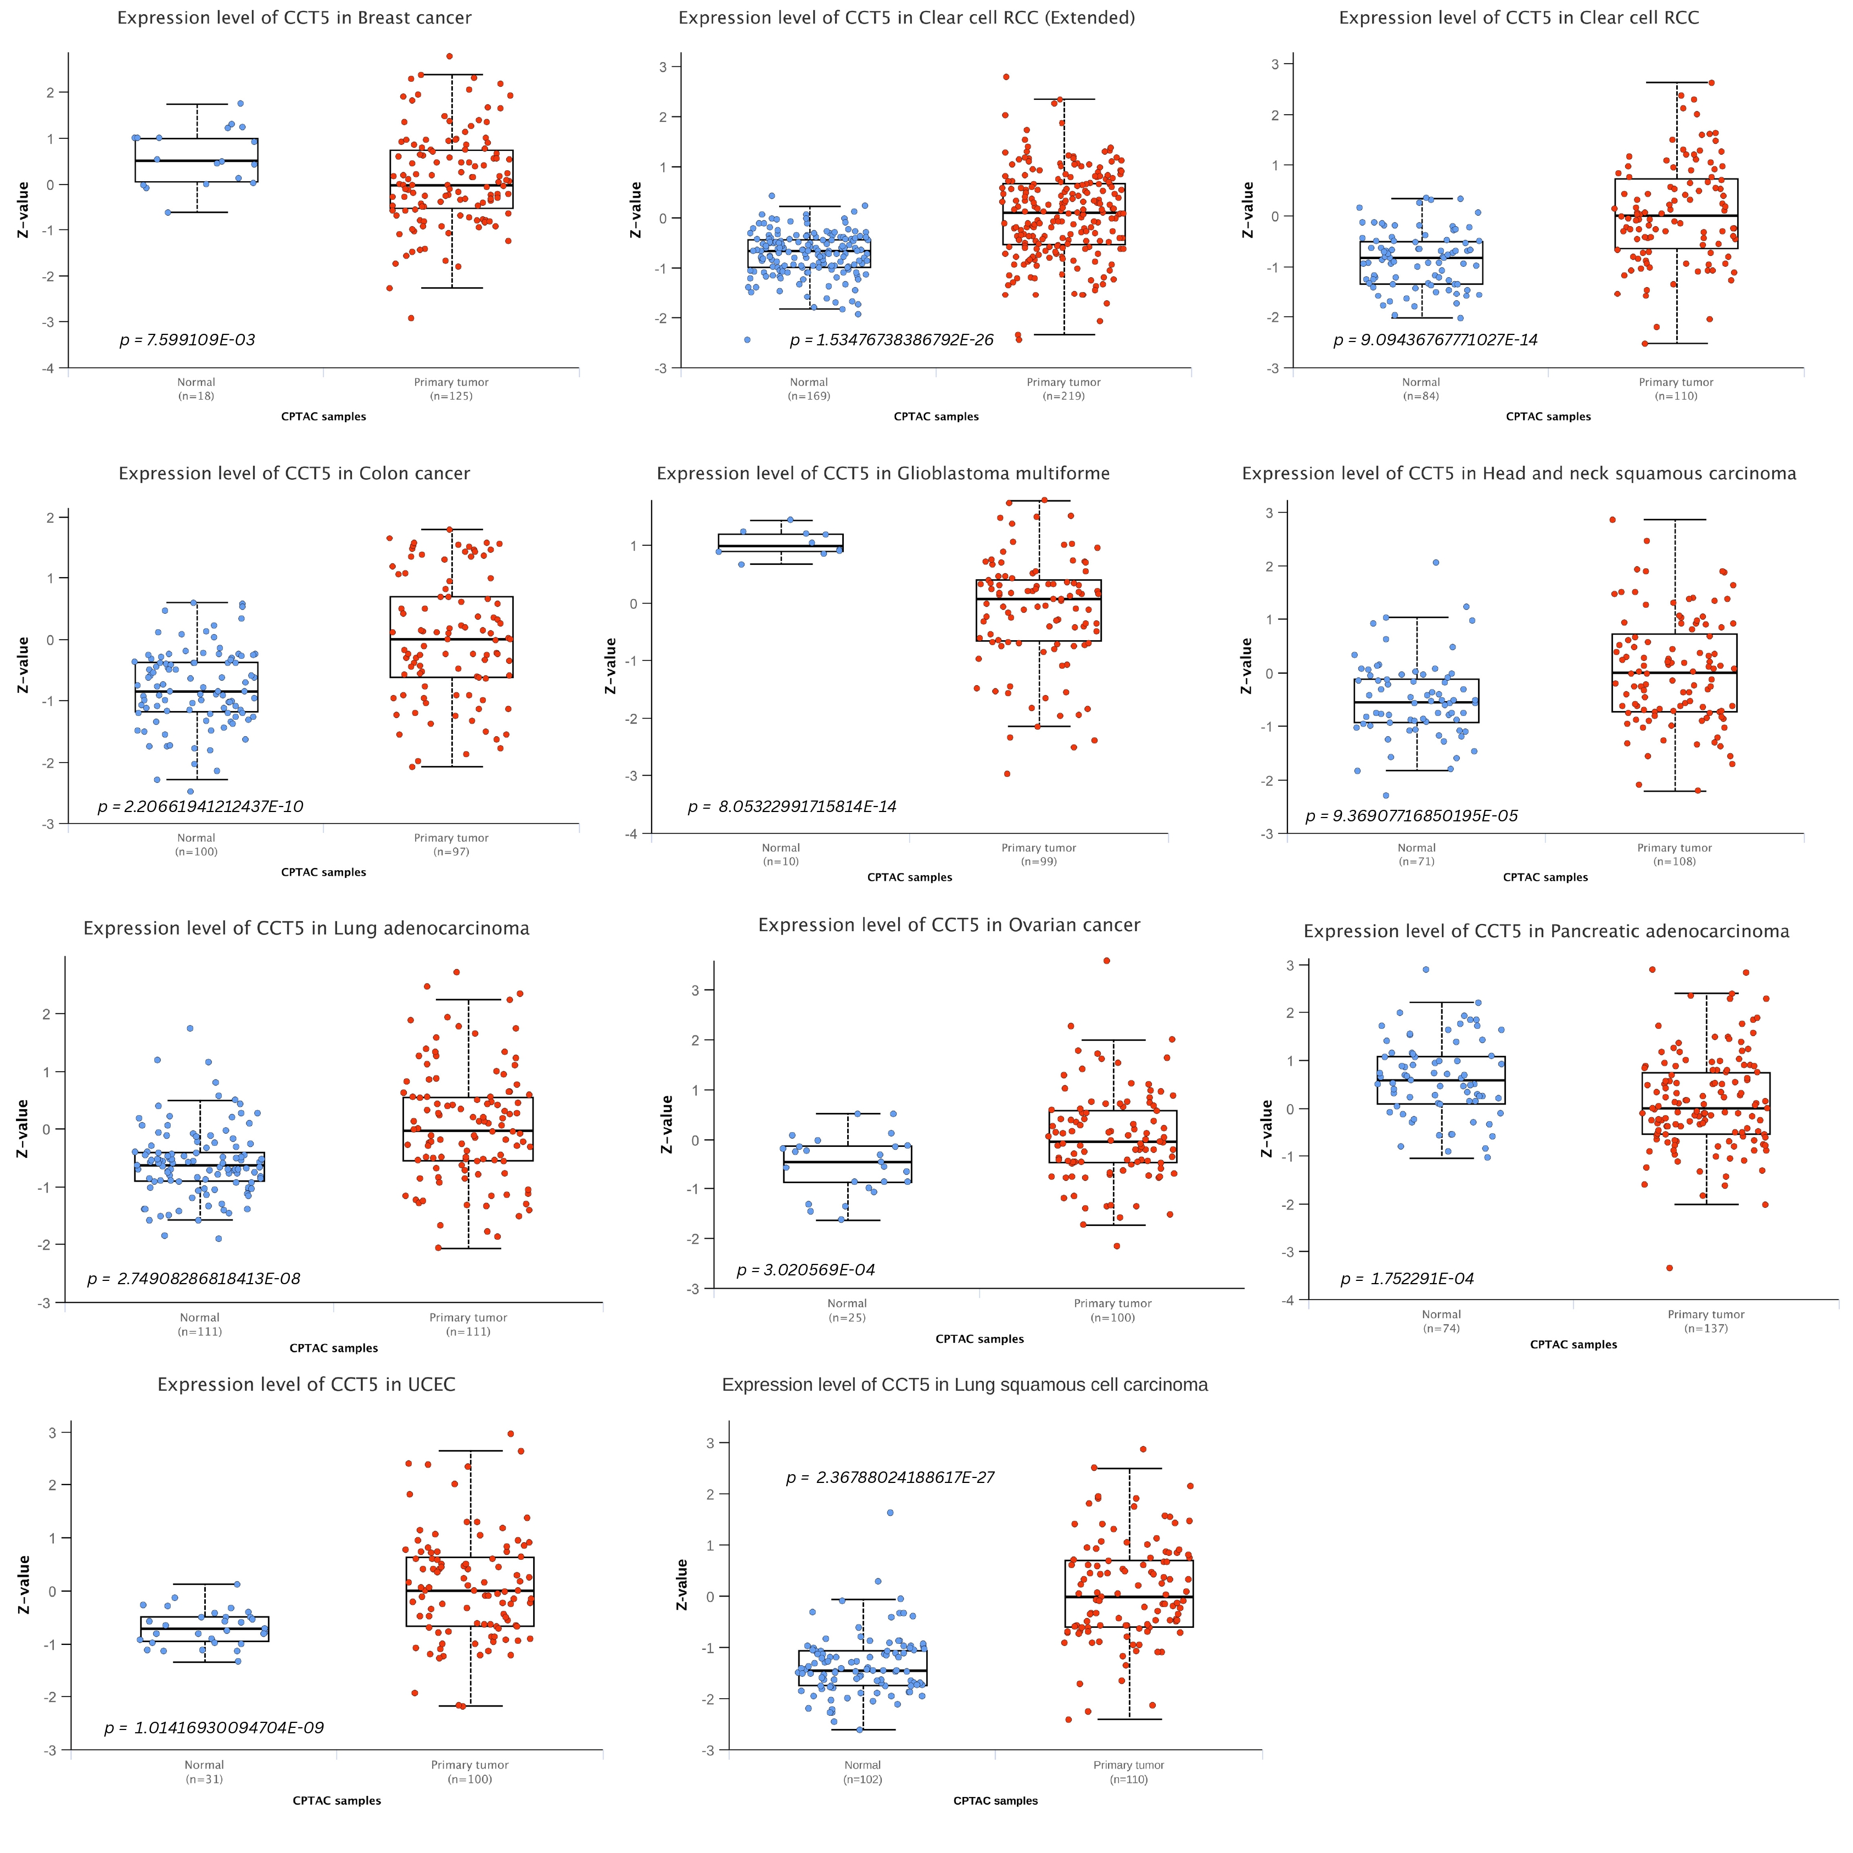

Supplementary Figure 2: Proteomic expression analysis of breast cancer, clear cell RCC, clear cell RCC (extended), colon cancer, glioblastoma multiforme, head and neck squamous carcinoma, lung adenocarcinoma, lung squamous cell carcinoma, ovarian cancer, pancreatic adenocarcinoma, and UCEC was performed using the UALCAN database (https://ualcan. path. uab. edu/) (p < 0.05).

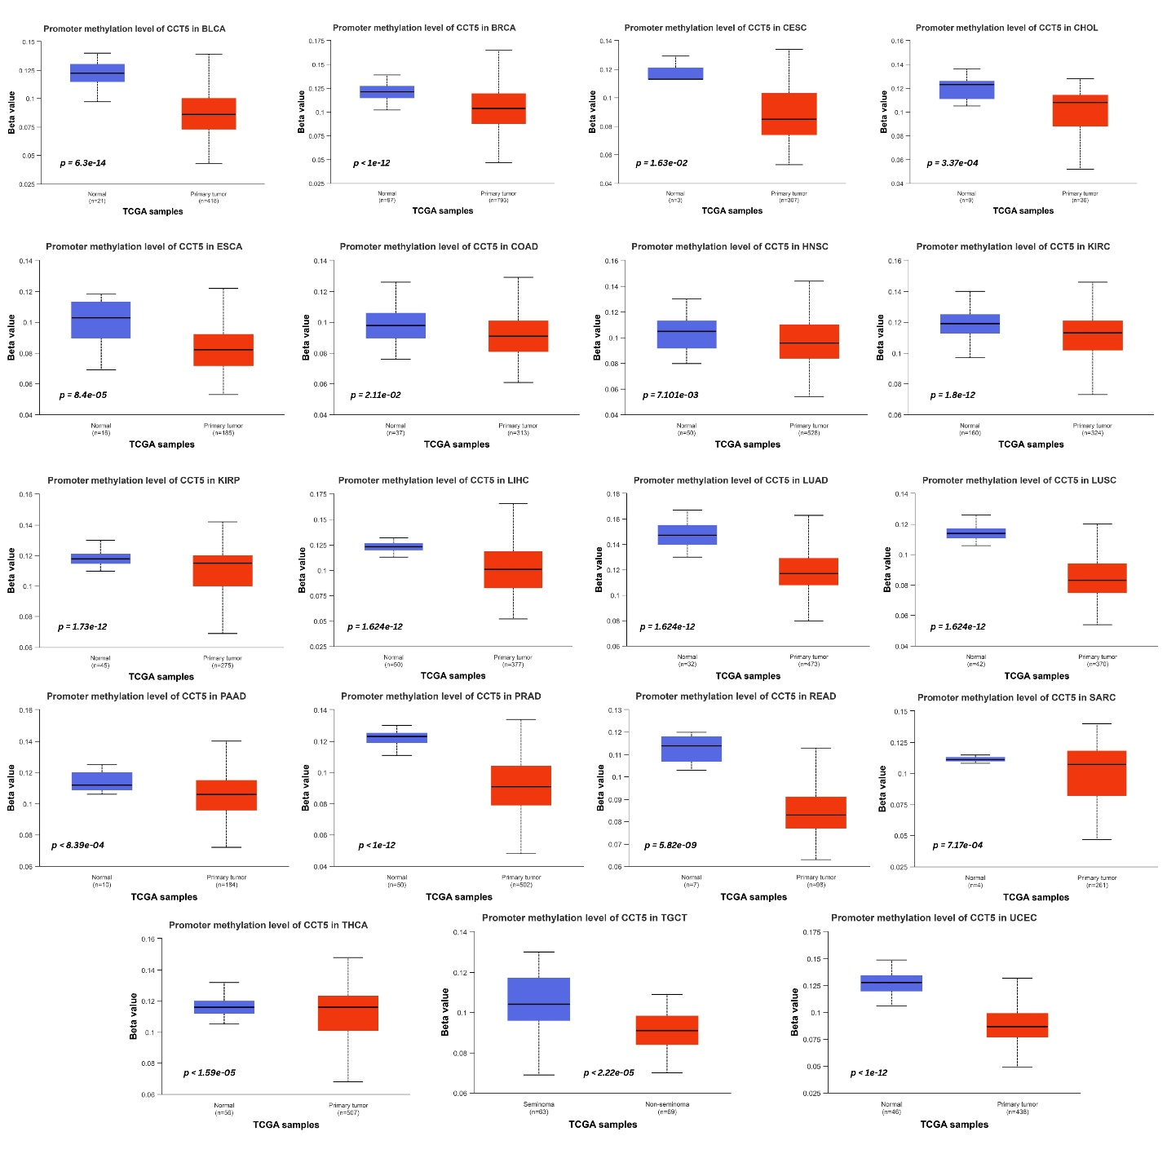
Supplementary Figure 3: DNA promoter methylation analysis of CCT5 with different tumor types analyzed using UALCAN (https://ualcan.path.uab.edu/). Significant promoter methylation levels were downregulated in the corresponding tumor types, including BLCA, BRCA, CESC, CHOL, COAD, ESCA, HNSC, KIRP, KIRC, LIHC, LUAD, LUSC, PAAD, PRAD, READ, SARC, TGCT, THCA, and UCEC.

