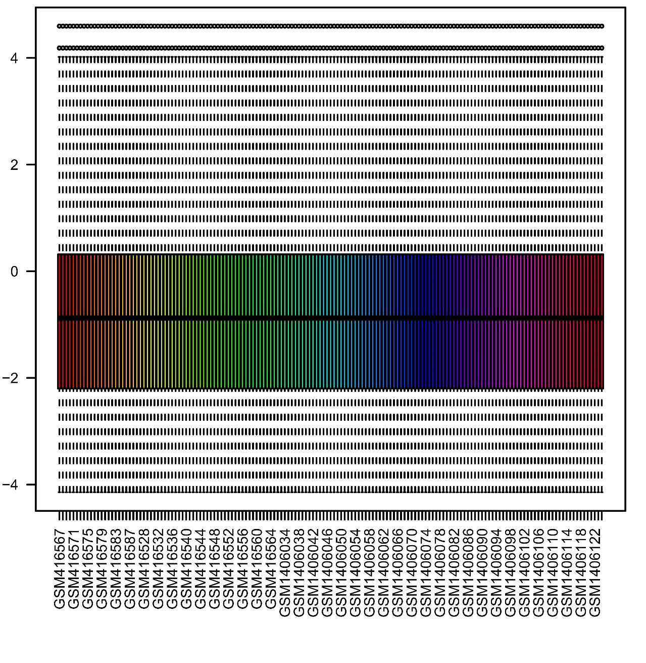
Supplementary Figure1: Normalized for total of 155 samples in GSE16561 combined with GSE58294.

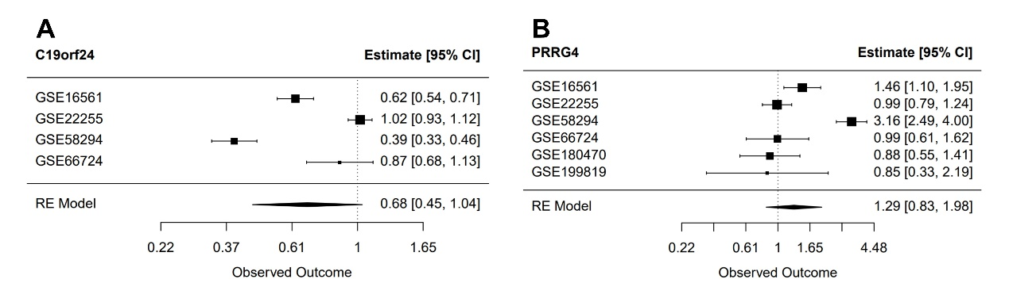
Supplementary Figure2: Meta-analysis of c19orf24 and PRRG4.
Representative graphs showing the effect sizes of c19orf24 (A) and PRRG4 (B) on the risk of IS across four or six distinct datasets, respectively. The RE model represents the result of the meta-analysis.

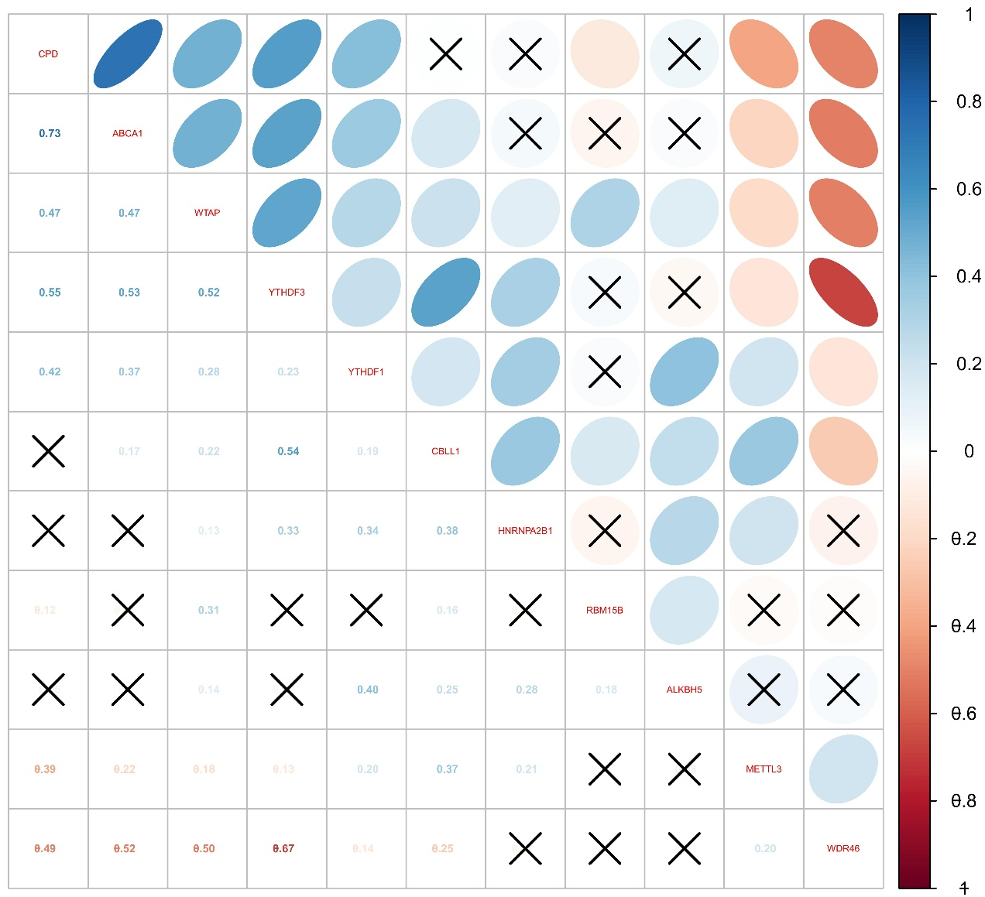
Supplementary Figure3: Correlations between eight key m6A regulators and three key genes.

