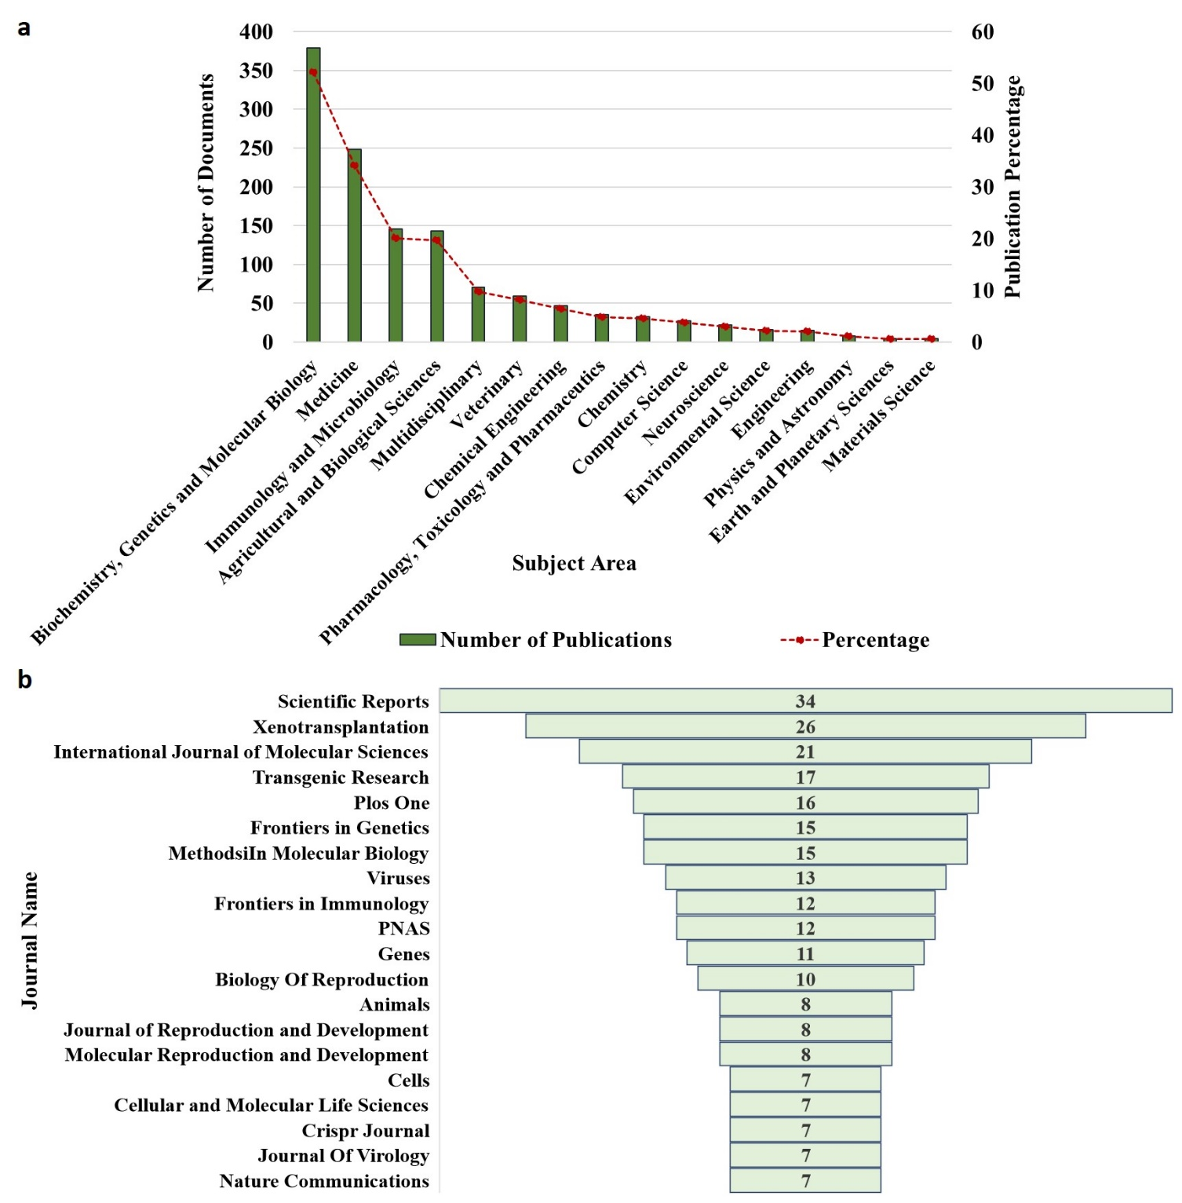
Supplementary Figure 1. The graphical representation for the a. subject area (X axis = different subject area specified by the SCOPUS; Y axis = Number of documents; Secondary Y axis = Publication percentage of documents, b. Funnel chart representing top 20 journals publishing documents on genome editing in pigs. Values within the bar represents the number of publications on genome editing in pigs corresponding to the journal during 2010-2023.
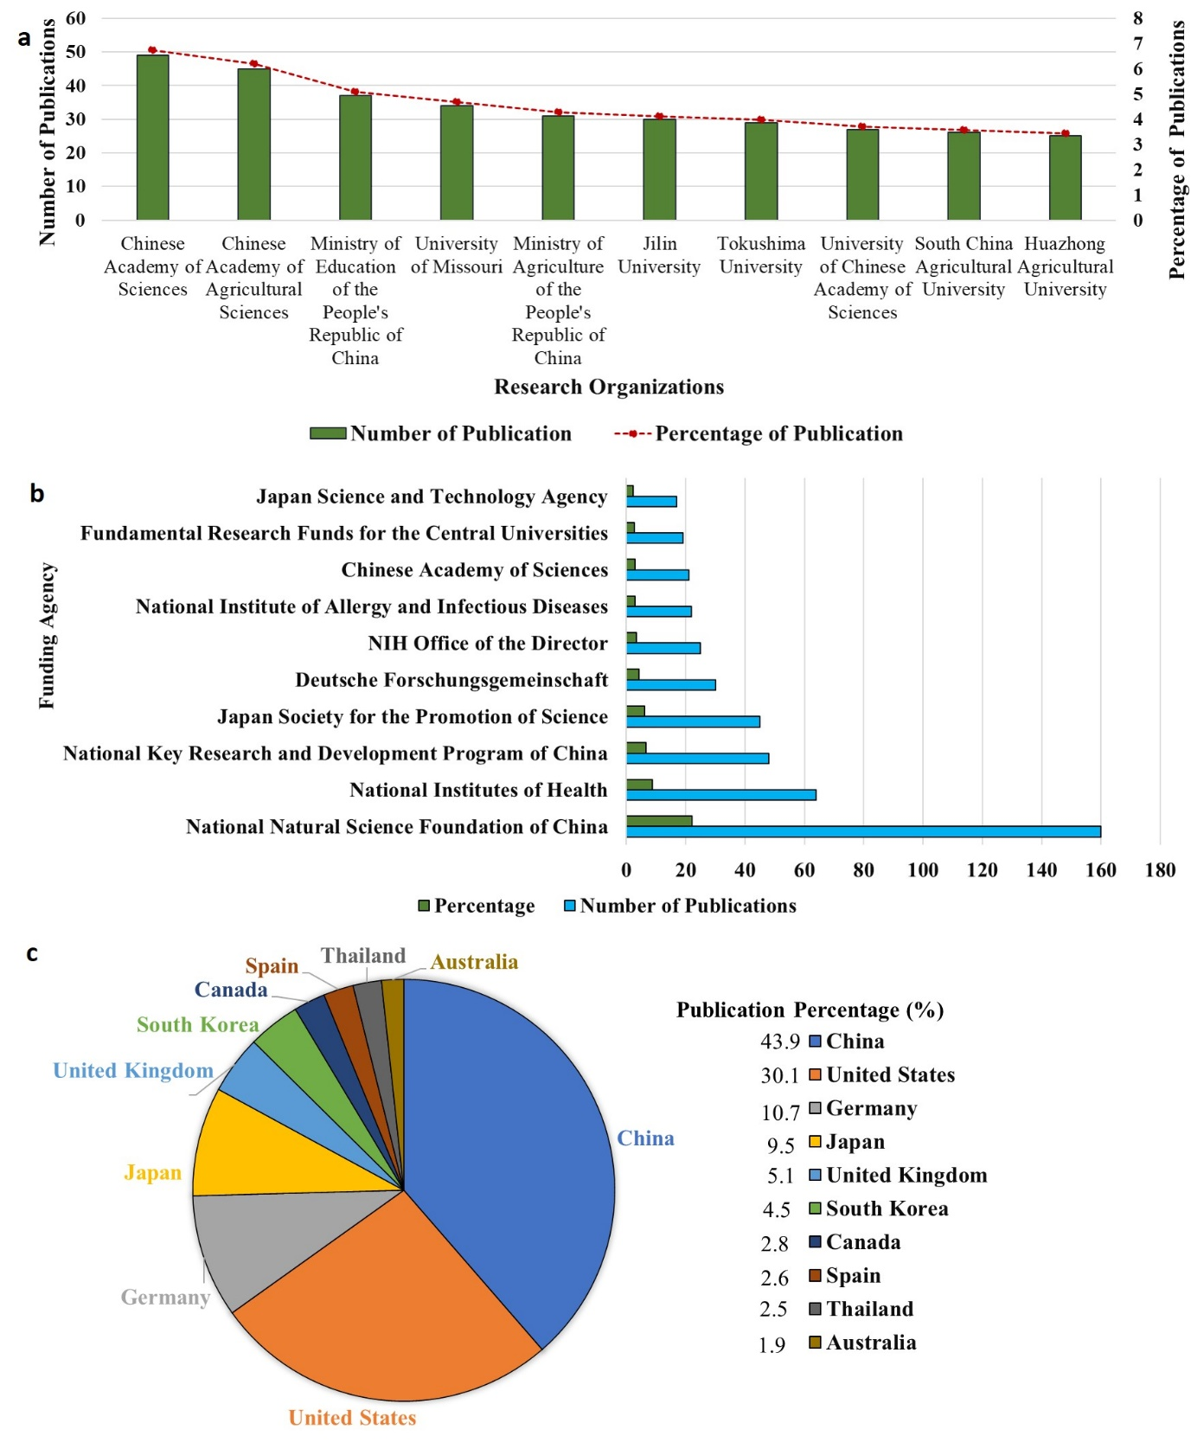
Supplementary Figure 2. The graphical representation for top 10 research institutions (X axis = research organizations; Y axis = Number of publications; Secondary Y axis = Publication percentage of documents), b. Top 10 funding agency acknowledged in the research publications (X axis = publication and percentage count; Y axis = funding agency name), c. Pie chart for top 10 countries leading the publication front in genome editing on pigs. The publication percentage is displayed country wise.
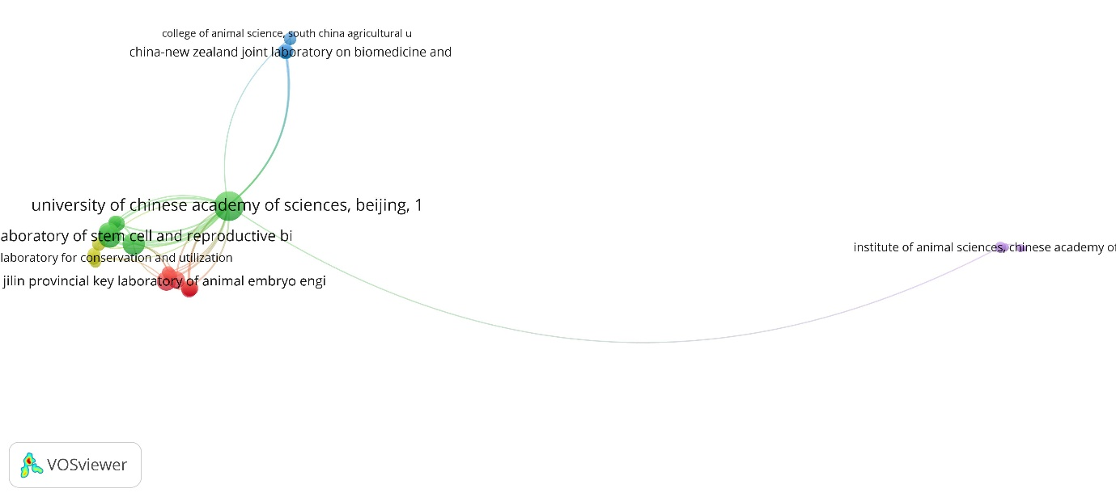
a
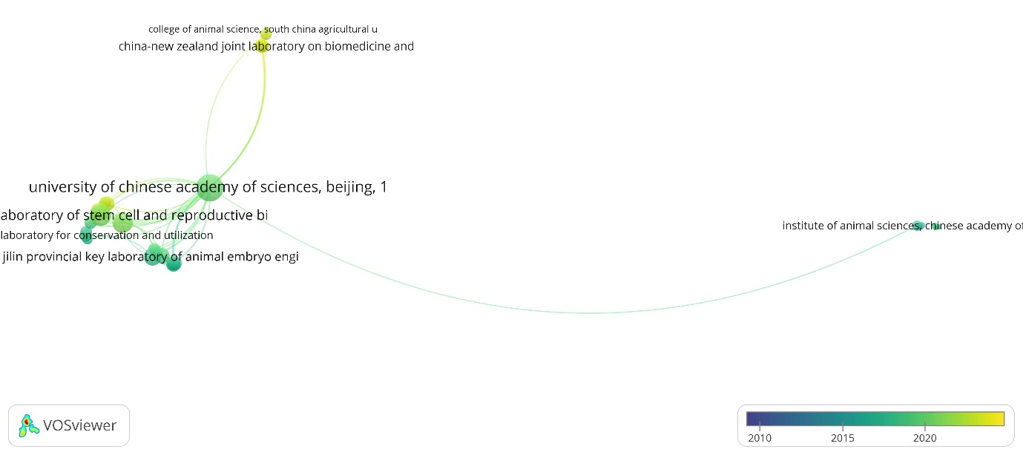
b
Supplementary Figure 3. Co-authorship analysis for organizations conducting genome editing research on pigs. a. Network visualization was conducted with weights given to total link strength. Different colours indicate different clusters. b. Overlay visualization was conducted with weights given to total link strength and scores to the average publication year (2010-2023). Larger circle indicates higher link strength of organizations. More vibrant colours between the organizations indicates their higher connection, while transparent colours indicate lesser connections between them.
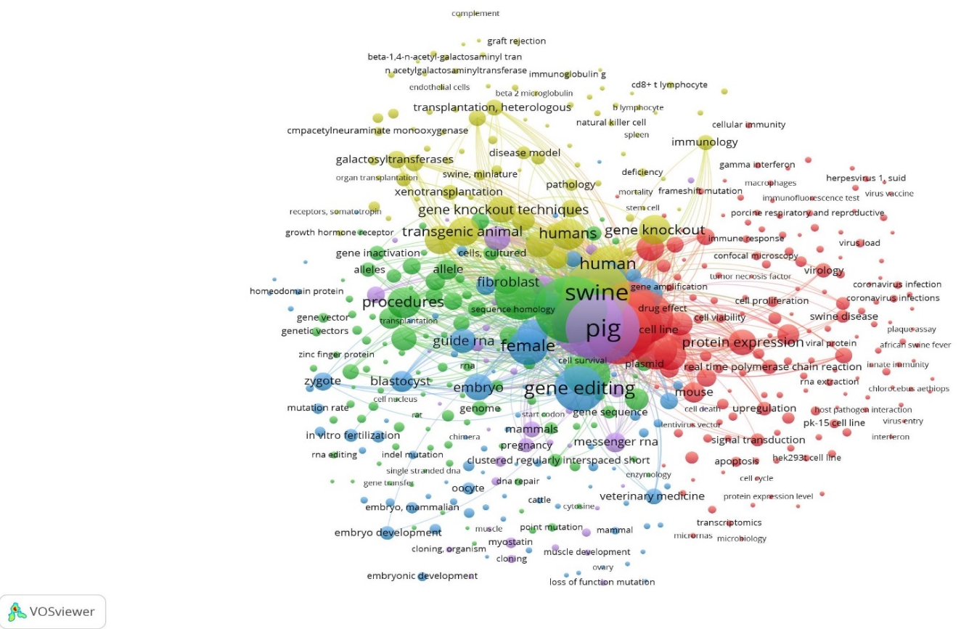
a
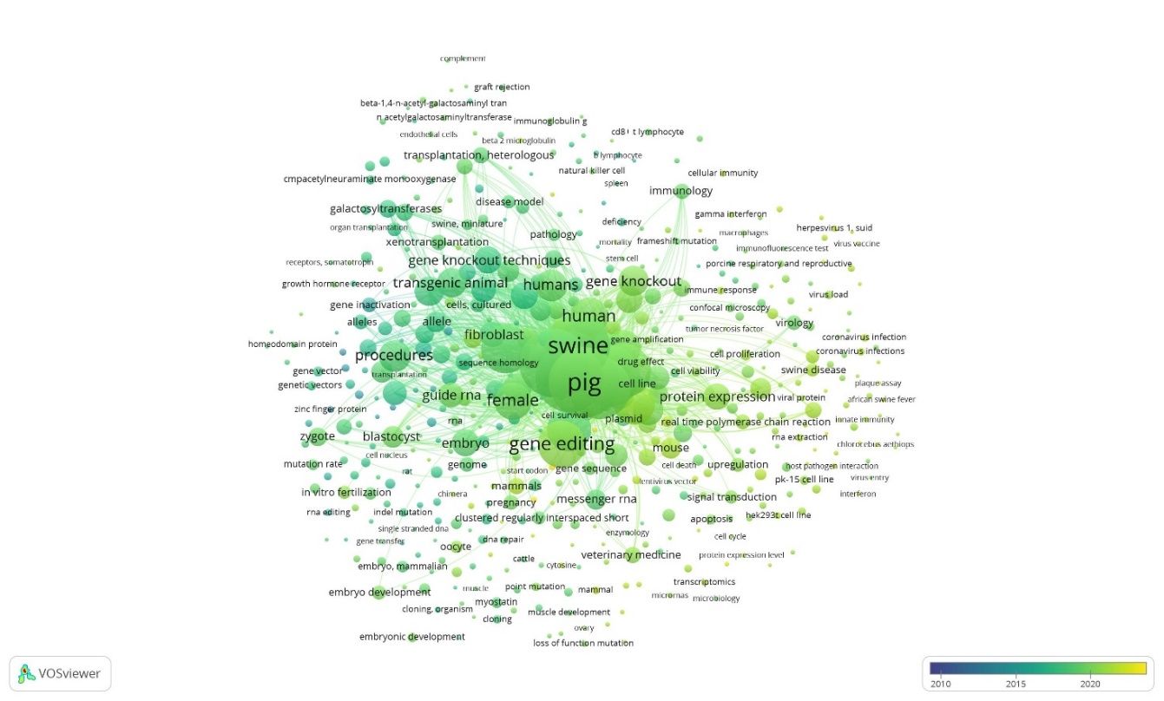
b
Supplementary Figure 4. Co-occurrence analysis for index keywords in research publications on genome editing in pigs. a. Network visualization was conducted with weights given to occurrences of keywords. Different colours indicate different clusters. b. Overlay visualization was conducted with weights given to occurrences and scores to the average publication year (2010-2023). Larger circle indicates higher occurrence of keywords. More vibrant colours between the organizations indicates their higher connection, while transparent colours indicate lesser connections between them.
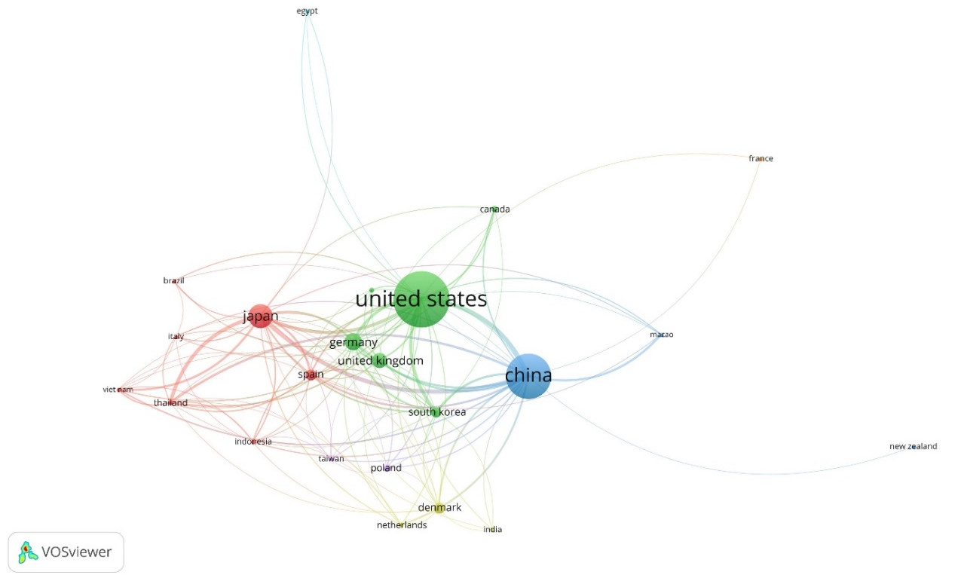
a
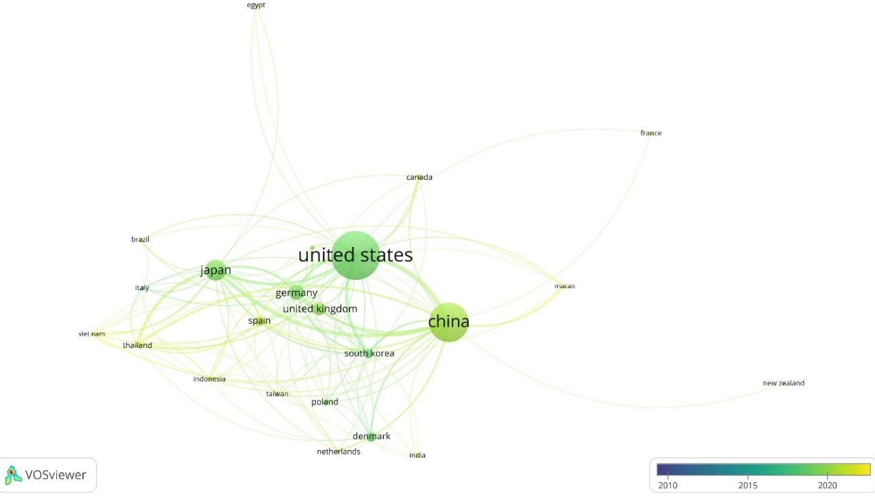
b
Supplementary Figure 5. Citation analysis for countries for research publications on genome editing in pigs. a. network visualization for countries b. Overlay visualization for countries with timelines 2010-2023. Network visualization was conducted with weights given to citations. Different colours indicate different clusters. Overlay visualization was conducted with weights given to citations and scores to the average publication year (2010-2023). Larger circle indicates higher citation of the country. More vibrant colours between the countries indicates their higher connection, while transparent colours indicate lesser connections between them.

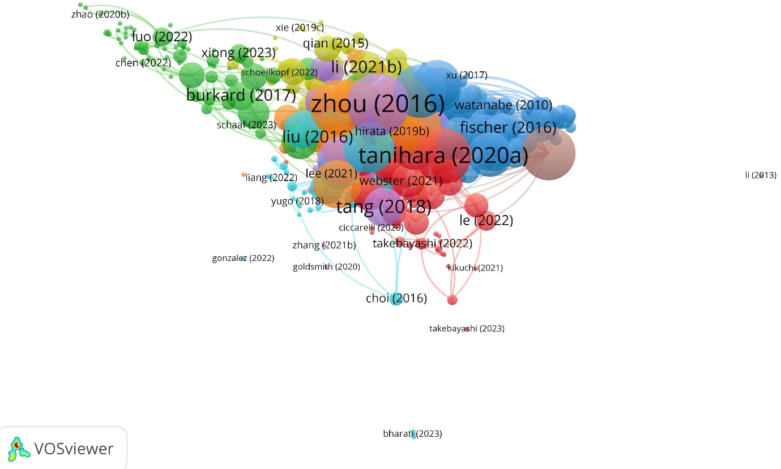
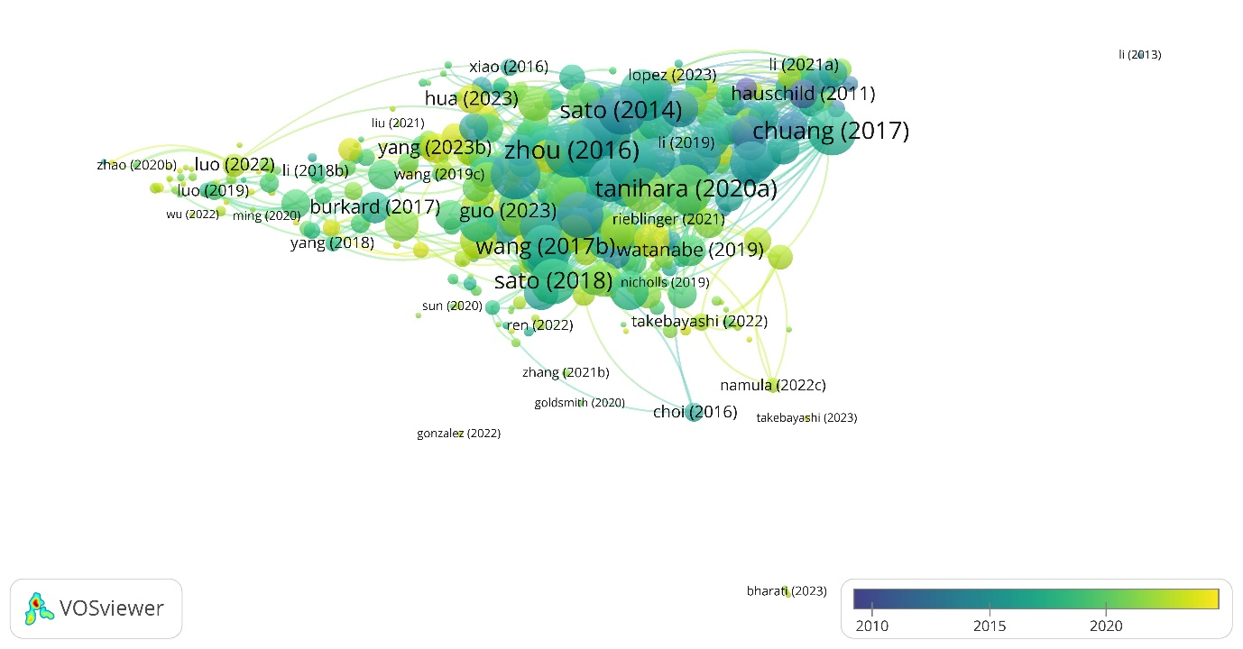
a

Supplementary Figure 6. Bibliometric coupling analysis for research articles a. network visualization of research articles, b. overlay visualization of research articles with timelines 2010-2023. Network visualization was conducted with weights given to total link strength. Different colours indicate different clusters. Overlay visualization was conducted with weights given to total link strength and scores to the publication year (2010-2023). Larger circle indicates higher link strength of research articles. More vibrant colours between the research articles indicates their higher connections while transparent colours indicate lesser connections between them.
b
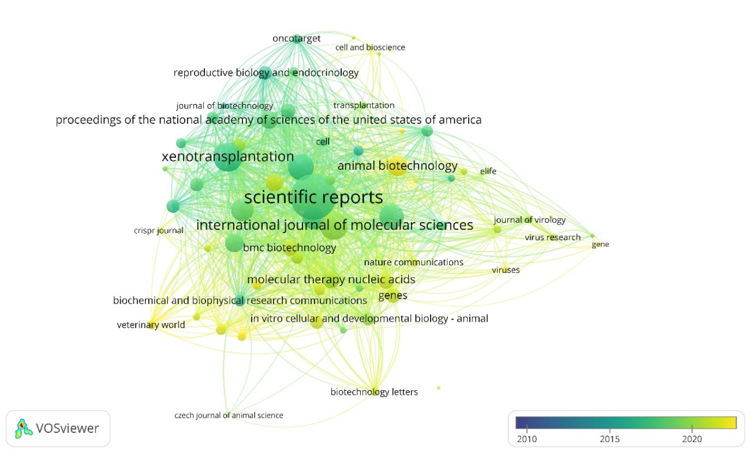
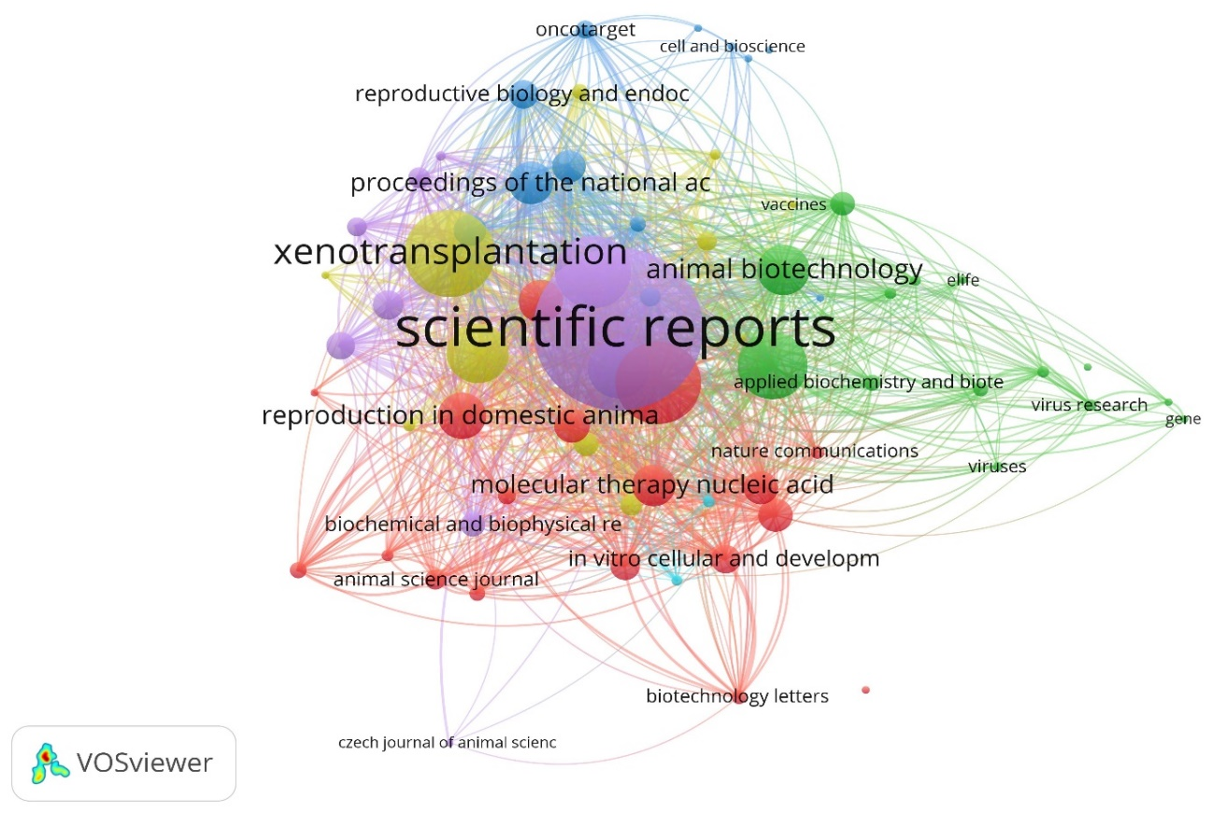
Supplementary Figure 7. Bibliometric coupling analysis for journals a. network visualization of journals, b. overlay visualization of journal with timelines 2010-2023. Network visualization was conducted with weights given to total link strength. Different colours indicate different clusters. Overlay visualization was conducted with weights given to total link strength and scores to the publication year (2010-2023). Larger circle indicates higher link strength of journal. More vibrant colours between the journal indicates their higher connections while transparent colours indicate lesser connections between them.
b
a
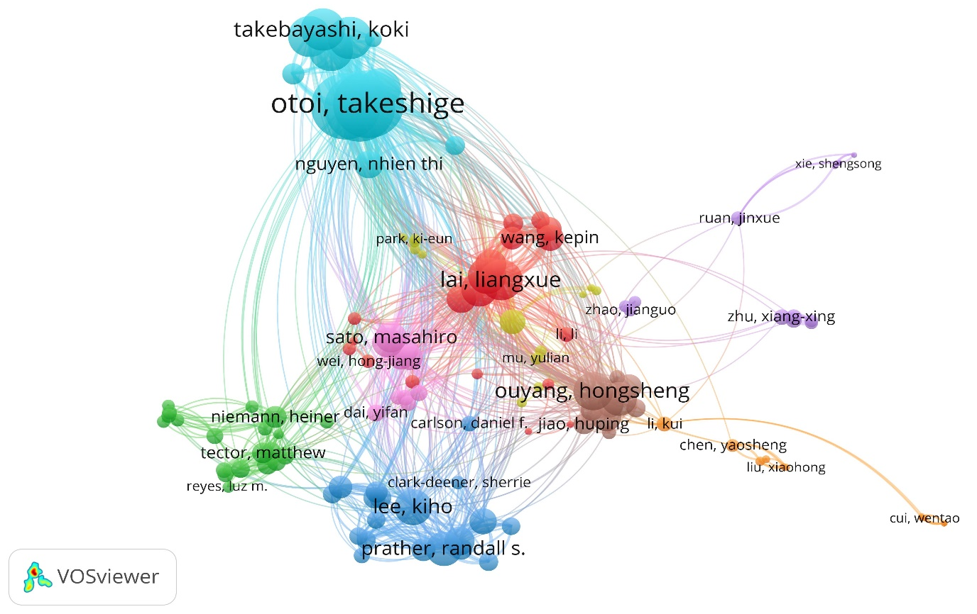
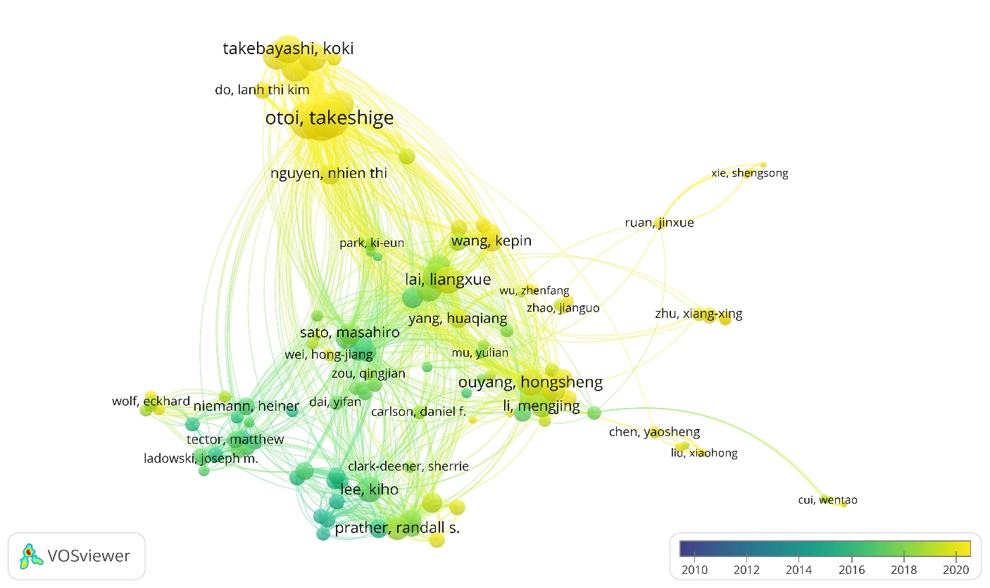
Supplementary Figure 8. Bibliometric coupling analysis for authors a. network visualization of authors, b. overlay visualization of authors with timelines 2010-2023. Network visualization was conducted with weights given to total link strength. Different colours indicate different clusters. Overlay visualization was conducted with weights given to total link strength and scores to the publication year (2010-2023). Larger circle indicates higher link strength of authors. More vibrant colours between the authors indicates their higher connections while transparent colours indicate lesser connections between them
b
a
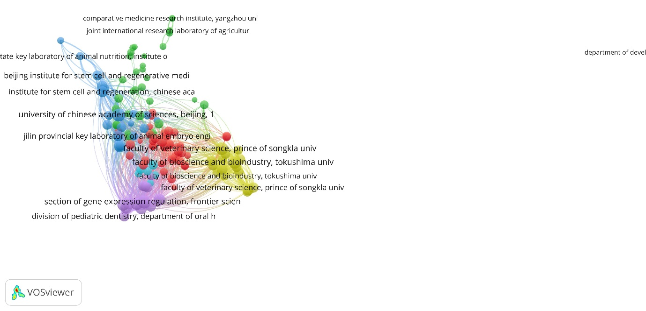
a
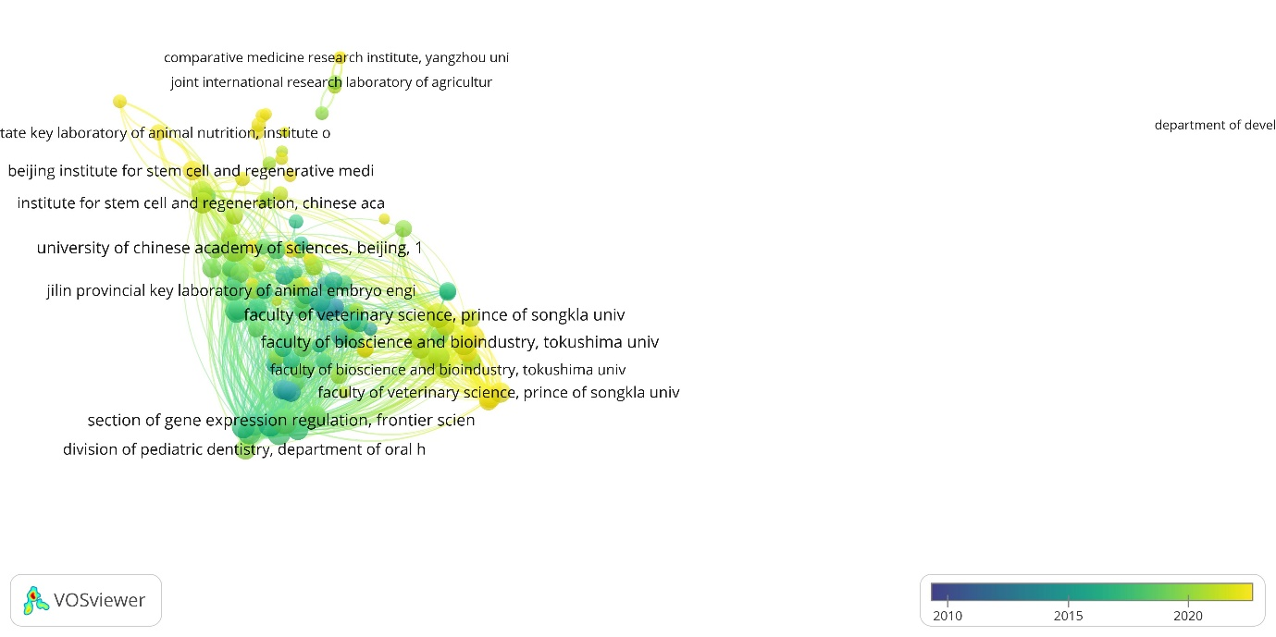
b
Supplementary Figure 9. Bibliometric coupling analysis for research organizations a. network visualization of research organizations, b. overlay visualization of journal with timelines 2010-2023. Network visualization was conducted with weights given to total link strength. Different colours indicate different clusters. Overlay visualization was conducted with weights given to total link strength and scores to the publication year (2010-2023). Larger circle indicates higher link strength of publication/journal. More vibrant colours between the research organizations indicates their higher connections while transparent colours indicate lesser connections between them

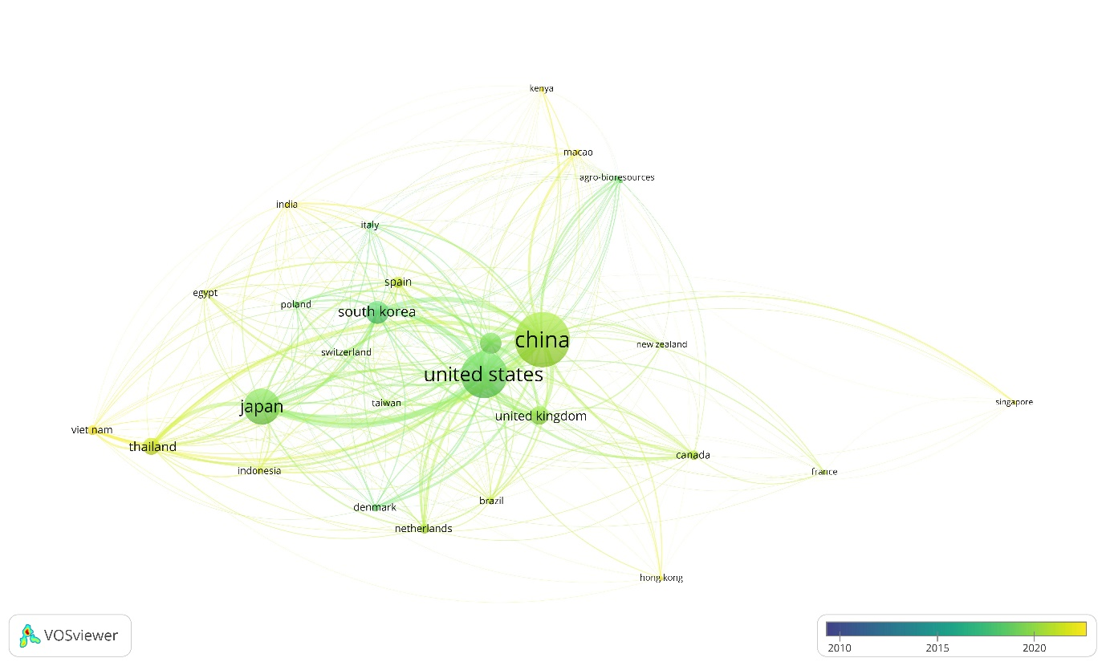
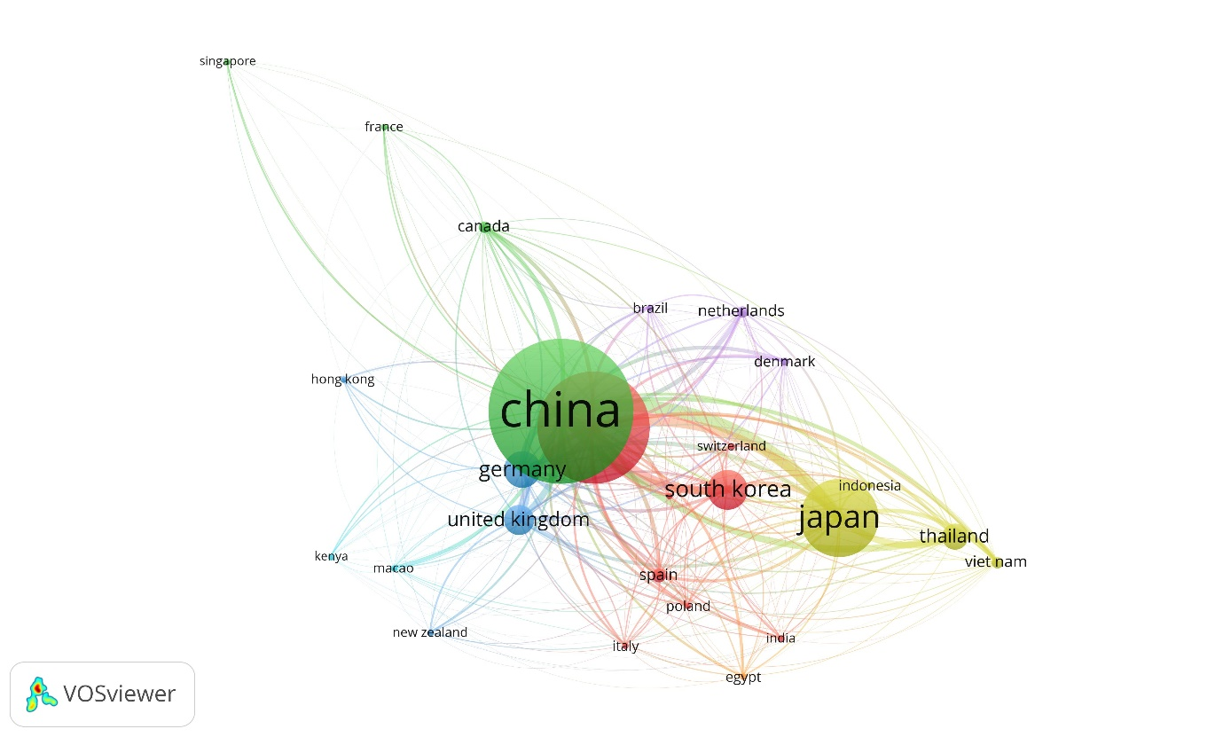
Supplementary Figure 10. Bibliometric coupling analysis for countries a. network visualization of countries, b. overlay visualization of countries with timelines 2010-2023. Network visualization was conducted with weights given to total link strength. Different colours indicate different clusters. Overlay visualization was conducted with weights given to total link strength and scores to the publication year (2010-2023). Larger circle indicates higher link strength of publication/journal. More vibrant colours between the countries indicates their higher connections while transparent colours indicate lesser connections between them.
b
a

