Supplementary Material:
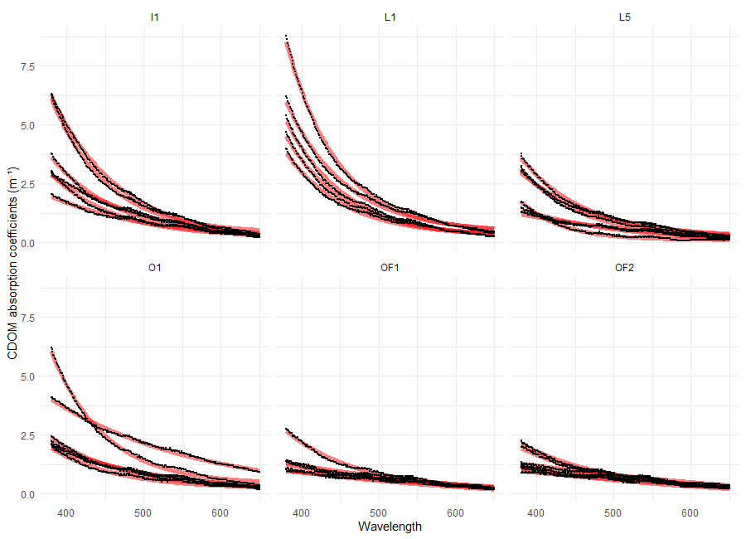
Supplementary Figure 1. Relationship between CDOM absorption coefficients and wavelength (nm). Each section corresponds to a separate sampling site and the different lines are replications from different seasons. Black line represents observed absorption coefficients, while red lines are non-linear regression models predictions (according to Stedmon et al., 2000). Absorption coefficients are corrected for baseline offset.

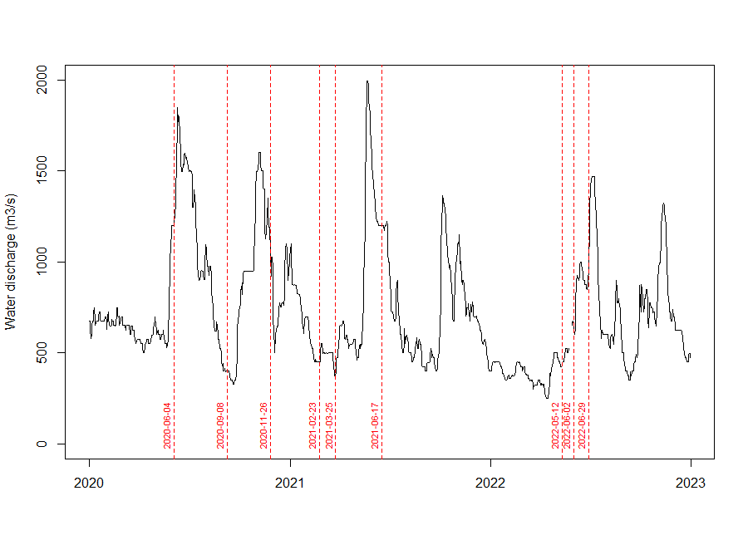
Supplementary Figure 2. Daily water discharge volumes (m³/s) from the Glomma river at Solbergfoss monitoring station (NVE, 2023). Dotted lines represent dates of sampling.

Station | Latitude | Longitude | Average salinity (PSU) | Bottom depth (m)
L1 | 59.21 | 10.96 | 1.82 | 22
I1 | 59.11 | 11.00 | 16.87 | 50
L5 | 59.14 | 10.96 | 18.67 | 52
Ø1 | 59.13 | 10.83 | 20.34 | 50
OF1 | 59.04 | 10.76 | 23.74 | 452
OF2 | 59.18 | 10.69 | 24.53 | 352
Supplementary Table 1. Table listing latitudes and longitudes of sampling stations.
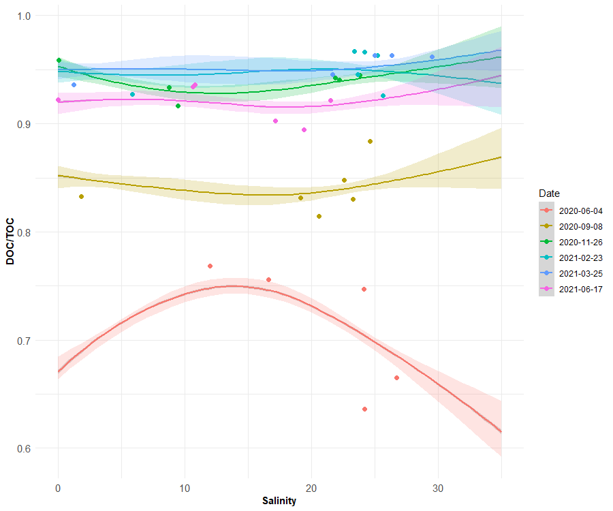
Supplementary Figure 3. Relationship between DOC/TOC and salinity divided into 6 sampling dates.

Cruise number | Date | Site | Salinity (PSU) | pN (mg/L) | POC (mg/L) | tN (mg/L) | TOC (mg/L) | DOC (mg/L) | δ¹³C (‰)
1 | 04.06.2020 | OF1 | 26.7 | 0.064 | 0.640 | 0.277 | 1.912 | 1.272 | -25.1
1 | 04.06.2020 | OF2 | 24.2 | 0.068 | 0.768 | 0.385 | 2.112 | 1.344 | -25.6
1 | 04.06.2020 | Ø1 | 24.1 | 0.064 | 0.588 | 0.404 | 2.322 | 1.734 | -25.5
1 | 04.06.2020 | L5 | 16.6 | 0.108 | 0.720 | 0.429 | 2.948 | 2.228 | -26.5
1 | 04.06.2020 | I1 | 12.0 | 0.068 | 0.620 | 0.412 | 2.677 | 2.057 | -27.2
2 | 08.09.2020 | OF1 | 23.3 | 0.053 | 0.388 | 0.28 | 2.283 | 1.895 | -25.4
2 | 08.09.2020 | OF2 | 24.6 | 0.042 | 0.261 | 0.323 | 2.250 | 1.989 | -25.5
2 | 08.09.2020 | Ø1 | 22.6 | 0.054 | 0.357 | 0.344 | 2.348 | 1.991 | -25.5
2 | 08.09.2020 | I1 | 19.2 | 0.055 | 0.405 | 0.362 | 2.404 | 1.999 | -25.9
2 | 08.09.2020 | L5 | 20.6 | 0.054 | 0.435 | 0.331 | 2.347 | 1.912 | -25.5
2 | 08.09.2020 | L1 | 1.8 | 0.053 | 0.474 | 0.665 | 2.832 | 2.358 | -27.6
3 | 26.11.2020 | OF2 | 23.8 | 0.040 | 0.130 | 0.504 | 2.353 | 2.223 | -24.9
3 | 26.11.2020 | OF1 | 21.9 | 0.042 | 0.159 | 0.562 | 2.763 | 2.604 | -25.9
3 | 26.11.2020 | I1 | 8.8 | 0.023 | 0.292 | 0.691 | 4.393 | 4.101 | -27.8
3 | 26.11.2020 | Ø1 | 9.5 | 0.024 | 0.367 | 0.644 | 4.378 | 4.011 | -24.1
3 | 26.11.2020 | L1 | 0.1 | 0.032 | 0.233 | 0.823 | 5.601 | 5.368 | -28.0
3 | 26.11.2020 | L5 | 22.2 | 0.025 | 0.152 | 0.452 | 2.534 | 2.382 | -25.8
4 | 23.02.2021 | OF2 | 25.7 | 0.026 | 0.210 | 0.273 | 2.835 | 2.625 | -24.9
4 | 23.02.2021 | OF1 | 25.2 | 0.013 | 0.103 | 0.169 | 2.805 | 2.702 | -24.9
4 | 23.02.2021 | I1 | 24.2 | 0.012 | 0.097 | 0.162 | 2.905 | 2.808 | -24.6
4 | 23.02.2021 | Ø1 | 23.7 | 0.022 | 0.156 | 0.166 | 2.860 | 2.704 | -24.9
4 | 23.02.2021 | L5 | 23.4 | 0.011 | 0.095 | 0.143 | 2.830 | 2.735 | -25.0
4 | 23.02.2021 | L1 | 5.9 | 0.030 | 0.322 | 0.393 | 4.415 | 4.093 | -27.9
5 | 25.03.2021 | OF2 | 29.5 | 0.008 | 0.084 | 0.165 | 2.21 | 2.126 | -25.1
5 | 25.03.2021 | I1 | 26.4 | 0.010 | 0.100 | 0.153 | 2.675 | 2.575 | -24.9
5 | 25.03.2021 | Ø1 | 25.0 | 0.009 | 0.089 | 0.165 | 2.405 | 2.316 | -24.9
5 | 25.03.2021 | L5 | 21.7 | 0.015 | 0.157 | 0.231 | 2.860 | 2.703 | -25.7
5 | 25.03.2021 | L1 | 1.2 | 0.029 | 0.327 | 0.445 | 5.130 | 4.803 | -28.5
6 | 17.06.2021 | OF2 | 19.4 | 0.056 | 0.383 | 0.140 | 3.640 | 3.257 | -25.4
6 | 17.06.2021 | OF1 | 21.5 | 0.043 | 0.282 | 0.2 | 3.595 | 3.313 | -25.4
6 | 17.06.2021 | I1 | 10.8 | 0.036 | 0.255 | 0.097 | 3.970 | 3.715 | -27.1
6 | 17.06.2021 | Ø1 | 17.2 | 0.041 | 0.350 | 0.140 | 3.605 | 3.255 | -25.7
6 | 17.06.2021 | L5 | 10.6 | 0.036 | 0.264 | 0.329 | 3.990 | 3.726 | -27.5
6 | 17.06.2021 | L1 | 0.0 | 0.037 | 0.312 | 0.261 | 4.000 | 3.688 | -28.2
Supplementary Table 2. Table showing nutrient concentrations, salinity and δ13C of each collected water sample.

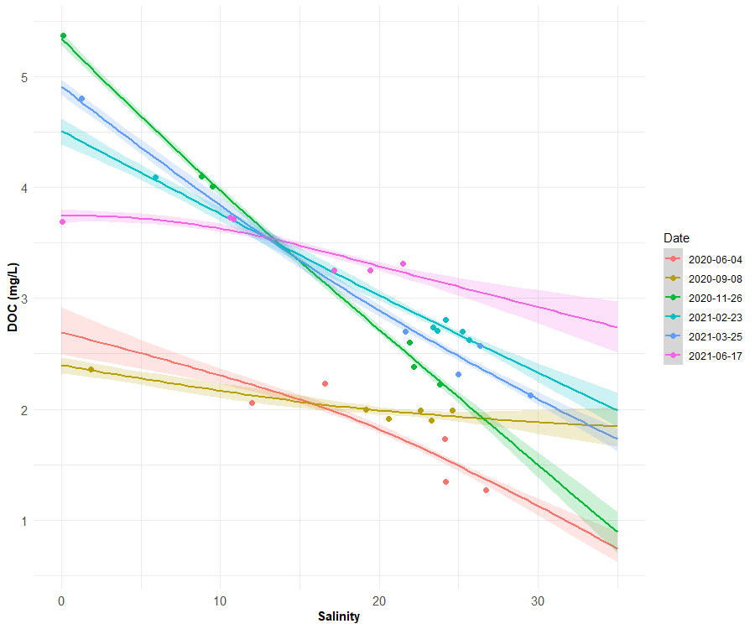
Supplementary Figure 4. Relationship between DOC (mg/L) and salinity divided into 6 sampling dates.

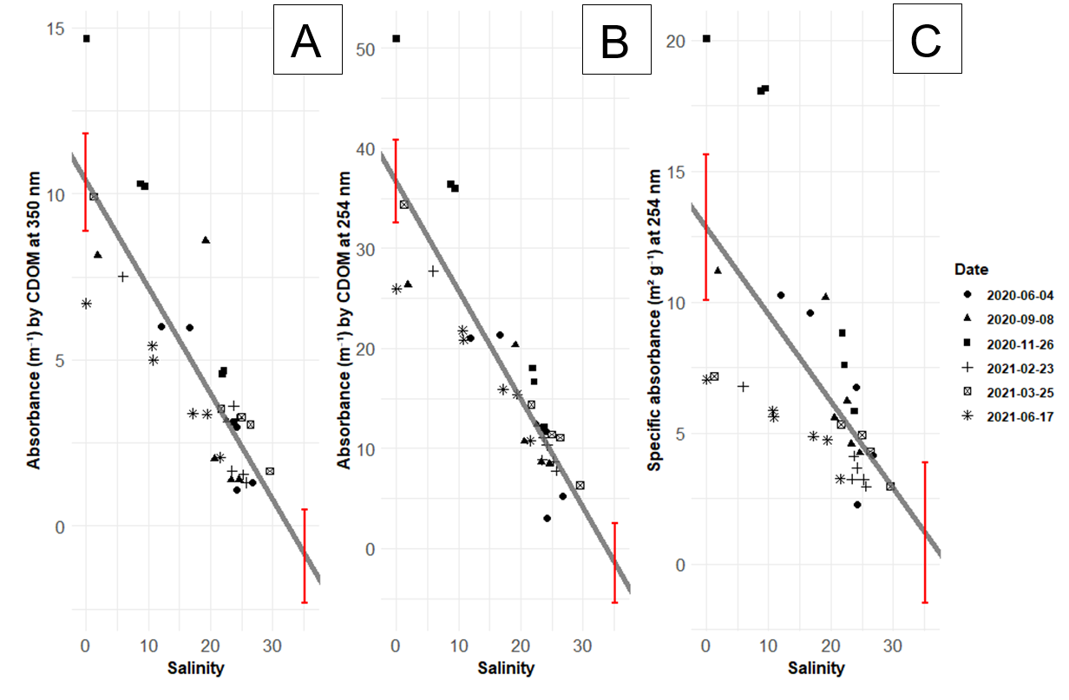
Supplementary Figure 5. Relationship between salinity and saemix (Comets et al., 2017) model parameter estimates: A) absorption coefficient at 350 nm (a₃₅₀; m⁻¹), B) absorption coefficient at 254 nm (a₂₅₄; m⁻¹) and C) specific absorption coefficient at 254 nm (SUVA₂₅₄; m² g⁻¹). Red bars represent confidence intervals for freshwater and marine endmembers estimated by simple linear regression. Shapes of datapoints correspond to sampling dates.

Cruise number | Date | Site | Salinity (PSU) | S (µm⁻¹) | a443 (m⁻¹) | sa443 (m² g⁻¹)
1 | 04.06.2020 | OF1 | 26.7 | 14.863 | 6.839 | 3.325
1 | 04.06.2020 | OF2 | 24.2 | 15.297 | 6.549 | 2.939
1 | 04.06.2020 | Ø1 | 24.1 | 11.866 | 4.422 | 2.550
1 | 04.06.2020 | L5 | 16.6 | 8.998 | 2.428 | 1.909
1 | 04.06.2020 | I1 | 12.0 | 3.416 | 4.919 | 3.660
2 | 08.09.2020 | OF1 | 23.3 | 11.343 | 15.047 | 7.527
2 | 08.09.2020 | OF2 | 24.6 | 14.380 | 10.189 | 4.321
2 | 08.09.2020 | Ø1 | 22.6 | 10.314 | 3.581 | 1.873
2 | 08.09.2020 | I1 | 19.2 | 11.759 | 5.361 | 2.692
2 | 08.09.2020 | L5 | 20.6 | 7.562 | 3.145 | 1.660
2 | 08.09.2020 | L1 | 1.8 | 7.768 | 3.176 | 1.597
3 | 26.11.2020 | OF2 | 23.8 | 15.852 | 10.806 | 5.360
3 | 26.11.2020 | OF1 | 21.9 | 16.401 | 14.726 | 5.795
3 | 26.11.2020 | I1 | 8.8 | 13.133 | 6.245 | 2.845
3 | 26.11.2020 | Ø1 | 9.5 | 16.309 | 10.340 | 5.219
3 | 26.11.2020 | L1 | 0.1 | 14.639 | 5.072 | 2.482
3 | 26.11.2020 | L5 | 22.2 | 13.840 | 3.732 | 1.799
4 | 23.02.2021 | OF2 | 25.7 | 6.855 | 9.939 | 3.540
4 | 23.02.2021 | OF1 | 25.2 | 15.254 | 8.297 | 2.027
4 | 23.02.2021 | I1 | 24.2 | 8.694 | 3.438 | 1.257
4 | 23.02.2021 | Ø1 | 23.7 | 5.268 | 14.350 | 5.306
4 | 23.02.2021 | L5 | 23.4 | 6.646 | 4.327 | 1.602
4 | 23.02.2021 | L1 | 5.9 | 5.808 | 4.076 | 1.553
5 | 25.03.2021 | OF2 | 29.5 | 12.847 | 4.024 | 1.562
5 | 25.03.2021 | I1 | 26.4 | 15.485 | 10.771 | 2.242
5 | 25.03.2021 | Ø1 | 25.0 | 21.243 | 2.173 | 0.804
5 | 25.03.2021 | L5 | 21.7 | 12.652 | 4.470 | 1.930
5 | 25.03.2021 | L1 | 1.2 | 7.393 | 3.724 | 1.752
6 | 17.06.2021 | OF2 | 19.4 | 15.873 | 5.141 | 1.384
6 | 17.06.2021 | OF1 | 21.5 | 16.598 | 6.451 | 1.749
6 | 17.06.2021 | I1 | 10.8 | 16.580 | 5.281 | 1.417
6 | 17.06.2021 | Ø1 | 17.2 | 16.814 | 3.148 | 0.967
6 | 17.06.2021 | L5 | 10.6 | 13.635 | 2.520 | 0.761
6 | 17.06.2021 | L1 | 0.0 | 13.207 | 4.442 | 1.364
Supplementary Table 3. Table showing spectral slope (S), absorption coefficient at 443 nm (a443) and specific absorption coefficient at 443 nm (sa443) of each collected water sample.

