Figure S4: Mantel test of the relationship between pairs of population genetic distance Fst/(1-Fst) and their geographic distance LN km.
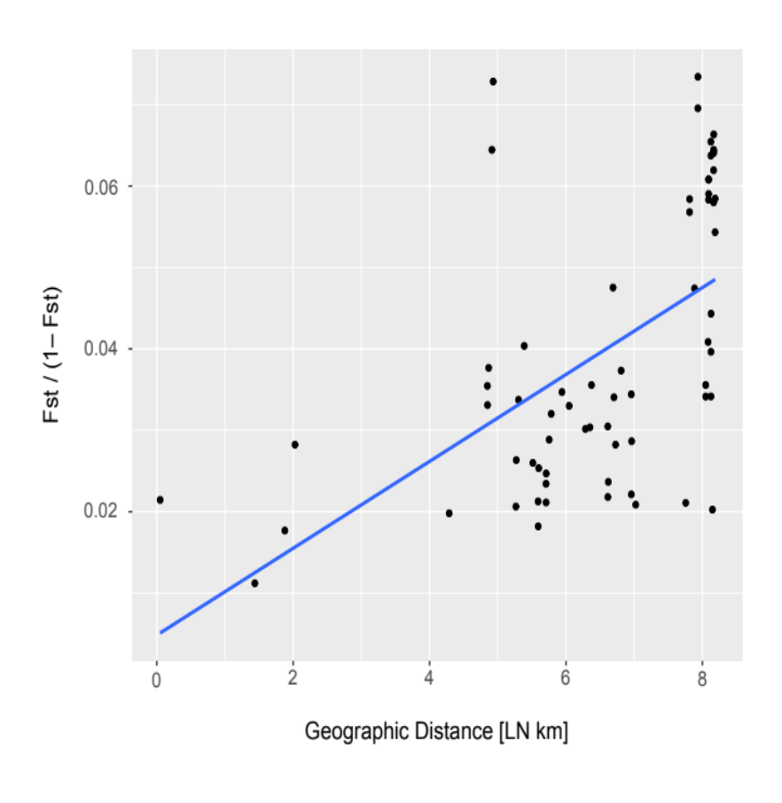
Lona (CH) vs. Hornsund (SJ)
Hornsund (SJ) vs. Longyearbyen_2 (SJ)

