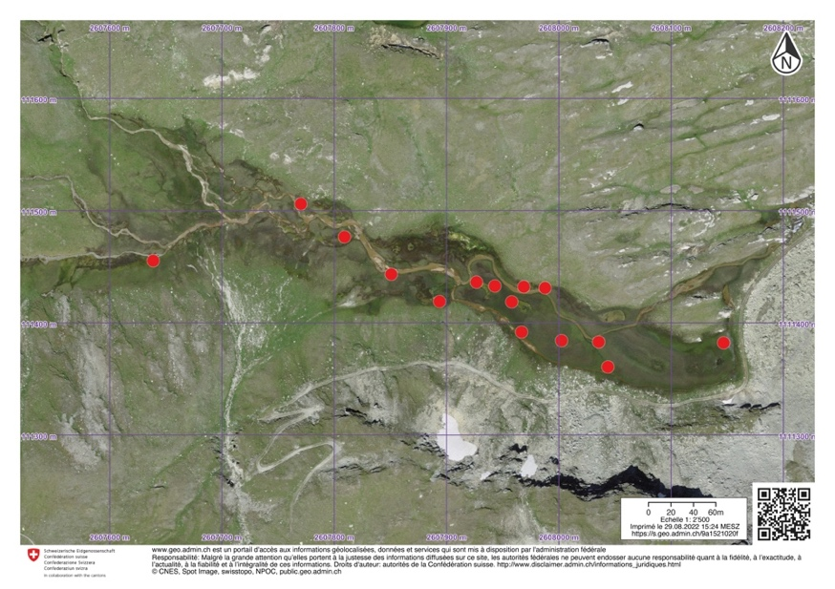
Figure S1: Lona marsh satellite imagery in map.geo.admin. Red dots represent sampling location of C. lonana.

