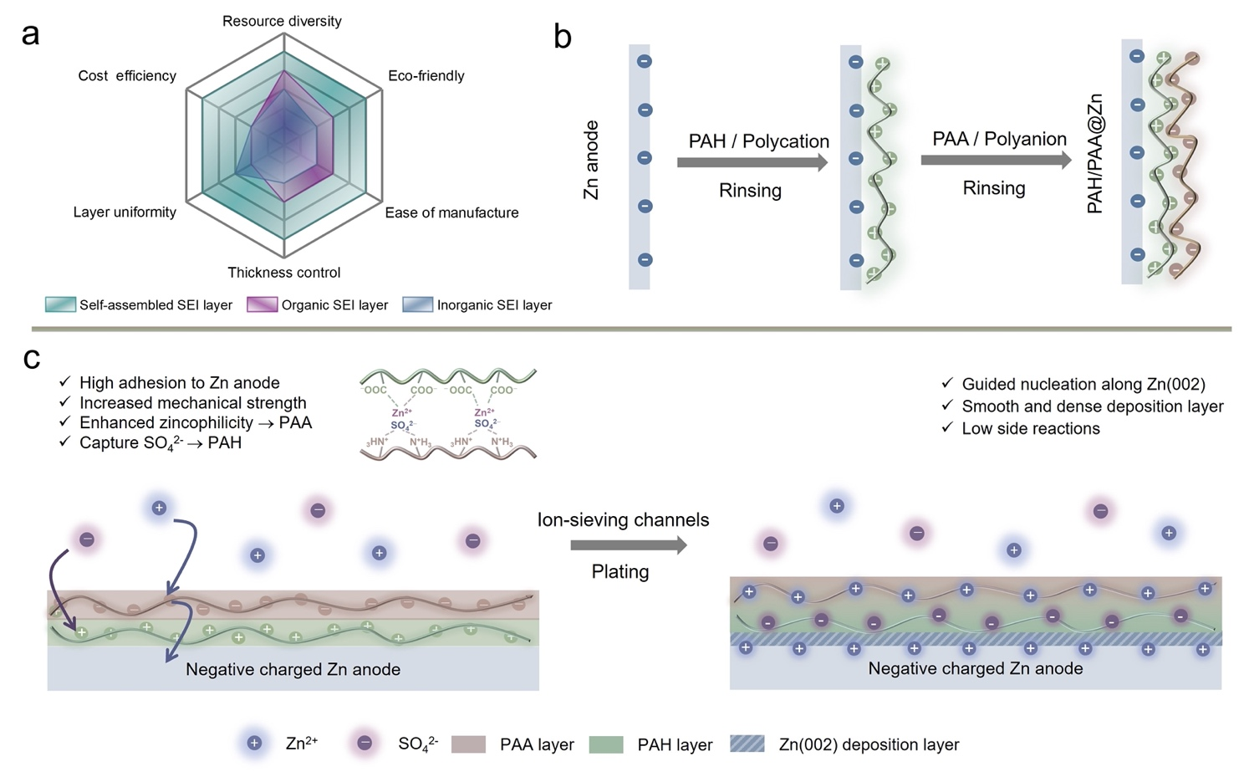
Scheme 1. (a) Radar chart comparing commercial prospects of different strategies to stabilize Zn anodes. (b) Preparation process of the LbL self-assembly PAH/PAA multilayers on Zn anodes. (c) Diffusion and deposition behaviors of Zn²⁺ on the PAH/PAA coating surface.

