Supporting information

Experimental section
Preparation of LBL self-assembly of PAH/PAA multilayers coated Zn anode
500 mg PAH (Sigma-Aldrich, average M_{w} ∼50,000) was mixed in 10 mL distilled water to form PAH aqueous solution. PAA aqueous solution was prepared by 450 mg PAA (Sigma-Aldrich, average M_{w} ∼450,000) and 10mL distilled water. Zn@PAH/PAA was coated by a 50 μm doctor blade, where the PAH layer was coated on the Zn foil first and dried under UV light, after rinsing with water for 5-10 min, the PAA layer was then coated on the Zn foil. Repeat above steps to obtain the PAH/PAA multilayers coated Zn foil. According to GCD curves (Figure S1), three double layers coated Zn foil exhibits the best cycling performance, so three double PAH/PAA multilayer was used to prepare the Zn@PAH/PAA in this work.

Battery Assembly
For full cell assembly, commercial MnO₂ (Sigma-Aldrich) was mixed and grounded with carbon black and PVDF at a 7:2:1 weight ratio in NMP solution. The mixture was evenly coated on a hydrophilic carbon paper with the areal loading mass around 1.5-2 mg cm⁻², and dried in a vacuum oven at 65 °C overnight. Afterwards, the dried cathode was assembled with the PAH/PAA multilayers coated Zn anode in a CR2032-coin cell using 2 M ZnSO₄ and 0.2 M MnSO₄ as the electrolyte. For symmetrical cell assembly, the PAH/PAA multilayers coated Zn foil was assembled with 2 M ZnSO₄ as the electrolyte.

Materials Characterisation
X-ray diffraction (XRD) patterns were obtained by a Bruker Vantec500 under the radiation source of Cu metal. Scanning electron microscopy (SEM) images were collected by a JEOL JSM-6701F Field Emission Scanning Electron Microscope (JEOL, Japan) at the acceleration voltage of 15 kV. The Energy-dispersive X-ray spectroscopy (EDX) images were collected by a Carl Zeiss EVO MA10 (Carl Zeiss AG, Germany) and UItim Extreme Silicon Drift Detectors (Oxford Instrumental plc, UK). Transmission electron microscope (TEM) images were carried out by a JEOL JEM-2100 Electron Microscope. Fourier transform infrared spectroscopy (FTIR) was measured by a Shimadzu IRTracer-100 with the wavenumber from 400 to 4000 cm⁻¹. The Raman data was obtained by a Thermo ScientificTM DXR3 Raman Microscope with a laser wavelength of 532 nm. The optical images and depth profile were collected by a Keyence VXH-7000N Digital Microscope, the HER reaction was observed on anode and Zn deposition was observed on cathode in the discharge process.

Electrochemical Characterisation
The long-term galvanostatic charge-discharge (GCD) test was operated by NEWARE battery testing systems. The cyclic voltammetry (CV) was measured by a VMP3 Biologic potentiostat. The electrochemical impedance spectroscopy (EIS) was tested by a Gamry Interface 1000E.

Computational Details
Density functional theory (DFT) calculations were performed using the Vienna ab initio Simulation Program (VASP). The generalized gradient approximation (GGA) method in Perdew-Burke-Ernzerhof (PBE) functional was applied to describe the exchange-correlation interaction. Conjugate gradient algorithm was employed for geometrical optimization. The convergence criterion for the total energy and ionic force were 10⁻⁴ eV and 0.03 eV/Å, respectively. The cut-off energy for the plane-wave basis set was 500 eV. Monkhorst-Pack scheme was used to sample the Brillouin zone with k-point of 1×1×1 for geometrical optimization. The van der Waals (vdW) interaction was considered through DFT-D3 correction. To avoid the interlayer interactions, the vacuum layer was larger than 20 Å. To obtain the diffusion energy barriers of Zn ions on electrode surface, the climbing image nudged elastic band (CI-NEB) method was adopted. A 6×6 supercell of Zn (002) surface containing 2 atomic layers was constructed as the Zn electrode model.
The adsorption energy (E_{ads}) is defined as
$E_{ads}=E_{total}-E_{surface}-E_{adsorbent}$ (1)
Where E_{total}, E_{surface}, and E_{adsorbent} represent the total energies of the adsorption system, the substrate, and adsorbent, respectively. It means stronger adsorption with more negative adsorption energy.
The binding energy is calculated as
$E_{b}=E_{total}-\sum_{i}{n_{i}μ_{i}}$ (2)
Where n_{i} is the number of atoms, and μ_{i} is the corresponding chemical potential.
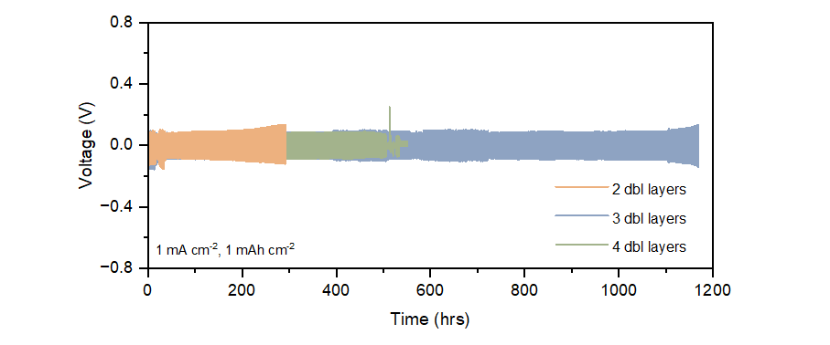
Figure S1. Galvanostatic charge-discharge (GCD) curves of the symmetric battery with different PAH/PAA layers at 1 mA cm⁻² and 1 mAh cm⁻².
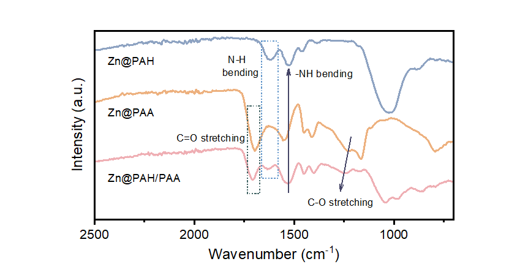

Wavenumber (cm⁻¹)  Chemical composition | Zn@PAH | Zn@PAA | Zn@PAH/PAA
C=O stretching (carboxylic acid) | N/A | 1695 | 1710
C-O stretching (carboxylic acid) | N/A | 1232 | 1247
N-H bending (amine) | 1624 | N/A | 1633
-NH bending (amide) | 1527 | N/A | 1532

Figure S2. Fourier transform infrared (FTIR) spectra of Zn@PAH, Zn@PAA, and Zn@PAH/PAA.

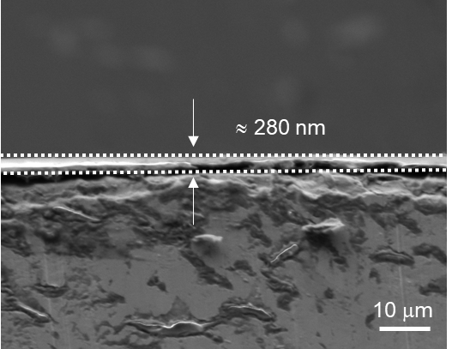
Figure S3. The cross-section SEM image of Zn@PAH/PAA before cycling.

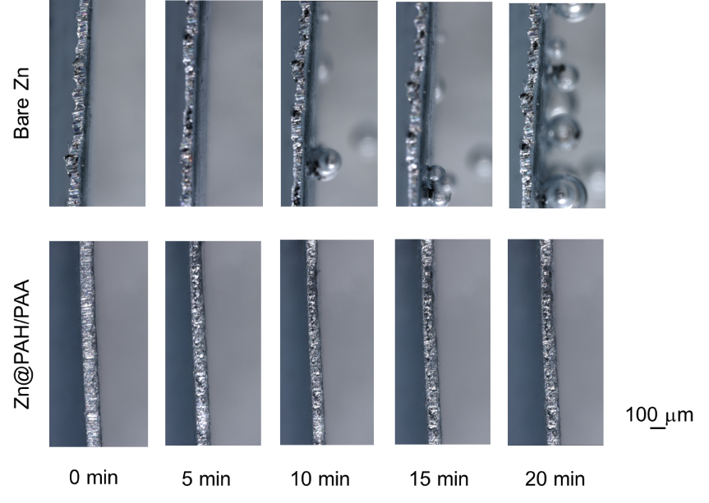
Figure S4. In-situ optical image of Zn stripping on Zn@PAH/PAA and Bare Zn at a current density of 30 mA cm⁻².
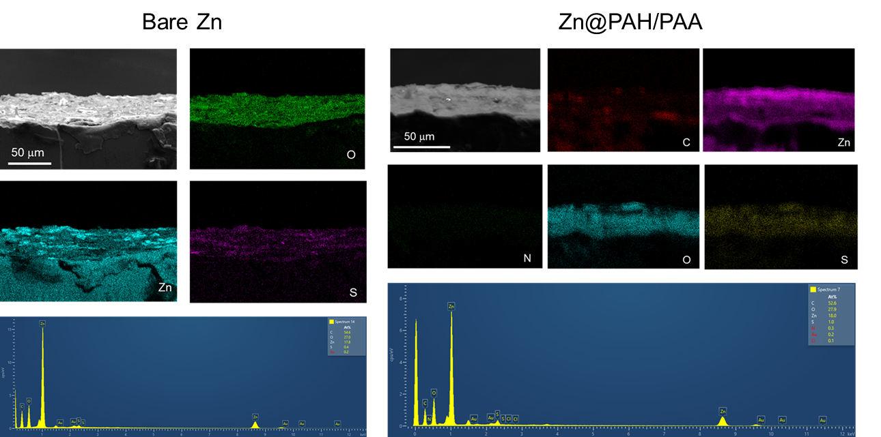

Figure S5. EDX images of Zn@PAH/PAA and Bare Zn after 50 cycles at 0.5 mA cm⁻² and 0.5 mAh cm⁻².
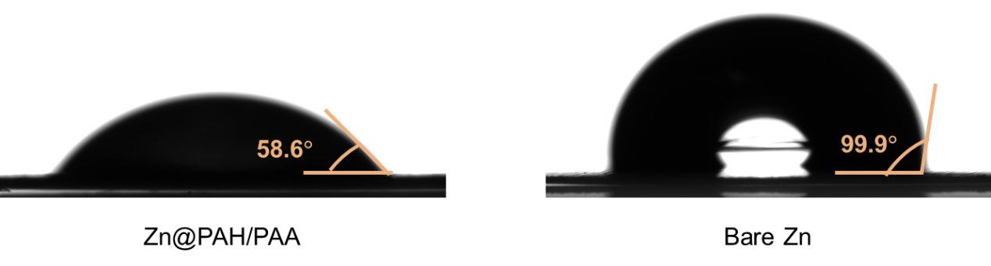
Figure S6. Contact angle test of 2M ZnSO₄ on Zn@PAH/PAA and Bare Zn.
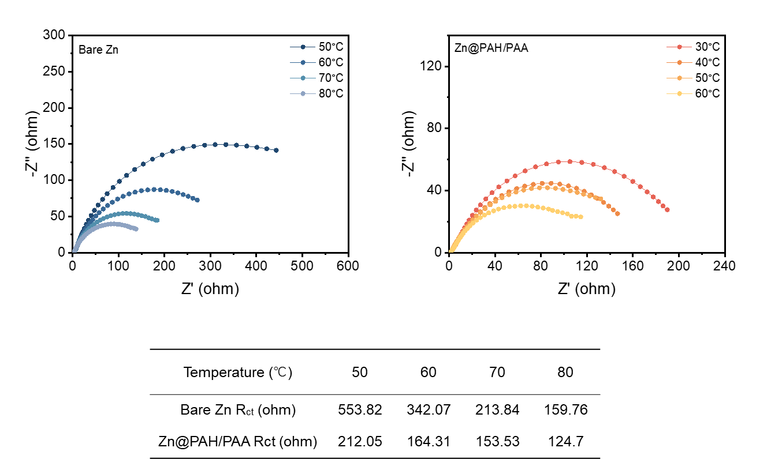

Figure S7. EIS test at different temperatures of Zn@PAH/PAA and Bare Zn.
Zn transference number was calculated by the equation as below, where the potentiation polarisation (∇V) is 5 mV, R_{o} and R_{ss} are the initial and steady state resistances, and I₀ and I_{ss} are initial and steady currents, respectively.
$t_{+}=\frac{(∇V/I_{0}-R_{0})}{(∇V/I_{ss}-R_{ss})}$
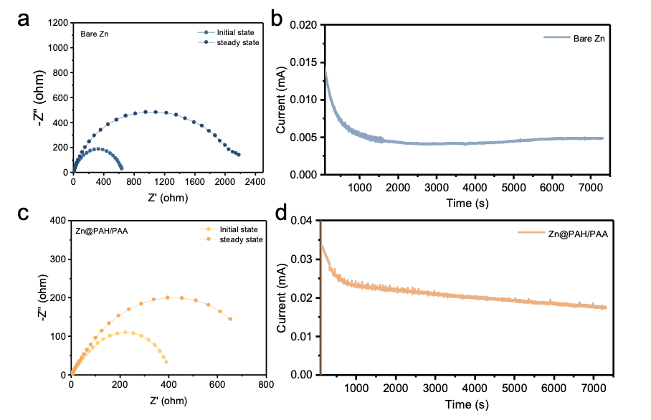
Figure S8. Zn transference number calculation. EIS test at before and after the potentiostatic polarisation for Bare Zn (a) and Zn@PAH/PAA (c). Current profile under the potentiostatic polarisation (∇V= 5 mV) for Bare Zn (b) and Zn@PAH/PAA (d).

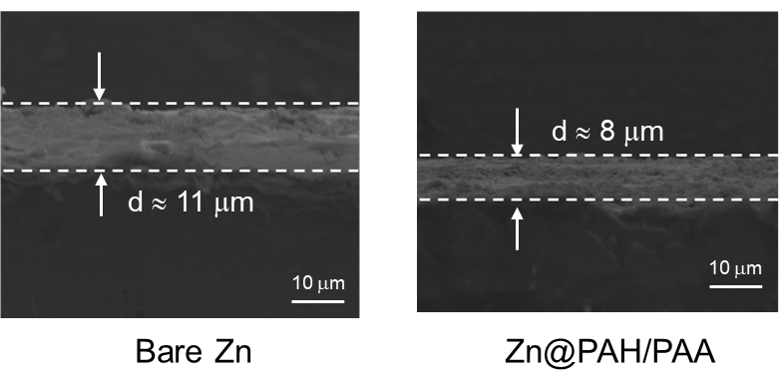
Figure S9. Cross-section SEM images after 50 cycles at 0.5 mA cm⁻² and 0.5mAh cm⁻².

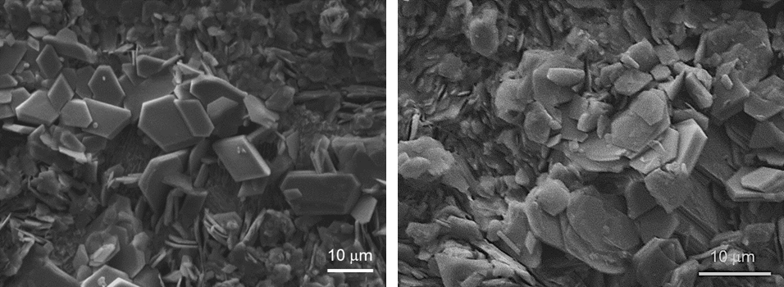
Figure S10. SEM images of Bare Zn after 50 cycles at 0.5 mA cm⁻² and 0.5mAh cm⁻².

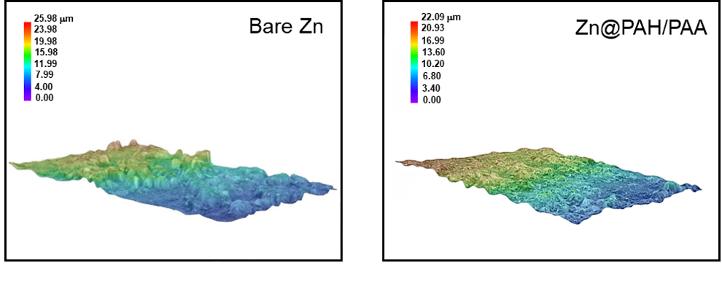
Figure S11. 3D depth profiles of Zn@PAH/PAA and Bare Zn after 50 cycles at 0.5 mA cm⁻² and 0.5mAh cm⁻².

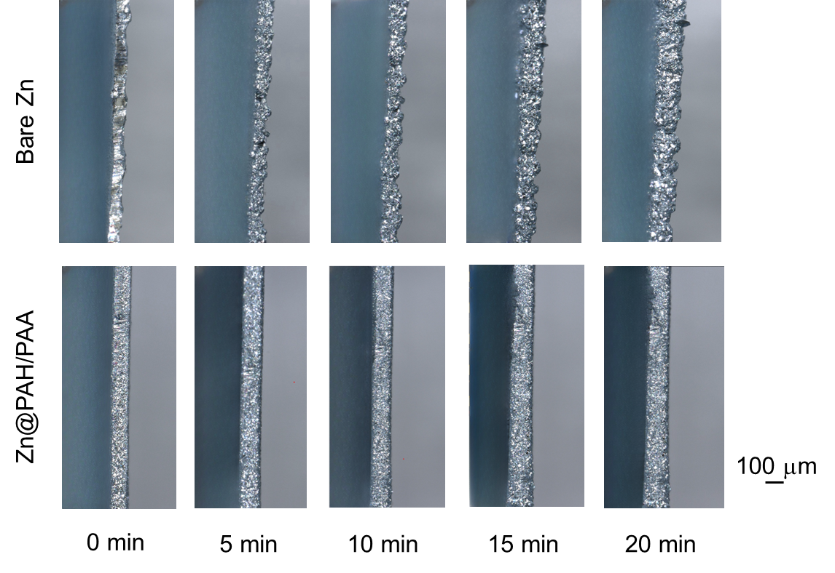
Figure S12. In-situ optical image of Zn plating on Zn@PAH/PAA and Bare Zn at a current density of 30 mA cm⁻².
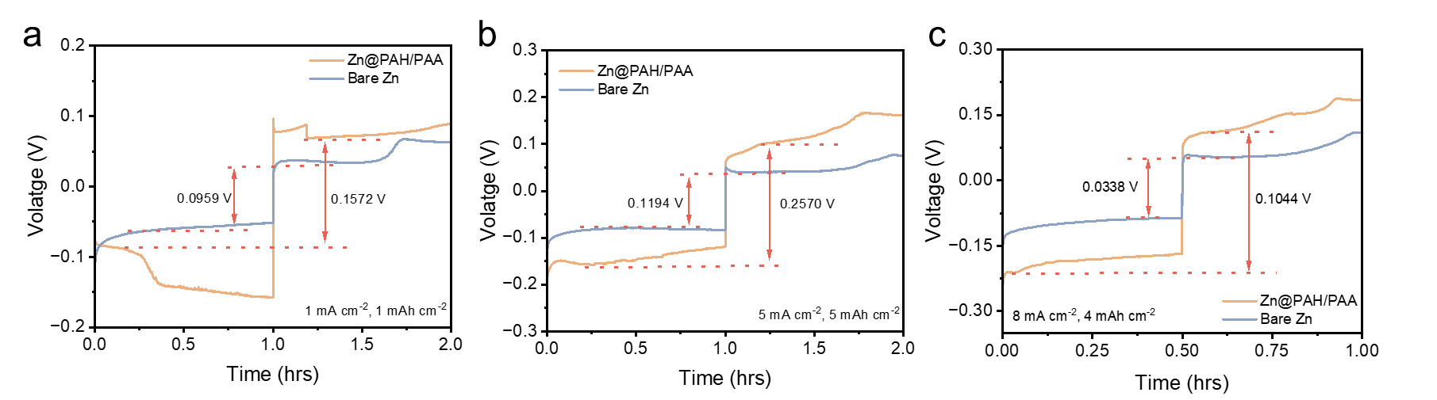
Figure S13. The voltage profile of the symmetric Zn cell at 1 mA cm⁻² and 1 mAh cm⁻² (a), 5 mA cm⁻² and 5 mAh cm⁻² (b), and 8 mA cm⁻² and 4 mAh cm⁻² (c).

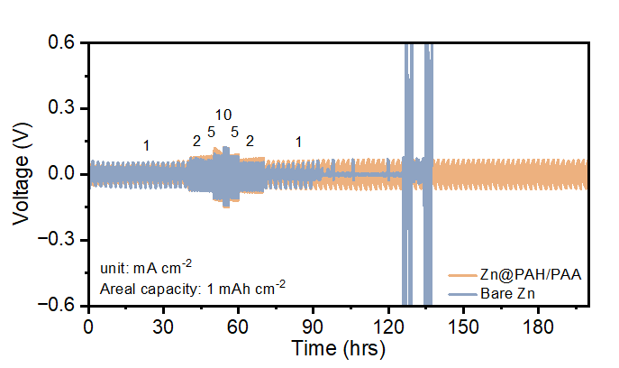
Figure S14. The rate performance of the symmetric Zn cell.
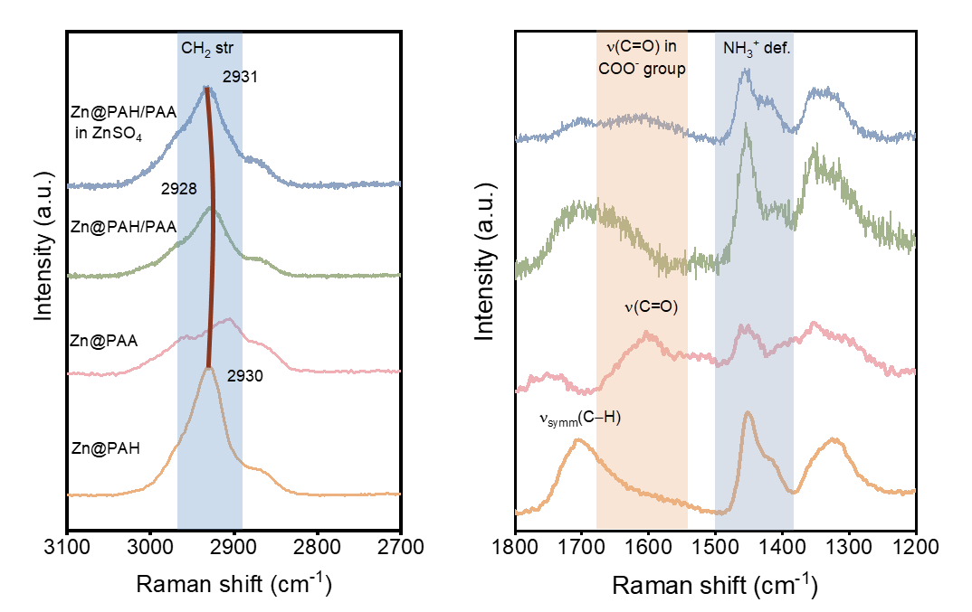
Figure S15. In-situ Raman spectra of different substrates.
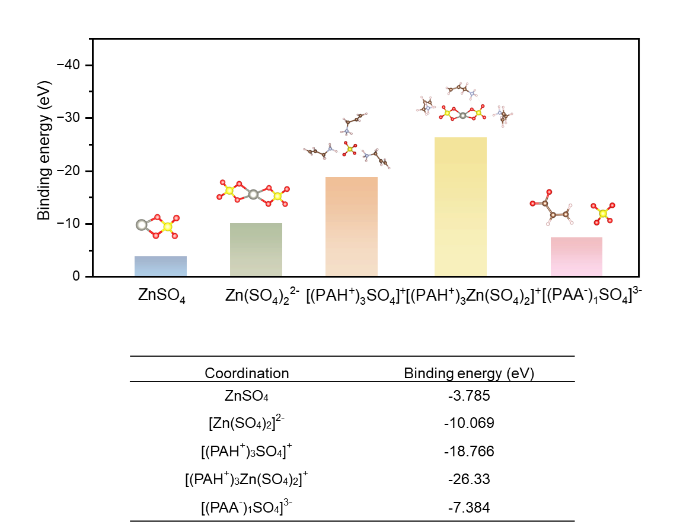
Figure S16. The binding energy of different coordination structure of PAH⁺.
Figure S17. CV curves at a scan rate of 0.1 mV s⁻¹ for the Zn-MnO₂ full cell.
Figure S18. The correspond voltage-capacity profile at different current density.

Table S1 XRD Intensity.

Plane | SA-coated Zn | Bare Zn
002 | 0.795 | 0.555
100 | 0.505 | 0.693
101 | 0.742 | 0.730

Table S2 Comparison of recent anode performance on CPC, cycle number and average CE.

Sample (coating layer) | Test condition | Cycle number | Cumulative plated capacity (mAh cm⁻²) | Average CE (%)
CCF (cerium based conversion film)¹ | 1.13 mA cm⁻²;0.57 mAh cm⁻² | 120 | 68.4 | 99.1
ZCS (Zn3(PO₄)₂ and ZnF₂ composite SEI layer)² | 4 mA cm⁻²;2 mAh cm⁻² | 90 | 180 | 99.54
PVA@SR-ZnMoO₄³ | 0.5 mA cm⁻²;0.5 mAh cm⁻² | ~500 | ~250 | 99.42
Polyamide (PA)⁴ | 0.4 mA cm⁻²;0.4 mAh cm⁻² | ~300 | ~120 | 97.34
ZnS⁵ | 2 mA cm⁻²;1 mAh cm⁻² | 200 | 200 | 99.2
ZnO(3D)⁶ | 2 mA cm⁻²;0.5 mAh cm⁻² | 300 | 150 | 99.55
PVB(poly(vinyl butyral))⁷ | 4 mA cm⁻²;2 mAh cm⁻² | 110 | 220 | 99.4
PAH/PAA | 0.5 mA cm⁻²;0.25 mAh cm⁻² | 1585 | 396 | 99.7

Table S3 The periodic band changes at -CH₂ and C=O groups.

CH₂ stretching
Cycle | 1st Dis | 1 st Chr | 2nd Dis | 2nd Chr | 3rd Dis | 3rd Chr
Raman shift (cm⁻¹) | 2925.8 | 2929.1 | 2926.4 | 2929.9 | 2924.4 | 2928.2

C=O vibration
Cycle | 1st Dis | 1 st Chr | 2nd Dis | 2nd Chr | 3rd Dis | 3rd Chr
Raman shift (cm⁻¹) | 1609.9 | 1616.7 | 1594.5 | 1604.7 | 1599.6 | 1604.2

Table S4 Comparison of anode performance regarding Zn metal pouch cells on capacity, cycle number and C-rate.

Reference | Material | Capacity (Ah) | C-rate | Cycle number
44 | VO₂ | 0.8 | 0.31 C | 200
45 | Zn_{0.25}V₂O₅⋅nH₂O | 2.3 | 0.16 C | 160
46 | Zn_{x}V₂O₅⋅nH₂O | 0.9 | 0.34 C | 200
47 | Commercial VOX | 2.7 | 0.14 C | 220
48 | V₂O₅⋅nH₂O | 1.32 | 0.17 C | 65
This work | VO₂ | 17.36 | 1.7 C | 250

Reference
1 Deng, C. et al. Stabilization of Zn metal anode through surface reconstruction of a cerium‐based conversion film. Advanced Functional Materials 31, 2103227 (2021).
2 Chu, Y. et al. In situ built interphase with high interface energy and fast kinetics for high performance Zn metal anodes. Energy & Environmental Science 14, 3609-3620 (2021).
3 Chen, A. et al. Multifunctional SEI-like structure coating stabilizing Zn anodes at a large current and capacity. Energy & Environmental Science 16, 275-284 (2023).
4 Zhao, Z. et al. Long-life and deeply rechargeable aqueous Zn anodes enabled by a multifunctional brightener-inspired interphase. Energy & Environmental Science 12, 1938-1949 (2019).
5 Hao, J. et al. An in‐depth study of Zn metal surface chemistry for advanced aqueous Zn‐ion batteries. Advanced Materials 32, 2003021 (2020).
6 Xie, X. et al. Manipulating the ion-transfer kinetics and interface stability for high-performance zinc metal anodes. Energy & Environmental Science 13, 503-510 (2020).
7 Hao, J. et al. Designing dendrite‐free zinc anodes for advanced aqueous zinc batteries. Advanced Functional Materials 30, 2001263 (2020).

