Supplementary Figures and Tables

Fig. S1 CtFTs promoter element analysis.

Fig. S2 PCR electrophoresis results of E.coli transformed by pCAMBIA3301-CtFTs.

Fig.S3 PCR electrophoresis results of Agrobacterium tumefaciens transformed by pCAMBIA3301-CtFTs.
Fig. S4 Screening of transgenic Arabidopsis thaliana lines with high expression of CtFTs. A:CtFT1 line;B:CtFT2 line;C:CtFT3 line.

Fig. S5 PCR Electrophoresis results of E.coli liquid transformed by pGreen II 62-SK-CtFTs
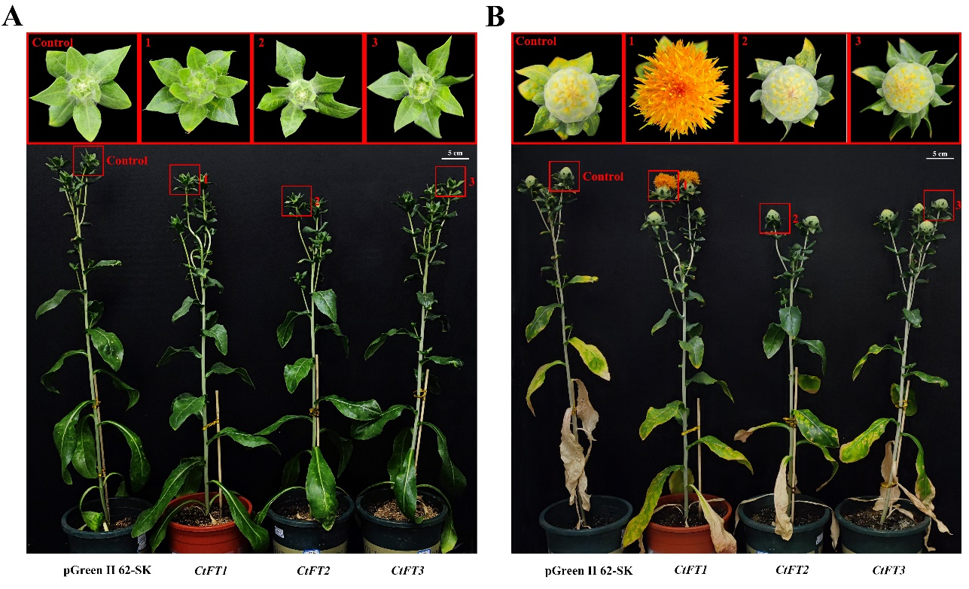
Fig. S6 Growth phenotype of transient overexpression of pGreenII62-SK-CtFTs in Carthamus tinctorius and empty Vector. A: safflower growth phenotype before injection; B: safflower growth phenotype 20 days after injection

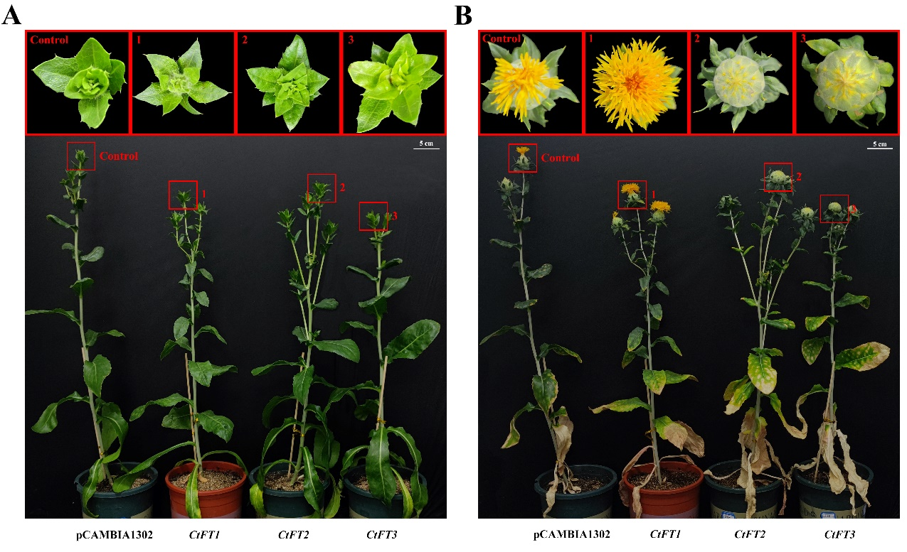
Fig. S7 Growth phenotype of transient overexpression of pCAMBIA1302-CtFTs in Carthamus tinctorius and empty Vector. A: safflower growth phenotype before injection; B: safflower growth phenotype 20 days after injection

Table S1. Physicochemical Properties of Carthamus tinctorius PEBP Family proteins
Gene Name | Gene ID | Protein Length | PI | MW (Da) | Subcellular  Localization | Instability Index | GRAVY
CtFT1 | CCG016893.1 | 175 | 7.75 | 19719.28 | cytoplasm | 42.40 | -0.406
CtFT2 | CCG011803.1 | 174 | 6.29 | 19681.24 | cytoplasm | 50.17 | -0.384
CtFT3 | CCG016894.1 | 176 | 6.83 | 19933.46 | cytoplasm | 45.07 | -0.449
CtTFL1-1 | CCG013216.1 | 152 | 9.16 | 17259.85 | cytoplasm | 43.06 | -0.297
CtTFL1-2 | CCG019669.1 | 170 | 4.76 | 19524.06 | microbody | 21.35 | -0.204
CtTFL1-3 | CCG000764.1 | 212 | 5.21 | 23811.78 | microbody | 58.35 | -0.557
CtMFT | CCG027220.1 | 151 | 9.55 | 16987.44 | cytoplasm | 35.33 | -0.384

Table S2. Primers used in qPCR for key structural genes of the flavonoid pathway in Arabidopsis.
Primer Name | Primer Sequence
qRT-AtCHS-F;  qRT-AtCHS-R | AGAAGTTCAAGCGCATGTGC;  AGAGAAGGAGCCATGTAAGCAC
qRT-AtCHI-F;  qRT-AtCHI-R | ACGCCGTTCCTTCTCTATCTG;  ACGGCAGTTTCATTGTCACC
qRT-AtF3H-F;  qRT-AtF3H-R | TCAGATCGTTGAGGCTTGTG;  ATGTCGAAACGGAGCTTGTC
qRT-AtF3’H-F;  qRT-AtF3’H-R | TGGATTACAAGCCACACGTG;  ACGACAAACGCTCCTTCAAC
qRT-AtFLS-F;  qRT-AtFLS-R | TGCAGTGCATGTGAAGAAGC;  CGAGACCTTCTTTCAACGCATC
qRT-AtDFR-F;  qRT-AtDFR-R | TCGGTCCATTCATCACAACG;  TGAGCGTTGCATAAGTCGTC
qRT-AtANS-F;  qRT-AtANS-R | TGCAAACGATCAAGCCACTG;  TTGTCCACTCGCGTTGTTAG
qRT-18srRNA-F;  qRT-18srRNA-R | GAGAAACGGCTACCACATCCAA;  TCGTTTGAGCCCGGTATTGTTA

Table S3. Primers used in qPCR for key structural genes of the flavonoid pathway in Carthamus tinctorius.

Primer Name | Primer Sequence
qRT-CtCHS1-F;  qRT-CtCHS1-R | AGACACAAGCGCTCGACATGT;  ATCTTGGACCAGGTCGAGGAA
qRT-CtCHI1-F;  qRT-CtCHI1-R | CGGTATGCAACATGCCGAA;  AAGATACTTGGCAATGGTTGCG
qRT-CtF3H-F;  qRT-CtF3H-R | GTCAAGTTGCATTCCCTTCTCG;  TTTTGCGGCTGAGATGTGAG
qRT-CtF3'H3-F;  qRT-CtF3'H3-R | TCCTTAACCCTAGGCTCATGCC;  TCTTGCCAGGAGGTGAAAAGC
qRT-CtFLS1-F;  qRT-CtFLS1-R | TGAAACAAGTGGTCCACCCAC;  ACCATAGCCAAGCCTGCAAA
qRT-CtDFR2-F;  qRT-CtDFR2-R | GAATCATCGGTTCTAACGGTGG;  GTTTGTGTAACTGGAGGCCGAG
qRT-CtANS1-F;  qRT-CtANS1-R | TGCCGGTGAAGGAGAAGAAA;  CAGCCCAATCAAGCTTTTGC
qRT-18srRNA-F;  qRT-18srRNA-R | GAGAAACGGCTACCACATCCAA;  TCGTTTGAGCCCGGTATTGTTA

