Appendix A
Climate change and the variability in community structure of Alpine Lepidoptera: unstable spring and fuzzy autumn

Werner Ulrich, Thomas Schmitt, Patrick Gros & Jan Christian Habel

Figure A1. Differences in monthly average temperature ΔT in average monthly temperatures between T1 (1990‒1999), T2 (2000‒2009), and T3 (2010‒2022). a)–c) Salzburg (430 m asl.), d)–f) Rauris (950 m asl.), g)–i) Schmittenhöhe (1965 m asl.) weather stations. Error bars denote standard errors. Black lines are third order polynomial regressions.

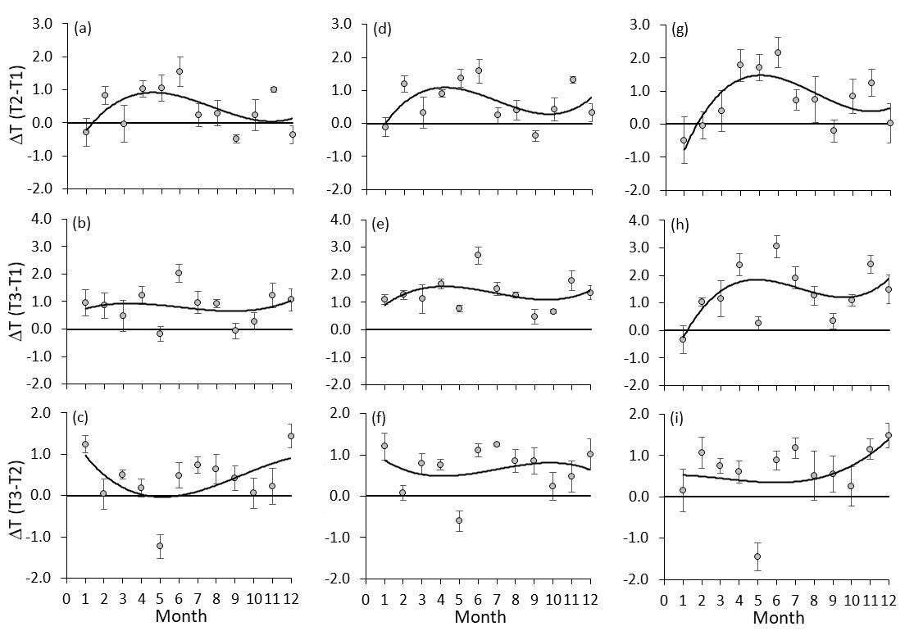
Figure A2. Differences in monthly average precipitation ΔP in average monthly temperatures between T1 (1990‒1999), T2 (2000‒2009), and T3 (2010‒2022). a)–c) Salzburg (430 m asl.), d)–f) Rauris (950 m asl.), g)–i) Schmittenhöhe (1965 m asl.) weather stations. Error bars denote standard errors. Black lines are third order polynomial regressions.

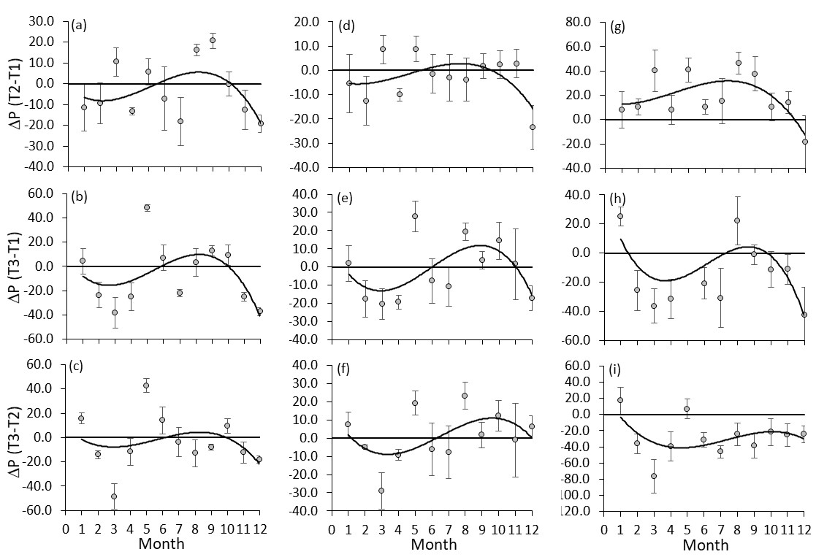
Figure A3. a) Annual numbers of Lepidoptera records in the Haus der Natur museum database on Lepidoptera of the Salzburg region (1990–2022). b) Total numbers of records from all years within 50 m bands from 380 to 3130 m asl. c) Annual numbers of Lepidoptera species. The inlet in a) shows the increase of richness (S) with increasing number of records (N). This is best fit by a power function with coefficient of determination r² = 0.50.

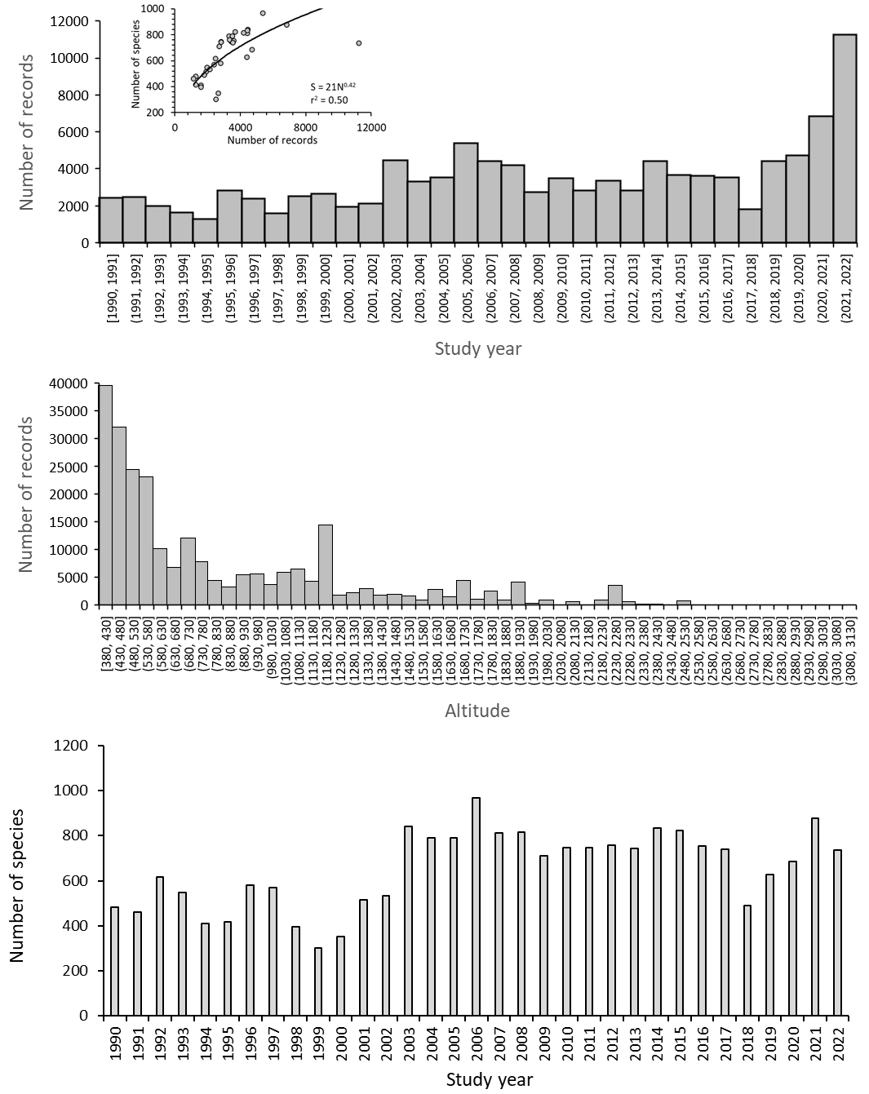
Figure A4. Maximum J_{S} and r_{S} values (J_{S}(w,w_{max}); r_{S}(w,w_{max}) in dependence on study year for lower (380–800 m asl.; a, c) and higher (800–1500 m asl.; b, d) altitudes. The four ordinary least squares regression lines (in red) are parametrically significant at P < 0.001.

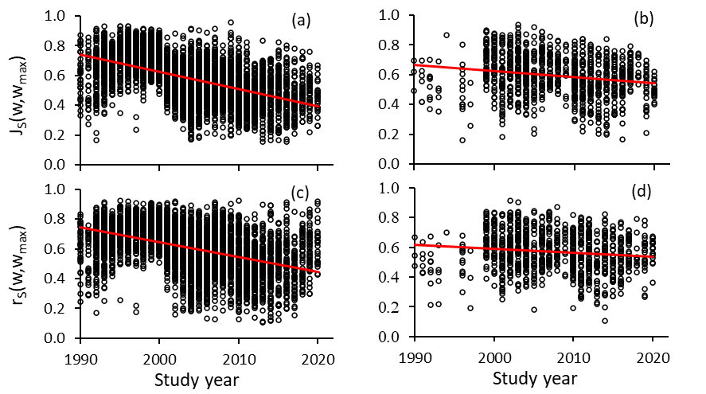
Figure A5. Differences in weeks Δw = w_{max} – w of J_{S}(w,w_{max}) (a) and r_{S}(w,w_{max}) (b) in dependence on the focal week w for all w communities taken from the T1 (1990–2000) time window and the w_{max} weeks from the T3 time window (2012–2022). Errors denote standard errors. Blue data: lowland; red data higher elevation.

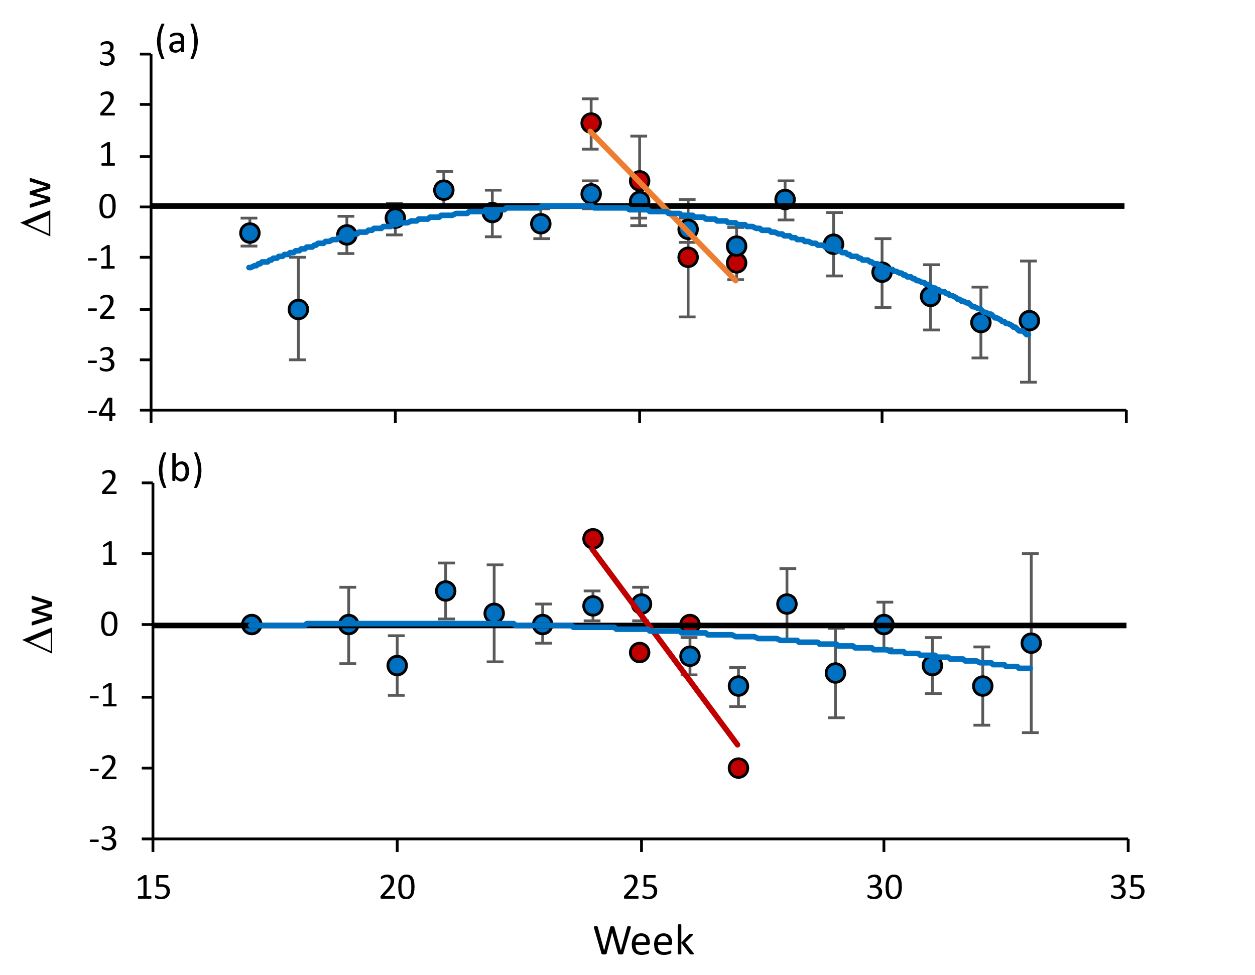
Table A1. General linear model; monthly precipitation and temperature as response, altitude as predicting factor, and study year and month as covariates.
Variable | β-value | St.Error | t-value | partial η²
Precipitation
Study year | -0.07 | 0.02 | -3.40*** | 0.01
Month | 0.11 | 0.02 | 5.47*** | 0.01
Month² | -0.54 | 0.03 | -24.86*** | 0.22
Altitude | - | - | 3.44*** | 0.01
r² model | - | - | - | 0.24
Temperature
Study year | 0.08 | 0.01 | 8.54*** | 0.04
Month | 0.21 | 0.02 | 23.29*** | 0.21
Month² | -0.92 | 0.01 | -92.06*** | 0.80
Altitude | - | - | -10.12*** | 0.21
r² model | - | - | - | 0.84

