Association between hematocrit-to-albumin ratio and acute kidney injury in patients with acute pancreatitis: a retrospective cohort study
supplementary materials

Hospital admission information for patients with AP was extracted according to International Classification of Diseases, 9th Revision (ICD - 9) code 5770 and 10th Revision (ICD - 10) codes K859, K8520, K8580, K8591, K8500, K8592, K8511, K8530, K853, K8581, K850, K8501, K8582, K8502, K8531, K8590, K858, K8510, K851, K8512, K860, K852, K8521, K8522, K51011, K51018, K51019, J0140, and J0141, with a total of 1609 had been admitted to the ICU.
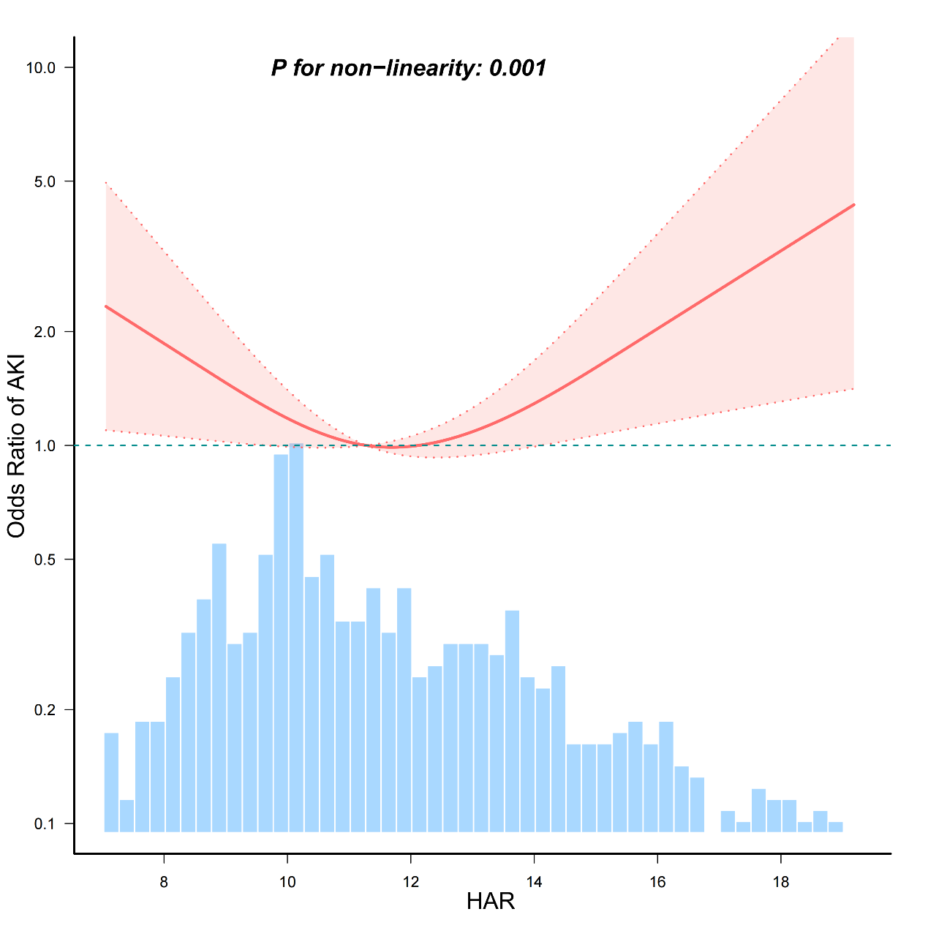
Figure S1. The Nonlinear association between HAR and AKI in patients with acute pancreatitis. Adjusted for all covariates as model 3 with MIMIC-IV database. Solid lines represent the odds ratio of AKI and dotted lines represent the corresponding 95% CI. OR = 1 was set as the reference line. (takes the upper limit of 97%).
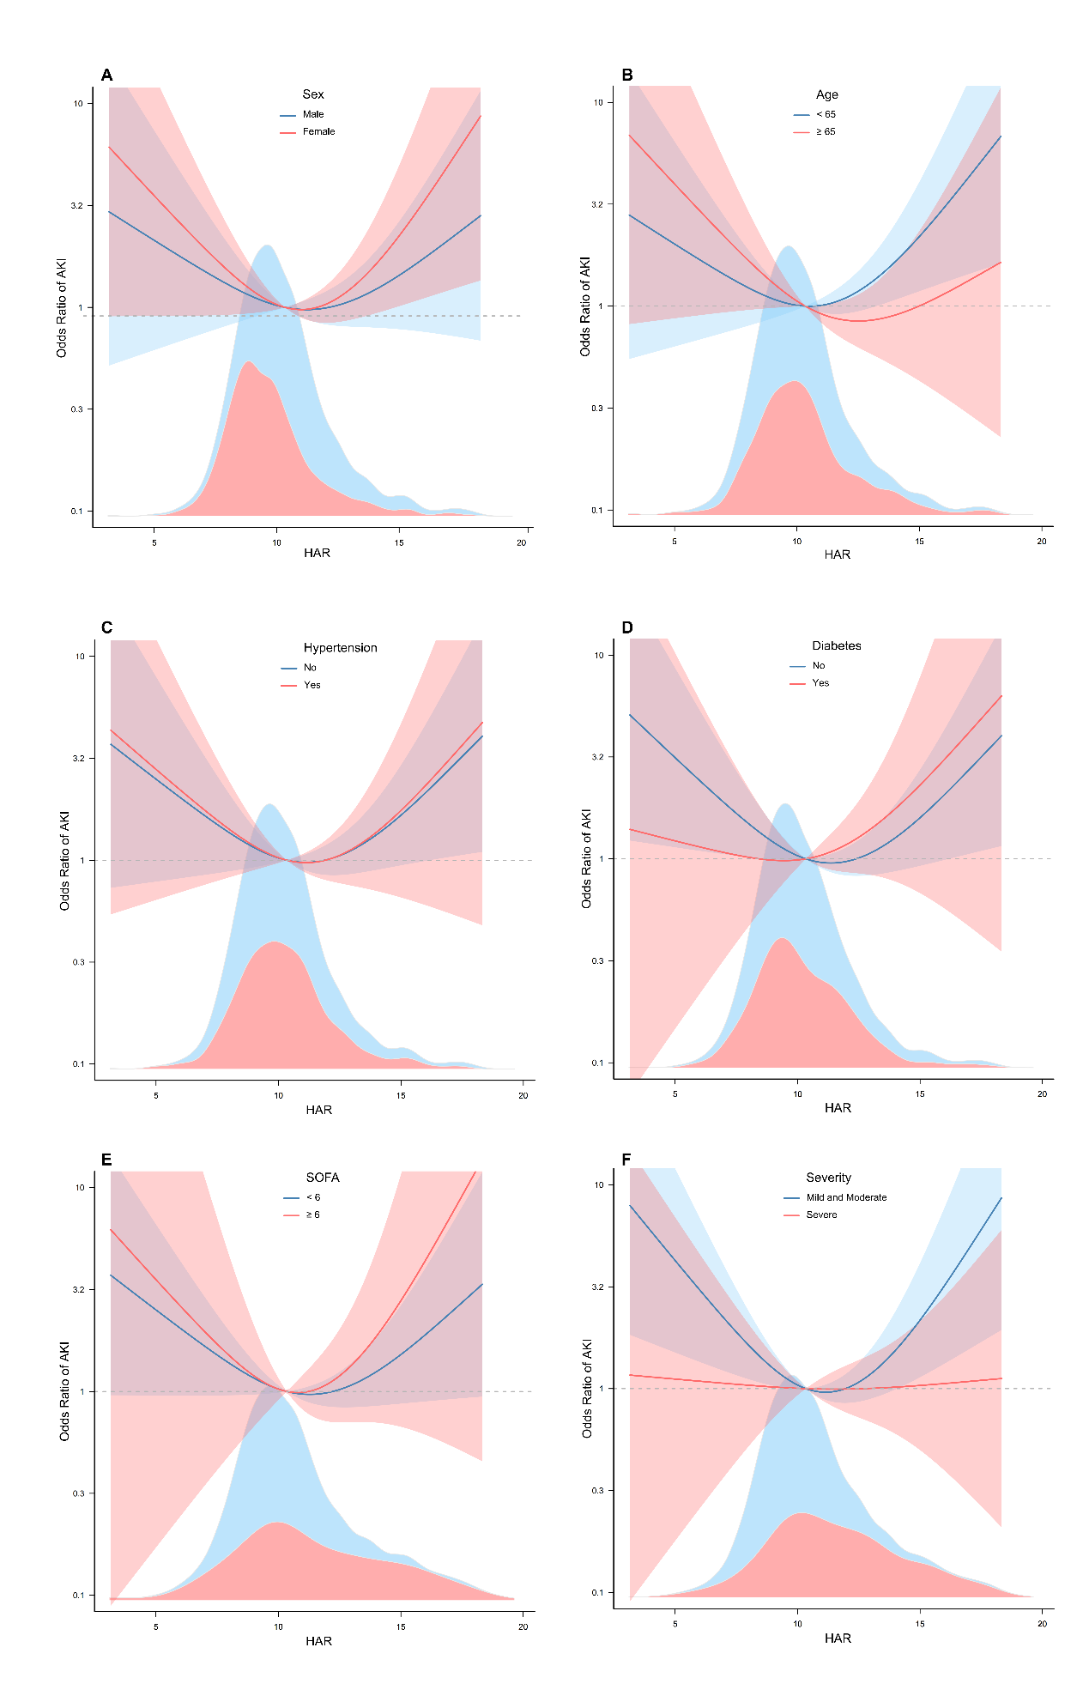
Figure S2. Subgroups with Chinese population. Solid lines represent the odds ratio of AKI and dotted lines represent the corresponding 95% CI. ORs were adjusted for variates with model 3. OR = 1 was set as the reference line.

 | Characteristics |  | Chinese population  Total  (n = 1514) |  | MIMIC-IV  Total  (n = 672)
 | Sex (%)
 | male |  | 812 (53.6) |  | 387 (57.6)
 | female |  | 702 (46.4) |  | 285 (42.4)
 | Age (years) |  | 53.0 (41.0, 65.0) |  | 56.0 (45.0, 70.0)
Death (%) |  | 23 (1.5) |  | 96 (14.3)
 | ICU (%) |  | 247 (16.3) |  | N/A
 | LOS (days) |  | 16.6 ± 12.7 |  | 12.0 (6.0, 20.0)
 | Hypertension (%) |  | 392 (25.9) |  | 375 (55.8)
 | DM (%) |  | 225 (14.9) |  | 255 (37.9)
 | CHD (%) |  | 103 (6.8) |  | 123 (18.3)
 | SBP (mmHg) |  | 129.0 (117.0, 143.0) |  | 126.0 (110.0, 144.2)
 | DBP (mmHg) |  | 80.0 (72.0, 90.0) |  | 73.0 (61.0, 85.0)
 | HR (bpm) |  | 80.0 (72.0, 93.0) |  | 98.5 (83.0, 114.0)
 | RR (bpm) |  | 20.0 (19.0, 20.0) |  | 22.0 (18.0, 26.0)
 | SpO₂(%) |  | 99.0 (97.0, 100.0) |  | N/A
 | P/F |  | N/A |  | 218.2 (152.7, 329.0)
 | Ventilation (%) |  | 158 (10.4) |  | 556 (82.7)
 | Transfusion (%) |  | 168 (11.1) |  | 61 (9.1)
 | CRRT (%) |  | 92 (6.1) |  | 55(8.2)
 | WBC (×10^9/L) |  | 9.8 (6.6, 13.6) |  | 11.8 (7.7, 17.5)
 | HGB (g/L) |  | 129.0 (114.0, 145.0) |  | 11.4 (10.0, 13.0)
 | HCT (%) |  | 38.5 (34.5, 42.7) |  | 34.2 (30.0, 39.2)
 | PCT (ng/ml) |  | 0.2 (0.1, 0.9) |  | N/A
 | CRP (mg/L) |  | 37.1 (6.6, 134.7) |  | N/A
 | AST (U/L) |  | 41.0 (23.0, 139.5) |  | 73.0 (35.0, 178.2)
 | ALB (g/dl) |  | 3.8 (3.4, 4.2) |  | 3.0 (2.6, 3.5)
 | FPG (mmol/L) |  | 6.7 (5.3, 9.1) |  | 7.3 (5.6, 10.1)
 | TG (mmol/L) |  | 1.5 (1.0, 3.6) |  | 1.8 (1.1, 3.9)
 | Na (mmol/L) |  | 139.6 (136.7, 141.8) |  | 138.0 (135.0, 141.0)
 | Ca (mmol/L) |  | 2.2 (2.0, 2.4) |  | 2.0 (1.9, 2.1)
 | CREA (μmol/L) |  | 68.0 (55.0, 85.2) |  | 97.2 (61.9, 159.1)
 | Lac (mmol/L) |  | N/A |  | 1.7 (1.2, 2.6)
 | AKI (%) |  | 257 (17.0) |  | 322 (47.9)
 | SOFA |  | 2.7 ± 2.5 |  | 5.0 (3.0, 9.0)
 | Etiology (%) |  |  |  | N/A
 | biliary |  | 1019 (67.3)
 | hyperlipidemic |  | 354 (23.4)
 | alcoholic |  | 51 (3.4)
 | others |  | 90 (5.9)
 | Severity (%) |  |  |  | N/A
 | mild and moderate |  | 1343 (88.7)
 | severe |  | 171 (11.3)
 | BISAP |  | 1.0 (0.0, 2.0) |  | N/A
Table S1. Baseline characteristics of included patients grouped by two databases of Chinese population and MIMIC-IV.

Variables | Total (n = 1514) | Non-ICU (n = 1267) | ICU (n = 247) | p
Sex (%) |  |  |  | 0.108
male | 812 (53.6) | 668 (52.7) | 144 (58.3)
female | 702 (46.4) | 599 (47.3) | 103 (41.7)
Age (years) | 53.0 (41.0, 65.0) | 52.0 (41.0, 64.0) | 58.0 (44.5, 70.0) | < 0.001
Hypertension (%) | 392 (25.9) | 319 (25.2) | 73 (29.6) | 0.151
DM (%) | 225 (14.9) | 181 (14.3) | 44 (17.8) | 0.154
CHD (%) | 103 (6.8) | 76 (6) | 27 (10.9) | 0.005
COPD (%) | 64 (4.2) | 47 (3.7) | 17 (6.9) | 0.023
Weight(kg) | 64.0 (55.0, 75.0) | 65.0 (56.0, 75.0) | 62.0 (54.0, 75.0) | 0.136
Height(cm) | 164.0 (158.0, 170.0) | 163.0 (157.5, 170.0) | 167.0 (160.0, 172.0) | < 0.001
BMI | 24.2 (21.7, 26.7) | 24.2 (22.0, 26.7) | 23.1 (20.2, 26.6) | < 0.001
SBP (mmHg) | 129.0 (117.0, 143.0) | 130.0 (119.0, 143.0) | 123.0 (106.5, 145.0) | < 0.001
DBP (mmHg) | 80.0 (72.0, 90.0) | 80.0 (73.0, 90.0) | 78.0 (66.0, 88.0) | < 0.001
HR (bpm) | 80.0 (72.0, 93.0) | 78.0 (72.0, 90.0) | 95.0 (80.0, 114.5) | < 0.001
Temperature | 36.5 (36.4, 36.7) | 36.5 (36.4, 36.6) | 36.6 (36.5, 36.8) | < 0.001
RR (bpm) | 20.0 (19.0, 20.0) | 20.0 (19.0, 20.0) | 20.0 (19.0, 23.0) | < 0.001
SpO₂(%) | 99.0 (97.0, 100.0) | 99.0 (98.0, 100.0) | 97.0 (94.0, 99.0) | < 0.001
Ventilation (%) | 158 (10.4) | 5 (0.4) | 153 (61.9) | < 0.001
Transfusion (%) | 168 (11.1) | 36 (2.8) | 132 (53.4) | < 0.001
CRRT (%) | 92 (6.1) | 16 (1.3) | 76 (30.8) | < 0.001
WBC(×10⁹/L) | 9.8 (6.6, 13.6) | 9.6 (6.5, 13.1) | 11.7 (8.1, 17.4) | < 0.001
HGB(g/L) | 129.0 (114.0, 145.0) | 129.0 (115.5, 145.0) | 127.0 (100.0, 144.5) | 0.009
HCT (%) | 38.5 (34.5, 42.7) | 38.7 (34.9, 42.5) | 37.9 (30.2, 43.0) | 0.020
PLT(×10⁹/L) | 179.0 (137.0, 233.0) | 183.0 (142.0, 234.0) | 157.0 (110.5, 216.0) | < 0.001
NEUT(×10⁹/L) | 8.2 (4.9, 11.6) | 7.9 (4.7, 11.2) | 9.6 (6.6, 15.1) | < 0.001
LYMPH(×10⁹/L) | 1.0 (0.7, 1.4) | 1.0 (0.7, 1.4) | 0.8 (0.6, 1.2) | < 0.001
MONO(×10⁹/L) | 0.6 (0.4, 0.8) | 0.5 (0.4, 0.7) | 0.6 (0.4, 1.0) | < 0.001
RDW (fL) | 13.0 (12.4, 13.7) | 13.1 (12.5, 13.7) | 12.8 (12.3, 13.3) | < 0.001
PCT (ng/ml) | 0.2 (0.1, 0.9) | 0.1 (0.0, 0.5) | 1.3 (0.4, 8.1) | < 0.001
CRP (mg/L) | 37.1 (6.6, 134.7) | 31.4 (5.9, 116.6) | 93.4 (14.4, 206.5) | < 0.001
AST(U/L) | 41.0 (23.0, 139.5) | 38.0 (22.0, 134.0) | 54.0 (31.0, 186.5) | < 0.001
ALT(U/L) | 46.0 (22.0, 153.0) | 47.0 (22.0, 157.0) | 41.0 (21.0, 95.0) | 0.114
TBIL (µmol/L) | 21.8 (13.3, 42.6) | 22.2 (13.7, 43.7) | 20.1 (11.8, 37.5) | 0.056
DBIL (µmol/L) | 7.8 (4.0, 22.2) | 7.7 (4.0, 23.0) | 8.9 (4.3, 21.2) | 0.292
ALB (g/dl) | 3.8. (3.4, 4.2) | 3.9.3(3.5, 4.3) | 3.2 (2.8, 3.8) | < 0.001
FPG (mmol/L) | 6.7 (5.3, 9.1) | 6.6 (5.3, 8.9) | 7.9 (5.8, 11.1) | < 0.001
AMY(U/L) | 167.5 (67.0, 699.8) | 164.0 (65.7, 703.0) | 193.0 (79.5, 637.0) | 0.139
LIPASE(U/L) | 204.1 (69.3, 716.4) | 208.0 (69.8, 733.8) | 185.4 (65.2, 650.0) | 0.421
PA (mg/L) | 160.1 (107.8, 212.8) | 163.3 (113.0, 209.7) | 136.0 (89.2, 250.0) | 0.119
HbA1c | 5.9 (5.4, 7.2) | 5.9 (5.4, 7.2) | 5.9 (5.4, 7.4) | 0.348
TG (mmol/L) | 1.5 (1.0, 3.6) | 1.5 (1.0, 3.8) | 1.7 (1.1, 3.2) | 0.207
CHOL (mmol/L) | 4.6 (3.7, 5.9) | 4.6 (3.8, 5.8) | 4.5 (3.1, 9.9) | 0.588
LDL (mmol/L) | 2.1 (1.5, 2.9) | 2.2 (1.5, 2.9) | 1.7 (1.1, 2.6) | < 0.001
HDL (mmol/L) | 1.1 (0.8, 1.5) | 1.2 (0.9, 1.5) | 0.7 (0.4, 1.2) | < 0.001
Na(mmol/L) | 139.6 (136.7, 141.8) | 139.6 (136.9, 141.7) | 138.8 (135.4, 142.1) | 0.136
Ca(mmol/L) | 2.2 (2.0, 2.4) | 2.2 (2.1, 2.4) | 2.0 (1.8, 2.2) | < 0.001
BUN (mmol/L) | 5.3 (4.0, 7.1) | 5.0 (3.9, 6.5) | 8.4 (5.5, 14.1) | < 0.001
CREA (µmol/L) | 68.0 (55.0, 85.2) | 66.0 (53.5, 79.0) | 101.0 (69.0, 195.5) | < 0.001
HAR | 10.1 (9.0, 11.3) | 10.0 (9.0, 11.0) | 11.0 (9.5, 13.2) | < 0.001
Etiology of AP (%) | nan | nan | nan | < 0.001
biliary | 1019 (67.3) | 916 (72.3) | 103 (41.7)
hyperlipidemic | 354 (23.4) | 310 (24.5) | 44 (17.8)
alcoholic | 51 (3.4) | 41 (3.2) | 10 (4)
others | 90 (5.9) | 0 (0) | 90 (36.4)
Severity (%) | nan | nan | nan | < 0.001
mild and moderate | 1343 (88.7) | 1266 (99.9) | 77 (31.2)
severe | 171 (11.3) | 1 (0.1) | 170 (68.8)
SOFA | 2.7 ± 2.5 | 2.1 ± 1.6 | 5.9 ± 3.7 | < 0.001
BISAP | 1.0 (0.0, 2.0) | 1.0 (0.0, 2.0) | 2.0 (1.0, 3.0) | < 0.001
Death (%) | 23 (1.5) | 0 (0) | 23 (9.3) | < 0.001
LOS(days) | 16.6 ± 12.7 | 15.0 ± 8.2 | 25.2 ± 23.6 | < 0.001
ICU (%) | 247 (16.3) | 0 (0) | 247 (100) | < 0.001
AKI (%) | 257 (17.0) | 125 (9.9) | 132 (53.4) | < 0.001
Table S2. Non-ICU vs. ICU in Chinese population

 | Chinese population |  |  | MIMIC-IV population
Characteristics | No-AKI (n = 1257) | AKI (n = 257) | p-value | No-AKI (n= 350) | AKI (n = 322) | p-value
Sex (%) |  |  | < 0.001 |  |  | 0.135
male | 642 (51.1) | 170 (66.1) |  | 192 (54.9) | 195 (60.6)
female | 615 (48.9) | 87 (33.9) |  | 158 (45.1) | 127 (39.4)
Age (years) | 53.0 (41.0, 64.0) | 56.0(44.0, 69.0) | 0.002 | 54.0 (43.0, 67.0) | 59.5 (47.0, 72.8) | 0.001
Death (%) | 5 (0.4) | 18 (7) | < 0.001 | 18 (5.1) | 78 (24.2) | < 0.001
LOS(days) | 13.0 (10.0, 18.0) | 16.0 (10.0, 26.0) | < 0.001 | 9.0 (5.0, 16.0) | 16.0 (8.0, 26.0) | < 0.001
ICU (%) | 115 (9.1) | 132 (51.4) | < 0.001 | 350（100） | 322（100）
Hypertension (%) | 304 (24.2) | 88 (34.2) | < 0.001 | 204 (58.3) | 171 (53.1) | 0.177
DM (%) | 177 (14.1) | 48 (18.7) | 0.059 | 121 (34.6) | 134 (41.6) | 0.06
CHD (%) | 77 (6.1) | 26 (10.1) | 0.021 | 58 (16.6) | 65 (20.2) | 0.226
COPD (%) | 48 (3.8) | 16 (6.2) | 0.081 | N/A | N/A
Weight(kg) | 64.0 (56.0, 75.0) | 65.0 (55.0, 75.0) | 0.704 | 79.1 (68.8, 96.5) | 83.2 (71.1, 99.4) | 0.016
Height(cm) | 163.0(158.0, 170.0) | 167.0(158.0, 172.0) | 0.001 | 170.0(163.0, 178.0) | 170.0(163.0, 178.0) | 0.877
BMI | 24.1 (21.8, 26.7) | 24.2 (20.8, 26.9) | 0.437 | N/A | N/A
SBP (mmHg) | 130.0(119.0, 143.0) | 123.0(110.0, 140.0) | < 0.001 | 130.0(113.0, 146.0) | 122.0(105.2, 143.0) | 0.005
DBP (mmHg) | 80.0 (74.0, 90.0) | 80.0 (66.0, 89.0) | < 0.001 | 76.0 (64.0, 88.8) | 68.0 (58.0, 81.8) | < 0.001
HR (bpm) | 78.0 (72.0, 90.0) | 90.0 (76.0, 110.0) | < 0.001 | 99.0 (83.0, 114.0) | 98.0 (83.0, 115.0) | 0.599
Temperature | 36.5 (36.4, 36.6) | 36.5 (36.4, 36.8) | 0.013 | N/A | N/A
RR (bpm) | 20.0 (19.0, 20.0) | 20.0 (19.0, 21.0) | 0.009 | 21.0 (17.0, 24.8) | 22.0 (19.0, 27.0) | < 0.001
SpO₂(%) | 99.0 (98.0, 100.0) | 98.0 (96.0, 100.0) | < 0.001 | N/A | N/A
P/F | N/A | N/A |  | 231.7 (172.9, 374.0) | 207.9 (138.2, 296.3) | < 0.001
Ventilation (%) | 73 (5.8) | 85 (33.1) | < 0.001 | 1.6 (0.7, 3.2) | 3.4 (1.2, 11.0) | < 0.001
Transfusion (%) | 70 (5.6) | 98 (38.1) | < 0.001 | 26 (7.4) | 35 (10.9) | 0.121
CRRT (%) | 21 (1.7) | 71 (27.6) | < 0.001 | 11 (3.1) | 44 (13.7) | < 0.001
PLT (×10⁹/L) | 181.0(139.0, 234.0) | 172.0(110.0, 227.0) | 0.004 | 198.0(138.2, 285.5) | 177.0(122.2, 242.0) | < 0.001
PCT (ng/ml) | 0.1 (0.0, 0.6) | 1.1 (0.2, 6.5) | < 0.001 | N/A | N/A
CRP (mg/L) | 31.4 (5.9, 119.0) | 88.7 (16.9, 200.2) | < 0.001 | N/A | N/A
ALB(g/dl) | 3.9 (3.5, 4.3) | 3.5 (2.9, 4.0) | < 0.001 | 3.1 (2.7, 3.6) | 3.0 (2.4, 3.3) | < 0.001
FPG (mmol/L) | 6.6 (5.3, 8.9) | 7.5 (5.7, 11.2) | < 0.001 | 6.7 (5.3, 9.3) | 7.9 (5.9, 12.3) | < 0.001
TG (mmol/L) | 1.5 (1.0, 3.4) | 1.8 (1.2, 6.4) | < 0.001 | 1.6 (1.1, 3.3) | 2.0 (1.2, 5.2) | 0.008
Ca (mmol/L) | 2.2 (2.1, 2.4) | 2.1 (1.9, 2.3) | < 0.001 | 2.0 (1.9, 2.2) | 2.0 (1.8, 2.1) | < 0.001
CREA (µmol/L) | 65.8 (53.8, 77.0) | 143.0 (107.0, 226.0) | < 0.001 | 70.7 (53.0, 88.4) | 145.9 (97.2, 265.2) | < 0.001
AMY(U/L) | 163.0 (64.5, 716.0) | 202.0(92.0, 607.0) | 0.065 | 168.0(64.5, 425.0) | 280.0(78.2, 746.0) | < 0.001
PA (mg/L) | 162.3(111.0, 210.0) | 144.8(92.0, 230.0) | 0.625 | N/A | N/A
Severity of AP (%)  Mild and moderate | 1181 (94) | 162 (63) | < 0.001 | N/A | N/A
severe | 76 (6) | 95 (37)
Etiology of AP (%) |  |  | < 0.001 | N/A | N/A
biliary | 887 (70.6) | 132 (51.4)
hyperlipidemic | 289 (23) | 65 (25.3)
alcoholic | 42 (3.3) | 9 (3.5)
others | 39 (3.1) | 51 (19.8)
Lac (mmol/L) | N/A | N/A |  | 1.5 (1.1, 2.0) | 2.0 (1.4, 3.5) | < 0.001
HAR | 10.0 (9.0, 11.0) | 10.7 (9.2, 12.8) | < 0.001 | 11.4 ± 2.6 | 12.2 ± 3.6 | 0.002
Table S3. Baseline characteristics of included patients grouped by the occurrence of AKI in two databases of Chinese population and MIMIC-IV.

Characteristics | OR_95CI | p-value
Sex | 0.53 (0.4~0.71) | <0.001
Age | 1.01 (1.01~1.02) | 0.001
Death | 18.86 (6.93~51.29) | <0.001
LOS | 1.02 (1.01~1.03) | <0.001
ICU | 10.49 (7.69~14.31) | <0.001
Hypertension | 1.63 (1.22~2.18) | 0.001
DM | 1.4 (0.99~1.99) | 0.06
CHD | 1.72 (1.08~2.75) | 0.022
SBP | 0.99 (0.98~1) | 0.001
DBP | 0.99 (0.98~1) | 0.003
HR | 1.03 (1.02~1.04) | <0.001
RR | 1.04 (1.02~1.06) | <0.001
SpO₂ | 0.85 (0.81~0.89) | <0.001
Ventilation | 8.02 (5.64~11.39) | <0.001
Transfusion | 10.45 (7.38~14.81) | <0.001
CRRT | 22.47 (13.48~37.44) | <0.001
WBC | 1.07 (1.05~1.09) | <0.001
HGB | 1 (0.99~1) | 0.277
HCT | 0.97 (0.95~0.99) | 0.012
PCT | 1.02 (1.01~1.02) | <0.001
CRP | 1 (1~1.01) | <0.001
AST | 1 (1~1) | 0.036
ALB | 0.91 (0.89~0.93) | <0.001
FPG | 1.06 (1.04~1.08) | <0.001
TG | 1.03 (1.01~1.05) | 0.005
Na | 0.94 (0.91~0.97) | <0.001
Ca | 0.16 (0.09~0.26) | <0.001
CREA | 1.06 (1.05~1.06) | <0.001
SOFA | 1.48 (1.4~1.57) | <0.001
BISAP | 1.845(1.64~2.08) | <0.001
Severity. severe vs. mild and moderate | 9.11 (6.46~12.85) | <0.001
Etiology. Hyperlipidemic vs. biliary | 1.51 (1.09~2.09) | 0.013
Etiology. Alcoholic vs. biliary | 1.44 (0.69~3.03) | 0.336
Etiology. Others vs. biliary | 8.79 (5.57~13.85) | <0.001
HAR | 1.24(1.17~1.32) | <0.001
Table S4. Univariate Logistic regression analysis for AKI in Chinese population.

 | Chinese population |  | MIMIC-IV population
Characteristics | The number of missing values | The percentage of missing values (%) | The number of missing values | The percentage of missing values (%)
Age | 0 | 0.0 | 0 | 0.0
AKI | 0 | 0.0 | 0 | 0.0
ALB | 7 | 0.4499 | 0 | 0.0
ALT | 7 | 0.4499 | 14 | 2.0833
AMY | 57 | 3.6632 | 377 | 56.1012
AST | 78 | 5.0129 | 12 | 1.7857
BISAP | 1 | 0.0643 | 672 | 100
BMI | 53 | 3.4062 | 672 | 100
BUN | 1 | 0.0643 | 3 | 0.4464
Ca | 1 | 0.0643 | 6 | 0.8929
CHD | 0 | 0.0 | 0 | 0.0
CHOL | 284 | 18.2519 | N/A | N/A
CKD | 0 | 0.0 | N/A | N/A
COPD | 0 | 0.0 | N/A | N/A
CREA | 0 | 0.0 | 1 | 0.1488
CRP | 25 | 1.6067 | 656 | 97.619
CRRT | 0 | 0.0 | 0 | 0.0
DBIL | 7 | 0.4499 | 534 | 79.4643
DBP | 236 | 15.1671 | 1 | 0.1488
Death | 0 | 0.0 | 0 | 0.0
DM | 0 | 0.0 | 0 | 0.0
Etiology | 0 | 0.0 | 672 | 100
FPG | 89 | 5.7198 | 517 | 76.9345
HBA1c | 1046 | 67.2237 | 672 | 100
HCT | 0 | 0.0 | 0 | 0.0
HDL | 285 | 18.3162 | 672 | 100
Height | 53 | 3.4062 | 301 | 44.7917
HGB | 0 | 0.0 | 0 | 0.0
HR | 237 | 15.2314 | 0 | 0.0
Hypertension | 0 | 0.0 | 0 | 0.0
ICU | 0 | 0.0 | 0 | 0.0
LDL | 285 | 18.3162 | 672 | 100
LIPASE | 170 | 10.9254 | 672 | 100
LOS | 0 | 0.0 | 0 | 0.0
LYMPH | 0 | 0.0 | 672 | 100
MONO | 0 | 0.0 | 339 | 50.4464
Na | 1 | 0.0643 | 1 | 0.1488
NEU | 0 | 0.0 | 326 | 48.5119
PA | 498 | 32.0051 | 672 | 100
PCT | 241 | 15.4884 | 672 | 100
PLT | 0 | 0.0 | 0 | 0.0
RR | 239 | 15.3599 | 0 | 0.0
SBP | 236 | 15.1671 | 1 | 0.1488
Severity | 0 | 0.0 | 672 | 100
Sex | 0 | 0.0 | 0 | 0.0
SOFA | 7 | 0.4499 | 0 | 0.0
SpO₂ | 422 | 27.1208 | 672 | 100
TBIL | 7 | 0.4499 | 6 | 0.8929
Temperature | 19 | 1.2211 | 672 | 100
TG | 103 | 6.6195 | 416 | 61.9048
Transfusion | 0 | 0.0 | 0 | 0.0
Ventilation | 0 | 0.0 | 0 | 0.0
WBC | 0 | 0.0 | 0 | 0.0
Weight | 52 | 3.3419 | 21 | 3.125
Lac | 917 | 60.5680 | 169 | 25.1488
Table S5. Details of missing values in two databases of Chinese population and MIMIC-IV.

Abbreviation: LOS Length of hospital stay, DM diabetes mellitus, CHD coronary heart disease, SBP systolic blood pressure, DBP diastolic blood pressure, HR heart rate, RR respiratory rate, SpO₂ pulse oxygen saturation, P/F PaO₂/FiO₂, Ventilation noninvasive or invasive mechanical ventilation, Transfusion blood transfusion, CRRT continuous renal replacement treatment, WBC white blood cell count, HGB hemoglobin, HCT hematocrit, PCT procalcitonin, CRP C-reactive protein, AST aspartate aminotransferase, ALB albumin, FPG fasting plasma glucose, TG triglyceride, Na sodium, Ca calcium, CREA creatinine, Lac lactic acid, AKI Acute kidney injury, SOFA sequential organ failure assessment score, BISAP Bedside Index of Severity in Acute Pancreatitis score, HAR dividing the hematocrit level (%) by the ALB level (g/dl).

