Supplementary Material
Catalyst and base-free, direct oxidation of chitin to lactic acid with hydrogen peroxide

Xiao Duª, Tengfei Liª, Lumei Wang ª, Dezhang Renª and Zhibao Huo*^{,a}

ª College of Oceanography and Ecological Science, Shanghai Ocean University, 999 Huchenghuan Road, Shanghai, 201306, China

* Corresponding author
Zhibao Huo, E-mail: zbhuo@shou.edu.cn
Address: College of Oceanography and Ecological Science, Shanghai Ocean University, 999 Huchenghuan Road, Shanghai, 201306, China

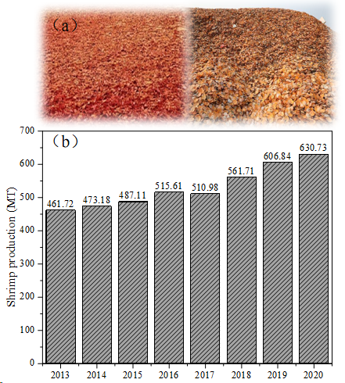
Fig S1. (a) Shrimp shells and crab shells, (b) annual production of shrimp.
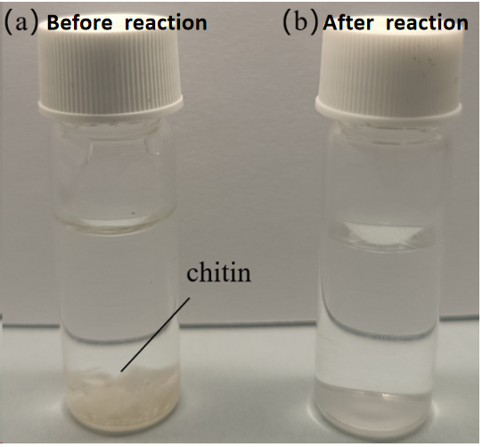
Fig S2. Chitin samples before and after the reaction.
Fig S3. The role of CuO for the conversion of chitin to organic acids.
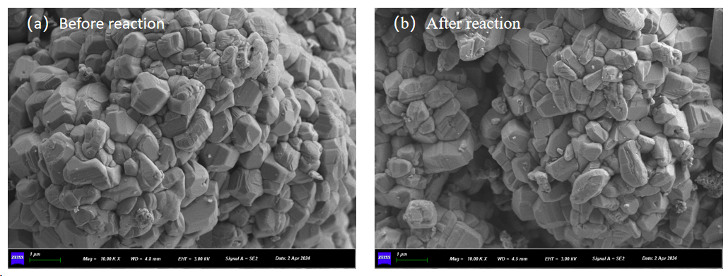
Fig S4. SEM images before and after reaction with CuO
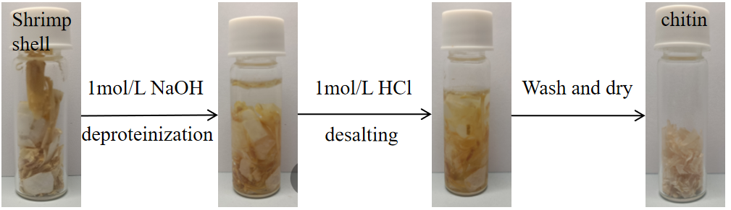
Fig S5. Chitin from shrimp shell.

