Supplementary Information for
Controllable tip exposure of ultramicroelectrodes coated by diamond-like carbon via direct microplasma jet for enhanced stability and fidelity in single-cell recording

Zhiyuan Du^{1,2}, Qingda Xu^{1,2}, Ye Xi^{1,2}, Mengfei Xu^{1,2}, Jiawei Cao^{1,2}, Longchun Wang¹, Xiuyan Li¹, Xiaolin Wang¹, Qingkun Liu¹, Zude Lin¹, Bin Yang¹, and Jingquan Liu^{1*}
¹ National Key Laboratory of Advanced Micro and Nano Manufacture Technology, Shanghai Jiao Tong University, Shanghai, 200240, China and
² DCI Joint Team, Collaborative Innovation Center of IFSA, Department of Micro/Nano Electronics, Shanghai Jiao Tong University, Shanghai, 200240, China

*Corresponding author: Jingquan Liu
Email: jqliu@sjtu.edu.cn; Tel: 86-21-34207209; Fax: 86-21-34206883

Table S1

Table S1. Comparison with previous works in recent researchers.
Author | Exposed tip size | Controllability | Insulation | Encapsulation method
Pan et al. [28] | Random | - | + | Inserted into wax solution
Hunt et al. [29] | 20 μm in length | - | + | Inserted into wax solution
Roberts et al. [14] | 5 μm in length | + | - | Placed into phenolic solution for electro-polymerization
Gao et al. [31] | Only a ring on the cross-section | - | ++ | Inserted into wax solution and mechanical polish
Xu et al. [15] | Only a ring on the cross-section | - | ++ | Inserted into wax solution and grind by diamond disk
Zhang et al. [35] | About 5 μm in length | + | ++ | Inserted into glass micropipette and wax solution
Wu et al. [36] | 4 μm in length | + | ++ | Inserted into glass micropipette and wax solution
Jiao et al. [25] | 5 μm in length | + | ++ | Inserted into glass micropipette and wax solution
Jiang et al. [37] | 10 μm in length | + | ++ | Inserted into glass micropipette and wax solution
Xu et al. [38] | 28 μm in length | + | - | Inserted into glass micropipette micromanipulator
Xi et al. [44] | 33 μm in length | - | - | Deposited with parylene-C and etched by plasma jet
This work | 0.8 μm in length | ++ | ++ | Deposited with DLC and etched by microplasma jet branch
Technique performance in each work is ranked as follows: –, poor; +, fair; ++, good.

Figure S1

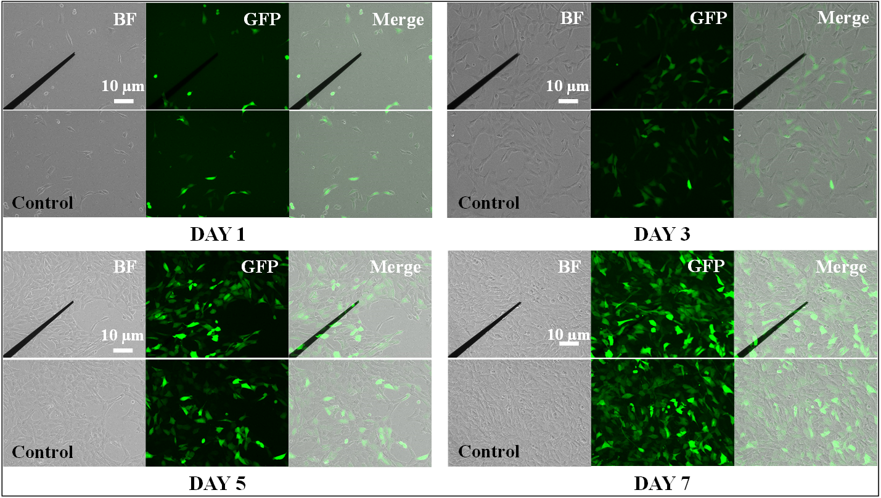
Fig. S1: Biocompatibility testing of the DLC-UME within 7 days.

Equation S1

Eq. S1: Formula for accelerated aging of UMEs.
f =2Δ^{T/10}
Δ T is equal to the difference between the ambient temperature during electrochemical testing and the reference temperature.

Figure S2

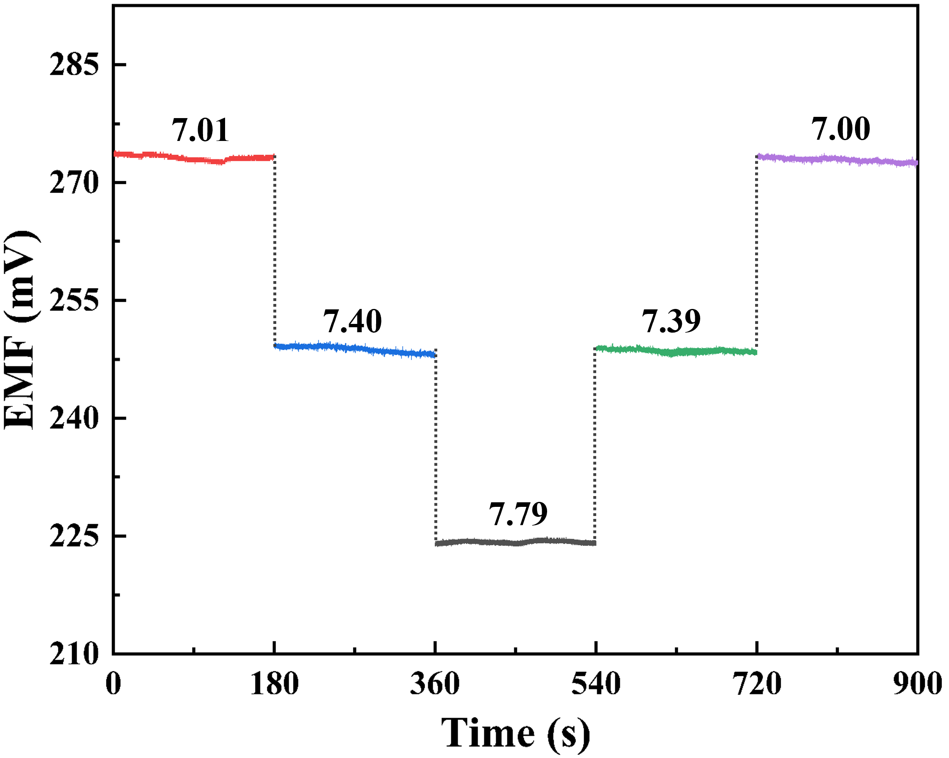
Fig. S2: Dynamic potential response of the DLC-UME in solutions with different pH values.

