Supplementary Information
The Role of Tyr34 in Proton-Coupled Electron Transfer of Human Manganese Superoxide Dismutase
Jahaun Azadmanesh¹, Katelyn Slobodnik¹, Lucas R. Struble¹, Erika A. Cone¹, Medhanjali Dasgupta¹, William E. Lutz¹, Siddhartha Kumar¹, Amarnath Natarajan¹, Leighton Coates², Kevin L. Weiss³, Dean A. A. Myles³, Thomas Kroll⁴, and Gloria E. O. Borgstahl¹*
¹Eppley Institute for Research in Cancer and Allied Diseases, 986805 Nebraska Medical Center, Omaha, NE 68198-6805, USA
²Second Target Station, Oak Ridge National Laboratory, 1 Bethel Valley Road, Oak Ridge, TN 37831, USA
³Neutron Scattering Division, Oak Ridge National Laboratory, 1 Bethel Valley Road, Oak Ridge, TN 37831, USA
⁴Stanford Synchrotron Radiation Lightsource, SLAC National Accelerator Laboratory, Menlo Park, CA 94025, USA
*gborgstahl@unmc.edu

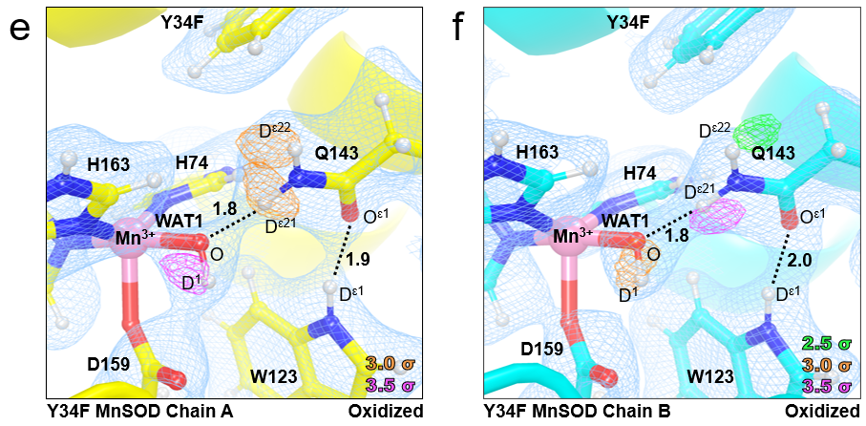
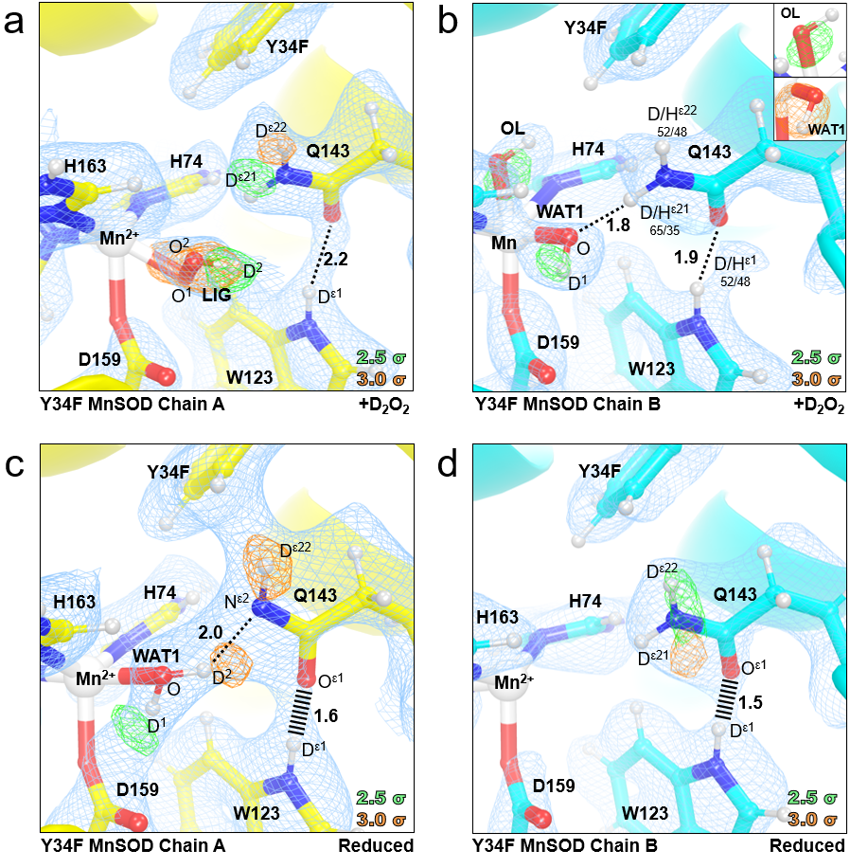
Supplementary Figure 1: Neutron structure and protonation states at the active sites of D₂O₂-soaked, reduced, and oxidized Tyr34Phe MnSOD. a-b Neutron structure of D₂O₂-soaked Tyr34Phe MnSOD. For the exchangeable protons of Gln143 and Trp123 of chain B, positive omit difference density was not present above 2.0σ due to density cancellation with hydrogen’s negative neutron scattering length density. As an alternative, the proton positions were refined for H/D occupancy. Furthermore, an omit density for a hydroxide ion was observed to be bound to the Mn ion, opposite Asp159 (part b, inset top). WAT1 was interpreted to be a hydroxide ion (inset bottom). However, since the chain B active site contains partially-occupied atoms, all other Tyr34Phe MnSOD structures are five-coordinate, and the HERFD-XANES indicate five-coordinate complexes for Tyr34Phe MnSOD, this six-coordinate complex was not evaluated for mechanistic information. c-d Neutron structure of reduced Tyr34Phe MnSOD. For chain B, due to data quality issues, the nuclear density was difficult to interpret and density for WAT1 was not present. Since the HERFD-XANES data indicates that reduced Tyr34Phe MnSOD is five-coordinate like chain A, chain B was not evaluated for mechanistic information. e-f Neutron structure of oxidized Tyr34Phe MnSOD. Green, orange, and magenta omit |F_{o}| - |F_{c}| difference neutron scattering length density of protons displayed at 2.5 σ, 3.0σ, and 3.5 σ, respectively. Light blue 2|F_{o}| - |F_{c}| density is displayed at 1.0σ. Distances are in Å. Dashed lines indicate typical hydrogen bonds, and hashed lines indicate SSHBs, hydrogen bonds < 1.8 Å. D₂O₂-soaked and oxidized structures were solved to 2.3 Å resolution, while the reduced structure was solved to 2.5 Å resolution.

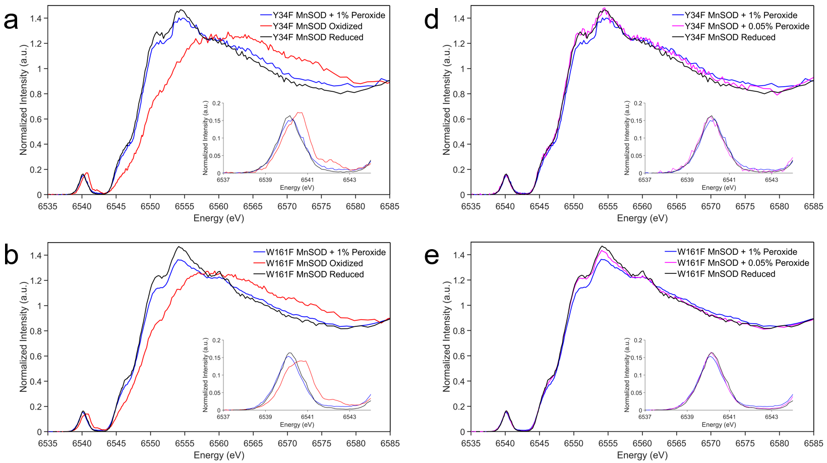
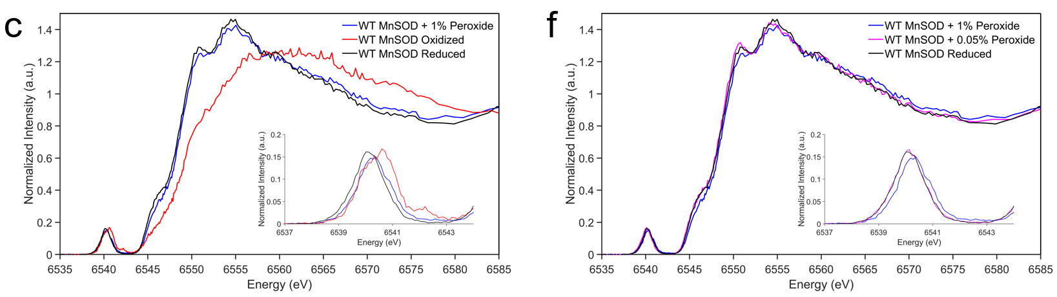
Supplementary Figure 2: Kα HERFD-XANES spectra of MnSOD. a-c HERFD-XANES of Tyr34Phe, Trp161Phe, and wildtype MnSOD in the 1% H₂O₂-soaked, oxidized, and reduced states. d-f HERFD-XANES of Tyr34Phe, Trp161Phe, and wildtype MnSOD in the 1% H₂O₂-soaked, 0.05% H₂O₂-soaked, and reduced states.
Supplementary Table 1. EXAFS fitting results for superoxide-soaked Tyr34Phe MnSOD.
Fit with Amino Acid Ligands and Dioxygen Species (5-coordinate)
Mn-O |  |  | Mn-N |  |  |  | Mn⸱⸱⸱C |  |  |  | Mn⸱⸱⸱C |  |  |  |  |  | Mn⸱⸱⸱O
n | r (Å) | σ² x 10³ (Å²) | n | r (Å) | σ² x 10³ (Å²) |  | n |  | r (Å) | σ² x 10³ (Å²) | n |  | r (Å) |  |  | σ² x 10³ (Å²) | n | r (Å) | σ² x 10³ (Å²)
2 | 2.11 | 8.3 | 3 | 2.15 | 7.3 |  | 5 |  | 3.13 | 1.9 | 2 |  | 3.37 |  |  | 10 | 1 | 2.44 | 7.3
Mn⸱⸱⸱O⸱⸱⸱O |  |  | Mn⸱⸱⸱C⸱⸱⸱O |  |  |  | Mn⸱⸱⸱C⸱⸱⸱N |  |  |  | Mn⸱⸱⸱O⸱⸱⸱C⸱⸱⸱O
n | r (Å) | σ² x 10³ (Å²) | n | r (Å) | σ² x 10³ (Å²) |  | n | r (Å) |  | σ² x 10³ (Å²) | n | r (Å) |  |  | σ² x 10³ (Å²)
2 | 2.78 | 0.6 | 2 | 3.30 | 0 |  | 12 | 3.47 |  | 10 | 1 | 3.18 |  |  | 0
χ² |  |  |  |  |  | Reduced χ² |  |  |  |  |  |  |  | R-Factor
41.79 |  |  |  |  |  | 10.20 |  |  |  |  |  |  |  | 0.0699
Fit with Amino Acids Ligands, Dioxygen Species, and Hypothetical Solvent Molecule (6-coordinate)
Mn-O |  |  | Mn-N |  |  |  | Mn⸱⸱⸱C |  |  |  | Mn⸱⸱⸱C |  |  |  |  |  | Mn⸱⸱⸱O
n | r (Å) | σ² x 10³ (Å²) | n | r (Å) | σ² x 10³ (Å²) |  | n |  | r (Å) | σ² x 10³ (Å²) | n |  | r (Å) |  |  | σ² x 10³ (Å²) | n | r (Å) | σ² x 10³ (Å²)
3 | 2.11 | 8.3 | 3 | 2.15 | 7.3 |  | 5 |  | 3.13 | 1.9 | 2 |  | 3.37 |  |  | 10 | 1 | 2.44 | 7.3
Mn⸱⸱⸱O⸱⸱⸱O |  |  | Mn⸱⸱⸱C⸱⸱⸱O |  |  |  | Mn⸱⸱⸱C⸱⸱⸱N |  |  |  | Mn⸱⸱⸱O⸱⸱⸱C⸱⸱⸱O
n | r (Å) | σ² x 10³ (Å²) | n | r (Å) | σ² x 10³ (Å²) |  | n | r (Å) |  | σ² x 10³ (Å²) | n | r (Å) |  |  | σ² x 10³ (Å²)
2 | 2.78 | 0.6 | 2 | 3.30 | 0 |  | 12 | 3.47 |  | 10 | 1 | 3.18 |  |  | 0
χ² |  |  |  |  |  | Reduced χ² |  |  |  |  |  |  |  | R-Factor
69.93 |  |  |  |  |  | 17.06 |  |  |  |  |  |  |  | 0.1170
Fit Only with Amino Acid Ligands (4-coordinate)
Mn-O |  |  | Mn-N |  |  |  | Mn⸱⸱⸱C |  |  |  | Mn⸱⸱⸱C |  |  |  |  |  | Mn⸱⸱⸱O
n | r (Å) | σ² x 10³ (Å²) | n | r (Å) | σ² x 10³ (Å²) |  | n |  | r (Å) | σ² x 10³ (Å²) | n |  | r (Å) |  |  | σ² x 10³ (Å²) | n | r (Å) | σ² x 10³ (Å²)
1 | 2.11 | 8.3 | 3 | 2.15 | 7.3 |  | 5 |  | 3.13 | 1.9 | 2 |  | 3.37 |  |  | 10 | - | - | -
Mn⸱⸱⸱O⸱⸱⸱O |  |  | Mn⸱⸱⸱C⸱⸱⸱O |  |  |  | Mn⸱⸱⸱C⸱⸱⸱N |  |  |  | Mn⸱⸱⸱O⸱⸱⸱C⸱⸱⸱O
n | r (Å) | σ² x 10³ (Å²) | n | r (Å) | σ² x 10³ (Å²) |  | n | r (Å) |  | σ² x 10³ (Å²) | n | r (Å) |  |  | σ² x 10³ (Å²)
- | - | - | 2 | 3.30 | 0 |  | 12 | 3.47 |  | 10 | 1 | 3.18 |  |  | 0
χ² |  |  |  |  |  | Reduced χ² |  |  |  |  |  |  |  | R-Factor
54.38 |  |  |  |  |  | 7.661 |  |  |  |  |  |  |  | 0.0910

Supplementary Table 2. EXAFS fitting results for peroxide-soaked Tyr34Phe MnSOD.
Fit with Amino Acid Ligands and Dioxygen Species (5-coordinate)
Mn-O |  |  | Mn-N |  |  |  | Mn⸱⸱⸱C |  |  |  | Mn⸱⸱⸱C |  |  |  |  |  | Mn⸱⸱⸱O
n | r (Å) | σ² x 10³ (Å²) | n | r (Å) | σ² x 10³ (Å²) |  | n |  | r (Å) | σ² x 10³ (Å²) | n |  | r (Å) |  |  | σ² x 10³ (Å²) | n | r (Å) | σ² x 10³ (Å²)
2 | 2.11 | 8.3 | 3 | 2.15 | 7.3 |  | 5 |  | 3.13 | 1.9 | 2 |  | 3.37 |  |  | 10 | 1 | 2.44 | 7.3
Mn⸱⸱⸱O⸱⸱⸱O |  |  | Mn⸱⸱⸱C⸱⸱⸱O |  |  |  | Mn⸱⸱⸱C⸱⸱⸱N |  |  |  | Mn⸱⸱⸱O⸱⸱⸱C⸱⸱⸱O
n | r (Å) | σ² x 10³ (Å²) | n | r (Å) | σ² x 10³ (Å²) |  | n | r (Å) |  | σ² x 10³ (Å²) | n | r (Å) |  |  | σ² x 10³ (Å²)
2 | 2.78 | 0.6 | 2 | 3.30 | 0 |  | 12 | 3.47 |  | 10 | 1 | 3.18 |  |  | 0
χ² |  |  |  |  |  | Reduced χ² |  |  |  |  |  |  |  | R-Factor
43.08 |  |  |  |  |  | 10.51 |  |  |  |  |  |  |  | 0.0522
Fit with Amino Acids Ligands, Dioxygen Species, and Hypothetical Solvent Molecule (6-coordinate)
Mn-O |  |  | Mn-N |  |  |  | Mn⸱⸱⸱C |  |  |  | Mn⸱⸱⸱C |  |  |  |  |  | Mn⸱⸱⸱O
n | r (Å) | σ² x 10³ (Å²) | n | r (Å) | σ² x 10³ (Å²) |  | n |  | r (Å) | σ² x 10³ (Å²) | n |  | r (Å) |  |  | σ² x 10³ (Å²) | n | r (Å) | σ² x 10³ (Å²)
3 | 2.11 | 8.3 | 3 | 2.15 | 7.3 |  | 5 |  | 3.13 | 1.9 | 2 |  | 3.37 |  |  | 10 | 1 | 2.44 | 7.3
Mn⸱⸱⸱O⸱⸱⸱O |  |  | Mn⸱⸱⸱C⸱⸱⸱O |  |  |  | Mn⸱⸱⸱C⸱⸱⸱N |  |  |  | Mn⸱⸱⸱O⸱⸱⸱C⸱⸱⸱O
n | r (Å) | σ² x 10³ (Å²) | n | r (Å) | σ² x 10³ (Å²) |  | n | r (Å) |  | σ² x 10³ (Å²) | n | r (Å) |  |  | σ² x 10³ (Å²)
2 | 2.78 | 0.6 | 2 | 3.30 | 0 |  | 12 | 3.47 |  | 10 | 1 | 3.18 |  |  | 0
χ² |  |  |  |  |  | Reduced χ² |  |  |  |  |  |  |  | R-Factor
98.32 |  |  |  |  |  | 23.99 |  |  |  |  |  |  |  | 0.1191
Fit Only with Amino Acid Ligands (4-coordinate)
Mn-O |  |  | Mn-N |  |  |  | Mn⸱⸱⸱C |  |  |  | Mn⸱⸱⸱C |  |  |  |  |  | Mn⸱⸱⸱O
n | r (Å) | σ² x 10³ (Å²) | n | r (Å) | σ² x 10³ (Å²) |  | n |  | r (Å) | σ² x 10³ (Å²) | n |  | r (Å) |  |  | σ² x 10³ (Å²) | n | r (Å) | σ² x 10³ (Å²)
1 | 2.11 | 8.3 | 3 | 2.15 | 7.3 |  | 5 |  | 3.13 | 1.9 | 2 |  | 3.37 |  |  | 10 | - | - | -
Mn⸱⸱⸱O⸱⸱⸱O |  |  | Mn⸱⸱⸱C⸱⸱⸱O |  |  |  | Mn⸱⸱⸱C⸱⸱⸱N |  |  |  | Mn⸱⸱⸱O⸱⸱⸱C⸱⸱⸱O
n | r (Å) | σ² x 10³ (Å²) | n | r (Å) | σ² x 10³ (Å²) |  | n | r (Å) |  | σ² x 10³ (Å²) | n | r (Å) |  |  | σ² x 10³ (Å²)
- | - | - | 2 | 3.30 | 0 |  | 12 | 3.47 |  | 10 | 1 | 3.18 |  |  | 0
χ² |  |  |  |  |  | Reduced χ² |  |  |  |  |  |  |  | R-Factor
62.15 |  |  |  |  |  | 8.755 |  |  |  |  |  |  |  | 0.0753

Supplementary Table 3. Active site Mn bond lengths of MnSOD neutron crystal structures.
Neutron | Tyr34Phe  D₂O₂-Soaked^{b} |  | Tyr34Phe  Mn³⁺SOD |  | Tyr34Phe  Mn²⁺SOD |  | Wildtype  Mn³⁺SOD |  | Wildtype  Mn²⁺SOD^{c}
PDB ID | 9BVY |  | 9BWM |  | 9BW2 |  | 7KKS |  | 7KKW
Mn Bonds (Å) | A | B | A | B | A | B | A | B | A | B
Mn-N^{ε2}(H26) | 2.17 | 2.10 | 2.13 | 2.14 | 2.10 | 2.07 | 2.07 | 2.07 | 2.26 | 2.10
Mn-N^{ε2}(H74) | 2.23 | 2.18 | 2.22 | 2.16 | 2.11 | 2.11 | 2.13 | 2.12 | 2.19 | 2.25
Mn-O^{ε2}(D159) | 2.13 | 2.03 | 2.11 | 2.11 | 2.15 | 2.16 | 1.95 | 1.94 | 2.44 | 2.15
Mn-N^{ε2}(H163) | 2.21 | 2.19 | 2.22 | 2.22 | 2.13 | 2.13 | 2.06 | 2.14 | 2.23 | 2.21
Mn-O(WAT1) | - | 1.76 | 2.20 | - | 1.95 | 1.93 | 1.78 | 1.76 | 2.12 | 2.22
Mn-O¹(LIG)ª | 2.00 | - | - | - | - | - | - | - | - | -
Mn-O²(LIG) | 2.34 | - | - | - | - | - | - | - | - | -
Mn-O(OL) | - | 1.80 | - | - | - | - | - | - | 1.82 | -
Neutron | Trp161Phe  D₂O₂-Soaked^{d} |  | Trp161Phe  Mn³⁺SOD |  | Trp161Phe  Mn²⁺SOD
PDB ID | 8VHW |  | 8VJ0 |  | 8VHY
Mn Bonds (Å) | A | B | A | B | A | B
Mn-N^{ε2}(H26) | 2.13 | 2.20 | 2.01 | 2.01 | 2.20 | 2.11
Mn-N^{ε2}(H74) | 2.13 | 2.28 | 2.15 | 2.15 | 2.19 | 2.16
Mn-O^{ε2}(D159) | 2.20 | 2.05 | 2.01 | 2.01 | 2.13 | 2.20
Mn-N^{ε2}(H163) | 2.25 | 2.17 | 2.15 | 2.15 | 2.14 | 2.15
Mn-O(WAT1) | 2.13 | - | 1.84 | 1.84 | 2.37 | 2.24
Mn-O¹(LIG)ª | - | 1.94 | - | - | - | -
Mn-O²(LIG) | - | 2.61 | - | - | - | -
Mn-O(OL) | - | - | - | - | - | -
ªO¹(LIG) refers to the closest oxygen atom of the dioxygen species.
^{b}Only chain A of D₂O₂-soaked Tyr34Phe MnSOD is bound by a dioxygen species, denoted as LIG. For chain A, an ⁻OD molecule (denoted OL for oxygen ligand) is observed binding opposite of Asp159 and is six-coordinate. Note that HERFD-XANES (Supplementary Fig. 2a) and EXAFS suggest a five-coordinate complex (Supplementary Table 2).
^{c}For chain A of wildtype Mn²⁺SOD, an ⁻OD molecule is observed binding opposite of Asp159 and is six-coordinate. Chain B is in the typical five-coordinated state. Note that HERFD-XANES suggest a five-coordinate complex (Supplementary Fig. 2c).
^{d}Only chain B of D₂O₂-soaked Trp161Phe MnSOD is bound by a dioxygen species.

Supplementary Table 4. Active site Mn bond lengths of DFT-optimized structures
Wildtype Mn³⁺SOD (S=2) |  | Tyr34Phe Mn³⁺SOD (S=2)
Bond | DFT (Å) | Bond | DFT (Å)
Mn-N^{ε2}(H26) | 2.06 | Mn-N^{ε2}(H26) | 2.04
Mn-N^{ε2}(H74) | 2.13 | Mn-N^{ε2}(H74) | 2.11
Mn-N^{ε2}(H163) | 2.06 | Mn-N^{ε2}(H163) | 2.09
Mn-O^{δ2}(D159) | 1.95 | Mn-O^{δ2}(D159) | 1.98
Mn-O(WAT1) | 1.80 | Mn-O(WAT1) | 1.82
Wildtype Mn²⁺SOD (S=5/2) |  | Tyr34Phe Mn²⁺SOD (S=5/2)
Bond | DFT (Å) | Bond | DFT (Å)
Mn-N^{ε2}(H26) | 2.23 | Mn-N^{ε2}(H26) | 2.22
Mn-N^{ε2}(H74) | 2.18 | Mn-N^{ε2}(H74) | 2.18
Mn-N^{ε2}(H163) | 2.19 | Mn-N^{ε2}(H163) | 2.19
Mn-O^{δ2}(D159) | 2.06 | Mn-O^{δ2}(D159) | 2.06
Mn-O(WAT1) | 2.14 | Mn-O(WAT1) | 2.13
Trp161Phe Mn²⁺SOD + HO₂⁻ (S=5/2) |  | Tyr34Phe Mn²⁺SOD + HO₂⁻ (S=5/2)
Bond | DFT (Å) | Bond | DFT (Å)
Mn-N^{ε2}(H26) | 2.24 | Mn-N^{ε2}(H26) | 2.28
Mn-N^{ε2}(H74) | 2.16 | Mn-N^{ε2}(H74) | 2.20
Mn-N^{ε2}(H163) | 2.15 | Mn-N^{ε2}(H163) | 2.16
Mn-O^{δ2}(D159) | 2.06 | Mn-O^{δ2}(D159) | 2.17
Mn-O(PEO) | 2.08 | Mn-O(PEO) | 2.10
Tyr34Phe Mn³⁺SOD + HO₂⁻ (S=2) |  | Tyr34Phe Mn²⁺SOD + HO₂● (S=3)
Bond | DFT (Å) | Bond | DFT (Å)
Mn-N^{ε2}(H26) | 2.00 | Mn-N^{ε2}(H26) | 2.12
Mn-N^{ε2}(H74) | 2.07 | Mn-N^{ε2}(H74) | 2.16
Mn-N^{ε2}(H163) | 2.19 | Mn-N^{ε2}(H163) | 2.17
Mn-O^{δ2}(D159) | 2.01 | Mn-O^{δ2}(D159) | 2.01
Mn-O(PEO) | 1.82 | Mn-O(SUP) | 2.37

Supplementary Table 5. Data collection and refinement statistics for Tyr34Phe MnSOD.
Data Collection Statistics
 | Neutron |  |  | X-ray
Variant | Tyr34Phe MnSOD
Chemical State | D₂O₂-Soaked | Reduced | Oxidized | H₂O₂-Soaked | Reduced
PDB Code | 9BVY | 9BW2 | 9BWM | 9BWQ | 9BWR
Growth Conditions | Microgravity |  |  | Earth
Diffraction Source | MaNDi |  |  | SSRL Beamline 14-1 | Rigaku FR-E SuperBright
Temperature (K) | 100 | 296 | 296 | 100 | 100
Space group | P6₁22 |  |  | P6₁22
a, b, c (Å) | 78.69. 78.69, 239.94 | 79.4, 79.4, 238.43 | 79.29, 79.29, 240.61 | 78.22, 78.22,  239.50 | 78.09, 78.09,  235.19
α, β, γ (°) | 90, 90, 120 |  |  | 90, 90, 120
Wavelengths (Å) | 2-4 |  |  | 0.9795 | 1.5418
No. of images | 11 | 10 | 13 | 625 | 386
Exposure time | 36 h | 28 h | 35 h | 1 s | 300 s
No. of unique reflections | 18698 | 14940 | 20703 | 85139 | 65175
Total No. of reflections | 73477 | 123482 | 161187 | 170167 | 526729
Resolution range (Å) | 14.84-2.30  (2.37-2.30) | 14.55-2.50  (2.58-2.5) | 14.39-2.28 (2.36-2.28) | 39.13-1.40  (1.45-1.40) | 50.00-1.50  (1.53-1.50)
Multiplicity | 4.1 (3.4) | 8.3 (6.7) | 7.79 (6.15) | 13.5 (13.6) | 8.1 (5.8)
I/σ(I) | 5.1 (2.7) | 6.6 (3.8) | 7.4 (3.7) | 7.3 (1.6) | 7.5 (1.38)
R_{merge} | 0.277 (0.266) | 0.321 (0.292) | 0.246 (0.323) | - | -
R_{meas} | 0.310 (0.305) | 0.340 (0.315) | 0.263 (0.349) | 0.039 (0.458) | 0.299 (0.816)
CC _{1/2} | 0.783 (0.259) | 0.766 (0.117) | 0.953 (0.476) | 0.999 (0.788) | 0.847 (0.578)
R_{pim} | 0.133 (0.142) | 0.106 (0.112) | 0.090 (0.127) | 0.027 (0.324) | 0.089 (0.411)
Completeness (%) | 90.4 (75.3) | 91.3 (90.7) | 97.78 (88.40) | 98.8 (97.5) | 94.4 (85.2)
Refinement Statistics
R_{work} | 0.265 | 0.293 | 0.242 | 0.184 | 0.189
R_{free} | 0.299 | 0.330 | 0.275 | 0.205 | 0.210
ªNo. of atoms  Protein  ^{b}Solvent  Mn | 6547  1068  2 | 6233  496  2 | 6617  147  2 | 3160  571  2 | 3160  782  2
R.m.s. deviations  Bond lengths (Å)  Bond angles (°) | 0.002  0.541 | 0.006  0.522 | 0.001  0.505 | 0.004  0.683 | 0.003  0.638
Average B-factor  Protein  Water  Mn  Peroxide | 3.69  3.73  3.45  2.38  2.98 | 15.36  15.45  13.87  14.70  - | 35.45  35.42  36.74  42.91  - | 19.65  18.42  25.90  14.21  16.82 | 18.38  15.41  30.07  9.99  -
^{c}Coordinate Error (Å) | 0.30 | 0.42 | 0.30 | 0.15 | 0.15
ªNo. of atoms is inclusive of H/D atoms for neutron structures.
^{b}The neutron structure of reduced and oxidized Tyr34Phe were collected at room temperature and, as a result, have fewer solvent atoms compared to the other structures.
^{c}Estimated coordinate error determined by PHENIX. Note that the disorder of atom positions is reflected by the B-factor.

