Supporting Information
One-step litchi like bimetallic nanozyme-assisted indirect competitive immunoassay for the detection of acetamiprid in vegetables
Beibei Liu^{a,b}, Rongqi Zhaiª, Jie Zhang^{b}, Guangyang Liuª, Xiaodong Huangª, Jun Lvª, Jing Chenª, Maojun Jin^{c}, Jing Wang^{c}, Donghui Xu^{a,*}, Ge Chen ^{a,*}.
ªInstitute of Vegetables and Flowers, Chinese Academy of Agricultural Sciences, State Key Laboratory of Vegetable Biobreeding, Key Laboratory of Vegetables Quality and Safety Control, Ministry of Agriculture and Rural Affairs of China, Ministry of Agriculture Vegetable Product Quality Safety Risk Assessment Laboratory, Beijing, 100081, P. R. China
^{b}College of Plant Science and Technology, Beijing University of Agriculture, Beijing 102206, P. R. China
^{c}Institute of Quality Standard and Testing Technology for Agro-Products, Chinese Academy of Agricultural Sciences; Key Laboratory of Agro-Product Quality and Safety, Ministry of Agriculture and Rural Affairs of China 100081, P. R. China
- Kinetic analysis of the Au@Pt nanozymes
The steady-state kinetic analysis ^{[1, 2]} was explored by varying the substrate concentrations. In this work, 50 μL of Au@Pt nanozymes was mixed with 100 μL of sodium acetate (0.1 M, pH 5.5) and TMB solution (the final concentrations of the TMB solution were 0.1, 0.2, 0.4, 0.6, 0.8, and 1 mM). Then, 100 μL of H₂O₂ was added at a fixed final concentration (7 mM). After incubation for 5 min, the OD was measured at 652 nm. For the analysis of the H₂O₂ substrate, the final concentration of H₂O₂ was varied (0.5, 1, 3, 7, 10, and 20 mM) while maintaining a fixed final concentration of TMB (0.2 mM). With this formula, the initial reaction velocity (𝜈) was determined:
$$A=ε×l×c$$
where c is the oxTMB concentration, 𝑙 is the solution's thickness, and molar extinction coefficient of oxTMB (3.9 × 10⁴ M⁻¹ cm⁻¹) is represented by 𝜀 and 𝐴, respectively.
$$v=\frac{c}{t}$$
where 𝑡 is the reaction time.
- Optimization of the AuNPs 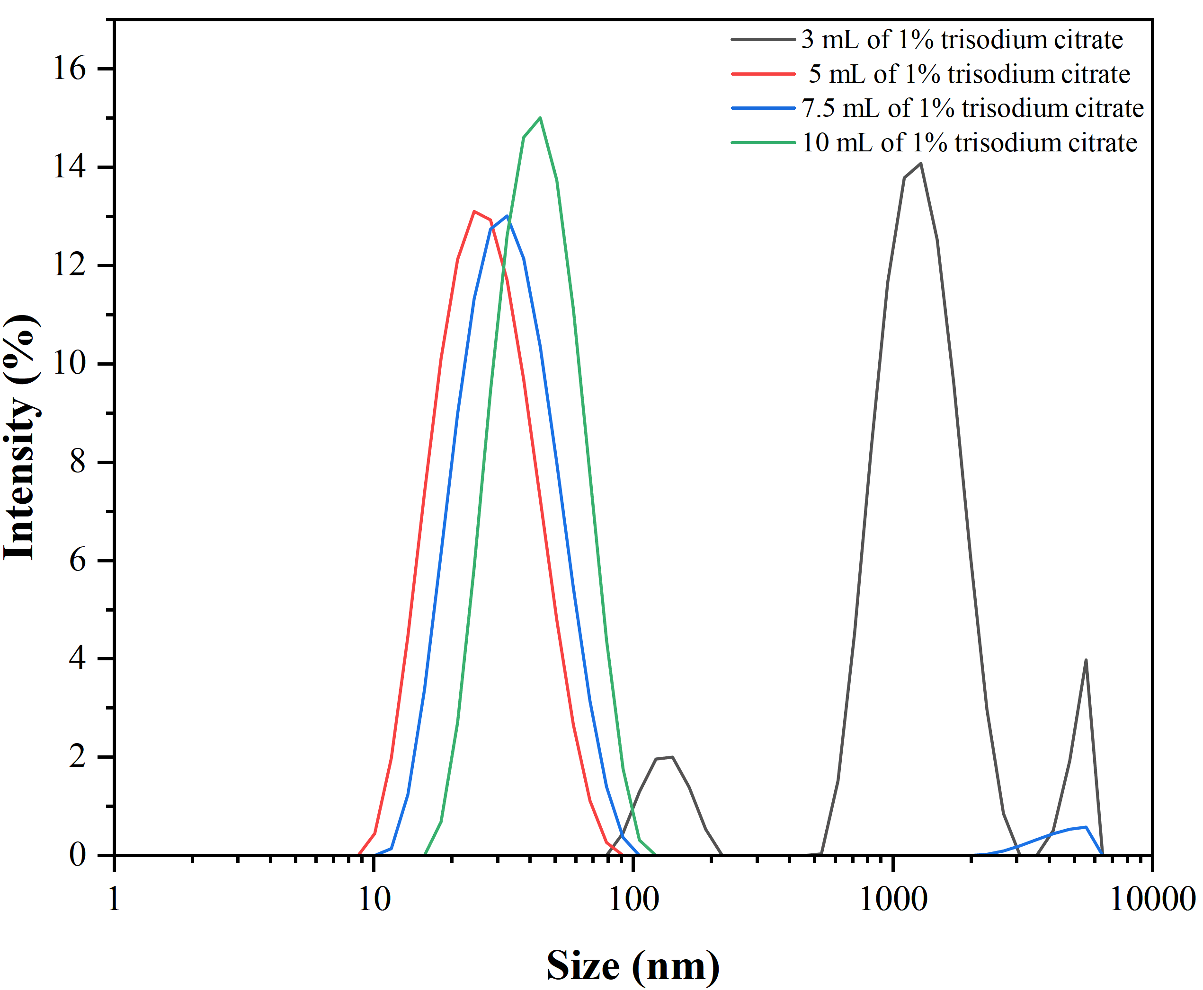
Figure S2. The particle size distribution of the Au NPs
- The formula for calculating the percent inhibition ^{[3]} of calibration curve was as follows:
$Inhibition rate \left(\%\right)=(1-\frac{T}{T_{0}})$ × 100%
The responses to the standard solution (T) and the absence of acetamiprid (T₀) are the respective responses.
4. HRP-assisted indirect competitive immunoassay
The steps were as follows: 100 µL/well of OVA-hapten solution with a concentration of 1 mg/L in PBS buffer with a pH7.4 was dispensed into a 96-well flat-bottom plate at 4°C overnight. There PBST washes were performed on the plate. 300 μL of 2% BSA was utilized to block empty binding sites in each well with for 1 h. Subsequently, clean the plate using PBST. ACE (50 µL/well) dispersed in 10% methyl alcohol and mAb (50 µL/well) were introduced. Then, the plate was incubated for 2 h. After three washing steps, goat anti-mouse IgG-HRP was diluted (1/1000) and put in 100 µL/well. After 1 h, TMB (100 µL/well) was added. With the use of a microplate reader, the absorbance at 650 nm was measured.
5. Recovery experiment
The spiked samples at different concentrations were detected with the Au@Pt-assisted indirect competitive immunoassay to verified the recovery ^{[4]} of acetamiprid from sample extracts. The recovery was calculated using the following formula:
$$Recovery=\frac{c'}{c}×100\%$$
where 𝐶′ is measured concentration, 𝐶 is the actual spiked concentration

References
- Xu S-L, Zhang G-G, Fang B-L, Xiong Q-R, Duan H-W, Lai W-H, Lateral flow immunoassay based on polydopamine-coated gold nanoparticles for the sensitive detection of zearalenone in maize. ACS Applied Materials & Interfaces, 2019; 11(34): 31283.
- Liu S-j, Luo X, Shu, R, Liao Y-J, Dou L-N, Bu T, Wang S-C, Li Y-C., Sun J, Zhang D-H, et al., Engineered core shell multifunctional nano-tracer in raman-silent region with highly retained affinity, Small, 2022; 18(45): 2204859.
- Liu S-j, Shu R, Ma J-Q, Dou L-N, Zhang W-T, Wang S-C, Ji Y-W, Li Y-C, Xu J-K, Zhang D-H, et al., Mussel-inspired Fe-based tannic acid nanozyme: a renewable bioresource-derived high-affinity signal tag for dual-readout multiplex lateral flow immunoassay, Chem. Eng. J., 2022; 446: 137382.
- Yang H-G, Yang R-T, Zhang P, Qin Y-M, Chen T, Ye F-G. A bimetallic (Co/2Fe) metal-organic framework with oxidase and peroxidase mimicking activity for colorimetric detection of hydrogen peroxide, Microchimica Acta, 2017; 184: 4629–4635.

