Supplementary information
“Free energy landscape with two barriers and a transient intermediate state determining the unfolding and folding dynamics of cold shock protein”

Haiyan Hong^{1#}, Zilong Guo^{1,2#}, Hao Sun¹, Ping Yu¹, Huanhuan Su¹, Xuening Ma¹, Hu Chen^{1,2*}
¹ Research Institute for Biomimetics and Soft Matter, Fujian Provincial Key Lab for Soft Functional Materials Research, Department of Physics, Xiamen University, Xiamen 361005, China
²Center of Biomedical Physics, Wenzhou Institute, University of Chinese Academy of Sciences, Wenzhou, China 325000

＃ Contributed equally to this work
E-mail: chenhu@xmu.edu.cn

Supplementary Note 1
Theoretical model and data analysis
In Bell's model, unfolding distance $x_{\text{u}}$ is supposed independent on force, then force-dependent unfolding rate $k_{\text{u}}\left(f\right)$ is given by¹:
$k_{\text{u}}\left(f\right)=k_{\text{u}}^{0}exp\left(fx_{\text{u}}/k_{\text{B}}T\right)$ (1)
where$k_{\text{u}}^{0}$denotes the unfolding rate at zero force if the formula can be extrapolated to zero force. $k_{\text{B}}$ the Boltzmann constant, and $T$ the absolute temperature. When force increases with constant loading rate$r$ from zero, and protein's initial state is its native sate, unfolding force distribution can be derive$P\left(f\right)$²
$P\left(f\right)=\frac{k_{u}^{0}}{r}exp\left[\frac{{fx}_{u}}{k_{B}T}+\frac{k_{u}^{0}*k_{B}T}{{ rx}_{u}}\left(1-exp\frac{{fx}_{u}}{k_{B}T}\right)\right]$ (2)
And, if $f$ is replaced by$f=f_{0}-r*t$, then the folding force distribution is
$P\left(f\right)=\frac{k_{f}^{0}}{r}exp\left[\frac{{-fx}_{f}}{k_{B}T}+\frac{k_{f}^{0}*k_{B}T}{{ rx}_{f}}\left(exp\frac{{-f_{0}x}_{f}}{k_{B}T}-exp\frac{{-fx}_{f}}{k_{B}T}\right)\right]$ (3)
where $k_{\text{f}}^{0}$ denotes the folding rate at zero force, ${ x}_{f}$ is a constant folding distance in Bell’s model.
Eq. (2) gives the most probable unfolding force$F_{u}^{*}$ by:^{3,4}
$F_{u}^{*}=\frac{k_{B}T}{x_{u}}ln\frac{rx_{u}}{k_{u}^{0}k_{B}T}$ (4)
If we model protein's native state as a solid body, its extension along force direction $x_{Csp }$ changes due to orientation fluctuation:
$x_{Csp }\left(f\right)=l_{0}coth(\frac{fl_{0}}{k_{B}T})-\frac{k_{B}T}{f}$ (5)
Where $l_{0}$ donates the end-to-end distance of Csp on the basis of the crystal structure of Csp (PDB: 1G6P).
Unfolded peptide is modeled as a worm-like chain (WLC) whose force-extension curve is given by:
$\frac{fA}{k_{B}T} = \frac{x_{chain }}{L }+\frac{1}{{4(1-x_{chain}/L)}^{2}}-\frac{1}{4}$ (6)
where A denotes the persistence length, $x_{chain }$ the extension, and L the contour length of peptide. Force-dependent extension$x_{chain }\left(f\right)$ is derived by inverse function of Eq. (6). Unfolding and folding stepsize is dependent on force: ${Δx\left(f\right)=x_{chain }\left(f\right)-x}_{Csp }\left(f\right)$. Therefore, protein folding free energy at force$f$ is given by:
$ΔG\left(f\right)=ΔG_{0}-\int_{0}^{f}{Δx\left(f^{'}\right)df'}$ (7)
where 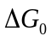 is folding free energy at zero force. Folding probability, i.e., the probability of protein to be at its native state, is determined by$ΔG\left(f\right)$:
$P_{\text{f}}\left(f\right)=\frac{1}{exp\left(-ΔG\left(f\right)/k_{\text{B}}T\right){+}1}$ (8)
$P_{\text{f}}\left(f\right)=\frac{1}{exp\left(\left(f-f_{\text{c}}\right)∆x/k_{\text{B}}T\right){+}1}$ (9)
where $f_{\text{c}}$ is the critical force at which the protein has 50% probability at its native state. Force-dependent protein folding free energy $ΔG\left(f\right)$ of Csp can also be determined by the ratio between folding rate $k_{f}(f)$ and unfolding rate $k_{u}(f)$ at the same force $f$:
$ΔG(f)=k_{B}T\ln{\frac{k_{f}(f)}{k_{u}(f)}}$ (10)
Therefore, equilibrium measurement gives $ΔG(f)$ directly, from which $ΔG_{0}$ can be determined by Eq. (7).
Folding happens at small forces from a stretched polypeptide to native state crossing a folding transition state. We assume the folding transition state has extension $x_{TS}\left(f\right)$. Therefore, force-dependent folding rate follows:
$k_{\text{f}}\left(f\right)=k_{\text{f}}^{0}exp\left(-\int_{0}^{f}{x_{f}\left(f^{'}\right)df'}/k_{\text{B}}T\right)$ (11)
Where $x_{f}\left(f\right)=x_{chain }\left(f\right)-x_{TS}\left(f\right)$ denotes the folding distance.

Supplementary Note 2
NIU Model and Fitting Parameters
As shown in Fig. 4a and 4b in main text, logarithm of unfolding rate at different force range gives different slopes. We fit force-dependent unfolding rate over full force range according to the model proposed by Olga K. Dudko⁵. Unfolding rate of Csp $k_{u}$, can be written as:
$k_{u}=\frac{k_{IU}k_{NI}}{{k_{IN}+k}_{IU}{+k}_{NI}}$ (12)
where $k_{NI}$ denotes transition rate from N to I, $k_{IN}$ transition rate from I to N, and $k_{IU}$ transition rate from I to U.
For transient hidden I state with high free energy, we assumed that $k_{NI}≪k_{IN}$and $k_{NI}≪k_{IU}$, then Eq. (12) can be simplified as:
$k_{u}=\frac{k_{IU}k_{NI}}{{k_{IN}+k}_{IU}}$ (13)
All transition rates are force-dependent. We suppose that transition rates of $k_{NI}$, $k_{IU}$, and $k_{IN}$ follow Bell's model:
$k_{\text{NI}}(f) =k_{\text{NI}}^{0}\exp{(}fx_{\text{NI}}/k_{B}T)$ (14)
$k_{\text{IN}}\left(f\right)=k_{\text{IN}}^{0}\exp{(}-fx_{\text{IN}}/k_{B}T)$ (15)
$k_{\text{IU}}(f) =k_{\text{IU}}^{0}\exp{(}fx_{\text{IU}}/k_{B}T)$ (16)
where $k_{\text{NI}}^{0}$ is zero force transition rate from N to I, and $x_{\text{NI}}$ denotes the transition distance from N to I, etc. Each transition rate has two parameters in Bell's model, and there are totally six parameters.
As shown in the Fig. 4a, Eq. (13) can fit the experimental unfolding rates over full force range with one set of parameters in Supplementary Table1. The fitting results${ k}_{\text{NI}}^{0}$ = 0.029 s⁻¹ and $x_{\text{IN}}$ = 0.53 nm are consistent with Bell's model fitting result at forces ranging from 10 to 50 pN in Fig. 4a ($k_{u,1}^{0}$ = 0.028 s and $x_{u,1}$= 0.53 nm).
Meanwhile, the summation of transition distances${ x}_{\text{NI}}$, $x_{\text{IN}}$and $x_{\text{IU}}$ gives the extension difference between N and TS2 states of 2.96 nm, which agrees with Bell's model fitting results at force range of 5-7 pN ($x_{u,2}$ = 2.9 nm, Fig. 4b).

Supplementary Table 1: One set of parameters in Supplementary Eqs. (13)-(16) to reproduce the force-dependent unfolding rate of Csp (Fig. 4a).
$k_{\text{NI}}^{0}$ (s⁻¹) | ${ x}_{\text{NI}}$ (nm) | $k_{\text{IN}}^{0}$ (s⁻¹) | $x_{\text{IN}}$ (nm) | $k_{\text{IU}}^{0}$ (s⁻¹) | $x_{\text{IU}}$ (nm)
0.029 | 0.53 | 9.9 | 0.83 | 0.21 | 1.6

As the six parameters are not independent, different sets of parameters can fit the experimental results. Value range of dependent parameters are given in Supplementary Fig. 6. From the viewpoint of free energy landscape (Fig. 4c), $k_{\text{u}}\left(f\right)$ is not sensitive to the position and the free energy of I state, as long as the I state is located between the two transition states TS1 and TS2.

Supplementary Figures
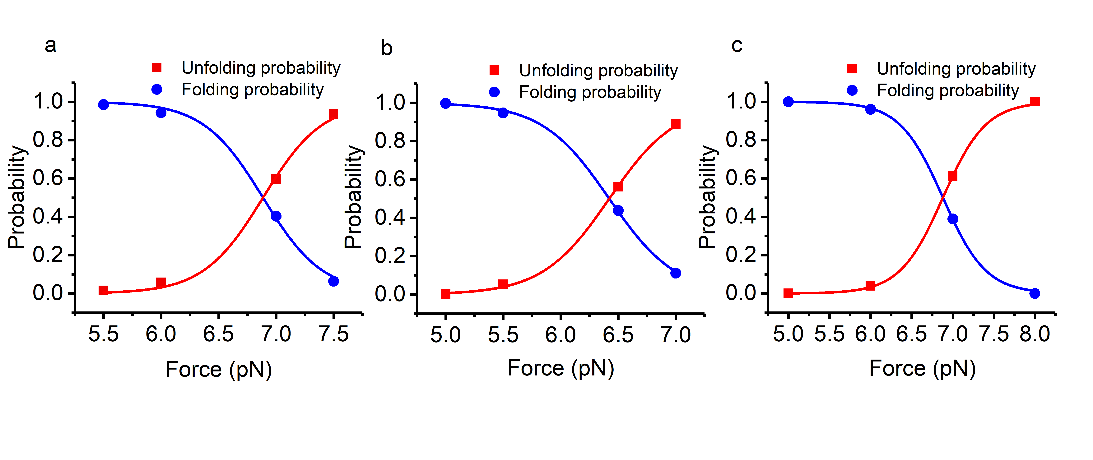
Supplementary Figure 1. Force-dependent folding and unfolding probability of Csp. (a, b, c) Three independent equilibrium measurements are shown.
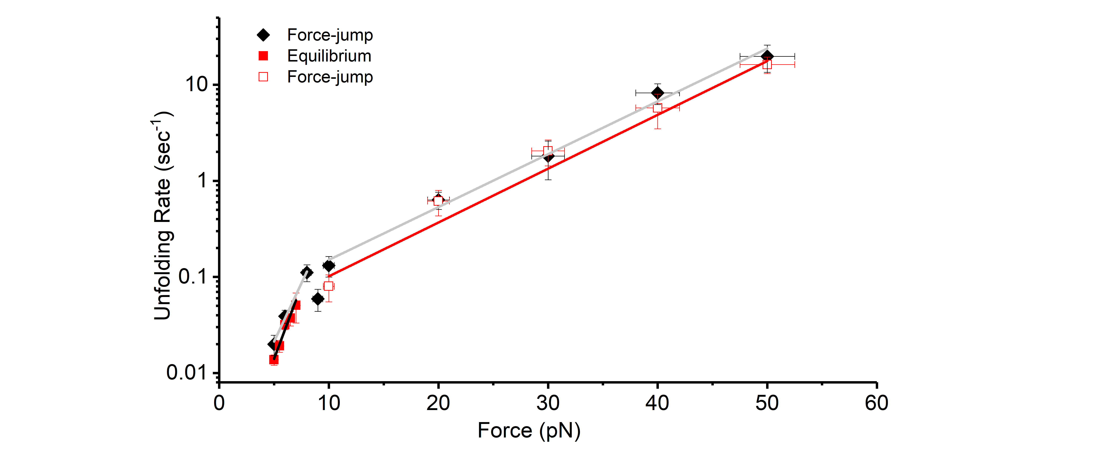
Supplementary Figure 2. Force-dependent unfolding rates obtained from force-jump measurement of one Csp tether in force range of 5-50 pN. The unfolding rates are on two linear lines with distinct slopes, which is consistent with the result from both equilibrium measurements and force-jump measurements in main text.

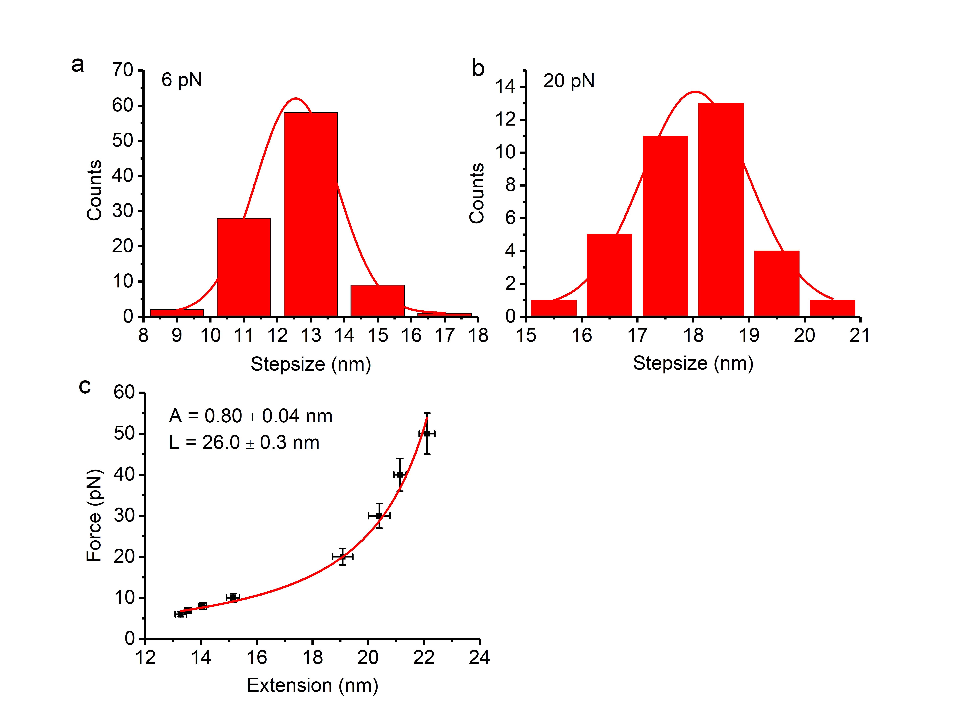
Supplementary Figure 3. Force-extension curve of unfolded peptide obtained from unfolding stepsize at different forces. (a, b) Histogram of unfolding stepsize at 6 and 20 pN for Csp, respectively. (c) Extension of unfolded peptide is obtained from extension of native state and unfolding stepsize. Worm-like chain fitting gives persistence length of 0.80 nm and contour length of 26.0 nm for unfolded polypeptide of Csp.
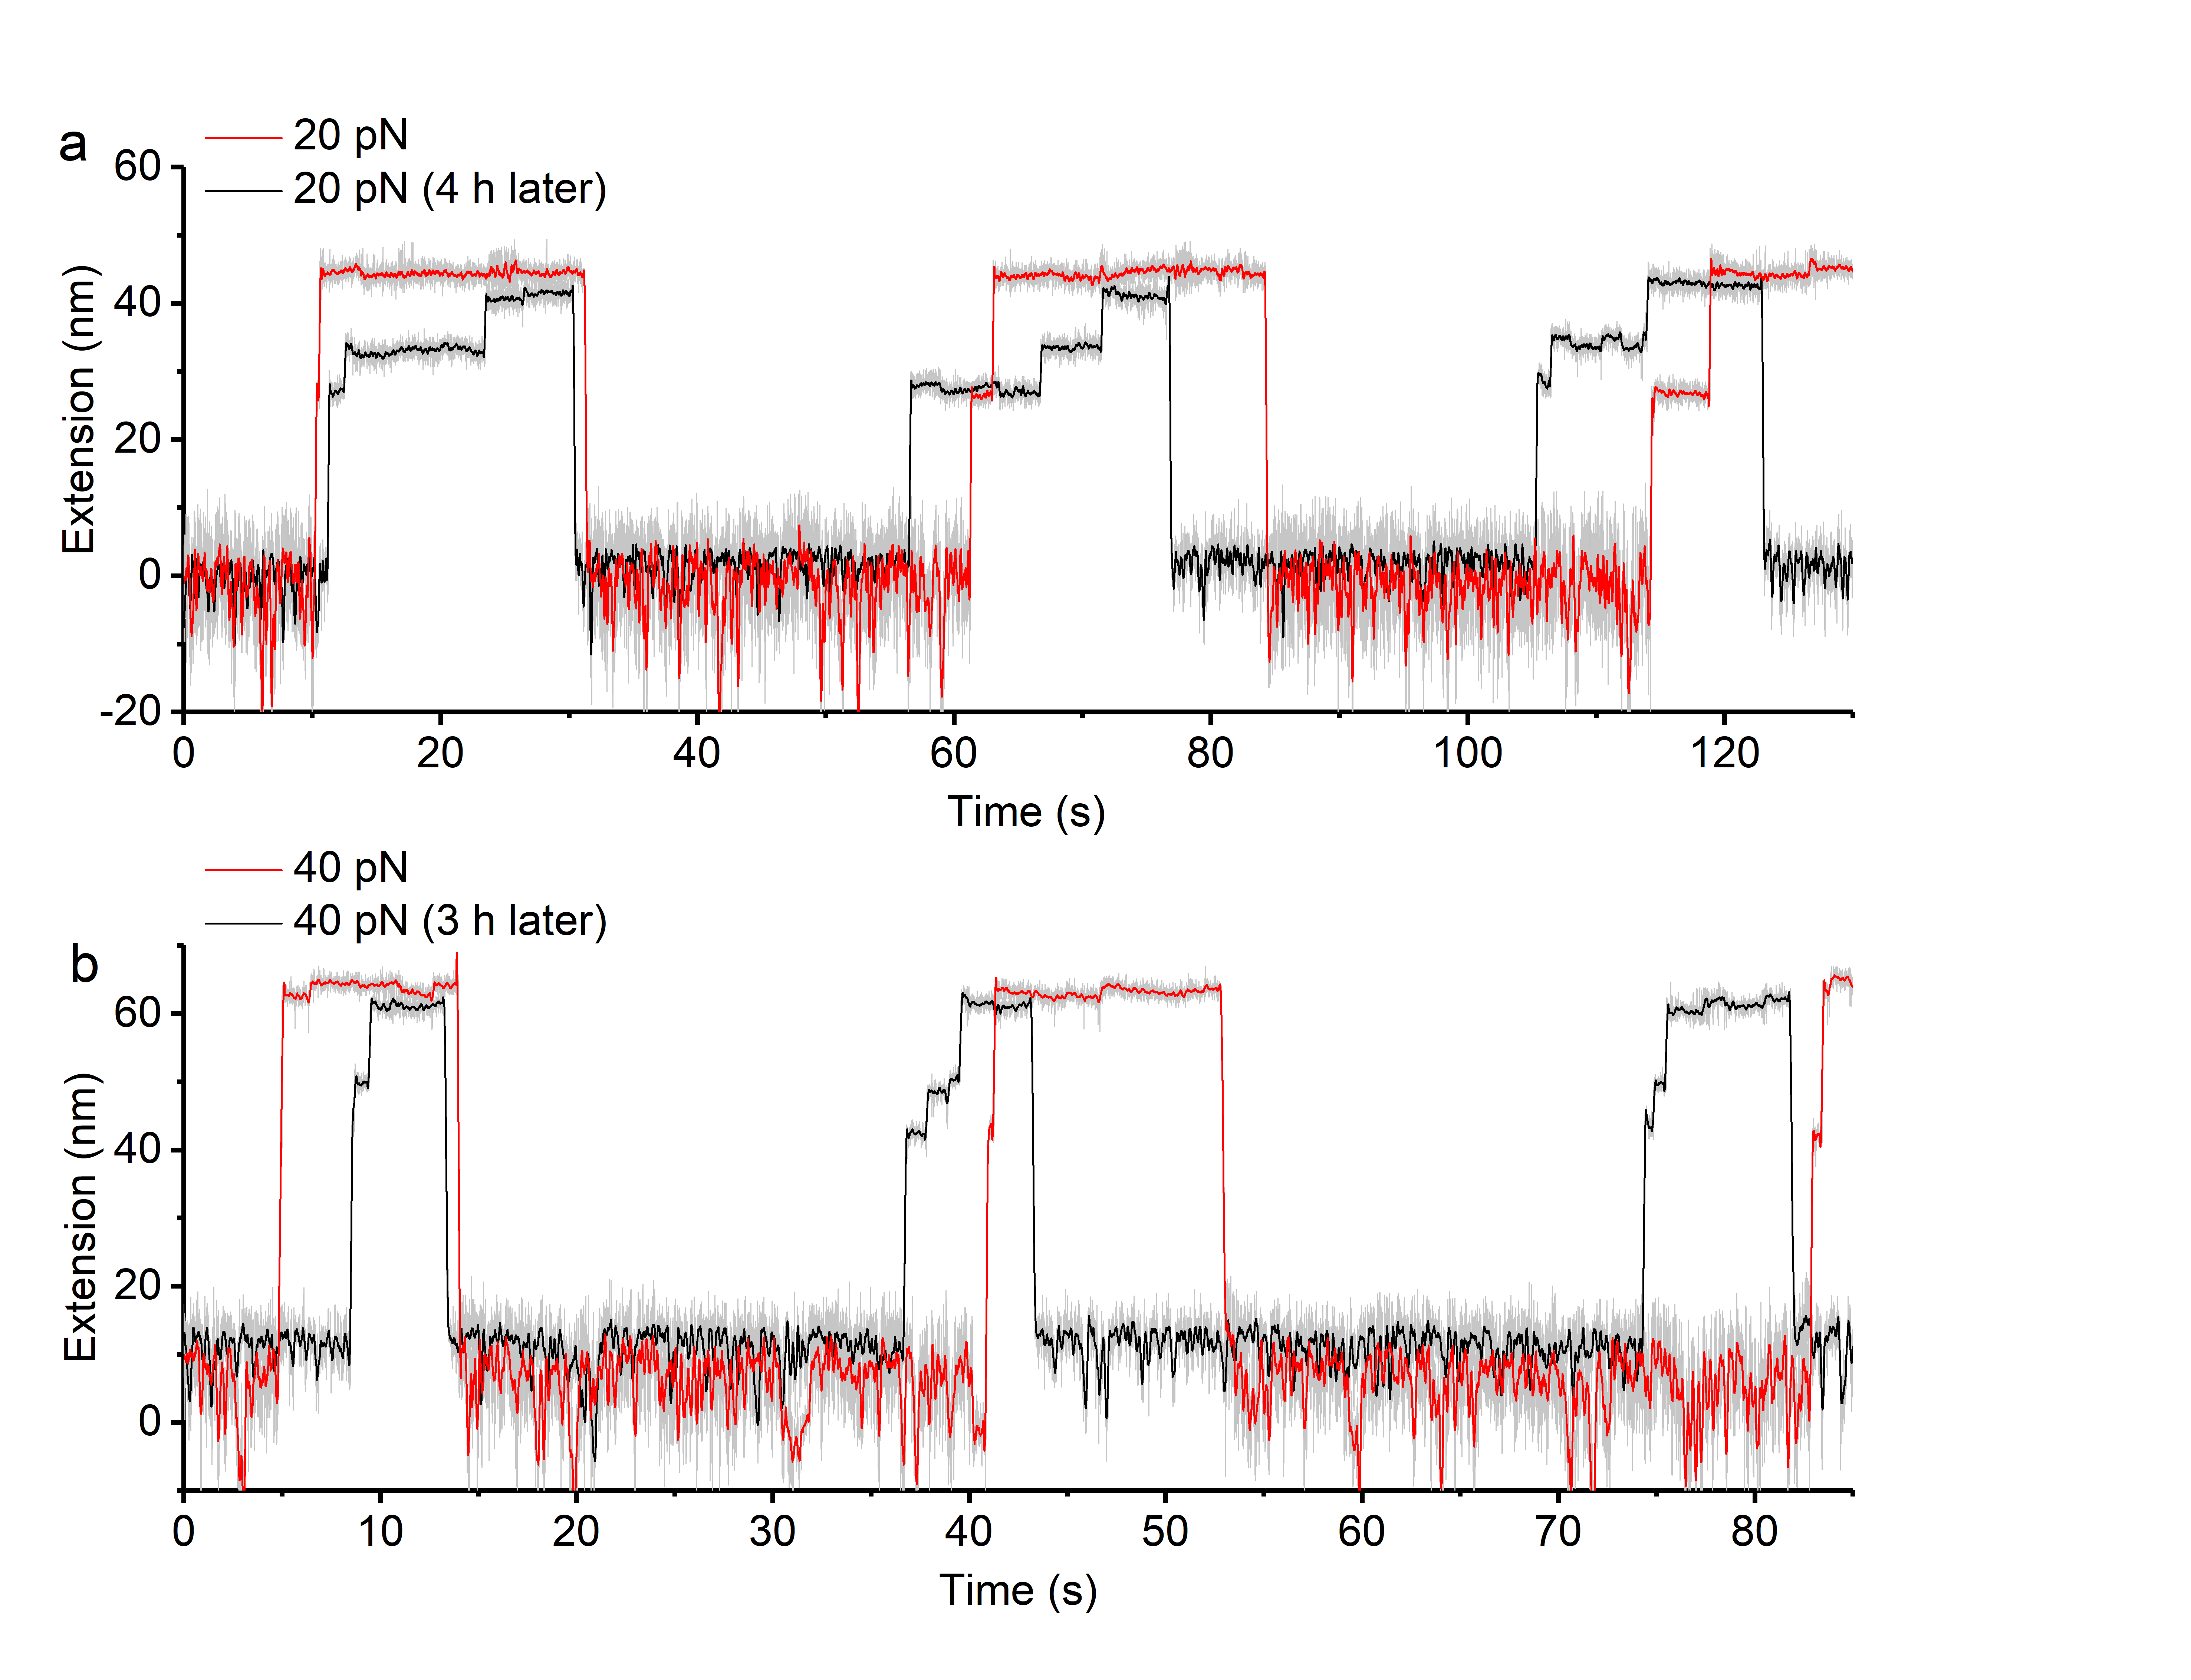
Supplementary Figure 4. Occasional observation of multi-step unfolding events of Csp after several hours measurement. (a, b) From the start of experiment, Csp unfolded with one step within three hours continuous measurement. Multi-step unfolding events of Csp started to be recorded in force-jump experiments after three hours.

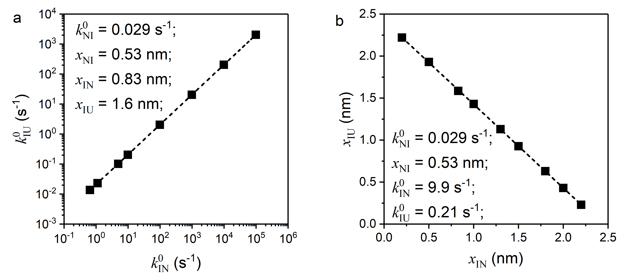
Supplementary Figure 5. The interdependence between parameters to fit force-dependent unfolding rate by NIU model. (a) The parameters were fixed to values in Supplementary Tab. 1, except for $k_{\text{IN}}^{0}$ and $k_{\text{IU}}^{0}$, which were adjusted at the same time to fit force-dependent unfolding rates in Fig. 4A. These two parameters show a linear relationship. (b) The same operation was applied to $x_{\text{IN}}$ and $x_{\text{IU}}$. Linear relationship shows the summation of $x_{\text{IN}}$ and $x_{\text{IU}}$ is ~2.4 nm.

Supplementary References

1 Bell, G. I. Models for the specific adhesion of cells to cells. Science 200, 618-627 (1978).
2 Schlierf, M., Li, H. & Fernandez, J. M. The unfolding kinetics of ubiquitin captured with single-molecule force-clamp techniques. Proc. Natl. Acad. Sci. USA 101, 7299-7304 (2004).
3 Strunz, T., Oroszlan, K., Schafer, R. & Guntherodt, H. J. Dynamic force spectroscopy of single DNA molecules. Proc. Natl. Acad. Sci. USA 96, 11277-11282 (1999).
4 Sulchek, T. A. et al. Dynamic force spectroscopy of parallel individual Mucin1-antibody bonds. Proc. Natl. Acad. Sci. USA 102, 16638-16643 (2005).
5 Pierse, C. A. & Dudko, O. K. Distinguishing signatures of multipathway conformational transitions. Phys. Rev. Lett. 118, 088101 (2017).

