Extended data
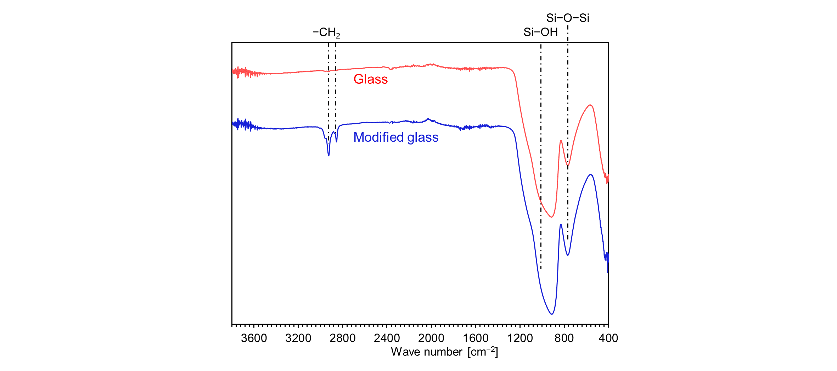Extended Data Figure 1 | Surface chemistry of the probe substrate surface.
FT-IR spectrum of the glass substrate before and after modification with phenyl silane.
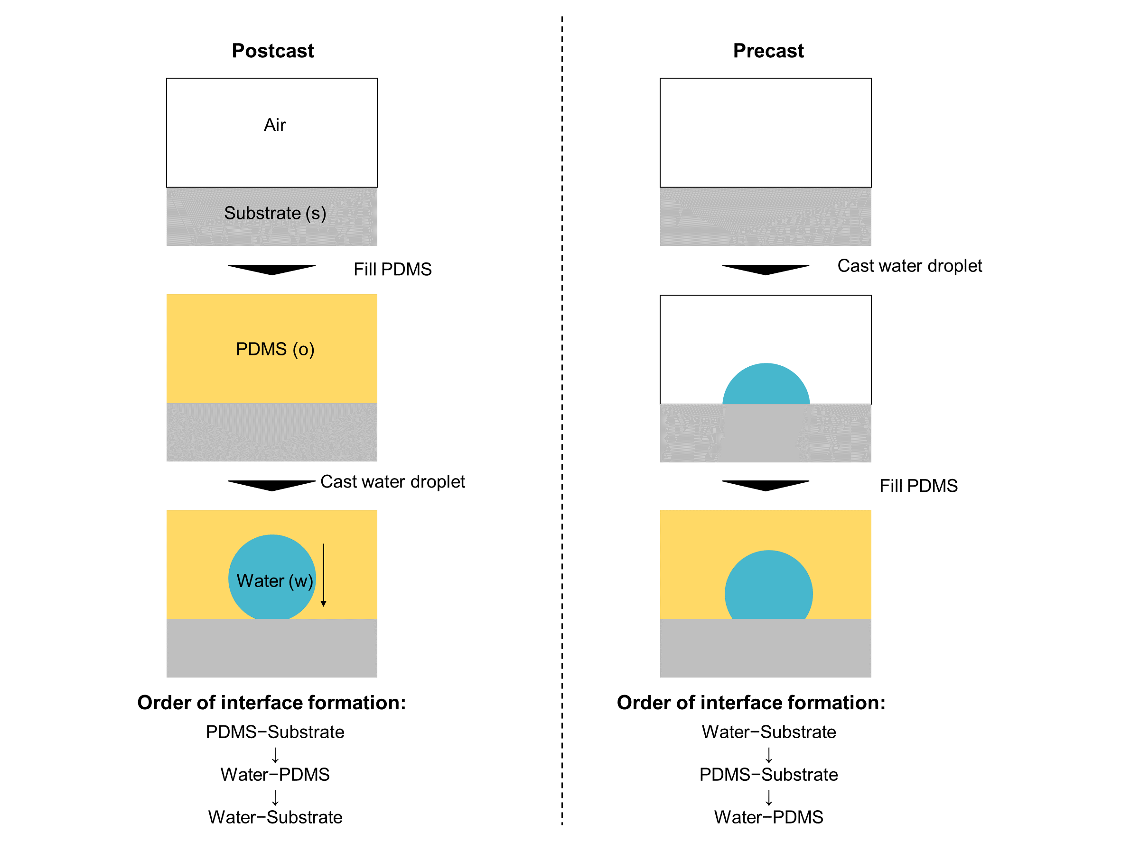 Extended Data Figure 2 | Interface formation order.
We adjusted the order of interface formation by casting the water droplet before/after the filling of PDMS as a surrounding media.

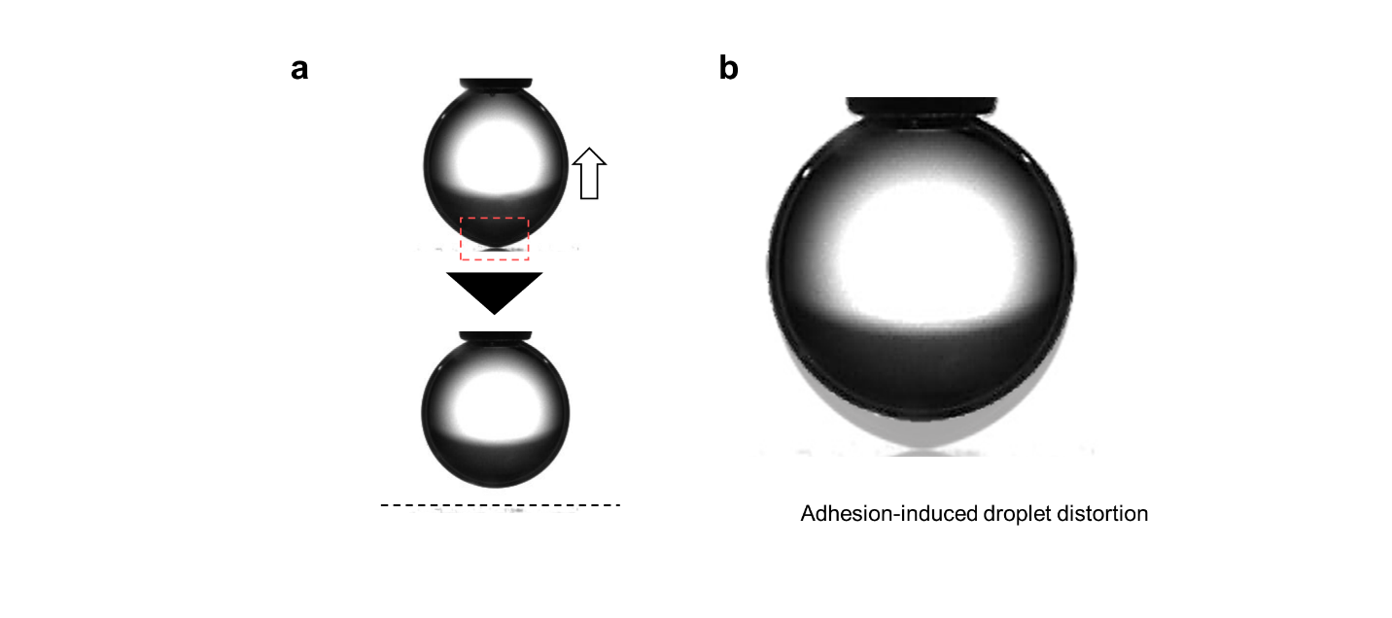 Extended Data Figure 3 | Water adhesion-induced droplet distortion.
a, Contact line receding behaviour by pulling the precast water droplet from phenyl silane-modified glass substrate under PDMS−OH (HLB = 0.12) condition. b, Droplet distortion in the pulling condition explains the non-zero adhesion behaviour of the droplet to the substrate.

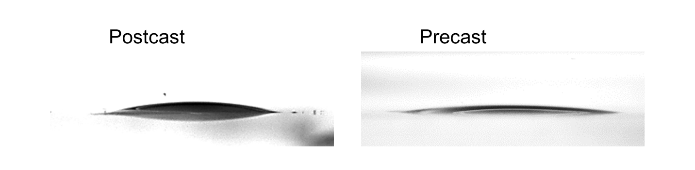 Extended Data Figure 4 |Water wettability of unmodified glass substrate under PDMS−OH (HLB = 0.12).
Photos of pre/postcast 0.5 μL water droplets under PDMS−OH (HLB = 0.12).

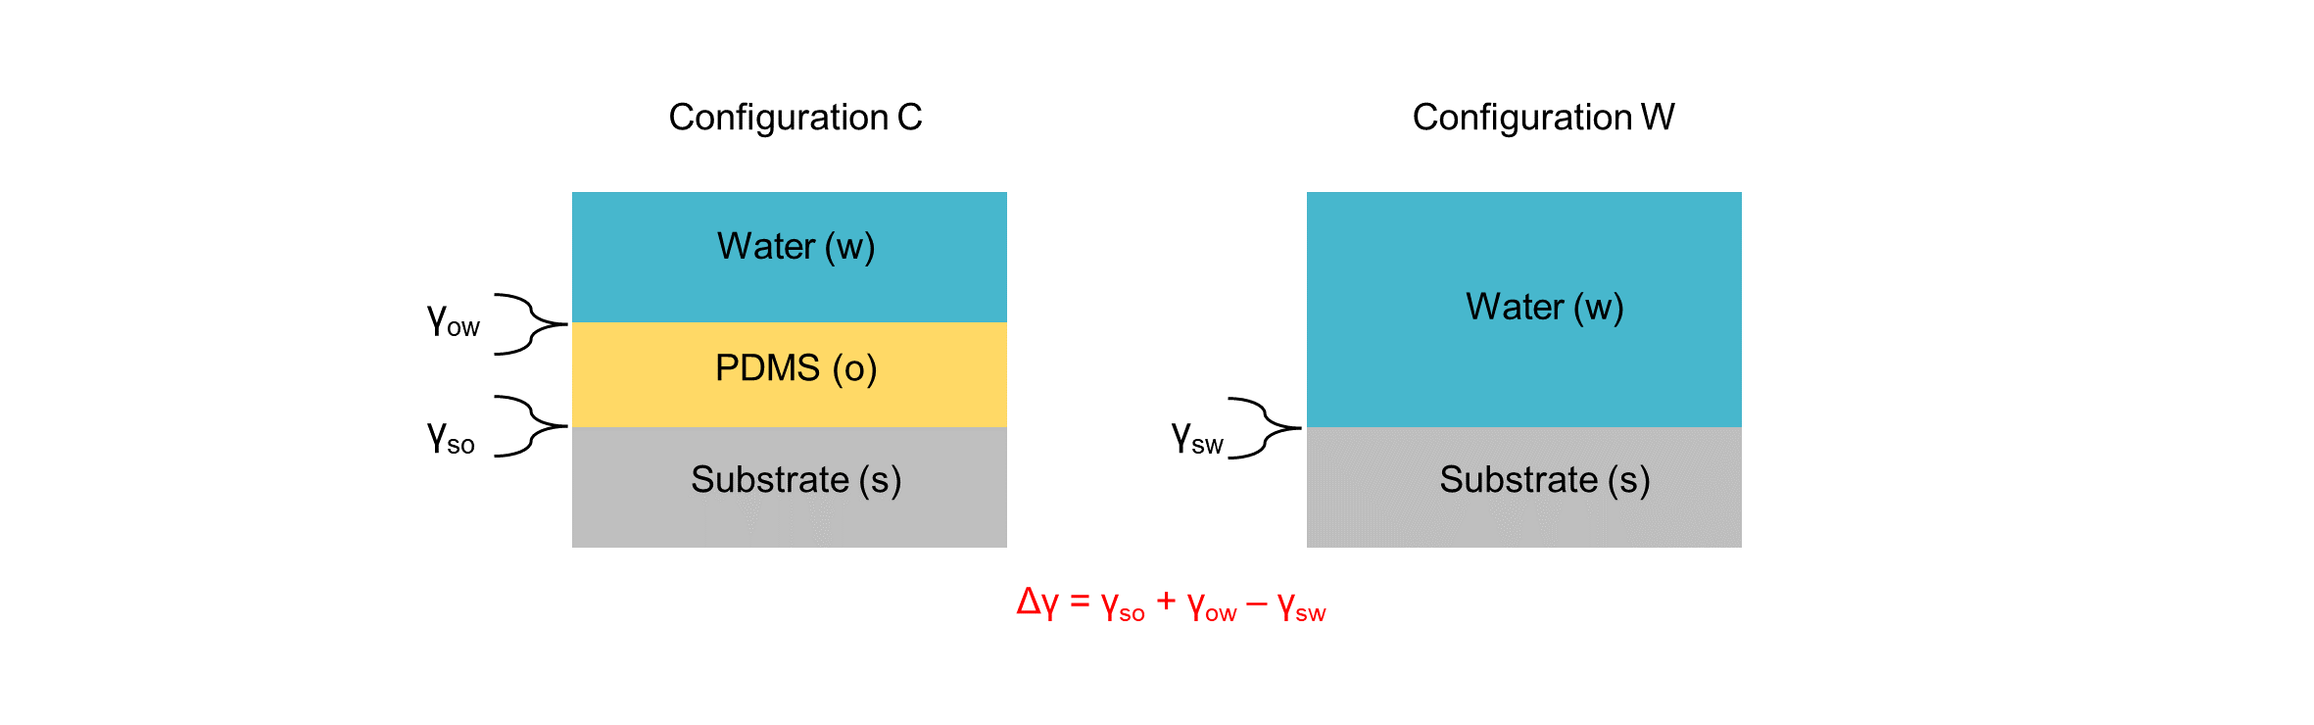 Extended Data Figure 5 |The interfacial energy difference between two configurations.
Simplified scheme and possible interfacial energies of the configuration C and W.

 Extended Data Figure 6 |Time dependence on water−PDMS interfacial energy.

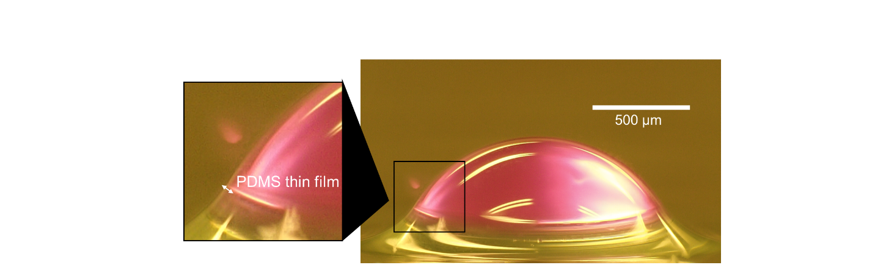 Extended Data Figure 7 | Wrapping droplet
Digital microscopic image of a 0.5 μL water droplet wrapped with PDMS−OH (HLB = 0.12). Since the PDMS wrapped droplet has lower interfacial energy (that is, γ_{ow} + γ_{o} =57.9±2.8 mN/m) than bare droplet one (that is, γ_{w} =71.6±0.5 mN/m), PDMS−OH spreads to wrap the water droplet. This magnitude relation in interfacial energy is applicable for PDMS (HLB = 0) and PDMS (HLB = 0.73).

 Extended Data Figure 8 | HLB effect on the interfacial energy difference of configurations C and W.

 Extended Data Figure 9 | Intermolecular interaction between PDMS−NH₂ and silanol.
Distance dependence of the intermolecular interaction energy between the −OH groups on the substrate surface and the molecular end group of PDMS−NH₂.

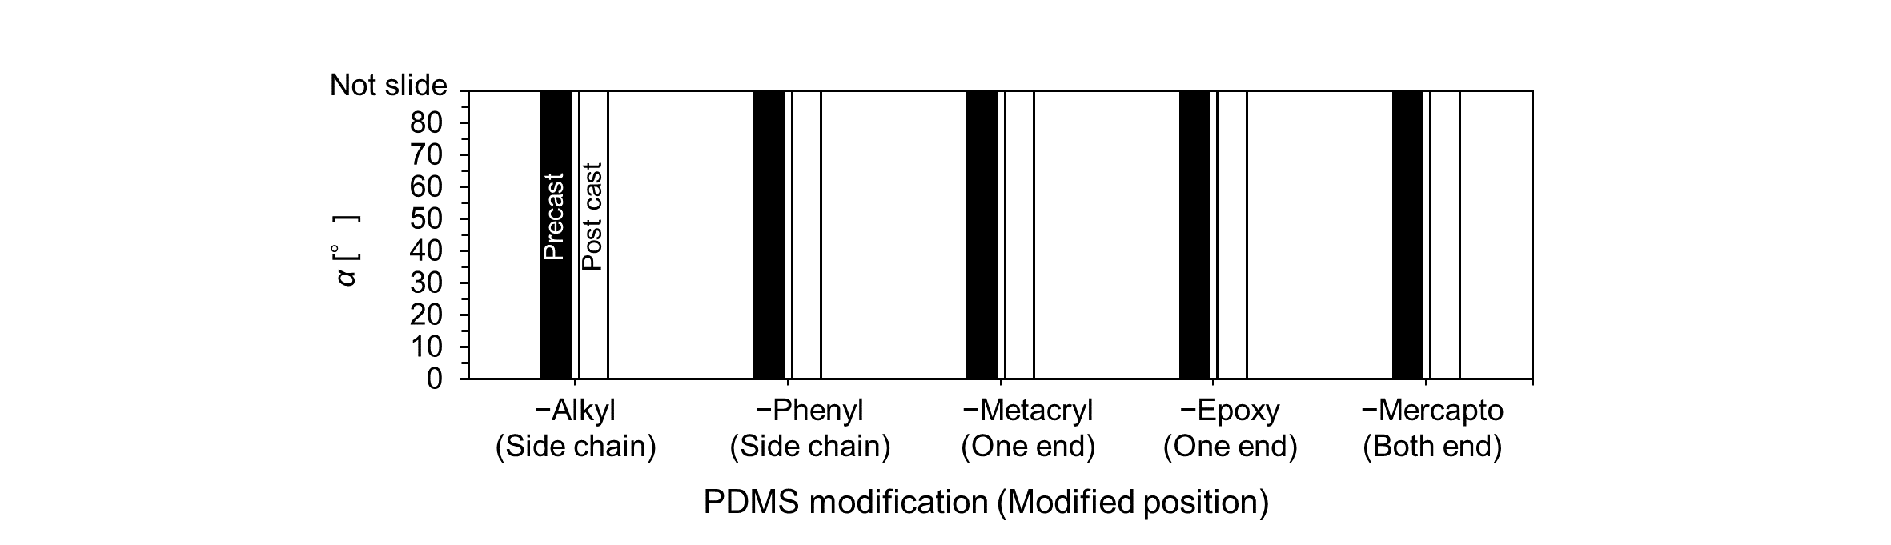 Extended Data Figure 10 | PDMS modification effect on pre/postcast water sliding angle.
Sliding angle of 5 μL pre/postcast water droplets under various modified PDMS. The wettability is not branched since both pre/postcast droplets exhibit non-sliding behaviour without dilution by non-modified PDMS.

Extended Data Table 1| Summary of interfacial energies and contact angles of PDMS and water.
Liquid | Surface tension  (in air) [mN/m] | Interfacial tension with water [mN/m] | Static contact angle on probe substrate [°]
Water | 71.6±0.5 | − | 79.4±1.9
PDMS  (HLB = 0) | 19.8±0.3 | 38.1±2.5 | 2.2±0.6
PDMS−OH (HLB = 0.12) | 19.9±0.2 | 20.1±1.7 | 2.0±0.2
PDMS−OH (HLB = 0.73) | 21.4±0.4 | 7.5±0.5 | 14.9±0.6
PDMS−NH₂ | 20.5±0.3 | 7.2±0.3 | −

