Supplemental Material

Oral Bacillus subtilis Spores-based Vaccine for Mass Vaccination against Porcine Reproductive and Respiratory Syndrome

Huitae Min¹, Hye-Sim Cho², Hoe-Suk Lee³, Young-Tae Park^{1,*}, Hu-Jang Lee^{4,*}, Hyun-Sik Park^{2,*}

Affiliations:
¹ Natural Product Research Center, Korea Institute of Science and Technology (KIST), Gangneung 25451, Republic of Korea
² Research and Development Department, JBBIOTECH, Seoul, 08507, Republic of Korea
³Department of Biochemical Engineering, Gangneung-Wonju National University, Gangneung, 25457, Republic of Korea
⁴Institute of Animal Medicine, College of Veterinary Medicine, Gyeongsang National University, Chinju, 52828, Republic of Korea

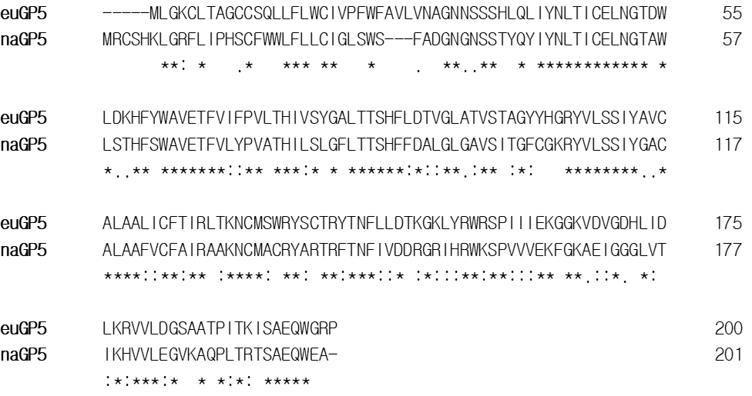
FIGURE S1 Amino acids sequence alignment of euGP5 and naGP5
Amino acid sequences of euGP5 and naGP5 were aligned using ClustalX2. The genes for translating them were optimized for expression in B. subtilis and synthesized.

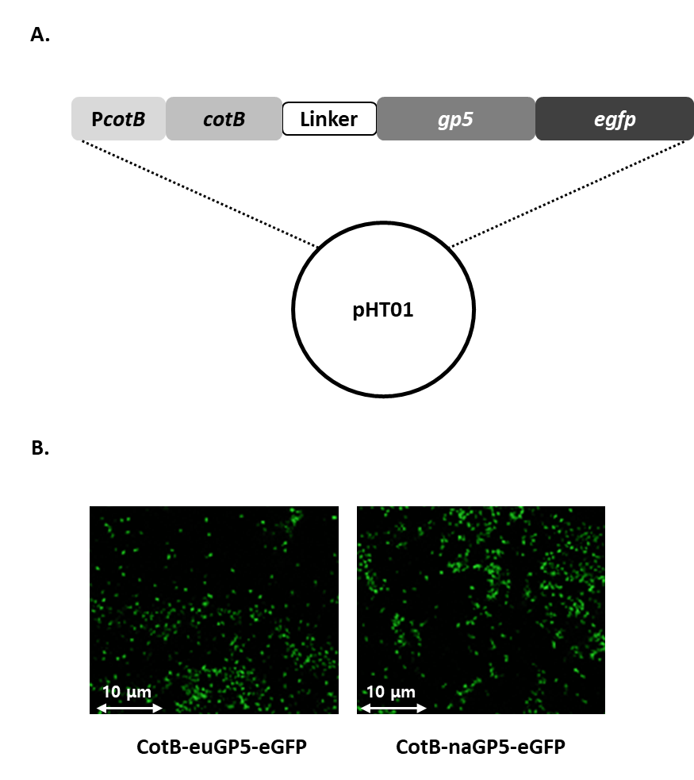
FIGURE S2 Enhanced green fluorescent protein integration and expression following C-terminus of CotB-GP5 in B. subtilis spores
(A) Enhanced green fluorescent protein (eGFP) was genetically integrated into the C-terminus of the gp5 gene in each constructed plasmid (for euGP5 or naGP5) and their schematic diagram was shown. This illustrates that the expression of eGFP is linked to the expression of the CotB-GP5 fusion proteins, allowing for fluorescent visualization. (B) Spores sporulated with each constructed plasmid were examined their fluorescence signals using a confocal microscopy.

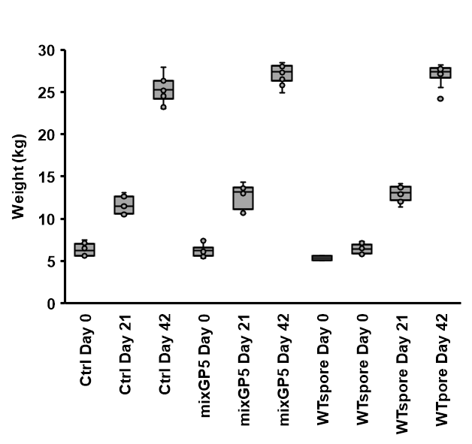
FIGURE S3 Weight gain in pigs administered sCotB-mixGP5 and Wild-Type B. subtilis spores
Pigs were divided into three groups: the first group received no treatment (Ctrl), the second group received wild-type B. subtilis spores, and the third group received a mixture of sCotB-euGP5 and sCotB-naGP5 (sCotB-mixGP5). Average weight gain over the experimental period for each group were measured.

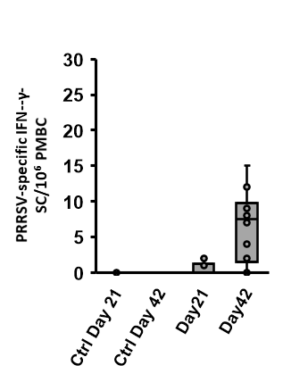
FIGURE S4 Expression of IFN-γ in pigs following oral administration of sCotB-mixGP5
The expression levels of interferon-gamma (IFN-γ) were measured to evaluate the cell-mediated immune response in pigs administered with the sCotB-mixGP5 vaccine as described in the Materials and methods section.

