Nitrophenyl-Group-Containing Heterocycles. 2. Synthesis, Characterization, Anticancer Activity, Apoptotic Induction and Cell Cycle Arrest of Some New 5,6,7,8-Tetrahydro-isoquinolines Bearing 2-Nitrophenyl Group
Abdelreheem A. Saddik¹, Etify A. Bakhite^{1*} , Reda Hassanien², Naseer Farhan², Eman M. Sayed^{2*} , Marwa Sharaky ³
¹Chemistry Department, Faculty of Science, assuit University, Assiut 71516, Egypt.
²Chemistry Department, Faculty of Science, New Valley University, 72511 El-Kharja, Egypt. ³ Cancer biology department, pharmacology unit, national cancer institute, Cairo university, Cairo, E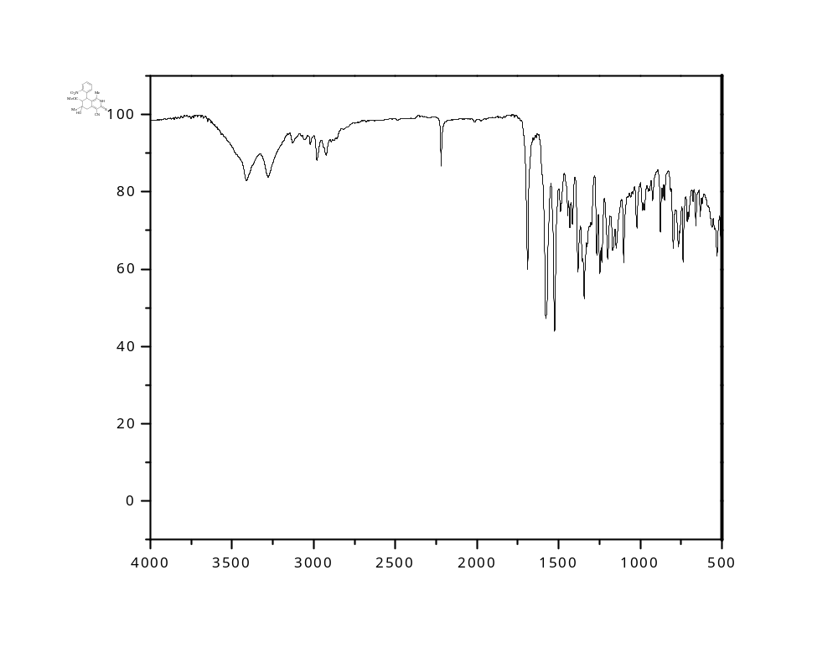

Figure S1: IR spectrum of the start 7-acetyl-6-hydroxy-1,6-dimethyl-8-(2-nitrophenyl)-3-thioxo-2,3,5,6,7,8-terahydroisoquinoline-4-carbonitrile (2).
Figure S2: ¹H NMR spectrum of the start 7-acetyl-6-hydroxy-1,6-dimethyl-8-(2-nitrophenyl)-3-thioxo-2,3,5,6,7,8-tetrahydroisoquinoline-4-carbonitrile (2).

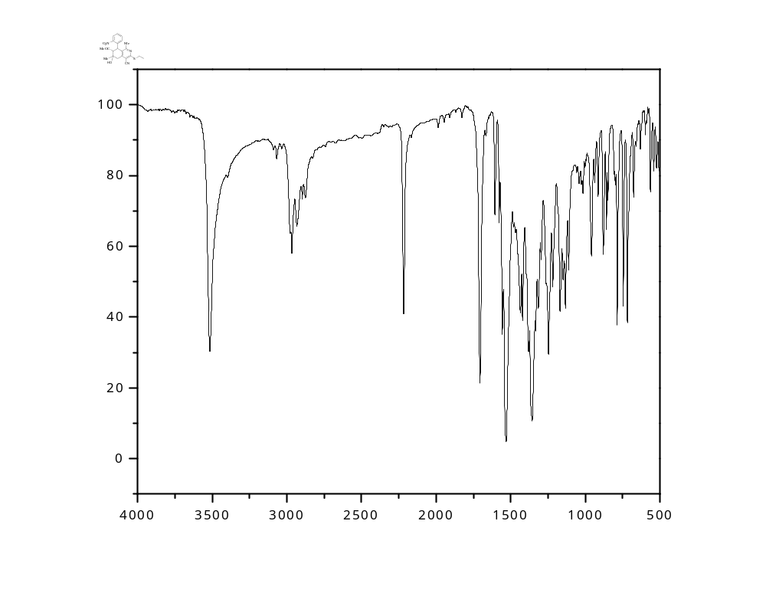Figure S3: IR spectrum of 7-acetyl-3-(ethylthio)-6-hydroxy-1,6-dimethyl-8-(2-nitrophenyl)-5,6,7,8-tetrahydroisoquinoline-4-carbonitrile (3).

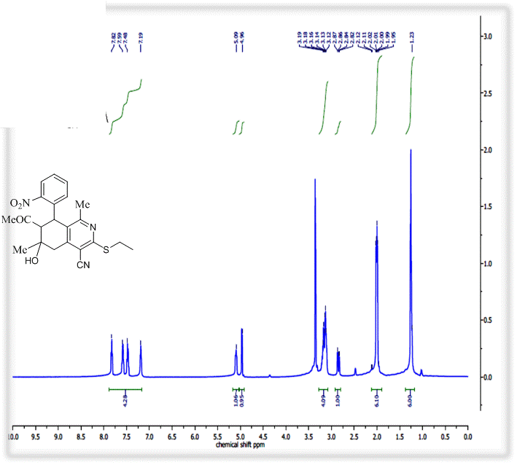
Figure S4: ¹H NMR spectrum of 7-acetyl-3-(ethylthio)-6-hydroxy-1,6-dimethyl-8-(2-nitrophenyl)-5,6,7,8-tetrahydroisoquinoline-4-carbonitrile (3).

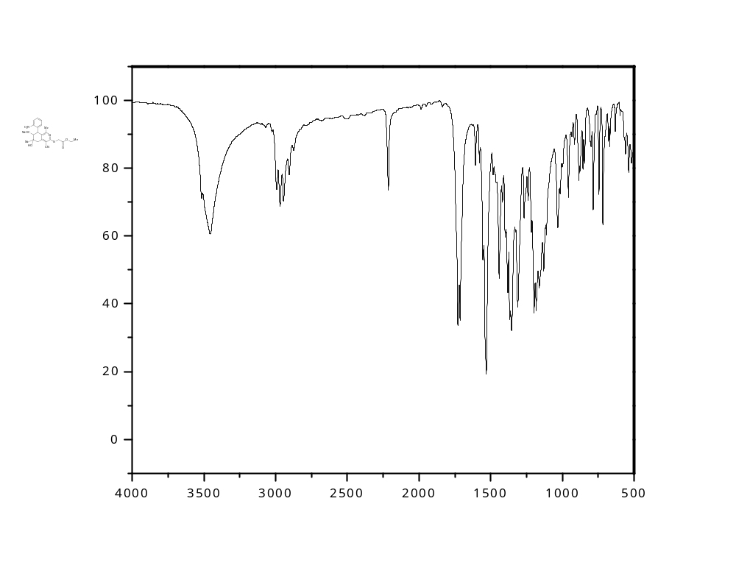
Figure S5: IR spectrum of ethyl 2-((7-acetyl-4-cyano-6-hydroxy-1,6-dimethyl-8-(2-nitrophenyl)-5,6,7,8-tetrahydroisoquinolin-3-yl)thio)acetate (4)
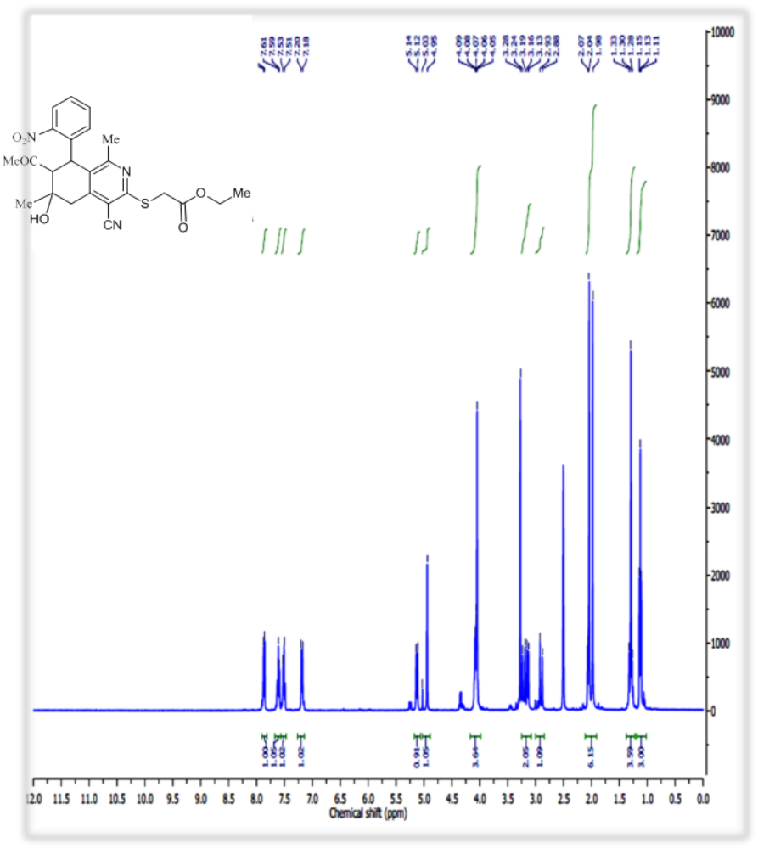
Figure S6: ¹H NMR spectrum of the ethyl 2-((7-acetyl-4-cyano-6-hydroxy-1,6-dimethyl-8-(2-nitrophenyl)-5,6,7,8-tetrahydroisoquinolin-3-yl)thio)acetate (4)

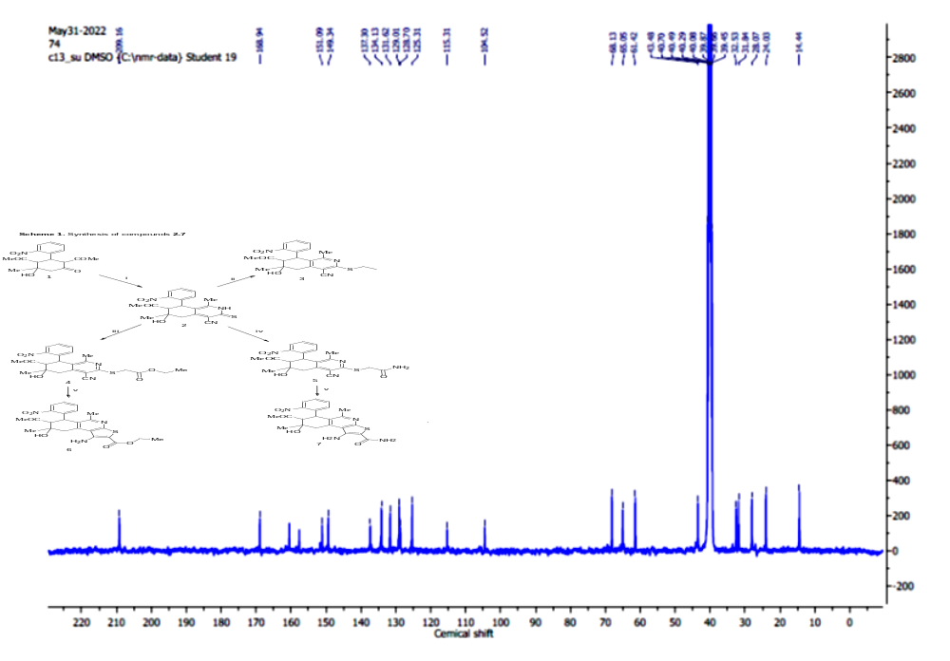

Figure S7: ¹³C NMR spectrum of the ethyl 2-((7-acetyl-4-cyano-6-hydroxy-1,6-dimethyl-8-(2-nitrophenyl)-5,6,7,8-tetrahydroisoquinolin-3-yl)thio)acetate (4)
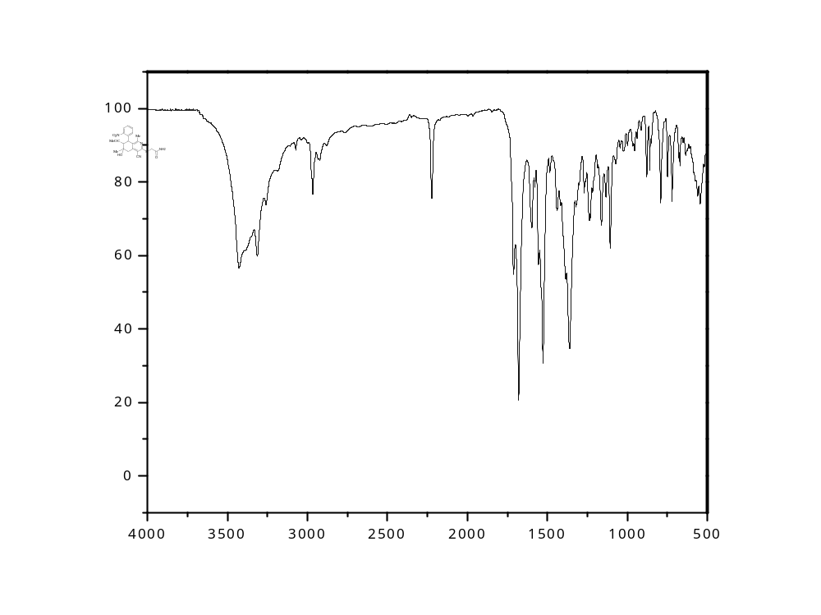
Figure S8: IR spectrum of the 2-((7-acetyl-4-cyano-6-hydroxy-1,6-dimethyl-8-(2-nitrophenyl)-5,6,7,8-tetrahydroisoquinolin-3-yl)thio)acetamide (5).

Figure S9: ¹H NMR spectrum of the 2-((7-acetyl-4-cyano-6-hydroxy-1,6-dimethyl-8-(2-nitrophenyl)-5,6,7,8-tetrahydroisoquinolin-3-yl)thio)acetamide (5).
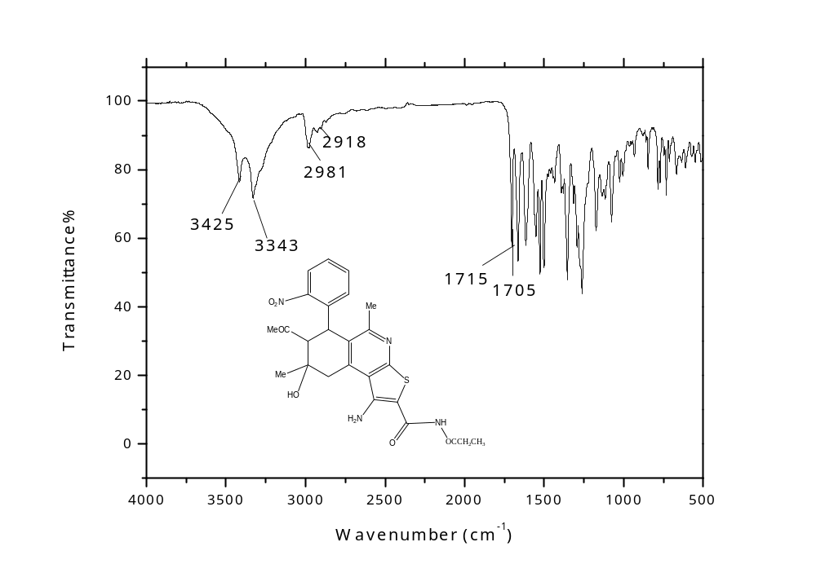

Figure S10: IR spectrum of the ethyl 7-acetyl-1-amino-8-hydroxy-5,8-dimethyl-6-(2-nitrophenyl)-6,7,8,9-tetrahydrothieno[2,3-c]isoquinoline-2-carboxylate (6):

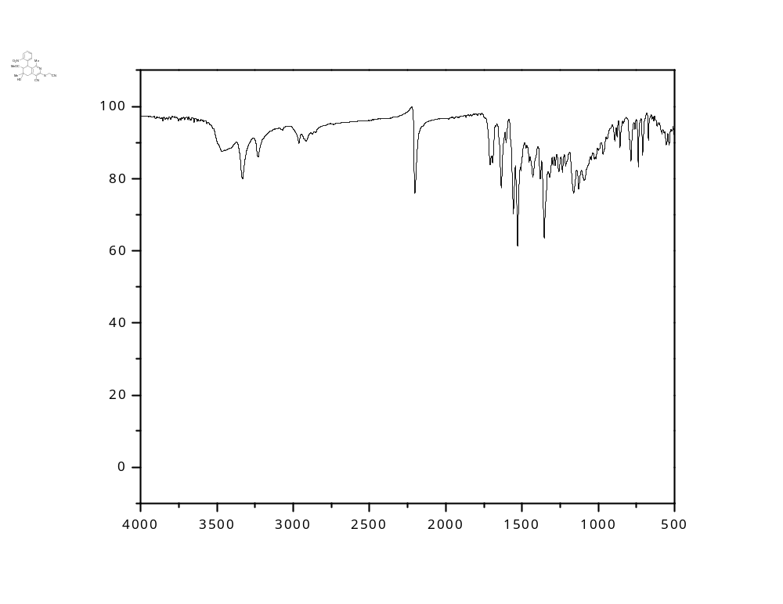Figure S11: IR spectrum of the 2-((7-acetyl-4-cyano-6-hydroxy-1,6-dimethyl-8-(2-nitrophenyl)-5,6,7,8-tetrahydroisoquinolin-3-yl)thio)acetyl cyanide (7).

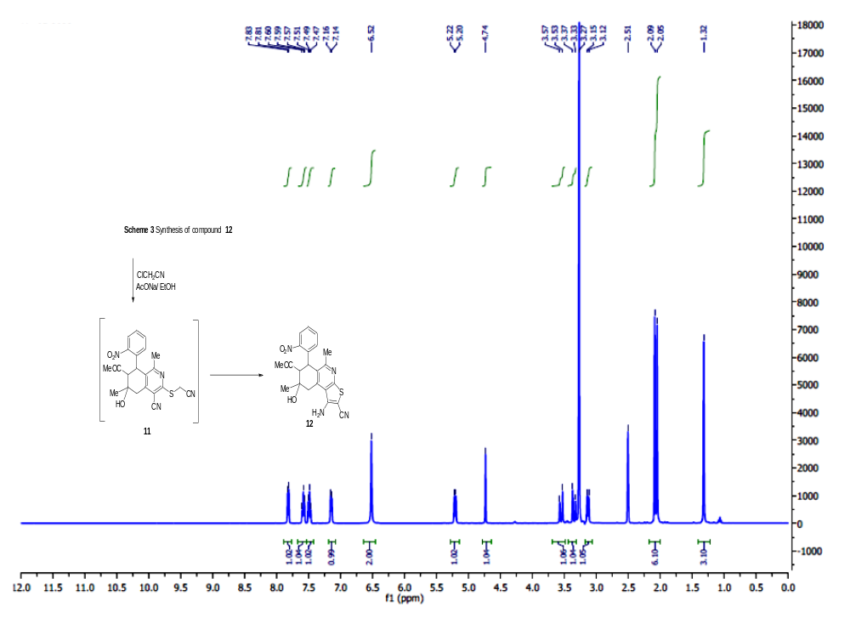
Figure S12: ¹H NMR spectrum of the 2-((7-acetyl-4-cyano-6-hydroxy-1,6-dimethyl-8-(2-nitrophenyl)-5,6,7,8-tetrahydroisoquinolin-3-yl)thio)acetyl cyanide (7)

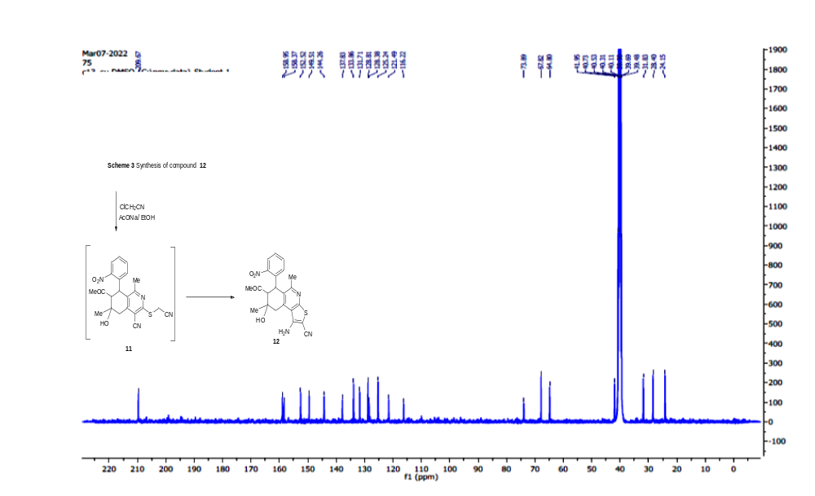
Figure S13: ¹³CNMR spectrum of the 2-((7-acetyl-4-cyano-6-hydroxy-1,6-dimethyl-8-(2-nitrophenyl)-5,6,7,8-tetrahydroisoquinolin-3-yl)thio)acetyl cyanide (7)

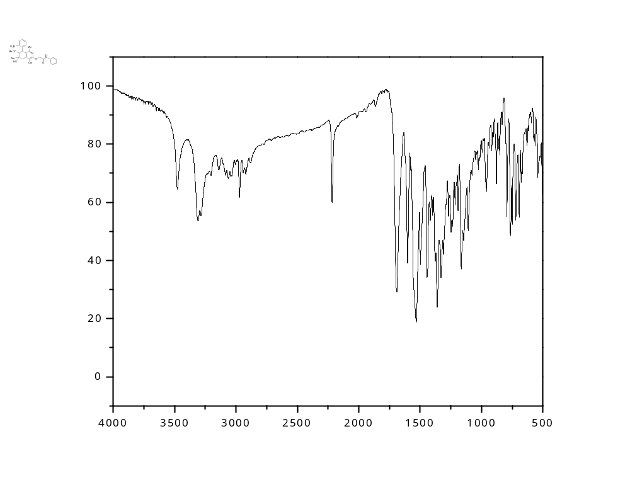

Figure S14: IR spectrum of the 2-((7-acetyl-4-cyano-6-hydroxy-1,6-dimethyl-8-(2-nitrophenyl)-5,6,7,8-tetrahydroisoquinolin-3-yl)thio)-N-phenylacetamide (9a).
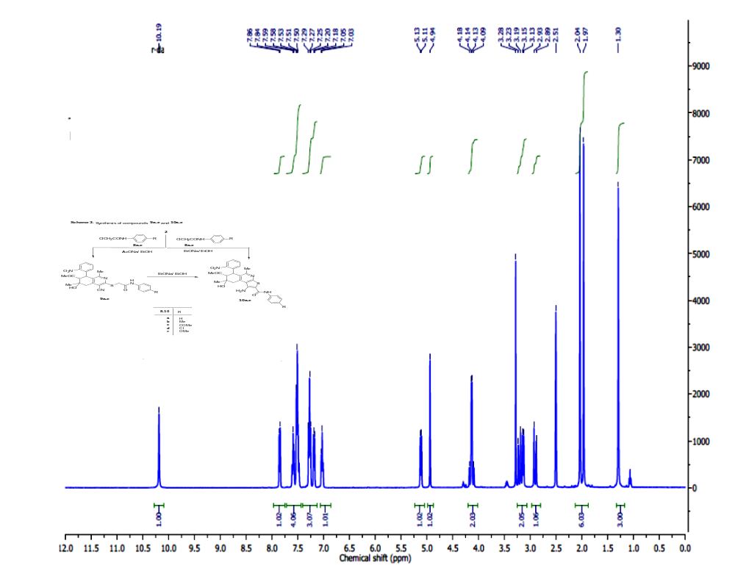

Figure 15: ¹H NMR spectrum of the 2-((7-acetyl-4-cyano-6-hydroxy-1,6-dimethyl-8-(2-nitrophenyl)-5,6,7,8-tetrahydroisoquinolin-3-yl)thio)-N-phenylacetamide (9a).

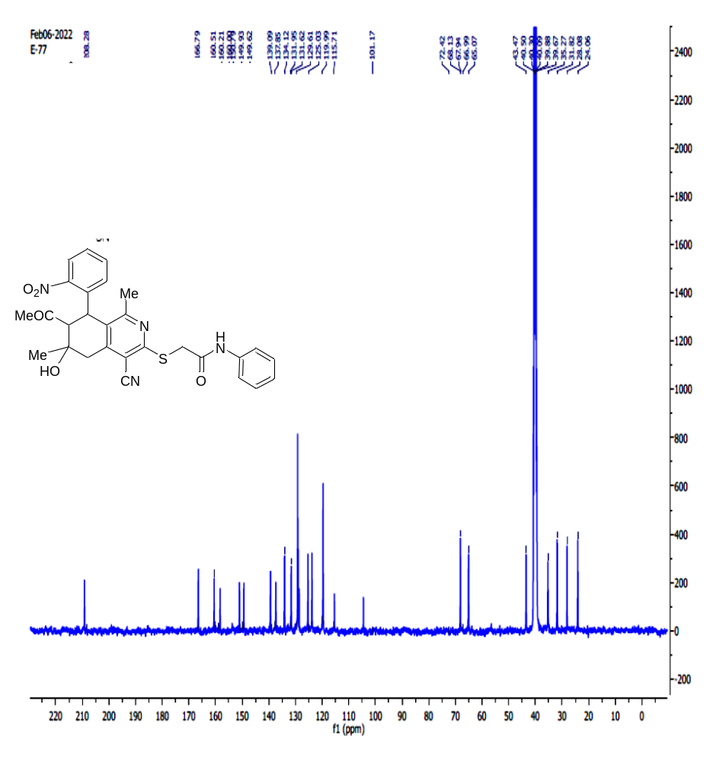
Figure S16: ¹³C NMR spectrum of the 2-((7-acetyl-4-cyano-6-hydroxy-1,6-dimethyl-8-(2-nitrophenyl)-5,6,7,8-tetrahydroisoquinolin-3-yl)thio)-N-phenylacetamide (9a).

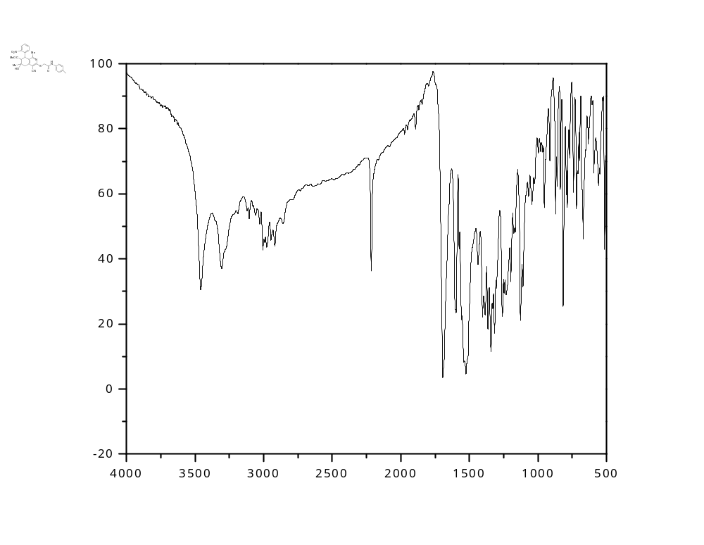
Figure S17: IR spectrum of the 2-((7-acetyl-4-cyano-6-hydroxy-1,6-dimethyl-8-(2-nitrophenyl)-5,6,7,8-tetrahydroisoquinolin-3-yl)thio)-N-(4-chlorophenyl)acetamide (9b).

Figure S18: ¹H NMR spectrum of the 2-((7-acetyl-4-cyano-6-hydroxy-1,6-dimethyl-8-(2-nitrophenyl)-5,6,7,8-tetrahydroisoquinolin-3-yl)thio)-N-(4-chlorophenyl)acetamide (9b).

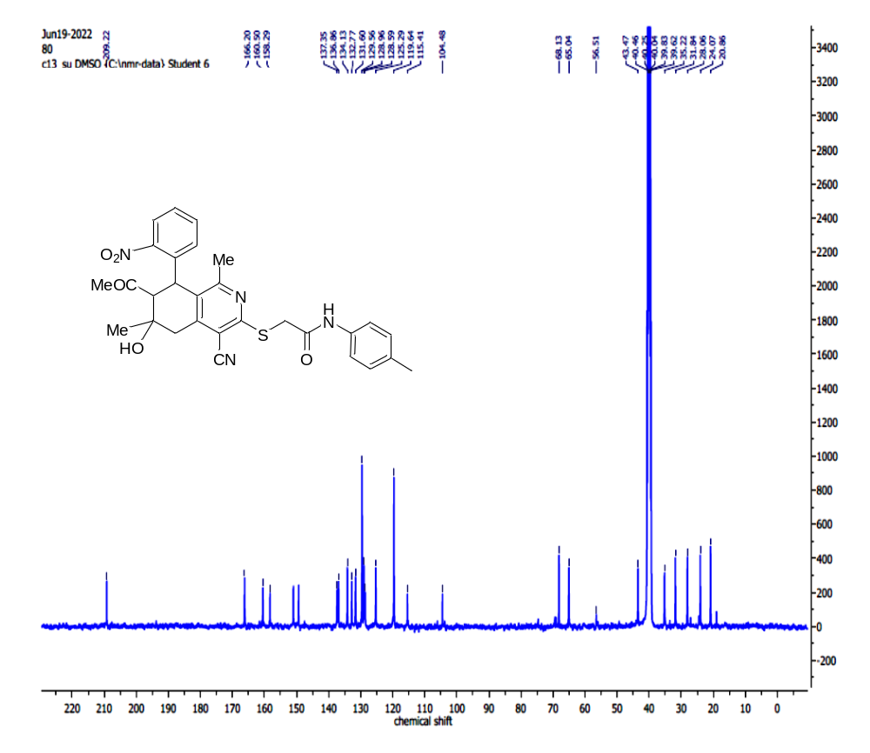
Figure S19: ¹³C NMR spectrum of the 2-((7-acetyl-4-cyano-6-hydroxy-1,6-dimethyl-8-(2-nitrophenyl)-5,6,7,8-tetrahydroisoquinolin-3-yl)thio)-N-(4-chlorophenyl)acetamide (9b).

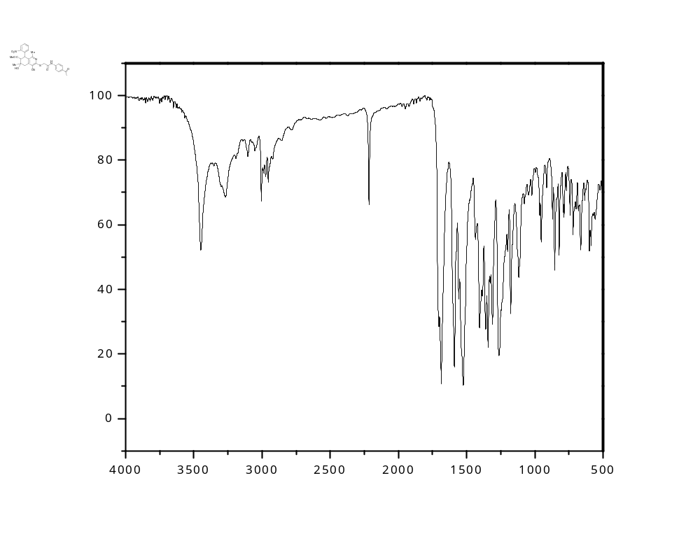

Figure S20: IR spectrum of the 2-((7-acetyl-4-cyano-6-hydroxy-1,6-dimethyl-8-(2-nitrophenyl)-5,6,7,8-tetrahydroisoquinolin-3-yl)thio)-N-(4-acetylphenyl)acetamide (9c).
Figure S21: ¹H NMR spectrum of the 2-((7-acetyl-4-cyano-6-hydroxy-1,6-dimethyl-8-(2-nitrophenyl)-5,6,7,8-tetrahydroisoquinolin-3-yl)thio)-N-(4-acetylphenyl)acetamide (9c).
Figure S22: ¹³C NMR spectrum of the 2-((7-acetyl-4-cyano-6-hydroxy-1,6-dimethyl-8-(2-nitrophenyl)-5,6,7,8-tetrahydroisoquinolin-3-yl)thio)-N-(4-acetylphenyl)acetamide (9c).

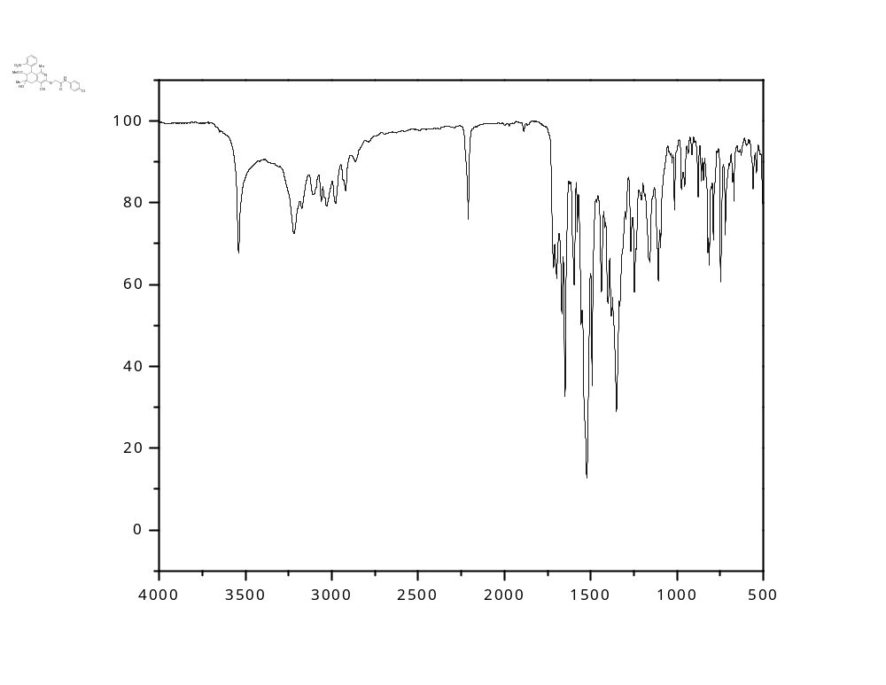

Figure S23: IR spectrum of2-((7-acetyl-4-cyano-6-hydroxy-1,6-dimethyl-8-(2-nitrophenyl)-5,6,7,8-tetrahydroisoquinolin-3-yl)thio)-N-(4-chlorophenyl)acetamide (9d).-

Figure S24: ¹H NMR spectrum of 2-((7-acetyl-4-cyano-6-hydroxy-1,6-dimethyl-8-(nitrophenyl)5,6,7,8-tetrahydroisoquinolin-3-yl)thio)-N-(4-chlorophenyl)acetamide (9d).

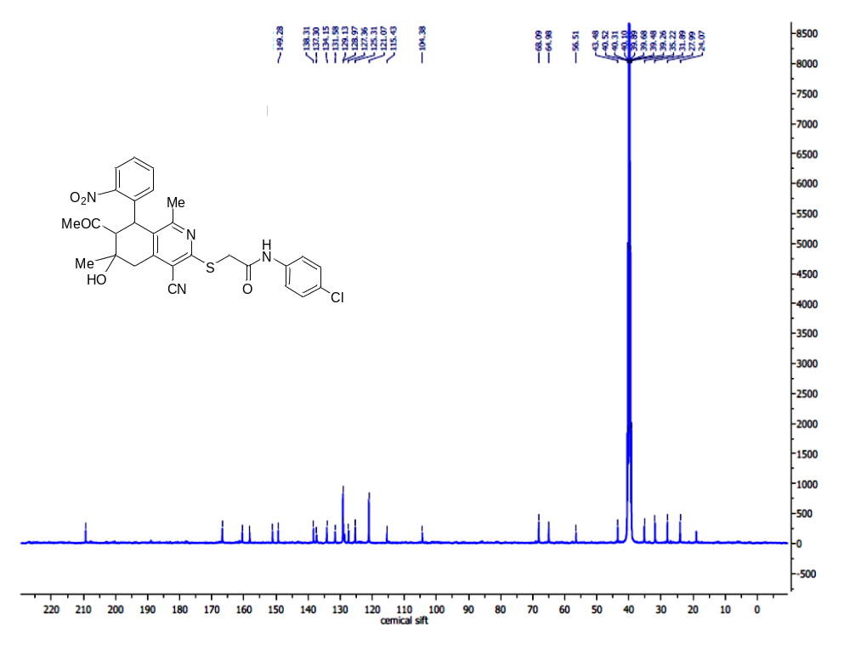
Figure S25: ¹³C NMR spectrum of 2-((7-acetyl-4-cyano-6-hydroxy-1,6-dimethyl-8-(2-nitrophenyl)-5,6,7,8-tetrahydroisoquinolin-3-yl)thio)-N-(4-chlorophenyl)acetamide (9d).

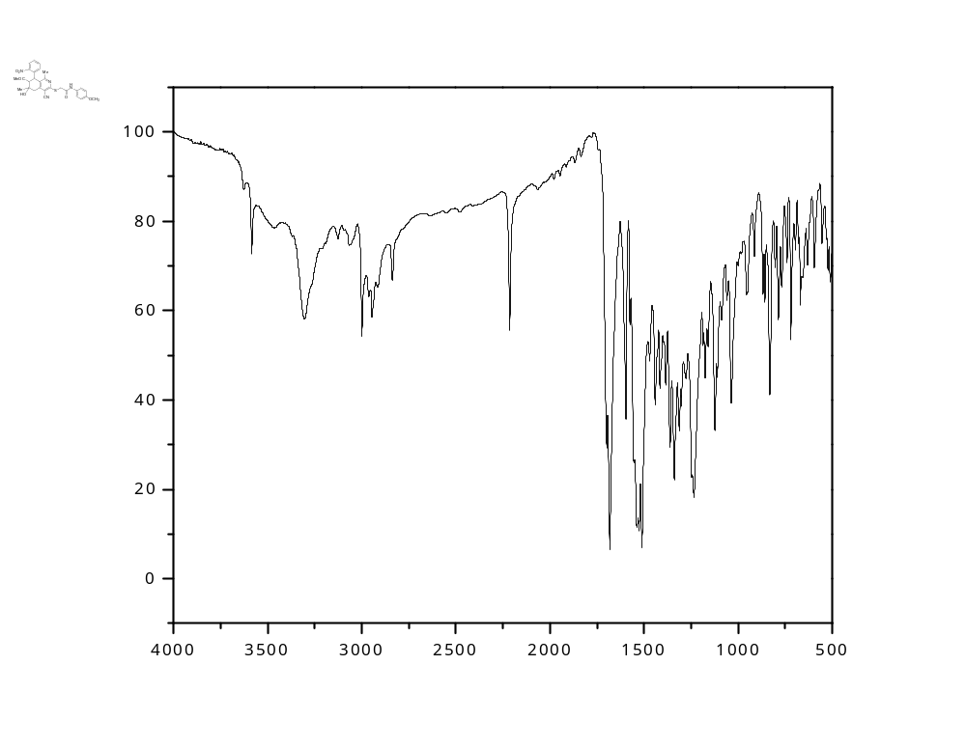
Figure S26: IR spectrum of the 2-((7-acetyl-4-cyano-6-hydroxy-1,6-dimethyl-8-(2-nitrophenyl)-5,6,7,8-tetrahydroisoquinolin-3-yl)thio)-N-(4-methoxyphenyl)acetamide (10e).
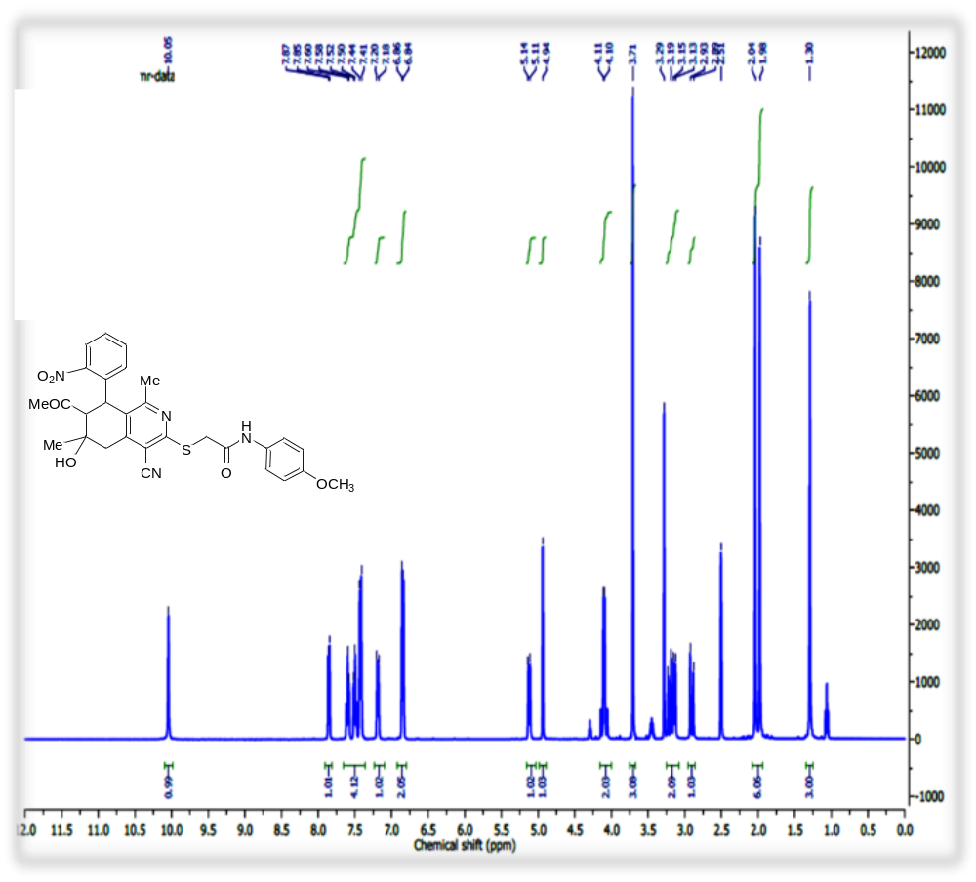

Figure S27: ¹H NMR spectrum of the 2-((7-acetyl-4-cyano-6-hydroxy-1,6-dimethyl-8-(2-nitrophenyl)-5,6,7,8-tetrahydroisoquinolin-3-yl)thio)-N-(4-methoxyphenyl)acetamide (9e).
Figure S28: ¹³C NMR spectrum of the 2-((7-acetyl-4-cyano-6-hydroxy-1,6-dimethyl-8-(2-nitrophenyl)-5,6,7,8-tetrahydroisoquinolin-3-yl)thio)-N-(4-methoxyphenyl)acetamide (9e).

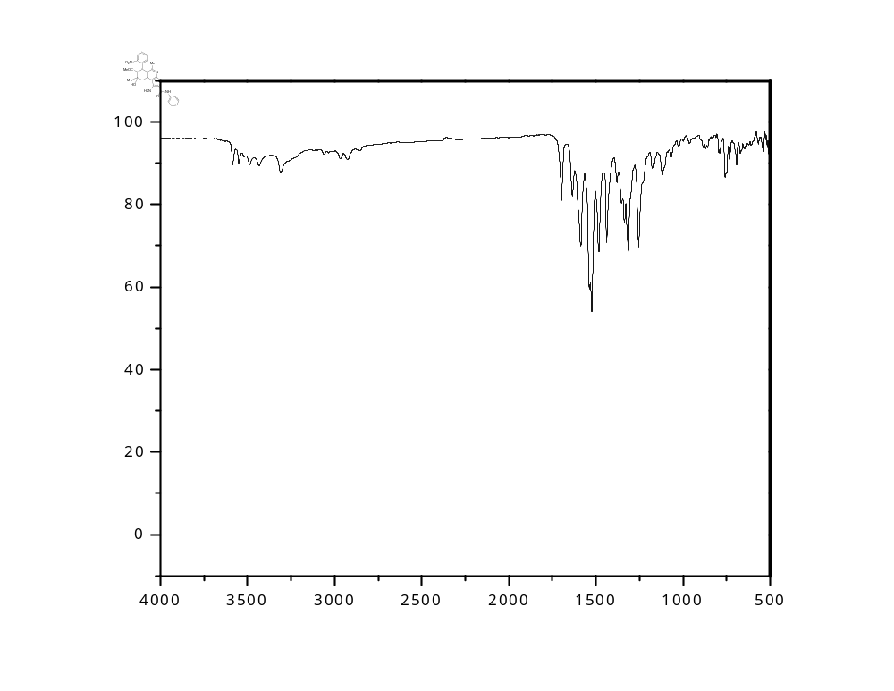

Figure S29: IR spectrum of the 7-acetyl-1-amino-8-hydroxy-5,8-dimethyl-6-(2-nitrophenyl)-N-phenyl-6,7,8,9-tetrahydrothieno[2,3-c]isoquinoline-2-carboxamide (10a).
Figure
Figure S30: ¹HNMR spectrum of the 7-acetyl-1-amino-8-hydroxy-5,8-dimethyl-6-(2-nitrophenyl)-N-phenyl-6,7,8,9-tetrahydrothieno[2,3-c]isoquinoline-2-carboxamide (10a).

Figure S31: ¹³C NMR spectrum of the 7-acetyl-1-amino-8-hydroxy-5,8-dimethyl-6-(2-nitrophenyl)-N-phenyl-6,7,8,9-tetrahydrothieno[2,3-c]isoquinoline-2-carboxamide (10a).

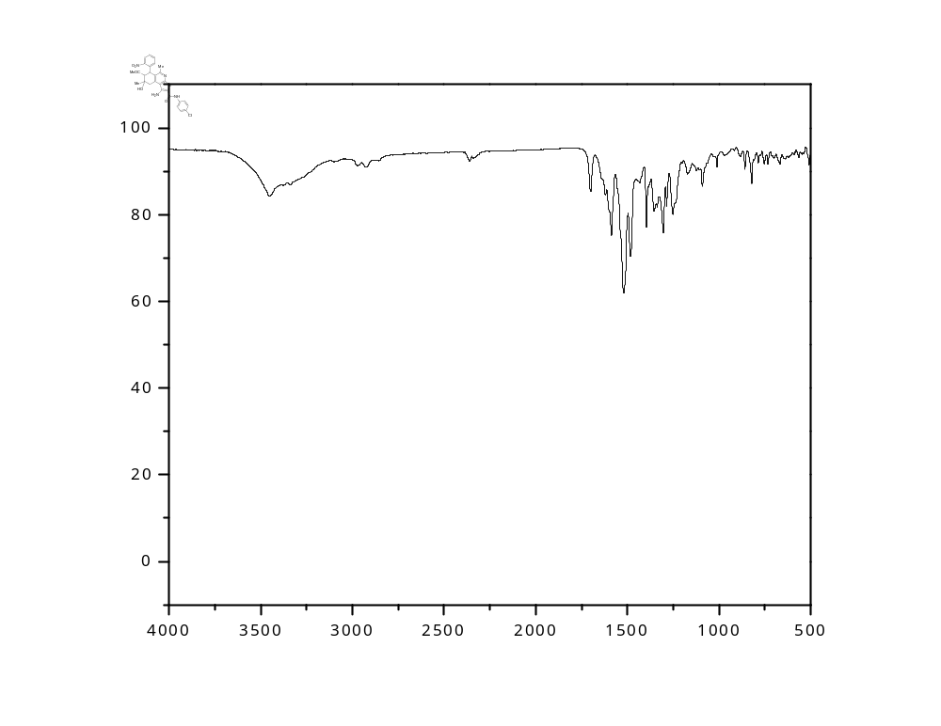

Figure S32: IR spectrum of the 7-acetyl-1-amino-N-(4-chlorophenyl)-8-hydroxy-5,8-dimethyl-6-(2-nitrophenyl)-6,7,8,9-tetrahydrothieno[2,3-c]isoquinoline-2-carboxamide (10d).

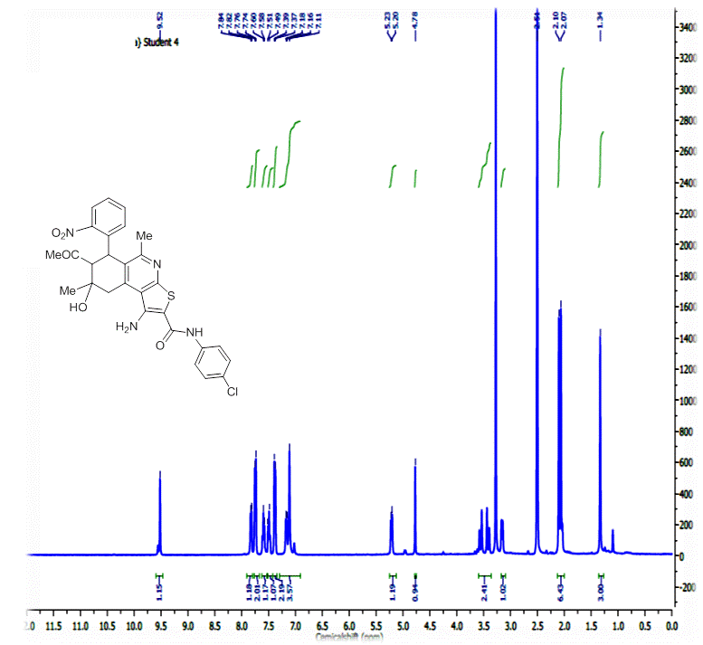
Figure S33: ¹H NMR spectrum of the 7-acetyl-1-amino-N-(4-chlorophenyl)-8-hydroxy-5,8-dimethyl-6-(2-nitrophenyl)-6,7,8,9-tetrahydrothieno[2,3-c]isoquinoline-2-carboxamide (10d).

Table S1 : Raw data of anticancer activity for all synthesized compounds at one spot concentration 100 µg/ml against eight cell lines.

Column1 | Column2 | Column3 | Column5 | Column6 | Column7 | Column8 | Column9 | Column10
Compd. NO.
 | MG-63 | S.D. | HCT116 | S.D. | CACO2 | S.D. | HSF | S.D.
2 | 44.00504838 | 3.662975945 | 57.54520167 | 2.130102002 | 47.13038054 | 1.878495936 | 62.4593556 | 3.583906489
3 | 38.24148086 | 4.695830488 | 53.12934631 | 2.778161941 | 58.2345602 | 1.143499861 | 57.7298256 | 2.709178655
4 | 39.84013462 | 4.430534992 | 60.77885953 | 5.243665672 | 56.11353712 | 2.427533706 | 47.67957434 | 2.660360627
5 | 36.55868742 | 3.320853323 | 64.88178025 | 1.498363103 | 47.50467873 | 3.259028341 | 47.11794265 | 4.121730959
6 | 38.83045856 | 3.445619727 | 54.41585535 | 3.362328539 | 49.90642545 | 2.90734378 | 56.93171741 | 2.37343224
7 | 38.15734119 | 1.262095078 | 73.50486787 | 1.35605007 | 57.0492826 | 0.902400258 | 68.54862548 | 1.210499275
9a | 38.57803955 | 3.17620296 | 71.00139082 | 0.995068708 | 28.38427948 | 2.152892567 | 55.48329885 | 1.932707187
9b | 37.40008414 | 2.313458491 | 63.07371349 | 0.275982404 | 42.01497193 | 6.786789344 | 56.90215785 | 1.451732682
9c | 46.0244005 | 2.839947637 | 72.60083449 | 1.620470125 | 50.71740487 | 3.5426752 | 51.31540053 | 3.510376958
9d | 31.08960875 | 2.313458491 | 58.58831711 | 1.605855805 | 42.91952589 | 2.475749823 | 48.27076559 | 3.357320926
9e | 44.46781658 | 1.217120416 | 63.69958275 | 3.721744668 | 54.92825951 | 3.1245566 | 51.87703222 | 3.001132757
10d | 36.34833824 | 2.811763536 | 41.51599444 | 3.73390647 | 47.31752963 | 3.4566566 | 54.36003547 | 1.967654655
DOX | 63.8199411 | 1.927882076 | 70.86230876 | 5.148737215 | 74.82844666 | 4.239866784 | 58.9122081 | 4.190791274

Compd. NO. | Column11 | Column12 | Column13 | Column14 | Column15 | Column16 | Column17 | Column18 | Column19 | Column24
 | A549 | S.D. | H460 | S.D. | HUH7 | S.D. | HEPG2 | S.D. | MCF7 | S.D.
2 | 38.65760408 | 0.515053341 | 52.94400385 | 2.920935276 | 33.92206336 | 1.481604739 | 61.89468113 | 3.460359045 | 49.50867052 | 1.360839002
3 | 38.82752761 | 3.371815605 | 71.04061524 | 0.907213943 | 45.41631623 | 2.145895849 | 66.39322572 | 2.313574278 | 70.23121387 | 4.44936541
4 | 27.01784197 | 6.633550143 | 49.21893776 | 4.731265947 | 26.82926829 | 5.343105189 | 70.0979095 | 2.425284835 | 64.45086705 | 0.867052023
5 | 37.25573492 | 2.118514467 | 38.69262197 | 3.787950577 | 16.42837118 | 4.105059054 | 62.68854194 | 2.100358278 | 65.63583815 | 2.176858966
6 | 44.68988955 | 3.754694952 | 63.32612353 | 1.243212416 | 41.43537987 | 0.21165782 | 71.28870071 | 1.82817946 | 40.1734104 | 3.126200528
7 | 35.42905692 | 6.022704706 | 65.03244412 | 3.965392934 | 39.22063359 | 2.720527848 | 72.7441122 | 0.407377727 | 31.47398844 | 1.777632869
9a | 10 | 5.150533412 | 50.66089882 | 5.096232597 | 32.21194281 | 5.311237478 | 64.30272559 | 1.568419319 | 41.61849711 | 3.28260598
9b | 28.63211555 | 2.548853016 | 63.92694064 | 1.406066088 | 29.6327446 | 2.56942848 | 67.21354856 | 0.286230586 | 40.1734104 | 4.335260116
9c | 13.67884452 | 11.34263458 | 59.43282865 | 1.881929531 | 31.87552565 | 2.225190337 | 63.53532681 | 2.885695873 | 52.02312139 | 4.364066148
9d | 46.30416313 | 1.282894551 | 62.58111031 | 2.271946829 | 44.96776002 | 1.141878994 | 65.89044721 | 1.652553056 | 50 | 3.909754121
9e | 33.38997451 | 3.757577636 | 57.29391973 | 0.541135797 | 36.33305299 | 0.51158642 | 62.1593014 | 0.920102601 | 41.32947977 | 5.773116866
10d | 32.32795242 | 1.851211433 | 55.37130497 | 4.29028855 | 25.9882254 | 5.887300252 | 67.61047896 | 0.96250508 | 47.51445087 | 1.611255476
DOX | 32.03058624 | 1.946718647 | 72.89113194 | 1.806772038 | 52.76142417 | 1.287464256 | 58.90447208 | 0.595836478 | 73.95953757 | 0.132444384

Table S2 : raw data for anticancer activity for all synthesized compound against HTC116 cell line.
Column1 | Column2 | Column3 | Column4 | Column5 | Column6
 | 0 | 12.5 | 25 | 50 | 100
2 | 0.86210001 | 0.8883 | 0.9181 | 0.59130001 | 0.47530001
 | 0.90039998 | 0.80269998 | 0.87559998 | 0.69959998 | 0.46200001
 | 0.96950001 | 0.76200002 | 0.82770002 | 0.62660003 | 0.54350001
Average | 0.91066666 | 0.81766667 | 0.8738 | 0.63916667 | 0.49360001
S.D. | 0.05443109 | 0.06446644 | 0.04522686 | 0.05523279 | 0.04372333
3 | 0 | 12.5 | 25 | 50 | 100
 | 0.86210001 | 0.92720002 | 0.57359999 | 0.40920001 | 0.3716
 | 0.90039998 | 0.7022 | 0.5359 | 0.51410002 | 0.47569999
 | 0.96950001 | 0.81569999 | 0.50520003 | 0.46200001 | 0.5377
average | 0.91066666 | 0.81503334 | 0.53823334 | 0.46176668 | 0.46166666
S.D. | 0.05443109 | 0.11250149 | 0.03425963 | 0.05245039 | 0.08393452
4 | 0 | 12.5 | 25 | 50 | 100
 | 0.86210001 | 0.97469997 | 0.84560001 | 0.71780002 | 0.41080001
 | 0.90039998 | 0.79259998 | 0.81290001 | 0.7026 | 0.37380001
 | 0.96950001 | 0.88249999 | 0.82779998 | 0.66759998 | 0.4147
average | 0.91066666 | 0.88326665 | 0.82876666 | 0.696 | 0.39976667
S.D. | 0.05443109 | 0.09105242 | 0.01637142 | 0.02574259 | 0.02257218
5 | 0 | 12.5 | 25 | 50 | 100
 | 0.86210001 | 7.4425 | 0.72956 | 0.63638 | 0.42506
 | 0.90039998 | 0.73954 | 0.63324 | 0.63844 | 0.4167
 | 0.96950001 | 0.75917 | 0.69870001 | 0.57921 | 0.59170002
averga | 0.91066666 | 2.98040333 | 0.68716667 | 0.61801 | 0.47782001
S.D. | 0.05443109 | 3.86430153 | 0.04918485 | 0.03361757 | 0.09871152
6 | 0 | 12.5 | 25 | 50 | 100
 | 0.86210001 | 0.94738 | 0.76095 | 0.67720002 | 0.64994
 | 0.90039998 | 0.93933 | 0.74908 | 0.75808 | 0.64571
 | 0.96950001 | 0.85630004 | 0.80699998 | 0.68089998 | 0.5456
 | 0.91066666 | 0.91433668 | 0.77234333 | 0.70539333 | 0.61375
S.D. | 0.05443109 | 0.05042211 | 0.03059472 | 0.04566548 | 0.05905752
7 | 0 | 12.5 | 25 | 50 | 100
 | 0.86210001 | 0.94029999 | 0.8294 | 0.41410003 | 0.3326
 | 0.90039998 | 0.93440002 | 0.8355 | 0.4581 | 0.39019999
 | 0.96950001 | 0.93980002 | 0.86210001 | 0.47628 | 0.3486
averga | 0.91066666 | 0.93816668 | 0.84233334 | 0.43610001 | 0.35713333
S.D. | 0.05443109 | 0.00327158 | 0.01738802 | 0.03197097 | 0.02973303

Column1 | Column2 | Column3 | Column4 | Column5 | Column6
 | 0 | 12.5 | 25 | 50 | 100
9A | 1.0085 | 1.0138 | 0.8507 | 0.5162 | 0.45755
 | 0.9848 | 0.9383 | 0.7898 | 0.4915 | 0.45118
 | 1.0105 | 0.9045 | 0.8272 | 0.5163 | 0.4579
Averga | #NAME? | 0.9522 | 0.822567 | 0.508 | 0.455543
S.D. | 0.014296 | 0.05596 | 0.030713 | 0.01429 | 0.003783
9B | 0 | 12.5 | 25 | 50 | 100
 | 1.0085 | 0.8666 | 0.8997 | 0.6805 | 0.5105
 | 0.9848 | 0.876 | 0.7899 | 0.6314 | 0.3966
 | 1.0105 | 0.9102 | 0.7458 | 0.74651 | 0.4193
Averga | 1.001267 | 0.884267 | 0.8118 | 0.686137 | 0.442133
S.D. | 0.011672 | 0.018735 | 0.06471 | 0.047162 | 0.049223
9C | 0 | 12.5 | 25 | 50 | 100
 | 1.0085 | 1.0211 | 0.8926 | 0.47813 | 0.4237
 | 0.9848 | 0.8604 | 0.76976 | 0.46046 | 0.4105
 | 1.0105 | 0.8242 | 0.707 | 0.5388 | 0.4763
averga | 1.001267 | 0.9019 | 0.789787 | 0.492463 | 0.436833
S.D. | 0.014296 | 0.104805 | 0.094407 | 0.04109 | 0.034811
9D | 0 | 12.5 | 25 | 50 | 100
 | 1.0085 | 1.1136 | 0.7999 | 0.6582 | 0.74612
 | 0.9848 | 0.8684 | 0.9161 | 0.8576 | 0.65999
 | 1.0105 | 1.1032 | 0.9282 | 0.878 | 0.65988
averga | 1.001267 | 1.0284 | 0.8814 | 0.797933 | 0.688663
S.D. | 0.014296 | 0.138662 | 0.07084 | 0.121442 | 0.049759
9E | 0 | 12.5 | 25 | 50 | 100
 | 1.0085 | 0.8771 | 0.7379 | 0.5171 | 0.3531
 | 0.9848 | 0.9371 | 0.9544 | 0.6698 | 0.3213
 | 1.0105 | 0.9048 | 0.8855 | 0.642 | 0.3357
averga | 1.001267 | 0.906333 | 0.859267 | 0.609633 | 0.3367
S.D. | 0.014296 | 0.030029 | 0.110608 | 0.081333 | 0.015924
10D | 0 | 12.5 | 25 | 50 | 100
 | 1.0085 | 0.962 | 0.886 | 0.768 | 0.63221
 | 0.9848 | 0.921 | 0.829 | 0.801 | 0.63598
 | 1.0105 | 0.941 | 0.8001 | 0.7265 | 0.601546
averga | 1.001267 | 0.941333 | 0.8575 | 0.765167 | 0.623245
S.D. | 0.014296 | 0.020502 | 0.043709 | 0.037331 | 0.018886

Table S3 : raw data for anticancer activity for all synthesized compound against HEGP2 cell line.

Column1 | Column2 |  | Column3 |  | Column4 |  | Column5 |  | Column6
 | 0 |  | 12.5 |  | 25 |  | 50 |  | 100
2 | 0.94120002 |  | 0.88499999 |  | 0.75929999 |  | 0.54860002 |  | 0.3646
 | 0.97430003 |  | 0.90149999 |  | 0.685 |  | 0.49669999 |  | 0.3933
 | 0.81889999 |  | 0.7852 |  | 0.67650002 |  | 0.54439998 |  | 0.38699999
averge | 0.91146668 |  | 0.85723333 |  | 0.70693334 |  | 0.52989999 |  | 0.38163333
S.D. | 0.08185564 |  | 0.06292585 |  | 0.04554956 |  | 0.02882864 |  | 0.01508387
3 | 0 |  | 12.5 |  | 25 |  | 50 |  | 100
 | 0.94120002 |  | 0.66820002 |  | 0.5104 |  | 0.38350001 |  | 0.28169999
 | 0.97430003 |  | 0.66219997 |  | 0.5618 |  | 0.3574 |  | 0.32640001
 | 0.81889999 |  | 0.61009997 |  | 0.4077 |  | 0.3777 |  | 0.308
averga | 0.91146668 |  | 0.64683332 |  | 0.4933 |  | 0.37286667 |  | 0.30536667
S.D. | 0.08185564 |  | 0.03195316 |  | 0.07846024 |  | 0.01370487 |  | 0.02246606
4 | 0 |  | 12.5 |  | 25 |  | 50 |  | 100
 | 0.94120002 |  | 0.73159999 |  | 0.73600012 |  | 0.3482 |  | 0.34459999
 | 0.97430003 |  | 0.78130001 |  | 0.7422 |  | 0.30999982 |  | 0.2362
 | 0.81889999 |  | 0.91960001 |  | 0.72430003 |  | 0.35579998 |  | 0.30379999
averga | 0.91146668 |  | 0.81083333 |  | 0.73416672 |  | 0.33799994 |  | 0.29486666
S.D. | 0.08185564 |  | 0.09741748 |  | 0.00908973 |  | 0.02454475 |  | 0.05474936
5 | 0 |  | 12.5 |  | 25 |  | 50 |  | 100
 | 0.94120002 |  | 0.76620001 |  | 0.8592 |  | 0.61180001 |  | 0.28889999
 | 0.97430003 |  | 0.92769998 |  | 0.7001 |  | 0.79299998 |  | 0.152
 | 0.81889999 |  | 0.87440002 |  | 0.52829999 |  | 0.6476 |  | 0.27250001
averga | 0.91146668 |  | 0.8561 |  | 0.69586666 |  | 0.68413333 |  | 0.2378
S.D. | 0.08185564 |  | 0.08229051 |  | 0.16549062 |  | 0.09596546 |  | 0.07475607
6 | 0 |  | 12.5 |  | 25 |  | 50 |  | 100
 | 0.94120002 |  | 0.82349998 |  | 0.58358 |  | 0.38339 |  | 0.33919999
 | 0.97430003 |  | 0.74638 |  | 0.4788 |  | 0.43020001 |  | 0.2209
 | 0.81889999 |  | 0.75074 |  | 0.53955 |  | 0.3752 |  | 0.22139999
averga | 0.91146668 |  | 0.77353999 |  | 0.53397667 |  | 0.39626334 |  | 0.26049999
S.D. | 0.08185564 |  | 0.0433215 |  | 0.05261187 |  | 0.02967393 |  | 0.06815665
7 | 0 |  | 12.5 |  | 25 |  | 50 |  | 100
 | 0.94120002 |  | 0.66899991 |  | 0.53000016 |  | 0.35051 |  | 0.21209999
 | 0.97430003 |  | 0.7173 |  | 0.59899998 |  | 0.3035 |  | 0.2358
 | 0.81889999 |  | 0.64810002 |  | 0.6663 |  | 0.3048 |  | 0.17129999
averge | 0.91146668 |  | 0.67813331 |  | 0.59843338 |  | 0.31960333 |  | 0.2064
S.D. | 0.08185564 |  | 0.03549258 |  | 0.06815168 |  | 0.02677385 |  | 0.03262561
Column1 | Column2 | Column3 |  | Column4 |  | Column5 |  | Column6
 | 0 | 12.5 |  | 25 |  | 50 |  | 100
9A | 0.99769998 | 0.93540001 |  | 0.89948 |  | 0.61040002 |  | 0.50950003
 | 0.97299999 | 0.8976 |  | 0.88752 |  | 0.72479999 |  | 0.5582
 | 0.93254 | 0.89300001 |  | 0.93199998 |  | 0.6663 |  | 0.46309999
averga | 0.96774666 | 0.90866667 |  | 0.90633333 |  | 0.66716667 |  | 0.51026667
S.D. | 0.03289611 | 0.02326571 |  | 0.02301832 |  | 0.05720491 |  | 0.04755464
9B | 0 | 12.5 |  | 25 |  | 50 |  | 100
 | 0.99769998 | 0.90670002 |  | 0.86978 |  | 0.71179998 |  | 0.48109999
 | 0.97299999 | 0.93010002 |  | 0.85110003 |  | 0.62599999 |  | 0.36579999
 | 0.93254 | 0.95200002 |  | 0.82810003 |  | 0.6049 |  | 0.4382
averga | 0.96774666 | 0.92960002 |  | 0.84966002 |  | 0.64756666 |  | 0.42836666
S.D. | 0.03289611 | 0.02265414 |  | 0.02087727 |  | 0.05661927 |  | 0.05827558
9C | 0 | 12.5 |  | 25 |  | 50 |  | 100
 | 0.99769998 | 0.92500001 |  | 0.74839997 |  | 0.52689999 |  | 0.44330001
 | 0.97299999 | 0.98659998 |  | 0.6027 |  | 0.55989999 |  | 0.44679999
 | 0.93254 | 0.87050003 |  | 0.79650003 |  | 0.57909 |  | 0.50160003
averga | 0.96774666 | 0.92736667 |  | 0.71586667 |  | 0.55529666 |  | 0.46390001
S.D. | 0.03289611 | 0.05808615 |  | 0.10091296 |  | 0.02639777 |  | 0.03269604
9D | 0 | 12.5 |  | 25 |  | 50 |  | 100
 | 0.99769998 | 0.79229999 |  | 0.68480003 |  | 0.4738 |  | 0.32980001
 | 0.97299999 | 0.66839999 |  | 0.63859 |  | 0.53295 |  | 0.21960001
 | 0.93254 | 0.65930003 |  | 0.63525 |  | 0.42111 |  | 0.2174
averga | 0.96774666 | 0.70666667 |  | 0.65288001 |  | 0.47595333 |  | 0.25560001
S.D. | 0.03289611 | 0.07430007 |  | 0.02769395 |  | 0.05595109 |  | 0.0642685
9E | 0 | 12.5 |  | 25 |  | 50 |  | 100
 | 0.99769998 | 0.74599999 |  | 0.67199999 |  | 0.61080003 |  | 0.48230001
 | 0.97299999 | 0.74220002 |  | 0.70669998 |  | 0.64979 |  | 0.44279999
 | 0.93254 | 0.87970001 |  | 0.6304 |  | 0.66460001 |  | 0.43380001
averga | 0.96774666 | 0.7893 |  | 0.66969999 |  | 0.64173001 |  | 0.45296667
S.D. | 0.03289611 | 0.07831175 |  | 0.03820195 |  | 0.02779087 |  | 0.02579891
10D | 0 | 12.5 |  | 25 |  | 50 |  | 100
 | 0.99769998 | 0.866 |  | 0.81167 |  | 0.77684 |  | 0.5684
 | 0.97299999 | 0.89767 |  | 0.88347 |  | 0.74256 |  | 0.55621
 | 0.93254 | 0.93215 |  | 0.83278 |  | 0.69978 |  | 0.6152
averga | 0.96774666 | 0.89860667 |  | 0.84264 |  | 0.73972667 |  | 0.57993667
S.D. | 0.03289611 | 0.03308495 |  | 0.03690155 |  | 0.03860805 |  | 0.03114123

