Scheme 1
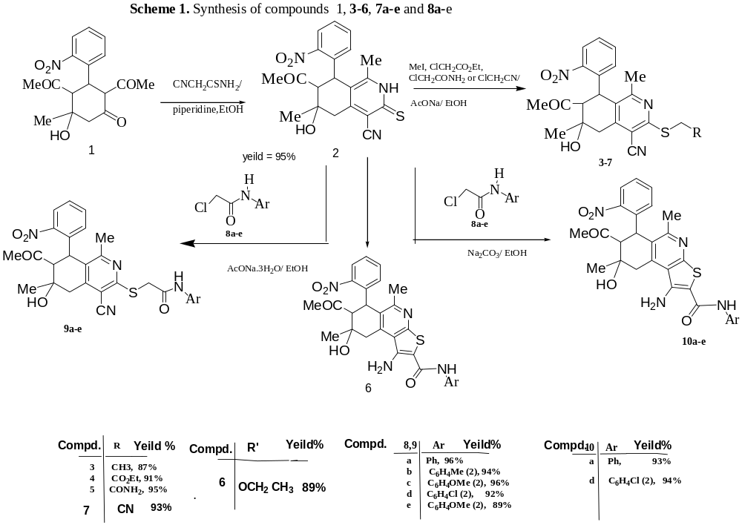
Scheme 2: SAR study of the interaction position of isoquinoline compound 3.
