Additional file 10:
a
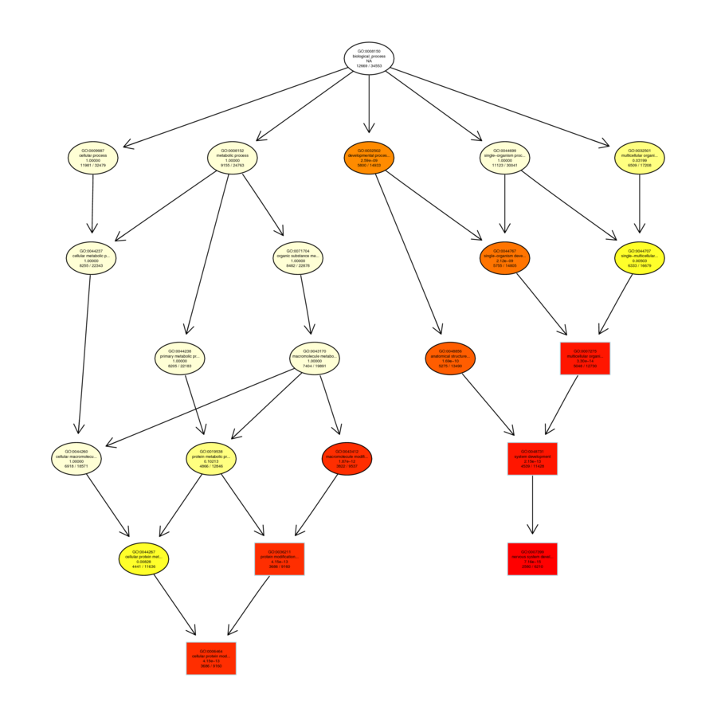
b
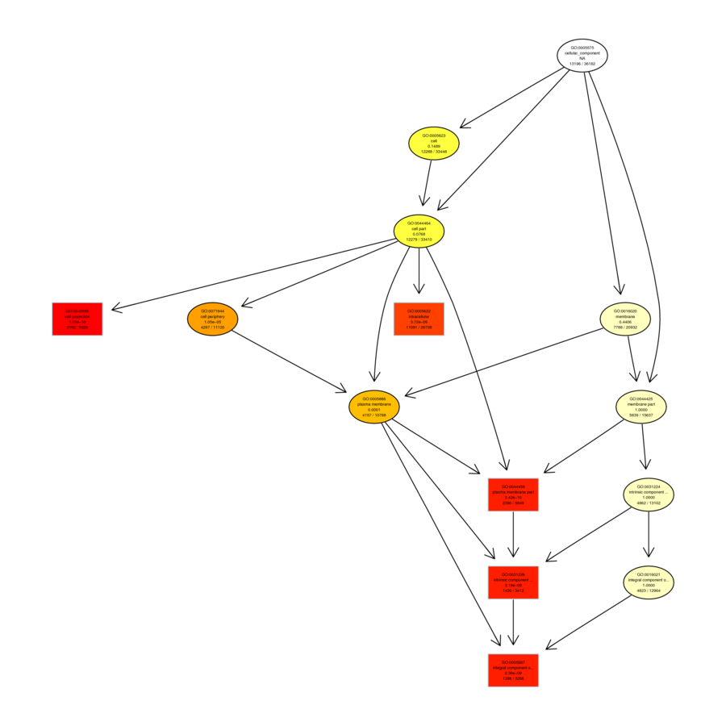
c
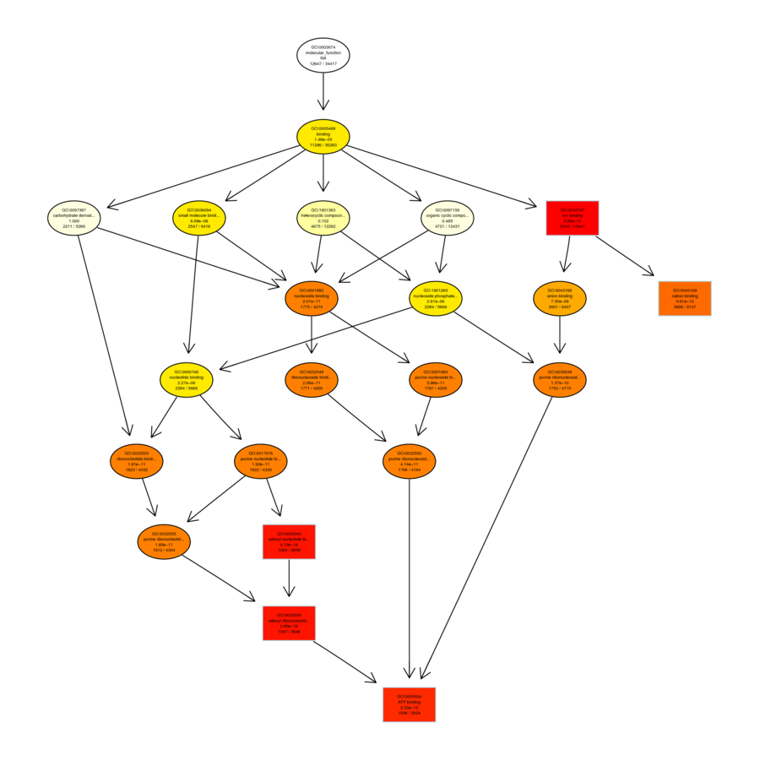
Supplementary Figure 7. Directed acyclic graph of GO enrichment
(a) LD-vs-HD_DEGseq. Biological_Process. Top GO；LD-vs-HD_DEGseq. Cellular_Component. Top GO；LD-vs-HD_DEGseq. Molecular_Function. Top GO.

