Additional information

Additional file 1:
a b
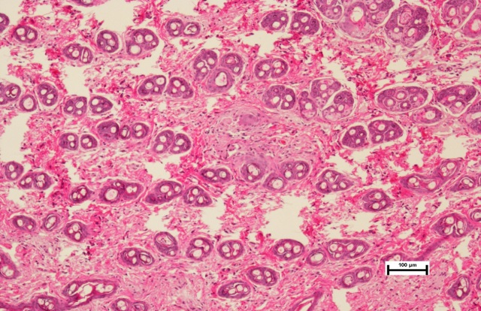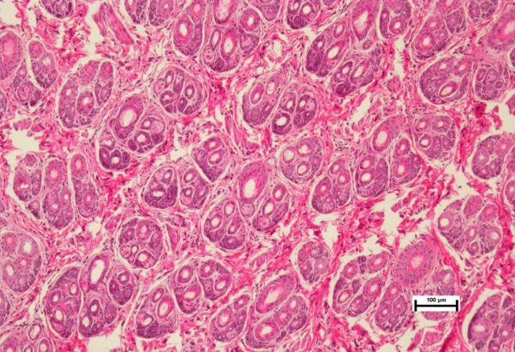
Supplementary Figure 1. Skin crosscutting HE staining of Rex rabbits with different hair density（100 magnification）(a) Low wool density (b) High wool density

Supplementary Table 1. Statistics of hair follicle numbers of Rex rabbits with different hair density
Items | Different hair follicle density |  | R-MSE | P-value
Items | Low density (LD) | High density (HD) | R-MSE | P-value
Hair follicle density (Count/mm²) | 152.00±6.11^{b} | 182.67±2.96 ª | 8.3166 | 0.0107
Note: Data shown are mean values ± s. d., and n =3 per group. In the same row, values with with different letter superscripts mean significant difference(P<0.05).

Additional file 2:

Supplementary Table 2. RNA quality of six dermal papilla cell samples
Sample name | Concentration (ng/ μL) | Volume (μL) | Total (μg) | RIA | 28S/18S
LD1 | 568 | 25 | 14.20 | 10.0 | 2.2
LD2 | 567 | 25 | 14.18 | 10.0 | 2.1
LD3 | 385 | 25 | 9.63 | 10.0 | 2.0
HD1 | 508 | 25 | 12.70 | 10.0 | 2.1
HD2 | 360 | 25 | 9.00 | 10.0 | 1.9
HD3 | 462 | 25 | 11.55 | 10.0 | 2.2

a
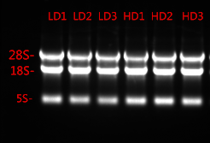

b

LD1
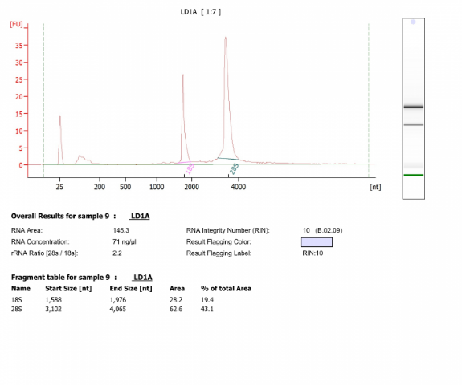

HD1
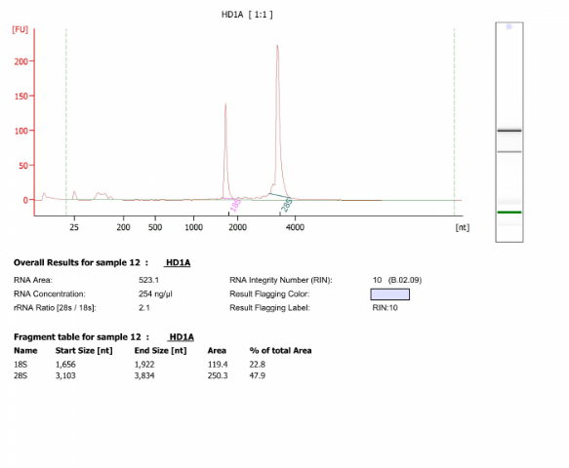

LD2
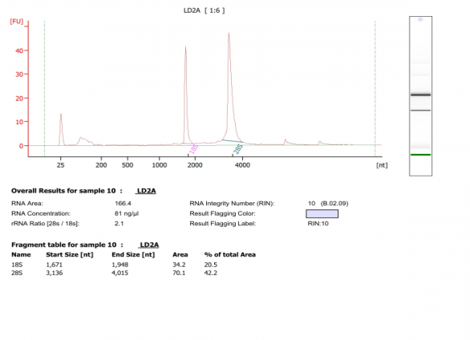
HD2
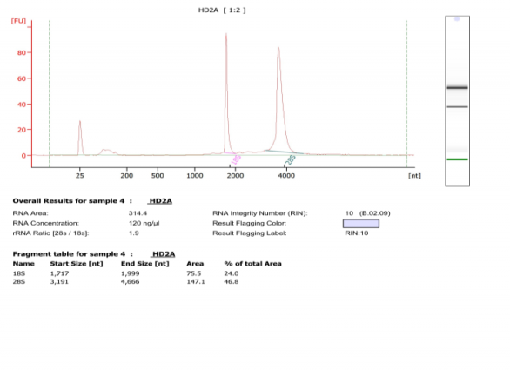
LD3
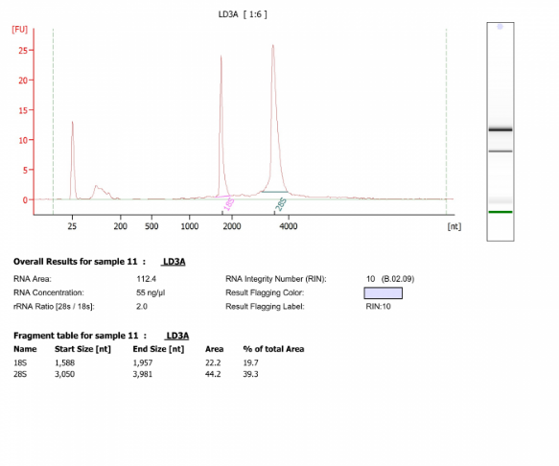
HD3
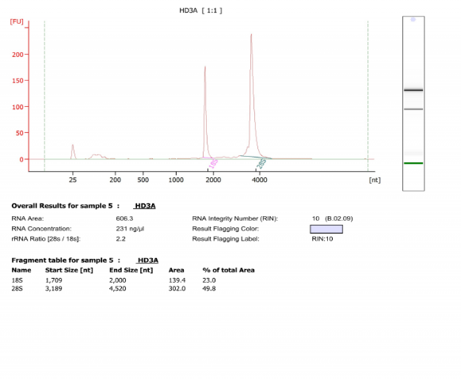
Supplementary Figure 2. RNA quality (a) Agarose electrophoresis of RNA in dermal papilla cells; (b) Quality test results of total RNA by Agilent 2100
Additional file 3:
Supplementary Table 3. Statistics of sequence data of each sample
Items | Sample name
Items | LD1 | LD2 | LD3 | HD1 | HD2 | HD3
Total raw reads | 41780505 | 41931741 | 43766730 | 41075486 | 43457108 | 43799741
Low quality tag count | 634583 | 514665 | 345688 | 495739 | 484764 | 466868
Invalid adapter tag count | 1648457 | 1480626 | 1400707 | 1412236 | 1849500 | 1309939
PolyA tag count | 1023 | 403 | 748 | 510 | 578 | 583
Short valid length tag | 1565698 | 494036 | 1053680 | 664348 | 500149 | 873188
Total clean reads | 37930744 | 39442011 | 40965907 | 38502653 | 40622117 | 41149163
Clean reads ratio (%) | 90.79 | 94.06 | 93.60 | 93.74 | 93.48 | 93.95
Q20 of clean tag (%) | 99.20 | 99.20 | 99.20 | 99.10 | 99.20 | 99.00
Q30 of clean tag (%) | 95.15 | 95.18 | 95.26 | 95.25 | 95.22 | 95.16

Additional file 4:
LD1
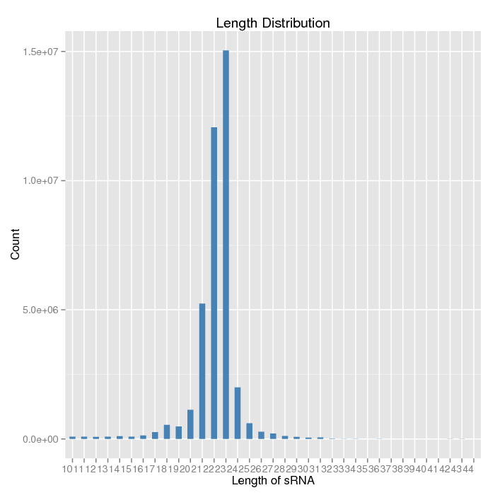
HD1
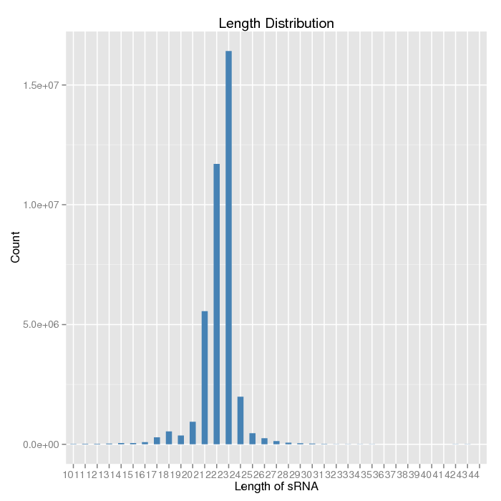

LD2
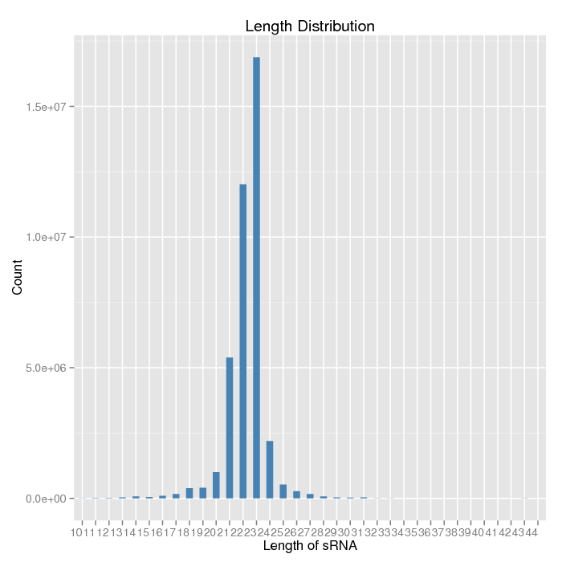

HD2
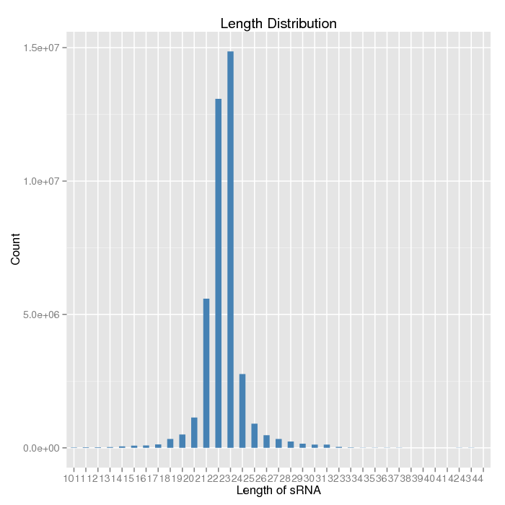

LD3
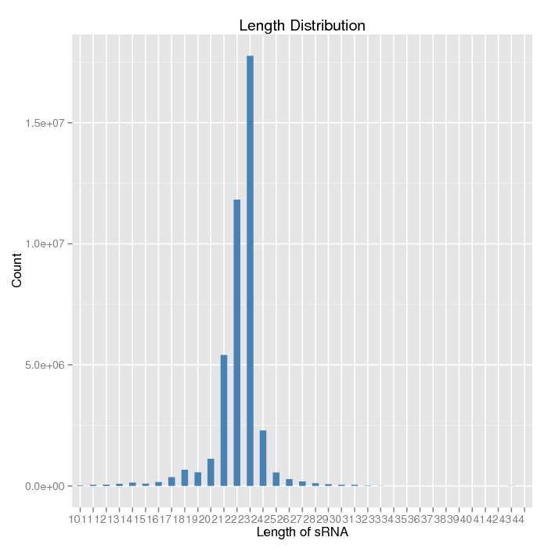
HD3
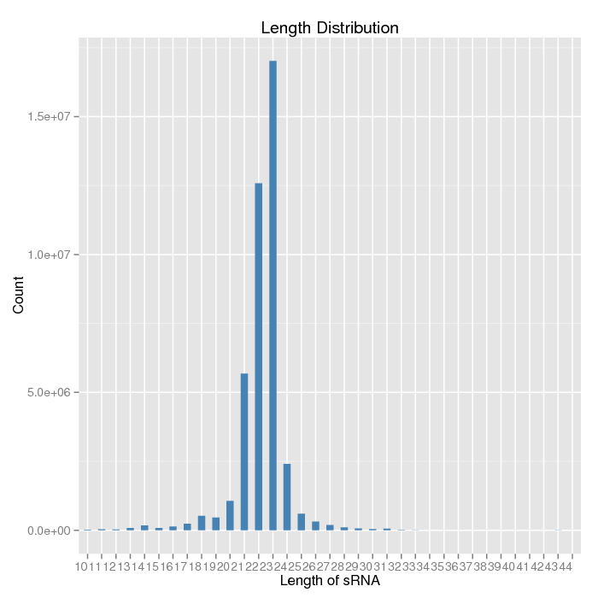
Supplementary Figure 3. Length distribution map of Small RNA
The X-axis is the length of small RNA, and the Y-axis is the corresponding number of small RNA

Additional file 5:

Supplementary Table 4. Alignment clean tag in genome
Sample name | Total tag | Mapped tag | Percentage (%)
LD1 | 37930744 | 34863360 | 91.91
LD2 | 39442011 | 35910940 | 91.05
LD3 | 40965907 | 37877015 | 92.46
HD1 | 38502653 | 35719844 | 92.77
HD2 | 40622117 | 36613764 | 90.13
HD3 | 41149163 | 37698053 | 91.61

Additional file 6:
LD1
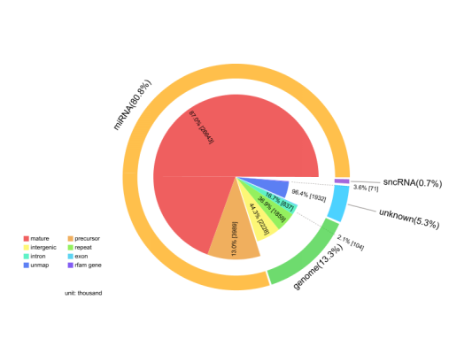
HD1
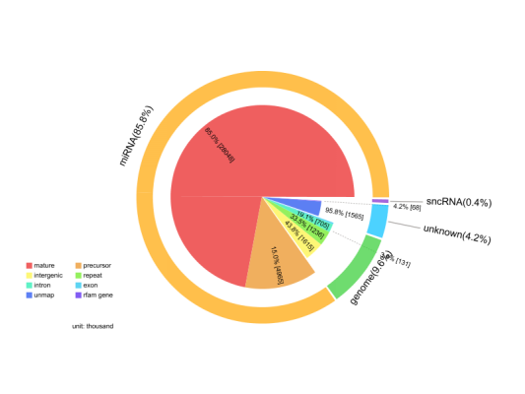
LD2
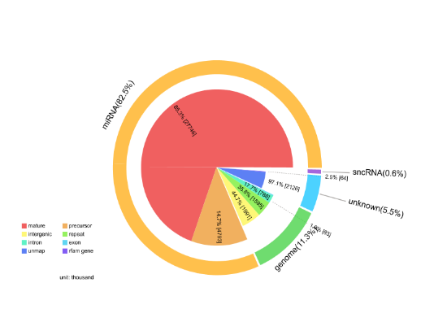
HD2
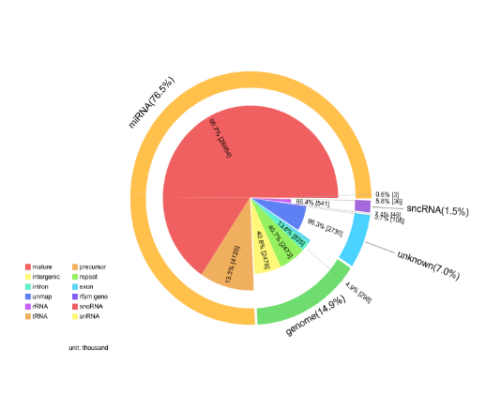

LD3
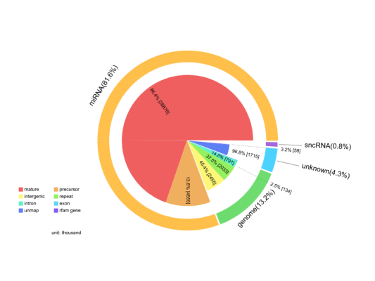
HD3
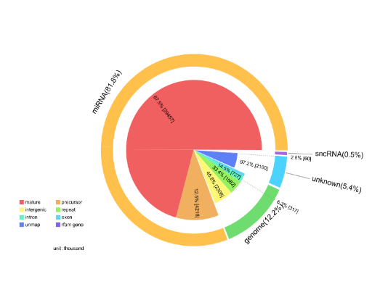
Supplementary Figure 4. Statistical distribution map of Small RNA types
In order to make each unique small RNA have a unique annotation, the annotation statistics of small RNA traverse the annotation according to the priority order of microRNA > piRNA > snoRNA > Rfam > other sRNA.
Additional file 7:

LD1
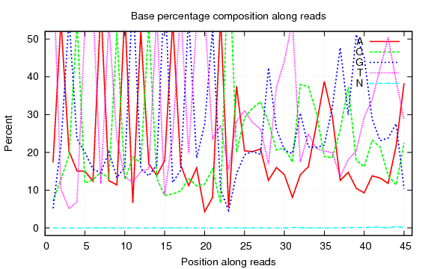

HD1
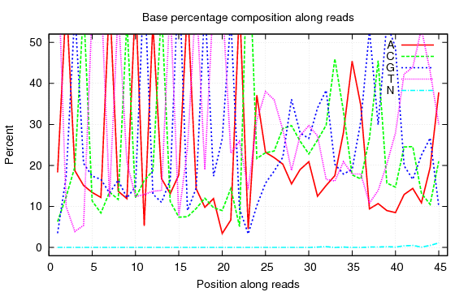
LD2
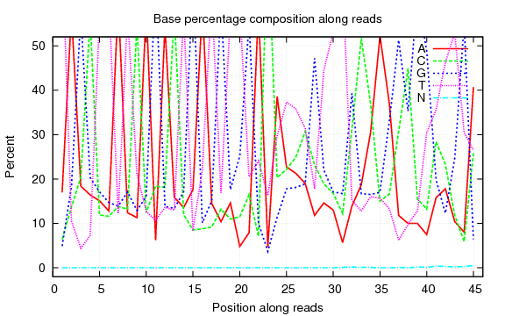
HD2
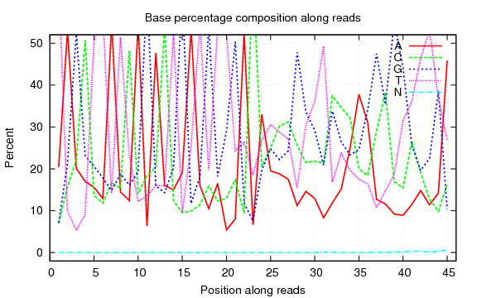
LD3
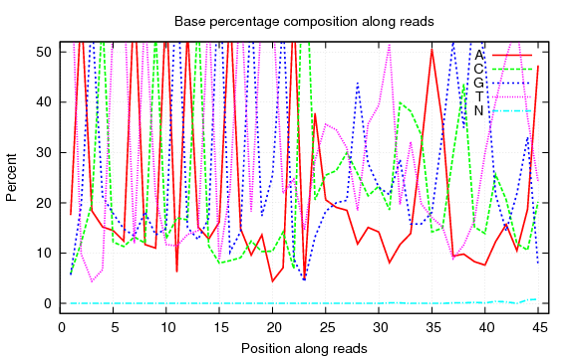
HD3
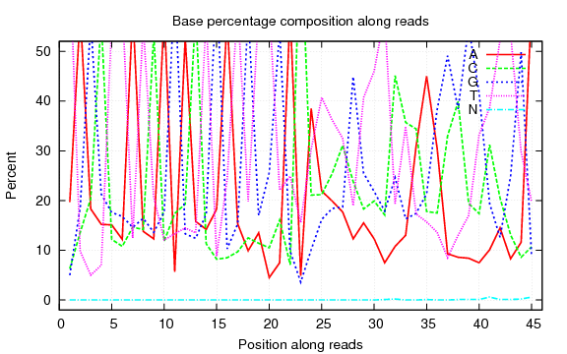
Supplementary Figure 5. The quantity distribution maps of clean tag base in each sample

The X-axis is the position of the base in read, and the Y-axis represents the proportion of the base.
Additional file 8:

LD1
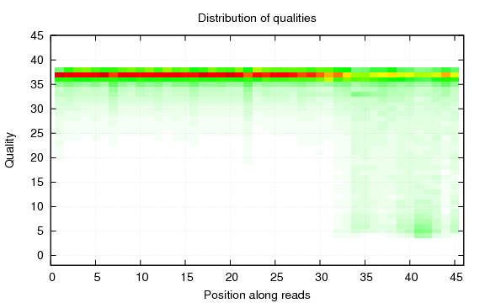

HD1
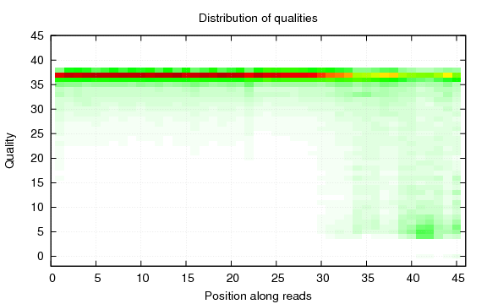

LD2
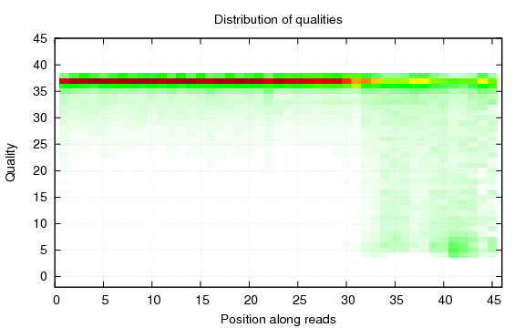
HD2
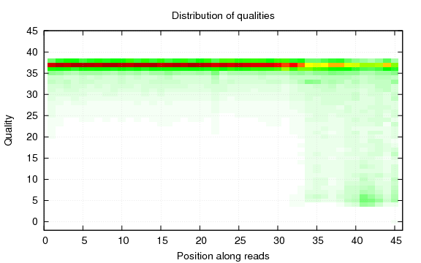
LD3
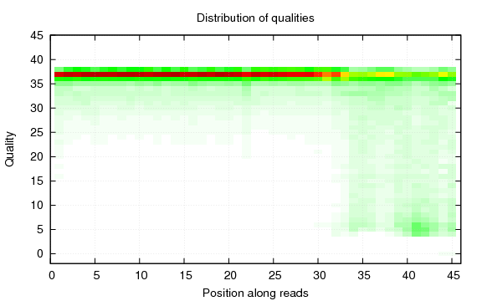
HD3
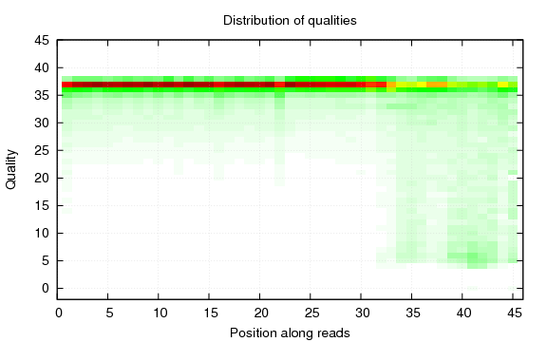

Supplementary Figure 6. The quality distribution maps of the clean tag base in each sample
The X-axis is the position of base in read, and the Y-axis represents the base mass value.

