For submission to Discover Nano, May 2024.

Preparation Irinotecan Hydrochloride Loaded PEGylated Liposomes Using Novel Method Supercritical Fluid and Condition Optimized by Box-Behnken Design
Misagh Mohammadi¹, Mehrnaz Karimi¹, Farhad Raofie¹*
- Department of Analytical Chemistry and pollutants, Shahid Beheshti University, Tehran
, Iran, 198396941.

* Corresponding author, email: f_raofie@sbu.ac.ir Fax: +98-21-22431661
¹https://orcid.org/0000-0001-9227-2107
² https://orcid.org/0000-0002-1005-5203
³ https://orcid.org/0000-0002-7911-6764

Supplementary material

Figure caption:
Fig. S1: Graphs of the a) size, b) count, c) encapsulation efficiency of nanoliposomes content versus the calculated one during the experimental range of this study.

Fig. S2: Counter plots as a function of (a, d, g) flow rate and temperature, (b, e, h) temperature and pressure drop, and (c, f, i) pressure drop and flow rate for the mean size, Count, and EE, respectively.

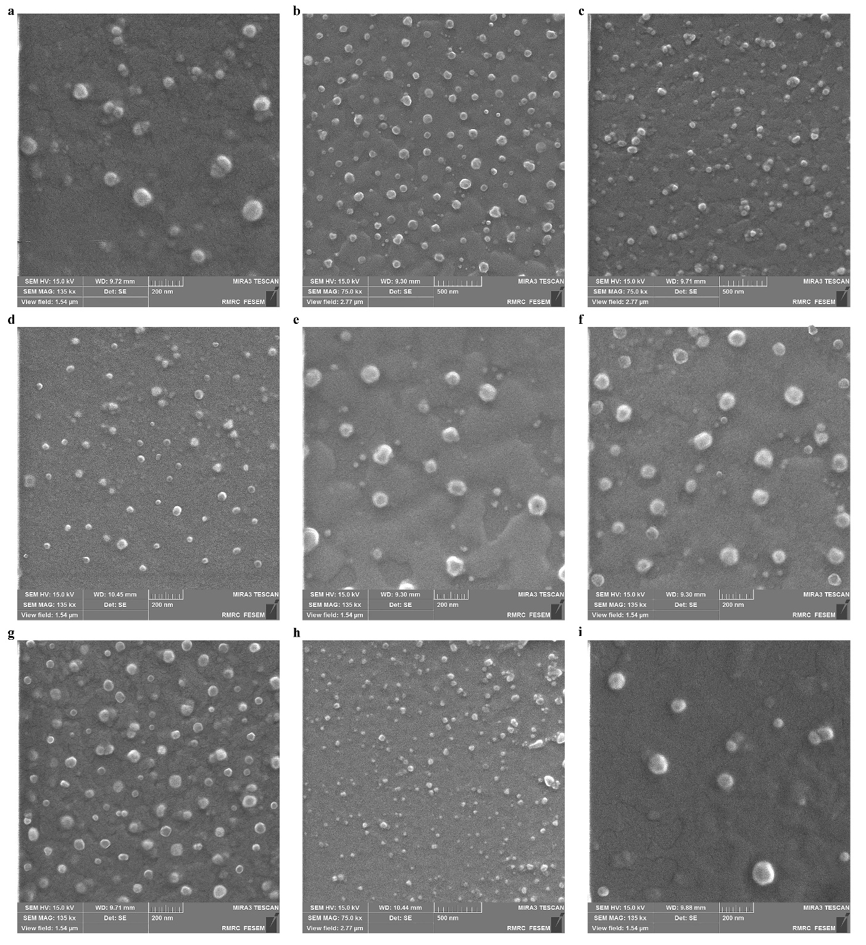
Fig. S3: FESEM images of produced irinotecan PEGylated liposomes for experiments 3, 4, 6, 7, 8, 9, 10, 12, and 15, respectively.

Tables
Table S1: coded levels of independent variables used in the RSM design.
X_{i} | Independent variables | Units | Coded values |  |  | Response (Y₁) | Response (Y₂) | Response (Y₃)
 |  |  | -1 | 0 | 1
A | Flow rate | mL/min | 1.0 | 2.0 | 3.0 | Mean size  (nm) | Count | EE  (%)
B | Pressure drop | MPa | 15.0 | 22.5 | 30.0 | Mean size  (nm) | Count | EE  (%)
C | Temperature | ˚C | 40.0 | 52.5 | 65.0 | Mean size  (nm) | Count | EE  (%)

Table S2: ANOVA of predicted second-order polynomial model for mean size of produced irinotecan PEGylated liposomes.
Source | Sum of Squares | Df | Mean Square | F-Ratio | P-Value
A: Flow rate | 6.12 | 1 | 6.12 | 1.53 | 0.341
B: Pressure drop | 4050.00 | 1 | 4050.00 | 1012.50 | 0.001
C: Temperature | 300.12 | 1 | 300.12 | 75.03 | 0.013
AA | 33.23 | 1 | 33.23 | 8.31 | 0.102
AB | 30.25 | 1 | 30.25 | 7.56 | 0.111
AC | 100.00 | 1 | 100.00 | 25.00 | 0.038
BB | 600.23 | 1 | 600.23 | 150.06 | 0.007
BC | 6.25 | 1 | 6.25 | 1.56 | 0.338
CC | 887.08 | 1 | 887.08 | 221.77 | 0.004
Lack-of-fit | 193.75 | 3 | 64.58 | 16.15 | 0.059
Pure error | 8.00 | 2 | 4.00
Total (corr.) | 6081.33 | 14

Table S3: ANOVA of predicted second-order polynomial model for count of produced irinotecan PEGylated liposomes.
Source | Sum of Squares | Df | Mean Square | F-Ratio | P-Value
A: Flow rate | 84.50 | 1 | 84.50 | 1.03 | 0.418
B: Pressure drop | 313236.00 | 1 | 313236.00 | 3804.49 | 0.001
C: Temperature | 40755.10 | 1 | 40755.10 | 495.00 | 0.002
AA | 46661.60 | 1 | 46661.60 | 566.74 | 0.002
AB | 812.25 | 1 | 812.25 | 9.87 | 0.088
AC | 9120.25 | 1 | 9120.25 | 110.77 | 0.009
BB | 608.10 | 1 | 608.10 | 7.39 | 0.113
BC | 52900.00 | 1 | 52900.00 | 642.51 | 0.002
CC | 21420.40 | 1 | 21420.40 | 260.17 | 0.004
Lack-of-fit | 3983.25 | 3 | 1327.75 | 16.13 | 0.059
Pure error | 164.67 | 2 | 82.33
Total (corr.) | 487234.00 | 14

Table S4: ANOVA of predicted second-order polynomial model for EE of produced irinotecan PEGylated liposomes.
Source | Sum of Squares | Df | Mean Square | F-Ratio | P-Value
A: Flow rate | 364.50 | 1 | 364.50 | 364.50 | 0.003
B: Pressure drop | 84.50 | 1 | 84.50 | 84.50 | 0.012
C: Temperature | 84.50 | 1 | 84.50 | 84.50 | 0.012
AA | 48.52 | 1 | 48.51 | 48.52 | 0.020
AB | 132.25 | 1 | 132.25 | 132.25 | 0.007
AC | 0.25 | 1 | 0.25 | 0.25 | 0.667
BB | 48.52 | 1 | 48.51 | 48.52 | 0.020
BC | 12.25 | 1 | 12.25 | 12.25 | 0.073
CC | 96.98 | 1 | 96.98 | 96.98 | 0.010
Lack-of-fit | 10.00 | 3 | 3.33 | 3.33 | 0.239
Pure error | 2 | 2 | 1
Total (corr.) | 859.60 | 14

