SUPPLEMENTARY INFORMATION

Astroglial disinhibition of cortical circuits disrupts cognition via kynurenic acid
Viktor Beilmann^{1§}, Johanna Furrer^{1§}, Sina M. Schalbetter², Ron Schaer², Edoardo Tiziani³, Kim D. Ferrari^{1,4}, Felisa Herrero², Celine Heeb², Alexandra von Faber-Castell^{1,4}, Jacqueline Condrau^{1,4}, Ulrike Weber-Stadlbauer^{2,4}, Matthias T. Wyss^{1,4}, Aiman S. Saab^{1,4}, Sarah Beggiato³, Urs Meyer^{2,4}, Bruno Weber^{1,4}, Tina Notter^{1,4}*
¹ Institute of Pharmacology and Toxicology, University of Zurich, Zurich, Switzerland.
² Institute of Veterinary Pharmacology and Toxicology, University of Zurich, Zurich, Switzerland.
³ Department of Life Sciences and Biotechnology, University of Ferrara, Ferrara, Italy.
⁴ Neuroscience Center Zurich, University and ETH Zurich, Zurich, Switzerland.

§ These authors contributed equally to this study.

Correspondence:
Dr. Tina Notter (PhD)
Institute of Pharmacology and Toxicology, University of Zurich
Winterthurerstrasse 190, CH-8057, Zurich, Switzerland.
E-mail: tina.notter@pharma.uzh.ch
Tel.: +41 44 63 55315

SUPPLEMENTARY DATA

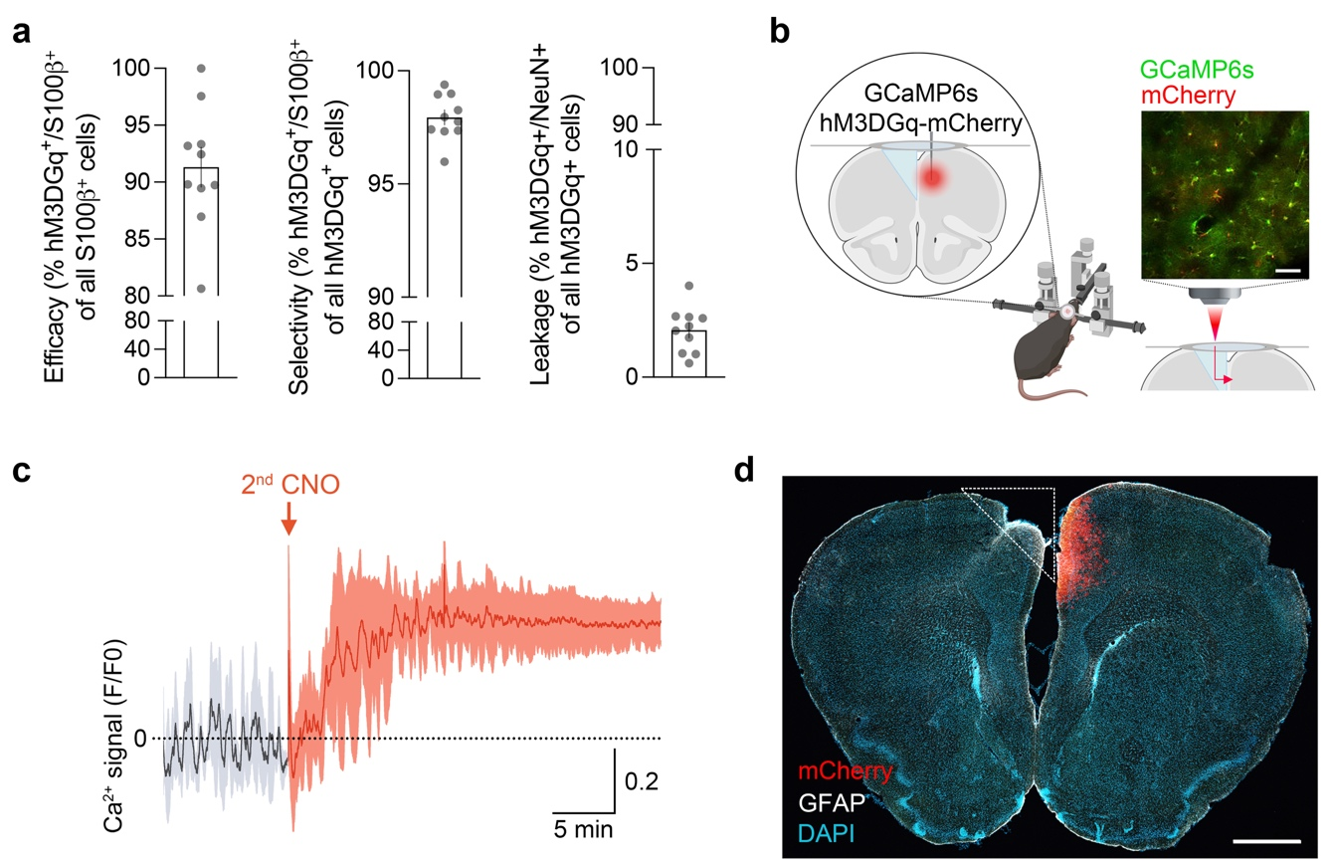

Figure S1. Selectivity and effectiveness of hM3DGq-based stimulation of prefrontal astrocytes. (a) Quantification of the efficacy of transduction, as well as cellular selectivity of hM3DGq-mCherry construct expression in astrocytes (S100β) and neurons (NeuN). Scatter bar plots represent the % of astrocytes that express hM3DGq-mCherry (left plot, efficacy of transduction), the % of hM3DGq-mCherry-positive cells that were astrocytes (middle plot, selectivity), or the % of hM3DGq-mCherry-positive cells that were neurons (right plot, leakage) in the PFC. N = 10 male mice. (b) Simplified scheme of surgical procedure for subsequent in vivo two-photon Ca²⁺ imaging of prefrontal astrocytes. The photomicrograph shows a high-resolution image of prefrontal astrocytes co-expressing the hM3DGq-mCherry and GCaMP6s construct acquired by in vivo two-photon imaging in awake animals. Scale bar = 25 μm. (c) Ca²⁺ response (F/F0 ratio, means ± SD) measured 48 hrs after the first imaging session and CNO (1 mg/kg) challenge. Baseline Ca²⁺ activity and Ca²⁺ response in astrocytes to a second CNO treatment are comparable to the first CNO treatment (see main Figure 1). (d) Representative tile scan image of a brain section stained for mCherry (red), GFAP (white), and DAPI (blue) showing the location of microprism implantation (dashed line). Scale bar = 1mm.

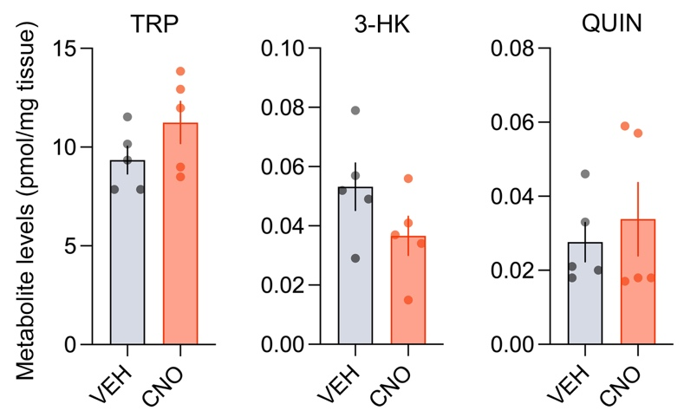

Figure S2. Effects of astrocyte stimulation on prefrontal levels of metabolites of the kynurenine pathway. Male mice expressing hM3DGq in prefrontal astrocytes were treated with VEH or CNO (1 mg/kg) 30 min before collection of brain samples. Levels of tryptophan (TRP), 3-hydroxykynurenine (3-HK), and quinolinic acid (QUIN) in the PFC after VEH or CNO treatment. Each data point represents the pooled samples of two mice.

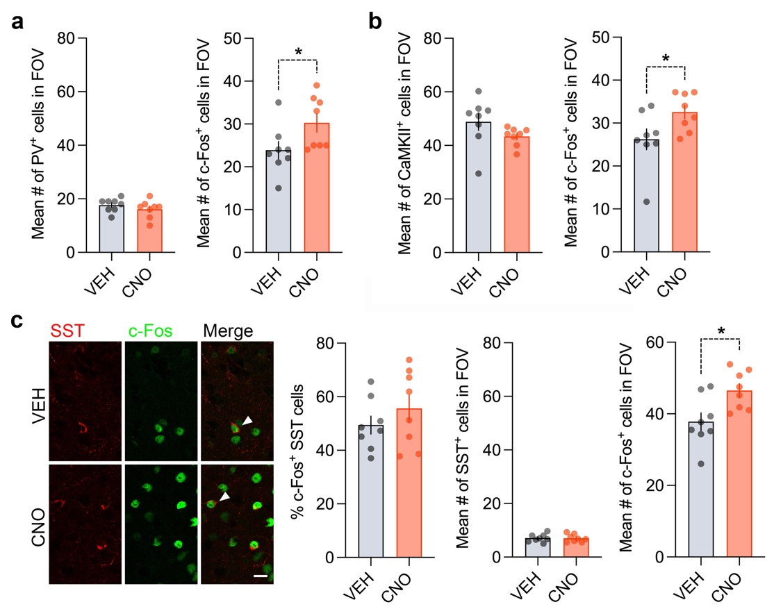

Figure S3. Cell-type-specific c-Fos mapping in the PFC following astrocyte stimulation. (a) c-Fos expression in parvalbumin (PV+) interneurons. The bar plots depict the mean number (#) of PV+ cells (left) and the mean # of c-Fos positive cells (right) in the of view (FOV). *p < 0.05, t₍₁₄₎ = 2.16. (b) c-Fos expression in Ca²⁺/calmodulin-dependent protein kinase II (CaMKII+) excitatory pyramidal cells. The bar plots depict the mean # of CaMKII+ cells (left) and the mean # of c-Fos positive cells the mean (right) in the FOV. *p < 0.05, t₍₁₄₎ = 2.22. (c) c-Fos expression in somatostatin (SST+) interneurons. SST (red) and c-Fos (green) expression in the PFC after VEH or CNO treatment; arrowhead denotes a c-Fos-positive SST interneurons. Scale bar = 25 μm. The bar plots depict the % of c-Fos positive SST cells (left), the mean # of SST+ cells in the FOV (middle), and the mean # of c-Fos positive cells in the FOV. *p < 0.05, t₍₁₄₎ = 2.79. All data are means ± SEM with individual values overlaid.
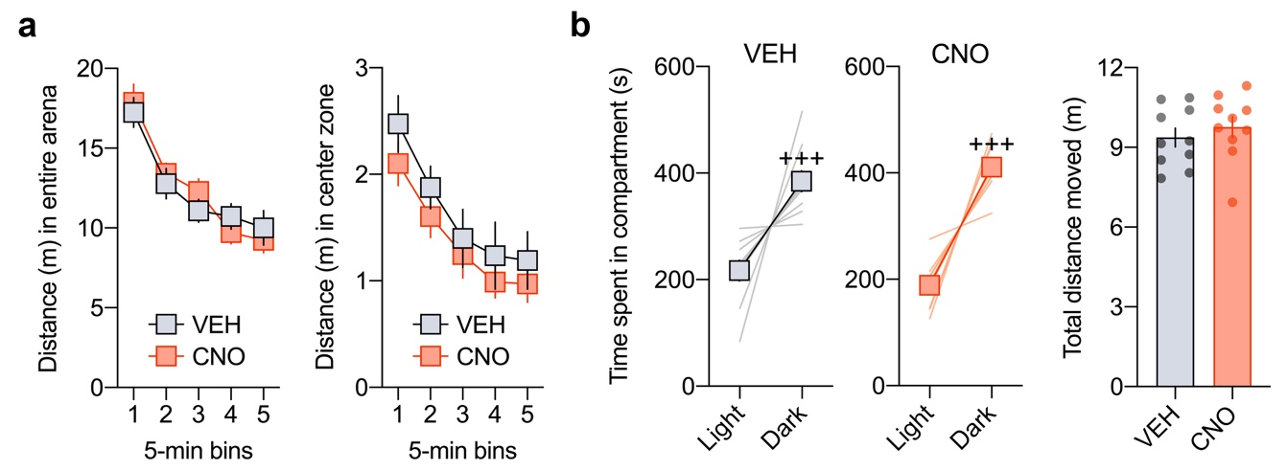

Figure S4. Performance in the open field and light-dark box tests after chemogenetic activation of prefrontal astrocytes. Male mice expressing hM3DGq in prefrontal astrocytes were treated with VEH or CNO 30 min before testing. (a) Distance moved as a function of 5-min bins in the entire arena (left) and center zone (right) during the open field test of exploratory activity. (b) Time spent in the light and dark compartments (line plots) and total distance moved (box plot) in the light-dark box test of innate anxiety-like behavior. ⁺⁺⁺p < 0.001, reflecting the significant main effect of compartment revealed by repeated-measure ANOVA (F_{(1,18)} = 67.5). All data are means ± SEM with individual values overlaid.

Figure S5. Clozapine-N-oxide treatment in ConV-expressing control mice does not alter behavior and cognition. (a) Male mice expressing a control AAV9-hGFAP-EGFP (ConV) in the prefrontal cortex were orally treated with vehicle (VEH) or CNO (1 mg/kg) and were then subjected to behavioral and cognitive testing 30 min after treatment. (b) Time spent in the light and dark compartments (line plots) and total distances moved (box plot) in the light-dark box test of innate anxiety-like behavior. ⁺⁺⁺p < 0.001, reflecting the significant main effect of compartment revealed by repeated-measure ANOVA (F_{(1,18)} = 37.9). (c) Distance moved in the entire arena and center zone during the open field test of exploratory activity. (d) Absolute exploration times of the temporally remote and recent objects (line plots) and temporal order memory index (bar plot) in the temporal order memory test for objects. ⁺⁺p < 0.01, reflecting the significant main effect of object in VEH-treated (F_{(1,9)} = 10.3) and CNO-treated (F_{(1,9)} = 11.7) mice revealed by repeated-measure ANOVA. (e) Total number of arm entries and percent spontaneous alternation in the Y-maze test of working memory. (f) Prepulse inhibition (PPI) test of pre-attentive filtering. The line plots show % PPI as a function of prepulse intensity (71, 77, and 83 dB_{A}) for each of the three pulse conditions (P100, P110 and P120, which correspond to pulse intensities of 100, 110, and 120 dB_{A}). The bar plot depicts the mean % PPI across all prepulse and pulse intensities. All data are means ± SEM with individual values overlaid.

Figure S6. Chemogenetic activation of prefrontal astrocytes impairs cognition in female mice. (a) Female mice expressing hM3DGq in the prefrontal cortex were treated with vehicle (VEH) or clozapine-N-oxide (CNO, 1 mg/kg) and were subjected to behavioral and cognitive testing 30 min after treatment. (b) Time spent in the light and dark compartments (line plots) and total distances moved (box plot) in the light-dark box test of innate anxiety-like behavior. ⁺⁺⁺p < 0.001, reflecting the significant main effect of compartment revealed by repeated-measure ANOVA (F_{(1,18)} = 26.7). (c) Distance moved in the entire arena and center zone during the open field test of exploratory activity. (d) Absolute exploration times of the temporally remote and recent objects (line plots) and temporal order memory index (bar plot) in the temporal order memory test for objects. ⁺⁺p < 0.01, reflecting the significant main effect of object in VEH-treated mice revealed by repeated-measure ANOVA (F_{(1,9)} = 15.4); **p < 0.01, t₍₁₈₎ = 3.75. (e) Total number of arm entries and percent spontaneous alternation in the Y-maze test of working memory. *p < 0.05, t₍₁₈₎ = 2.70. (f) Prepulse inhibition (PPI) test of pre-attentive filtering. The line plots show % PPI as a function of prepulse intensity (71, 77, and 83 dB_{A}) for each of the three pulse conditions (P100, P110, and P120, which correspond to pulse intensities of 100, 110 and 120 dB_{A}). The bar plot depicts the mean % PPI across all prepulse and pulse intensities. *p < 0.05, reflecting the significant main effect of treatment in the P120 condition (F_{(1,18)} = 5.19). All data are means ± SEM with individual values overlaid.

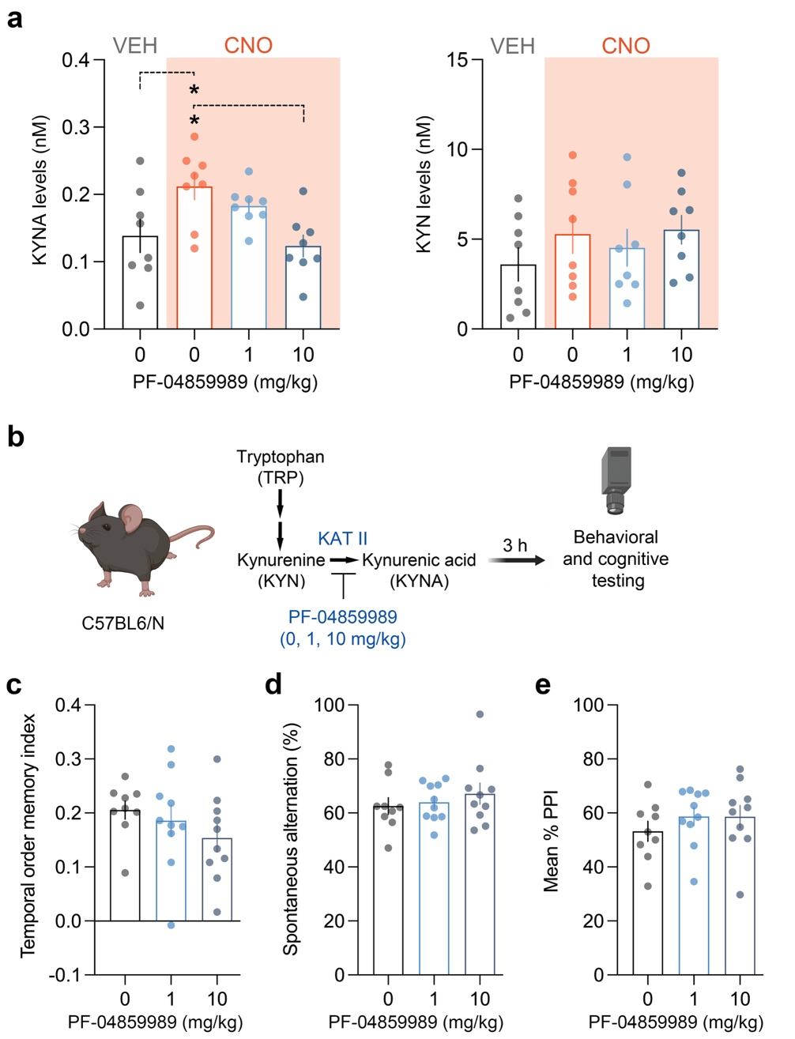

Figure S7. Blocking kynurenic acid (KYNA) synthesis prevents KYNA elevation in response to prefrontal astrocyte stimulation but has no pro-cognitive effect in C57BL6/N mice. (a) hM3DGq-expressing mice were pretreated with the KAT II inhibitor PF-04859989 (0, 1, or 10 mg/kg, i.p.) 2.5 hours before receiving CNO or VEH. 30 min after CNO or VEH administration brains were collected for metabolite measurements. *p < 0.05, based on post-hoc test following ANOVA (F_{(3,28)} = 1.866, p < 0.01). Each data point represents the sample of one mouse. (b) Male C57BL6/N mice received 0, 1 or 10 mg/kg PF-04859989 and were subjected to behavioral and cognitive testing 3 hours (h) after treatment. (c) Temporal order memory index in the temporal order memory test for objects. (d) Percent spontaneous alternation in the Y-maze test of working memory. (e) Prepulse inhibition (PPI) test of pre-attentive filtering. All data are means ± SEM, with individual data points overlaid.

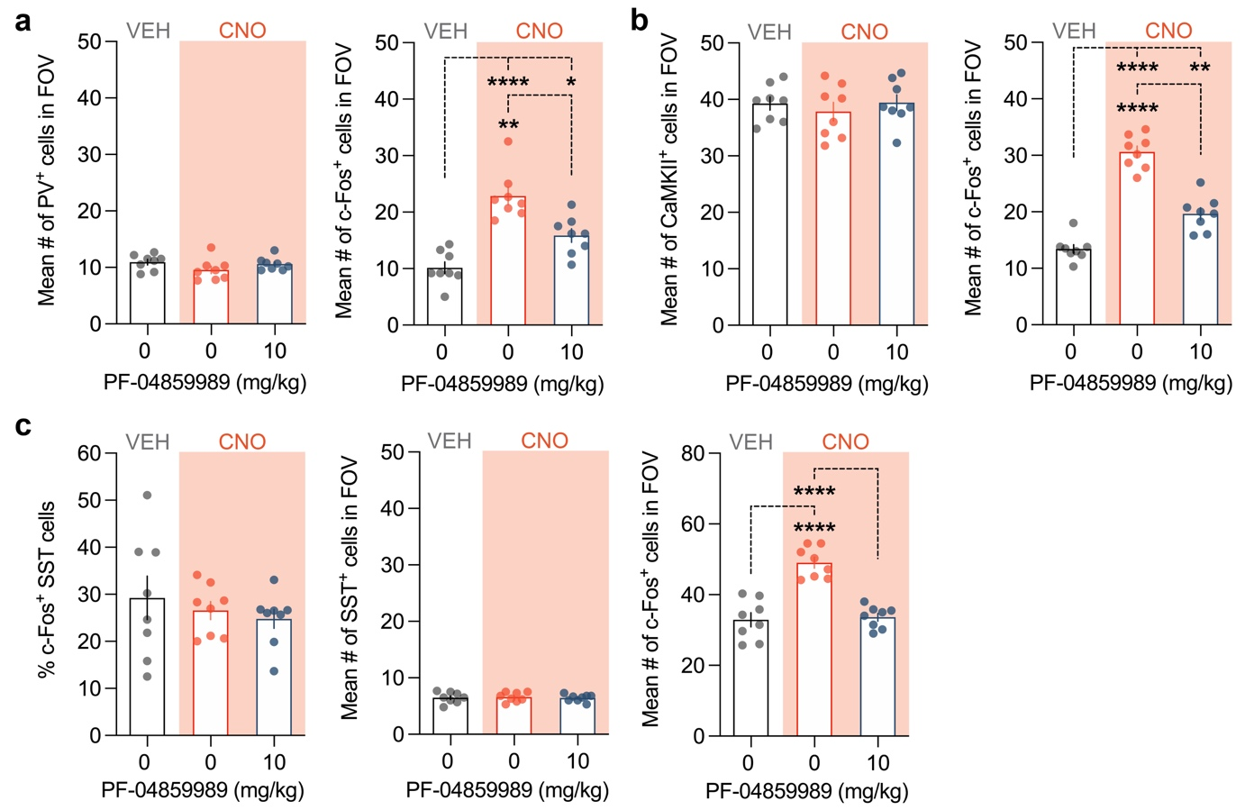

Figure S8. Blocking KYNA synthesis restores astrocyte-induced changes in prefrontal activity pattern. Cell-type-specific c-Fos mapping in PFC of VEH-treated hM3DGq mice receiving vehicle (0 mg/kg) and clozapine-N-oxide (CNO, 1 mg/kg)-treated hM3DGq mice treated with 0 or 10 mg/kg PF-04859989. (a) c-Fos expression in PV+ interneurons. The bar plots depict the mean number (#) of PV positive cells and the mean # of c-Fos positive cells in the field of view (FOV). *p < 0.05, **p < 0.01 and ****p < 0.0001, based on post-hoc test following ANOVA (F_{(2,21)} = 24.72, p < 0.0001). (b) c-Fos expression in CaMKII+ pyramidal cells. The bar plots depict the mean # of CaMKII positive cells and the mean # c-Fos positive cells in the FOV. **p < 0.01 and ****p < 0.0001, based on post-hoc test following ANOVA (F_{(2,21)} = 79.59, p < 0.0001). (c) c-Fos expression in SST+ interneurons. The bar plots depict the % of c-Fos positive SST interneurons, the mean # of SST+ cells, and the mean # of c-Fos positive cells in the FOV. ****p < 0.0001, based on post-hoc test following ANOVA (F_{(2,21)} = 32.96, p < 0.0001). All data are means ± SEM with individual values overlaid.

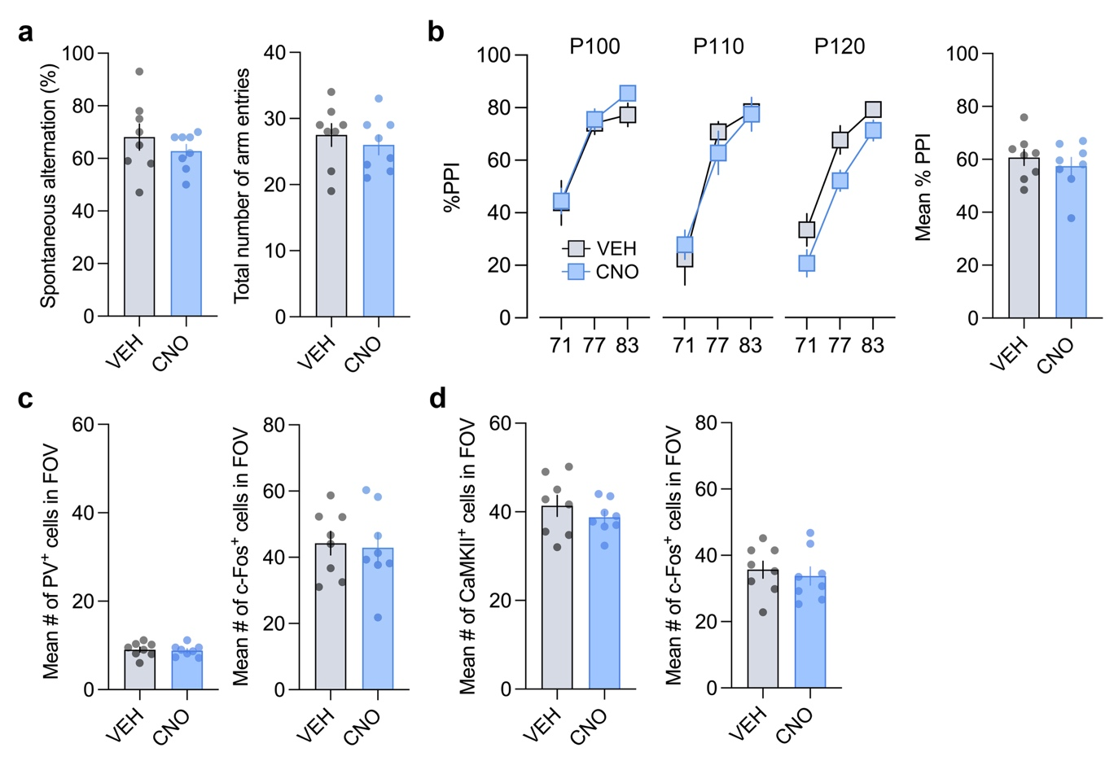
Figure S9. KAT II knockdown prevents astrocyte-mediated cognitive and neuronal deficits. Male mice expressing KATII^{KD}-hM3DGq in prefrontal astrocytes were treated with VEH or CNO (1 mg/kg) 30 min prior to cognitive testing. After the last test, animals were left undisturbed for one week, after which they were again treated with either VEH or CNO. 2 hours after treatment, brains were collected for subsequent c-Fos mapping. (a) Percent spontaneous alternation and total number of arm entries in the Y-maze test of working memory. (b) Prepulse inhibition (PPI) test of pre-attentive filtering. The line plots show % PPI as a function of prepulse intensity (71, 77 and 83 dB_{A}) for each of the three pulse conditions (P100, P110 and P120, which correspond to pulse intensities of 100, 110 and 120 dB_{A}). The bar plot depicts the mean % PPI across all prepulse and pulse intensities. (c) c-Fos expression in PV+ interneurons. The bar plots depict the mean # of PV+ cells and the mean # of c-Fos positive cells in the FOV. (d) c-Fos expression in CaMKII+ pyramidal cells. The bar plots depict the mean # of CaMKII+ cells and the mean # of c-Fos positive cells in the FOV. All data are means ± SEM with individual values overlaid.

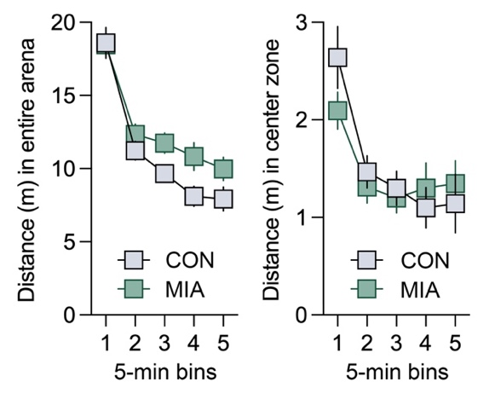
Figure S10. Open field test in the maternal immune activation model. Pregnant mice were exposed to 0.9% NaCl (CON) treatment or maternal immune activation (MIA) induced by poly(I:C) administration on gestation day (GD) 12. The resulting male offspring underwent testing once they reached adulthood. The line plots show the distance moved as a function of 5-min bins in the entire arena (left) and center zone (right) during the open field test. All data are means ± SEM. N = 13 (CON) and N = 17 (MIA) male mice in each test.

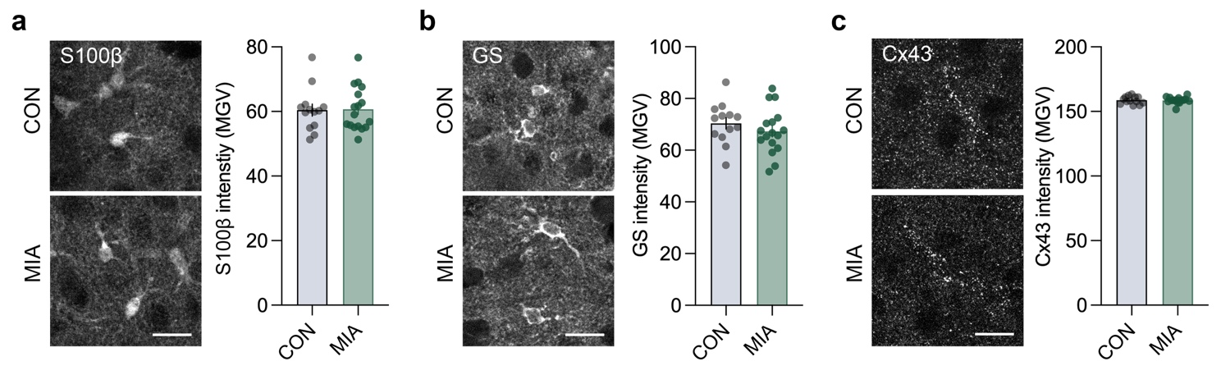
Figure S11. Immunohistochemical analyses of astrocyte markers in the maternal immune activation model. Immunohistochemical analyses of astrocyte markers were conducted in the medial prefrontal cortex (spanning anterior cingulate, prelimbic, and infralimbic cortices) once the offspring reached adulthood. (a) Representative stains against S100β corresponding mean intensity (mean grey value, MGV). (b) Representative stains against glutamine synthetase (GS) and corresponding mean intensity (MGV). (c) Representative stains against connexin 43 (Cx43) and corresponding mean intensity (MGV). All data are means ± SEM with individual values overlaid.

SUPPLEMENTARY METHODS
Animals
All experiments were performed using male or female C57BL6/N mice (Charles Rivers, Sulzfeld, Germany). They were group-housed (4-5 animals per cage) in individually ventilated cages (Allentown Inc., Bussy-Saint-Georges, France). The cages were kept in a specific-pathogen-free (SPF) holding room, which was temperature- and humidity-controlled (21 ± 3 °C, 50 ± 10%) under a reversed light–dark cycle (lights off: 09:00 AM–09.00 PM). All animals had ad libitum access to standard rodent chow (Kliba 3336, Kaiseraugst, Switzerland) and water throughout the entire study. All procedures were conducted during the dark cycle and had been previously approved by the Cantonal Veterinarian’s Office of Zurich. All efforts were made to minimize the number of animals used and their suffering. An overview of the different cohorts of animals and the respective numbers used is provided in the Supplementary Table 1. In addition, the number of animals used in each experiment is specified in the legends of the main and extended figures.

Cohort | Experimental procedure | Experimental  groups | Sample size
1 | Awake in vivo two-photon imaging |  | 4
2 | Behavioral testing of hM3DGq-expressing male mice | VEH  CNO | 10  10
3 | Behavioral testing of ConV-expressing male mice | VEH  CNO | 10  10
4 | Behavioral testing of hM3DGq-expressing female mice | VEH  CNO | 10  10
5 | Kynurenine metabolite measurement in hM3DGq-expressing male mice | VEH  CNO | 10  10
6 | Behavioral testing of hM3DGq-expressing male mice after pharmacological inhibition of KATII | 0mg/kg PF-04859989/VEH  0mg/kg PF-04859989/CNO  1mg/kg PF-04859989/CNO  10mg/kg PF-04859989/CNO | 10  10  10  10
7 | Behavioral testing of C57BL6/N male mice after pharmacological inhibition of KATII | 0mg/kg PF-04859989  1mg/kg PF-04859989  10mg/kg PF-04859989 | 9  10  10
8 | Knockdown verification (mRNA and protein) of KATII^{KD}-hM3DGq-expressing male mice and wild-type controls | KATII^{KD}-hM3DGq mice  Wild-type mice | 8  8
9 | In vivo two-photon imaging in prefrontal astrocytes expressing KATII^{KD}-hM3DGq |  | 3
10 | Behavioral testing of KATII^{KD}-hM3DGq-expressing and hM3DGq-expressing male mice | VEH, KATII^{KD}-hM3DGq  CNO, KATII^{KD}-hM3DGq  VEH, hM3DGq  CNO, hM3DGq | 10  10  9  10
11 | c-Fos expression analyses of  behaviorally exposed hM3DGq-expressing male mice | VEH  CNO | 8  8
12 | c-Fos expression analysis of behaviorally tested hM3DGq-expressing male mice after pharmacological inhibition of KATII | 0mg/kg PF-04859989/VEH  0mg/kg PF-04859989/CNO  10mg/kg PF-04859989/CNO | 8  8  8
13 | Behavioral testing and c-Fos expression analyses of KATII^{KD}-hM3DGq-expressing male mice | VEH  CNO | 8  8
14 | Behavioral testing and postmortem analyses in the maternal immune activation (MIA) model | CON  MIA | 13  17
15 | Behavioral testing with pharmacological inhibition of KATII in the MIA model | CON/0mg/kg PF-04859989  MIA/0mg/kg PF-04859989  CON/10mg/kg PF-04859989  MIA/10mg/kg PF-04859989 | 7  14  8  15

Supplementary Table S1: Overview of the different cohorts of animals and sample sizes used in this study.

Adeno-associated viruses
The following recombinant adeno-associated viruses (AAVs) were used: AAV9-hGFAP-hM3DGq-mCherry (hM3DGq-mCherry; physical titre: 9.2 × 10E11 vg/mL), AAV9-hGFAP-EGFP (ConV; physical titre: 7.6 × 10E11 vg/mL), AAV9-hGFAP-GCaMP6s (GCaMP6s; physical titre: 3.2 × 10E12 vg/mL), custom made AAV9-hGFAP-chI[4x:sh(mAadat)]-HA_hM3DGq (KATIIKD-hM3DGq; physical titre: 7.7 × 10E12 vg/mL, see next paragraph). The hgfaABC1D GFAP (hGFAP) promoter was used for all constructs to ensure astrocyte-specific expression. For Ca²⁺ imaging of PV interneurons AAV8-hSyn-dlox-jGCaMP8m(rev)-dlox (loxP(rev)-GCaMP; physical titre: 4.2 × 10E12 vg/mL) was injected in transgenic PV^{Cre} mice (JAX:008069). All AAVs were produced and purchased from the Viral Vector Facility of the University of Zurich, Switzerland (www.vvf.uzh.ch).

Kynurenine aminotransferase II knockdown strategy and AAV production
To selectively knockdown KAT II expression in astrocytes, we employed the miRNA-adapted short/small hairpin (sh) RNA (shRNAmir) strategy^{5, 6}. Construct design and AAV production were conducted by the Viral Vector Facility, University of Zurich, Switzerland according to established protocols. In brief, the shRNA silencing constructs were custom-designed against the mAadat transcript NM_011834.2 using the online BLOCK-iT™ RNAi Designer tool (Invitrogen, ThermoFisher Scientific). 4 out of the 10 suggested 21-mer shRNA sequences were selected based on their target selectivity (as assessed using the online tool GenScript's siRNA Target Finder (https://www.genscript.com/tools/sirna-target-finder)) and highest probability ranking for knockdown efficacy. The following 21-mer shRNA sequences were chosen: 5’-GCAACAACCCTACAGGCAACT-3’, 5’-GGTTGAGAGTAGGGTTTATGA-3’, 5’-GGTTTATGACTGGCCCTAAGA-3’, and 5’-GGGTTTCCTGGCTCATATTGA-3’. The four sequences were cloned in silico into the optimized miR-E backbone⁶ and linked, resulting in a chain of 4 hairpins, separated by a spacer sequence. The shRNAmir-E cassette was synthesized using the GeneArt Gene Synthesis service (ThermoFischer Scientific) and cloned into a pssAAV-2-hGFAP-HA_hM3D(Gq)-bGHp(A) backbone, generating the pssAAV-2-hGFAP-chI[4x:sh(mAadat)]-HA_hM3DGq-bGHp(A). The construct was then packaged in AAV9 to produce the AAV9-hGFAP-chI[4x:sh(mAadat)]-HA_hM3DGq.

Stereotaxic surgery
The stereotaxic surgery was performed when the animals reached 10 weeks of age, using methods established and validated before^{7, 8}. Anesthesia of the animals was induced by inhalation of 4% isoflurane (ZDG9623V, Baxter, Switzerland) in oxygen. After anesthesia induction, the heads of the animals were shaved, and vitamin A cream (Bausch & Lomb Swiss AG) was applied on the eyes to avoid dehydration. The animals were injected with the analgesic Temgesic [buprenorphine (0.1 mg/kg, s.c.), Reckitt Benckiser, Switzerland] and fixed into the stereotaxic frame (MTM-3, World Precision Instruments, USA) while kept under constant isoflurane/oxygen flow [1 to 3% isoflurane in oxygen (600 ml/min)]. All animals were kept on a temperature-controlled heating plate (ATC1000, World Precision Instruments, USA) during the entire surgical procedure to avoid anesthesia-induced hypothermia. Prior to incision, local anesthetics were administered subcutaneously at the incision site (50 μl of a mixture of 1 mL lidocaine (10mg/mL) and 1 mL bupivacaine (5 mg/mL) in 2 mL saline). A longitudinal incision of the skin was made to expose the skull. The skull was cleaned of connective tissue, and the bone above the target area was removed using a micro drill (OmniDrill35, World Precision Instruments, USA) with a rose burr (ø 0.3 mm). Intracerebral injections were performed using a NanoFil needle and syringe (NANOFIL, NF35BV, World Precision Instruments, USA) connected to an automated pump (UMP3T-1, World Precision Instruments, USA).
Mice received a single, bilateral injection of AAV of interest into the medial portion of the prefrontal cortex (PFC, anteroposterior [AP] = +1.8 mm, mediolateral [ML] = ±0.3 mm, dorsoventral [DV]= −1.9 mm). Solutions were injected at an infusion rate of 10 nL/s and a total volume of 450 nL. After insertion of the needle, a small drop of Histoacryl (B. Braun, Switzerland) was applied at the site of injection to avoid reflux of the injected substances. After injection, the needle was kept in place for 5 min to avoid reflux of the substances before retracting it. Incisions were sutured with a surgical thread (G0932078, B. Braun, Switzerland), and the animals were placed in a temperature-controlled chamber (Harvard Apparatus, USA) until full recovery from anesthesia. After the surgery, the animals were placed back in their home cage and closely monitored for three consecutive days after surgery.

DREADD activation
hM3DGq was activated with 1 mg/kg clozapine-N-oxide (CNO, BML-NS105-0025, Enzo Life Sciences, Switzerland) dissolved in 0.9% NaCl (B. Braun, Switzerland). The dose of 1 mg/kg was chosen based on previous chemogenetic studies in rodents^{7, 9-11}. CNO (1 mg/kg) or vehicle (0.9% sterile saline, VEH) were given via the micropipette-guided drug administration (MDA) method as described in detail elsewhere^{11, 12} or via injection (s.c. or i.p.) during in vivo two-photon imaging of anesthetized mice. For behavioral testing and tissue collection for brain metabolite measurements, CNO or VEH were given 30 min prior to testing or tissue collection. For c-Fos analyses, CNO or VEH were given either 2 hrs (behaviorally naïve cohort) or 5 hrs (behaviorally tested cohorts) prior to tissue collection. In the awake two-photon imaging experiments, VEH or CNO were given via MDA during imaging sessions.

In vivo two-photon imaging in awake and anesthetized Mice
Microprism cranial window assembly: On the day of the surgery, a custom-made right angle microprism (1.5-mm side length and 1-mm width, S-BSL7, protected aluminum coating on hypotenuse surface to enable internal reflection; Optosigma) was bonded to a circular glass window (3 mm diameter coverslip) using UV curing optical adhesive (Norland #81).
Surgery and virus injection: Surgery and AAV injections were performed using methods established and validated before^{13, 14}. Headplate implantation, craniotomy, AAV injection and microprism implantation were performed under midazolam (5 mg/kg), fentanyl (0.05 mg/kg), and medetomidine (0.5 mg/kg) anesthesia. First, a chrome steel head plate was implanted. In brief, anesthetized animals were fixed in a stereotaxic frame and an incision was made along the midline to expose the skull. The bone was cleaned, and a bonding agent (Prime & Bond) applied to the skull and polymerized with blue light. A round head plate was attached to the exposed bone using light-cured dental cement (Tetric EvoFlow). The skull over the PFC was left exposed for the craniotomy. Next, the craniotomy was performed using a dental drill (rotate, H-4-002). The skull was first thinned and carefully removed in small bone fragments leaving the dura intact. A custom-made micro injector¹⁵ was used to unilaterally inject a 1:1 mixture of AAV9-hGFAP-hM3DGq-mCherry or AAV9-hGFAP-chI[4x:sh(mAadat)]-HA_hM3DGq together with AAV9-hGFAP-GCaMP6s virus (injection volume of 600 nL and injection speed of 10 nL/s). AAVs were injected at a depth of 1.2 mm below cortical surface opposing the site of microprism implantation. Next, the microprism was implanted, whereby an incision in the dura along the side of the sinus was created where the microprism was inserted. The microprism was then gently inserted into the subdural space within the fissure so that the prism surface sat flush opposite the hemisphere to be imaged (with the cerebral falx between the microprism surface and PFC cortex to be imaged). The area beneath the microprism (i.e., the medial portion of the PFC of the contralateral site, which was not imaged) was compressed but remained intact. Dental cement was then used to secure the glass cover slip in place.
Training for awake in vivo two-photon imaging: One week after surgery, the training of animals for awake imaging commenced. During the first five days, mice were handled, during which their head was manually fixed by holding the head plate by the experimenter. During these five days, the handling and manual fixation times were gradually increased from 5 min handling and no fixation (first day) to 20 min handling and 5 min fixation (fifth day). At the end of each session, a reward in the form of 40% condensed milk was given via MDA. On day 6, the animals were introduced to being head fixed in the awake imaging setup, whereby the animals were allowed to explore the imaging setup with manual fixation by the experimenter. As of day 7, the animals were being gradually head-fixed in the imaging setup. As for the handling and manual fixation, the times during which animals were head fixed to the imaging setup were gradually increased from 5 to 45 min. The animals were being rewarded with 40% condensed milk via MDA during head fixation and after each session.
In vivo two-photon imaging in awake mice: Imaging commenced 2 weeks (Ca²⁺ response in PV interneurons) or 4 weeks (Ca²⁺ response in astrocytes expressing KATII^{KD}-hM3DGq) after virus injection and microprism implantation using a custom-built two-photon laser-scanning microscope¹⁶. A 16× water immersion microscope objective was used (W Plan-Apochromat 16×/1.0 DIC VIS-IR, Zeiss). GCaMP and mCherry were excited at 940 nm and 1100 nm with a Ti:sapphire laser (Mai Tai; Spectra-Physics) with power between 10 and 30 mW. Fluorescence emission was detected with a GaAsP photomultiplier module (Hamamatsu Photonics) fitted with 520/550 nm band pass filter or a 607/670 band pass filter and separated by a 560 nm dichroic mirror (BrightLine; Semrock). The two-photon laser-scanning microscope was controlled by a customized version of “ScanImage” (r3.8.1; Janelia Research Campus). All imaging was performed in head-fixed awake mice on an air-lifted platform. High resolution images (512 x 512 pixels) at a frequency of 0.74 frames per second and averages of 20 frames of every spot were acquired at the start of every imaging session to ensure localization of the imaging spot over multiple sessions. For Ca²⁺ response measurements, images (128 x 128 pixels) were acquired at a frequency of 5.92 frames per second without averaging. For the first imaging session, 10 min baseline activity was recorded. After 10 min, the imaging session was briefly stopped to administer VEH via MDA. Imaging was continued immediately after administration (~10 to 30 s), and activity after VEH was recorded for 15 min. After this, the session was briefly stopped again, and CNO (1 mg/kg) was administered via MDA and imaging was continued for 30 min thereafter. One hr after termination of the CNO imaging session, the animals were reimaged for 5 min to assess the duration of CNO-induced overactivation of prefrontal astrocytes. For the second imaging session (at least 48 hrs after the first session), 10 min baseline activity was recorded before administration of CNO (1 mg/kg) as described above. Imaging after CNO was continued for 30 min.
In vivo two-photon imaging in anesthetized mice: Imaging in anesthetized mice (1–1.5% isoflurane anesthesia) was conducted as described above with some changes. Imaging commenced 4 weeks after virus injection and microprism implantation. A 16× water immersion microscope objective was used (W Plan-Apochromat 16×/1.0 DIC VIS-IR, Zeiss). GCaMP6s was excited at 940 nm with a Ti:sapphire laser (Mai Tai; Spectra-Physics) with power between 10 and 30 mW. Fluorescence emission was detected with a GaAsP photomultiplier module fitted with 520/550 nm band pass filter and separated by a 560 nm dichroic mirror (BrightLine; Semrock). Imaging was performed in head-fixed mice on a heating map. For Ca²⁺ response measurements in astrocytes: images (512 x 512 pixels) were acquired at a frequency of 0.74 frames per second without averaging. During the first 10 min, baseline activity was recorded. After 10 min, the imaging session was briefly stopped to administer VEH injection (s.c. injection volume 2 mL/kg). Imaging was continued immediately after administration (~10 to 30 s) and Ca²⁺ activity in response to VEH was recorded for 10 min. After this, the session was briefly stopped again and CNO (1 mg/kg, s.c. at 2 mL/kg injection volume) was administered. Imaging was immediately resumed and continued for 20 min thereafter. Ca²⁺ response measurements in PV+ interneurons: images (128 x 128 pixels) were acquired at a frequency of 11.84 frames per second without averaging. Baseline activity was recorded for 5 min. Imaging session was briefly stopped to administer CNO (1 mg/kg, s.c. at 2 mL/kg injection volume). Imaging was immediately resumed and continued for 10 min thereafter.
Quantification and analysis: Image analysis was performed using the ImageJ software. For each field of view, baseline F0 was defined as the average pixel intensity during the baseline activity recordings of the respective session. This baseline was then subtracted from all pixel intensities for the remaining imaging session. The resulting difference was divided by F0 to obtain dF/F0. To correct for intensity changes due to movement, dF/F0 of the GCaMP signal was normalized to dF/F0 of the mCherry signal for each frame.

Kynurenine aminotransferase II inhibition
Kynurenine aminotransferase II (KATII) was inhibited with 1 mg/kg or 10 mg/kg PF-04859989 hydrochloride (PZ0250, Sigma-Aldrich), which was dissolved in sterile water and freshly prepared prior to each experiment. 1 or 10 mg/kg PF-04859989, or sterile water (vehicle, 0 mg/kg), were injected i.p. using an injection volume of 5 mL/kg 3 hours prior to behavioral testing. The doses and post injection interval were chosen based on previous studies in rodents^{17, 18}.

Maternal immune activation model
Timed matings were initiated two weeks after animals had acclimated to the facility. Breeding pairs were set up following previously established protocols¹, and the presence of a vaginal plug was used to confirm mating success, marking gestational day (GD) 0. Dams were housed individually from this point forward. A pregnancy was considered successful if a dam exhibited both a vaginal plug on GD 0 and a weight increase of at least 3 grams by GD 12.
On GD 12, pregnant females were randomly assigned to receive either an intraperitoneal (i.p.) injection of low molecular weight (LMW) poly(I:C) (InvivoGen, Toulouse, France; cat.#: tlrl-picw) or a control injection of pyrogen-free 0.9% NaCl (B. Braun, Melsungen, Switzerland). All treated animals received the same lot of poly(I:C) (lot. #: PIW-41-05), which had been previously characterized for quality, composition, and immunostimulatory activity^{2, 3}. Based on dose-response data from earlier work with C57BL6/N mice^{2, 3}, poly(I:C) was administered at a dose of 10 mg/kg in a volume of 10 mL/kg. Control animals received an equivalent volume of vehicle. After injection, dams were returned to their home cages and left undisturbed until five days postpartum.
The study involved two independently bred cohorts of animals that underwent the same breeding and treatment procedures. In cohort 1, the number of control and MIA-treated dams was 7 and 7, respectively; in cohort 2, these numbers were 4 and 6. A full description of the maternal treatment protocol is available in the MIA model reporting checklist⁴, provided in Supplementary Table S2.
Male offspring born to CON and MIA dams were weaned on postnatal day (PND) 21. All males per litter were selected. This led to a group size of N = 13 (CON) and N = 17 (MIA) in cohort 1 and N = 15 (CON) and N = 29 (MIA) in cohort 2. Littermates were housed in groups of 2 to 4 per cage.
The offspring of cohort 1 were used for the assessment of cognitive deficits in temporal order memory for objects (see below), followed by post-mortem investigations of astrocyte markers using immunohistochemical techniques (see below) and peripheral levels of kynurenine (KYN) and kynurenic acid (KYNA) using high-performance liquid chromatography with fluorimetric detection. The offspring of cohort 2 were used for the pharmacological rescue study of the cognitive deficits using the KATII inhibitor PF-04859989 (see below). All offspring were kept in temperature- and humidity-controlled holding rooms under a reversed light–dark cycle and ad libitum food access as described above. Behavioral testing in both cohorts commenced when the offspring reached 12 weeks of age. A minimum of a 1-week resting period was imposed after behavioral testing before the animals were killed and tissue was collected for subsequent post-mortem analyses (see below).

Behavioral testing
Mice undergoing multiple behavioral tests were given a minimum inter-test interval (ITI) of 48 hours between tests with the exception between open field test and the temporal order memory test. Because the open field test also serves as habituation to the arena for the temporal order memory test, a 24-hrs ITI was implemented between the two tests.

- Light-dark box test
A light-dark box test was used to measure innate anxiety-like behavior¹⁹. The apparatus consisted of four identical multi-conditioning boxes (Multi Conditioning System, TSE Systems, Germany), each containing a dark (1 lux) and a bright (100 lux) compartment. The two compartments were separated from each other by a dark plexiglass wall with an integrated, electrically controlled door. To start a trial, each mouse was placed in the dark compartment. After 5 s, the door automatically opened, allowing access to both the dark and bright compartments for 10 min. The measurements collected from this test included the distance moved and time spent in the light compartment.

- Open field test
A standard open field exploration task served to assess spontaneous locomotor activity and innate anxiety-like behavior¹⁹. The apparatus consisted of four identical open-field arenas [40 cm (length) by 40 cm (width) by 35 cm (height)] made of white polyvinyl chloride (OCB Systems Ltd., UK). It was positioned in a testing room with diffused lighting (~30 lux in the center of the arena). A digital camera was mounted above the arena, captured images at a rate of 5 Hz, and transmitted them to a PC running the EthoVision (Noldus Technology, The Netherlands) tracking system. The animals were recorded for 25 min before they were placed back into their home cage. For the purpose of data collection, the arena was conceptually partitioned into two areas: a center zone (measuring 10 cm by 10 cm) in the middle of the area and a peripheral zone occupying the remaining area. The measurements collected from this test included the total distance moved, and the distance moved in the center zone.

- Temporal order memory test
A temporal order memory test for objects was used to the animals’ capacity to discriminate the relative recency of stimuli²⁰. The test apparatus consisted of an open field as described above, with minor modifications (see below). The test procedure consisted of three consecutive phases, which were each separated by 60 min.
Sample phase 1: For this phase, a first pair of identical objects (blue aluminum hairspray bottles, 250 ml, 20 cm high) was placed in the open-field arena in opposing corners approximately 5 cm from the walls. To start a trial, the animals were gently placed into the center of the open field and were allowed to freely explore the objects for 10 min. They were then removed from the apparatus again and kept in a holding room for 60 min before the start of the next phase.
Sample phase 2: For this phase, a novel pair of identical objects (LEGO Duplo brick pile, 15 cm high) was placed in the open-field arena, thereby allocating them in the same position as the first pair of objects (see above). To start a trial, the animals were gently placed into the center of the open field again and were allowed to freely explore the novel pair of objects for 10 min. They were then removed from the apparatus once more and kept in a holding room for 60 min before the start of the actual test phase.
Test phase: In the test phase, the open field was equipped with one object used in sample phase 1 (temporally more remote object) and one object in sample phase 2 (temporally more recent object), with the corner allocation of the objects being counterbalanced across groups. To start the test trial, the animals were placed into the center of the open field and were allowed to freely explore either object for 5 min. For each animal, a temporal order memory index was calculated by the following formula: [(time spent with phase 1 object)/(time spent with phase 1 object + time spent with phase 2 object)] − 0.5. The temporal order memory index was used to compare the animals’ capacity to discriminate the relative recency of stimuli,²⁰ with values > 0 signifying a capacity to discriminate between the temporally more remote object presented in sample phase 1 and the temporally more recent object presented in sample phase 2. In addition, the relative amount of time exploring the objects in sample phases 1 and 2 of the test was analyzed to measure object exploration per se and to explore possible side preferences while exploring the objects (data not shown).

- Short-term memory test in the Y-maze
A spontaneous alternation task in the Y-maze was used to assess working memory^{21, 22}. This task is based on the innate tendency of rodents to explore novel environments, that is, their preference to investigate a new arm of the Y-maze rather than returning to one that was previously visited^{21, 22}. The apparatus was made of transparent Plexiglas and consisted of three identical arms (50 cm × 9 cm; length × width) surrounded by transparent Plexiglas walls 10 cm in height. The three arms radiated from a central triangle (8 cm on each side) and were spaced 120° from each other. The maze was elevated 90 cm above the floor and was positioned in a dimly lit room. A digital camera was mounted above the Y-maze apparatus. Images were captured at a rate of 5 Hz and transmitted to a PC running the EthoVision tracking system (Noldus Information Technology), which calculated the total distance moved (m) in the Y-maze.
To start the test, the animals were gently placed in the center of the Y maze and allowed to explore freely for 5 min, whereby the number and sequence of arm entries (defined as entry of the whole body into an arm) were observed and recorded by an experimenter who was blinded to the treatment conditions. Alternation was defined as entry into the three arms in any non-repeating order (for example, ABC, BAC, CBA). Working memory was indexed by the percentage alternation score, which was calculated as the total number of alternations divided by the possible alternations given the number of arm entries (total number of arm entries - 2). In addition to the analysis of percentage alternation, the total distance moved was recorded and analyzed to assess general activity during the 5-min testing period.

- Prepulse inhibition of the acoustic startle reflex
Pre-attentive filtering was assessed using the paradigm of prepulse inhibition (PPI) of the acoustic startle reflex. PPI of the acoustic startle reflex refers to the reduction in startle reaction in response to a startle-eliciting pulse stimulus when it is shortly preceded by a weak prepulse stimulus. The apparatus consisted of four startle chambers for mice (San Diego Instruments, USA) and has been fully described elsewhere²³. In the demonstration of PPI, the animals were presented with a series of discrete trials comprising a mixture of 4 trial types. These included pulse-alone trials, prepulse-plus-pulse trials, prepulse-alone trials, and no-stimulus trials in which no discrete stimulus other than the constant background noise was presented. The pulse and prepulse stimuli used were in the form of a sudden elevation in broadband white noise level (sustaining for 40 and 20 ms, respectively) from the background (65 dB_{A}), with a rise time of 0.2–1.0 ms. In all trials, 3 different intensities of pulse (100, 110, and 120 dB_{A}) and 3 intensities of prepulse (71, 77, and 83 dB_{A}) were used. The stimulus-onset asynchrony of the prepulse and pulse stimuli on all prepulse-plus-pulse trials was 100 ms (onset-to-onset).
The protocol used for the PPI test was extensively validated before^{1, 24, 25}. A session began with the animals being placed into the Plexiglas enclosure. They were acclimatized to the apparatus for 2 min before the first trial began. The first 6 trials consisted of 6 startle-alone trials; such trials served to habituate and stabilize the animals’ startle response and were not included in the analysis. Subsequently, the animals were presented with 10 blocks of discrete test trials. Each block consisted of the following: three pulse-alone trials (100, 110, or 120 dB_{A}), 3 prepulse-alone trials 71, 77, and 83 dB_{A}), 9 possible combinations of prepulse-plus-pulse trials (3 levels of pulse × 3 levels of prepulse), and one no stimulus trial. The 16 discrete trials within each block were presented in a pseudorandom order, with a variable interval of 15 s on average (ranging from 10 to 20 s). For each of the 3 pulse intensities (100, 110, or 120 dB_{A}), PPI was indexed by percent inhibition of the startle response obtained in the pulse-alone trials by the following expression: 100% × [1 − (mean reactivity on prepulse-plus-pulse trials/mean reactivity on pulse-alone trials)], for each animal, and at each of the three possible prepulse intensities. In addition to PPI, reactivity to pulse-alone trials and prepulse-alone trials were also analyzed.

Immunohistochemistry
Sample collection and processing: The animals were deeply anesthetized with an overdose of pentobarbital (Esconarkon ad us. vet., Streuli Pharma AG, Switzerland) and transcardially perfused with ice-cold artificial cerebrospinal fluid (pH 7.4)^{1, 7, 26}. The brains were immediately removed from the skull and postfixed in 4% PFA for 6 hrs before cryoprotection in 30% sucrose in PBS for 24-48 hours. The brains were cut coronally with a sliding microtome at 30 μm (eight serial sections) and stored at −20°C in cryoprotectant solution [50 mM sodium phosphate buffer (pH 7.4) containing 15% glucose and 30% ethylene glycol; Sigma-Aldrich, Switzerland] until further processing.
Immunofluorescent staining: Immunofluorescent stainings were performed according to established protocols^{1, 7, 11, 26}. Briefly, the brain sections were rinsed in tris buffer (pH 7.4) before incubating with primary antibodies (GFAP, chicken, polyclonal, ab4674, Abcam, UK, 1:2000; S100β⁺, rabbit monoclonal (EP1576Y), ab52642, Abcam, Switzerland, 1:1000; GS, mouse monoclonal, 610518, BD Transduction Laboratories, 1:1000; Cx43, rabbit polyclonal, 3512, Cell Signaling, USA, 1:1000; mCherry, rat monoclonal (16D7), M11217, Invitrogen, Switzerland, 1:1000; Iba1, rabbit polyclonal, 019-19741, Wako Chemicals, USA, 1:2000; NeuN, rabbit monoclonal (EPR12763), ab177487, Abcam, Switzerland, 1:500; c-Fos, rabbit, monoclonal (9F6), 2250, Cell Signaling, USA, 1:1000; CaMKII alpha, mouse, monoclonal (6G9), GeneTex, USA, 1:500; PV, guinea pig, polyclonal, 195 004, Synaptic Systems, Germany, 1:1000; SST, mouse, monoclonal (C11), AA 27-116, Antibodies online, USA, 1:500; HA-tag, goat, polyclonal, A190-138A, Fortis Life Sciences, USA, 1:2000). The primary antibodies were diluted in tris buffer containing 0.2% Triton X-100 and 2% normal serum. The sections were incubated free-floating under constant agitation (100 rpm) overnight at 4°C. The following day, sections were washed three times for 10 min in tris buffer before a 30-min incubation period with secondary antibodies (Alexa488 (Molecular Probes, Eugene, USA, 1:1000), Cy3 (Jackson ImmunoResearch, UK, 1:500), or Cy5 (Jackson ImmunoResearch, UK, 1:500), and DAPI (1 mg/mL H₂O; Thermo Fisher Scientific, Switzerland, 1:3000)) diluted in tris buffer containing 2% normal serum at room temperature. After incubation, which was shielded from light, the sections were washed 3 × 10 min in tris buffer, mounted onto gelatinized glass slides, coverslipped with Dako fluorescence mounting medium (S3023, Agilent, Switzerland), and stored in the dark at 4°C until image acquisition.
Image acquisition: Immunofluorescence images were captured by laser scanning confocal microscopy or with Airyscan confocal microscopy (Zeiss LSM800 with Airyscan). To assess the selectivity of hM3DGq construct expression, 6 images randomly selected from 3 consecutive sections within the area of construct expression were acquired per animal using a 40× (oil, NA 1.4) objective with a zoom of 0.45. Each image contained 4 consecutive optical sections (1024 x 1024 pixels, spaced 1 μm in z). Higher resolution image stacks for representative images of cell type specific expression of hM3DGq-mCherry were acquired in Airyscan mode using a 40× lens, NA 1.4, oil and processed using the default settings provided by ZEN 2.6 blue edition software (Zeiss, Switzerland). For the c-Fos expression analyses in different cell types of the PFC, 6 randomly selected single plane images (1024 x 1024 pixels) within the area of construct expression across 3 consecutive sections were acquired per animal using a 25× (oil, NA 0.8) objective with a zoom of 1. For the intensity analyses of astrocyte markers, 9 images randomly selected from 3 consecutive sections within the PFC were acquired per animal using a 25× (oil, NA 0.8) objective with a zoom of 0.7. Each image contained 3 consecutive optical sections (1024 x 1024 pixels, spaced 1 μm in z). Imaging for each experiment were acquired on the same experimental day by an experimenter blinded to the experimental conditions, whereby imaging settings were kept constant throughout an entire imaging day. Final illustrations were obtained using ImageJ or Imaris software, with contrast and brightness uniformly adjusted across each entire image.
Image analyses: Image analyses were performed using the ImageJ software by an experimenter blinded to the experimental conditions. For the assessment of selective expression of the hM3DGq construct in astrocytes, the number of mCherry⁺, S100β⁺, NeuN⁺, mCherry⁺/ S100β⁺, and mCherry⁺/NeuN⁺ cells were counted within each image. Efficacy of transduction was calculated by dividing the number of colocalized cells (mCerry⁺/S100β⁺) with the number of S100β⁺ cells. Expression selectivity was then calculated by dividing the number of colocalized cells with the number of total mCherry⁺ cells and multiplied by 100. For the colocalization analyses of c-Fos expression within the different cell types of the PFC, the number of c-Fos⁺ cells, the number of target cells, and the number of co-localized cells were counted within each image. The percentage of c-Fos⁺ cells was calculated as follows: (number of co-localized cells/number of target cell) * 100 for each image (referred to as field of view (FOV)). The mean % of c-Fos⁺ cells, the mean number of target cell, and the mean number of c-Fos⁺ cells were than calculated over the 6 images for each animal. For immunofluorescence-stained sections against astrocyte specific markers, intensity (mean grey value) per marker was measured and calculated on z-projected images with a threshold applied to remove background. The mean intensity was than calculated over the 9 images for each animal.

Liquid chromatography-nanoelectrospray ionization tandem mass spectrometry
Brain metabolites of the kynurenine pathway were measured using liquid chromatography-nanoelectrospray ionization tandem mass spectrometry (LC-NSI-MS/MS) performed at the Functional Genomic Center Zurich (Metabolomics at FGCZ, University of Zurich).
Sample collection: Male mice expressing hM3DGq in the PFC were treated orally with 1 mg/kg CNO or 0.9% saline. 30 min after treatment they were deeply anesthetized with an overdose of pentobarbital (Esconarkon ad us. vet., Streuli Pharma AG, Switzerland) and transcardially perfused with ice-cold artificial cerebrospinal fluid (pH 7.4)^{1, 7, 26} to flush out blood-derived metabolites of the kynurenine pathway. The brains were immediately removed from the skull, and the PFC was dissected on ice as described before^{7, 8, 21}. The PFC samples from two mice were pooled, weighed and homogenized in 200 μL 80% ice-cold methanol using a sterile BioMasher (9791A, Takara, France). The samples were frozen with dry ice and transported to the Functional Genomics Center Zurich, University of Zurich for targeted metabolomic analysis.
Sample processing: The thawed samples were centrifuged (15 min / 14 krpm / +4 °C). From each clear, colorless supernatant 180 µL were transferred to 1.5 mL eppendorf tubes, evaporated to dryness under a gentle stream of nitrogen and re-dissolved in 200 µL water containing 10 mM ammonium formate (pH 4.2) and 0.1 % (v/v) formic acid prior to mass spectrometry analysis.
LC-NSI-MS/MS analysis: LC-NSI-MS/MS was performed on a TSQ Quantiva triple quadrupole mass spectrometer (ThermoFisher Scientific, United States) coupled to an ACQUITY UPLC M-Class (Waters, United States) system using nanoelectrospray ionization. The analysis was conducted using a capillary column (150 µm ID, 5.5 cm length, 15 µm orifice) created by hand packing a commercially available fused-silica emitter (MSWIL, Netherlands) with HSS T3 separation media (Waters, United States). The mobile phase consisted of 10 mM ammonium formate (pH 4.2) and 0.1 % (v/v) formic acid in water (A1) and 0.1 % (v/v) formic acid in acetonitrile (B1). A 1 µL injection loop was used and the sample (1 µL) was loaded onto the capillary column with 2 µL/min flow at the initial conditions (92.5 % A1, 7.5 % B1) and eluted under isocratic conditions at a flow rate of 2 µL/min over 10 min, following by ramping to 98 % B1 within 1 min and holding at this composition for an additional 4 min. The column was then re-equilibrated at the initial conditions for 5 min before the next injection. The nanoelectrospray source was operated in positive ion mode and the voltage set at 2.7 kV. The ion transfer tube temperature was 250 °C and the radio frequency (RF) lens set at 90 V. The collision gas was Ar at 1.5 mTorr with a collision energy of 14 eV and the quadrupoles were operated at a resolution of 0.4 Da for Q1 and of 0.7 Da for Q3. The mass transitions for monitoring the analytes were m/z 190 → 144.1 for KYNA, 209.1 → 192.2 for KYN, m/z 205.1 → 146.1 for TRP, m/z 168 → 124 for QUIN, and m/z 225 → 162.1 for 3-HK, respectively.
The quantitation of the analytes was done using the mass spectrometers vendor software package Quan Browser in the software suit Xcalibur based on the peak areas and the constructed calibration curves. Calibration curves were constructed for each analyte during each analysis using a series of standard solutions of analytes. Pmole/mg tissue was calculated using the following calculation: ((nM of metabolite measured in injected volume) * 0.001 * 200)/(tissue weight).
High-performance liquid chromatography with fluorimetric detection
Plasma kynurenine (KYN) and kynurenic acid (KYNA) were measured in CON and MIA offspring using high-performance liquid chromatography (HPLC) with fluorimetric detection (HPLC-FLD).
Sample collection: The animals were deeply anesthetized with an overdose of pentobarbital (Esconarkon ad us. vet., Streuli Pharma AG, Switzerland). Prior to transcardial perfusion with ice-cold, artificial cerebrospinal fluid (CSF) (pH 7.4) and subsequent brain collection (see above), the atrium was incised, and blood was collected into EDTA-coated blood collection tubes (cat. # 365975, BD, USA) to avoid coagulation. Plasma was separated by centrifugation (2000 × g, 10 min) and stored at −20 °C until further use.
Sample processing: plasma samples for KYN and KYNA measurements were diluted (1:2 v/v and 1:10 v/v, respectively) with ultrapure water to a final volume of 100 µl with. Next, the diluted samples were acidified with 25 µl of 6% perchloric acid. After centrifugation (12,000 × g, 10 min), metabolite levels were measured in 20 µl of the resulting supernatant by HPLC-FLD.
HPLC-FLD: 20 μL of each processed supernatant was injected onto a 3 μm C18 reversed-phase HPLC column (100 mm × 4 mm; Dr. Maisch GmbH, Ammerbuch, Germany). The mobile phase consisted of 50 mM sodium acetate and 4% acetonitrile (v/v), pH adjusted to 6.2 with glacial acetic acid, and was delivered at a flow rate of 0.5 mL/min. Zinc acetate (0.5 M, unadjusted pH) was introduced post-column using a peristaltic pump (AXP, Dionex/Thermo Fisher Scientific, Waltham, MA, USA) at 0.1 mL/min.
In the eluate, KYN and KYNA were determined by fluorimetric detection using a Jasco FP-2020 Plus spectrofluorometer (Jasco Inc., Tokyo, Japan). Excitation/emission wavelengths were 365/480 nm for KYN and 344/398 nm for KYNA. Under these conditions, retention times of KYN and KYNA were approximately 6 minutes and 14 minutes, respectively.

Quantitative real-time PCR analysis
Quantitative RT-PCR was used to measure mAadat RNA levels in PFC extracted from adult C57BL6/N mice expressing no construct (referred to as wild-type) and mice that express the KATIIKD-hM3DGq-HA construct in astrocytes. RNA extraction and quantitative RT-PCR analyses were performed according to established protocols^{7, 11, 27}. In brief, the animals were deeply anesthetized with an overdose of Nembutal (Abbott 23 Laboratories, North Chicago, IL, USA) and transcardially perfused with 20 ml ice-cold, artificial CSF (pH 7.4). After decapitation, the brains were immediately extracted from the skull, frozen on dry ice, and stored at −80 °C until further processing. One hemisphere was cut into 1-mm coronal brain sections using razorblade cuts and subsequent micro-dissection of the medial portion of the PFC. Total RNA was extracted using the SPLIT RNA extraction kit (Lexogen, Austria) following the manufacturer’s recommendations. Extracted RNA was quantified by Nanodrop (DeNovix DS-11+ spectrophotometer, Labgene Scientific SA, Switzerland) and analyzed by a TaqMan qRT-PCR instrument (CFX384 real-time system, Bio-Rad Laboratories) using the iScript one-step qRT-PCR kit for probes (Bio-Rad Laboratories) as previously described^{7, 11}. A mouse TaqMan gene expression assay for Aadat (assay ID: Mm00496169_m1, catalogue number: 4331182; Thermo Fisher Scientific, Zurich, Switzerland) was used. The samples were run in 384-well formats in triplicates as multiplexed reactions with the normalizing internal control (36B4) as validated previously ^{7, 11}. Relative gene expression was calculated with the 2−ΔΔCt method. All RT-PCRs and analyses were conducted by an experimenter blind to the experimental conditions. Relative changes in mAadat expression were finally compared to the average relative mAadat expression in the PFC of wild-type C57BL6/N mice.

Western blot analysis
Western blot was used to investigate KATII protein levels in total PFC homogenates extracted from adult C57BL6/N male mice expressing no construct (referred to as wild-type) and adult male mice that express KATIIKD-hM3DGq-HA construct in astrocytes. PFC were dissected from one brain hemisphere as described above (see previous paragraph). Lysis and sample preparation were performed as previously described^{28, 29}, with the following adaptations: Tissue was lysed in ice-cold RIPA buffer with a TissueLyserII (Qiagen, Germany) and centrifuged at 10,000 × g at 4°C for 30 min. The supernatant was collected, and total protein concentration was measured using the Qubit Protein and Protein Broad Range (BR) Assay Kit according to protocol (Q33211, Thermo Fisher Scientific, Switzerland). Equal amounts of protein (180 μg) were run under reducing conditions on 4-20% Bis-Tris (M00657, GenScript, UK) and then electrophoretically transferred onto PVDF membranes (ISEQ00005, Millipore, USA). The blots were blocked with 5% non-fat dry milk in PBS-T for 1hr. The membrane was cut and incubated with the respective primary antibodies (AADAT, rabbit, polyclonal, PA5-88974, Invitrogen,Switzerland, 1:700, and Histone 3, rabbit, monoclonal (D1H2), 4499, Cell Signaling, USA, 1:1000) in blocking solution overnight at 4°C. The membranes were washed and incubated with horse radish peroxidase-conjugated anti-rabbit secondary antibody (anti-rabbit hrp-linked, Cytiva NA934, Millipore, USA) in blocking solution for 1 h at room temperature. After washing the immunocomplexes were visualized by chemiluminescence using the SuperSignal West Pico PLUS Chemiluminescent Substrate (34579, Invitrogen, Switzerland). Images were acquired using the Image Lab™ Upgrade for ChemiDoc™ XRS+ System (1708299, Bio-Rad, USA). Tiff images were analyzed using the Fiji software. Levels of KAT II were analyzed with reference to H3 as the housekeeping control. Each sample was run twice, and the average was used in the final analysis. All analyses were conducted by an experimenter who was blind to the experimental conditions. Levels of KAT II protein in the PFC of KATIIKD-hM3DGq-HA mice were finally compared to the average KAT II levels in the PFC of wild-type C57BL6/N mice.

Statistical Analyses
All behavioral, cognitive, immunohistochemical and molecular data were acquired and analyzed in a blind manner, in which the treatment conditions were blinded in the form of numerical codes. Likewise, all samples collected for HPLC-FLD and LC-NSI-MS/MS analyses were randomly labeled by an experimenter before the measurements and analysis were conducted, with the samples being unblinded once all data were collected and analyzed. All statistical analyses were performed using SPSS Statistics (version 28.0, IBM, Armonk, NY, USA) and Prism (version 10.0; GraphPad Software, La Jolla, CA, USA). Statistical significance was set at p < 0.05. All data met the assumptions of normal distribution and equality of variance.
In the temporal order memory test, temporal order memory index was assessed by independent Student’s t-test (two-tailed). In the open field test, the total distance moved, and the distance moved in the center zone were assessed using 2 × 5 (treatment × bins) repeated-measure ANOVAs. In the Y-maze test, spontaneous alternation and total arm entries were assessed using independent Student’s t-tests (two-tailed). In the PPI test, % PPI and startle reactivity to pulse-alone trials were analyzed using 2 × 3 × 3 (treatment × prepulse intensity × pulse intensity) and 2 × 3 (treatment × pulse intensity) repeated-measure ANOVAs, respectively. In the light-dark box test, the time spent in the light or dark compartment was analyzed by a 2 × 2 (treatment × compartment) repeated-measure ANOVA, whereas the total distance moved was evaluated using independent Student’s t-test (two-tailed). Groups differences in the pharmacological rescue study in hM3DGq mice (behavioral data and postmortem analyses) were assessed using one-way ANOVA. Data from the pharmacological rescue study involving the MIA model were assessed using two-way ANOVA. Likewise, behavioral data involving KATIIKD-hM3DGq- and hM3DGq-expressing mice were assessed using two-way ANOVA. Whenever appropriate, ANOVAs were followed by Tukey’s post-hoc test for multiple comparisons. Group differences in metabolites of the KYN pathway were assessed by independent Student’s t-tests (two-tailed). Group differences in the c-Fos analyses were either assessed by independent Student’s t-tests (two-tailed) or one-way ANOVA followed by Tukey’s post-hoc test. Correlative analyses were separately conducted for CON and MIA offspring using Pearson's product moment correlations.

SUPPLEMENTARY REFERENCES

1. Notter, T., et al. Translational evaluation of translocator protein as a marker of neuroinflammation in schizophrenia. Molecular psychiatry 23, 323-334 (2018).
2. Tillmann, K.E., et al. Differential effects of purified low molecular weight Poly(I:C) in the maternal immune activation model depend on the laboratory environment. Transl Psychiatry 14, 300 (2024).
3. Mueller, F.S., et al. Influence of poly(I:C) variability on thermoregulation, immune responses and pregnancy outcomes in mouse models of maternal immune activation. Brain Behav Immun 80, 406-418 (2019).
4. Kentner, A.C., et al. Maternal immune activation: reporting guidelines to improve the rigor, reproducibility, and transparency of the model. Neuropsychopharmacology 44, 245-258 (2019).
5. Ahmadpour, N., et al. Cortical astrocyte N-methyl-D-aspartate receptors influence whisker barrel activity and sensory discrimination in mice. Nat Commun 15, 1571 (2024).
6. Fellmann, C., et al. An optimized microRNA backbone for effective single-copy RNAi. Cell Rep 5, 1704-1713 (2013).
7. Notter, T., et al. Neuronal activity increases translocator protein (TSPO) levels. Mol Psychiatry (2020).
8. Schalbetter, S.M., et al. Adolescence is a sensitive period for prefrontal microglia to act on cognitive development. Sci Adv 8, eabi6672 (2022).
9. Farrell, M.S., et al. A Gαs DREADD mouse for selective modulation of cAMP production in striatopallidal neurons. Neuropsychopharmacology 38, 854-862 (2013).
10. Soden, M.E., et al. Genetic Isolation of Hypothalamic Neurons that Regulate Context-Specific Male Social Behavior. Cell Rep 16, 304-313 (2016).
11. Schalbetter, S.M., et al. Oral application of clozapine-N-oxide using the micropipette-guided drug administration (MDA) method in mouse DREADD systems. Lab Anim (NY) 50, 69-75 (2021).
12. Scarborough, J., et al. Preclinical validation of the micropipette-guided drug administration (MDA) method in the maternal immune activation model of neurodevelopmental disorders. Brain Behav Immun 88, 461-470 (2020).
13. Stobart, J.L., et al. Long-term In Vivo Calcium Imaging of Astrocytes Reveals Distinct Cellular Compartment Responses to Sensory Stimulation. Cereb Cortex 28, 184-198 (2018).
14. Low, R.J., Gu, Y. & Tank, D.W. Cellular resolution optical access to brain regions in fissures: imaging medial prefrontal cortex and grid cells in entorhinal cortex. Proc Natl Acad Sci U S A 111, 18739-18744 (2014).
15. Mächler, P., et al. In Vivo Evidence for a Lactate Gradient from Astrocytes to Neurons. Cell Metab 23, 94-102 (2016).
16. Mayrhofer, J.M., et al. Design and performance of an ultra-flexible two-photon microscope for in vivo research. Biomed Opt Express 6, 4228-4237 (2015).
17. Kozak, R., et al. Reduction of brain kynurenic acid improves cognitive function. J Neurosci 34, 10592-10602 (2014).
18. Linderholm, K.R., et al. Inhibition of kynurenine aminotransferase II reduces activity of midbrain dopamine neurons. Neuropharmacology 102, 42-47 (2016).
19. Belzung, C. & Griebel, G. Measuring normal and pathological anxiety-like behaviour in mice: a review. Behav Brain Res 125, 141-149 (2001).
20. Barker, G.R., Bird, F., Alexander, V. & Warburton, E.C. Recognition memory for objects, place, and temporal order: a disconnection analysis of the role of the medial prefrontal cortex and perirhinal cortex. J Neurosci 27, 2948-2957 (2007).
21. Mueller, F.S., et al. Behavioral, neuroanatomical, and molecular correlates of resilience and susceptibility to maternal immune activation. Mol Psychiatry 26, 396-410 (2021).
22. Lalonde, R. The neurobiological basis of spontaneous alternation. Neurosci Biobehav Rev 26, 91-104 (2002).
23. Meyer, U., Feldon, J., Schedlowski, M. & Yee, B.K. Towards an immuno-precipitated neurodevelopmental animal model of schizophrenia. Neurosci Biobehav Rev 29, 913-947 (2005).
24. Weber-Stadlbauer, U., et al. Transgenerational transmission and modification of pathological traits induced by prenatal immune activation. Mol Psychiatry 22, 102-112 (2017).
25. Giovanoli, S., Weber-Stadlbauer, U., Schedlowski, M., Meyer, U. & Engler, H. Prenatal immune activation causes hippocampal synaptic deficits in the absence of overt microglia anomalies. Brain Behav Immun 55, 25-38 (2016).
26. Notter, T., Panzanelli, P., Pfister, S., Mircsof, D. & Fritschy, J.M. A protocol for concurrent high-quality immunohistochemical and biochemical analyses in adult mouse central nervous system. The European journal of neuroscience 39, 165-175 (2014).
27. Purves-Tyson, T.D., et al. Increased levels of midbrain immune-related transcripts in schizophrenia and in murine offspring after maternal immune activation. Mol Psychiatry 26, 849-863 (2021).
28. Krstic, D., et al. Systemic immune challenges trigger and drive Alzheimer-like neuropathology in mice. J Neuroinflammation 9, 151 (2012).
29. Labouesse, M.A., et al. Hypervulnerability of the adolescent prefrontal cortex to nutritional stress via reelin deficiency. Mol Psychiatry 22, 961-971 (2017).

