Supplementary materials

Supplementary methods
1. Murine subcutaneous tumor model
Routinely cultured Hepa1-6 cells and B16 cells at the logarithmic growth stage were digested and prepared as a cell suspension containing 1 × 10⁷ cells/mL PBS. The middle and posterior armpits were selected as the injection points and disinfected with 75% alcohol. Before inoculation, the cell suspension was mixed well with a 200 μL pipette; 100 μL of the cell suspension was injected subcutaneously. Post-inoculation, the mice were fed normally, and the longest tumor was measured with a vernier caliper every 3–4 days. The shortest diameter line (mm), tumor volume (mm³), and mouse weight (g) were recorded.

2. Hematoxylin and eosin staining
Mouse organs were harvested and fixed in 4% paraformaldehyde, embedded in paraffin, sectioned, and stained with hematoxylin and eosin (HE). Images were acquired using TissueFAXS SL Spectra TissueGnostics, Vienna, Austria) and Pannoramic MIDI (Budapest, Hungary).

3. Immunofluorescence analysis
Immunofluorescence analysis was performed after antigen retrieval. Sections were microwaved (800 watts, low power) in 10 mM citric acid for 2 min at high power, followed by 5 min at 50% power. The sections were then cooled for 60 min at 25°C, washed in PBS, and blocked with 0.5% BSA/PBS for 30 min at 37°C. Sections were incubated with primary antibodies (Table S2) overnight for 12 h at 4°C and then for 30 min at 37°C. After washing in PBS, sections were incubated with 1:400 diluted goat/donkey anti-rat Alexa Fluor 488, goat/donkey anti-rabbit Alexa Fluor 594, or goat/donkey anti-mouse Alexa Fluor 647 (Abcam, Cambridge, UK) secondary antibodies for 45 min at 37°C. Finally, sections were washed and mounted with DAPI (Mounting Medium with DAPI-Aqueous, Fluor Shield Abcam, Cambridge, MA, USA; ab104139) and stored in the dark at −30°C until imaging. Identical confocal settings were used to limit the intra-experimental variability. Fluorescent signals were detected using a laser scanning confocal microscope and automatic slide slice scan (Leica STELLARIS STED, China). For quantification of the immunofluorescence results, images of the indicated tissues were analyzed using Leica Application Suite X 1.8.0.13313. Alternatively, the absolute number of positive cells/mm² in nine fields of interest was statistically analyzed. The investigators were blinded to the experimental groups while conducting the studies.

4. Flow cytometry analysis and sorting
After anesthesia with pentobarbital sodium solution and cervical dislocation, the thymus was isolated from the anterior mediastinum of each mouse. Thymic lobes were digested enzymatically using 0.25 mg/mL papain (Worthington Biochemicals, USA), 0.25 mg/mL collagenase IV (Roche Life Science, Germany), and 0.1 mg/mL DNase I (Roche Life Science). Single-cell suspensions were obtained from the thymus of mice as described previously [14,15 S41, S42]. The cells were stained with monoclonal antibodies (Table S2). For intracellular staining of FoxP3, a FoxP3/Transcription Factor Staining Buffer Kit (MultiSciences Biotech Co., Ltd, Hangzhou, China) was used following the manufacturer’s instructions. Cell phenotypes were evaluated using CytoFLEXLX (Beckman Coulter Life Sciences, Brea, CA, USA). The data were analyzed with the CytExpert and FlowJo V10.0.7 (FlowJo, Ashland, OR, USA). A BD FACSAria III cell sorter (BD Biosciences, USA) was used for flow cytometry sorting.

5. CD3⁺ T lymphocyte transfer
CD3⁺ T lymphocytes were isolated via magnetically activated cell sorting (EasySep™ Cell Separation, Stemcell) from the tumors or spleens of tumor-bearing mice with cachexia or tumor-free mice. Next, 1.5 × 10⁶ CD3⁺ T lymphocytes were transferred into tumor-free mice via caudal vein injection. After 12h, the mice were sacrificed, and their lungs, liver, stomach, small intestine, thyroid, skin, salivary glands, pancreas, brain, and eyes were dissected and placed in 4% paraformaldehyde for preservation. These organs were cut into 4-mm sections and stained with HE for microscopic evaluation.

6. Caspase activity and NO analysis
M-MDSCs were collected to measure the production of NO in the indicated conditioned media and the activity of caspase-3 using a Nitric Oxide Content Assay Kit and Caspase-3 Activity detection kit (Beijing Boxbio Science & Technology, Beijing, China), respectively, following the manufacturer’s instructions.

7. Quantitative reverse transcription-polymerase chain reaction of inducible NO synthase
M-MDSCs were collected, processed using TRIzol reagent (Invitrogen, Carlsbad, CA, USA) to extract total RNA, and then reverse transcribed from 1 μg of total RNA to cDNA using the PrimeScript®RT reagent Kit (TaKaRa Biomedical Technology, Beijing, China), following the manufacturer’s instructions. Premix Ex Taq™ (Probe qPCR, TaKaRa) was used to perform real-time quantitative assays. The relevant primer sequences used in the experiment are shown as follows: Ms-NOS2 (F) 5'-CACCTTGGAAGAGGAGCAAC-3'; Ms-NOS2 (R) 5'-AAGGCCAAACACAGCATACC-3'.

8. Enzyme-linked immunosorbent assay (ELISA)
Supernatants from the T-cell and M-MDSC co-culture systems and the plasma of patients and donors were collected. Interferon-γ (IFN-γ) quantification in the supernatants was determined through ELISA (Human IFN Gamma ELISA Kit, ThermoFisher Scientific, USA) following the manufacturer’s instructions (Table S2).

9. T-cell proliferation and activation assay
T-cell proliferation was determined using the 5,6-carboxyfluorescein diacetate succinimidyl ester (CFSE) dilution assay. Briefly, a freeze-dried powder of CFSE (500 μg) was dissolved in 180 μL of anhydrous dimethyl sulfoxide and frozen at −30°C. T-cells were sorted from patients with cancer and healthy donors, labeled with CFSE, and cultured alone or with M-MDSCs at different ratios (2:1, 4:1, 8:1) for 3 days. The cells were then stained for surface marker expression with CD4-FITC or CD8-APC antibodies; T-cell proliferation was analyzed using a flow cytometer. Where indicated, 1 mM L-arginine, 0.5 mM nor-NOHA (arginase I specific inhibitor; Cayman Chemicals, Ann Arbor, Michigan, USA), or 100 μM L-NMMA [inducible NO synthase (iNOS) inhibitor; Cayman Chemicals], was added to the culture on day 0.

Supplementary figures
Figure S1. Loss of weight, skeletal muscle mass, and fat of in situ HCC models with or without cachexia. In the non-cachexia group, the in situ HCC model was built 1 week later than the cachexia group. (A). The weights are measured every 3 days. At about 3-4 weeks, the mice with or without cachexia were tested. (n = 6, two-way ANOVA). (B) The loss of skeletal muscle mass was assessed by the weight of the tibialis anterior (TA), gastrocnemius(G), and quadriceps (Q). (n = 6, two-way ANOVA). (C) The loss of fat mass was evaluated using the weight of gonadal fat (GF) and inguinal fat (IF). (n = 6, two-way ANOVA). ns not significant, *P < 0.05, **P < 0.01, ***P < 0.0006, ****P < 0.0001.

Figure S2. Infiltration of activated T-cells is associated with thymus involution in 1-year-old C57BL/6 mice. (A–B) Inflammatory cell infiltration in the lungs, liver, stomach, small intestine (S. int), skin, thyroid, salivary glands, pancreas, brain, and eyes of HCC in situ mice that lost < 5% (HCC without cachexia) or 5–10% weight (HCC with cachexia). Sham-operated mice were utilized as the tumor-free control. Typical results of hematoxylin-eosin (HE) staining (A) and decagons representing a single mouse (B) (n = 6). Scale bars, 100 μm. (C) Immunofluorescence of CD4 and CD8 T-cells in the lungs, liver, stomach, and S.int of the mice. Bars, 100 μm. (D) Typical results of gross anatomy of the thymus glands. (E–F) Statistical analysis of the weights (E) and absolute cell numbers (F) of mouse thymuses. (n = 6, two-way ANOVA). ns not significant, *P < 0.05, **P < 0.01, ***P < 0.0006.

Figure S3. Infiltration of activated T-cells corresponds with thymus involution in C57L mice of HCC with cachexia. (A–B) Inflammatory cell infiltration in the lungs, liver, stomach, small intestine (S. int), skin, thyroid, salivary glands, pancreas, brain, and eyes of HCC in situ mice that lost < 5% (HCC without cachexia) or 5–10% weight (HCC with cachexia). Sham-operated mice were utilized as the tumor-free control. Typical results of hematoxylin-eosin (HE) staining (A) and decagons representing a single mouse (B) (n = 6). Scale bar, 100 μm. (C) Immunofluorescence of CD4 and CD8 T-cells in the lungs, liver, stomach, and small intestine of the mice. Scale bar, 100 μm. (D) Typical results of gross anatomy of the thymus glands. (E–F) Statistical analysis of the weights (E) and absolute cell numbers (F) of mouse thymuses. (n = 6, two-way ANOVA). ns not significant, *P < 0.05, **P < 0.01, ***P < 0.0006.

Figure S4. Subcutaneous HCC and B16/F10 tumor models. (A) Inflammatory cell infiltration in the lung, liver, stomach, small intestine (S. int), skin, thyroid, salivary gland, pancreas, brain, and eye of the subcutaneous (S.C) HCC (Hep1-6 cells) and melanoma (B16F10 cells) mice models with tumor reaching the diameters of 1.5cm. Sham-operated mice were utilized as tumor-free control. Typical results of Hematoxylin-eosin staining (n=6). (scale bars,100um). (B) Immunofluorescence of CD4 and CD8 T cells in lung, liver, stomach, and S.int of above mice. (scale bars,100um). (C) Typical results of gross anatomy and HE staining of thymus glands of above mice. (D) The body weights of three groups of mice before the operation and sacrificed. (E) The loss of skeletal muscle mass was assessed by the weight of the tibialis anterior (TA), gastrocnemius(G), and quadriceps (Q). (F) The loss of fat mass was evaluated using the weight of gonadal fat (GF) and inguinal fat (IF). ns: not significant.

Figure S5. Thymic epithelial cell (mTEC) abundance is decreased in the thymuses of mice with HCC-related cachexia. (A) Gating strategy of double negative (DN) (CD4⁻CD8⁻), double positive (DP) (CD4⁺CD8⁺), single positive (SP) (CD4⁺CD8⁻ and CD4⁻CD8⁺), mature T (CD3⁺CD4⁺CD8⁻ and CD3⁺CD4⁻CD8⁺), T memory (CD4⁺CD8⁻CD44^{high}CD62L^{low} and CD4⁻CD8⁺CD44^{high}CD62L^{low}) and Treg (CD4⁺CD25⁺FOXP3⁺) cells in the thymus. (B) Statistical analysis of different thymocytes of the mice with HCC that lost < 5% (HCC without cachexia), 5–10% weight (HCC with cachexia), and sham-operated mice. (n = 5, paired t-test). (C) Absolute cell numbers of different thymocytes. (D) Gating strategy and statistical analysis of mTECs, mature mTECs, and cTECs in mice. *P < 0.05, **P < 0.01, ns not significant.

Figure S6. Gene expression analysis of mTECs. (A) Gene expression profiles of total mTECs from tumor-free mice and HCC mice with cachexia. (B) Kyoto Encyclopedia of Genes and Genomes pathway analysis of mTEC gene expression in tumor-free mice and HCC mice with cachexia. (C) Gene ontology analysis of mTECs in tumor-free mice and HCC mice with cachexia.

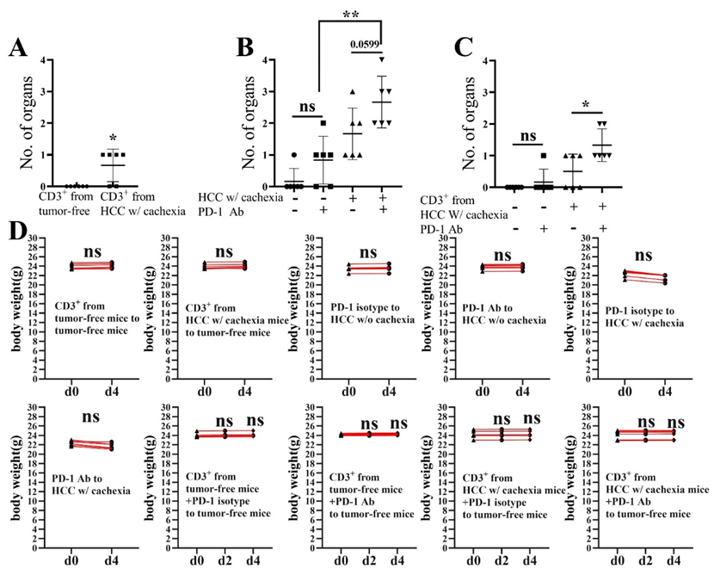
Figure S7. Statistical analysis of results shown in Figure 4. (A-C) Statistical analysis of inflammatory cell infiltration in the lungs, liver, stomach, small intestine, skin, thyroid, salivary glands, pancreas, brain, and eyes tested by HE staining. (D) The mouse body weights of d0, d2, and d4 in different groups.

Figure S8. Images and statistical analysis of immunofluorescence of CD4 and CD8 T-cells in the lungs, liver, stomach, and small intestine of the mice. Scale bars, 100 μm. (n = 6, two-way ANOVA). ns not significant, *P < 0.05, **P < 0.01, ***P < 0.0006. ****P < 0.0001.

Figure S9. T cells in the lungs of cachexic HCC mice were transferred to tumor-free mice. The recipient mice mainly developed lung inflammation. Tumor-free mice were transferred with CD3⁺ T-cells from the lung of cachexic HCC mice with inflammatory cell infiltration in the lungs, liver, stomach, small intestine, and skin tested by HE stainning. Typical HE stainning results (A) and statistical analysis (B) are shown (n = 6). Scale bars, 100 μm.

Figure S10. Gating strategy for isolation of mTEC and Annexin V-APC/7-AAD apoptosis.

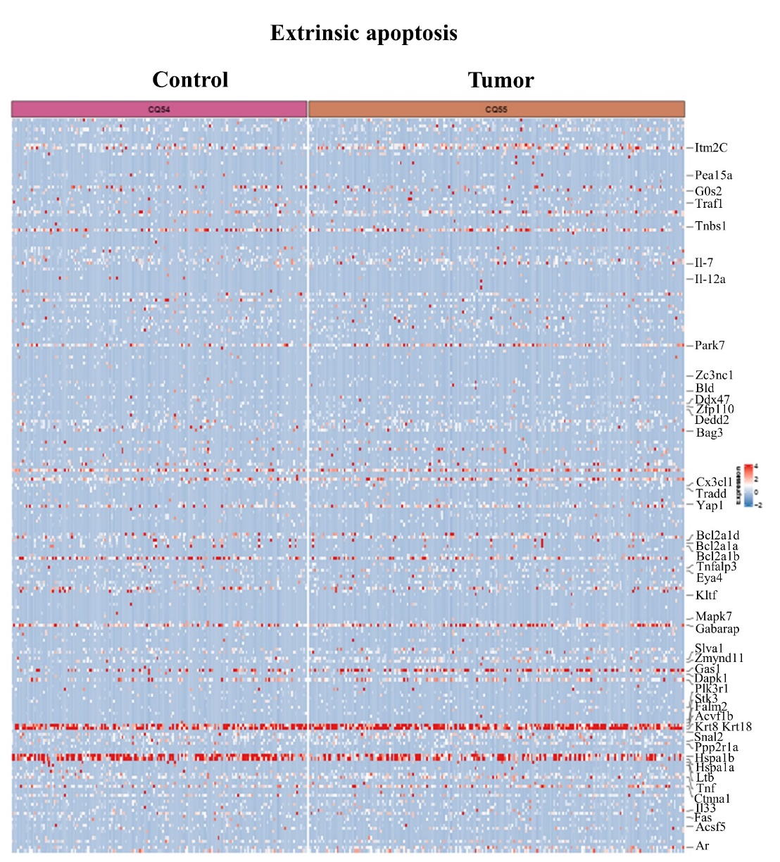

Figure S11. Extrinsic apoptosis-related genes expression of mTECs in tumor-free and cachexic HCC mice. A total of 241 genes related to extrinsic apoptosis were investigated among each mTEC from cachexic HCC and tumor-free mice with 48 genes reaching statistical significance.

Figure S12. Intrinsic apoptosis-related gene expression of mTECs in tumor-free and cachexia HCC mice. A total of 318 genes related to intrinsic apoptosis were investigated among each mTEC from the cachexic HCC and tumor-free mice, with 50 genes reaching statistical significance.

Figure S13. Suppressive activity of thymic M-MDSCs in cachexic HCC mice against the proliferation of circulating T-cells stimulated with anti-CD3/anti-CD28 antibodies. Representative figures of flow cytometry analysis, statistical analysis, IFN-γ, and NO levels are shown (n = 3 biologically independent samples, two-way ANOVA).

Figure S14 Monocytic myeloid-derived suppressor cells induce mTEC apoptosis through NO production. (A) Ghost DyeTW violet 450 test of mTEC from adult tumor-free mice cocultured with M-MDSCs from cachexic HCC mice with, monocytes from tumor-free mice, and vehicle control with typical results shown. (B) Caspase-3 activity of mTECs from adult tumor-free mice co-cultured with M-MDSCs from cachexic HCC mice (n = 3, paired t-test) (C) Apoptosis analysis of mTECs from adult tumor-free mice co-cultured with indicated cells and ratios (n = 3, two-way ANOVA). (D) iNOS expression in M-MDSCs from the spleens of HCC in situ cachexic mice and monocytes from spleens of tumor-free mice (n = 3, paired t-test). (E) NO production by M-MDSCs from cachexic HCC mice and monocytes from tumor-free mice under LPS stimulation (n = 3, two-way ANOVA). (F) NO levels in the supernatant of the M-MDSC and mTEC co-culture system above (n = 3, paired t-test). Survival (G), apoptosis (H), and Caspase-3 (I) activity of mTECs in M-MDSC and mTEC co-cultures treated with L-NMMA (n = 3, paired t-test).
Figure S15. M-MDSCs cause thymus involution and autoimmune T-cell infiltration in normal organs. (A) Inflammatory cell infiltration in the lung, liver, stomach, small intestine (S. int), skin, thyroid, salivary gland, pancreas, brain, and eye of tumor-free mice transferred with M-MDSC from the spleen of HCC mice with cachexia, monocytes from tumor-free mice or vehicle control (PBS). Typical results are shown. Each decagon represents a single mouse (n = 5). (B) Typical HE staining results of the thymus of HCC mice administrated with Ly6C antibody or isotype control. (C) Immunofluorescence analysis of β5T and KRT5 in the thymus of HCC mice administrated with Ly6C antibody or isotype control. Scale bars, 100 µm. (D) Statistical analysis of mTECs and mature mTECs by flow cytometry of the thymus of HCC mice administrated with Ly6C antibody or isotype control. (n = 3, paired t-test). (E, F) Inflammatory cell infiltration in multiple organs of HCC mice administrated with Ly6C antibody or isotype control. Scale bars, 100μm.

Figure S16. Images and statistical analysis of immunofluorescence of CD4 and CD8 in the lungs of tumor-free mice transferred with M-MDSC, monocytes, or vehicle control. Typical images and statistical analysis are shown. Scale bars, 25 μm.

Figure S17. The weight changes of mice in the M-MDSC transfer experiments and M-MDSC depletion experiments. (A) The weights of mice after M-MDSC or monocyte transfer. (B) The weights of mice after administration of anti-Ly6C antibody or its isotype.

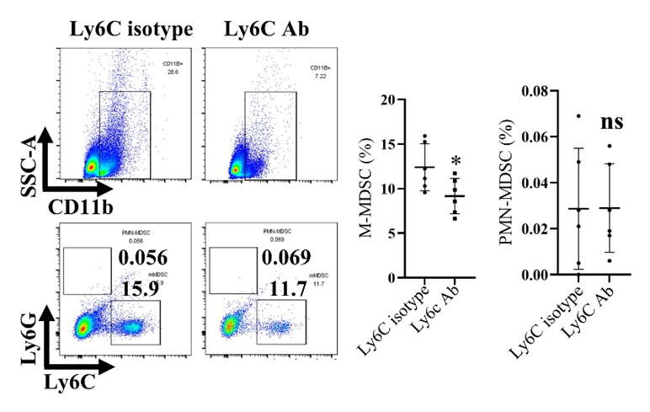
Figure S18. Flow cytometry analysis of thymic M-MDSCs in HCC mice treated with anti-Ly6C antibody or its isotype. Typical results and statistical analysis are shown.

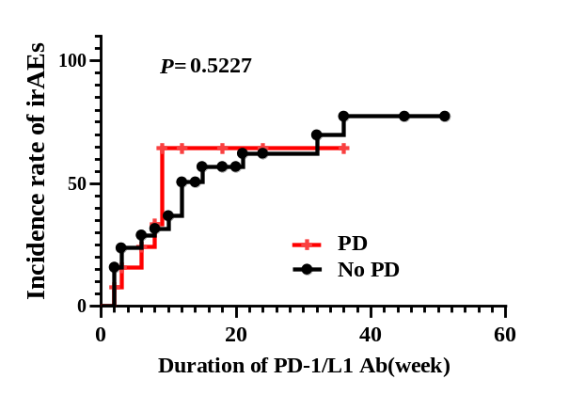
Figure S19. Kaplan -Meier failure function illustrating the accumulation of irAEs among patients who displayed (PD) or did not display (no PD) disease progression after the first ICI treatment.

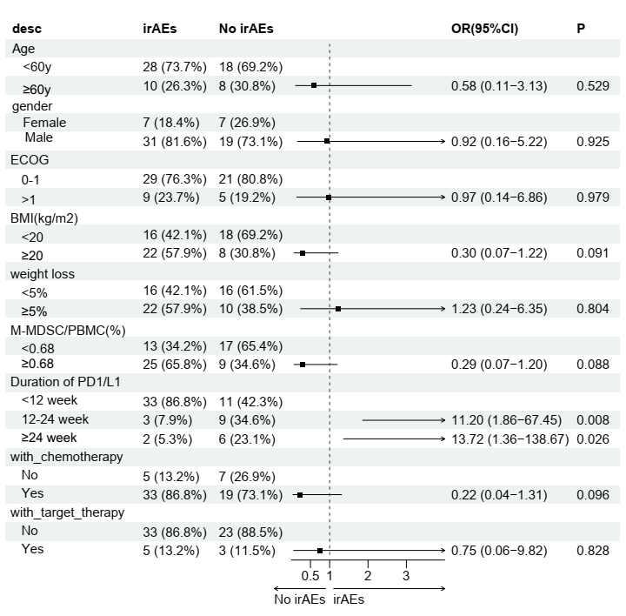
Figure S20. Multivariate Cox regression analysis of clinical parameters for the prediction of irAEs.

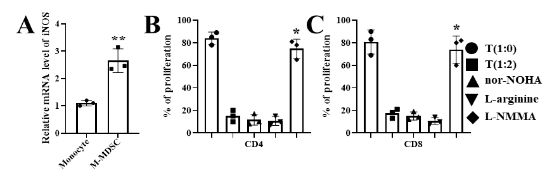
Figure S21. M-MDSCs and cachexia predict irAE occurrence in patients with cancer receiving ICIs. (A) iNOS production by M-MDSCs in patients with HCC and cachexia and monocytes from healthy donors. (n = 3, paired t-test). (B-C) CD4+ and CD8+ lymphocyte cells from health donors proliferation following L-NMMA, L-arginine, and nor-NOHA administration to the M-MDSC and T-cell co-culture system above (n = 3, two-way ANOVA). *P < 0.05, **P < 0.01.

Table S1
Clinical characteristics of patients with cancer treated with PD-1/L1 antibody
Characteristics | level | overall | No irAEs | irAEs | P
n |  | 64 | 26 | 38
Age (mean, SD) |  | 55.35 (10.120) | 56.76 (9.077) | 54.00 (11.070) | 0.3774
Sex (n, %) | Female | 14 (23.250) | 7 (28.571) | 7 (18.181) | 0.6985
Sex (n, %) | Male | 50 (76.744) | 19 (71.429) | 31 (81.818) | 0.6985
Body mass index (mean, SD) |  | 22.07(3.419) | 22.98(3.156) | 21.20(3.505) | 0.0859
weight loss before treatment | ≥5% | 32(50%) | 10(33.46%) | 22(57.89%) | 0.2929
weight loss before treatment | <5% | 32(50%) | 16(61.54%) | 16(42.11%) | 0.2929
M-MDSC/PBMC (%, median, IQR) |  | 0.68(0.55,0.93) | 0.580(0.435,0.820) | 0.855(0.635,0.972) | 0.008
Grade of irAEs | 0 | 26 | 26 | 0
Grade of irAEs | 1 | 7 | 0 | 7
Grade of irAEs | 2 | 12 | 0 | 12
Grade of irAEs | 3 | 16 | 0 | 16
Grade of irAEs | 4 | 3 | 0 | 3
PD-1 /PD-L1 Ab | Pembrolizumab | 4 | 3 | 1
PD-1 /PD-L1 Ab | Nivolumab | 5 | 3 | 2
PD-1 /PD-L1 Ab | Camrelizumab | 8 | 3 | 5
PD-1 /PD-L1 Ab | Tislelizumab | 24 | 7 | 17
PD-1 /PD-L1 Ab | Sintilimab | 18 | 7 | 11
PD-1 /PD-L1 Ab | Atezolizumab | 2 | 1 | 1
PD-1 /PD-L1 Ab | Durvalumab | 3 | 2 | 1
Duration of PD-1 /L1 Ab (week, mean, SD) |  | 13.47(11.76) | 18.10(13.48) | 9.045(7.859) | 0.0099
Duration of Follow up (week, mean, SD) |  | 22.60(12.00) | 28.52(13.72) | 17.45(6.76)
Location of irAE | Liver | 12 | 0 | 12
Location of irAE | Lung | 15 | 0 | 15
Location of irAE | Skin | 5 | 0 | 5
Location of irAE | Thyroid gland | 5 | 0 | 5
Location of irAE | Gut | 2 | 0 | 2
Location of irAE | Stomach | 1 | 0 | 1
Location of irAE | Heart | 2 | 0 | 2
Location of irAE | Kidney | 1 | 0 | 1
Diagnosis of primary cancer | HFPC | 19 | 10 | 9
Diagnosis of primary cancer | CRC | 2 | 0 | 2
Diagnosis of primary cancer | GAC | 10 | 2 | 8
Diagnosis of primary cancer | LUC | 16 | 8 | 8
Diagnosis of primary cancer | ESC | 7 | 2 | 5
Diagnosis of primary cancer | CEC | 2 | 2 | 0
Diagnosis of primary cancer | UCEC | 2 | 0 | 2
Diagnosis of primary cancer | NPC | 6 | 2 | 4

SD, Standard Deviation, IQR, Interquartile range, HEPC hepatobiliary cancer, CRC colorectal cancer, GAC gastric cancer, LUC lung cancer, ESC esophageal cancer, CEC cervical cancer, UCEC Uterine Corpus Endometrial Carcinoma, NPC nasopharyngeal carcinoma

Table S2 Reagents and resources.
REAGENT or RESOURCE | SOURCE | Clone | IDENTIFIER
APC/Fire™750 anti-mouse CD3 Antibody | BioLegend | 17A2 | Cat#100248
FITC anti-mouse CD4 Antibody | BioLegend | RM4-5 | Cat#100510
APC anti-mouse CD8a Antibody | BioLegend | 53-6.7 | Cat#100712
Brilliant Violet 605™ anti-mouse CD25 Antibody | BioLegend | PC61 | Cat#102036
PE anti-mouse/rat/human FOXP3 Antibody | BioLegend | 150D | Cat#320008
PE/Cyanine7 anti-mouse/human CD44 Antibody | BioLegend | IM7 | Cat#103030
APC/Fire™ 750 anti-mouse CD62L | BioLegend | MEL-14 | Cat#104450
PerCP/Cyanine5.5 anti-mouse CD326 (Ep-CAM) Antibody | BioLegend | G8.8 | Cat#118220
PE-Cy7 Anti-Mouse CD45 | Tonbo Biosciences | 30-F11 | Cat# 60-0451
PE anti-mouse Ly-51 Antibody | BioLegend | 6C3 | Cat#108308
Lectin from Ulex europaeus FITC Conjugate | Sigma Aldrich |  | L9006
APC Anti-Mouse CD80 | TONBO Bioscience | 16-10A1 | Cat#20-0801
violetFluor™ 450 Anti-Mouse MHC Class II | TONBO Bioscience | M5/114.15.2 | Cat#75-5321
FITC Anti-Human/Mouse CD11b | TONBO Bioscience | M1/70 | Cat#35-0112
APC Anti-Mouse Ly-6G | TONBO Bioscience | 1A8 | Cat#20-1276
PE Anti-Mouse Ly-6C | TONBO Bioscience | HK1.4 | Cat#50-5932
Annexin V-APC/ 7-AAD detection Kit | Procell China |  | P-CA-208
Brilliant Violet 605™ anti-human CD11b Antibody | BioLegend | ICRF44 | Cat#301332
PE/Cyanine7 anti-human CD14 Antibody | BioLegend | HCD14 | Cat#325618
PerCP/Cyanine5.5 anti-human CD15 (SSEA-1) Antibody | BioLegend | HI98 | Cat#301922
FITC Anti-Human HLA-DR | TONBO Bioscience | L243 | Cat#35-9952
Ghost DyeTM Violet 450 | TONBO Bioscience |  | Cat#13-0863-T100
CD4 Monoclonal Antibody, Rat / IgG1, kappa | Invitrogen, | 4SM95 | Cat#14-9766-82
CD8-α antibody, mouse IgG2a κ | Santa Cruz Biotechnology | D-9 | Cat#sc-7970
Anti-AIRE antibody, Rat | Abcam | 5H12 | Cat#ab243169
Anti-Mouse Fezf2/Fez1 Rabbit IgG Affinity Purify | Immuno-Biological Laboratories, Japan | F441 | Cat#18997
CK5 Antibody, Mouse Monoclonal | Affinity Bioscience |  | Cat#:BF0493
Cytokeratin5(KRT5) Mouse Monoclonal Antibody | OriGene Technologies | RCK102 | BM6002P
Anti-Ly6G antibody, Rabbit | Abcam | EPR22909-135 | Cat#ab238132
Ly-6C antibody, Rat | Santa Cruz Biotechnology | ER-MP20 | Cat#sc-52650
Donkey anti-rat Alexa Fluor 488 | Abcam |  | Cat#ab150153
Donkey anti-rabbit Alexa Fluor 594 | Abcam |  | Cat#ab175692
Donkey anti-mouse Alexa Fluor 647 | Abcam |  | Cat#ab150111
Goat anti-rat Alexa Fluor 488 | Abcam |  | Cat#ab150165
Goat anti-rabbit Alexa Fluor 594 | Abcam |  | Cat#ab150088
Goat anti-mouse Alexa Fluor 647 | Abcam |  | Cat#ab150119
anti-human CD3 in vivo Ready (OKT3) | Tonbo Biosciences |  | Cat # 40-0037-U500
anti- human CD28 in vivo Ready (CD28.2) | Tonbo Biosciences |  | Cat # 40-0289-U500
EasySep™ Mouse CD45 Positive Selection Kit | Stemcell, Vancouver, Canada |  | Cat#18945
FoxP3/Transcription Factor Staining Buffer Kit | MultiSciences Biotech |  | Cat#IC001
Recombinant Human IL2 | Peprotech, Rocky Hill, NJ |  | Cat#200-02
InVivoMab anti-mouse PD-1 (CD279) | BioXcell | RMP1-14 | Cat#BE0146
InVivoMAb rat IgG2a isotype control, anti-trinitrophenol | BioXcell | 2A3 | Cat#BE0089
InVivoMAb anti-mouse Ly6C | BioXcell | Monts 1 | Cat#BE0203
Caspase-3 Activity detection kit | Beijing Solarbio Science & Technology |  | Cat#BC3830
Human IFN Gamma ELISA Kit | Thermo Fisher |  | Cat#EHIFNG
Nitric Oxide (NO) Content Assay Kit | Beijing Boxbio Science & Technology |  | Cat#AKNM005M
L-NMMA | Cayman Chemical |  | Cat#NC0190932
Nor-NOHA | Cayman Chemical |  | Cat#10006861
TRIzol™ LS | Invitrogen, Thermo Fisher |  | Cat#10296010
PrimeScript®RT reagent Kit | TaKaRa |  | Cat#RR037A
Premix Ex Taq™ (Probe qPCR) | TaKaRa |  | Cat#RR390A

Supplementary references

S41 Kim MJ, Serwold T. Isolation of highly viable thymic epithelial cells for use in in vitro and in vivo experiments. Methods Mol Biol. 2019; 1899:143–56.

S42 Ohigashi I, Takahama Y. Flow cytometry analysis of thymic epithelial cells and their subpopulations. Methods Mol Biol. 2016; 1323:65–73.

S43 Xu D, Li C, Xu Y, Huang M, Cui D, Xie J. Myeloid-derived suppressor cell: A crucial player in autoimmune diseases. Front Immunol. 2022; 13:1021612.

S44 Li X, Chen J, Chen YJ, Qiao YD, Zhao LY, Jiang N, et al. Dexamethasone and lactoferrin induced PMN-MDSCs relieved inflammatory adverse events of anti-cancer therapy without tumor promotion. Commun Biol. 2021; 4:252.

S45 González R, Molina-Ruiz FJ, Bárcena JA, Padilla CA, Muntané J. Regulation of cell survival, apoptosis, and epithelial-to-mesenchymal transition by nitric oxide-dependent post-translational modifications. Antioxid Redox Signal. 2018; 29:1312–32.

S46 Nitta T, Tsutsumi M, Nitta S, Muro R, Suzuki EC, Nakano K, et al. Fibroblasts as a source of self-antigens for central immune tolerance. Nat Immunol. 2020; 21:1172–80.

