Extreme Mediterranean cyclones and associated variables in an atmosphere-only vs an ocean-coupled regional model
Marco Chericoni^{1,2}, Giorgia Fosser¹, Emmanouil Flaounas³, Gianmaria Sannino^{2,4}, Alessandro Anav²
¹University School for Advanced Studies IUSS, Pavia, Italy
²Italian National Agency for New Technologies, Energy and the Environment (ENEA), Rome, Italy
³Institute of Oceanography, Hellenic Centre for Marine Research, Athens, Greece
⁴ICSC Italian Research Center on High-Performance Computing, Big Data and Quantum Computing, Bologna, Italy

Correspondence to: Marco Chericoni (marco.chericoni@iusspavia.it)

Supplementary figures

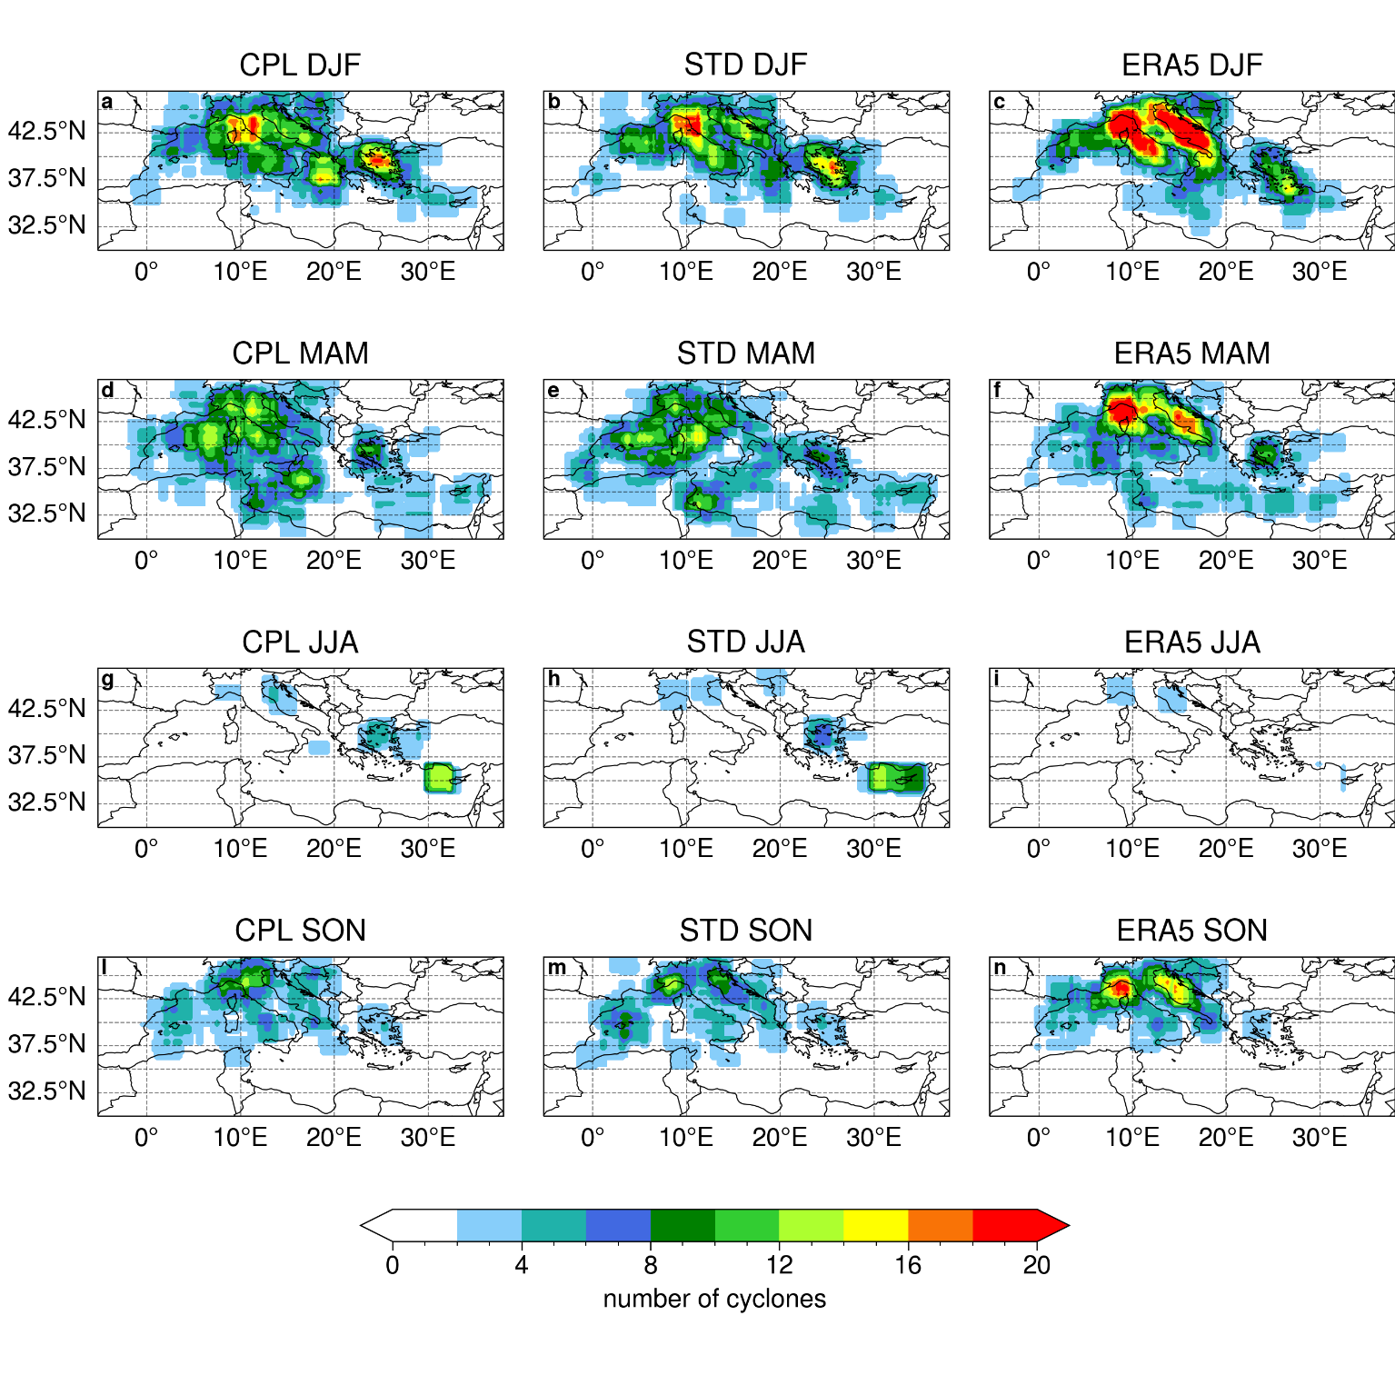
Figure S1: Spatial distribution of the 500 most intense cyclones in the 4 seasons for CPL (a, d, g, l), STD (b, e, h, m) and ERA5 (c, f, i, n).
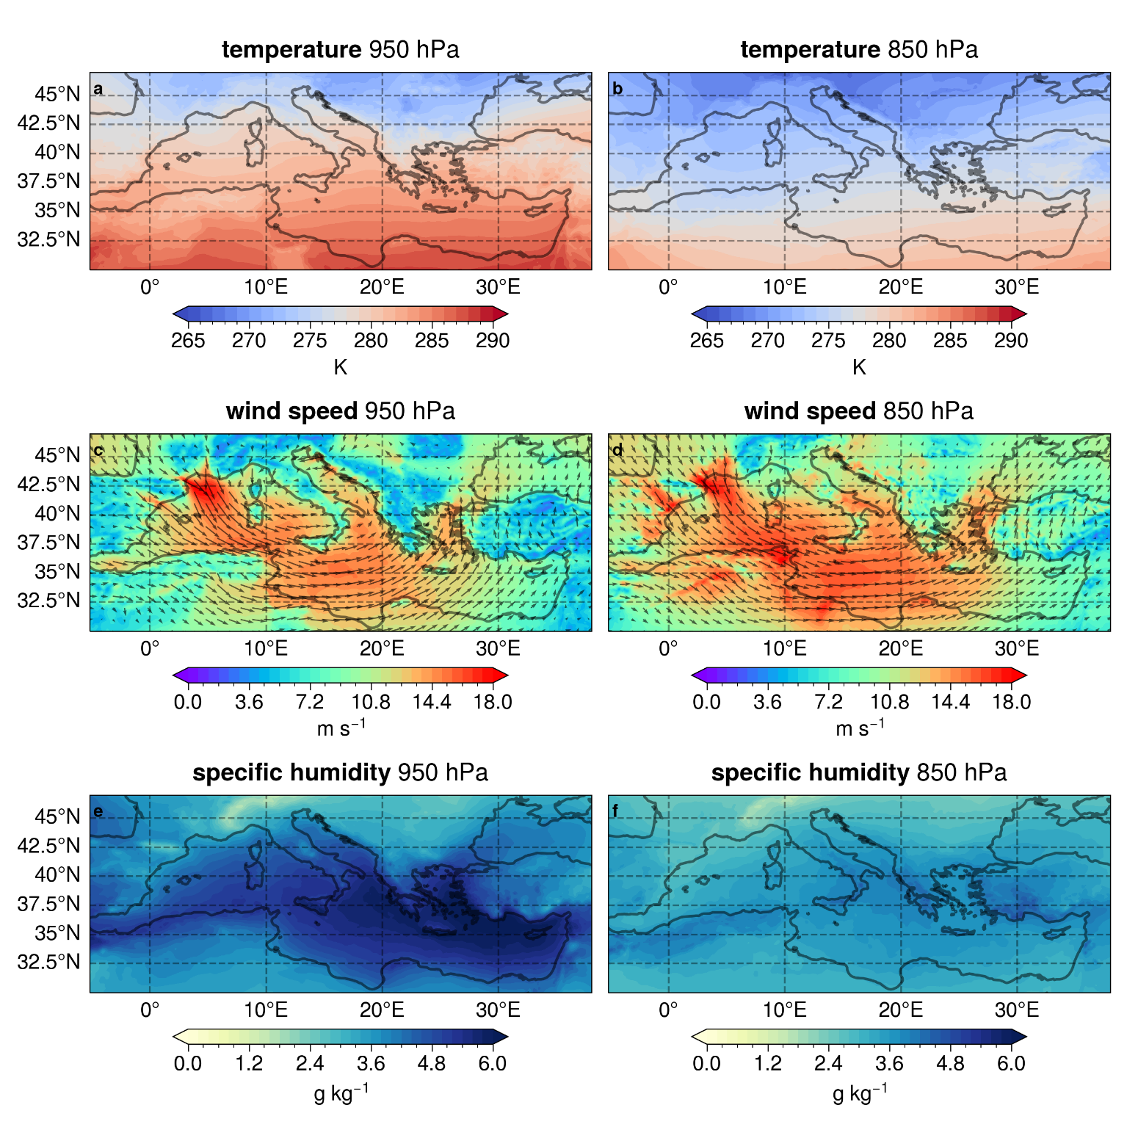
Figure S2: Maps for temperature (a,b), specific humidity (c,d) and wind speed at 950 hPa and 850 hPa from the STD simulation during extreme winter cyclones in common with CPL.
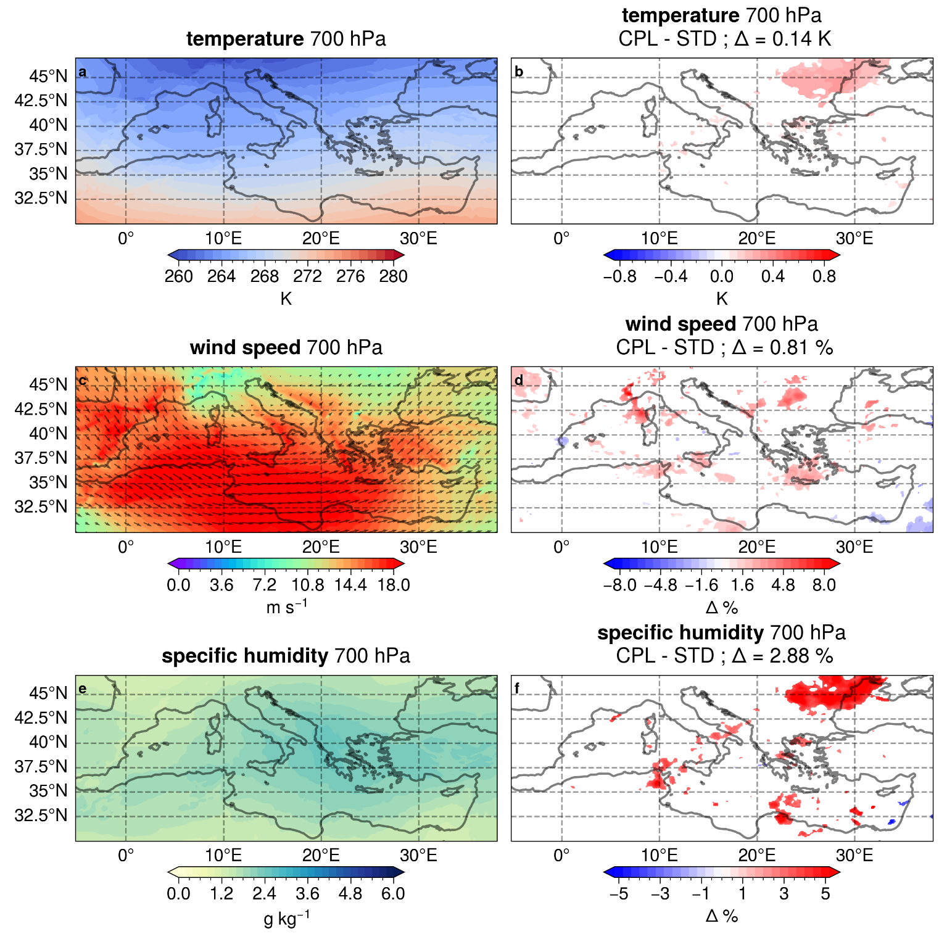
Figure S3: Maps of temperature (a, b), specific humidity (c, d) and wind speed (e, f) at 700 hPa from the STD simulation, together with the differences between CPL and STD, during the common extreme winter cyclones. The white colour in Fig. (b), (d) and (f) indicates no significant differences at 5% confidence level.

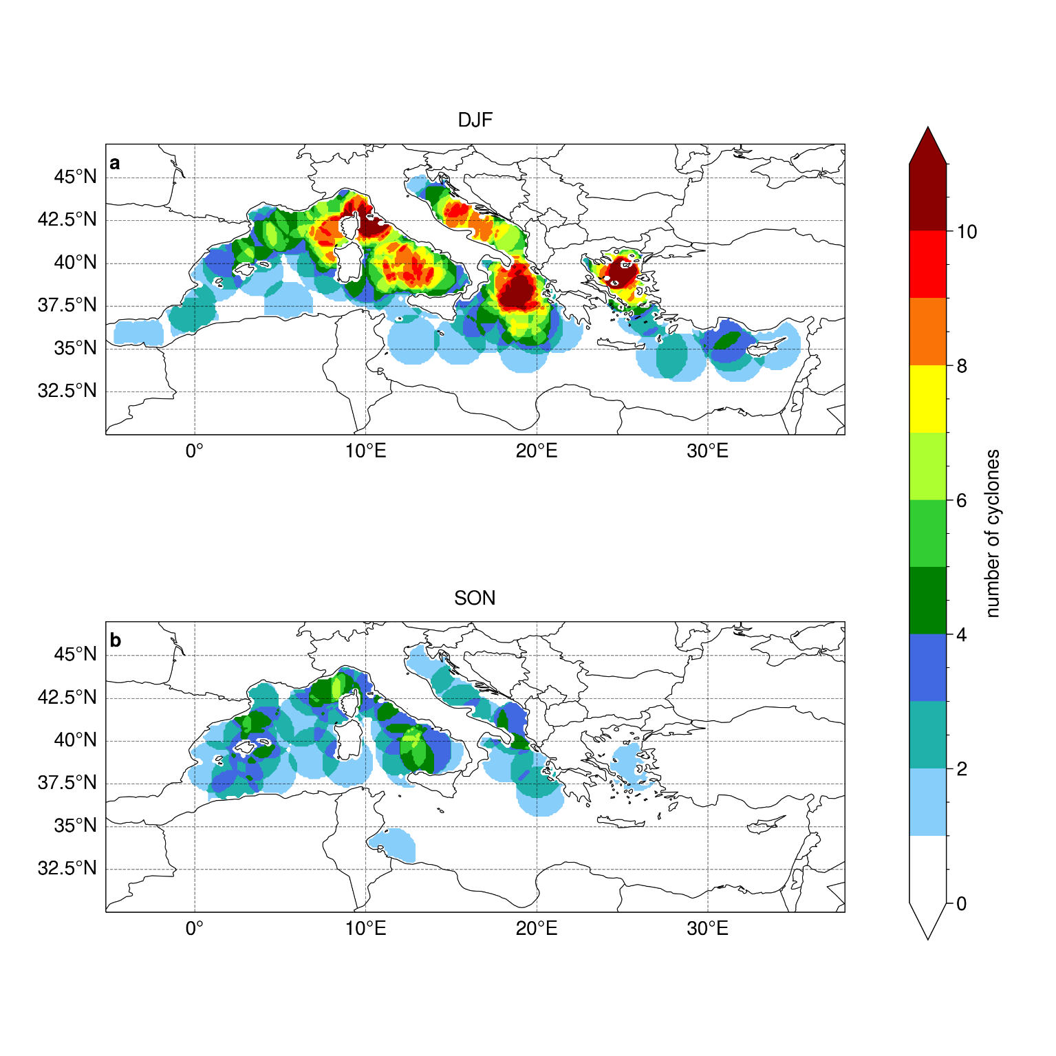
Figure S4: Distribution of winter (a) and autumn (b) cyclones within the extreme cyclones of the CPL model in common with STD, that present their minimum SLP point over the sea. Each cyclone is represented by a circular area, with a radius of 1.5°, around its minimum SLP tracking point.
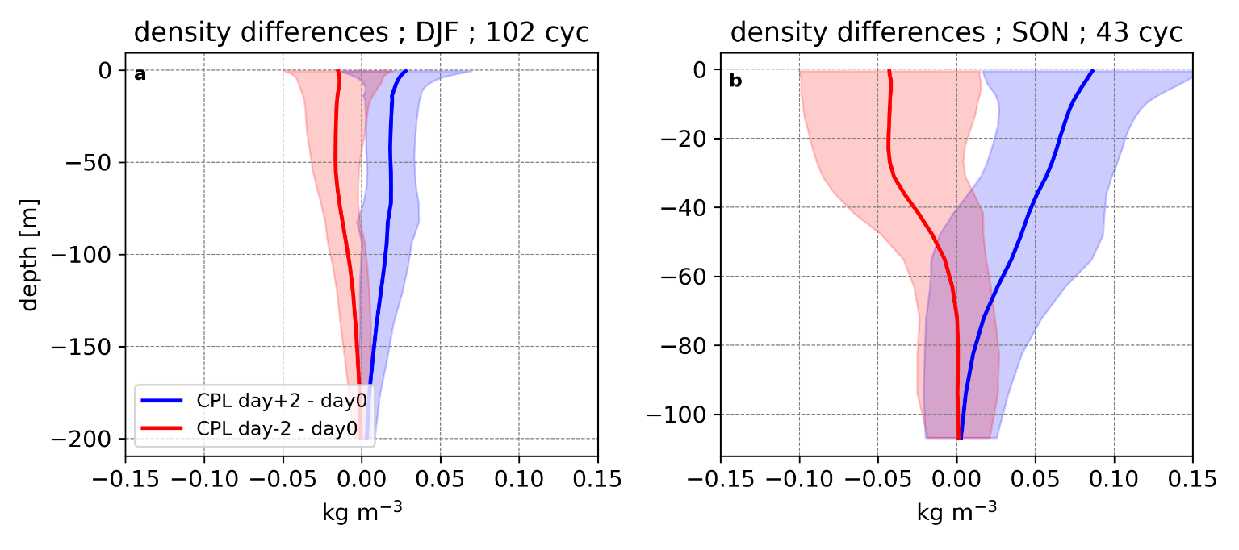
Figure S5: Same as Fig. 10c and d, but for density and only for the CPL model.

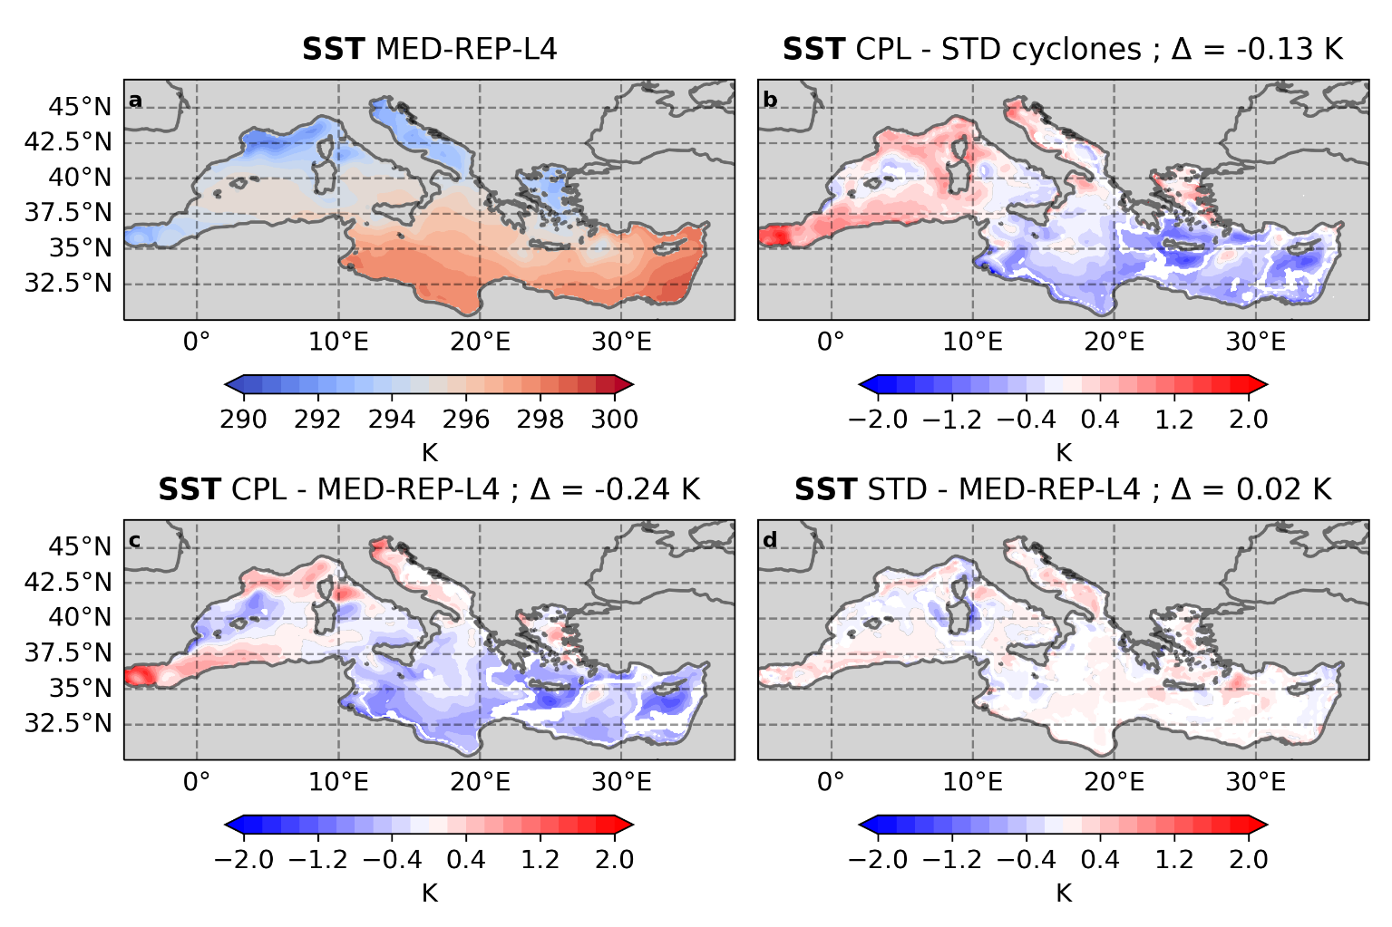
Figure S6: Same as Fig. 5 but for SON.

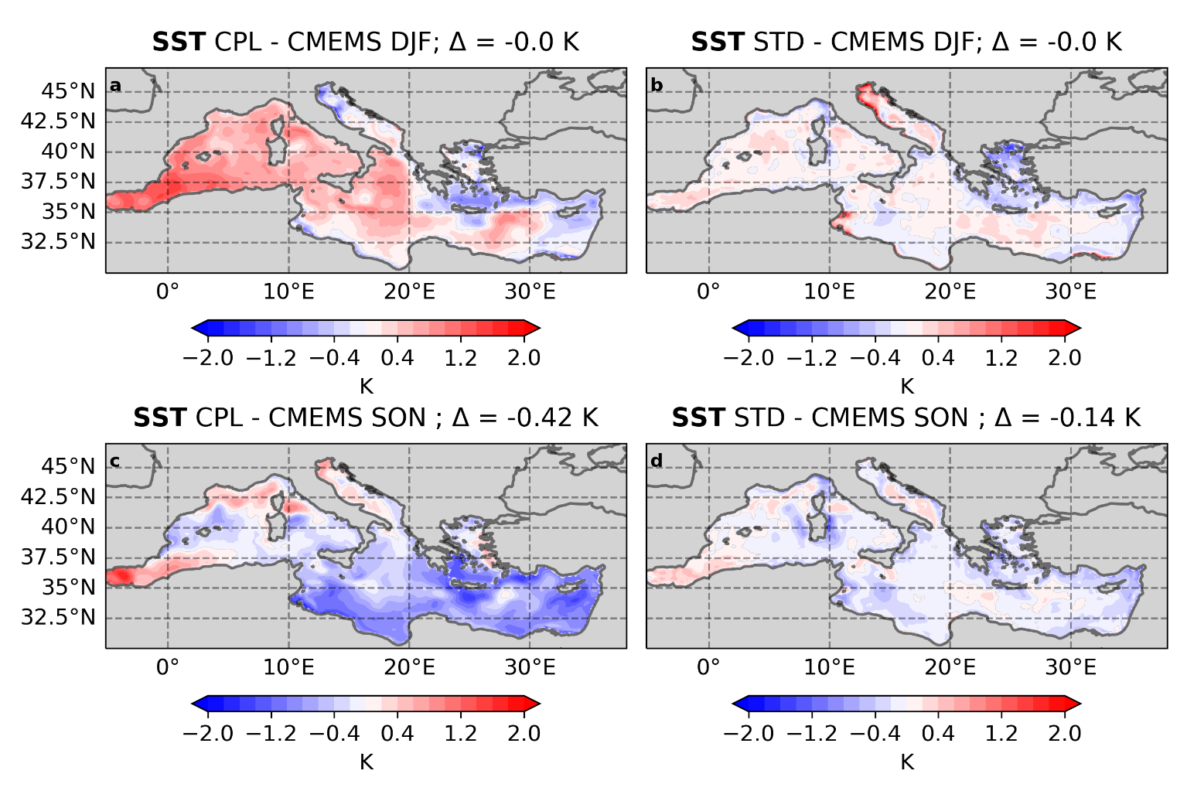
Figure S7: Maps of the climatological difference in SST between CPL and CMEMS MED-Currents in DJF (a) and SON (c) and between STD and CMEMS MED-Currents in DJF (b) and SON (d).

