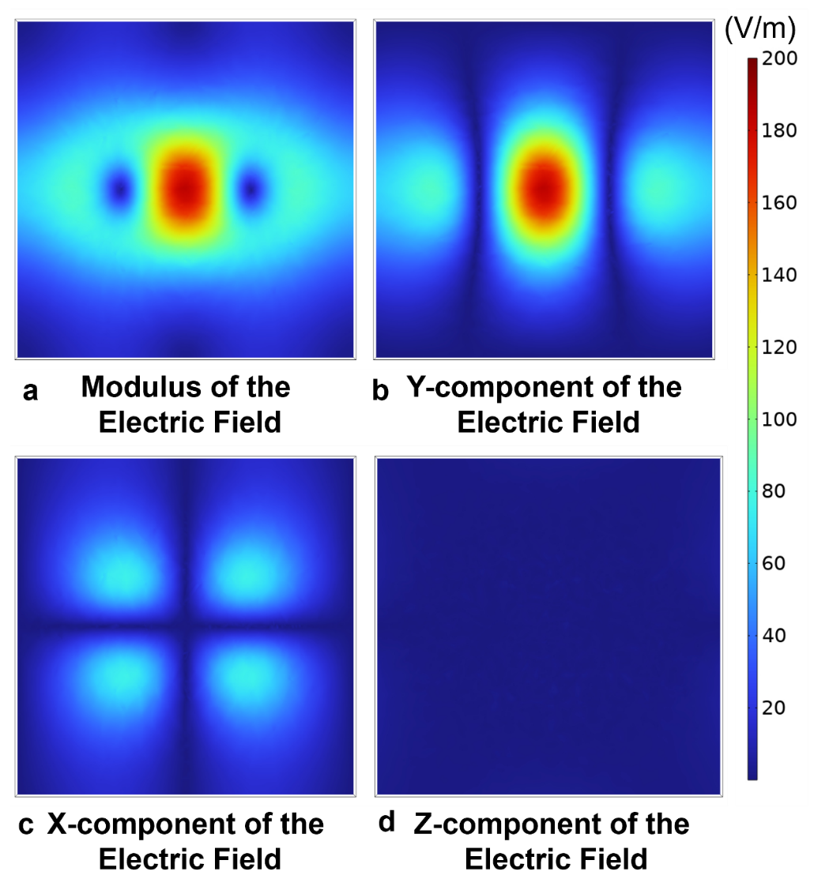
Figure S1: Induced electric field distribution in the xy plane of the 8-coil. (a) Model of induced electric field by the 8-coil, (b) Y-Component of the induced electric field, (c) X-Component of the induced electric field, (d) Z-Component of the induced electric field.

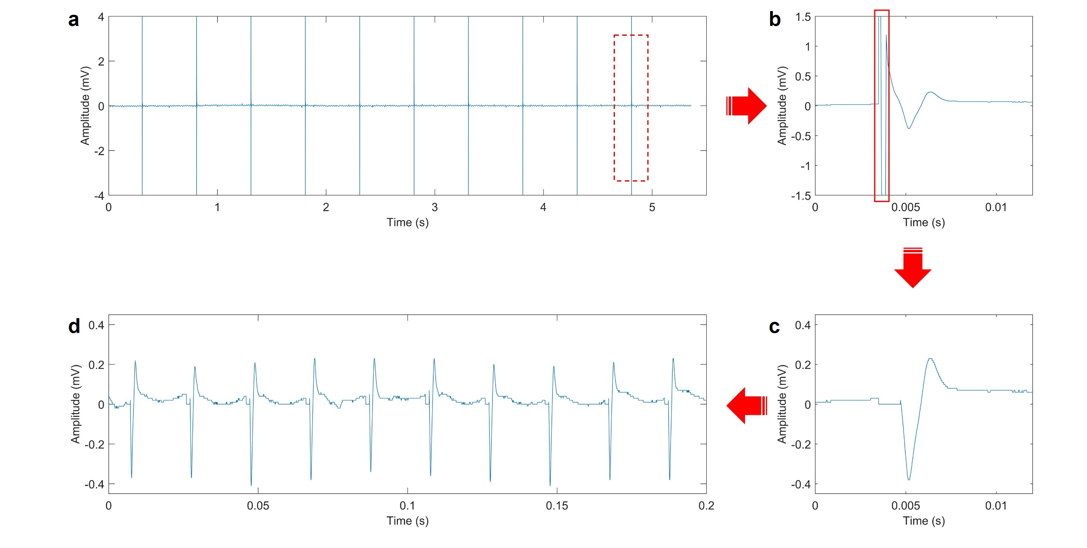
Figure S2: Processing of EMG from the mouse gastrocnemius muscle. (a) Raw data; (b) EMG with strong pulse electromagnetic interference from the stimulation coil. (c) EMG without interference after processing. (d) Integrated EMG.

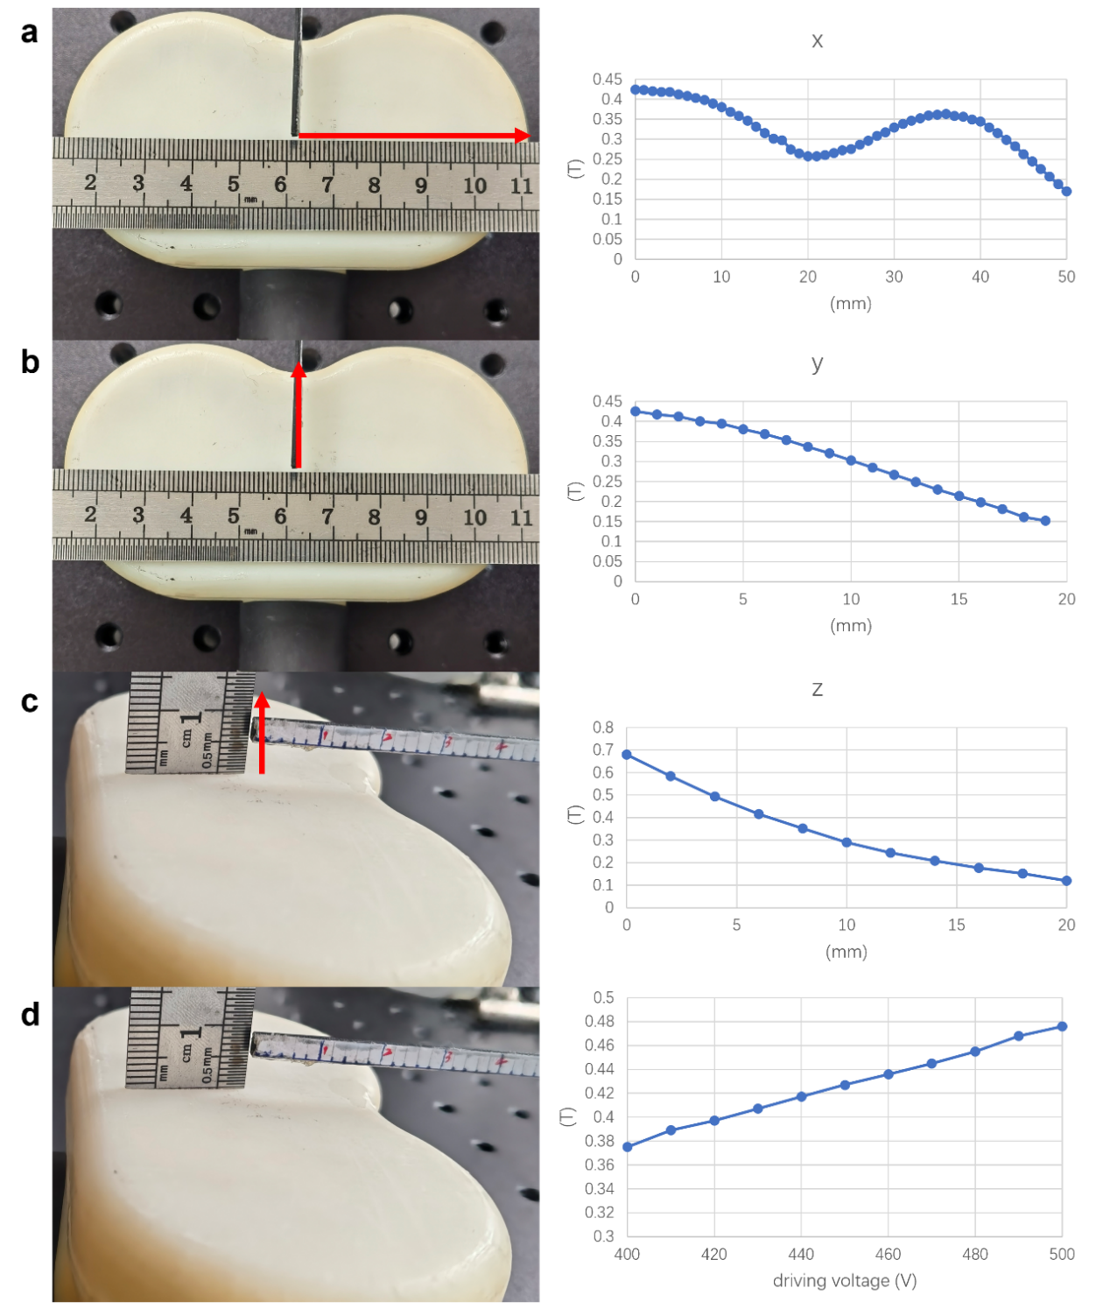
Figure S3: Magnetic field distribution of the 8-shaped coil under 460V excitation. (a) Magnetic field distribution along the coil's x-axis direction. (b) Magnetic field distribution along the coil's y-axis direction. (c) Magnetic field distribution along the coil's z-axis direction. (d) Magnetic field strength at indicated positions under different excitation voltages.

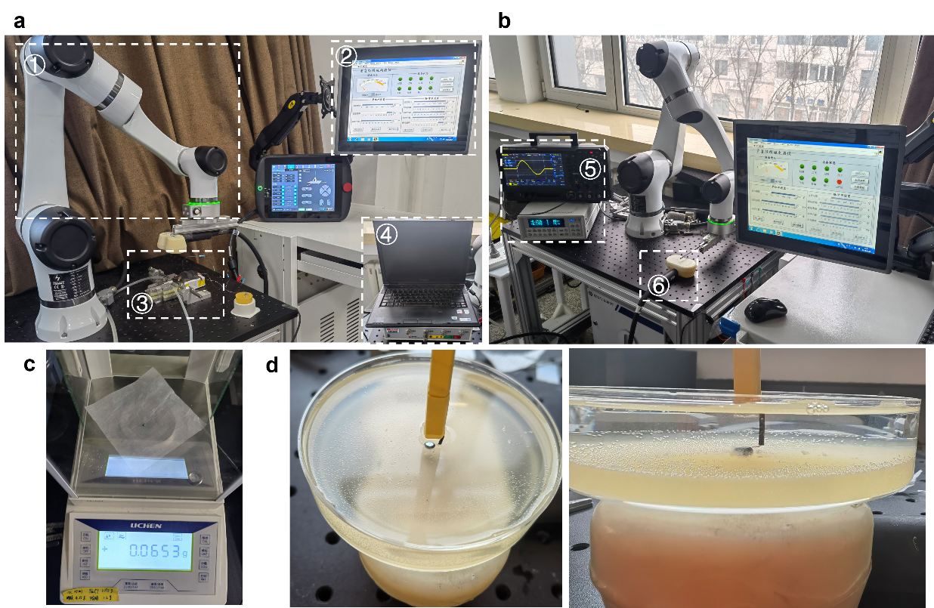
Figure S4: Physical setup of LM neuro-magnetic stimulation method. (a) Experimental setup for sciatic nerve electrical stimulation in mice. (b) Physical representation of the measured coil magnetic field distribution. (c) Weighing of LM measurement. (d) Measured distribution of induced electric field from LM. Notations: ① Control robotic arm, ② Stimulation voltage generator, ③ Mouse, ④ EMG signal recorder, ⑤ Magnetic field measurement device and oscilloscope, ⑥ 8-coil.

