Appendix

Image comparison
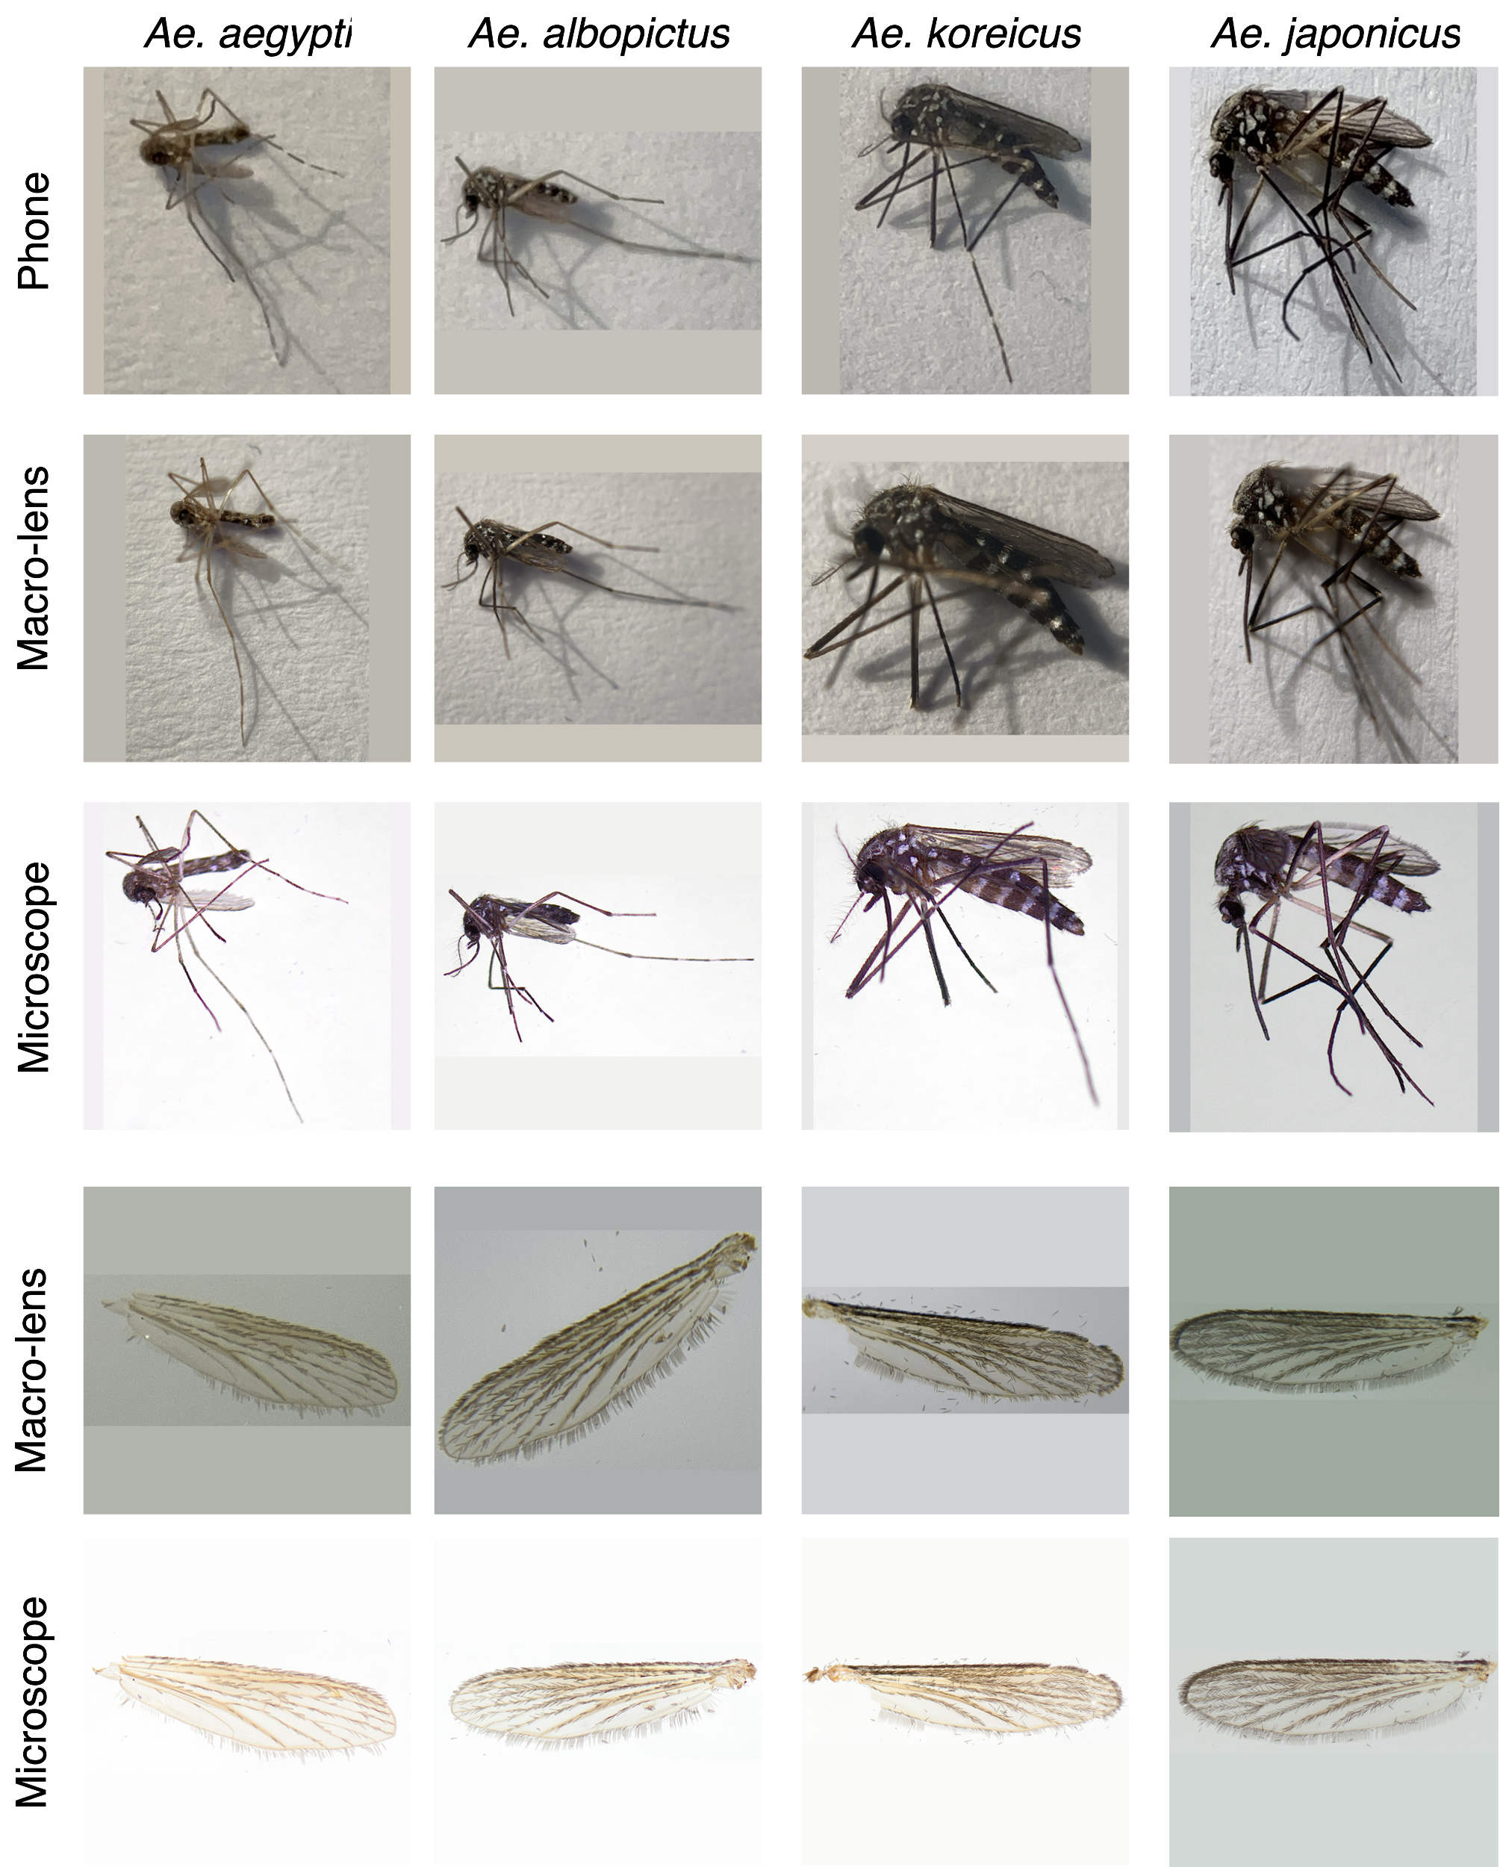
Appendix 1: Image of the samples with the identifier b50.

Hyperparameters
Appendix 2: Hyperparameters used for the depiction, device and demand experiment for both body and wing classification.
Parameters | CNN
Model Architecture | EfficientNetV2B0
Image Resolution | 300x300
Batch Size | 16
Learning Rate Transfer | 0.0005
Learning Rate FineTuning | 0.00001
Early Stop Patience | 12
RandAug Layers | 3
RandAug Magnitude | 0.05
RandomRotation Factor | 0.05
RandomTranslation Factor | 0.05
RandomColorDegeneration Factor | 0.25
RandomSharpness Factor | 0.25
GaussianNoise Factor | 0.1
Label Smoothing | 0.1
Dropout Probability | 0.5

GradCam
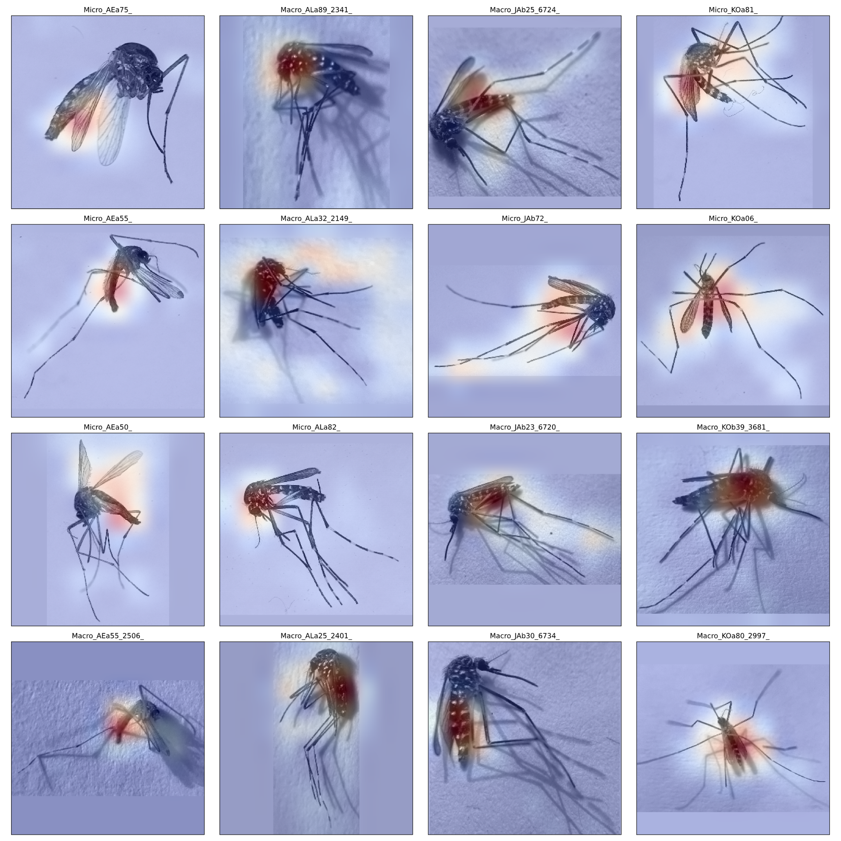
Appendix 3: Gradient weighted Class Activation Mapping (GradCam) generated from the body classifying model with the seed 9. All images are from successful prediction on the testing set. Red areas are the ones with the highest activation while blue areas are regions with the lowest relevance for classification. It can be observed that the model focuses on the thorax region for classification.
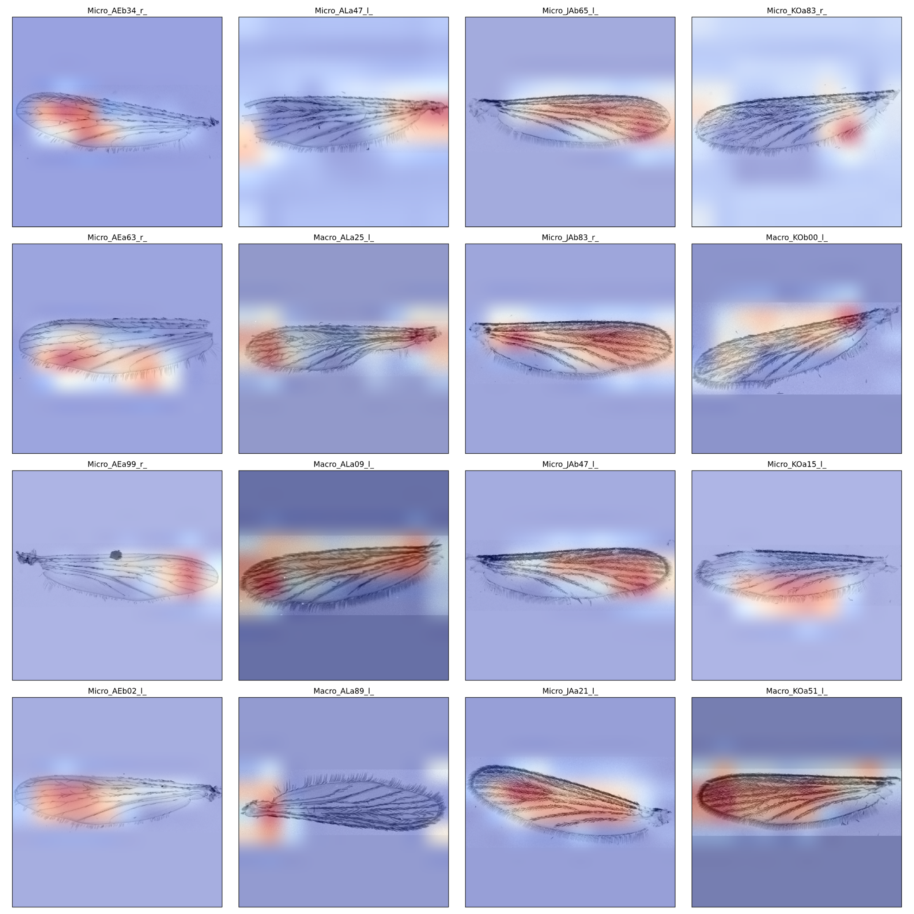
Appendix 4: Gradient weighted Class Activation Mapping (GradCam) generated from the wing classifying model with the seed 9. All images are from successful prediction on the testing set. Red areas are the ones with the highest activation while blue areas are regions with the lowest relevance for classification. It can be observed that the model often utilizes the whole wing for classification.

