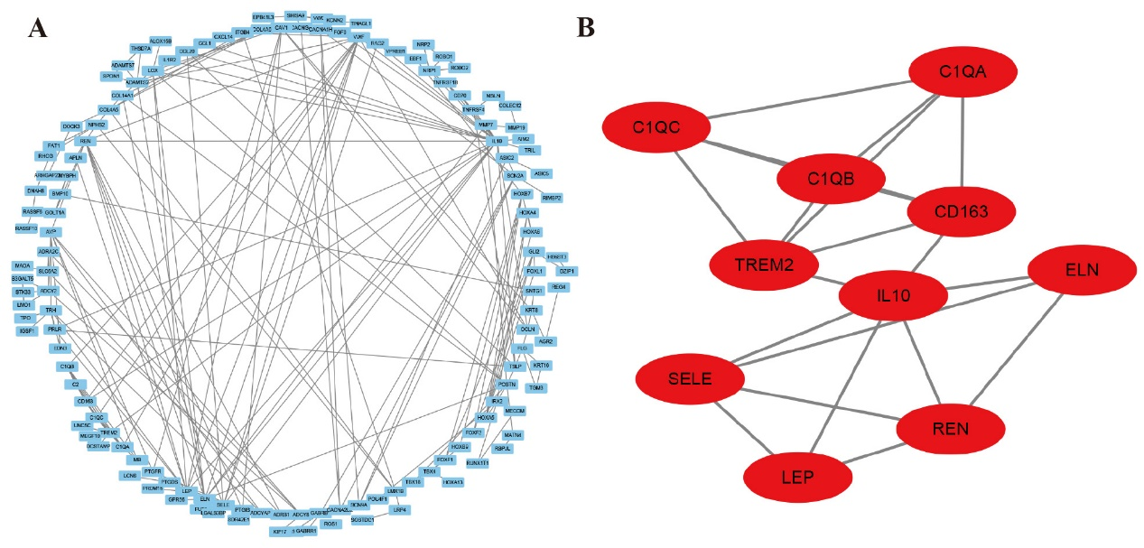
Figure S1. PPI network analysis of ARHGEF5-associated DEGs and identification of the most significant module. (A) Construction of PPI network of DEGs utilizing Cytoscape. (B) Derivation of the most significant module with ten nodes and 21 edges from the PPI network.

