Supplementary information for decarboxylative oxidation induced consecutive C-C bond cleavage

Table of Contents
1. General Information 3
2. Synthesis and Characterization of Substrates 4
3. Reaction Optimization and Control Experiments 21
4. Mechanistic Studies 25
5. General Procedures and Experimental Data 27
6. References 50
7. NMR Spectra Data 52

General Information
Commercial chemicals were used as supplied without further purification. The solvents were used directly from commercial reagents. The iridium photocatalysts [(dF(CF₃)ppy)₂-Ir-μ-Cl]₂ (Ir-1), [Ir(dF(CF₃)ppy)₂(dOMebpy)]PF₆ (Ir-2), [Ir(dF(CF₃)ppy)₂(dtbpy)]PF₆ (Ir-3) and [Ir(dF(CF₃)ppy)₂(bpy)]PF₆ (Ir-4) were synthesized following the published route¹. Organic solutions were concentrated under reduced pressure on an IKA rotary evaporator using a water bath. Chromatographic purification of products was accomplished using force-flow chromatography on silica gel (200-300 mesh) according to the method of Still². Thin-layer chromatography (TLC) was performed on 250 µm silica gel plates. TLC visualization was performed by UV lamp and KMnO₄ stain (1g KMnO₄, 1g NaHCO₃ and 100 mL H₂O). All key compounds were characterized by ¹H NMR, ¹³C NMR and HRMS. ¹H NMR spectra were recorded on an Agilent NMR Systems 400 MHz Spectrometer (¹H NMR at 400 MHz) and are internally referenced to residual protic CDCl₃ (δ 7.26 ppm) or protio DMSO-d₆ (2.50 ppm) unless otherwise noted. Data for ¹H NMR are reported as follows: chemical shift (δ ppm), multiplicity (s = singlet, d = doublet, t = triplet, q = quartet, m = multiplet, dd = doublet of doublets, dt = doublet of triplets, brs = broad singlet), and coupling constant (Hz). ¹³C NMR spectra were recorded on an Agilent NMR Systems 400 MHz Spectrometer (¹³C NMR at 101 MHz) and data are reported in terms of chemical shift relative to CDCl₃ (77.16 ppm) or DMSO-d₆ (39.52 ppm). For ¹H NMR analysis of crude reaction mixtures, mesitylene was used as internal standard, and added as a pure liquid. HRMS: electrospray ionization mass (ESI-MS) was performed on Agilent 6210 Series TOF MS. The blue LEDs were purchased from local market and used directly without any filters. The brand name of LEDs is Jin Dian Yuan and the model number is JDY-TG01. The shell material Seiko aluminum + PC.

Synthesis and Characterization of Substrates
General procedure A for the synthesis of acids
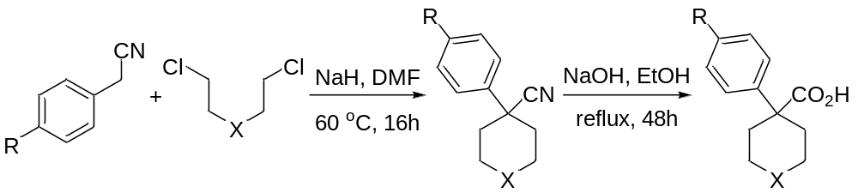
Figure S1. Preparation of acids from commercial compounds in two steps²
General procedure A for preparation of acids:
To a solution of substituted benzeneacetonitrile (2.00 g) and tert-butyl bis(2-chloroethyl)carbamate (1.0 equiv.) or 1-chloro-2-(2-chloroethoxy)ethane (1.0 equiv.) in DMF (25 mL) was added NaH (60% dispersion in mineral oil, 3.5 equiv.) portion wise at 0 ºC over 15 min and the reaction was stirred at room temperature for 1 hour. Then the mixture was heated at 60 ºC for 16 hours. The reaction mixture was poured into ice-water and extracted with ethyl acetate (3*50 mL). The combined organic layers were washed with brine (50 mL), dried over Na₂SO₄, filtered and concentrated. The crude product was purified by silica gel chromatography eluting with hexane/ethyl acetate (15 : 1) to provide the desired carbonitriles.
The mixture of carbonitrile in EtOH (20 mL) and 10 N NaOH (20 mL) was refluxed for 48 hours, cooled to room temperature, and then added 1 N HCl until pH to 5~6. The mixture was extracted by ethyl acetate (3*50 mL). The combined organic layers were washed with brine, dried over Na₂SO₄, filtered and concentrated. The crude product was recrystallized by ethyl acetate to give the desired acids.

1-(tert-butoxycarbonyl)-4-phenylpiperidine-4-carboxylic acid (1a)
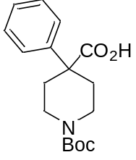
Prepared from phenylacetonitrile (2.00 g, 17.1 mmol) and tert-butyl bis(2-chloroethyl)carbamate (4.14 g, 17.1 mmol) according to the general procedures as a white solid (4.00 g, 77% yield for two steps). Data are consistent with those reported in the literature.²
¹H NMR (400 MHz, CDCl₃) δ 10.91 (brs, 1H), 7.40 (d, J = 7.7 Hz, 2H), 7.34 (t, J = 7.6 Hz, 2H), 7.27 (t, J = 7.2 Hz, 1H), 3.91 (brs, 2H), 3.09 (brs, 2H), 2.50 (d, J = 13.5 Hz, 2H), 1.86 (t, J = 10.5 Hz, 2H), 1.44 (s, 9H); ¹³C NMR (101 MHz, CDCl₃) δ 179.6, 155.1, 141.6, 128.8, 127.6, 126.1, 79.9, 49.2, 41.6, 33.4, 28.5; HRMS (ESI) calcd for C₁₇H₂₃NNaO₄ [M + Na] ⁺ m/z = 328.1519, found: 328.1527.

1-benzoyl-4-phenylpiperidine-4-carboxylic acid (2a)
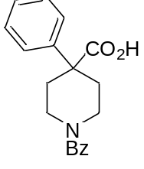
To a solution of 1a (2.00 g, 6.56 mmol, 1.0 equiv.) in DCM (30 mL) was added TFA (3.00 mL, 40.4 mmol, 6.0 equiv.) portion wise at 0 ºC and the reaction was stirred at room temperature for overnight and then concentrated. The crude product was used directly for the next step.
To the solution of the crude product in DCM (20 mL) was added DIPEA (2.16 mL, 13.1 mmol, 2.0 equiv.) and BzCl (0.91 mL, 7.87 mmol, 1.2 equiv.) at 0 ºC and the reaction was stirred at room temperature for overnight. The mixture was quenched by H₂O (10 mL) and extracted by ethyl acetate (3*50 mL). The combined organic layer was washed with brine, dried over Na₂SO₄, filtered and concentrated. The crude product was purified by silica gel chromatography eluting with hexane/ethyl acetate (4 : 1) to provide 2a (910 mg, 45% for two steps) as a white solid.
¹H NMR (400 MHz, DMSO-d₆) δ 12.82 (brs, 1H), 7.48 - 7.32 (m, 9H), 7.27 (t, J = 7.1 Hz, 1H), 4.30 (brs, 1H), 3.54 (brs, 1H), 3.32 - 2.98 (m, 2H), 2.55 - 2.47 (m, 2H), 1.84 (brs, 2H); ¹³C NMR (101 MHz, DMSO-d₆) δ 175.2, 169.1, 142.5, 136.2, 129.5, 128.7, 128.5, 127.2, 126.9, 125.9, 49.1, 45.2, 40.0, 33.8, 33.1; HRMS (ESI) calcd for C₁₉H₁₉NNaO₃ [M + Na] ⁺ m/z = 332.1257, found: 332.1252; IR v_{max}/cm⁻¹ (film) : 2929, 1718, 1591, 1571, 1447, 1228, 1200, 1007, 721, 696.

1-(tert-butoxycarbonyl)-4-(4-fluorophenyl)piperidine-4-carboxylic acid (3a)
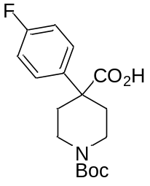
Prepared from 2-(4-fluorophenyl)acetonitrile (2.00 g, 14.8 mmol) and tert-butyl bis(2-chloroethyl)carbamate (3.59 g, 14.8 mmol) according to the general procedures as a white solid (2.30 g, 48% yield for two steps). Data are consistent with those reported in the literature.³
¹H NMR (400 MHz, CDCl₃) δ 11.12 (brs, 1H), 7.36 (dd, J = 8.4, 5.3 Hz, 2H), 7.02 (t, J = 8.5 Hz, 2H), 3.91 (brs, 2H), 3.06 (brs, 2H), 2.47 (d, J = 13.3 Hz, 2H), 1.79 (t, J = 10.5 Hz, 2H), 1.43 (s, 9H); ¹³C NMR (101 MHz, CDCl₃) δ 179.3, 162.1 (d, J = 248 Hz), 155.1, 137.4 (d, J = 3.2 Hz), 127.8 (d, J = 8.1 Hz), 115.6 (d, J = 21.3 Hz), 80.1, 48.7, 41.8, 33.5, 28.5; HRMS (ESI) calcd for C₁₇H₂₂FNNaO₄ [M + Na] ⁺ m/z = 346.1425, found: 346.1530.

1-(tert-butoxycarbonyl)-4-(4-chlorophenyl)piperidine-4-carboxylic acid (4a)
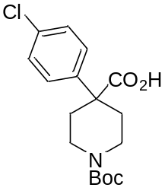
Prepared from 2-(4-chlorophenyl)acetonitrile (2.00 g, 10.8 mmol) and tert-butyl bis(2-chloroethyl)carbamate (2.62 g, 10.8 mmol) according to the general procedures as a white solid (1.80 g, 49% yield for two steps). Data are consistent with those reported in the literature.³
¹H NMR (400 MHz, CDCl₃) δ 11.10 (brs, 1H), 7.36 - 7.27 (m, 4H), 3.90 (brs, 2H), 3.06 (brs, 2H), 2.46 (d, J = 13.5 Hz, 2H), 1.87 - 1.72 (m, 2H), 1.43 (s, 9H); ¹³C NMR (101 MHz, CDCl₃) δ 179.0, 155.0, 140.1, 133.6, 129.0, 127.5, 80.2, 48.8, 41.5, 33.3, 28.5; HRMS (ESI) calcd for C₁₇H₂₂ClNNaO₄ [M + Na] ⁺ m/z = 362.1130, found: 362.1131.

1-(tert-butoxycarbonyl)-4-(4-(trifluoromethyl)phenyl)piperidine-4-carboxylic acid (5a)
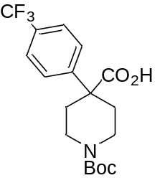
Prepared from 2-(4-(trifluoromethyl)phenyl)acetonitrile (2.00 g, 10.8 mmol) and tert-butyl bis(2-chloroethyl)carbamate (2.62 g, 10.8 mmol) according to the general procedures as a white solid (750 mg, 19% yield for two steps).
¹H NMR (400 MHz, CDCl₃) δ 11.41 (brs, 1H), 7.59 (d, J = 8.4 Hz, 2H), 7.52 (d, J = 8.3 Hz, 2H), 3.95 (d, J = 10.0 Hz, 2H), 3.08 (brs, 2H), 2.51 (d, J = 13.4 Hz, 2H), 1.91 - 1.77 (m, 2H), 1.43 (s, 9H); ¹³C NMR (101 MHz, CDCl₃) δ 178.3, 155.1, 145.7, 130.0 (q, J = 32.7 Hz), 126.6, 125.7 (q, J = 3.7 Hz), 124.0 (d, J = 271 Hz), 80.4, 49.4, 41.2, 33.4, 28.5; HRMS (ESI) calcd for C₁₇H₂₂F₃NNaO₄ [M + Na] ⁺ m/z = 396.1393, found: 396.1395; IR v_{max}/cm⁻¹ (film) : 2978, 1731, 1699, 1654, 1439, 1328, 1168, 1128, 1073, 1018, 930, 839.

1-(tert-butoxycarbonyl)-4-(4-methoxyphenyl)piperidine-4-carboxylic acid (6a)
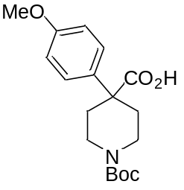
Prepared from 2-(4-methoxyphenyl)acetonitrile (2.00 g, 13.6 mmol) and tert-butyl bis(2-chloroethyl)carbamate (3.30 g, 13.6 mmol) according to the general procedures as a white solid (2.50 g, 55% yield for two steps). Data are consistent with those reported in the literature.²
¹H NMR (400 MHz, CDCl₃) δ 11.14 (brs, 1H), 7.31 (d, J = 8.8 Hz, 2H), 6.87 (d, J = 8.8 Hz, 2H), 3.89 (brs, 2H), 3.78 (s, 3H), 3.08 (brs, 2H), 2.47 (d, J = 13.5 Hz, 2H), 1.82 (t, J = 10.4 Hz, 2H), 1.44 (s, 9H); ¹³C NMR (101 MHz, CDCl₃) δ 179.9, 158.8, 154.9, 133.4, 127.1, 114.0, 79.7, 55.2, 48.3, 41.5, 33.2, 28.4; HRMS (ESI) calcd for C₁₈H₂₅NNaO₅ [M + Na] ⁺ m/z = 358.1625, found: 358.1629.

1-(tert-butoxycarbonyl)-4-(4-(tert-butyl)phenyl)piperidine-4-carboxylic acid (7a)
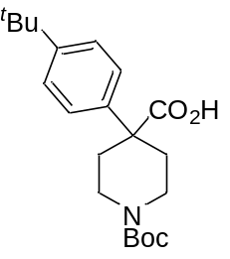
Prepared from 2-(4-(tert-butyl)phenyl)acetonitrile (2.00 g, 11.6 mmol) and tert-butyl bis(2-chloroethyl)carbamate (2.80 g, 11.6 mmol) according to the general procedures as a white solid (2.76 g, 66% yield for two steps). Data are consistent with those reported in the literature.²
¹H NMR (400 MHz, DMSO-d₆) δ 12.75 (brs, 1H), 7.36 (d, J = 8.5 Hz, 2H), 7.30 (d, J = 8.5 Hz, 2H), 3.80 (d, J = 13.4 Hz, 2H), 2.94 (brs, 2H), 2.35 (d, J = 13.5 Hz, 2H), 1.76 - 1.61 (m, 2H), 1.39 (s, 9H), 1.24 (d, J = 11.7 Hz, 9H); ¹³C NMR (101 MHz, DMSO-d₆) δ 175.2, 154.1, 149.3, 139.7, 125.5, 125.3, 78.8, 48.3, 41.7, 34.1, 33.2, 31.1, 28.1; HRMS (ESI) calcd for C₂₁H₃₁NNaO₄ [M + Na] ⁺ m/z = 384.2145, found: 384.2152.

4-([1,1'-biphenyl]-4-yl)-1-(tert-butoxycarbonyl)piperidine-4-carboxylic acid (8a)
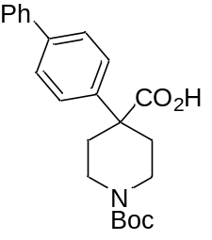
Prepared from 2-([1,1'-biphenyl]-4-yl)acetonitrile (2.00 g, 10.4 mmol) and tert-butyl bis(2-chloroethyl)carbamate (2.51 g, 10.4 mmol) according to the general procedures as a white solid (1.88 g, 47% yield for two steps).
¹H NMR (400 MHz, DMSO-d₆) δ 7.64 (t, J = 7.7 Hz, 4H), 7.52 - 7.42 (m, 4H), 7.37 (d, J = 7.2 Hz, 1H), 3.82 (d, J = 13.4 Hz, 2H), 2.99 (brs, 2H), 2.40 (d, J = 13.3 Hz, 2H), 1.88 -1.67 (m, 2H), 1.39 (s, 9H). ¹³C NMR (101 MHz, DMSO-d₆) δ 175.0, 154.0, 141.8 139.7, 138.9, 128.9, 127.5, 126.8, 126.6, 126.4, 78.7, 48.5, 41.4, 33.2, 28.1; HRMS (ESI) calcd for C₂₃H₂₇NNaO₄ [M + Na] ⁺ m/z = 404.1832, found: 404.1838; IR v_{max}/cm⁻¹ (film) : 2962, 2925, 1719, 1654, 1458, 1261, 1094, 1019, 799.

1-(tert-butoxycarbonyl)-4-(thiophen-3-yl)piperidine-4-carboxylic acid (9a)
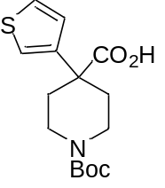
Prepared from 2-(thiophen-3-yl)acetonitrile (1.00 g, 8.13 mmol) and tert-butyl bis(2-chloroethyl)carbamate (1.97 g, 8.13 mmol) according to the general procedures as a white solid (1.32 g, 52% yield for two steps).
¹H NMR (400 MHz, CDCl₃) δ 10.10 (s, 1H), 7.27 (dd, J = 4.7, 3.3 Hz, 1H), 7.15 - 7.12 (m, 1H), 7.09 (d, J = 5.2 Hz, 1H), 3.78 (d, J = 12.1 Hz, 2H), 3.13 (t, J = 11.4 Hz, 2H), 2.42 (d, J = 13.7 Hz, 2H), 1.88 (t, J = 10.2 Hz, 2H), 1.42 (s, 9H); ¹³C NMR (101 MHz, CDCl₃) δ 179.2, 155.0, 142.7, 126.1, 126.1, 121.5, 80.0, 47.4, 41.3, 33.7, 28.5; HRMS (ESI) calcd for C₁₅H₂₁NNaO₄S [M + Na] ⁺ m/z = 334.1083, found: 334.1084; IR v_{max}/cm⁻¹ (film) : 3102, 2972, 1718, 1636, 1438, 1365, 1223, 1188, 1135, 852, 775, 695.

4-phenyltetrahydro-2H-pyran-4-carboxylic acid (48a)
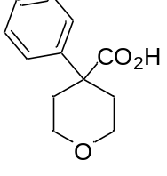
Prepared from phenylacetonitrile (2.00 g, 17.1 mmol) and 1-chloro-2-(2-chloroethoxy)ethane (2.00 mL, 17.1 mmol) according to the general procedures as a white solid (2.31 g, 66% yield for two steps).
¹H NMR (400 MHz, CDCl₃) δ 10.81 (s, 1H), 7.43 (d, J = 7.4 Hz, 2H), 7.37 (t, J = 7.6 Hz, 2H), 7.30 (t, J = 7.1 Hz, 1H), 3.95 (dt, J = 11.9, 3.6 Hz, 2H), 3.65 (t, J = 11.2 Hz, 2H), 2.53 (d, J = 13.2 Hz, 2H), 2.11 - 1.93 (m, 2H); ¹³C NMR (101 MHz, CDCl₃) δ 180.0, 141.8, 128.9, 127.6, 126.0, 65.6, 48.4, 34.1; IR v_{max}/cm⁻¹ (film) : 2952, 1883, 1720, 1438, 1301, 1224, 1205, 1128, 1023, 932, 826, 700.

4-(4-fluorophenyl)tetrahydro-2H-pyran-4-carboxylic acid (49a)
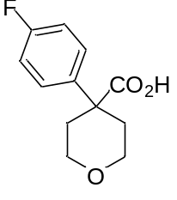
Prepared from 2-(4-fluorophenyl)acetonitrile (2.00 g, 14.8 mmol) and 1-chloro-2-(2-chloroethoxy)ethane (1.73 mL, 14.8 mmol) according to the general procedures as a white solid (2.50 g, 75% yield for two steps).
¹H NMR (400 MHz, DMSO-d₆) δ 7.42 (dd, J = 8.2, 5.8 Hz, 2H), 7.17 (t, J = 8.8 Hz, 2H), 3.80 (d, J = 11.8 Hz, 2H), 3.45 (t, J = 11.2 Hz, 2H), 2.37 (d, J = 13.2 Hz, 2H), 1.88 - 1.72 (m, 2H).; ¹³C NMR (101 MHz, DMSO-d₆) δ 175.3, 161.2 (d, J = 245 Hz), 139.3 (d, J = 2.9 Hz), 127.9 (d, J = 8.2 Hz), 115.2 (d, J = 21.2 Hz), 64.9, 47.5, 34.2; IR v_{max}/cm⁻¹ (film) : 2970, 2881, 1718, 1512, 1301, 1235, 1221, 1131, 1099, 1029, 895, 828, 737.

4-(4-chlorophenyl)tetrahydro-2H-pyran-4-carboxylic acid (50a)
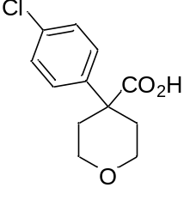
Prepared from 2-(4-chlorophenyl)acetonitrile (2.00 g, 13.2 mmol) and 1-chloro-2-(2-chloroethoxy)ethane (1.55 mL, 13.2 mmol) according to the general procedures as a white solid (2.50 g, 79% yield for two steps).
¹H NMR (400 MHz, DMSO-d₆) δ 12.71 (brs, 1H), 7.41 (s, 4H), 3.80 (dt, J = 11.7, 3.5 Hz, 2H), 3.44 (t, J = 11.2 Hz, 2H), 2.35 (d, J = 13.1 Hz, 2H), 1.85 - 1.75 (m, 2H); ¹³C NMR (101 MHz, DMSO-d₆) δ 175.0, 142.1, 131.8, 128.5, 127.8, 64.8, 47.6, 33.9; IR v_{max}/cm⁻¹ (film) : 2967, 2861, 1730, 1685, 1491, 1249, 1110, 1092, 1011, 819, 669.

4-(4-methoxyphenyl)tetrahydro-2H-pyran-4-carboxylic acid (51a)
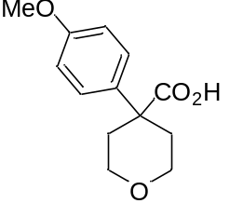
Prepared from 2-(4-methoxyphenyl)acetonitrile (2.00 g, 13.6 mmol) and 1-chloro-2-(2-chloroethoxy)ethane (1.59 mL, 13.6 mmol) according to the general procedures as a white solid (2.03 g, 63% yield for two steps). Data are consistent with those reported in the literature.⁴
¹H NMR (400 MHz, DMSO-d₆) δ 12.45 (brs, 1H), 7.35 - 7.28 (m, 2H), 6.95 - 6.89 (m, 2H), 3.84 - 3.76 (m, 2H), 3.73 (s, 3H), 3.45 (t, J = 10.8 Hz, 2H), 2.36 (d, J = 13.2 Hz, 2H), 1.85 - 1.72 (m, 2H).; ¹³C NMR (101 MHz, DMSO-d₆) δ 175.7, 158.2, 135.1, 126.9, 113.9, 65.0, 55.1, 47.2, 34.3.

4-([1,1'-biphenyl]-4-yl)tetrahydro-2H-pyran-4-carboxylic acid (52a)
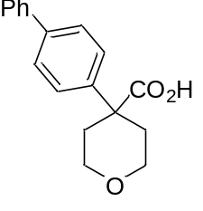
Prepared from 2-([1,1'-biphenyl]-4-yl)acetonitrile (2.00 g, 10.4 mmol) and 1-chloro-2-(2-chloroethoxy)ethane (1.21 mL, 10.4 mmol) according to the general procedures as a white solid (1.14 g, 39% yield for two steps).
¹H NMR (400 MHz, DMSO-d₆) δ 12.71 (s, 1H), 7.68 - 7.63 (m, 4H), 7.51 - 7.43 (m, 4H), 7.36 (t, J = 7.3 Hz, 1H), 3.84 (d, J = 11.7 Hz, 2H), 3.48 (t, J = 10.7 Hz, 2H), 2.41 (d, J = 13.2 Hz, 2H), 1.93 - 1.82 (m, 2H).; ¹³C NMR (101 MHz, DMSO-d₆) δ 175.2, 142.2, 139.7, 138.8, 128.9, 127.5, 126.8, 126.6, 126.3, 64.9, 47.7, 34.0; IR v_{max}/cm⁻¹ (film) : 2968, 1701, 1684, 1654, 1559, 1508, 1457, 1244, 1026, 823, 698.

General procedure B for the synthesis of acids
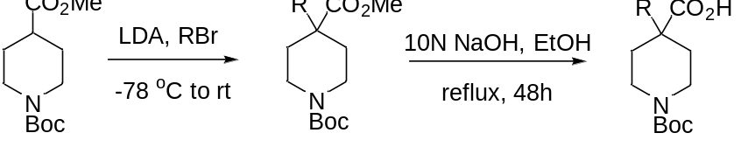
Figure S2. Preparation of acids from commercial compounds in two steps.
General procedure B for the preparation of acids:
To a stirred solution of LDA (2.0 M in solution in hexane, 6.20 mL, 12.3 mmol, 1.5 equiv.) in THF (20 mL) was added dropwise a solution of 1-(tert-butyl) 4-methyl piperidine-1,4-dicarboxylate (2.00 g, 8.23 mmol, 1.0 equiv.) in THF (10 mL) at -78 ºC under N_{2.} The mixture was stirred at this temperature for 1 h before the solution of RBr (1.5 equiv.) in THF (10 mL) was added. Then the reaction was warmed to room temperature and stirred overnight. The mixture was quenched with sat. NH₄Cl (20 mL) and extracted with ethyl acetate (3*50 mL). The combined organic layer was washed with brine, dried over Na₂SO₄, filtered and concentrated. The crude product was purified by silica gel chromatography eluting with hexane/ethyl acetate (15 : 1) to provide the desired esters.
To the ester in EtOH (20 mL) was added 10 N NaOH (20 mL). The mixture was refluxed for 48 hours before it was cooled to room temperature and then neutralized with 1 N HCl until pH to 5~6. The mixture was extracted by ethyl acetate (3*50 mL). The combined organic layer was washed with brine, dried over Na₂SO₄, filtered and concentrated. The crude product was recrystallized by ethyl acetate to give the desired acids.

4-allyl-1-(tert-butoxycarbonyl)piperidine-4-carboxylic acid (12a)
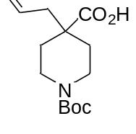
Prepared from 1-(tert-butyl) 4-methyl piperidine-1,4-dicarboxylate (2.00 g, 8.23 mmol) and 3-bromoprop-1-ene (1.06 mL, 12.3 mmol) according to the general procedures as a white solid (1.56 g, 70% yield for two steps). Data are consistent with those reported in the literature.⁵
¹H NMR (400 MHz, CDCl₃) δ 9.16 (brs, 1H), 5.74 - 5.63 (m, 1H), 5.07 (s, 1H), 5.04 - 5.02 (m, 1H), 3.83 (brs, 2H), 2.96 (t, J = 11.2 Hz, 2H), 2.28 (d, J = 7.4 Hz, 2H), 2.06 (d, J = 13.6 Hz, 2H), 1.41 (s, 9H), 1.39 - 1.31 (m, 2H); ¹³C NMR (101 MHz, CDCl₃) δ 181.0, 155.1, 132.5, 118.9, 79.8, 45.9, 44.2, 41.2, 32.8, 28.6; HRMS (ESI) calcd for C₁₄H₂₃NNaO₄ [M + Na] ⁺ m/z = 292.1519, found: 292.1521.

4-benzyl-1-(tert-butoxycarbonyl)piperidine-4-carboxylic acid (13a)
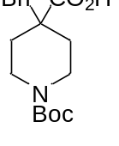
Prepared from 1-(tert-butyl) 4-methyl piperidine-1,4-dicarboxylate (2.00 g, 8.23 mmol) and BnBr (1.47 mL, 12.3 mmol) according to the general procedures as a white solid (1.20 g, 46% yield for two steps). Data are consistent with those reported in the literature.⁶
¹H NMR (400 MHz, CDCl₃) δ 7.27-7.22 (m, 3H), 7.10 - 7.08 (m, 2H), 3.94 (brs, 2H), 2.94-2.80 (m, 2H), 2.86 (s, 2H), 2.05 (d, J = 13.5 Hz, 2H), 1.47-1.43 (m, 2H), 1.43 (s, 9H); ¹³C NMR (101 MHz, CDCl₃) δ 180.7, 155.1, 136.1, 130.0, 128.2, 127.0, 79.9, 47.3, 46.4, 41.4, 33.0, 28.5; HRMS (ESI) calcd for C₁₈H₂₅NNaO₄ [M + Na] ⁺ m/z = 342.1676, found: 342.1679.

1-(tert-butoxycarbonyl)-4-isopropylpiperidine-4-carboxylic acid (14a)
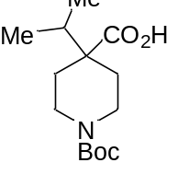
Prepared from 1-(tert-butyl) 4-methyl piperidine-1,4-dicarboxylate (2.00 g, 8.23 mmol) and 2-bromopropane (2.32 mL, 12.3 mmol) according to the general procedures as a white solid (0.50 g, 22% yield for two steps).
¹H NMR (400 MHz, CDCl₃) δ 10.77 (brs, 1H), 4.00 (brs, 2H), 2.78 (s, 2H), 2.04 (d, J = 13.1 Hz, 2H), 1.79 - 1.72 (m, 1H), 1.36 (s, 9H), 1.38- 1.31 (m, 2H), 0.90 (d, J = 6.9 Hz, 6H); ¹³C NMR (101 MHz, CDCl₃) δ 180.9, 155.1, 79.7, 49.4, 41.8, 36.2, 30.6, 28.6, 17.6; HRMS (ESI) calcd for C₁₄H₂₅NNaO₄ [M + Na] ⁺ m/z = 294.1676, found: 294.1678.

- hydroxy-1,2-dimethylcyclopentane-1-carboxylic acid (37a)
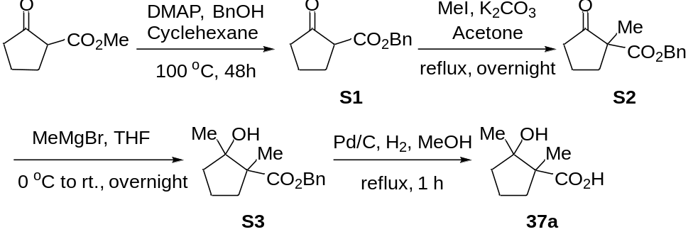
Figure S3. Preparation of 37a from commercial compounds in four steps
A mixture of methyl 2-cyclopentanonecarboxylate (1.42 g, 10.0 mmol), phenylmethanol (1.19 g, 11.0 mmol, 1.1 equiv.) and DMAP (61 mg, 0.50 mmol, 0.05 equiv.) in cyclohexane (20 mL) was heated overnight in a Dean-Stark trap. The reaction mixture was cooled to room temperature, quenched with H₂O (20 mL) and then extracted with ethyl acetate (3*50 mL). The combined organic layers were washed with brine (50 mL), dried over Na₂SO₄, filtered and concentrated. The crude product was purified by silica gel chromatography eluting with hexane/ethyl acetate (10: 1) to provide the desired intermediate S1 as colorless oil (1.16 g, 53% yield).
To the mixture of S1 (1.16 g, 5.30 mmol) and K₂CO₃ (2.93 g, 21.2 mmol, 4.0 equiv.) in acetone (20 mL) was added MeI (1.32 mL, 21.2 mmol, 4.0 equiv.) by dropwise under N₂ and the resulting mixture was stirred and refluxed overnight. The reaction was cooled to room temperature, quenched with H₂O (20 mL) and extracted with ethyl acetate (3*50 mL). The combined organic layers were washed with brine (50 mL), dried over Na₂SO₄, filtered and concentrated. The crude product was purified by silica gel chromatography eluting with hexane/ethyl acetate (5: 1) to provide the desired intermediate S2 as colorless oil (719 mg, 58% yield).
To a solution of S2 (719 mg, 3.10 mmol) in dry THF (25 mL) was added MeMgBr (4.65 mL, 4.65 mmol, 1.0 M in THF, 1.5 equiv.) by dropwise at 0 ºC over 5 min and the reaction was stirred at 0 ºC for 1 hour. Then the mixture was allowed to stir at room temperature overnight. The reaction mixture was quenched with sat. NH₄Cl and extracted with ethyl acetate (3*50 mL). The combined organic layers were washed with brine (50 mL), dried over Na₂SO₄, filtered and concentrated. The crude product was purified by silica gel chromatography eluting with hexane/ethyl acetate (5: 1) to provide S3 as colorless oil (347 mg, 45% yield).
To a stirred solution of S3 (347 mg, 1.40 mmol) in degassed methanol (5 mL) was added 10% palladium on carbon (12 mg). The reaction mixture was then stirred under a hydrogen atmosphere for 1 hour then filtered through celite. The filtrate was concentrated in vacuo and recrystallized by ethyl acetate to give 37a as a white solid (205 mg, 93% yield).
1H NMR (400 MHz, CDCl₃) δ 2.25 - 2.13 (m, 1H), 1.97 - 1.87 (m, 1H), 1.87 - 1.78 (m, 1H), 1.78 - 1.60 (m, 3H), 1.29 (d, J = 2.4 Hz, 6H); ¹³C NMR (101 MHz, CDCl₃) δ 182.5, 80.7, 55.3, 37.3, 32.9, 25.1, 19.7, 18.0; HRMS (ESI) calcd for C₈H₁₄NaO₃ [M + Na] ⁺ m/z = 181.0835, found: 181.0836; IR v_{max}/cm⁻¹ (film) : 3434, 2972, 2882, 1698, 1378, 1298, 1129, 923, 818.

2-hydroxy-2-methyl-1-phenylcyclopentane-1-carboxylic acid (38a)
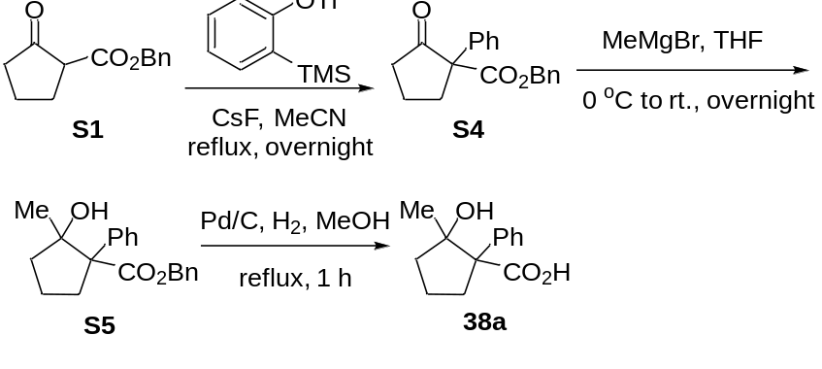
Figure S4. Preparation of 38a from S1 in three steps
The mixture of S1 (2.18 g, 10 mmol), 2-(trimethylsilyl) phenyl trifluoromethanesulfonate (3.58 g, 12 mmol, 1.2 equiv.) and CsF (2.28 g, 15 mmol, 1.5 equiv.) in MeCN (30 mL) under N₂ was refluxed overnight. The solvent was removed in vacuum. The residue was diluted with H₂O (20 mL) and extracted by ethyl acetate (3*50 mL). The combined organic layers were washed with brine, dried over Na₂SO₄, filtered and concentrated. The residue was purified by silica gel chromatography eluting with hexane/ethyl acetate (5: 1) to provide S4 (white solid, 677 mg, 23% yield).
To a solution of S4 (677 mg, 2.30 mmol) in dry THF (25 mL) was added MeMgBr (3.45 mL, 3.45 mmol, 1.0 M in THF, 1.5 equiv.) by dropwise at 0 ºC over 5 min and the reaction was stirred at 0 ºC for 1 hour. Then the mixture was allowed to stir at room temperature overnight. The reaction mixture was quenched with sat. NH₄Cl, and then extracted with ethyl acetate (3*50 mL). The combined organic layers were washed with brine (50 mL), dried over Na₂SO₄, filtered and concentrated. The crude product was purified by silica gel chromatography eluting with hexane/ethyl acetate (5: 1) to provide S5 as colorless oil (341 mg, 48% yield).
To a stirred solution of S5 (341 mmol, 1.10 mmol) in degassed methanol (10 mL) was added 10% palladium on carbon (6 mg). The reaction mixture was then stirred under a hydrogen atmosphere for 1 hour then filtered through celite. The filtrate was reduced in vacuo, then the crude product was recrystallized by ethyl acetate to give 38a as a white solid (220 mg, 95% yield).
1H NMR (400 MHz, DMSO-d₆) δ 9.30 (s, 1H), 7.51 (d, J = 7.4 Hz, 2H), 7.17 (t, J = 7.4 Hz, 2H), 7.07 (t, J = 7.8 Hz, 1H), 2.66 (t, J = 10.6 Hz, 1H), 1.91 - 1.72 (m, 2H), 1.57 (m, J = 10.8 Hz, 2H), 1.46 (m, J = 15.1, 10.7 Hz, 1H), 0.77 (s, 3H); ¹³C NMR (101 MHz, DMSO-d₆) δ 178.9, 144.0, 127.5, 127.0, 125.1, 80.5, 60.7, 31.9, 24.9, 17.9; HRMS (ESI) calcd for C₁₃H₁₆NaO₃ [M + Na] ⁺ m/z = 243.0992, found: 243.0991; IR v_{max}/cm⁻¹ (film) : 3434, 3056, 2967, 2878, 1685, 1599, 1497, 1447, 1375, 1262, 722.

1-hydroxy-1,2-dimethyl-1,2,3,4-tetrahydronaphthalene-2-carboxylic acid (39a)
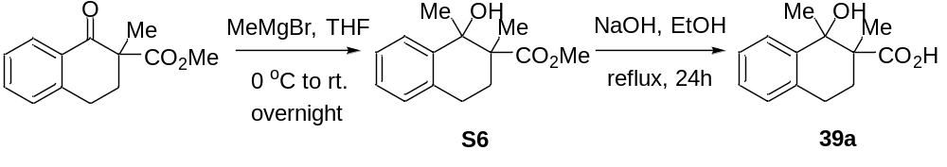
Figure S5. Preparation of 39a from commercial compounds in two steps
To a solution of methyl ester 2-naphthalenecarboxylic acid (2.18 g, 10 mmol) in dry THF (25 mL) was added MeMgBr (15 mL, 15 mmol, 1.0 M in THF, 1.5 equiv.) by dropwise at 0 ºC and the reaction was stirred at 0 ºC for 1 hour. Then the mixture was allowed to stir at room temperature overnight. The reaction mixture was quenched with sat. NH₄Cl and then extracted with ethyl acetate (3*50 mL). The combined organic layers were washed with brine (50 mL), dried over Na₂SO₄, filtered and concentrated. The crude product was purified by silica gel chromatography eluting with hexane/ethyl acetate (5: 1) to provide S6 as colorless oil (1.17 g, 50% yield).
The mixture of S6 (1.17 g, 5.0 mmol) in EtOH (20 mL) and 1 N NaOH (20 mL) was refluxed for 24 hours, cooled to room temperature, and then added 1 N HCl until pH to 5~6. The mixture was extracted by ethyl acetate (3*50 mL). The combined organic layers were washed with brine, dried over Na₂SO₄, filtered and concentrated. The crude product was recrystallized by ethyl acetate to give 39a as a white solid (990 mg, 90% yield).
1H NMR (400 MHz, DMSO-d₆) δ 7.47 (d, J = 7.5 Hz, 1H), 7.14 - 7.00 (m, 2H), 6.97 (d, J = 7.3 Hz, 1H), 2.82 - 2.65 (m, 2H), 1.90 (dddd, J = 14.3, 10.6, 9.5, 5.8 Hz, 2H), 1.24 (s, 3H), 0.94 (s, 3H); ¹³C NMR (101 MHz, DMSO-d₆) δ 181.8, 144.4, 133.6, 127.7, 125.5, 125.4, 125.3, 73.1, 46.4, 31.7, 28.3, 25.0, 19.3; HRMS (ESI) calcd for C₁₃H₁₆NaO₃ [M + Na] ⁺ m/z = 243.0992, found: 243.0996; IR v_{max}/cm⁻¹ (film) : 3400, 3021, 2932, 1702, 1604, 1455, 1212, 1037, 949, 772, 739.

1-hydroxy-2-methyl-1,2,3,4-tetrahydronaphthalene-2-carboxylic acid (40a)
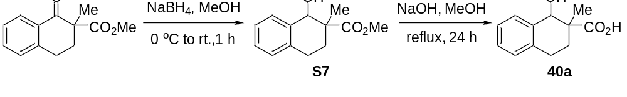Figure S6. Preparation of acid 40a from commercial compounds in two steps
To a solution of methyl ester 2-naphthalenecarboxylic acid (2.18 g, 10 mmol) in MeOH (25 mL) was added NaBH₄ (570 mg, 15 mmol, 1.5 equiv.) at 0 ºC under N₂. The reaction was stirred at 0 ºC under N₂ for 1 hour. The reaction was quenched with Na₂SO₄ and water, and then extracted with ethyl acetate (3*50 mL). The combined organic layers were washed with brine (50 mL), dried over Na₂SO₄, filtered and concentrated. The crude product was purified by silica gel chromatography eluting with hexane/ethyl acetate (5: 1) to provide S7 as colorless oil (1.46 g, 67% yield).
The mixture of S7 (1.46 g, 6.7 mmol) in EtOH (20 mL) and 1 N NaOH (20 mL) was refluxed for 24 hours, cooled to room temperature, and then added 1 N HCl until pH to 5~6. The mixture was extracted by ethyl acetate (3*50 mL). The combined organic layers were washed with brine, dried over Na₂SO₄, filtered and concentrated. The crude product was recrystallized by ethyl acetate to give 40a as a white solid (1.20 g, 90% yield).
¹H NMR (400 MHz, CDCl₃) δ 7.51 - 7.45 (m, 1H), 7.25 - 7.19 (m, 2H), 7.14 - 7.08 (m, 1H), 4.63 (s, 1H), 2.94 (dt, J = 17.8, 6.4 Hz, 1H), 2.86 - 2.76 (m, 1H), 2.35 (dt, J = 13.9, 7.0 Hz, 1H), 1.92 - 1.80 (m, 1H), 1.34 (s, 3H); ¹³C NMR (101 MHz, DMSO-d₆) δ 177.5, 137.7, 135.0, 130.4, 128.4, 127.2, 125.8, 72.3, 45.3, 24.9, 24.0,19.4; HRMS (ESI) calcd for C₁₂H₁₄NaO₃ [M + Na] ⁺ m/z = 229.0835, found: 229.0838; IR v_{max}/cm⁻¹ (film) : 2928, 1716, 1455, 1237, 1127, 1009, 826, 738.

1-hydroxy-2-phenyl-1,2,3,4-tetrahydronaphthalene-2-carboxylic acid (41a)
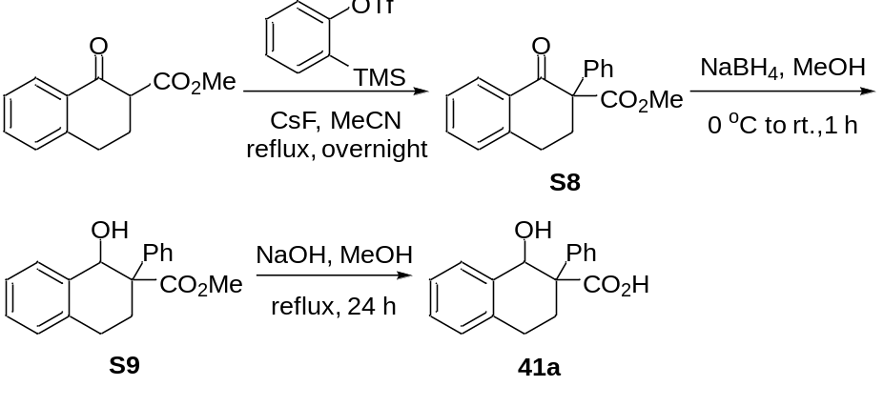
Figure S7. Preparation of 41a from commercial compounds in three steps
The mixture of methyl 1-oxo-1,2,3,4-tetrahydronaphthalene-2-carboxylate (2.04 g, 10 mmol), 2-(trimethylsilyl) phenyl trifluoromethanesulfonate (3.58 g, 12 mmol, 1.2 equiv) and CsF (2.28 g, 15 mmol, 1.5 equiv.) in MeCN (30 mL) under N₂ was refluxed overnight. The solvent was removed in vacuum. The residue was diluted with H₂O (20 mL) and extracted by ethyl acetate (3*50 mL). The combined organic layers were washed with brine, dried over Na₂SO₄, filtered and concentrated. The residue was purified by silica gel chromatography eluting with hexane/ethyl acetate (5: 1) to provide the desired intermediate S8 as a white solid (616 mg, 22% yield).
The mixture of S8 (616 mg, 2.2 mmol) in MeOH (25 mL) was added NaBH₄ (125 mg, 3.3 mmol, 1.5 equiv.) at 0 ºC under N₂ and the reaction was stirred at 0 ºC under N₂ for 1 hour. The reaction was quenched with Na₂SO₄ and water, and then extracted with ethyl acetate (3*50 mL). The combined organic layers were washed with brine (50 mL), dried over Na₂SO₄, filtered and concentrated. The crude product was purified by silica gel chromatography eluting with hexane/ethyl acetate (5: 1) to provide the desired intermediate S9 as colorless oil (508 mg, 82% yield).
The mixture of S9 (508 mg, 1.8 mmol) in EtOH (20 mL) and 1 N NaOH (20 mL) was refluxed for 24 hours, cooled to room temperature, and then added 1 N HCl until pH to 5~6. The mixture was extracted by ethyl acetate (3*50 mL). The combined organic layers were washed with brine, dried over Na₂SO₄, filtered and concentrated. The crude product was recrystallized by ethyl acetate to give 41a as a white solid (402 mg, 83% yield).
¹H NMR (400 MHz, CDCl₃) δ 7.52 (dd, J = 5.4, 3.4 Hz, 2H), 7.40 (ddd, J = 13.5, 6.3, 4.3 Hz, 3H), 7.34 - 7.29 (m, 1H), 7.25 - 7.19 (m, 2H), 7.13 - 7.09 (m, 1H), 5.31 (s, 1H), 2.92 (t, J = 7.2 Hz, 2H), 2.54 (t, J = 6.9 Hz, 2H); ¹³C NMR (176 MHz, CDCl₃) δ 178.3, 139.0, 136.3, 135.1, 129.8, 129.0, 128.8, 128.1, 127.8, 126.9, 126.4, 71.7, 54.1, 26.2, 24.3; HRMS (ESI) calcd for C₁₇H₁₆NaO₃ [M + Na] ⁺ m/z = 291.0992, found: 291.0992; IR v_{max}/cm⁻¹ (film) : 3399, 3060, 2925, 2854, 1705, 1600, 1493, 1264, 1186, 1080, 1002, 775, 738.

1-(tert-butoxycarbonyl)-4-hydroxy-3,4-dimethylpiperidine-3-carboxylic acid (42a)
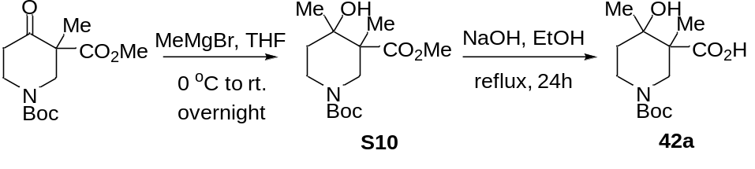
Figure S8. Preparation of 42a from commercial compounds in two steps
To a solution of 1-(tert-butyl) 3-methyl 3-methyl-4-oxopiperidine-1,3-dicarboxylate (1.00 g, 3.69 mmol) in dry THF (25 mL) was added MeMgBr (5.54 mL, 5.54 mmol, 1.0 M in THF, 1.5 equiv.) by dropwise at 0 ºC over 5 min and the reaction was stirred at 0 ºC for 1 hour. Then the mixture was allowed to stir at room temperature overnight. The reaction was quenched with sat. NH₄Cl, and then extracted with ethyl acetate (3*50 mL). The combined organic layers were washed with brine (50 mL), dried over Na₂SO₄, filtered and concentrated. The crude product was purified by silica gel chromatography eluting with hexane/ethyl acetate (5: 1) to provide the desired product S10.
The mixture of compound S10 in EtOH (20 mL) and 1 N NaOH (20 mL) was refluxed for 24 hours, cooled to room temperature, and then added 1 N HCl until pH to 5~6. The mixture was extracted by ethyl acetate (3*50 mL). The combined organic layers were washed with brine, dried over Na₂SO₄, filtered and concentrated. The crude product was recrystallized by ethyl acetate to give the desired product 42a as a white solid (800 mg, 79% yield for two steps).
¹H NMR (400 MHz, CDCl₃) δ 3.95 (m, 2H), 3.13 (d, J = 14.1 Hz, 1H), 2.90 (t, J = 11.8 Hz, 1H), 1.81 (td, J = 12.8, 4.8 Hz, 1H), 1.57 (dt, J = 13.5, 3.4 Hz, 1H), 1.43 (s, 9H), 1.35 (s, 3H), 1.29 (s, 3H); ¹³C NMR (176 MHz, CDCl₃) δ 179.2, 155.1, 80.3, 71.3, 49.6, 34.0, 31.4, 30.1, 28.3, 23.8, 16.8; HRMS (ESI) calcd for C₁₃H₂₃NNaO₅ [M + Na] ⁺ m/z = 296.1468, found: 296.1465; IR v_{max}/cm⁻¹ (film) : 2928, 2315, 1697, 1669, 1433, 1366, 1259, 1156, 972, 746.

4-(3,4-dichlorophenyl)-1-hydroxy-1,2-dimethyl-1,2,3,4-tetrahydronaphthalene-2-carboxylic acid (53a)
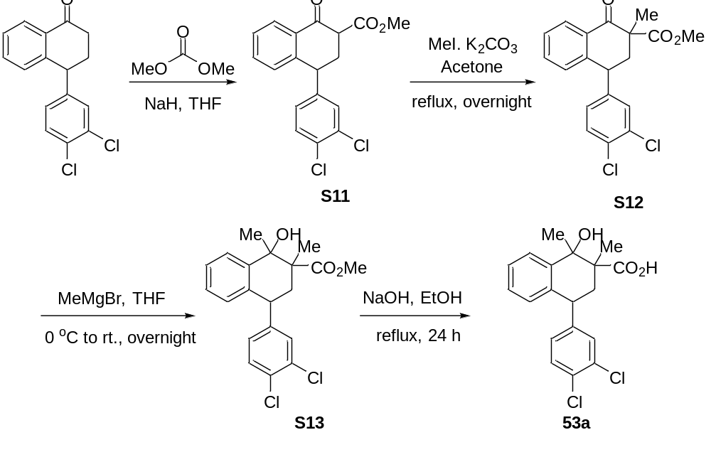
Figure S9. Preparation of 53a from commercial compounds in four steps
To the solution of 4-(3,4-Dichlorophenyl)-1-tetralone (2.91 g, 10 mmol) in dry THF (20 mL) was added NaH (60% dispersion in mineral oil, 1.40 g, 35 mmol, 3.5 equiv.) at 0 ºC over 5 min and the reaction was stirred under N₂ at room temperature for 1 hour. Then dimethyl carbonate (9.0 g, 100 mmol, 10 equiv.) was added into the flask by dropwise, the resulting mixture was stirred under N₂ at 70 ºC for 16 hours. Then reaction mixture was poured into ice-water and extracted with ethyl acetate (3*50 mL). The combined organic layers were washed with brine (50 mL), dried over Na₂SO₄, filtered and concentrated. The crude product was purified by silica gel chromatography eluting with hexane/ethyl acetate (5: 1) to provide the desired intermediate S11 as colorless oil (2.27 g, 65% yield).
To the mixture of S11 (2.27 g, 6.5 mmol) and K₂CO₃ (3.59 g, 26 mmol, 4 equiv.) in acetone (20 mL) was added MeI (1.62 mL, 26 mmol, 4 equiv.) by dropwise under N₂. The resulting mixture was stirred and refluxed overnight under N₂. The reaction was cooled to room temperature, quenched with H₂O (20 mL) and extracted with ethyl acetate (3*50 mL). The combined organic layers were washed with brine (50 mL), dried over Na₂SO₄, filtered and concentrated. The crude product was purified by silica gel chromatography eluting with hexane/ethyl acetate (5: 1) to provide the desired intermediate S12 as a white solid (1.23 g, 52% yield).
To a solution of S12 (1.23 g, 3.4 mmol) in dry THF (25 mL) was added MeMgBr (5.1 mL, 5.1 mmol, 1.0 M in THF, 1.5 equiv.) by dropwise at 0 ºC over 5 min and the reaction was stirred at 0 ºC for 1 hour. Then the mixture was allowed to stir at room temperature overnight. The reaction mixture was quenched with sat. NH₄Cl and then extracted with ethyl acetate (3*50 mL). The combined organic layers were washed with brine (50 mL), dried over Na₂SO₄, filtered and concentrated. The crude product was purified by silica gel chromatography eluting with hexane/ethyl acetate (5: 1) to provide S13 as a white solid (794 mg, 62%).
The mixture of S13 (794 mg, 2.1 mmol) in EtOH (20 mL) and 1 N NaOH (20 mL) was refluxed for 24 hours, cooled to room temperature, and then added 1 N HCl until pH to 5~6. The mixture was extracted by ethyl acetate (3*50 mL). The combined organic layers were washed with brine, dried over Na₂SO₄, filtered and concentrated. The crude product was recrystallized by ethyl acetate to give 53a as a white solid (837 mg, 23% yield).
¹H NMR (400 MHz, CDCl₃)) δ 7.72 (d, J = 8.0 Hz, 1H), 7.38 (d, J = 8.2 Hz, 1H), 7.30 (t, J = 7.6 Hz, 1H), 7.23 (d, J = 2.1 Hz, 1H), 7.17 - 7.11 (m, 1H), 6.96 (dd, J = 8.3, 2.1 Hz, 1H), 6.76 (d, J = 7.8 Hz, 1H), 4.18 - 4.07 (m, 1H), 2.41 (dd, J = 14.6, 6.8 Hz, 1H), 2.19 (dd, J = 14.5, 12.3 Hz, 1H), 1.68 (s, 3H), 1.44 (s, 3H); ¹³C NMR (101 MHz, CDCl₃) δ 181.6, 146. 6, 141.6, 134.8, 132.6, 130.7, 130.6, 129.1, 128.1, 127.5, 127.4, 126.0, 74.3, 53.4, 49.6, 41.9, 38.5, 31.1, 18.7; HRMS (ESI) calcd for C₁₉H₁₈Cl₂NaO₃ [M + Na] ⁺ m/z = 387.0525, found: 387.0527; IR v_{max}/cm⁻¹ (film) : 3399, 2925, 2854, 1704, 1600, 1493, 1447, 1384, 1260, 1186, 1080, 775, 699.

10,13-dimethyl-3-phenylhexadecahydro-1H-cyclopenta[a]phenanthrene-3-carboxylic acid (5 4a)
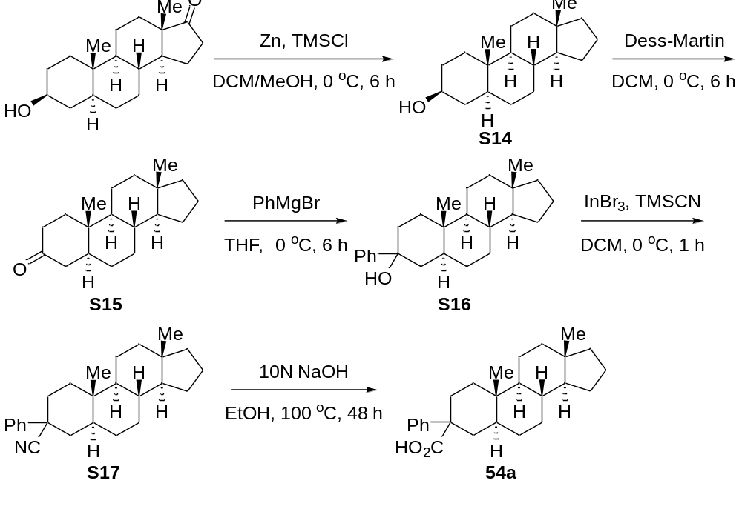
Figure S10. Preparation of 54a from commercial compounds in five steps
To the mixture of 3-hydroxy-10,13-dimethylhexadecahydro-17H-cyclopenta[a]phenanthren-17- one (2.0 g, 6.9 mmol) and Zn powder (14,0 g, 131.1mmol, 19 equiv.) in 100 mL DCM/MeOH (V/V=1:1) was added TMSCl (28 mL, 224.3 mmol, 32.5 equiv.) by dropwise with ice bath. The resulting mixture was stirred at room temperature overnight. The mixture was filtered the solid, and then removed the solvent in vacuum. The residue was extracted with EA (3*50 mL), and then concentrated. The crude product (S14, 1.7 g, 6.1 mmol, 93% yield) was obtained.
To the solution of the S14 (1.7 g, 6.1 mmol,) in DCM was added Dess-Martin periodinane (2.8 g, 6.7 mmol, 1.1 equiv.), the resulting mixture was stirred at room temperature for 6 hours. The mixture was filtered the solid, and then removed the solvent in vacuum. The residue was extracted with EA (3*50 mL), and then concentrated. The crude product (S15, 1.5 g, 5.5 mmol, 90% yield) was obtained.
To a solution of S15 (1.5 g, 5.5 mmol) in dry THF (25 mL) was added PhMgBr (3.2 mL, 8.3 mmol, 2.6 M in THF, 1.5 equiv.) by dropwise at 0 ºC over 5 min and the reaction was stirred at 0 ºC for 1 hour. Then the mixture was allowed to stir at room temperature overnight. The reaction mixture was quenched with sat. NH₄Cl and then extracted with ethyl acetate (3*50 mL). The combined organic layers were washed with brine (50 mL), dried over Na₂SO₄, filtered and concentrated. The crude product was purified by silica gel chromatography eluting with hexane/ethyl acetate (5: 1) to provide S16 as a white solid (1.06 g, 3.0 mmol, 55% yield).
The solution of S16 (1.06 g, 3.0 mmol) in DCM was added dropwise into the mixture of TMSCN (600 mg, 6.0 mmol, 2 equiv) and InBr₃ (105 mg, 0.3 mmol, 0.1 equiv) in DCM under N₂ at 0 ºC. The resulting mixture was stirred for 1 hour. Removed the solvent, after the dryness and concentration, the residue was purified by chromatography with hexane/ethyl acetate (10: 1) to provide S17 as a white solid (723 mg, 2.0 mmol, 67% yield).
The mixture of S17 (723 mg, 2.0 mmol) in EtOH (20 mL) and 10 N NaOH (20 mL) was refluxed for 48 hours, cooled to room temperature, and then added 1 N HCl until pH to 5~6. The mixture was extracted by ethyl acetate (3*50 mL). The combined organic layers were washed with brine, dried over Na₂SO₄, filtered and concentrated. The crude product was purified by chromatography with hexane/ethyl acetate (10: 1) to provide 54a as a white solid (200 mg, 0.53 mmol, 27% yield).
¹H NMR (400 MHz, CDCl₃) δ 7.49 - 7.42 (m, 2H), 7.38 - 7.32 (m, 2H), 7.27 - 7.23 (m, 1H), 2.51 (dd, J = 14.6, 3.2 Hz, 1H), 2.18 (dt, J = 14.3, 2.8 Hz, 1H), 2.00 (td, J = 14.5, 3.7 Hz, 1H), 1.87 (dd, J = 14.3, 12.8 Hz, 1H), 1.66 - 1.54 (m, 5H), 1.52 - 1.33 (m, 3H), 1.30 - 1.15 (m, 5H), 1.14-0.96 (m, 4H), 0.84 (s, 3H), 0.82 - 0.71 (m, 2H), 0.65 (s, 3H), 0.49 (ddd, J = 14.9, 10.9, 4.1 Hz, 1H); ¹³C NMR (101 MHz, CDCl₃) δ 181.5, 139.4, 128.6, 127.6, 126.8, 54.4, 54.3, 49.6, 41.3, 40.8, 40.4, 38.8, 36.0, 35.7, 34.8, 34.4, 32.1, 28.6, 27.7, 25.4, 20.9, 20.4, 17.5, 12.4; HRMS (ESI) calcd for C₂₆H₃₆NaO₂ [M + Na] ⁺ m/z = 403.2608, found: 403.2624; IR v_{max}/cm⁻¹ (film) : 3445, 2934, 2856, 2026, 1699, 1631, 1615, 1355, 1276, 722, 697, 667.

10,13-dimethyl-17-(6-methylheptan-2-yl)-3-phenylhexadecahydro-1H-cyclopenta[a]phenanthrene-3-carboxylic acid (55a)
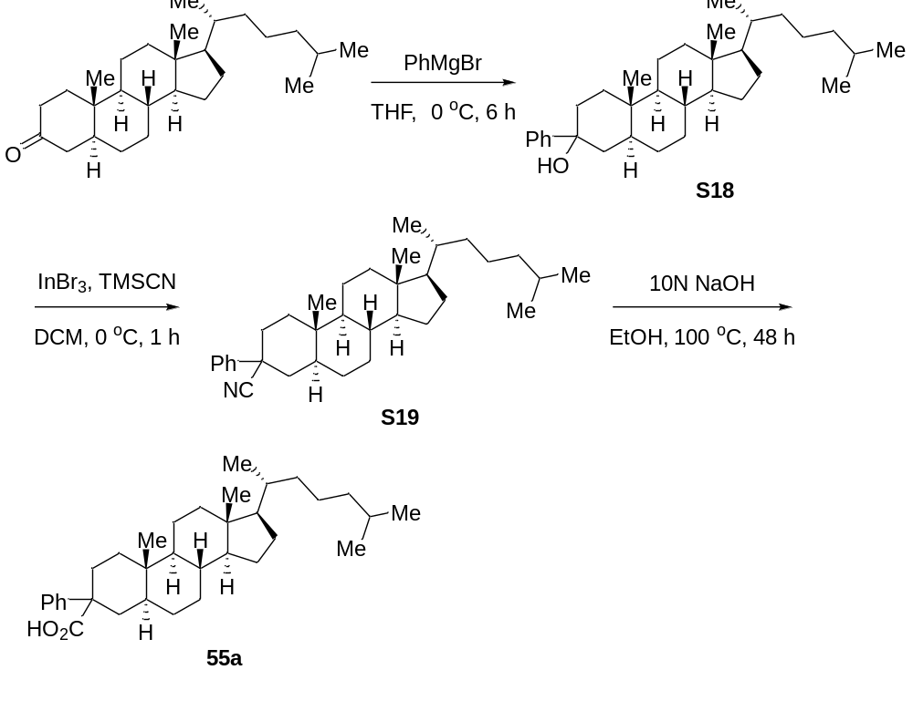Figure S11. Preparation of 55a from commercial compounds in three steps
To a solution of 5α-cholestan-3-one (3.9 g, 10.0 mmol) in dry THF (50 mL) was added PhMgBr (5.8 mL, 15 mmol, 2.6 M in THF, 1.5 equiv.) by dropwise at 0 ºC over 5 min and the reaction was stirred at 0 ºC for 1 hour. Then the mixture was allowed to stir at room temperature overnight. The reaction mixture was quenched with sat. NH₄Cl and then extracted with ethyl acetate (3*100 mL). The combined organic layers were washed with brine (50 mL), dried over Na₂SO₄, filtered and concentrated. The crude product was purified by silica gel chromatography eluting with hexane/ethyl acetate (5: 1) to provide S18 as a white solid (2.46 g, 5.3 mmol, 53% yield).
The solution of S18 (2.40 g, 5.2 mmol) in DCM was added by dropwise into the flask with the mixture of TMSCN (1.0 g, 10.4 mmol, 2 equiv) and InBr₃ (185 mg, 0.52 mmol, 0.1 equiv) in DCM under N₂ at 0 ºC. The resulting mixture was stirred for 1 hour. Removed the solvent, after the dryness and concentration, the residue was purified by chromatography with hexane/ethyl acetate (10: 1) to provide S18 as a white solid (1.48 g, 3.1 mmol, 60% yield).
The mixture of S18 (1.4 g, 3.0 mmol) in EtOH (20 mL) and 10 N NaOH (20 mL) was refluxed for 48 hours, cooled to room temperature, and then added 1 N HCl until pH to 5~6. The mixture was extracted by ethyl acetate (3*50 mL). The combined organic layers were washed with brine, dried over Na₂SO₄, filtered and concentrated. The crude product was purified by chromatography with hexane/ethyl acetate (5: 1) to provide 55a as a white solid (369 mg, 0.75 mmol, 25% yield).
¹H NMR (400 MHz, CDCl₃) δ 7.45 (d, J = 7.8 Hz, 2H), 7.33 (t, J = 7.6 Hz, 2H), 7.28 - 7.23 (m, 1H), 2.49 (d, J = 14.5 Hz, 1H), 2.18 - 2.13 (m, 1H), 1.98 (d, J = 3.3 Hz, 1H), 1.86 (t, J = 13.6 Hz, 2H), 1.73 (dt, J = 15.4, 7.8 Hz, 2H), 1.61 - 1.41 (m, 5H), 1.35 - 1.19 (m, 9H), 1.07 (d, J = 6.8 Hz, 4H), 1.00 - 0.92 (m, 4H), 0.83-0.86 (m, 12H), 0.78 - 0.71 (m, 1H), 0.58 (s, 3H), 0.47 - 0.40 (m, 1H); ¹³C NMR (176 MHz, CDCl₃) δ 180.8, 139.5, 128.6, 127.6, 126.8, 56.4, 56.3, 54.0, 49.6, 42.5, 41.3, 39.9, 39.5, 36.2, 35.9, 35.8, 35.3, 34.9, 34.3, 31.8, 28.5, 28.2, 28.0, 27.7, 24.1, 23.9, 22.8, 22.6, 20.9 18.6, 12.4, 12.0; HRMS (ESI) calcd for C₃₄H₅₂NaO₂ [M + Na] ⁺ m/z = 515.3860, found: 515.3977; IR v_{max}/cm⁻¹ (film) : 3465, 2929, 2026, 1637, 1599, 1356, 1260, 1077, 773, 696, 667, 606.

Reaction Optimization and Control Experiment
General procedure: To a 25 mL round bottomed flask equipped with a magnetic stirrer bar were added acid (0.5 mmol, 1.0 equiv.), photocatalyst (0.015 mmol, 0.03 equiv.), copper (0.1 mmol, 0.2 equiv.), ligand (0.125 mmol, 0.25 equiv.), base (0.75 mmol, 1.5 equiv.) and DCM (10 mL). The flask was quickly degassed three times and flushed with oxygen through balloon, and then the mixture was irradiated with three 45 W blue LEDs (5 cm away) at 15 ºC for 40 hours. The reaction mixture was filtered and concentrated. The residue was purified by column chromatography on silica with petroleum ether/ethyl acetate as eluent.

(a) Optimization tables of reaction conditions
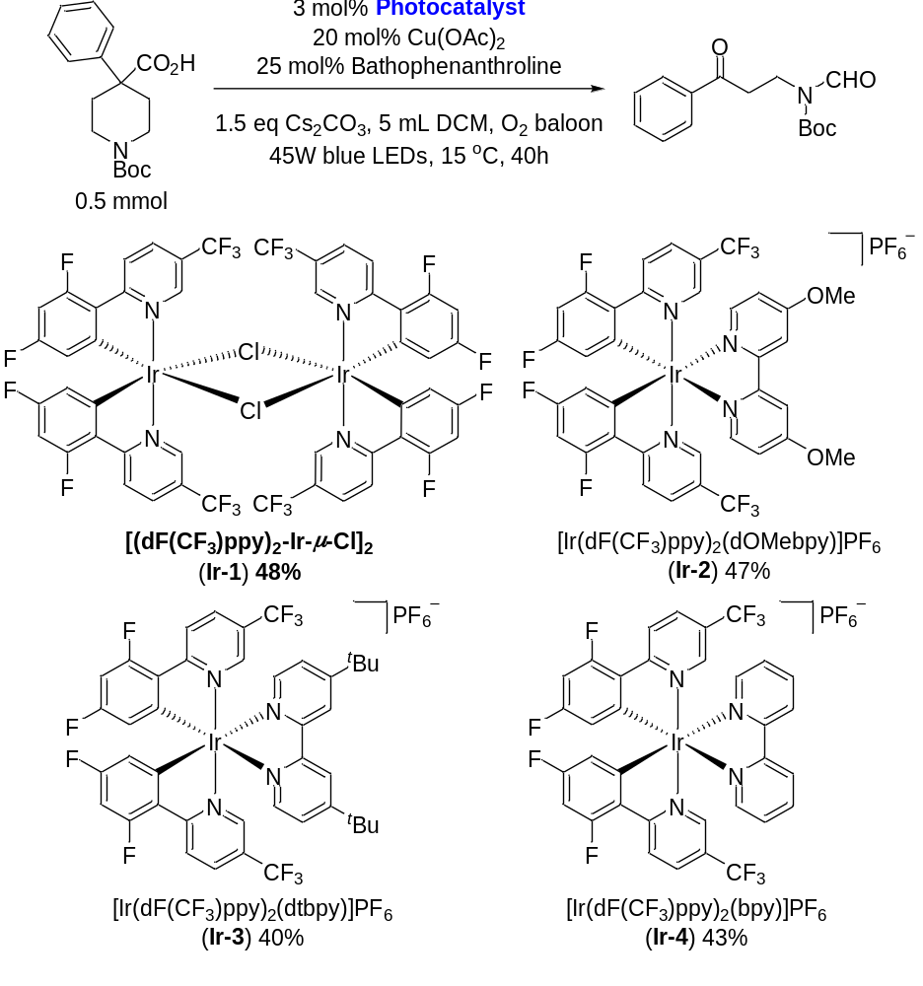
Figure S3. Evaluation of different photocatalysts.
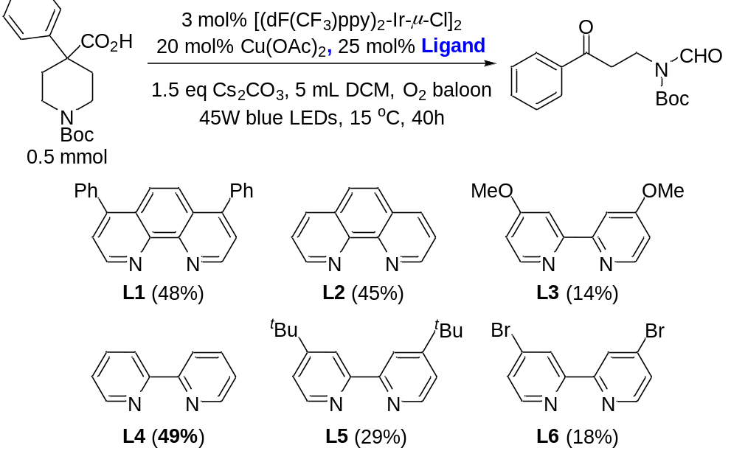
Figure S4. Evaluation of different ligands.
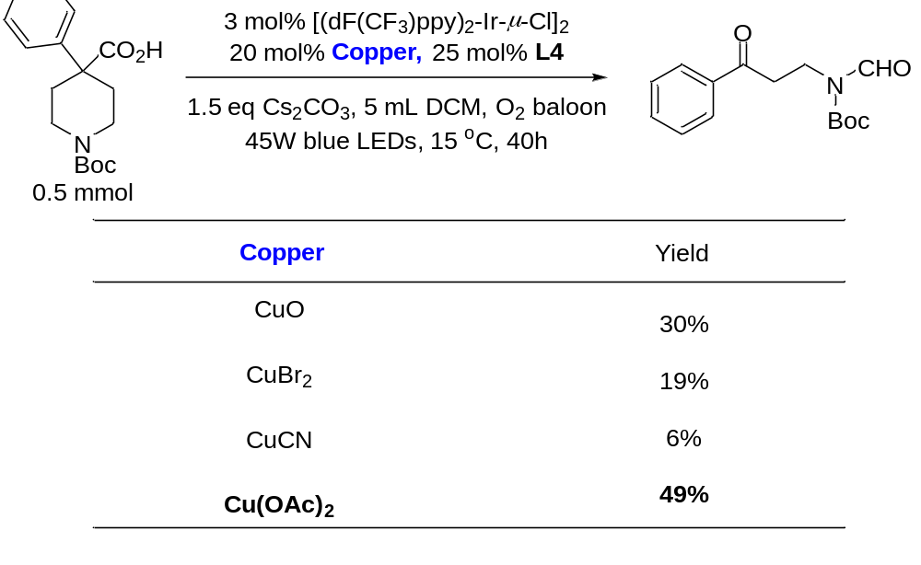
Figure S5. Evaluation of different coppers.
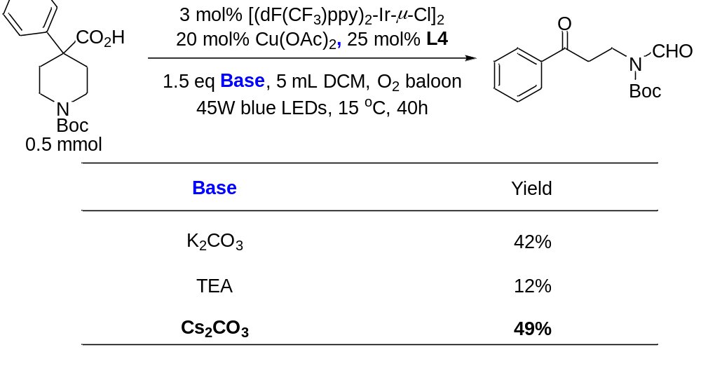
Figure S6. Evaluation of different bases.

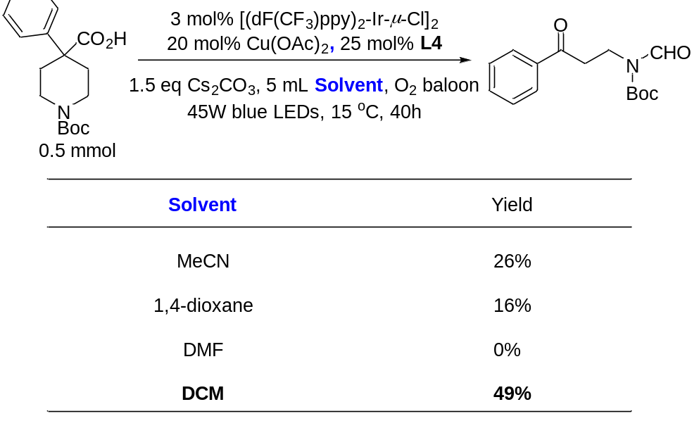
Figure S7. Evaluation of different solvents.
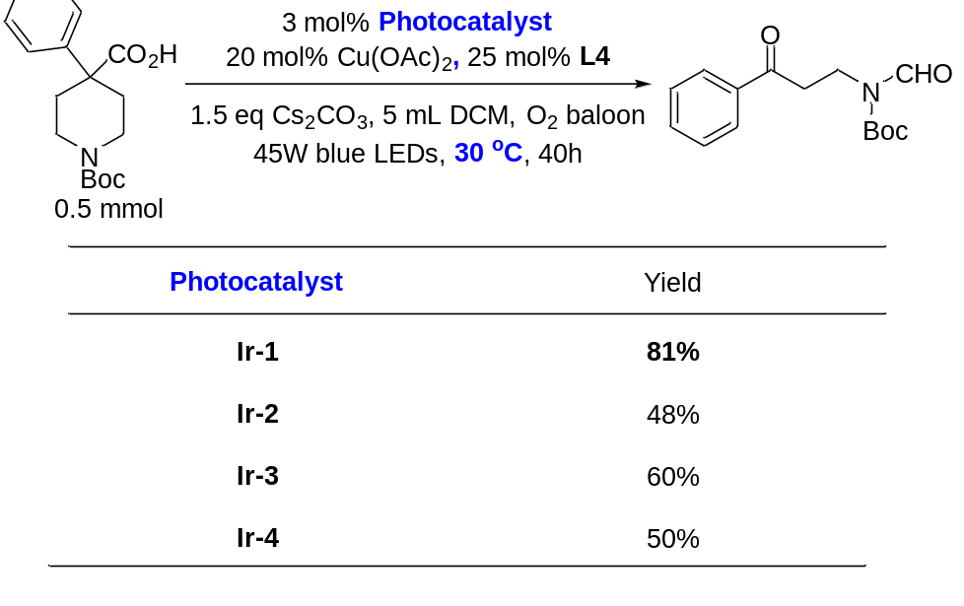
Figure S8. Evaluation of different photocatalysts at 30 ºC.

(b) Control Experiments
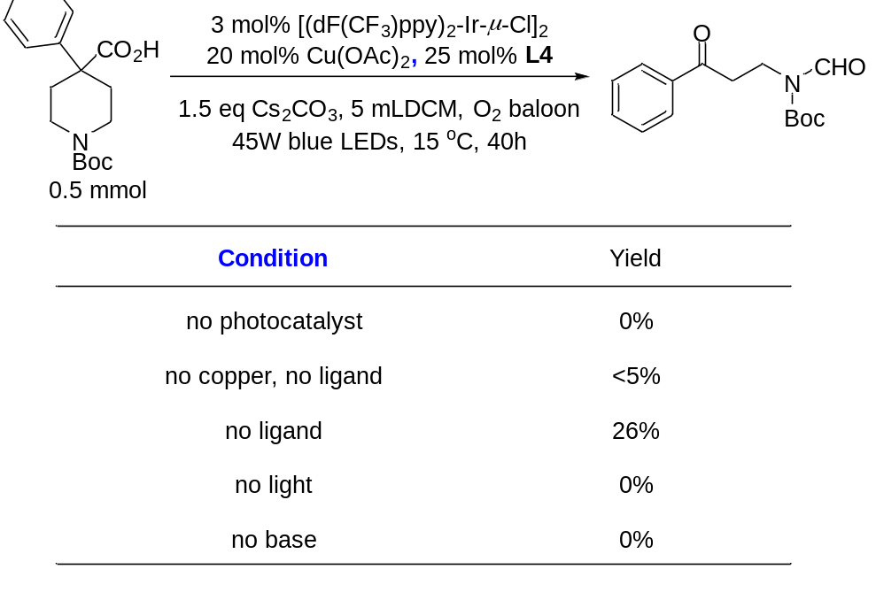
Figure S9. Control reactions. Yields determined by ¹H NMR analysis.

Mechanistic Studies
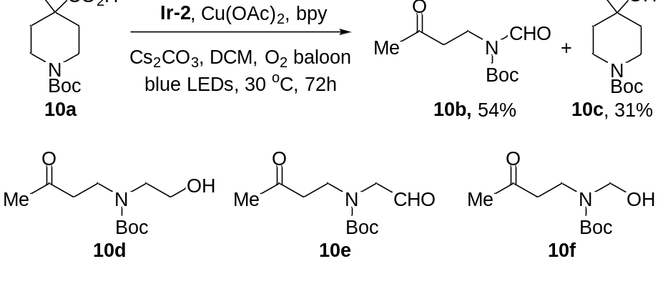
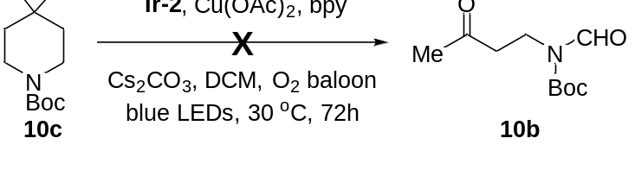
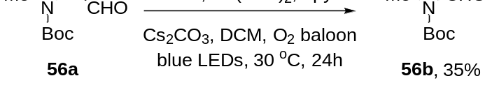
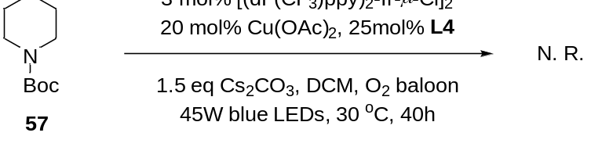
Figure S10 The reactions for mechanistic studies.
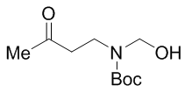
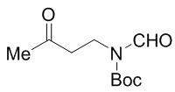
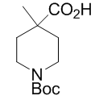
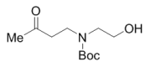
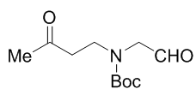
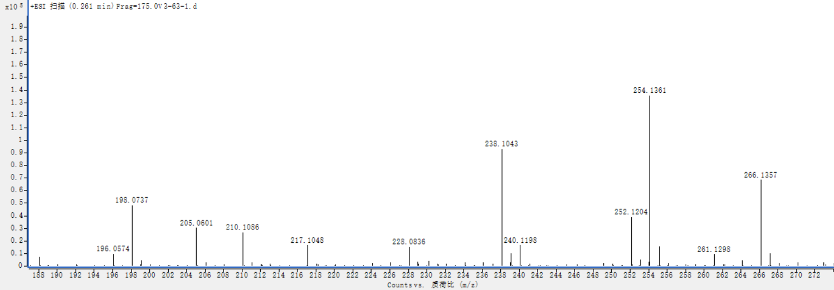

This experiment was executed as follows: to a 25 mL round-bottom flask equipped with a stir bar was added 1-(tert-butoxycarbonyl)-4-methylpiperidine-4-carboxylic acid (49 mg, 0.20 mmol), [Ir(dF(CF₃)ppy)₂(dOMebpy)]PF₆ (16.7 mg, 0.015 mmol, 0.03 equiv.), Cu(OAc)₂ (18.1 mg, 0.1 mmol, 0.2 equiv.), 2,2’-bipyridine (19.5 mg, 0.125 mmol, 0.25 equiv.), Cs₂CO₃ (245 mg, 0.75 mmol, 1.5 equiv.) and DCM (10 mL). The flask was quickly degassed three times and flushed with oxygen through balloon, and then the mixture was heated to 30 ºC in an oil bath and irradiated with three 45 W blue LEDs (5 cm away) for 24 hours. The reaction was monitor by LC-MS. Substrates can be detected in mass spectrometry. After 72 hours, the reaction mixture was filtered, concentrated and purified by column chromatography on silica. Compounds 10b and 10c were obtained. The photocatalytic reaction of 10c as the starting material under standard conditions resulted in nothing. But the reaction went well when compound 56a was used as the starting material. So, we proposed the following mechanism:
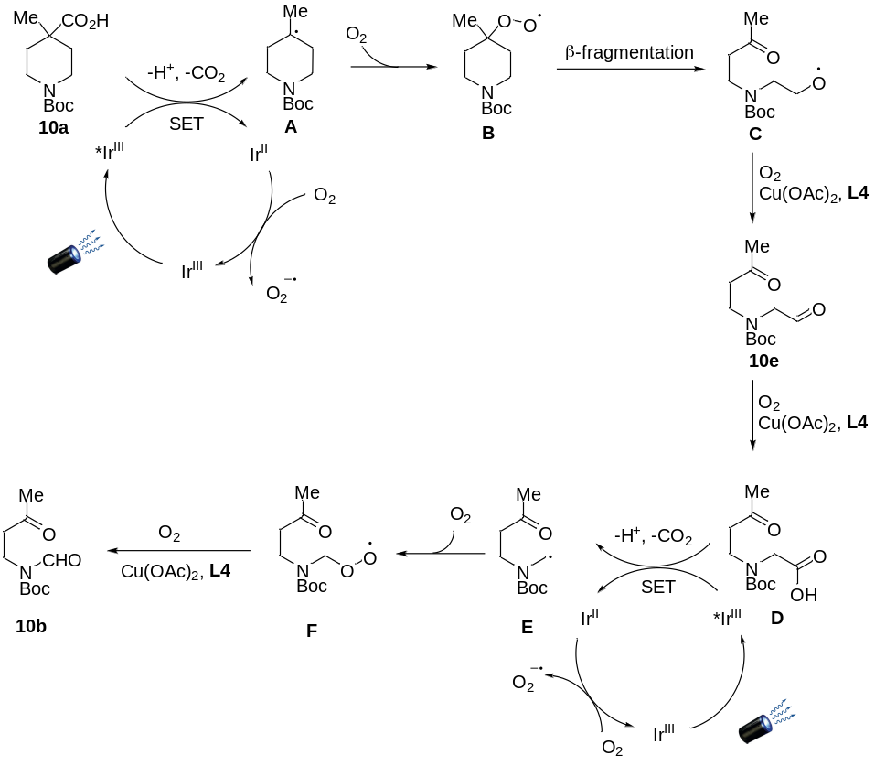
Figure S11 Proposed mechanism for photocatalystic reaction

General Procedures and Experimental Data
(a) General procedure A for the reaction: To a 50 mL round bottomed flask equipped with a magnetic stirrer bar were added acid (0.5 mmol, 1.0 equiv.), photocatalyst (Ir-1 or Ir-2) (0.015 mmol, 0.03 equiv.), Cu(OAc)₂ (18.1 mg, 0.1 mmol, 0.2 equiv.), 2,2’-bipyridine (19.5 mg, 0.125 mmol, 0.25 equiv.), Cs₂CO₃ (245 mg, 0.75 mmol, 1.5 equiv.) and DCM (10 mL). The flask was quickly degassed three times and flushed with oxygen through balloon, and then the mixture was heated to 30 ºC in an oil bath and irradiated with three 45 W blue LEDs (5 cm away) for 40 hours or 72 hours. The reaction mixture was filtered and concentrated. The residue was purified by column chromatography on silica with petroleum ether/ethyl acetate mixture as the eluent.
(b) General procedure B for the reaction: To a 50 mL round bottomed flask equipped with a magnetic stirrer bar were added acid (0.5 mmol, 1.0 equiv.), [(dF(CF₃)ppy)₂-Ir-μ-Cl]₂ (Ir-1) (22.3 mg, 0.015 mmol, 0.03 equiv.), Cu(OAc)₂ (18.1 mg, 0.1 mmol, 0.2 equiv.), 2,2’-bipyridine (19.5 mg, 0.125 mmol, 0.25 equiv.), Cs₂CO₃ (245 mg, 0.75 mmol, 1.5 equiv.), Selectfluor (265 mg, 0.75 mmol, 1.5 equiv.) and DCM (10 mL). The flask was quickly degassed three times and flushed with oxygen through balloon, and then the mixture was heated to 30 ºC in an oil bath and irradiated with three 45 W blue LEDs (5 cm away) for 40 hours. The reaction mixture was filtered and concentrated. The residue was purified by column chromatography on silica with petroleum ether/ethyl acetate mixture as the eluent.

tert-butyl formyl(3-oxo-3-phenylpropyl)carbamate (1b)
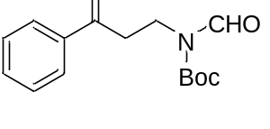
Prepared following the general procedure A employing 1a (153 mg, 0.5 mmol, 1.0 equiv.), [(dF(CF₃)ppy)₂-Ir-μ-Cl]₂ (22.3 mg, 0.015 mmol, 0.03 equiv.), Cu(OAc)₂ (18.1 mg, 0.1 mmol, 0.2 equiv.), 2,2’-bipyridine (19.5 mg, 0.125 mmol, 0.25 equiv.), Cs₂CO₃ (245 mg, 0.75 mmol, 1.5 equiv.) and DCM (10 mL) for 40 hours. The desired product was obtained as white solid (112 mg, 81% yield) after purification by flash column chromatography on silica gel (petroleum ether/ethyl acetate = 10/1). Data are consistent with those reported in the literature.⁷
¹H NMR (400 MHz, CDCl₃) δ 9.16 (s, 1H), 7.91 (d, J = 7.4 Hz, 2H), 7.54 (t, J = 7.4 Hz, 1H), 7.43 (t, J = 7.7 Hz, 2H), 4.01 (t, J = 7.6 Hz, 2H), 3.19 (t, J = 7.6 Hz, 2H), 1.50 (s, 9H); ¹³C NMR (101 MHz, CDCl₃) δ 197.7, 163.0, 152.2, 136.6, 133.4, 128.7, 128.1, 84.4, 37.0, 36.7, 28.1; HRMS (ESI) calcd for C₁₅H₁₉NNaO₄ [M + Na] ⁺ m/z = 300.1206, found: 300.1207.

N-formyl-N-(3-oxo-3-phenylpropyl)benzamide (2b)
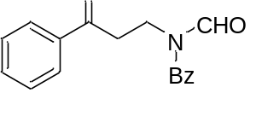
Prepared following the general procedure A employing 2a (155 mg, 0.5 mmol, 1.0 equiv.), [(dF(CF₃)ppy)₂-Ir-μ-Cl]₂ (22.3 mg, 0.015 mmol, 0.03 equiv.), Cu(OAc)₂ (18.1 mg, 0.1 mmol, 0.2 equiv.), 2,2’-bipyridine (19.5 mg, 0.125 mmol, 0.25 equiv.), Cs₂CO₃ (245 mg, 0.75 mmol, 1.5 equiv.) and DCM (10 mL) for 40 hours. The desired product was obtained as white solid (80 mg, 57% yield) after purification by flash column chromatography on silica gel (petroleum ether/ethyl acetate = 10/1).
¹H NMR (400 MHz, CDCl₃) δ 8.94 (s, 1H), 7.96 (d, J = 7.9 Hz, 2H), 7.61 - 7.53 (m, 4H), 7.53 - 7.43 (m, 4H), 4.30 (t, J = 7.1 Hz, 2H), 3.39 (t, J = 7.1 Hz, 2H); ¹³C NMR (101 MHz, CDCl₃) δ 197.9, 172.5, 164.2, 136.7, 133.5, 132.5, 129.1, 128.8, 128.2, 36.9, 36.5; HRMS (ESI) calcd for C₁₇H₁₅NNaO₃ [M + Na] ⁺ m/z = 304.0944, found: 304.0942.

tert-butyl (3-(4-fluorophenyl)-3-oxopropyl)(formyl)carbamate (3b)
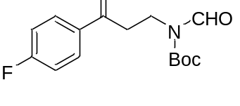
Prepared following the general procedure A employing 3a (162 mg, 0.5 mmol, 1.0 equiv.), [(dF(CF₃)ppy)₂-Ir-μ-Cl]₂ (22.3 mg, 0.015 mmol, 0.03 equiv.), Cu(OAc)₂ (18.1 mg, 0.1 mmol, 0.2 equiv.), 2,2’-bipyridine (19.5 mg, 0.125 mmol, 0.25 equiv.), Cs₂CO₃ (245 mg, 0.75 mmol, 1.5 equiv.) and DCM (10 mL) for 40 hours. The desired product was obtained as white solid (128 mg, 87% yield) after purification by flash column chromatography on silica gel (petroleum ether/ethyl acetate = 10/1).
¹H NMR (400 MHz, CDCl₃) δ 9.14 (s, 1H), 8.02 - 7.85 (m, 2H), 7.17 - 7.03 (m, 2H), 3.99 (t, J = 7.6 Hz, 2H), 3.16 t, J = 7.6 Hz, 2H), 1.50 (s, 9H); ¹³C NMR (101 MHz, CDCl₃) δ 196.2, 165.8 (d, J = 256 Hz)., 163.0, 152.2, 133.0, 130.8 (d, J = 9.4 Hz), 115.8 (d, J = 22.0 Hz), 84.5, 36.9, 36.7, 28.1; HRMS (ESI) calcd for C₁₅H₁₈FNNaO₄ [M + Na] ⁺ m/z = 318.1112, found: 318.1109; IR v_{max}/cm⁻¹ (film) : 2979, 1740, 1686, 1598, 1344, 1150, 1014, 849, 811, 778.

tert-butyl (3-(4-chlorophenyl)-3-oxopropyl)(formyl)carbamate (4b)
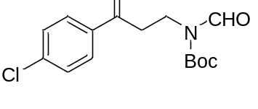
Prepared following the general procedure A employing 4a (170 mg, 0.5 mmol, 1.0 equiv.), [(dF(CF₃)ppy)₂-Ir-μ-Cl]₂ (22.3 mg, 0.015 mmol, 0.03 equiv.), Cu(OAc)₂ (18.1 mg, 0.1 mmol, 0.2 equiv.), 2,2’-bipyridine (19.5 mg, 0.125 mmol, 0.25 equiv.), Cs₂CO₃ (245 mg, 0.75 mmol, 1.5 equiv.) and DCM (10 mL) for 40 hours. The desired product was obtained as white solid (120 mg, 77% yield) after purification by flash column chromatography on silica gel (petroleum ether/ethyl acetate = 10/1).
¹H NMR (400 MHz, CDCl₃) δ 9.14 (s, 1H), 7.85 (d, J = 8.6 Hz, 2H), 7.40 (d, J = 8.6 Hz, 2H), 3.99 (t, J = 7.6 Hz, 2H), 3.16 (t, J = 7.6 Hz, 2H),, 1.51 (s, 9H); ¹³C NMR (101 MHz, CDCl₃) δ 196.5, 163.0, 152.1, 139.8, 134.9, 129.5, 129.1, 84.5, 37.0, 36.6, 28.1; HRMS (ESI) calcd for C₁₅H₁₈ClNNaO₄ [M + Na] ⁺ m/z = 334.0817, found: 334.0815; IR v_{max}/cm⁻¹ (film) : 2979, 1740, 1686, 1598, 1507, 1344, 1150, 1014, 987, 849, 811, 778.

tert-butyl formyl(3-oxo-3-(4-(trifluoromethyl)phenyl)propyl)carbamate (5b)

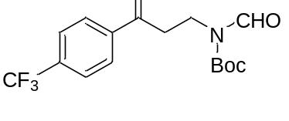
Prepared following the general procedure A employing 5a (187 mg, 0.5 mmol, 1.0 equiv.), [(dF(CF₃)ppy)₂-Ir-μ-Cl]₂ (22.3 mg, 0.015 mmol, 0.03 equiv.), Cu(OAc)₂ (18.1 mg, 0.1 mmol, 0.2 equiv.), 2,2’-bipyridine (19.5 mg, 0.125 mmol, 0.25 equiv.), Cs₂CO₃ (245 mg, 0.75 mmol, 1.5 equiv.) and DCM (10 mL) for 40 hours. The desired product was obtained as white solid (90 mg, 52% yield) after purification by flash column chromatography on silica gel (petroleum ether/ethyl acetate = 10/1).
¹H NMR (400 MHz, CDCl₃) δ 9.16 (s, 1H), 8.03 (d, J = 8.1 Hz, 2H), 7.72 (d, J = 8.2 Hz, 2H), 4.03 (t, J = 7.6 Hz, 2H), 3.23 (t, J = 7.6 Hz, 2H), 1.53 (s, 9H); ¹³C NMR (101 MHz, CDCl₃) δ 196.9, 163.1, 152.1, 139.2, 134.6 (d, J = 32.7 Hz), 128.5, 125.9 (q, J = 3.7 Hz), 123.7 (d, J = 274 Hz), 84.7, 37.4, 36.5, 28.1; HRMS (ESI) calcd for C₁₆H₁₈F₃NNaO₄ [M + Na] ⁺ m/z = 368.1080, found: 368.1086; IR v_{max}/cm⁻¹ (film) : 2981, 2936, 1741, 1691, 1326, 1150, 1067, 1016, 853, 805, 778.

tert-butyl formyl(3-(4-methoxyphenyl)-3-oxopropyl)carbamate (6b)
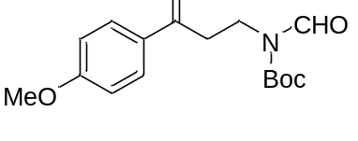
Prepared following the general procedure A employing 6a (168 mg, 0.5 mmol, 1.0 equiv.), [(dF(CF₃)ppy)₂-Ir-μ-Cl]₂ (22.3 mg, 0.015 mmol, 0.03 equiv.), Cu(OAc)₂ (18.1 mg, 0.1 mmol, 0.2 equiv.), 2,2’-bipyridine (19.5 mg, 0.125 mmol, 0.25 equiv.), Cs₂CO₃ (245 mg, 0.75 mmol, 1.5 equiv.) and DCM (10 mL) for 40 hours. The desired product was obtained as white solid (101 mg, 66% yield) after purification by flash column chromatography on silica gel (petroleum ether/ethyl acetate = 10/1).
¹H NMR (400 MHz, CDCl₃) δ 9.15 (s, 1H), 7.89 (d, J = 9.0 Hz, 2H), 6.90 (d, J = 8.9 Hz, 2H), 3.99 (t, J = 7.6 Hz, 2H), 3.83 (s, 3H), 3.14 (t, J = 7.6 Hz, 2H), 1.50 (s, 9H); ¹³C NMR (101 MHz, CDCl₃) δ 196.3, 163.7, 163.0, 152.3, 130.4, 129.8, 113.9, 84.4, 55.5, 36.9, 36.7, 28.1; HRMS (ESI) calcd for C₁₆H₂₁NNaO₅ [M + Na] ⁺ m/z = 330.1312, found: 330.1316; IR v_{max}/cm⁻¹ (film) : 2966, 2871, 1739, 1683, 1606, 1343, 1270, 1150, 1014, 987, 849, 794, 777.

tert-butyl (3-(4-(tert-butyl)phenyl)-3-oxopropyl)(formyl)carbamate (7b)
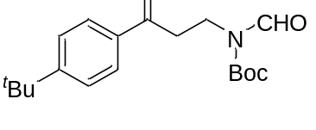
Prepared following the general procedure A employing 7a (181 mg, 0.5 mmol, 1.0 equiv.), [(dF(CF₃)ppy)₂-Ir-μ-Cl]₂ (22.3 mg, 0.015 mmol, 0.03 equiv.), Cu(OAc)₂ (18.1 mg, 0.1 mmol, 0.2 equiv.), 2,2’-bipyridine (19.5 mg, 0.125 mmol, 0.25 equiv.), Cs₂CO₃ (245 mg, 0.75 mmol, 1.5 equiv.) and DCM (10 mL) for 40 hours. The desired product was obtained as white solid (133 mg, 80% yield) after purification by flash column chromatography on silica gel (petroleum ether/ethyl acetate = 10/1).
¹H NMR (400 MHz, CDCl₃) δ 9.16 (s, 1H), 7.86 (d, J = 8.4 Hz, 2H), 7.45 (d, J = 8.4 Hz, 2H), 4.01 (t, J = 7.6 Hz, 2H), 3.18 (t, J = 7.6 Hz, 2H), 1.50 (s, 9H), 1.31 (s, 9H); ¹³C NMR (101 MHz, CDCl₃) δ 197.4, 163.0, 157.1, 152.3, 134.1, 128.1, 125.7, 84.3, 36.9, 36.8, 35.2, 31.1, 28.1; HRMS (ESI) calcd for C₁₉H₂₇NNaO₄ [M + Na] ⁺ m/z = 356.1832, found: 356.1836; IR v_{max}/cm⁻¹ (film) : 2978, 2842, 1739, 1685, 1601, 1344, 1259, 1171, 1149, 1029, 985, 845, 807, 777.

tert-butyl (3-([1,1'-biphenyl]-4-yl)-3-oxopropyl)(formyl)carbamate (8b)
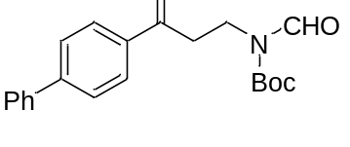
Prepared following the general procedure A employing 8a (191 mg, 0.5 mmol, 1.0 equiv.), [(dF(CF₃)ppy)₂-Ir-μ-Cl]₂ (22.3 mg, 0.015 mmol, 0.03 equiv.), Cu(OAc)₂ (18.1 mg, 0.1 mmol, 0.2 equiv.), 2,2’-bipyridine (19.5 mg, 0.125 mmol, 0.25 equiv.), Cs₂CO₃ (245 mg, 0.75 mmol, 1.5 equiv.) and DCM (10 mL) for 40 hours. The desired product was obtained as white solid (141 mg, 80% yield) after purification by flash column chromatography on silica gel (petroleum ether/ethyl acetate = 10/1).
¹H NMR (400 MHz, CDCl₃) δ 9.20 (s, 1H), 8.01 (d, J = 8.3 Hz, 2H), 7.67 (d, J = 8.3 Hz, 2H), 7.61 (d, J = 7.2 Hz, 2H), 7.46 (t, J = 7.4 Hz, 2H), 7.40 (t, J = 7.2 Hz, 1H), 4.06 (t, J = 7.6 Hz, 2H), 3.25 (t, J = 7.6 Hz, 2H), 1.54 (s, 9H); ¹³C NMR (101 MHz, CDCl₃) δ 197.4, 163.1, 152.3, 146.1, 139.9, 135.3, 129.0, 128.7, 128.4, 127.4, 127.3, 84.5, 37.1, 36.8, 28.1; HRMS (ESI) calcd for C₂₁H₂₃NNaO₄ [M + Na] ⁺ m/z = 376.1519, found: 376.1516; IR v_{max}/cm⁻¹ (film) : 2978, 1739, 1684, 1604, 1344, 1149, 1014, 851, 762, 698.

tert-butyl formyl(3-oxo-3-(thiophen-3-yl)propyl)carbamate (9b)
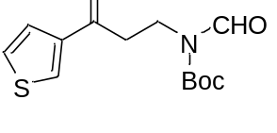
Prepared following the general procedure A employing 9a (156 mg, 0.5 mmol, 1.0 equiv.), [(dF(CF₃)ppy)₂-Ir-μ-Cl]₂ (22.3 mg, 0.015 mmol, 0.03 equiv.), Cu(OAc)₂ (18.1 mg, 0.1 mmol, 0.2 equiv.), 2,2’-bipyridine (19.5 mg, 0.125 mmol, 0.25 equiv.), Cs₂CO₃ (245 mg, 0.75 mmol, 1.5 equiv.) and DCM (10 mL) for 40 hours. The desired product was obtained as white solid (115 mg, 81% yield) after purification by flash column chromatography on silica gel (petroleum ether/ethyl acetate = 10/1).
¹H NMR (400 MHz, CDCl₃) δ 9.14 (s, 1H), 8.05 (dd, J = 2.7, 1.1 Hz, 1H), 7.50 (dd, J = 5.1, 1.0 Hz, 1H), 7.29 (dd, J = 5.1, 2.9 Hz, 1H), 3.98 (t, J = 7.6 Hz, 2H), 3.09 (t, J = 7.6 Hz, 2H), 1.50 (s, 9H); ¹³C NMR (101 MHz, CDCl₃) δ 192.0, 163.0, 152.2, 142.0, 132.4, 126.9, 126.6, 84.5, 38.3, 36.7, 28.1; HRMS (ESI) calcd for C₁₃H₁₇NNaO₄S [M + Na] ⁺ m/z = 306.0770, found: 306.0772; IR v_{max}/cm⁻¹ (film) : 2979, 1740, 1684, 1512, 1343, 1149, 1014, 798, 777.

tert-butyl formyl(3-oxobutyl)carbamate (10b and 16b)
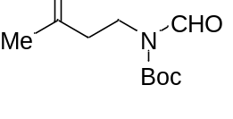
(a) Prepared following the general procedure A employing 1-(tert-butoxycarbonyl)-4-methylpiperidine-4-carboxylic acid (122 mg, 0.5 mmol, 1.0 equiv.), [Ir(dF(CF₃)ppy)₂(dOMebpy)]PF₆ (16.7 mg, 0.015 mmol, 0.03 equiv.), Cu(OAc)₂ (18.1 mg, 0.1 mmol, 0.2 equiv.), 2,2’-bipyridine (19.5 mg, 0.125 mmol, 0.25 equiv.), Cs₂CO₃ (245 mg, 0.75 mmol, 1.5 equiv.) and DCM (10 mL) for 72 hours. The desired product was obtained as colorless oil (58 mg, 54% yield) after purification by flash column chromatography on silica gel (petroleum ether/ethyl acetate = 10/1).
(b) Prepared following the general procedure A employing 1-(tert-butoxycarbonyl)-3-methylpyrrolidine-3-carboxylic acid (115 mg, 0.5 mmol, 1.0 equiv.), [Ir(dF(CF₃)ppy)₂(dOMebpy)]PF₆ (16.7 mg, 0.015 mmol, 0.03 equiv.), Cu(OAc)₂ (18.1 mg, 0.1 mmol, 0.2 equiv.), 2,2’-bipyridine (19.5 mg, 0.125 mmol, 0.25 equiv.), Cs₂CO₃ (245 mg, 0.75 mmol, 1.5 equiv.) and DCM (10 mL) for 72 hours. The desired product was obtained as colorless oil (69 mg, 64% yield) after purification by flash column chromatography on silica gel (petroleum ether/ethyl acetate = 10/1).
¹H NMR (400 MHz, CDCl₃) δ 9.10 (s, 1H), 3.83 (t, J = 7.6 Hz, 2H), 2.66 (t, J = 7.6 Hz, 2H), 2.14 (s, 3H), 1.52 (s, 9H); ¹³C NMR (101 MHz, CDCl₃) δ 206.1, 162.8, 152.0, 84.2, 41.7, 35.7, 29.9, 27.9; HRMS (ESI) calcd for C₁₀H₁₇NNaO₄ [M + Na] ⁺ m/z = 238.1050, found: 238.1044; IR v_{max}/cm⁻¹ (film) : 2980, 1741, 1691, 1371, 1343, 1152, 1054, 852, 777.

tert-butyl formyl(3-oxopentyl)carbamate (11b)
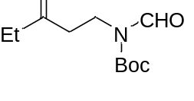
Prepared following the general procedure A employing 1-(tert-butoxycarbonyl)-4-ethylpiperidine-4-carboxylic acid (129 mg, 0.5 mmol, 1.0 equiv.), [Ir(dF(CF₃)ppy)₂(dOMebpy)]PF₆ (16.7 mg, 0.015 mmol, 0.03 equiv.), Cu(OAc)₂ (18.1 mg, 0.1 mmol, 0.2 equiv.), 2,2’-bipyridine (19.5 mg, 0.125 mmol, 0.25 equiv.), Cs₂CO₃ (245 mg, 0.75 mmol, 1.5 equiv.) and DCM (10 mL) for 72 hours. The desired product was obtained as colorless oil (50 mg, 44% yield) after purification by flash column chromatography on silica gel (petroleum ether/ethyl acetate = 10/1).
¹H NMR (400 MHz, CDCl₃) δ 9.06 (s, 1H), 3.80 (t, J = 7.6 Hz, 2H), 2.60 (t, J = 7.6 Hz, 2H), 2.38 (q, J = 7.3 Hz, 2H), 1.48 (s, 9H), 0.99 (t, J = 7.3 Hz, 3H); ¹³C NMR (101 MHz, CDCl₃) δ 208.8, 162.9, 152.1, 84.3, 40.5, 36.0, 28.0, 7.6; HRMS (ESI) calcd for C₁₁H₁₉NNaO₄ [M + Na] ⁺ m/z = 252.1206, found: 252.1202; IR v_{max}/cm⁻¹ (film) : 2979, 2940, 1741, 1690, 1371, 1342, 1152, 1069, 852, 778.

tert-butyl 4-oxopiperidine-1-carboxylate (12b, 13b and 14b)
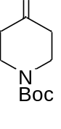
(a) Prepared following the general procedure A employing 12a (135 mg, 0.5 mmol, 1.0 equiv.), [Ir(dF(CF₃)ppy)₂(dOMebpy)]PF₆ (16.7 mg, 0.015 mmol, 0.03 equiv.), Cu(OAc)₂ (18.1 mg, 0.1 mmol, 0.2 equiv.), 2,2’-bipyridine (19.5 mg, 0.125 mmol, 0.25 equiv.), Cs₂CO₃ (245 mg, 0.75 mmol, 1.5 equiv.) and DCM (10 mL) for 72 hours. The desired product was obtained as colorless oil (54 mg, 54% yield) after purification by flash column chromatography on silica gel (petroleum ether/ethyl acetate = 10/1).

(b) Prepared following the general procedure A employing 13a (160 mg, 0.5 mmol, 1.0 equiv.), [Ir(dF(CF₃)ppy)₂(dOMebpy)]PF₆ (16.7 mg, 0.015 mmol, 0.03 equiv.), Cu(OAc)₂ (18.1 mg, 0.1 mmol, 0.2 equiv.), 2,2’-bipyridine (19.5 mg, 0.125 mmol, 0.25 equiv.), Cs₂CO₃ (245 mg, 0.75 mmol, 1.5 equiv.) and DCM (10 mL) for 72 hours. The desired product was obtained as colorless oil (59 mg, 59% yield) after purification by flash column chromatography on silica gel (petroleum ether/ethyl acetate = 10/1).

(c) prepared following the general procedure A employing 14a (136 mg, 0.5 mmol, 1.0 equiv.), [Ir(dF(CF₃)ppy)₂(dOMebpy)]PF₆ (16.7 mg, 0.015 mmol, 0.03 equiv.), Cu(OAc)₂ (18.1 mg, 0.1 mmol, 0.2 equiv.), 2,2’-bipyridine (19.5 mg, 0.125 mmol, 0.25 equiv.), Cs₂CO₃ (245 mg, 0.75 mmol, 1.5 equiv.) and DCM (10 mL) for 72 hours. The desired product was obtained as colorless oil (61 mg, 61% yield) after purification by flash column chromatography on silica gel (petroleum ether/ethyl acetate = 10/1).

Data are consistent with those reported in the literature.⁸
¹H NMR (400 MHz, CDCl₃) δ 3.59 (t, J = 6.2 Hz, 4H), 2.31 (t, J = 6.2 Hz, 4H), 1.36 (s, 9H); ¹³C NMR (101 MHz, CDCl₃) δ 207.5, 154.2, 80.1, 42.8, 40.8, 28.1.

tert-butyl formyl(2-oxopropyl)carbamate (15b)
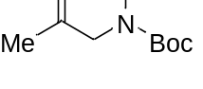
Prepared following the general procedure A employing 1-(tert-butoxycarbonyl)-3-methylazetidine-3-carboxylic acid (108 mg, 0.5 mmol, 1.0 equiv.), [(dF(CF₃)ppy)₂-Ir-μ-Cl]₂ (22.3 mg, 0.015 mmol, 0.03 equiv.), Cu(OAc)₂ (18.1 mg, 0.1 mmol, 0.2 equiv.), 2,2’-bipyridine (19.5 mg, 0.125 mmol, 0.25 equiv.), Cs₂CO₃ (245 mg, 0.75 mmol, 1.5 equiv.) and DCM (10 mL) for 72 hours. The desired product was obtained as white solid (58 mg, 58% yield) after purification by flash column chromatography on silica gel (petroleum ether/ethyl acetate = 10/1).
¹H NMR (400 MHz, CDCl₃) δ 9.18 (s, 1H), 4.38 (s, 2H), 2.16 (s, 3H), 1.49 (s, 9H); ¹³C NMR (101 MHz, CDCl₃) δ 200.4, 162.4, 151.8, 84.8, 49.5, 28.0, 27.0; HRMS (ESI) calcd for C₉H₁₅NNaO₄ [M + Na] ⁺ m/z = 224.0893, found: 224.0898; IR v_{max}/cm⁻¹ (film) : 2979, 2940, 1741, 1609, 1371, 1342, 1152, 1069, 852, 811, 778; IR v_{max}/cm⁻¹ (film) : 2979, 1735, 1697, 1397, 1363, 1329, 1155, 1034, 902, 851, 773.

tert-butyl formyl(4-oxopentyl)carbamate (17b)
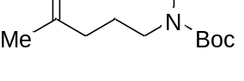
Prepared following the general procedure A employing 1-(tert-butoxycarbonyl)-3-methylpiperidine-3-carboxylic acid (122 mg, 0.5 mmol, 1.0 equiv.), [Ir(dF(CF₃)ppy)₂(dOMebpy)]PF₆ (16.7 mg, 0.015 mmol, 0.03 equiv.), Cu(OAc)₂ (18.1 mg, 0.1 mmol, 0.2 equiv.), 2,2’-bipyridine (19.5 mg, 0.125 mmol, 0.25 equiv.), Cs₂CO₃ (245 mg, 0.75 mmol, 1.5 equiv.) and DCM (10 mL) for 72 hours. The desired product was obtained as colorless oil (101 mg, 88% yield) after purification by flash column chromatography on silica gel (petroleum ether/ethyl acetate = 10/1).
¹H NMR (400 MHz, CDCl₃) δ 9.11 (s, 1H), 3.54 (t, J = 7.2 Hz, 2H), 2.39 (t, J = 7.2 Hz, 2H), 2.08 (s, 3H), 1.81 - 1.71 (m, 2H), 1.50 (s, 9H); ¹³C NMR (101 MHz, CDCl₃) δ 207.6, 163.2, 152.5, 84.1, 40.5, 39.8, 29.9, 28.0, 22.3; HRMS (ESI) calcd for C₁₁H₁₉NNaO₄ [M + Na] ⁺ m/z = 252.1206, found: 252.1201; IR v_{max}/cm⁻¹ (film) : 2979, 1737, 1689, 1371, 1344, 1151, 1067, 891, 853, 778.

tert-butyl formyl(4-oxohexyl)carbamate (18b)
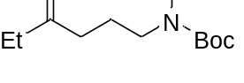
Prepared following the general procedure A employing 1-(tert-butoxycarbonyl)-3-ethylpiperidine-3-carboxylic acid (128 mg, 0.5 mmol, 1.0 equiv.), [Ir(dF(CF₃)ppy)₂(dOMebpy)]PF₆ (16.7 mg, 0.015 mmol, 0.03 equiv.), Cu(OAc)₂ (18.1 mg, 0.1 mmol, 0.2 equiv.), 2,2’-bipyridine (19.5 mg, 0.125 mmol, 0.25 equiv.), Cs₂CO₃ (245 mg, 0.75 mmol, 1.5 equiv.) and DCM (10 mL) for 72 hours. The desired product was obtained as colorless oil (95 mg, 78% yield) after purification by flash column chromatography on silica gel (petroleum ether/ethyl acetate = 10/1).
¹H NMR (400 MHz, CDCl₃) δ 9.09 (s, 1H), 3.52 (t, J = 7.0 Hz, 2H), 2.40 - 2.29 (m, 4H), 1.78-1.71 (m, 2H), 1.48 (s, 9H), 0.97 (t, J = 7.3 Hz, 3H); ¹³C NMR (101 MHz, CDCl₃) δ 210.3, 163.1, 152.4, 84.0, 39.8, 39.2, 35.8, 28.0, 22.3, 7.8; HRMS (ESI) calcd for C₁₂H₂₁NNaO₄ [M + Na] ⁺ m/z = 266.1363, found: 266.1369; IR v_{max}/cm⁻¹ (film) : 2978, 1736, 1689, 1371, 1341, 1152, 854, 777.

tert-butyl formyl(4-oxo-5-phenylpentyl)carbamate (19b)
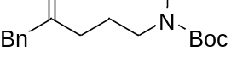
Prepared following the general procedure A employing 3-benzyl-1-(tert-butoxycarbonyl)piperidine-3-carboxylic acid (160 mg, 0.5 mmol, 1.0 equiv.), [Ir(dF(CF₃)ppy)₂(dOMebpy)]PF₆ (16.7 mg, 0.015 mmol, 0.03 equiv.), Cu(OAc)₂ (18.1 mg, 0.1 mmol, 0.2 equiv.), 2,2’-bipyridine (19.5 mg, 0.125 mmol, 0.25 equiv.), Cs₂CO₃ (245 mg, 0.75 mmol, 1.5 equiv.) and DCM (10 mL) for 72 hours. The desired product was obtained as colorless oil (47 mg, 31% yield) after purification by flash column chromatography on silica gel (petroleum ether/ethyl acetate = 10/1).
¹H NMR (400 MHz, CDCl₃) δ 9.13 (s, 1H), 7.31 (t, J = 7.2 Hz, 2H), 7.28 - 7.22 (m, 1H), 7.19 (d, J = 7.2 Hz, 2H), 3.67 (s, 2H), 3.55 (t, J = 7.0 Hz, 2H), 2.44 (t, J = 7.2 Hz, 2H), 1.82-1.74 (m, 2H), 1.52 (s, 9H); ¹³C NMR (101 MHz, CDCl₃) δ 207.2, 163.2, 152.5, 134.3, 129.5, 128.8, 127.1, 84.1, 50.2, 39.8, 38.9, 28.1, 22.3; HRMS (ESI) calcd for C₁₇H₂₃NNaO₄ [M + Na] ⁺ m/z = 328.1519, found: 328.1519; IR v_{max}/cm⁻¹ (film) : 2978, 1736, 1689, 1370, 1340, 1149, 852, 777, 700.

tert-butyl formyl(5-methyl-4-oxohexyl)carbamate (20b)
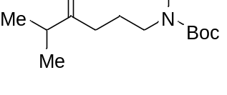
Prepared following the general procedure A employing 1-(tert-butoxycarbonyl)-3-isopropylpiperidine-3-carboxylic acid (136 mg, 0.5 mmol, 1.0 equiv.), [Ir(dF(CF₃)ppy)₂(dOMebpy)]PF₆ (16.7 mg, 0.015 mmol, 0.03 equiv.), Cu(OAc)₂ (18.1 mg, 0.1 mmol, 0.2 equiv.), 2,2’-bipyridine (19.5 mg, 0.125 mmol, 0.25 equiv.), Cs₂CO₃ (245 mg, 0.75 mmol, 1.5 equiv.) and DCM (10 mL) for 72 hours. The desired product was obtained as colorless oil (103 mg, 80% yield) after purification by flash column chromatography on silica gel (petroleum ether/ethyl acetate = 10/1).
¹H NMR (400 MHz, CDCl₃) δ 9.07 (s, 1H), 3.51 (t, J = 7.1 Hz, 2H), 2.53-2.46 (m, 1H), 2.38 (t, J = 7.3 Hz, 2H), 1.75-1.68 (m, 2H), 1.46 (s, 9H), 1.00 (d, J = 6.9 Hz, 6H); ¹³C NMR (101 MHz, CDCl₃) δ 213.4, 163.1, 152.4, 84.0, 40.7, 39.8, 37.2, 28.0, 22.3, 18.2. HRMS (ESI) calcd for C₁₃H₂₃NNaO₄ [M + Na] ⁺ m/z = 280.1519, found: 280.1512; IR v_{max}/cm⁻¹ (film) : 2927, 1735, 1685, 1559, 1508, 1458, 1157, 1019, 797.

4-oxo-4-phenylbutanal (21b)
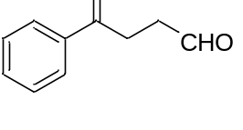
Prepared following the general procedure A employing 1-phenylcyclobutane-1-carboxylic acid (88 mg, 0.5 mmol, 1.0 equiv.), [(dF(CF₃)ppy)₂-Ir-μ-Cl]₂ (22.3 mg, 0.015 mmol, 0.03 equiv.), Cu(OAc)₂ (18.1 mg, 0.1 mmol, 0.2 equiv.), 2,2’-bipyridine (19.5 mg, 0.125 mmol, 0.25 equiv.), Cs₂CO₃ (245 mg, 0.75 mmol, 1.5 equiv.) and DCM (10 mL) for 40 hours. The desired product was obtained as white solid (71 mg, 88% yield) after purification by flash column chromatography on silica gel (petroleum ether/ethyl acetate = 10/1). Data are consistent with those reported in the literature.⁹
¹H NMR (400 MHz, CDCl₃) δ 9.92 (s, 1H), 7.99 (d, J = 8.1 Hz, 2H), 7.58 (t, J = 7.3 Hz, 1H), 7.48 (t, J = 7.5 Hz, 2H), 3.34 (t, J = 6.2 Hz, 2H), 2.94 (t, J = 6.1 Hz, 2H).; ¹³C NMR (101 MHz, CDCl₃) δ 200.8, 198.0, 136.6, 133.5, 128.8, 128.2, 37.8, 31.2; HRMS (ESI) calcd for C₁₀H₁₀NaO₂ [M+Na]⁺ m/z = 185.0573, found: 185.0573.

4-(4-fluorophenyl)-4-oxobutanal (22b)
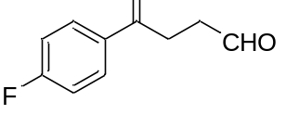
Prepared following the general procedure A employing 1-(4-fluorophenyl)cyclobutane-1-carboxylic acid (97 mg, 0.5 mmol, 1.0 equiv.), [(dF(CF₃)ppy)₂-Ir-μ-Cl]₂ (22.3 mg, 0.015 mmol, 0.03 equiv.), Cu(OAc)₂ (18.1 mg, 0.1 mmol, 0.2 equiv.), 2,2’-bipyridine (19.5 mg, 0.125 mmol, 0.25 equiv.), Cs₂CO₃ (245 mg, 0.75 mmol, 1.5 equiv.) and DCM (10 mL) for 40 hours. The desired product was obtained as white solid (58 mg, 65% yield) after purification by flash column chromatography on silica gel (petroleum ether/ethyl acetate = 10/1). Data are consistent with those reported in the literature.¹⁰
¹H NMR (400 MHz, CDCl₃) δ 9.91 (s, 1H), 8.02 (dd, J = 8.7, 5.5 Hz, 2H), 7.15 (t, J = 8.6 Hz, 2H), 3.30 (t, J = 6.3 Hz, 2H), 2.95 (t, J = 6.3 Hz, 2H); ¹³C NMR (101 MHz, CDCl₃) δ 200.6, 196.4, 165.0 (d, J = 256 Hz), 133.0, 130.9 (d, J = 10.3 Hz), 115.9 (d, J = 20.0 Hz), 37.7, 31.0; HRMS (ESI) calcd for C₁₀H₁₂FO₂ [M+H]⁺ m/z = 181.0659, found: 181.0652.

4-(4-bromophenyl)-4-oxobutanal (23b)
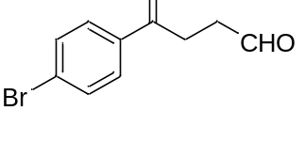
Prepared following the general procedure A employing 1-(4-bromophenyl)cyclobutane-1-carboxylic acid (127 mg, 0.5 mmol, 1.0 equiv.), [(dF(CF₃)ppy)₂-Ir-μ-Cl]₂ (22.3 mg, 0.015 mmol, 0.03 equiv.), Cu(OAc)₂ (18.1 mg, 0.1 mmol, 0.2 equiv.), 2,2’-bipyridine (19.5 mg, 0.125 mmol, 0.25 equiv.), Cs₂CO₃ (245 mg, 0.75 mmol, 1.5 equiv.) and DCM (10 mL) for 40 hours. The desired product was obtained as white solid (81 mg, 67% yield) after purification by flash column chromatography on silica gel (petroleum ether/ethyl acetate = 10/1). Data are consistent with those reported in the literature.¹¹
¹H NMR (400 MHz, CDCl₃) δ 9.90 (s, 1H), 7.85 (d, J = 8.6 Hz, 2H), 7.62 (d, J = 8.5 Hz, 2H), 3.29 (t, J = 6.3 Hz, 2H), 2.95 (t, J = 6.3 Hz, 2H). ¹³C NMR (101 MHz, CDCl₃) δ 200.5, 196.9, 135.3, 132.1, 129.7, 128.7, 37.7, 31.0; HRMS (ESI) calcd for C₁₀H₁₀BrO₂ [M+H]⁺ m/z = 240.9859, found: 240.9855.

5-oxo-5-phenylpentanal (24b)
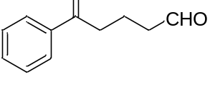
Prepared following the general procedure A employing 1-phenylcyclopentane-1-carboxylic acid (95 mg, 0.5 mmol, 1.0 equiv.), [(dF(CF₃)ppy)₂-Ir-μ-Cl]₂ (22.3 mg, 0.015 mmol, 0.03 equiv.), Cu(OAc)₂ (18.1 mg, 0.1 mmol, 0.2 equiv.), 2,2’-bipyridine (19.5 mg, 0.125 mmol, 0.25 equiv.), Cs₂CO₃ (245 mg, 0.75 mmol, 1.5 equiv.) and DCM (10 mL) for 40 hours. The desired product was obtained as white solid (62 mg, 70% yield) after purification by flash column chromatography on silica gel (petroleum ether/ethyl acetate = 10/1). Data are consistent with those reported in the literature.¹²
¹H NMR (400 MHz, CDCl₃) δ 9.81 (s, 1H), 7.96 (d, J = 7.9 Hz, 2H), 7.57 (t, J = 7.4 Hz, 1H), 7.47 (t, J = 7.6 Hz, 2H), 3.06 (t, J = 7.0 Hz, 2H), 2.60 (t, J = 7.1 Hz, 2H), 2.09 (p, J = 7.0 Hz, 2H); ¹³C NMR (101 MHz, CDCl₃) δ 202.1, 199.5, 136.9, 133.3, 128.8, 128.2, 43.2, 37.4, 16.7; HRMS (ESI) calcd for C₁₁H₁₂NaO₂ [M+Na]⁺ m/z = 199.0730, found: 199.0733.

benzophenone (25b and 26b)
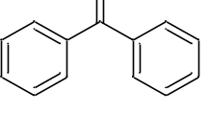
(a) Prepared following the general procedure A employing 2,2,2-triphenylacetic acid (144 mg, 0.5 mmol, 1.0 equiv.), [Ir(dF(CF₃)ppy)₂(dOMebpy)]PF₆ (16.7 mg, 0.015 mmol, 0.03 equiv.), Cu(OAc)₂ (18.1 mg, 0.1 mmol, 0.2 equiv.), 2,2’-bipyridine (19.5 mg, 0.125 mmol, 0.25 equiv.), Cs₂CO₃ (245 mg, 0.75 mmol, 1.5 equiv.) and DCM (10 mL) for 72 hours. The desired product was obtained as colorless oil (49 mg, 54% yield) after purification by flash column chromatography on silica gel (petroleum ether/ethyl acetate = 10/1).

(b) Prepared following the general procedure A employing 2,2-diphenylpentanoic acid (127 mg, 0.5 mmol, 1.0 equiv.), [Ir(dF(CF₃)ppy)₂(dOMebpy)]PF₆ (16.7 mg, 0.015 mmol, 0.03 equiv.), Cu(OAc)₂ (18.1 mg, 0.1 mmol, 0.2 equiv.), 2,2’-bipyridine (19.5 mg, 0.125 mmol, 0.25 equiv.), Cs₂CO₃ (245 mg, 0.75 mmol, 1.5 equiv.) and DCM (10 mL) for 72 hours. The desired product was obtained as colorless oil (47 mg, 52% yield) after purification by flash column chromatography on silica gel (petroleum ether/ethyl acetate = 10/1).

Data are consistent with those reported in the literature.¹³
¹H NMR (400 MHz, CDCl₃) δ 7.81 (d, J = 7.7 Hz, 4H), 7.59 (t, J = 7.4 Hz, 2H), 7.48 (t, J = 7.6 Hz, 4H); HRMS (ESI) calcd for C₁₃H₁₀NaO [M + Na] ⁺ m/z = 205.0624, found: 205.0623.

acetophenone (27b, 28b and 36b)
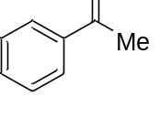
(a) Prepared following the general procedure A employing 2,2-diphenylpropanoic acid (113 mg, 0.5 mmol, 1.0 equiv.), [Ir(dF(CF₃)ppy)₂(dOMebpy)]PF₆ (16.7 mg, 0.015 mmol, 0.03 equiv.), Cu(OAc)₂ (18.1 mg, 0.1 mmol, 0.2 equiv.), 2,2’-bipyridine (19.5 mg, 0.125 mmol, 0.25 equiv.), Cs₂CO₃ (245 mg, 0.75 mmol, 1.5 equiv.) and DCM (10 mL) for 72 hours. The desired product was obtained as colorless oil (28 mg, 47% yield) after purification by flash column chromatography on silica gel (petroleum ether/ethyl acetate = 10/1).

(b) Prepared following the general procedure A employing 2-methyl-2-phenylpropanoic acid (132 mg, 0.5 mmol, 1.0 equiv.), [Ir(dF(CF₃)ppy)₂(dOMebpy)]PF₆ (16.7 mg, 0.015 mmol, 0.03 equiv.), Cu(OAc)₂ (18.1 mg, 0.1 mmol, 0.2 equiv.), 2,2’-bipyridine (19.5 mg, 0.125 mmol, 0.25 equiv.), Cs₂CO₃ (245 mg, 0.75 mmol, 1.5 equiv.) and DCM (10 mL) for 72 hours. The desired product was obtained as colorless oil (26 mg, 43% yield) after purification by flash column chromatography on silica gel (petroleum ether/ethyl acetate = 10/1).

(c) prepared following the general procedure A employing 3-phenylbutanoic acid (132 mg, 0.5 mmol, 1.0 equiv.), [Ir(dF(CF₃)ppy)₂(dOMebpy)]PF₆ (16.7 mg, 0.015 mmol, 0.03 equiv.), Cu(OAc)₂ (18.1 mg, 0.1 mmol, 0.2 equiv.), 2,2’-bipyridine (19.5 mg, 0.125 mmol, 0.25 equiv.), Cs₂CO₃ (245 mg, 0.75 mmol, 1.5 equiv.) and DCM (10 mL) for 72 hours. The desired product was obtained as colorless oil (40 mg, 66% yield) after purification by flash column chromatography on silica gel (petroleum ether/ethyl acetate = 10/1).

Data are consistent with those reported in the literature.¹⁴
¹H NMR (400 MHz, CDCl₃) δ 7.96 (d, J = 7.6 Hz, 2H), 7.57 (t, J = 7.4 Hz, 1H), 7.47 (t, J = 7.6 Hz, 2H), 2.61 (s, 3H).

1-(p-tolyl)ethan-1-one (29b)
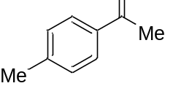
Prepared following the general procedure A employing 2-methyl-2-(p-tolyl)propanoic acid (89 mg, 0.5 mmol, 1.0 equiv.), [Ir(dF(CF₃)ppy)₂(dOMebpy)]PF₆ (16.7 mg, 0.015 mmol, 0.03 equiv.), Cu(OAc)₂ (18.1 mg, 0.1 mmol, 0.2 equiv.), 2,2’-bipyridine (19.5 mg, 0.125 mmol, 0.25 equiv.), Cs₂CO₃ (245 mg, 0.75 mmol, 1.5 equiv.) and DCM (10 mL) for 72 hours. The desired product was obtained as colorless oil (35 mg, 52% yield) after purification by flash column chromatography on silica gel (petroleum ether/ethyl acetate = 10/1). Data are consistent with those reported in the literature.¹⁵
¹H NMR (400 MHz, CDCl₃) δ 7.85 (d, J = 8.4 Hz, 2H), 7.25 (d, J = 8.4 Hz, 2H), 2.57 (s, 3H), 2.41 (s, 3H).

1-(4-chlorophenyl)ethan-1-one (30b)
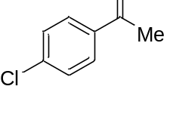
Prepared following the general procedure A employing 2-(4-chlorophenyl)-2-methylpropanoic acid (99 mg, 0.5 mmol, 1.0 equiv.), [Ir(dF(CF₃)ppy)₂(dOMebpy)]PF₆ (16.7 mg, 0.015 mmol, 0.03 equiv.), Cu(OAc)₂ (18.1 mg, 0.1 mmol, 0.2 equiv.), 2,2’-bipyridine (19.5 mg, 0.125 mmol, 0.25 equiv.), Cs₂CO₃ (245 mg, 0.75 mmol, 1.5 equiv.) and DCM (10 mL) for 72 hours. The desired product was obtained as colorless oil (31 mg, 41% yield) after purification by flash column chromatography on silica gel (petroleum ether/ethyl acetate = 10/1). Data are consistent with those reported in the literature.¹⁶
¹H NMR (400 MHz, CDCl₃) δ 7.89 (d, J = 8.4 Hz, 2H), 7.43 (d, J = 8.4 Hz, 2H), 2.59 (s, 3H).

1-(4-bromophenyl)ethan-1-one (31b)
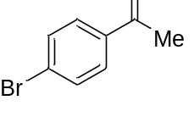
Prepared following the general procedure A employing 2-(4-bromophenyl)-2-methylpropanoic acid (121 mg, 0.5 mmol, 1.0 equiv.), [Ir(dF(CF₃)ppy)₂(dOMebpy)]PF₆ (16.7 mg, 0.015 mmol, 0.03 equiv.), Cu(OAc)₂ (18.1 mg, 0.1 mmol, 0.2 equiv.), 2,2’-bipyridine (19.5 mg, 0.125 mmol, 0.25 equiv.), Cs₂CO₃ (245 mg, 0.75 mmol, 1.5 equiv.) and DCM (10 mL) for 72 hours. The desired product was obtained as colorless oil (38 mg, 38% yield) after purification by flash column chromatography on silica gel (petroleum ether/ethyl acetate = 10/1). Data are consistent with those reported in the literature.¹⁷
¹H NMR (400 MHz, CDCl₃) δ 7.80 (d, J = 8.4 Hz, 2H), 7.58 (d, J = 8.4 Hz, 2H), 2.57 (s, 3H).

propiophenone (32b)
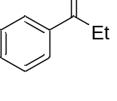
Prepared following the general procedure A employing 2-ethyl-2-phenylbutanoic acid (96 mg, 0.5 mmol, 1.0 equiv.), [Ir(dF(CF₃)ppy)₂(dOMebpy)]PF₆ (16.7 mg, 0.015 mmol, 0.03 equiv.), Cu(OAc)₂ (18.1 mg, 0.1 mmol, 0.2 equiv.), 2,2’-bipyridine (19.5 mg, 0.125 mmol, 0.25 equiv.), Cs₂CO₃ (245 mg, 0.75 mmol, 1.5 equiv.) and DCM (10 mL) for 72 hours. The desired product was obtained as colorless oil (58 mg, 86% yield) after purification by flash column chromatography on silica gel (petroleum ether/ethyl acetate = 10/1). Data are consistent with those reported in the literature.¹⁷
¹H NMR (400 MHz, CDCl₃) δ 7.96 (d, J = 7.2 Hz, 2H), 7.54 (t, J = 7.2 Hz, 1H), 7.44 (t, J = 7.2 Hz, 2H), 3.00 (q, J = 7.2 Hz, 2H), 1.22 (t, J = 7.2 Hz, 3H).

4-methoxybenzaldehyde (33b)
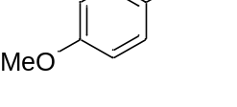
Prepared following the general procedure A employing 3-(4-methoxyphenyl)propanoic acid (96 mg, 0.5 mmol, 1.0 equiv.), [Ir(dF(CF₃)ppy)₂(dOMebpy)]PF₆ (16.7 mg, 0.015 mmol, 0.03 equiv.), Cu(OAc)₂ (18.1 mg, 0.1 mmol, 0.2 equiv.), 2,2’-bipyridine (19.5 mg, 0.125 mmol, 0.25 equiv.), Cs₂CO₃ (245 mg, 0.75 mmol, 1.5 equiv.) and DCM (10 mL) for 24h. The desired product was obtained as colorless oil (17 mg, 25% yield) after purification by flash column chromatography on silica gel (petroleum ether/ethyl acetate = 10/1). Data are consistent with those reported in the literature.¹⁸
¹H NMR (400 MHz, CDCl₃) δ 9.88 (s, 1H), 7.84 (d, J = 8.9 Hz, 2H), 7.00 (d, J = 8.7 Hz, 2H), 3.89 (s, 3H).

3,4-dimethoxybenzaldehyde (34b)
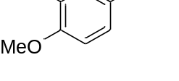
Prepared following the general procedure A employing 3-(3,4-dimethoxyphenyl)propanoic acid (105 mg, 0.5 mmol, 1.0 equiv.), [Ir(dF(CF₃)ppy)₂(dOMebpy)]PF₆ (16.7 mg, 0.015 mmol, 0.03 equiv.), Cu(OAc)₂ (18.1 mg, 0.1 mmol, 0.2 equiv.), 2,2’-bipyridine (19.5 mg, 0.125 mmol, 0.25 equiv.), Cs₂CO₃ (245 mg, 0.75 mmol, 1.5 equiv.) and DCM (10 mL) for 24h. The desired product was obtained as colorless oil (44 mg, 53% yield) after purification by flash column chromatography on silica gel (petroleum ether/ethyl acetate = 10/1). Data are consistent with those reported in the literature.¹⁹
¹H NMR (400 MHz, CDCl₃) δ 9.86 (s, 1H), 7.46 (d, J = 8.4 Hz, 1H), 7.41 (s, 1H), 6.98 (d, J = 8.4 Hz, 1H), 3.97 (s, 3H), 3.95 (s, 3H); HRMS (ESI) calcd for C₁₃H₁₁O [M + H] ⁺ m/z = 167.0703, found: 167.0708.

2,5-dimethoxybenzaldehyde (35b)
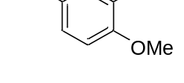
Prepared following the general procedure A employing 3-(2,5-dimethoxyphenyl)propanoic acid (105 mg, 0.5 mmol, 1.0 equiv.), [Ir(dF(CF₃)ppy)₂(dOMebpy)]PF₆ (16.7 mg, 0.015 mmol, 0.03 equiv.), Cu(OAc)₂ (18.1 mg, 0.1 mmol, 0.2 equiv.), 2,2’-bipyridine (19.5 mg, 0.125 mmol, 0.25 equiv.), Cs₂CO₃ (245 mg, 0.75 mmol, 1.5 equiv.) and DCM (10 mL) for 24h. The desired product was obtained as colorless oil (47 mg, 57% yield) after purification by flash column chromatography on silica gel (petroleum ether/ethyl acetate = 10/1). Data are consistent with those reported in the literature.²⁰
¹H NMR (400 MHz, CDCl₃) δ 10.43 (s, 1H), 7.31 (d, J = 3.2 Hz, 1H), 7.12 (dd, J = 9.2, 3.2 Hz, 1H), 6.93 (d, J = 9.2 Hz, 1H), 3.88 (s, 3H), 3.78 (s, 3H); HRMS (ESI) calcd for C₁₃H₁₁O [M + H] ⁺ m/z = 167.0703, found: 167.0703.

heptane-2,6-dione (37b)
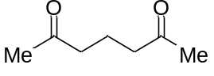
Prepared following the general procedure A employing (79 mg, 0.5 mmol, 1.0 equiv.), [Ir(dF(CF₃)ppy)₂(dOMebpy)]PF₆ (16.7 mg, 0.015 mmol, 0.03 equiv.), Cu(OAc)₂ (18.1 mg, 0.1 mmol, 0.2 equiv.), 2,2’-bipyridine (19.5 mg, 0.125 mmol, 0.25 equiv.), Cs₂CO₃ (245 mg, 0.75 mmol, 1.5 equiv.) and DCM (10 mL) for 48 hours. The desired product was obtained as colorless oil (54 mg, 85% yield) after purification by flash column chromatography on silica gel (petroleum ether/ethyl acetate = 10/1).
¹H NMR (400 MHz, CDCl₃) δ 2.38 (t, J = 7.1 Hz, 4H), 2.03 (s, 6H), 1.73 (p, J = 7.1 Hz, 2H); ¹³C NMR (101 MHz, CDCl₃) δ 208.1, 42.2, 29.6, 17.4; HRMS (ESI) calcd for C₇H₁₃O₂ [M + H] ⁺ m/z = 129.0910, found: 129.0910.

1-phenylhexane-1,5-dione (38b)
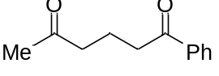
Prepared following the general procedure A employing (110 mg, 0.5 mmol, 1.0 equiv.), [Ir(dF(CF₃)ppy)₂(dOMebpy)]PF₆ (16.7 mg, 0.015 mmol, 0.03 equiv.), Cu(OAc)₂ (18.1 mg, 0.1 mmol, 0.2 equiv.), 2,2’-bipyridine (19.5 mg, 0.125 mmol, 0.25 equiv.), Cs₂CO₃ (245 mg, 0.75 mmol, 1.5 equiv.) and DCM (10 mL) for 48 hours. The desired product was obtained as colorless oil (71 mg, 75% yield) after purification by flash column chromatography on silica gel (petroleum ether/ethyl acetate = 10/1).
¹H NMR (400 MHz, CDCl₃) δ 7.96 (d, J = 7.4 Hz, 2H), 7.56 (t, J = 7.3 Hz, 1H), 7.46 (t, J = 7.6 Hz, 2H), 3.02 (t, J = 7.0 Hz, 2H), 2.57 (t, J = 7.0 Hz, 2H), 2.15 (s, 3H), 2.07 - 1.96 (m, 2H); ¹³C NMR (101 MHz, CDCl₃) δ 208.5, 199.7, 136.8, 133.1, 128.6, 128.0, 42.6, 37.4, 29.9, 18.2; HRMS (ESI) calcd for C₁₂H₁₄NaO₂ [M + Na] ⁺ m/z = 213.0886, found: 213.0888.

4-(2-acetylphenyl) butan-2-one (39b)
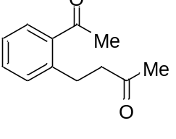
Prepared following the general procedure A employing (110 mg, 0.5 mmol, 1.0 equiv.), [Ir(dF(CF₃)ppy)₂(dOMebpy)]PF₆ (16.7 mg, 0.015 mmol, 0.03 equiv.), Cu(OAc)₂ (18.1 mg, 0.1 mmol, 0.2 equiv.), 2,2’-bipyridine (19.5 mg, 0.125 mmol, 0.25 equiv.), Cs₂CO₃ (245 mg, 0.75 mmol, 1.5 equiv.) and DCM (10 mL) for 48 hours. The desired product was obtained as colorless oil (66 mg, 70% yield) after purification by flash column chromatography on silica gel (petroleum ether/ethyl acetate = 10/1).
¹H NMR (400 MHz, CDCl₃) δ 7.62 (d, J = 7.5 Hz, 1H), 7.31 (t, J = 7.3 Hz, 1H), 7.19 (t, J = 7.8 Hz, 2H), 2.98 (t, J = 7.4 Hz, 2H), 2.68 (t, J = 7.4 Hz, 2H), 2.50 (s, 3H), 2.05 (s, 3H); ¹³C NMR (101 MHz, CDCl₃) δ 208.1, 201.5, 141.3, 137.2, 131.6, 131.4, 129.5, 126.1, 45.2, 29.6, 29.4, 28.5; HRMS (ESI) calcd for C₁₂H₁₄NaO₂ [M + Na] ⁺ m/z = 213.0886, found: 213.0887.

2-(3-oxobutyl) benzaldehyde (40b)
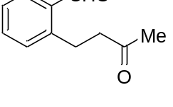
Prepared following the general procedure A employing (103 mg, 0.5 mmol, 1.0 equiv.), [Ir(dF(CF₃)ppy)₂(dOMebpy)]PF₆ (16.7 mg, 0.015 mmol, 0.03 equiv.), Cu(OAc)₂ (18.1 mg, 0.1 mmol, 0.2 equiv.), 2,2’-bipyridine (19.5 mg, 0.125 mmol, 0.25 equiv.), Cs₂CO₃ (245 mg, 0.75 mmol, 1.5 equiv.) and DCM (10 mL) for 48 hours. The desired product was obtained as colorless oil (53 mg, 60% yield) after purification by flash column chromatography on silica gel (petroleum ether/ethyl acetate = 10/1).
¹H NMR (400 MHz, CDCl₃) δ 10.19 (s, 1H), 7.80 (d, J = 7.5 Hz, 1H), 7.51 (t, J = 7.4 Hz, 1H), 7.41 (t, J = 7.0 Hz, 1H), 7.32 (d, J = 8.0 Hz, 1H), 3.28 (t, J = 7.6 Hz, 2H), 2.76 (t, J = 7.6 Hz, 2H), 2.15 (s, 3H); ¹³C NMR (176 MHz, CDCl₃) δ 207.7, 192.9, 143.5, 133.9, 133.8, 131.4, 126.9, 44.9, 29.9, 27.2; HRMS (ESI) calcd for C₁₁H₁₂NaO₂ [M + Na] ⁺ m/z =199.0730, found: 199.0731.

2-(3-oxo-3-phenylpropyl) benzaldehyde (41b)
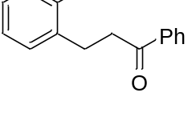
Prepared following the general procedure A employing (134 mg, 0.5 mmol, 1.0 equiv.), [Ir(dF(CF₃)ppy)₂(dOMebpy)]PF₆ (16.7 mg, 0.015 mmol, 0.03 equiv.), Cu(OAc)₂ (18.1 mg, 0.1 mmol, 0.2 equiv.), 2,2’-bipyridine (19.5 mg, 0.125 mmol, 0.25 equiv.), Cs₂CO₃ (245 mg, 0.75 mmol, 1.5 equiv.) and DCM (10 mL) for 48 hours. The desired product was obtained as colorless oil (59 mg, 50% yield) after purification by flash column chromatography on silica gel (petroleum ether/ethyl acetate = 10/1).
¹H NMR (400 MHz, CDCl₃) δ 10.24 (s, 1H), 7.97 (d, J = 7.3 Hz, 2H), 7.83 (d, J = 7.3 Hz, 1H), 7.54 (dd, J = 16.4, 7.5 Hz, 2H), 7.48 - 7.38 (m, 4H), 3.47 (t, J = 7.4 Hz, 2H), 3.32 (t, J = 7.3 Hz, 2H); ¹³C NMR (176 MHz, CDCl₃) δ 199.0, 192.9, 143.7, 136.8, 133.9, 133.7, 133.1, 131.6, 128.6, 128.1, 126.9, 40.1, 27.6; HRMS (ESI) calcd for C₁₆H₁₄NaO₂ [M + Na] ⁺ m/z =261.0886, found: 261.0882.

tert-butyl (3-oxobutyl) (2-oxopropyl) carbamate (42b) and
tert-butyl formyl(3-hydroxy-3-methyl-4-oxopentyl) carbamate (42c)
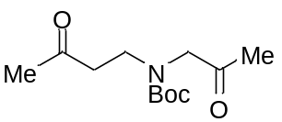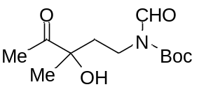
Prepared following the general procedure A employing (137 mg, 0.5 mmol, 1.0 equiv.), [Ir(dF(CF₃)ppy)₂(dOMebpy)]PF₆ (16.7 mg, 0.015 mmol, 0.03 equiv.), Cu(OAc)₂ (18.1 mg, 0.1 mmol, 0.2 equiv.), 2,2’-bipyridine (19.5 mg, 0.125 mmol, 0.25 equiv.), Cs₂CO₃ (245 mg, 0.75 mmol, 1.5 equiv.) and DCM (10 mL) for 48 hours. The desired products were obtained as colorless oil (42b, 100 mg, 75% yield; 42c, 30 mg, 23%) after purification by flash column chromatography on silica gel (petroleum ether/ethyl acetate = 10/1).
Data for 42b:
¹H NMR (400 MHz, CDCl₃) δ 4.04 (d, J = 18.4 Hz, 2H), 3.44 (dt, J = 12.0, 6.0 Hz, 2H), 2.76 (dd, J = 16.4, 10.5 Hz, 2H), 2.10 (dd, J = 22.3, 9.4 Hz, 6H), 1.41 (d, J = 32.8 Hz, 9H); ¹³C NMR (176 MHz, CDCl₃) δ 208.3, 207.7, 204.3, 204.2, 155.5, 155.2, 80.3, 80.1, 59.2, 58.5, 43.6, 43.5, 43.2, 42.8, 30.2, 30.1, 28.3, 28.1, 26.8, 26.5; HRMS (ESI) calcd for C₁₂H₂₁KNO₄ [M + K] ⁺ m/z = 282.1102, found: 282.1126; IR v_{max}/cm⁻¹ (film) : 3446, 2961, 2927, 1651, 1363, 1080, 966, 761.
Data for 42c:
¹H NMR (400 MHz, CDCl₃) δ 9.09 (s, 1H), 3.95 (s, 1H), 3.76 - 3.65 (m, 1H), 3.45 (m, 1H), 2.28 (s, 3H), 2.02 (ddd, J = 15.6, 9.9, 5.9 Hz, 1H), 1.88 (ddd, J = 13.6, 10.0, 5.1 Hz, 1H), 1.54 (s, 9H), 1.36 (s, 3H). ¹³C NMR (176 MHz, CDCl₃) δ 211.8, 163.1, 152.1, 84.4, 77.7, 36.7, 36.1, 28.0, 25.6, 23.6. HRMS (ESI) calcd for C₁₂H₂₁NaO₅ [M + Na] ⁺ m/z = 282.1312, found: 282.1314; IR v_{max}/cm⁻¹ (film) : 3467, 2962, 2316, 1654, 1630, 1079, 965, 704.

4-hydroxy-1-phenylbutan-1-one (43b)
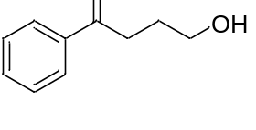
Prepared following the general procedure B employing 1-phenylcyclobutane-1-carboxylic acid (88 mg, 0.5 mmol, 1.0 equiv.), [(dF(CF₃)ppy)₂-Ir-μ-Cl]₂ (16.7 mg, 0.015 mmol, 0.03 equiv.), Cu(OAc)₂ (18.1 mg, 0.1 mmol, 0.2 equiv.), 2,2’-bipyridine (19.5 mg, 0.125 mmol, 0.25 equiv.), Selectfluor (265 mg, 0.75 mmol, 1.5 equiv.), Cs₂CO₃ (245 mg, 0.75 mmol, 1.5 equiv.) and DCM (10 mL) for 40 hours. The desired product was obtained as colorless oil (75% yield determined by ¹H NMR) after purification by flash column chromatography on silica gel (petroleum ether/ethyl acetate = 4/1). Data are consistent with those reported in the literature.⁹
¹H NMR (400 MHz, CDCl₃) δ 7.99 (d, J = 7.6 Hz, 2H), 7.57 (t, J = 7.6 Hz, 1H), 7.47 (t, J = 7.6 Hz, 2H), 3.76 (t, J = 6.0 Hz, 2H), 3.15 (t, J = 6.8 Hz, 2H), 2.07 - 2.00 (m, 2H); ¹³C NMR (101 MHz, CDCl₃) δ 200.7, 137.0, 133.3, 128.8, 128.2, 62.5, 35.4, 27.0; HRMS (ESI) calcd for C₁₀H₁₂NaO₂ [M+Na]⁺ m/z = 187.0730, found: 187.0730.

1-(4-fluorophenyl)-4-hydroxybutan-1-one (44b)
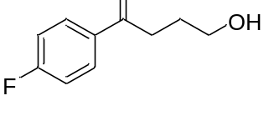
Prepared following the general procedure B employing 1-(4-fluorophenyl)cyclobutane-1-carboxylic acid (97 mg, 0.5 mmol, 1.0 equiv.), [(dF(CF₃)ppy)₂-Ir-μ-Cl]₂ (16.7 mg, 0.015 mmol, 0.03 equiv.), Cu(OAc)₂ (18.1 mg, 0.1 mmol, 0.2 equiv.), 2,2’-bipyridine (19.5 mg, 0.125 mmol, 0.25 equiv.), Selectfluor (265 mg, 0.75 mmol, 1.5 equiv.), Cs₂CO₃ (245 mg, 0.75 mmol, 1.5 equiv.) and DCM (10 mL) for 40 hours. The desired product was obtained as colorless oil (67 mg, 80% yield) after purification by flash column chromatography on silica gel (petroleum ether/ethyl acetate = 4/1). Data are consistent with those reported in the literature.²¹
¹H NMR (400 MHz, CDCl₃) δ 8.04 - 7.95 (m, 2H), 7.14 (t, J = 8.4 Hz, 2H), 3.75 (t, J = 6.0 Hz, 2H), 3.11 (t, J = 6.9 Hz, 2H), 2.07 - 1.95 (m, 2H); ¹³C NMR (101 MHz, CDCl₃) δ 199.0, 165.9 (d, J = 146 Hz), 133.4, 130.9 (d, J = 5.2 Hz), 115.9 (d, J = 12.4 Hz), 62.4, 35.3, 27.0; HRMS (ESI) calcd for C₁₀H₁₃FNaO₂ [M+Na]⁺ m/z = 205.0635, found: 205.0634.

1-(4-bromophenyl)-4-hydroxybutan-1-one (45b)
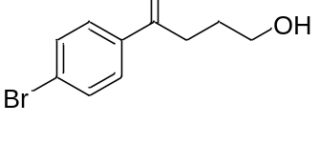
Prepared following the general procedure B employing 1-(4-bromophenyl)cyclobutane-1-carboxylic acid (127 mg, 0.5 mmol, 1.0 equiv.), [(dF(CF₃)ppy)₂-Ir-μ-Cl]₂ (16.7 mg, 0.015 mmol, 0.03 equiv.), Cu(OAc)₂ (18.1 mg, 0.1 mmol, 0.2 equiv.), 2,2’-bipyridine (19.5 mg, 0.125 mmol, 0.25 equiv.), Selectfluor (265 mg, 0.75 mmol, 1.5 equiv.), Cs₂CO₃ (245 mg, 0.75 mmol, 1.5 equiv.) and DCM (10 mL) for 40 hours. The desired product was obtained as colorless oil (73% yield determined by ¹H NMR) after purification by flash column chromatography on silica gel (petroleum ether/ethyl acetate = 4/1). Data are consistent with those reported in the literature.²¹
¹H NMR (400 MHz, CDCl₃) δ 7.84 (d, J = 8.6 Hz, 2H), 7.60 (d, J = 8.6 Hz, 2H), 3.74 (t, J = 6.0 Hz, 2H), 3.10 (t, J = 6.9 Hz, 2H), 2.05 - 1.98 (m, 2H); ¹³C NMR (101 MHz, CDCl₃) δ 199.5, 135.7, 132.1, 129.8, 128.5, 62.4, 35.3, 26.9; HRMS (ESI) calcd for C₁₀H₁₃BrNaO₂ [M+Na]⁺ m/z = 264.9835, found: 264.9838.

5-hydroxy-1-phenylpentan-1-one (46b)
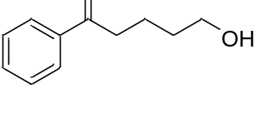
Prepared following the general procedure B employing 1-phenylcyclopentane-1-carboxylic acid (95 mg, 0.5 mmol, 1.0 equiv.), [(dF(CF₃)ppy)₂-Ir-μ-Cl]₂ (16.7 mg, 0.015 mmol, 0.03 equiv.), Cu(OAc)₂ (18.1 mg, 0.1 mmol, 0.2 equiv.), 2,2’-bipyridine (19.5 mg, 0.125 mmol, 0.25 equiv.), Selectfluor (265 mg, 0.75 mmol, 1.5 equiv.), Cs₂CO₃ (245 mg, 0.75 mmol, 1.5 equiv.) and DCM (10 mL) for 40 hours. The desired product was obtained as colorless oil (70% yield determined by ¹H NMR) after purification by flash column chromatography on silica gel (petroleum ether/ethyl acetate = 4/1). Data are consistent with those reported in the literature.²¹
¹H NMR (400 MHz, CDCl₃) δ 7.97 (d, J = 7.2 Hz, 2H), 7.57 (t, J = 7.3 Hz, 1H), 7.47 (t, J = 7.6 Hz, 2H), 3.68 (t, J = 6.3 Hz, 2H), 3.04 (t, J = 7.1 Hz, 2H), 1.90 - 1.81 (m, 2H), 1.72 - 1.62 (m, 2H); ¹³C NMR (101 MHz, CDCl₃) δ 200.5, 137.1, 133.2, 128.8, 128.2, 62.6, 38.2, 32.4, 20.3; HRMS (ESI) calcd for C₁₁H₁₄KO₂ [M+K]⁺ m/z = 217.0625, found: 217.0629.

6-hydroxy-1-phenylhexan-1-one (47b)
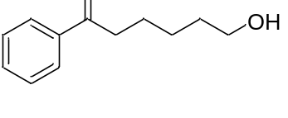
Prepared following the general procedure B employing 1-phenylcyclohexane-1-carboxylic acid (102 mg, 0.5 mmol, 1.0 equiv.), [(dF(CF₃)ppy)₂-Ir-μ-Cl]₂ (16.7 mg, 0.015 mmol, 0.03 equiv.), Cu(OAc)₂ (18.1 mg, 0.1 mmol, 0.2 equiv.), 2,2’-bipyridine (19.5 mg, 0.125 mmol, 0.25 equiv.), Selectfluor (265 mg, 0.75 mmol, 1.5 equiv.), Cs₂CO₃ (245 mg, 0.75 mmol, 1.5 equiv.) and DCM (10 mL) for 40 hours. The desired product was obtained as colorless oil (72 mg, 75% yield) after purification by flash column chromatography on silica gel (petroleum ether/ethyl acetate = 4/1). Data are consistent with those reported in the literature.²²
¹H NMR (400 MHz, CDCl₃) δ 7.96 (d, J = 9.0 Hz, 2H), 7.56 (t, J = 7.3 Hz, 1H), 7.46 (t, J = 7.7 Hz, 2H), 3.68 (t, J = 6.5 Hz, 2H), 3.00 (t, J = 7.3 Hz, 2H), 1.82 - 1.73 (m, 2H), 1.67 - 1.58 (m, 2H), 1.52 - 1.41 (m, 2H); ¹³C NMR (101 MHz, CDCl₃) δ 200.6, 137.1, 133.1, 128.7, 128.2, 62.8, 38.6, 32.6, 25.6, 24.0; HRMS (ESI) calcd for C₁₂H₁₆NaO₂ [M+Na]⁺ m/z =215.1043, found: 215.1042.

3-(2-hydroxyethoxy)-1-phenylpropan-1-one (48b)
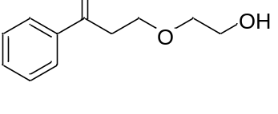
Prepared following the general procedure B employing 48a (103 mg, 0.5 mmol, 1.0 equiv.), [(dF(CF₃)ppy)₂-Ir-μ-Cl]₂ (16.7 mg, 0.015 mmol, 0.03 equiv.), Cu(OAc)₂ (18.1 mg, 0.1 mmol, 0.2 equiv.), 2,2’-bipyridine (19.5 mg, 0.125 mmol, 0.25 equiv.), Selectfluor (265 mg, 0.75 mmol, 1.5 equiv.), Cs₂CO₃ (245 mg, 0.75 mmol, 1.5 equiv.) and DCM (10 mL) for 40 hours. The desired product was obtained as colorless oil (77 mg, 80% yield) after purification by flash column chromatography on silica gel (petroleum ether/ethyl acetate = 4/1). Data are consistent with those reported in the literature.²³
¹H NMR (400 MHz, CDCl₃) δ 7.98 (d, J = 7.1 Hz, 2H), 7.58 (t, J = 7.6 Hz, 1H), 7.48 (t, J = 7.5 Hz, 2H), 3.94 (t, J = 6.0 Hz, 2H), 3.77 - 3.70 (m, 2H), 3.66 - 3.59 (m, 2H), 3.28 (t, J = 6.2 Hz, 2H); ¹³C NMR (101 MHz, CDCl₃) δ 198.6, 137.0, 133.5, 128.8, 128.3, 72.2, 65.9, 61.8, 38.8; HRMS (ESI) calcd for C₁₁H₁₄NaO₃ [M+Na]⁺ m/z =217.0835, found: 217.0836.

1-(4-fluorophenyl)-3-(2-hydroxyethoxy)propan-1-one (49b)
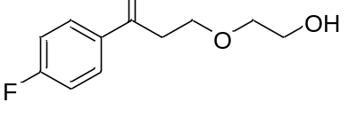
Prepared following the general procedure B employing 49a (112 mg, 0.5 mmol, 1.0 equiv.), [(dF(CF₃)ppy)₂-Ir-μ-Cl]₂ (16.7 mg, 0.015 mmol, 0.03 equiv.), Cu(OAc)₂ (18.1 mg, 0.1 mmol, 0.2 equiv.), 2,2’-bipyridine (19.5 mg, 0.125 mmol, 0.25 equiv.), Selectfluor (265 mg, 0.75 mmol, 1.5 equiv.), Cs₂CO₃ (245 mg, 0.75 mmol, 1.5 equiv.) and DCM (10 mL) for 40 hours. The desired product was obtained as colorless oil (75 mg, 73% yield) after purification by flash column chromatography on silica gel (petroleum ether/ethyl acetate = 4/1).
¹H NMR (400 MHz, CDCl₃) δ 8.00 (dd, J = 8.7, 5.5 Hz, 2H), 7.14 (t, J = 8.5 Hz, 2H), 3.93 (t, J = 6.1 Hz, 2H), 3.77 - 3.71 (m, 2H), 3.64 - 3.58 (m, 2H), 3.24 (t, J = 6.1 Hz, 2H); ¹³C NMR (101 MHz, CDCl₃) δ 197.0, 166.0 (d, J = 146 Hz), 133.5 (d, J = 1.7 Hz), 131.0 (d, J = 5.3 Hz), 115.9 (d, J = 12.5 Hz), 72.2, 65.9, 61.8, 38.7; HRMS (ESI) calcd for C₁₁H₁₃FNaO₃ [M+Na]⁺ m/z = 235.0741, found: 235.0740; IR v_{max}/cm⁻¹ (film) : 2971, 1735, 1701, 1370, 1340, 1152, 1024, 853, 777.

1-(4-chlorophenyl)-3-(2-hydroxyethoxy)propan-1-one (50b)
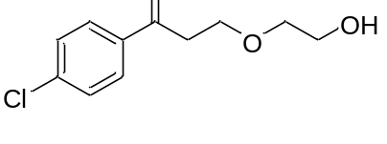
Prepared following the general procedure B employing 50a (120 mg, 0.5 mmol, 1.0 equiv.), [(dF(CF₃)ppy)₂-Ir-μ-Cl]₂ (16.7 mg, 0.015 mmol, 0.03 equiv.), Cu(OAc)₂ (18.1 mg, 0.1 mmol, 0.2 equiv.), 2,2’-bipyridine (19.5 mg, 0.125 mmol, 0.25 equiv.), Selectfluor (265 mg, 0.75 mmol, 1.5 equiv.), Cs₂CO₃ (245 mg, 0.75 mmol, 1.5 equiv.) and DCM (10 mL) for 40 hours. The desired product was obtained as colorless oil (80 mg, 70% yield) after purification by flash column chromatography on silica gel (petroleum ether/ethyl acetate = 4/1).
¹H NMR (400 MHz, CDCl₃) δ 7.91 (d, J = 8.5 Hz, 2H), 7.45 (d, J = 8.4 Hz, 2H), 3.93 (t, J = 6.0 Hz, 2H), 3.76 - 3.71 (m, 2H), 3.64 - 3.59 (m, 2H), 3.24 (t, J = 6.0 Hz, 2H); ¹³C NMR (101 MHz, CDCl₃) δ 197.4, 140.0, 135.3, 129.7, 129.1, 72.2, 65.8, 61.8, 38.7; HRMS (ESI) calcd for C₁₁H₁₃ClNaO₃ [M+Na]⁺ m/z = 251.0445, found: 251.0442; IR v_{max}/cm⁻¹ (film) : 2926, 1735, 1718, 1684, 1560, 1508, 1339, 1261, 762.

3-(2-hydroxyethoxy)-1-(4-methoxyphenyl)propan-1-one (51b)
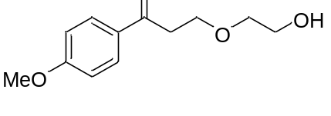
Prepared following the general procedure B employing 51a (118 mg, 0.5 mmol, 1.0 equiv.), [(dF(CF₃)ppy)₂-Ir-μ-Cl]₂ (16.7 mg, 0.015 mmol, 0.03 equiv.), Cu(OAc)₂ (18.1 mg, 0.1 mmol, 0.2 equiv.), 2,2’-bipyridine (19.5 mg, 0.125 mmol, 0.25 equiv.), Selectfluor (265 mg, 0.75 mmol, 1.5 equiv.), Cs₂CO₃ (245 mg, 0.75 mmol, 1.5 equiv.) and DCM (10 mL) for 40 hours. The desired product was obtained as colorless oil (56 mg, 50% yield) after purification by flash column chromatography on silica gel (petroleum ether/ethyl acetate = 4/1). Data are consistent with those reported in the literature.²⁴
¹H NMR (400 MHz, CDCl₃) δ 7.96 (d, J = 8.7 Hz, 2H), 6.94 (d, J = 8.7 Hz, 2H), 3.93 (t, J = 6.2 Hz, 2H), 3.88 (s, 3H), 3.77 - 3.71 (m, 2H), 3.64 - 3.59 (m, 2H), 3.22 (t, J = 6.1 Hz, 2H); ¹³C NMR (101 MHz, CDCl₃) δ 197.1, 163.8, 130.6, 130.2, 113.9, 72.2, 66.1, 61.8, 55.6, 38.4; HRMS (ESI) calcd for C₁₂H₁₆NaO₄, [M+Na]⁺ m/z = 247.0941, found: 247.0940.

1-([1,1'-biphenyl]-4-yl)-3-(2-hydroxyethoxy)propan-1-one (52b)
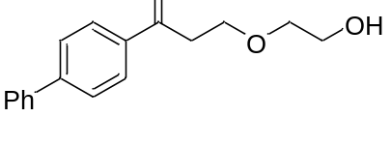
Prepared following the general procedure B employing 52a (141 mg, 0.5 mmol, 1.0 equiv.), [(dF(CF₃)ppy)₂-Ir-μ-Cl]₂ (16.7 mg, 0.015 mmol, 0.03 equiv.), Cu(OAc)₂ (18.1 mg, 0.1 mmol, 0.2 equiv.), 2,2’-bipyridine (19.5 mg, 0.125 mmol, 0.25 equiv.), Selectfluor (265 mg, 0.75 mmol, 1.5 equiv.), Cs₂CO₃ (245 mg, 0.75 mmol, 1.5 equiv.) and DCM (10 mL) for 40 hours. The desired product was obtained as colorless oil (77 mg, 68% yield) after purification by flash column chromatography on silica gel (petroleum ether/ethyl acetate = 4/1).
¹H NMR (400 MHz, CDCl₃) δ 8.05 (d, J = 8.3 Hz, 2H), 7.70 (d, J = 8.3 Hz, 2H), 7.63 (d, J = 7.3 Hz, 2H), 7.47 (d, J = 7.7 Hz, 2H), 7.41 (t, J = 7.2 Hz, 1H), 3.96 (t, J = 6.1 Hz, 2H), 3.77 - 3.73 (m, 2H), 3.66 - 3.61 (m, 2H), 3.31 (t, J = 6.1 Hz, 2H); ¹³C NMR (101 MHz, CDCl₃) δ 198.2, 146.2, 139.9, 135.7, 129.1, 128.9, 128.4, 127.4, 127.4, 72.2, 66.0, 61.8, 38.8; HRMS (ESI) calcd for C₁₇H₁₈NaO₃ [M+Na]⁺ m/z = 293.1148, found: 293.1148; IR v_{max}/cm⁻¹ (film) : 2962, 1685, 1458, 1261, 1093, 799.
1-(4-fluorophenyl)-4-(piperidin-1-yl) butan-1-one (Primaperone)
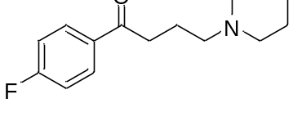
Prepared following the general procedure C employing 22b (90 mg, 0.5 mmol, 1.0 equiv.), piperidine (44 mg, 0.52 mmol, 1.04 equiv.), sodium triacetoxyborohydride (212 mg, 1.0 mmol, 2.0 equiv.), and dry DCE (5 mL) for 6 hours. The desired product was obtained as white solid (106 mg, 85% yield) after purification by flash column chromatography on silica gel (petroleum ether/ethyl acetate = 5/1).
¹H NMR (400 MHz, CDCl₃) δ 7.97 - 7.91 (m, 2H), 7.09 - 7.00 (m, 2H), 2.90 (t, J = 7.2 Hz, 2H), 2.44 - 2.13 (m, 6H), 1.94 - 1.80 (m, 2H), 1.50 - 1.44 (m, 4H), 1.38 - 1.32 (m, 2H); ¹³C NMR (101 MHz, CDCl₃) δ 198.4, 165.5 (d, J = 252.5 Hz), 133.5 (d, J = 10.1 Hz), 130.6 (d, J = 10.1 Hz), 115.4 (d, J = 20.2 Hz) 58.3, 54.3, 36.2, 25.7, 24.3, 21.5; HRMS (ESI) calcd for C₁₅H₂₁FNO [M + H] ⁺ m/z = 250.1602, found: 250.1600.

1-(4-fluorophenyl)-4-(4-methylpiperidin-1-yl) butan-1-one (Melperone)
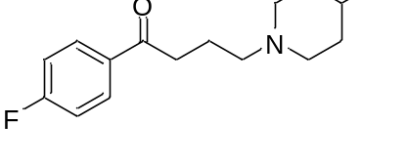
Prepared following the general procedure C employing 22b (90 mg, 0.5 mmol, 1.0 equiv.), 4-methylpiperidine (47 mg, 0.52 mmol, 1.04 equiv.), sodium triacetoxyborohydride (212 mg, 1.0 mmol, 2.0 equiv.), and dry DCE (5 mL) for 6 hours. The desired product was obtained as white solid (109 mg, 83% yield) after purification by flash column chromatography on silica gel (petroleum ether/ethyl acetate = 5/1).
¹H NMR (400 MHz, CDCl₃) δ 7.98 - 7.91 (m, 2H), 7.11 - 7.02 (m, 2H), 2.90 (t, J = 7.2 Hz, 2H), 2.81 (d, J = 11.6 Hz, 2H), 2.33 (dd, J = 13.6, 6.5 Hz, 2H), 1.93 - 1.81 (m, 4H), 1.57 - 1.48 (m, 2H), 1.31-1.22 (m, 1H), 1.11 (ddd, J = 15.5, 12.2, 3.7 Hz, 2H), 0.84 (d, J = 6.5 Hz, 3H); ¹³C NMR (101 MHz, CDCl₃) δ 198.3, 165.6 (d, J = 252.5 Hz), 133.4 (d, J = 10.1 Hz), 130.6 (d, J = 10.1 Hz), 115.5 (d, J = 30.3 Hz), 57.7, 53.6, 36.1, 33.6, 30.5, 21.6, 21.2; HRMS (ESI) calcd for C₁₆H₂₃FNO [M + H] ⁺ m/z = 264.1758, found: 264.1753.

4-(4-(4-chlorophenyl)-4-hydroxypiperidin-1-yl)-1-(4-fluorophenyl) butan-1-one (Haloperidol)
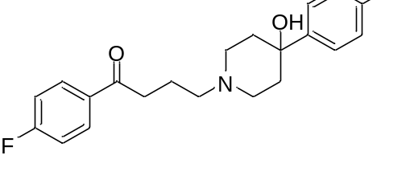
Prepared following the general procedure C employing 22b (90 mg, 0.5 mmol, 1.0 equiv.), 4-(4-chlorophenyl) piperidin-4-ol (110 mg, 0.52 mmol, 1.04 equiv.), sodium triacetoxyborohydride (212 mg, 1.0 mmol, 2.0 equiv.), and dry DCE (5 mL) for 6 hours. The desired product was obtained as white solid (150 mg, 80% yield) after purification by flash column chromatography on silica gel (DCM/MeOH = 20/1).
¹H NMR (400 MHz, CDCl₃) δ 8.06 - 7.98 (m, 2H), 7.41 - 7.35 (m, 2H), 7.32 - 7.27 (m, 2H), 7.17 - 7.09 (m, 2H), 2.98 (t, J = 7.0 Hz, 2H), 2.78 (d, J = 11.3 Hz, 2H), 2.47 (t, J = 7.2 Hz, 2H), 2.45 - 2.37 (m, 2H), 2.04 - 1.94 (m, 4H), 1.69 - 1.65 (m, 2H); ¹³C NMR (101 MHz, CDCl₃) δ 198.4, 165.6 (d, J = 262.6 Hz), 146.9, 133.7 (d, J = 3.03 Hz), 132.7, 130.7 (d, J = 10.1 Hz), 128.4, 126.1, 115.6 (d, J = 20.2 Hz), 71.1, 57.8, 49.3, 38.4, 36.2, 21.9; HRMS (ESI) calcd for C₂₁H₂₄FNO₂ [M + H] ⁺ m/z = 376.1474, found: 376.1476.

4-(2-acetylphenyl)-4-(3,4-dichlorophenyl) butan-2-one (53b)
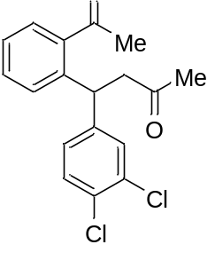
Prepared following the general procedure A employing 53a (183 mg, 0.5 mmol, 1.0 equiv.), [Ir(dF(CF₃)ppy)₂(dOMebpy)]PF₆ (16.7 mg, 0.015 mmol, 0.03 equiv.), Cu(OAc)₂ (18.1 mg, 0.1 mmol, 0.2 equiv.), 2,2’-bipyridine (19.5 mg, 0.125 mmol, 0.25 equiv.), Cs₂CO₃ (245 mg, 0.75 mmol, 1.5 equiv.) and DCM (10 mL) for 48 hours. The desired product was obtained as colorless oil (138 mg, 83% yield) after purification by flash column chromatography on silica gel (petroleum ether/ethyl acetate = 10/1).
¹H NMR (400 MHz, CDCl₃) δ 7.60 (dd, J = 7.7, 1.2 Hz, 1H), 7.39 (m, 1H), 7.36 (d, J = 2.1 Hz, 1H), 7.33 (d, J = 8.3 Hz, 1H), 7.27 (m, J = 7.6, 1.2 Hz, 1H), 7.20 (dd, J = 7.8 Hz, 1H), 7.16 (dd, J = 8.4, 2.1 Hz, 1H), 5.29 (t, J = 7.5 Hz, 1H), 3.21 (dd, J = 17.1, 8.0 Hz, 1H), 3.08 (dd, J = 17.1, 7.0 Hz, 1H), 2.59 (s, 3H), 2.10 (s, 3H); ¹³C NMR (101 MHz, CDCl₃) δ 205.8, 202.9, 143.8, 142.1, 138.8, 132.3, 131.4, 130.3, 130.3, 129.9, 128.6, 128.5, 127.7, 126.4, 49.5, 39.6, 30.0, 29.9; HRMS (ESI) calcd for C₁₈H₁₆NaO₂ [M + Na] ⁺ m/z =357.0470, found: 357.0473; IR v_{max}/cm⁻¹ (film) : 3064, 2963, 1716, 1687, 1470, 1357, 1251, 1029, 960, 814, 759, 597.

(3aS,5aS,6R,7R,9aS,9bS)-3a,6-dimethyl-6-(3-oxo-3-phenylpropyl)dodecahydro-1H-cyclopenta[a]naphthalene-7-carbaldehyde (54b)
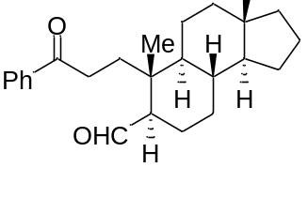
Prepared following the general procedure B employing 54a (190 mg, 0.5 mmol, 1.0 equiv.), [(dF(CF₃)ppy)₂-Ir-μ-Cl]₂ (16.7 mg, 0.015 mmol, 0.03 equiv.), Cu(OAc)₂ (18.1 mg, 0.1 mmol, 0.2 equiv.), 2,2’-bipyridine (19.5 mg, 0.125 mmol, 0.25 equiv.), Selectfluor (265 mg, 0.75 mmol, 1.5 equiv.), Cs₂CO₃ (245 mg, 0.75 mmol, 1.5 equiv.) and DCM (10 mL) for 40 hours. The desired product was obtained as colorless oil (40 mg, 22% yield, brms 50%) after purification by flash column chromatography on silica gel (petroleum ether/ethyl acetate = 10/1).
¹H NMR (400 MHz, CDCl₃) δ 9.76 (d, J = 3.8 Hz, 1H), 8.02 - 7.93 (m, 2H), 7.57 (t, J = 7.3 Hz, 1H), 7.48 (t, J = 7.4 Hz, 2H), 3.18 (ddd, J = 16.6, 12.1, 4.9 Hz, 1H), 2.77 (ddd, J = 16.2, 12.0, 4.2 Hz, 1H), 2.28 (d, J = 12.1 Hz, 1H), 2.01 - 1.93 (m, 1H), 1.84 (t, J = 11.7 Hz, 1H), 1.77 (dd, J = 7.8, 4.5 Hz, 1H), 1.73 - 1.64 (m, 5H), 1.47 (s, 1H), 1.36 (d, J = 11.8 Hz, 1H), 1.25 (s, 1H), 1.19 - 1.13 (m, 3H), 1.08 (s, 3H), 1.01 - 0.95 (m, 2H), 0.90 (d, J = 16.5 Hz, 2H), 0.77 (d, J = 8.8 Hz, 1H), 0.71 (s, 3H); ¹³C NMR (176 MHz, CDCl₃) δ 206.1, 200.3, 136.9, 133.1, 128.6, 128.2, 55.6, 54.5, 47.9, 40.7, 40.3, 38.5, 38.3, 35.3, 32.4, 31.6, 30.7, 25.5, 22.0, 20.5, 20.1, 17.5, 17.4; HRMS (ESI) calcd for C₂₅H₃₄NaO₂ [M + Na] ⁺ m/z = 389.2451, found: 389.2450; IR v_{max}/cm⁻¹ (film): 3468, 2829, 2026, 1656, 1631, 1598, 1355, 1276, 722, 697, 667.

(3R,3aR,5aS,6R,7R,9aS,9bS)-3a,6-dimethyl-3-((R)-6-methylheptan-2-yl)-6-(3-oxo-3-phenylpropyl)dodecahydro-1H-cyclopenta[a]naphthalene-7-carbaldehyde (55b)
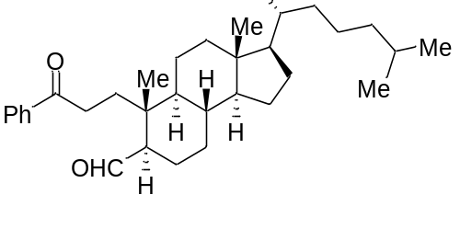
Prepared following the general procedure B employing 55a (246 mg, 0.5 mmol, 1.0 equiv.), [(dF(CF₃)ppy)₂-Ir-μ-Cl]₂ (16.7 mg, 0.015 mmol, 0.03 equiv.), Cu(OAc)₂ (18.1 mg, 0.1 mmol, 0.2 equiv.), 2,2’-bipyridine (19.5 mg, 0.125 mmol, 0.25 equiv.), Selectfluor (265 mg, 0.75 mmol, 1.5 equiv.), Cs₂CO₃ (245 mg, 0.75 mmol, 1.5 equiv.) and DCM (10 mL) for 40 hours. The desired product was obtained as colorless oil (42 mg, 18% yield，brms 35%) after purification by flash column chromatography on silica gel (petroleum ether/ethyl acetate = 10/1).
¹H NMR (400 MHz, CDCl₃) δ 9.88 (s, 1H), 7.93 (d, J = 7.6 Hz, 2H), 7.54 (t, J = 7.3 Hz, 1H), 7.45 (t, J = 7.5 Hz, 2H), 3.20 - 3.10 (m, 1H), 2.73 (dd, J = 16.0, 9.6 Hz, 1H), 2.52 - 2.43 (m, 1H), 2.32 (dd, J = 15.2, 3.2 Hz, 2H), 1.98 (d, J = 13.0 Hz, 1H), 1.79 (s, 2H), 1.31 - 1.23 (m, 9H), 1.17 (d, J = 12.6 Hz, 3H), 1.13 - 1.04 (m, 6H), 0.97 (s, 3H), 0.92 (s, 3H), 0.87 (d, J = 6.5 Hz, 3H), 0.85 (d, J = 1.9 Hz, 3H), 0.83 (d, J = 1.9 Hz, 3H), 0.64 (s, 3H). ¹³C NMR (176 MHz, CDCl₃) δ 203.4, 200.2, 137.3, 133.1, 128.7, 128.2, 56.3, 56.1, 50.1, 49.9, 42.3, 40.5, 40.2, 39.7, 39.5, 36.1, 35.8, 35.3, 31.4, 29.7, 28.2, 28.2, 28.0, 24.2, 23.8, 22.8, 22.6, 22.0, 18.6, 15.7, 11.9; HRMS (ESI) calcd for C₃₃H₅₀NaO₂ [M + Na] ⁺ m/z = 501.3703, found: 501.3709; IR v_{max}/cm⁻¹ (film): 3451, 2892, 2026, 1637, 1599, 1356, 1260, 1077, 773, 696, 667, 606.

General procedure C for the reaction
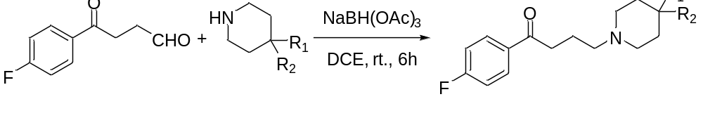
A solution of 22b (101 mg, 0.525 mmol), which obtained followed procedure A and the corresponding piperazine derivate (1.04 equiv.) in anhydrous DCE (5 mL) was added Sodium triacetoxyborohydride (212 mg, 1.0 mmol, 2.0 equiv.) at room temperature under an atmosphere of argon. The resulting mixture allowed to stir for 6 hours. The reaction mixture was quenched with sat. NaHCO₃ and extracted by DCM (3*20 mL). The combined organic layers were dried Na₂SO₄, filtered and concentrated in vacuo to afford the crude product. Purification by flash column chromatography afforded the desired product.

References
      - Lowry, M. S., Goldsmith, J. I., Slinker, J. D., Rohl, R., Pascal, R. A., Malliaras, G. G. & Bernhard, S. Single-layer electroluminescent devices and photoinduced hydrogen production from an ionic iridium(III) complex. Chem. Mater. 17, 5712-5719 (2005).
      - Liu, Y., Yin, Y., Zhang, Z., Li, C. J., Zhang, H., Zhang, D., Jiang, C., Nomie, K., Zhang, L., Wang, M. L. & Zhao, G. Structural optimization elaborates novel potent Akt inhibitors with promising anticancer activity. Eur. J. Med. Chem. 138, 543-551 (2017).
      - Zhang, D., Tong, D., Yang, D., Sun, J., Zhang, F. & Zhao, G. Design, synthesis and biological evaluation of AKT inhibitors bearing a piperidin-4-yl appendant. Med. Chem. Commun. 9, 1340-1350 (2018).
      - Agekyan, A. A. & Mkryan, G. G. Synthesis of p-aminobenzoic acid diamides based on 4-(4-methoxyphenyl)tetrahydro-2H-pyran-4-carboxylic acid and [4-(4-methoxyphenyl) tetrahydro-2H-pyran-4-yl]methylamine. Russ. J. Gen. Chem. 85, 1057-1062 (2015).
      - Ferreira, A. J., Solano, D. M., Oakdale, J. S. & Kurth M. J. Novel trinitrogen-containing triheterocycles via the intramolecular nitrile oxide cycloaddition reaction. Synthesis 20, 3241-3246 (2011).
      - Alkayal, A., Tabas, V., Montanaro, S., Wright, I. A., Malkov, A. V. & Buckley, B. R. Harnessing applied potential: selective β-hydrocarboxylation of substituted olefins. J. Am. Chem. Soc. 142, 1780-1785 (2020).
      - Minato, D., Arimoto, H., Nagasue, Y., Demizu, Y. & Onomura, O. Asymmetric electrochemical oxidation of 1,2-diols, aminoalcohols, and aminoaldehydes in the presence of chiral copper catalyst. Tetrahedron 64, 6675-6683 (2008).
      - Poirier, M., Pujol-Giménez, J., Manatschal, C., Bühlmann, S., Embaby, A., Javor, S., Hediger, M. A. & Reymond, J. Pyrazolyl-pyrimidones inhibit the function of human solute carrier protein SLC11A2 (hDMT1) by metal chelation. RSC Med. Chem. 11, 1023-1031 (2020).
      - Mir, N. A., Ramaraju, P., Vanaparthi, S., Choudhary, S., Singh, R. P., Sharma, P., Kant, R., Singh, R., Sankaranarayanan, M. & Kumar, I. Sequential multicomponent catalytic synthesis of pyrrole-3-carboxaldehydes: evaluation of antibacterial and antifungal activities along with docking studies. New J. Chem. 44, 16329-16339 (2020).
      - Shimkin, K. W., Gildner, P. G., & Watson, D. A. Copper-catalyzed alkylation of nitroalkanes with α-bromonitriles: synthesis of β-cyanonitroalkanes. Org. Lett. 18. 988-991 (2016).
      - Lee, S., Bae, H. Y. & List, B. Can a ketone be more reactive than an aldehyde? catalytic asymmetric synthesis of substituted tetrahydrofurans. Angew. Chem. Int. Ed. 57, 12162-12166 (2018).
      - Rono, L. J., Yayla, H. G., Wang, D. Y., Armstrong, M. F. & Knowles, R. R. Enantioselective photoredox catalysis enabled by proton-coupled electron transfer: development of an asymmetric aza-pinacol cyclization. J. Am. Chem. Soc. 135, 17735-17738 (2013).
      - Mukhopadhyay, S. & Batra, S. Direct transformation of arylamines to aryl halides via sodium nitrite and N-halosuccinimide. Chem. Eur. J. 24, 14622-14626 (2018).
      - Tachinami, T., Nishimura, T., Ushimaru, R., Noyori, R. & Naka, H. Hydration of terminal alkynes catalyzed by water-soluble cobalt porphyrin complexes. J. Am. Chem. Soc. 135, 50-53 (2013).
      - Kariofillis, S. K., Shields, B. J., Tekle-Smith, M. A., Zacuto, M. J. & Doyle, A. G. Nickel/photoredox-catalyzed methylation of (hetero)aryl chlorides using trimethyl orthoformate as a methyl radical source. J. Am. Chem. Soc. 142, 7683-7689 (2020).
      - Mack, J. B. C., Gipson, J. D., Bois, J. D. & Sigman, M. S. Ruthenium-catalyzed C-H hydroxylation in aqueous acid enables selective functionalization of amine derivatives. J. Am. Chem. Soc. 139, 9503-9506 (2017).
      - Gonzalez-de-Castro, A. & Xiao, J. Green and efficient: iron-catalyzed selective oxidation of olefins to carbonyls with O₂. J. Am. Chem. Soc. 137, 8206-8218 (2015).
      - González, J. R., González, A. Z. & Soderquist, J. A. (E)-2-boryl-1,3-butadiene derivatives of the 10-TMS-9-BBDs: highly selective reagents for the asymmetric synthesis of anti-1,2-disubstituted 3,4-pentadien-1-ols. J. Am. Chem. Soc. 131, 9924-9925 (2009).
      - Benischke, A. D., Anthore-Dalion, L., Berionni, G. & Knochel, P. Preparation of functionalized diaryl- and diheteroaryllanthanum reagents by fast halogen-lanthanum exchange. Angew. Chem. Int. Ed. 56, 16390-16394 (2017).
      - Alam, M. I., Alam, M. A., Alam, O., Nargotra, A., Taneja, S. C. & Koul, S. Molecular modeling and snake venom phospholipase A₂ inhibition by phenolic compounds: structure-activity relationship. Eur. J. Med. Chem. 114, 209-219 (2016).
      - Murphy, S. K. & Dong, V. M. Enantioselective ketone hydroacylation using Noyori’s transfer hydrogenation catalyst. J. Am. Chem. Soc. 135, 5553-5556 (2013).
      - Xie, J., Guo, L., Yang, X., Wang, L. & Zhou, Q. Enantioselective synthesis of 2,6-cis-disubstituted tetrahydropyrans via a tandem catalytic asymmetric hydrogenation/oxa-Michael cyclization: an efficient approach to (-)-centrolobine. Org. Lett. 14, 4758-4761 (2012).
      - Hosokawa, T., Ohta, T., Kanayama, S. & Murahashi, S. PaIladium(II)-catalyzed acetalization of terminal olefins bearing electron-withdrawing substituents with optically active diols. J. Org. Chem. 52, 1758-1764 (1987).
      - Alcaide, B., Almendros, P., Quirós, M. T., López, R., Menéndez, M. I. & Sochacka-Ćwikła, A. Unveiling the reactivity of propargylic hydroperoxides under gold catalysis. J. Am. Chem. Soc. 135, 898-905 (2013).

NMR Spectra Data
