Table 1 | Optimization of the reaction conditionª
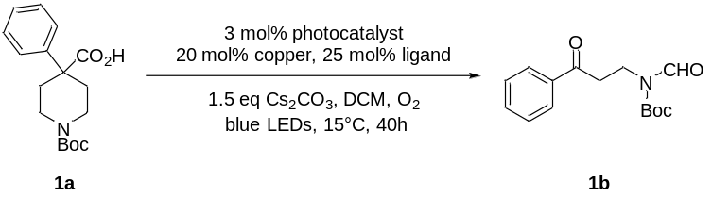
Entry | Photocatalyst | Copper | Ligand | Yields^{b}
1 | Ir-1 | - | - | < 5%
2 | Ir-1 | Cu(OAc)₂ | - | 26%
3 | Ir-1 | Cu(OAc)₂ | L1 | 48%
4 | Ir-1 | Cu(OAc)₂ | L2 | 45%
5 | Ir-1 | Cu(OAc)₂ | L3 | 14%
6 | Ir-1 | Cu(OAc)₂ | L4 | 49%
7 | Ir-1 | Cu(OAc)₂ | L5 | 29%
8 | Ir-1 | Cu(OAc)₂ | L6 | 18%
9 | Ir-1 | CuO | L4 | 30%
10 | Ir-1 | CuBr₂ | L4 | 19%
11 | Ir-1 | CuCN | L4 | 6%
12^{c} | Ir-1 | Cu(OAc)₂ | L4 | 81%
13^{c} | Ir-2 | Cu(OAc)₂ | L4 | 48%
14^{c} | Ir-3 | Cu(OAc)₂ | L4 | 60%
15^{c} | Ir-4 | Cu(OAc)₂ | L4 | 50%
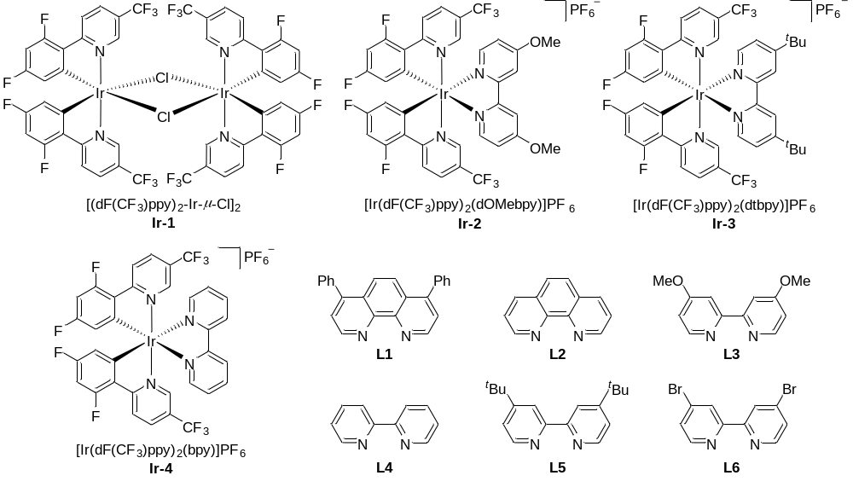ªReaction conditions: 1 (0.5 mmol), photocatalyst (0.015 mmol), copper (0.1 mmol), ligand (0.125 mmol), Cs₂CO₃ (0.75 mmol), DCM (10 mL), 45W blue LEDs, 15ºC. ^{b}Isolated yield. ^{c}the reaction was carried out at 30ºC.

Table 2 | Substrate scope of piperidine-4-carboxylic acids
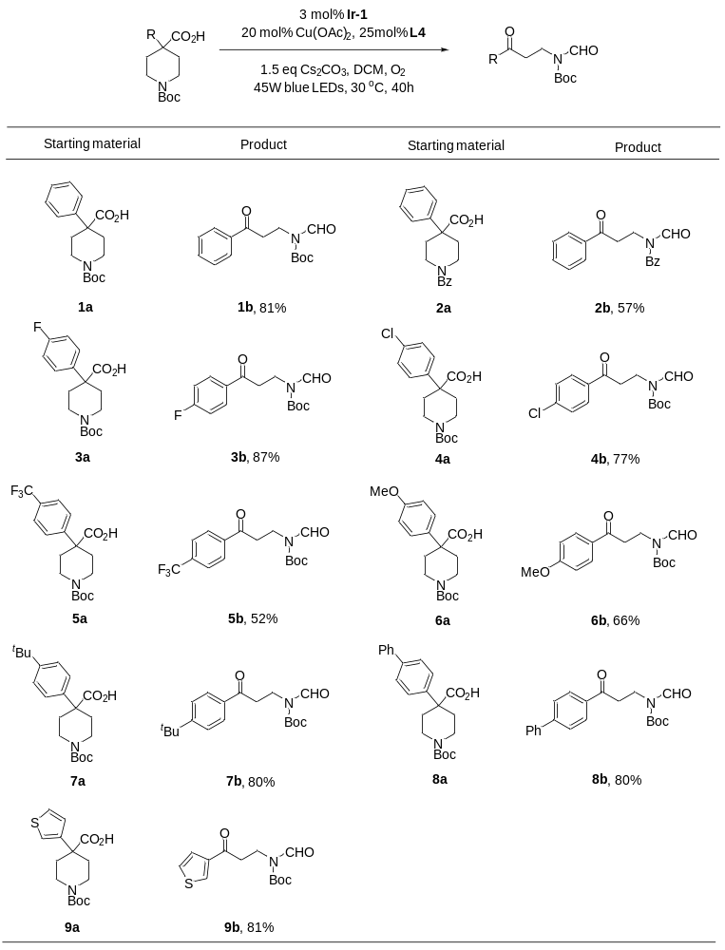Reaction conditions: substrate (0.5 mmol), Ir-1 (0.015 mmol), Cu(OAc)₂ (0.1 mmol), L4 (0.125 mmol), Cs₂CO₃ (0.75 mmol), DCM (10 mL), 45W blue LEDs, 30ºC, 40 h.

Table 3 | Substrate scope of piperidine-4-carboxylic acids
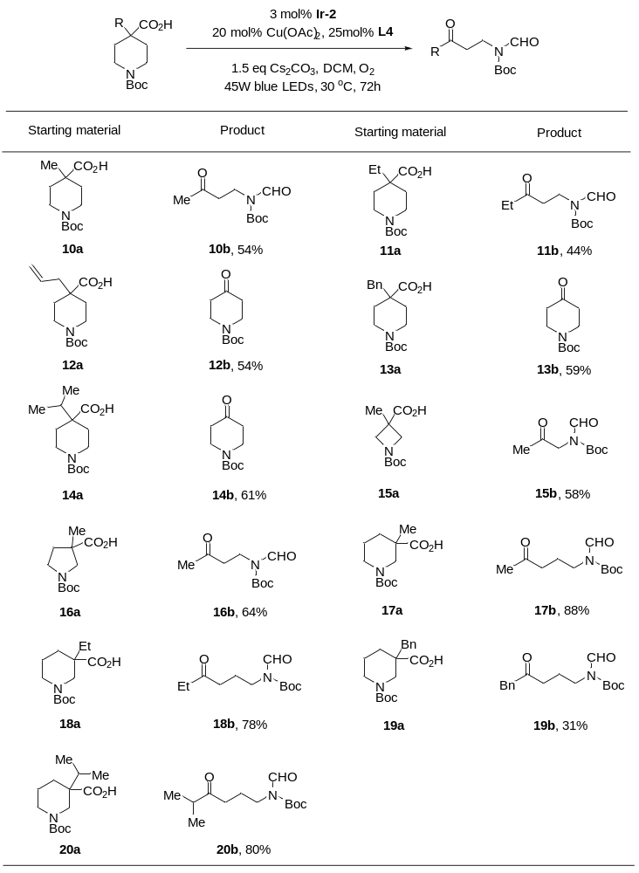
Reaction conditions: substrate (0.5 mmol), Ir-2 (0.015 mmol), Cu(OAc)₂ (0.1 mmol), L4 (0.125 mmol), Cs₂CO₃ (0.75 mmol), DCM (10 mL), 45W blue LEDs, 30ºC, 72 h.

Table 4 | Substrate scope of all carbon cyclic acids
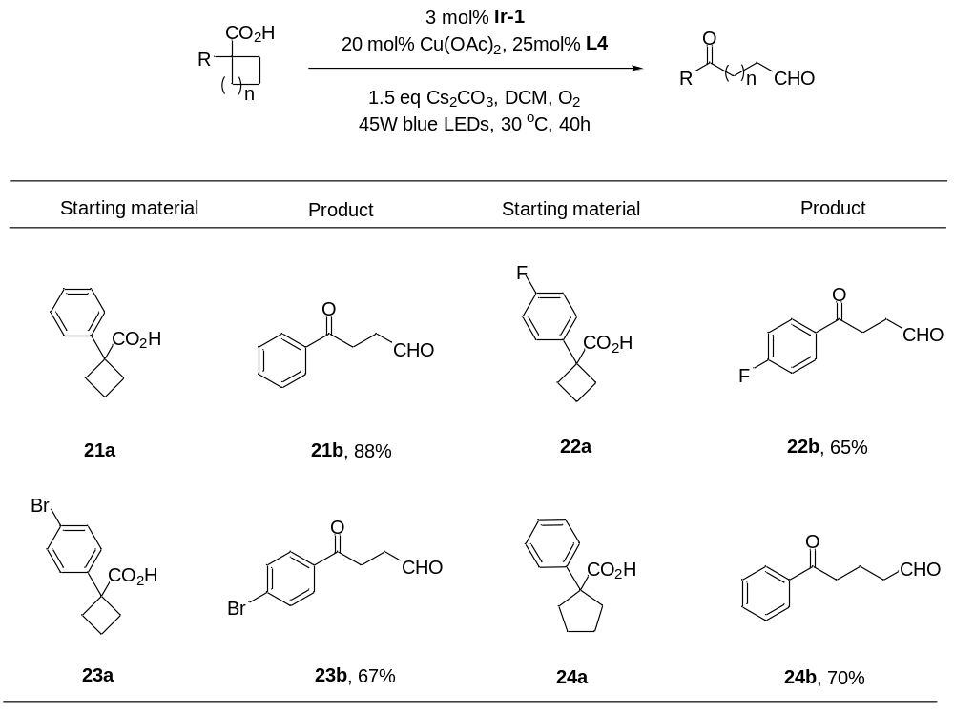
Reaction conditions: substrate (0.5 mmol), Ir-1 (0.015 mmol), Cu(OAc)₂ (0.1 mmol), L4 (0.125 mmol), Cs₂CO₃ (0.75 mmol), DCM (10 mL), 45W blue LEDs, 30ºC, 40 h.

Table 5| Substrate scope of acyclic acids
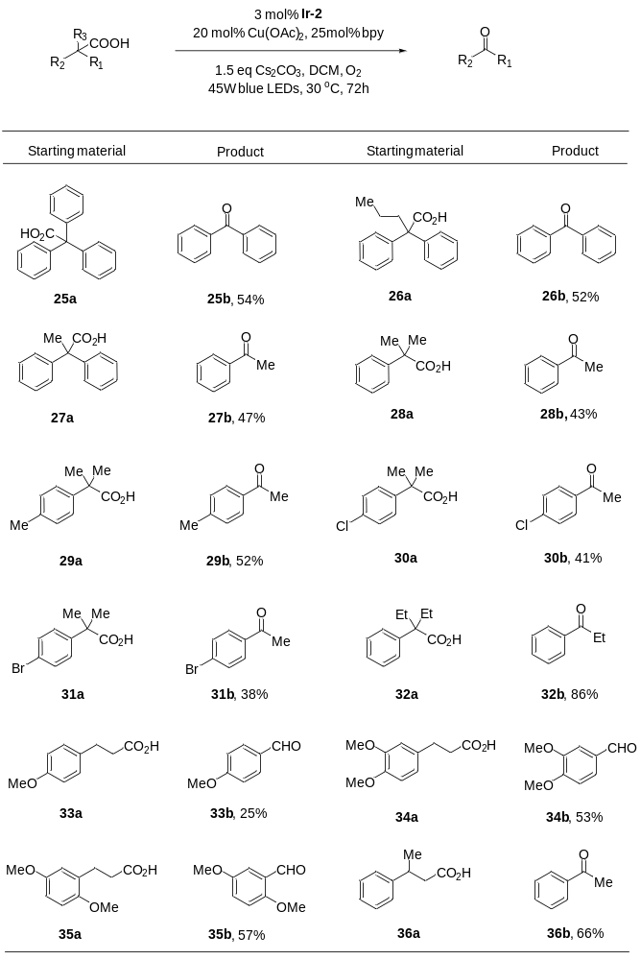
Reaction conditions: substrate (0.5 mmol), Ir-2 (0.015 mmol), Cu(OAc)₂ (0.1 mmol), L4 (0.125 mmol), Cs₂CO₃ (0.75 mmol), DCM (10 mL), 45W blue LEDs, 30ºC, 72 h.

Table 6| Substrate scope of β-hydroxy acids
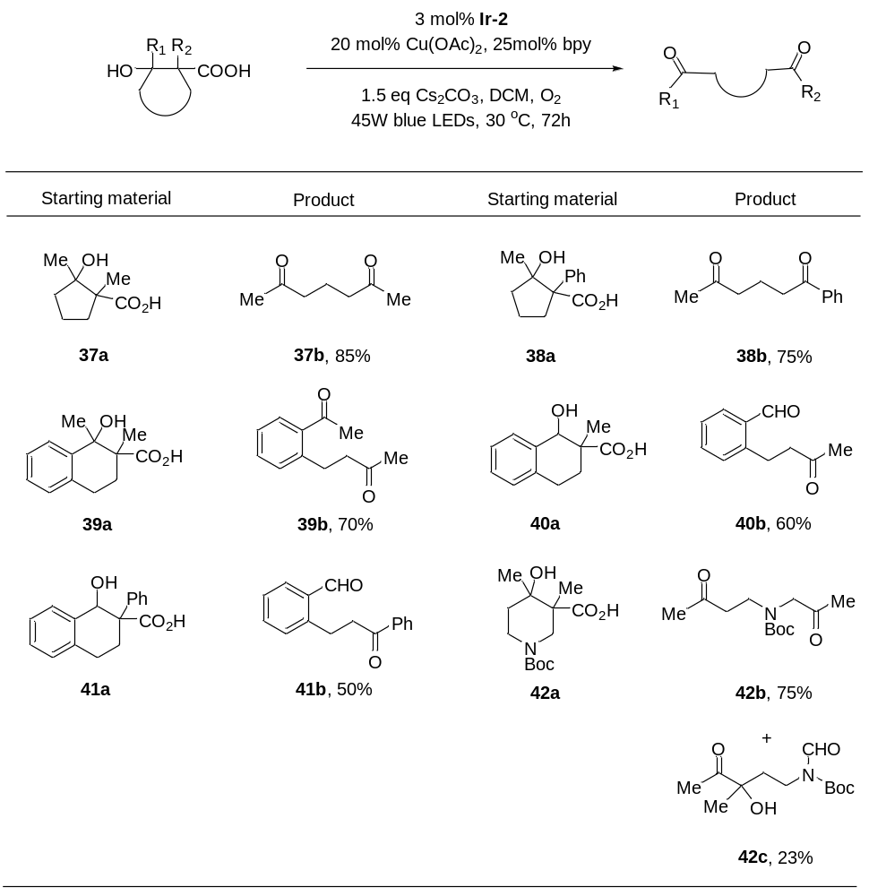
Reaction conditions: substrate (0.5 mmol), Ir-2 (0.015 mmol), Cu(OAc)₂ (0.1 mmol), L4 (0.125 mmol), Cs₂CO₃ (0.75 mmol), DCM (10 mL), 45W blue LEDs, 30ºC, 72 h.

Table 7| Substrate scope for the ketone-alcohol products
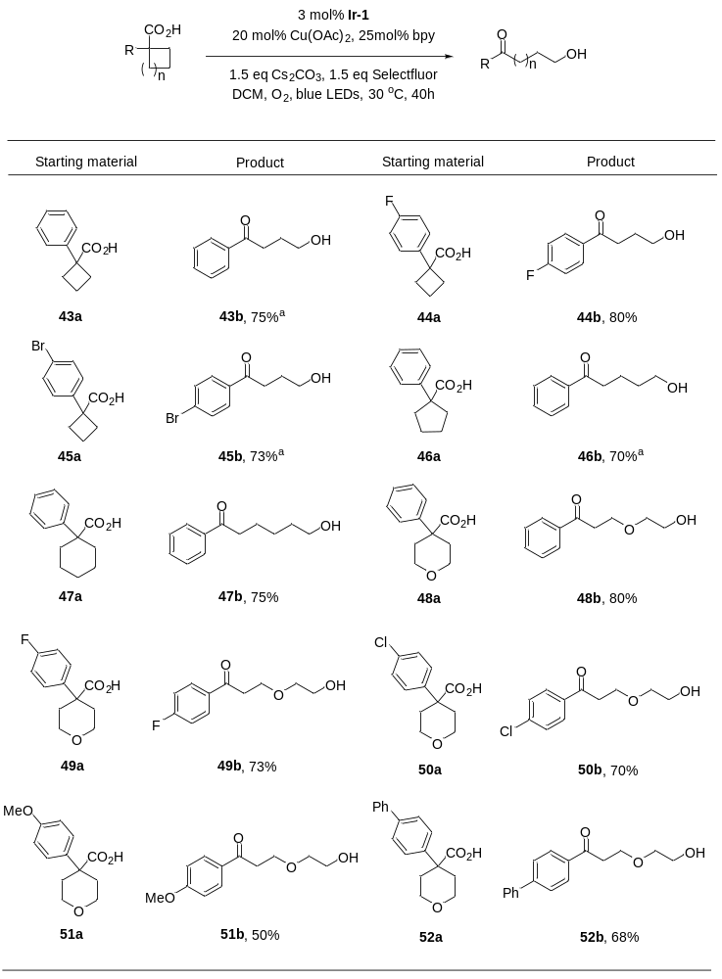
Reaction conditions: substrate (0.5 mmol), Ir-1 (0.015 mmol), Cu(OAc)₂ (0.1 mmol), L4 (0.125 mmol), Cs₂CO₃ (0.75 mmol), Selectfluor (0.75 mmol), DCM (10 mL), 45W blue LEDs, 30ºC, 72 h. ª Yields were determined by ¹H NMR.

